3GPP TSG-RAN WG2 Meeting #118 Electronic R2-220xxxx

Online, May, 2022

**Agenda item: 6.17.3**

**Source: Apple**

**Title: DRAFT Summary of [AT118-e][075][feMIMO] BFD Resource Handling (Apple)**

**WID/SID: NR_feMIMO-Core**

**Document for: Discussion and Decision**

# 1 Introduction

This document reflects the content and outcome of the following email discussion:

* [AT118-e][075][feMIMO] BFD Resource Handling ()

Scope: Applies to MAC and RRC. Await info from RAN1. Take into account incoming LSes (or RAN1 decisions) when applicable/available. Address Open issues. Attempt to converge, Identify agreements and discussion points. The discussion should assume that R2 will follow R1 requests.

Intended outcome: Report for CB (maybe multiple revisions, as it may need to be updated multiple times dep on R1 progress).

Deadline: Set by rapporteur, for CB W2 Wednesday

# 2 Contact Points

Respondents to the email discussion are kindly asked to fill in the following table.

|  |  |  |
| --- | --- | --- |
| Company | Name | Email Address |
| LGE | Hanul Lee | hanul.lee@lge.com |
| Intel | Youn Heo | Youn.hyoung.heo@intel.com |
| vivo | Chenli | Chenli5g@vivo.com |
|  |  |  |
|  |  |  |

# 3 Discussion

## 3.1 RAN1 LS (R2-2206359 / R1-2205168)

RAN1 provides the answers to the BFD resources handling in their LS as below:

|  |
| --- |
| **Issue 7: Max values FFS in Rel-17 TS 38.331**  Some maximum values are still missing from RRC configuration and RAN2 needs those for ASN.1 freezing.  **Question 8:** Please provide value for maxNrofCandidateBeams-r17 and maxNrofBFDResourcePerSet-r17.  **Answer 8**:   * maxNrofCandidateBeams-r17 is 64 per set per CC according to the latest LS reply * Regarding maxNrofBFDResourcePerSet-r17, RAN1 has agreed to introduce MAC-CE for BFD-RS activation (in addition to RRC configuration):   + If UE supports MAC-CE based BFD RS activation, maxNrofBFDResourcePerSet-r17 is 64     - The intended operation is for MAC-CE to activate 1 or 2 out of the (maximum of) 64 configured BFD-RS resources from the set   + Otherwise, maxNrofBFDResourcePerSet-r17 is 2 |
| **Issue 8: Possibilities for BFD-RS configuration**  The existing RRC signalling for BFD-RS configuration allows the following possibilities:   * Alt.1: Two explicit BFD-RS sets: e.g. failureDetectionSet1-r17 and failureDetectionSet2-r17 with respective bfdRSSetId-r17 * Alt.2: Only one explicit BFD-RS set: e.g. failureDetectionSet1-r17 or failureDetectionSet2-r17 with bfdRSSetId-r17. It requires that the UE determines BFD-RS for the other BFD-RS set, e.g. according to TCI state(s) for PDCCH reception and the corresponding coreset pool index. * Alt.3: BFD-RS without explicit BFD-RS set: e.g. failureDetectionSet1-r17 or failureDetectionSet2-r17 without bfdRSSetId-r17. It requires that the UE determines the BFD-RS set which each BFD-RS belongs to.   RAN2 thinks that at least Alt.1 is possible, but would like to understand whether RAN1 specifications support Alt.2 or Alt.3.  **Question 9:** Please confirm whether Alt.2 and Alt.3 are allowed configurations according to the existing RAN1 specifications, or whether RRC signalling for BFD-RS configuration should exclude Alt.2 and Alt.3.  **Answer 9**: Based on RAN1 agreements and Rel-17 RAN1 specification,   * Alt1 is allowed. * Alt2 is excluded.   The current formulation of Alt3 in the LS is unclear. If the only difference between Alt1 and Alt3 is that Alt1 includes an explicit bfdRSSetId parameter in BeamFailureDetectionSet-r17 IE whereas Alt3 doesn’t, Alt3 is excluded. |

## Clarification on the BFD-RS sets configuration

According to the RAN1 answer 9 on Issue#8, only Alt 1 is allowed, so we can clarify in RRC that the two sets (i.e. failureDetectionSet1-r17 and failureDetectionSet2-r17) are always provided together;

#### **Question 1: Do you agree with the following RRC design for the BFD-RS configuration?**

* The two sets (i.e. failureDetectionSet1-r17 and failureDetectionSet2-r17) are always provided together.

|  |  |  |
| --- | --- | --- |
| Company | Agree or not? | Comments |
| OPPO | Agree |  |
| LGE | Agree |  |
| Intel | Agree |  |
| vivo | Agree |  |
|  |  |  |

## For the UE who supports the MAC CE based BFD-RS activation

According to the RAN1 answer 8 on Issue#7, UE will indicate the support of the MAC-CE based BFD-RS activation via its UE capability. It’s noted that RAN1 has decided to introduce the new UE capability for it.

For the UE who supports the MAC CE based BFD-RS activation, the BFD-RS configuration and activation mechanism can be described as below:

* NW can configure the candidate BFD-RS resources per set via RRC signaling;
  + The max number of the BFD-RS per set (i.e. *maxNrofBFDResourcePerSet-r17*) is 64;
* The new MAC CE is introduced to indicate the actual used BFD-RS resources per set
  + MAC-CE to activate 1 or 2 out of the (maximum of) 64 configured BFD-RS resources from the set.

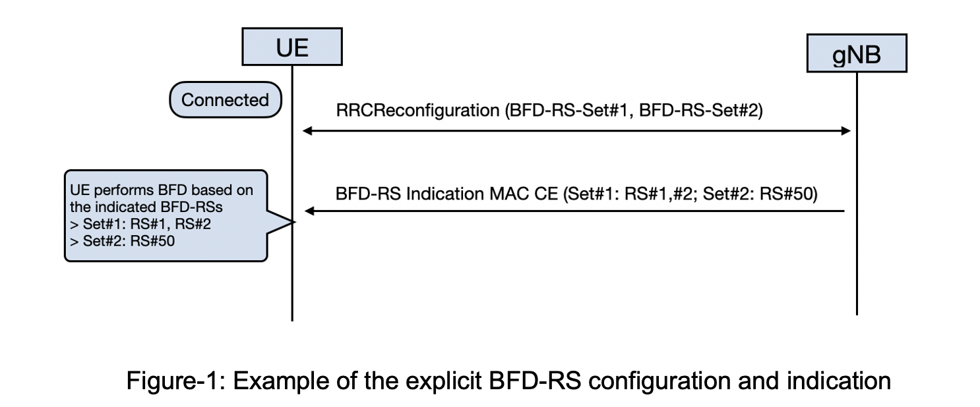

#### **Question 2: Do you agree with the above BFD-RS configuration and activation mechanism if UE supports it?**

|  |  |  |
| --- | --- | --- |
| Company | Agree or not? | Comments |
| OPPO | Agree |  |
| LGE | Agree | Regarding the time gap between the configuration of BFD-RS sets and the reception of the MAC CE, it should be discussed whether UE considers as no activated BFD-RS as in legacy (i.e., the UE performs beam monitoring based on the activated TCI-State for PDCCH) or UE does not perform beam monitoring. |
| Intel | Agree |  |
| vivo | Agree |  |
|  |  |  |

#### **Question 3: For RRC configuration, do you agree to set the max number of the candidate BFD-RS per set (i.e. maxNrofBFDResourcePerSet-r17) to 64?**

maxNrofBFDResourcePerSet-r17 INTEGER ::= 64

|  |  |  |
| --- | --- | --- |
| Company | Agree or not? | Comments |
| OPPO | Agree |  |
| LGE | Agree |  |
| Intel | Agree |  |
| vivo | Agree |  |
|  |  |  |

For the MAC CE design, according to RAN1 LS, we can assume the MAC CE design according to the following principles:

1. The MAC CE is designed in the per CC per BWP granularity;
2. The MAC CE always includes the full information of the two sets;
3. The MAC CE includes 1 or 2 BFD-RS resources out of the configured BFD-RS resources from the set;
4. UE deactivates all the previous activated BFD-RS upon receiving the new MAC CE for the same BWP and serving cell.

#### **Question 4: For MAC CE design, do you agree with above principles for the BFD-RS indication MAC CE design?**

|  |  |  |
| --- | --- | --- |
| Company | Agree or not? | Comments |
| OPPO | Fine with 1) and 3) are fine  Not sure about 2)  No for 4) | So far such MAC CE is designed with A/D bits. there is some argument on whether explicit activation and implicit deactivation can be done for SP SRS resource for antenna switch but RAN2 agreed not to pursue that way |
| LGE | Agree |  |
| Intel | Agree |  |
| Vivo | Agree |  |
|  |  |  |

Figure-2 is provided as the format of the BFD-RS indication MAC CE for discussion.

* NOTE: If NW only provides one BFD-RS for a set, the V-bit is set to 0 for the second BFD-RS ID indication for this set.

Figure-2: The BFD-RS indication MAC CE

#### **Question 5: For MAC CE design, do you agree with format of the BFD-RS indication MAC CE as indicated in Figure-2?**

|  |  |  |
| --- | --- | --- |
| Company | Agree or not? | Comments |
| OPPO | No | The detail format is also related to one issue whether BFD resource of both sets will be always in the same MAC CE. If yes the setID could be saved since the order can be used to implicit indicate the setID. |
| LGE | Agree | In our understanding, V field is always set 1 when both BFD-RS set#0 and #1 is configured, and V field is set 0 when BFD-RS set#0 is configured and BFD-RS set#1 is not configured. |
| Intel | Agree | We think that it doesn’t need to activate both sets simultaneously. |
| vivo | Agree |  |
|  |  |  |

## 3.3 For the UE who doesnot support the MAC CE based BFD-RS activation

For the UE who doesnot support the MAC CE based BFD-RS activation, NW only configures and activates the BFD-RS resources per set by RRC configuration. NW can configure up to 2 BFD-RS resources per set via RRC configuration based on UE capability.

#### **Question 5: For RRC configuration, which way do you prefer to describe the configuration restriction on the max BFD-RS resources per set for the UE who doesnot support the MAC CE based activation?**

* Option 1: describe the restriction in the UE capability part (in 38.306)
* Option 2: describe the restriction in the field description of the set configuration , for example:

|  |
| --- |
| ***failureDetectionSet1, failureDetectionSet2***  Configures parameters for beamfailure detection towards beam failure detection resources configured in the set. If additionalPCIList is configured for the serving cell, each RS in one set can be associted only to one PCI.  NW doesnot configure more than 2 RS in one set for the UE who can not support the MAC CE based BFD-RS activation. |

|  |  |  |
| --- | --- | --- |
| Company | preference? | Comments |
| OPPO |  | We prefer to define one scheme. If RAN2 agree to introduce MAC CE, RRC only solution can be saved. |
| LGE | Option 2 | Option 2 is preferred as it is more familiar to specify in RRC. |
| Intel | Option 2 | It should be described in RRC field description. |
| vivo | Option 2 |  |
|  |  |  |

## 3.3 Other issues

|  |  |
| --- | --- |
| Company | Comments |
|  |  |
|  |  |
|  |  |

# 4 Conclusion

TBD.