3GPP TSG-RAN WG2 Meeting #118-e R2-22xxxxx
Online, 9th – 20th May 2022

Agenda item: 6.4.1
Source: vivo (Rapporteur)
Title: Summary of [AT118-e][068][eIAB] 37340 (vivo)
Document for: Discussion and Agreement

1 Introduction
This is to report of the following email discussion at RAN2#118-e meeting:
- [AT118-e][068][eIAB] 37340 (vivo)
Scope: 1. Address the remaining TS issues from tdocs submitted under AI 6.4 (and below), except those issues addressed in specific discussion. Review collect comments identify agreement points, points for online CB etc. 2. Progress the CR, merge all TS impacts into a single CR.
Intended outcome: Report, CR
Deadline: 1 for CB W2 Wed (CB only if needed, attempt offline agreement), 2 CR agreement is expected in Post meeting discussion

This email discussion is consisted of two phases: phase 1 and phase 2, the deadline of each phase is outlined as follow:
- Phase 1: Collect comments for agreeable parts, deadline: Monday May.16, 2022, 12:00 UTC.
- Phase 2: Propose TP for agreeable Work on the CR, deadline: Wednesday May. 18, 2022, 10:00 UTC

2 Contact Information
To make it easier to find the correct contact delegate in each company for potential follow-up questions, the rapporteur encourages the delegates who provide input to provide their contact information in this table:
Company | Contact: Name (E-mail)
vivo | Kimba Dit Adamou, Boubacar (kimba@vivo.com)
LG Electronics | Gyeong-Cheol LEE (gyeongcheol.lee@lge.com)

3 Discussion

3.1 Miscellaneous corrections
3.1.1 R2-2204790 [1]
The contribution [1] proposes to add the description in MCG/SCG failure handling for IAB-MT as follows:

7.7 SCG/MCG failure handling
RLF is declared separately for the MCG and for the SCG.
If radio link failure is detected for MCG, and fast MCG while the SCG is not deactivated link recovery is configured, the UE triggers fast MCG link recovery. Otherwise, the UE initiates the RRC connection re-establishment procedure. During the execution of PSCell addition or PSCell change, if radio link failure is detected for MCG, the UE initiates the RRC connection re-establishment procedure.
During fast MCG link recovery, the UE suspends MCG transmissions for all radio bearers, except SRB0, and, if any, BH RLC channels and reports the failure with MCGFailureInformation message to the MN via the SCG, using the SCG leg of split SRB1 or SRB3.
The UE includes in the MCGFailureInformation message the measurement results available according to current measurement configuration of both the MN and the SN. Once the fast MCG link recovery is triggered, the UE maintains the current measurement configurations from both the MN and the SN, and continues measurements based on configuration from the MN and the SN, if possible. The UE initiates the RRC connection re-establishment procedure if it does not receive an RRCConnectionReconfiguration message, RRCReconfiguration message, MobilityFromNRCommand message, MobilityFromEUTRACommand message, RRCConnectionRelease message or RRCRelease message within a certain time after fast MCG link recovery was initiated.
Upon reception of the MCGFailureInformation message, the MN can send RRCConnectionReconfiguration message, RRCReconfiguration message, MobilityFromNRCommand message, MobilityFromEUTRACommand message, RRCConnectionRelease message or RRCRelease message to the UE, using the SCG leg of split SRB1 or SRB3. Upon receiving an RRCConnectionReconfiguration message, RRCReconfiguration message, MobilityFromNRCommand message or MobilityFromEUTRACommand message, the UE resumes MCG transmissions for all radio bearers. Upon receiving an RRCConnectionRelease message or RRCRelease message, the UE releases all the radio bearers and configurations.
NOTE 1: It is up to network implementation to guarantee that the RRC-related messages are delivered to the UE by the SN before the release of its control plane resources.
The following SCG failure cases are supported:
- SCG RLF;
- SCG beam failure while the SCG is deactivated;
- SN addition/change failure;
- For EN-DC, NGEN-DC and NR-DC, SCG configuration failure or CPC configuration failure (only for messages on SRB3);
- For EN-DC, NGEN-DC and NR-DC, SCG RRC integrity check failure (on SRB3);
- For EN-DC, NGEN-DC and NR-DC, consistent UL LBT failure on PSCell;
- For IAB-MT, reception of a BH RLF indication from SCG;
- CPA/CPC execution failure.
Upon SCG failure, if MCG transmissions of radio bearers are not suspended, the UE suspends SCG transmissions for all radio bearers, and, if any, BH RLC channels and reports the SCGFailureInformation to the MN, instead of triggering re-establishment. If SCG failure is detected while MCG transmissions for all radio bearers are suspended, the UE initiates the RRC connection re-establishment procedure.
<text omitted>
According to the repporteur’s understanding, the change is related to the IAB-MT behavior to suspend the MCG/SCG transmissions for BH RLC channels, if any, during fast MCG link recovery or upon SCG failure.
Q1: Do you agree on the proposed change above in R2-2204790 [1]?
Company | Agree as is;  Agree with changes;  Disagree | Detailed Comments
LGE | Agree as is

Conclusion:

3.1.2 R2-2204790 [1] and R2-2204897 [2] (Correction on F1-C transfer in NR-DC)
- R2-2204897 [2]
[2] observes that the term “F1-termination” and “non-F1-termination” are used in this specification. While in TS 38.473, TS 38.401 and TS 38340, the termF1-terminating” and “non-F1-terminating” are used to describe whether the F1-connection is terminating in an IAB-donor. Add a reference to TS 38.473 The similar wording should be used in TS 37.340 as well as. More, reference to TS 38.473 is added, since the signaling to configure the BH RLC channel mapping for F1-C traffic is included in TS 38.473.

7.12 F1-C transfer in NR-DC
In NR-DC, the F1-AP message encapsulated in SCTP/IP or F1-C related (SCTP/)IP packet can be transferred via BAP sublayer or via SRB between the IAB-node and the corresponding non-F1-terminating node (as specified in TS 38.401 [7]), as specified in TS 38.331 [4]. When both MCG and SCG are configured to transfer the F1-AP message encapsulated in SCTP/IP or F1-C related (SCTP/)IP packet, it is up to the IAB-node implementation for path selection. Two scenarios are supported, as shown in Figure 7.12-1.
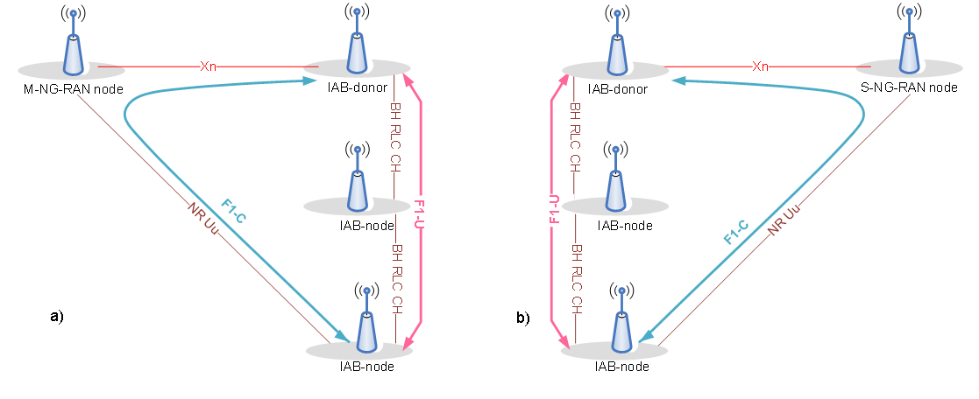
Figure 7.12-1: F1-C Transfer procedure in NR-DC; a) Scenario 1; b) Scenario 2
Scenario 1: IAB-node exchanges F1-AP message encapsulated in SCTP/IP or F1-C related (SCTP/)IP packet with the SN (F1-terminating node as specified in TS 38.401 [7]) using NR access link via MN (non-F1-terminating node), and exchanges F1-U traffic using backhaul link(s) with SN. SRB2 is used for transporting the F1-AP message encapsulated in SCTP/IP or F1-C related (SCTP/)IP packet between IAB-MT and MN (see TS 38.331 [4]), and the F1-AP message encapsulated in SCTP/IP or F1-C related (SCTP/)IP packet is transferred in a container via XnAP between MN and SN, see TS 38.423 [5].
Scenario 2: IAB-node exchanges F1-AP message encapsulated in SCTP/IP or F1-C related (SCTP/)IP packet with the MN (F1-terminating node) using NR access link via SN (non-F1-terminating node), and exchanges F1-U traffic using backhaul link(s) with MN. Split SRB2 is used for transporting the F1-AP message encapsulated in SCTP/IP or F1-C related (SCTP/)IP packet between IAB-MT and SN (see TS 38.331 [4]), and the F1-AP message encapsulated in SCTP/IP or F1-C related (SCTP/)IP packet is transferred in a container via XnAP between SN and MN, see TS 38.423 [5].
The F1-AP message encapsulated in SCTP/IP or the F1-C related (SCTP/)IP packet can be transferred either over BAP sublayer or over SRB, but the two mechanisms cannot be supported simultaneously on the same parent link. The F1-AP message encapsulated in SCTP/IP or the F1-C related (SCTP/)IP packet is transferred over BAP sublayer, if the BH RLC channel used for transferring the F1-C traffic is configured on the cell group indicated for F1-C traffic transfer according to TS 38.473 [23] and TS 38.331 [4].

Q2: Do you agree with proposed changes above R2-2204897 [2]?
Company | Agree/Disagree | Detailed Comments
LGE | Agree

Conclusion:

- R2-2100467 [2]
Also proposes correction also amend to update the caption of Figure 7.12-1, Figure 10.10.2-5 and Figure 10.15-2 to align the caption style of the figures for the similar procedures.

10.10.2 MR-DC with 5GC
<text omitted>
F1-C traffic transfer:
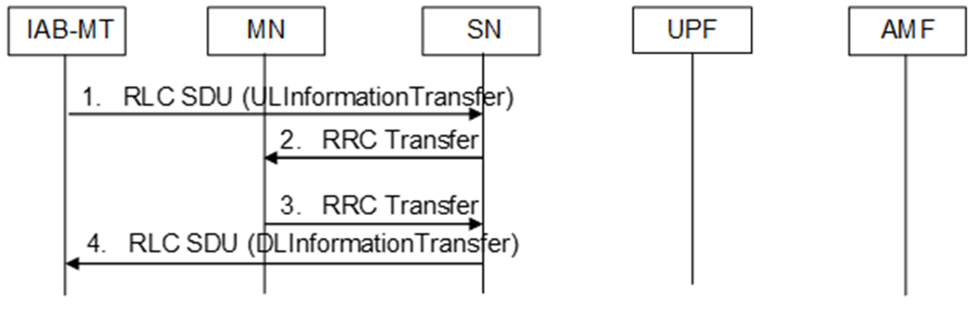
Figure 10.10.2-5: Scenario 2: F1-C Traffic Transfer procedure between IAB-MT and MN (F1-terminating node) in NR-DC
1. The IAB-MT sends a F1-AP message encapsulated in SCTP/IP or F1-C related (SCTP/)IP packet to the SN (non-F1-terminating node) via split SRB2 in a container within ULInformationTransfer encapsulated in a PDCP PDU as specified in TS 38.331 [4].
<text omitted>

F1-C traffic transfer:
Figure 10.10.2-5: Scenario 2: F1-C Traffic Transfer procedure between IAB-MT and MN (F1-terminating node) in NR-DC
1. The IAB-MT sends a F1-AP message encapsulated in SCTP/IP or F1-C related (SCTP/)IP packet to the SN (non-F1-terminating node) via split SRB2 in a container within ULInformationTransfer encapsulated in a PDCP PDU as specified in TS 38.331 [4].
2. The SN initiates the RRC Transfer procedure, in which it transfers the received PDCP PDU (ULInformationTransfer message) including F1-AP message.
3. When the MN (F1-terminating node) sends a F1-AP message encapsulated in SCTP/IP or F1-C related (SCTP/)IP packet, it starts the procedure by initiating the RRC Transfer procedure, if split SRB2 is determined to be used and usage of SCG path is determined. The MN sends the F1-AP message to the SN in a container within DLInformationTransfer encapsulated in a PDCP PDU specified in TS 38.331 [4].
4. The SN forwards the encapsulated DLInformationTransfer in a PDCP PDU as specified in TS 38.331 [4] to IAB-MT.
<text omitted>

4. The MN sends the received F1-AP message encapsulated in SCTP/IP or F1-C related (SCTP/)IP packet to the IAB-MT in a container within DLInformationTransfer as specified in TS 36.331 [10].
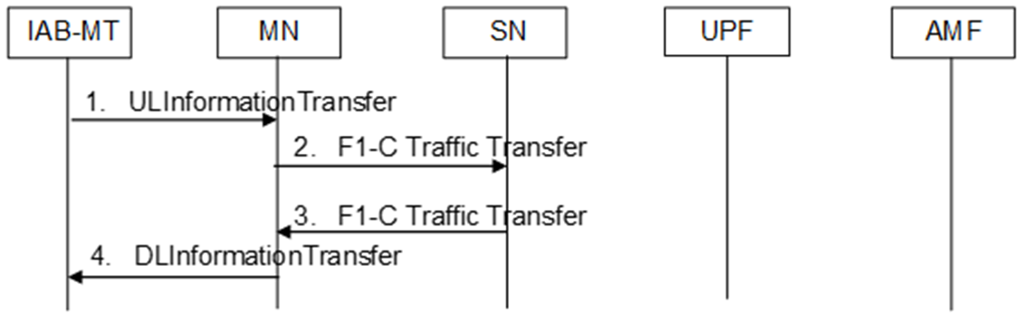
Figure 10.15-2: Scenario 1: F1-C Traffic Transfer procedure between IAB-MT and SN (F1-terminating node) in NR-DC

Q3: Do you agree with the proposed changes above in R2-2204897 [2]?
Company | Agree as is;  Agree with changes;  Disagree | Detailed Comments
LGE | Agree as is

Conclusion:

- R2-2205257[4]
It is proposed to move Figure 10.10.2-5 and the F1-C traffic transfer steps corresponding to the figure to Clause 10.15, and change the wording of “RRC Transfer” to “F1-C Traffic Transfer” in these steps.

Q4: Do you agree to move Figure 10.10.2-5 and the F1-C traffic transfer steps corresponding to the figure to Clause 10.15 in R2-2205257 [4]?
Company | Agree as is;  Agree with changes;  Disagree | Detailed Comments
LGE | Disagree | The scenario 2 is different from F1-C transfer in EN-DC and the scenario 1 in NR-DC. The scenario 1 and EN-DC case use SRB2 and the PDCP termination point is MCG, so the MCG can de-capsulate the F1-C massage from the RRC message and use F1-C traffic transfer procedure. However, the scenario 2 uses a split SRB2 and the PDCP termination point is MCG, not in SCG, so the SCG cannot de-capsulate the F1-C massage from the RRC message and just transfer the received RLC PDU to the MCG. Given explanation so far, we think that “F1-C Traffic Transfer” section for the scenario 2 is not correct and this should be specified in the current section.

Conclusion:

R2-2205257 [4] also proposes to further change wording of “RRC Transfer” to “F1-C Traffic Transfer” in these steps of Figure 10.10.2-5.

Q5: If the ANS to Q4 is Yes, do you agree to change wording of “RRC Transfer” to “F1-C Traffic Transfer” in these steps of Figure 10.10.2-5 as in R2-2205257 [4]?
Company | Agree as is;  Agree with changes;  Disagree | Detailed Comments
LGE | Disagree | See comments in Q4.

Conclusion:

3.2 Minor corrections
- R2-2204790 [1] and R2-2205257[4]
In Clause 10.10.2, it is proposed to delete the description that RRC Transfer procedure can provide F1-C traffic transfer function as follows:

10.10.2 MR-DC with 5GC
The RRC Transfer procedure is used to deliver an RRC message, encapsulated in a PDCP PDU between the MN and the SN (and vice versa) so that it may be forwarded to/from the UE using split SRB. The RRC transfer procedure is also used for:
- providing a SN measurement report, failure information report, SN UE assistance information or CPC execution completion from the UE to the SN;
- providing MCG failure information from the UE to the MN via the SN and an RRC reconfiguration, or release, or an inter-RAT handover command from the MN to the UE via the SN;

Additional details of the RRC transfer procedure are defined in TS 38.423 [5].
Split SRB:
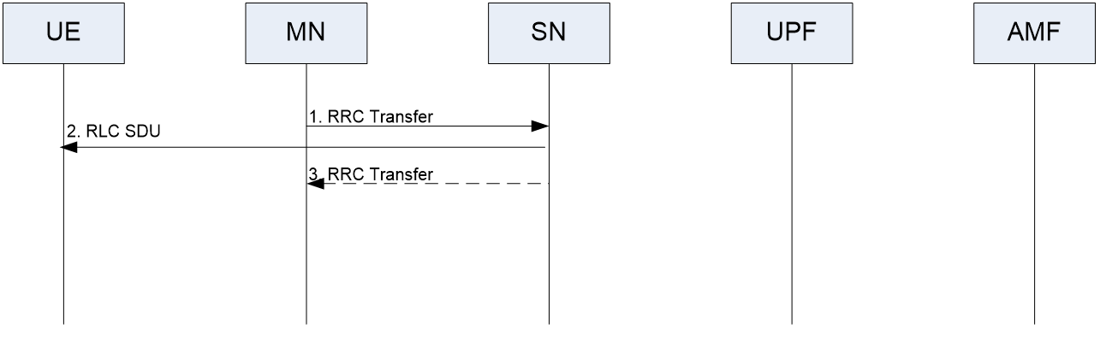
<text omitted>

Q6: Do you agree the changes proposed above by R2-2205257[4]?

Company | Agree as is;  Agree with changes;  Disagree | Detailed Comments
LGE | Disagree | See comments in Q4.

Conclusion:

- R2-2205521[3] and R2-2205900[5]
Contributions [3] and [5] made the similar observations that in IAB WI, there is an IABOtherInformation message transfer procedure for handling IP address allocation request and report ones already allocated in RRC layer. This should be captured in RRC Transfer procedure when MRDC is configured for IAB node and IABOtherInformation message is transferred to the donor node encapsulated in ULTransferMRDC message. And two options of changes are as follows:

Change option 1: R2-2205521[3]

10.10.2 MR-DC with 5GC
The RRC Transfer procedure is used to deliver an RRC message, encapsulated in a PDCP PDU between the MN and the SN (and vice versa) so that it may be forwarded to/from the UE using split SRB. The RRC transfer procedure is also used for:
- providing a SN measurement report, failure information report, SN UE assistance information, CPC execution completion, or IABOtherInformation from the UE to the SN;
- providing MCG failure information from the UE to the MN via the SN and an RRC reconfiguration, or release, or an inter-RAT handover command from the MN to the UE via the SN.
Additional details of the RRC transfer procedure are defined in TS 38.423 [5].
<text omitted>
Figure 10.10.2-2 shows an example signaling flow for UL RRC Transfer in case of the split SRB:
1. When the UE provides response to the RRC message, it sends it to the SN.
2. The SN initiates the RRC Transfer procedure, in which it transfers the received PDCP PDU with encapsulated RRC message.
SN measurement report, failure information report, SN UE assistance information, CPC execution completion, or IABOtherInformation:
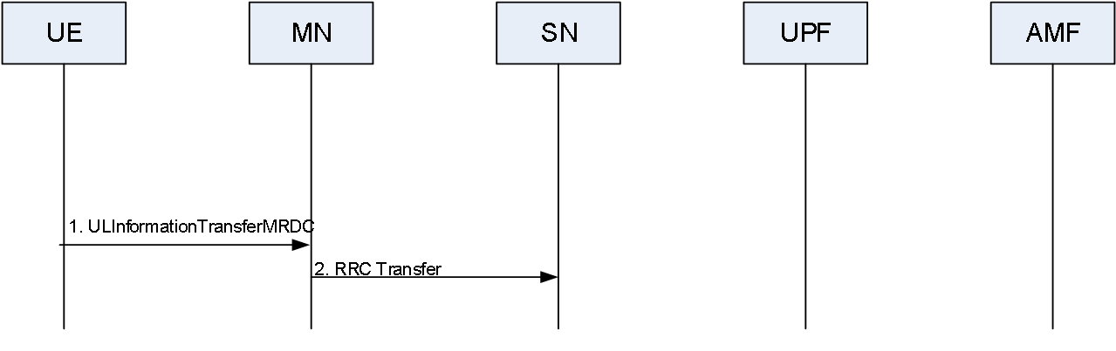
Figure 10.10.2-3: RRC Transfer procedure for SN measurement report, failure information report, SN UE assistance information, CPC execution completion, or IABOtherInformation
Figure 10.10.2-3 shows an example signaling flow for RRC Transfer in case of the forwarding of the SN measurement report, failure information report, SN UE assistance information, CPC execution completion, or IABOtherInformation from the UE:
1. When the UE sends an SN measurement report, failure information report, SN UE assistance information, CPC execution completion, or IABOtherInformation it sends it to the MN in a container called ULInformationTransferMRDC as specified in TS 38.331 [4].
2. The MN initiates the RRC Transfer procedure, in which it transfers the received SN measurement report, failure information, SN UE assistance information, CPC execution completion, or IABOtherInformation as an octet string.
MCG failure information and RRC Reconfiguration / RRC Release / inter-RAT handover command over SRB3:
<text omitted>

Change option 2: R2-2205900[5]

10.10.2 MR-DC with 5GC
The RRC Transfer procedure is used to deliver an RRC message, encapsulated in a PDCP PDU between the MN and the SN (and vice versa) so that it may be forwarded to/from the UE using split SRB. The RRC transfer procedure is also used for:
- providing a SN measurement report, failure information report, SN UE assistance information or CPC execution completion from the UE to the SN. If UE is IAB-MT, providing NR IAB other information from the IAB-MT to the SN when the IAB-donor is in the SN.
- providing MCG failure information from the UE to the MN via the SN and an RRC reconfiguration, or release, or an inter-RAT handover command from the MN to the UE via the SN.
Additional details of the RRC transfer procedure are defined in TS 38.423 [5].
Split SRB:
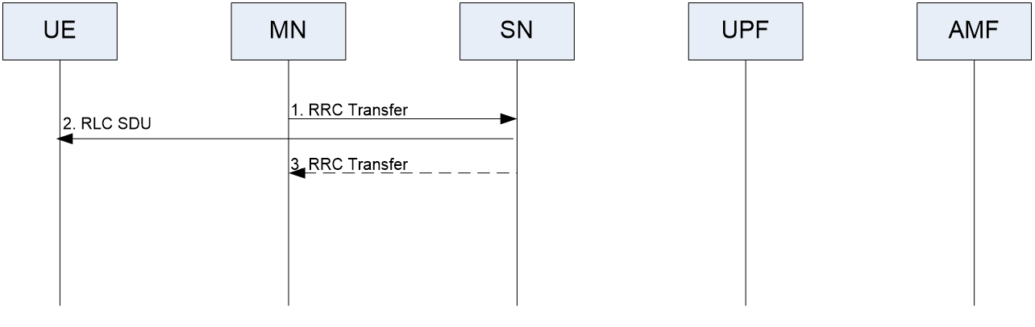
Figure 10.10.2-1: RRC Transfer procedure for split SRB (DL operation)
Figure 10.10.2-1 shows an example signaling flow for DL RRC Transfer in case of the split SRB:
1. The MN, when it decides to use the split SRBs, starts the procedure by initiating the RRC Transfer procedure. The MN encapsulates the RRC message in a PDCP PDU and ciphers with own keys.
NOTE: The usage of the split SRBs shall be indicated in the Secondary Node Addition procedure or Modification procedure.
2. The SN forwards the RRC message to the UE.
3. The SN may send PDCP delivery acknowledgement of the RRC message forwarded in step 2.
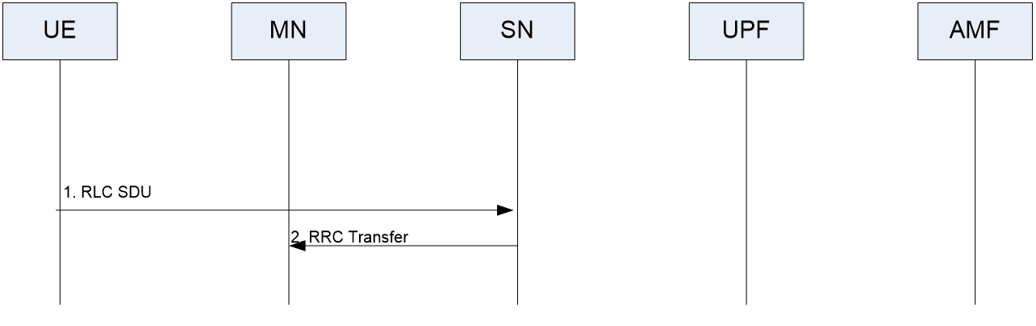
Figure 10.10.2-2: RRC Transfer procedure for split SRB (UL operation)
Figure 10.10.2-2 shows an example signaling flow for UL RRC Transfer in case of the split SRB:
1. When the UE provides response to the RRC message, it sends it to the SN.
2. The SN initiates the RRC Transfer procedure, in which it transfers the received PDCP PDU with encapsulated RRC message.
SN measurement report, failure information report, SN UE assistance information, CPC execution completion, or IAB other information:
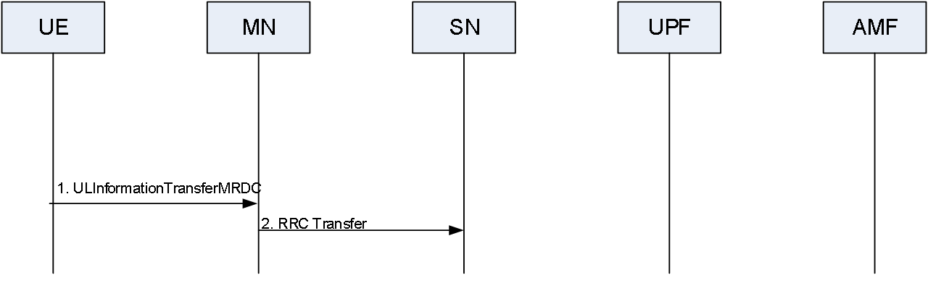
Figure 10.10.2-3: RRC Transfer procedure for SN measurement report, failure information report, SN UE assistance information, CPC execution completion, or IAB other information
Figure 10.10.2-3 shows an example signaling flow for RRC Transfer in case of the forwarding of the SN measurement report, failure information report, SN UE assistance information, CPC execution completion, or IAB other information from the UE:
1. When the UE sends an SN measurement report, failure information report, SN UE assistance information, CPC execution completion, or IAB other information it sends it to the MN in a container called ULInformationTransferMRDC as specified in TS 38.331 [4].
2. The MN initiates the RRC Transfer procedure, in which it transfers the received SN measurement report, failure information, SN UE assistance information, CPC execution completion, or IAB other information as an octet string.
MCG failure information and RRC Reconfiguration / RRC Release / inter-RAT handover command over SRB3:
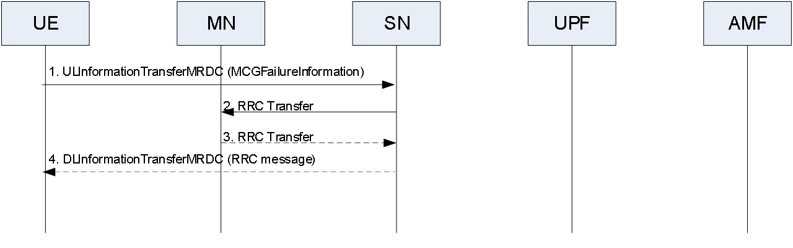
Figure 10.10.2-4: RRC Transfer procedure for MCG failure information
Figure 10.10.2-4 shows an example signaling flow for RRC Transfer in case of the forwarding of the MCG failure information from the UE:
1. When the UE sends MCGFailureInformation over SRB3, it sends it to the SN in a container called ULInformationTransferMRDC as specified in TS 38.331 [4].
2. The SN initiates the RRC Transfer procedure, in which it transfers the received MCGFailureInformation as an octet string.
3. The MN initiates the RRC Transfer procedure, in which it transfers the RRCConnectionReconfiguration, or RRCConnectionRelease, or MobilityFromNRCommand, or MobilityFromEUTRACommand as an octet string.
4. The SN sends the received RRC message to the UE in a container called DLInformationTransferMRDC, as specified in TS 38.331 [4].

Q7: Do you agree to capture IABOtherInformation message transfer procedure for handling IP address allocation request and report in case of MRDC as proposed R2-2205521[3] and R2-2205900[5]

Company | Agree as is;  Agree with changes;  Disagree | Detailed Comments
LGE | Agree

Q8: If the ANS to Q7 is Yes, which alternative to you prefer ?
- Change option 1: R2-2205521[3]
- Change option 2: R2-2205900[5]
Company | Option 1/2 | Detailed Comments
LGE | Option 1 | Both work and slightly prefer option 1, but option 2 is also ok if majority want it.

Conclusion:

- R2-2204790 [1]
In [1] it is noted “both” is configured for the F1-C transfer path and the BH RLC CH for F1-C is configured on the MCG/SCG, the MCG/SCG should be selected for the F1-C transfer. In other words, It is not totally up to implementation to select the MCG or the SCG for F1-C transfer if IAB-MT is configured with both. So, [1] thinks that the description for the case when both MCG and SCG are configured to transfer F1-C related traffic is not clear. [1] further proposed to the following change:

7.12 F1-C transfer in NR-DC
In NR-DC, the F1-AP message encapsulated in SCTP/IP or F1-C related (SCTP/)IP packet can be transferred via BAP sublayer or via SRB between the IAB-node and IAB-donor the corresponding non-F1-termination node (as specified in TS 38.401 [7]), as specified in TS 38.331 [4]. When both MCG and SCG are configured to transfer the F1-AP message encapsulated in SCTP/IP or F1-C related (SCTP/)IP packet, the F1-C related traffic is transferred over BAP sublayer, if the BH RLC channel used for transferring the F1-C related traffic is configured on the cell group indicated for F1-C related traffic transfer according to TS 38.331 [4]; otherwise, it is up to the IAB implementation for path selection. Two scenarios are supported, as shown in Figure 7.12-1.
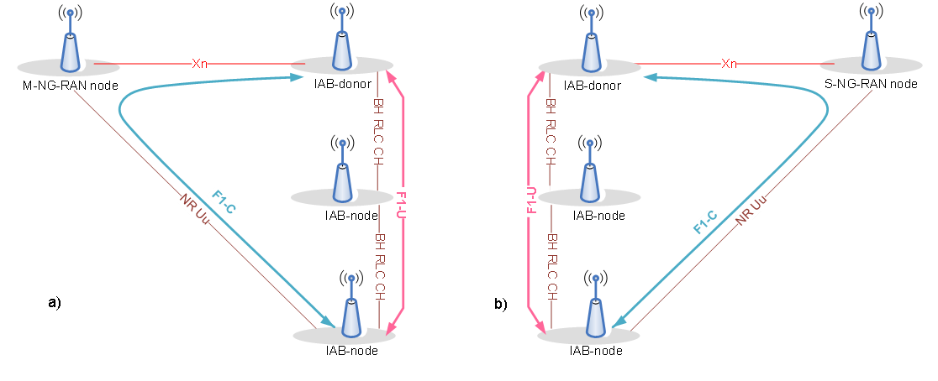
Figure 7.12-1: F1-C transfer in NR-DC; a) Scenario 1; b) Scenario 2
<text omitted>

The F1-AP message encapsulated in SCTP/IP or the F1-C related (SCTP/)IP packet can be transferred either over BAP sublayer or over SRB, but the two mechanisms cannot be supported simultaneously on the same parent link.
<text omitted>

For quick reference, the rapporteur has copied the corresponding agreements below:
Related agreements from RAN2-116e:
- The configuration of F1-C traffic on the indication of the the leg(s) used for transferring the F1-C traffic is configured to IAB-MT by a new field , e.g., f1c-TransferPath-r17 ENUMERATED {MCG, SCG, both}.
- As long as the BH RLC CH for F1-C on the indicated Cell Group is configured (the CG is indicated by the field f1c-TransferPath-r17), IAB node can be aware of whether to use F1-C transferring over BH or F1-C transferring over RRC, i.e. F1-C-over-BAP is selected as long as BH RLC CH for F1-C on the indicated CG is configured.
- It is not necessary for IAB-node to be aware whether the gNB allows “F1 over BAP” or only allows “F1-C over RRC” during cell (re)selection, in case the gNB broadcasts iab-Support.
- ONLY SRB2 is used for F1-C transport in CP/UP-separation scenario 1.
- ONLY split SRB2 is used for F1-C transport in CP/UP-separation scenario 2
Related agreementes from RAN2-116bis:
- The network is allowed to configure the primaryPath to SCG for the IAB-MT
- The IAB-MT should always follow the primary path configuration for all the RRC messages, regardless of whether F1-C information or IAB-unrelated information are contained

- Q9: Do you agree the changes proposed above by R2-2204790 [1]?

Company | Agree as is;  Agree with changes;  Disagree | Detailed Comments
LGE | Disagree | We think that R2-2204790 may misinterpret the below agreement. This agreement is for one Cell Group, not per UE.  Considering that the concerned sentence starts with “When both MCG and SCG are configured”, the proposed change is not correct and the current wording has no problem because the field description in f1c-TransferPathNRDC clearly said that “If IAB-MT is configured with both, it is up to IAB-MT to select the MCG or the SCG for F1-C transfer.”  - As long as the BH RLC CH for F1-C on the indicated Cell Group is configured (the CG is indicated by the field f1c-TransferPath-r17), IAB node can be aware of whether to use F1-C transferring over BH or F1-C transferring over RRC, i.e. F1-C-over-BAP is selected as long as BH RLC CH for F1-C on the indicated CG is configured.  In addition, considering the RAN2 agreement in RAN2#114e below, anyway there should be only one configuration available in one Cell group, i.e., either F1-C over RRC or F1-C over BAP, and the proposed clarification would not be needed.  - F1-C over RRC and F1-C over BAP should not be supported simultaneously on the same parent link.

- R2-2204790 [1]
Also in this contribution, it is also noted that he terms “F1-terminating node” and “non-F1-terminating node” are used in CU-UP separation scenarios, which are not appropriate and proposes:

7.12 F1-C transfer in NR-DC
In NR-DC, the F1-AP message encapsulated in SCTP/IP or F1-C related (SCTP/)IP packet can be transferred via BAP sublayer or via SRB between the IAB-node and IAB-donor, as specified in TS 38.331 [4]. When both MCG and SCG are configured to transfer the F1-AP message encapsulated in SCTP/IP or F1-C related (SCTP/)IP packet, it is up to the IAB implementation for path selection. Two scenarios are supported, as shown in Figure 7.12-1.
Figure 7.12-1: F1-C transfer in NR-DC; a) Scenario 1; b) Scenario 2
Scenario 1: IAB-node exchanges F1-AP message encapsulated in SCTP/IP or F1-C related (SCTP/)IP packet with the SN (IAB-donor) using NR access link via MN, and exchange F1-U traffic using backhaul link(s) with SN. SRB2 is used for transporting the F1-AP message encapsulated in SCTP/IP or F1-C related (SCTP/)IP packet between IAB-MT and MN (see TS 38.331 [4]), and the F1-AP message encapsulated in SCTP/IP or F1-C related (SCTP/)IP packet is transferred as a container via XnAP between MN and SN, see TS 38.423 [5].
Scenario 2: IAB-node exchanges F1-AP message encapsulated in SCTP/IP or F1-C related (SCTP/)IP packet with the MN (IAB-donor) using NR access link via SN, and exchange F1-U traffic using backhaul link(s) with MN. Split SRB2 is used for transporting the F1-AP message encapsulated in SCTP/IP or F1-C related (SCTP/)IP packet between IAB-MT and SN (see TS 38.331 [4]), and the F1-AP message encapsulated in SCTP/IP or F1-C related (SCTP/)IP packet is transferred as a container via XnAP between SN and MN, see TS 38.423 [5].
<text omitted>

1. When the IAB-MT sends a F1-AP message encapsulated in SCTP/IP or F1-C related (SCTP/)IP packet, it sends it to the MN in a container within ULInformationTransfer as specified in TS 36.331 [10].
2. The MN initiates the F1-C Traffic Transfer procedure, in which it transfers the received F1-AP message encapsulated in (SCTP/)IP or F1-C related (SCTP/)IP packet as an octet string.
3. When the SN sends a F1-AP message encapsulated in SCTP/IP or F1-C related (SCTP/)IP packet, it sends it to the MN as an octet string through the F1-C Traffic Transfer procedure.
4. The MN sends the received F1-AP message encapsulated in SCTP/IP or F1-C related (SCTP/)IP packet to the IAB-MT in a container within DLInformationTransfer as specified in TS 36.331 [10].
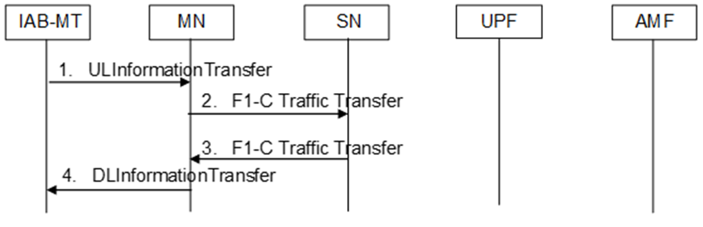
Figure 10.15-2: Scenario 1: F1-C is transported between IAB-MT and SN (IAB-donor) in NR-DC
1. The IAB-MT sends a F1-AP message encapsulated in SCTP/IP or F1-C related (SCTP/)IP packet to the MN via SRB2 in a container within ULInformationTransfer as specified in TS 38.331 [4].
2. The MN initiates the F1-C Traffic Transfer procedure, in which it transfers the received F1-AP message encapsulated in (SCTP/)IP or F1-C related (SCTP/)IP packet as an octet string.
3. The SN (IAB-donor) sends a F1-AP message encapsulated in SCTP/IP or F1-C related (SCTP/)IP packet to the MN as an octet string through the F1-C Traffic Transfer procedure.
4. The MN sends the received F1-AP message encapsulated in SCTP/IP or F1-C related (SCTP/)IP packet to the IAB-MT via SRB2 in a container within DLInformationTransfer as specified in TS 38.331 [4].
<text omitted>

- Q10: Do you agree the changes proposed above by R2-2204790 [1]?

Company | Agree as is;  Agree with changes;  Disagree | Detailed Comments
LGE | Disagree | We don’t see a problem on the current wording.

4 Conclusion
TBD

5 References
- R2-2204790 Miscellaneous corrections on IAB in 37.340 ZTE, Sanechips CR Rel-17 37.340 17.0.0 0311 - F NR_IAB_enh-Core
- R2-2204897 Miscilaneous Corrections to 37340 vivo(Rapporteur) CR Rel-17 37.340 17.0.0 0313 - B NR_IAB_enh-Core
- R2-2205521 Inclusion of IABOtherInformation message in RRC Transfer procedure Samsung R&D Institute UK draftCR Rel-17 37.340 17.0.0 NR_IAB_enh-Core
- R2-2205257 Corrections on F1-C traffic transfer for eIAB in TS 37.340 Huawei, HiSilicon CR Rel-17 37.340 17.0.0 0315 - F NR_IAB_enh-Core
- 2-2205900 Corrections to IAB MR-DC procedures Ericsson CR Rel-17 37.340 17.0.0 0322 - F NR_IAB_enh-Core

