3GPP TSG-RAN WG2 #118-e Tdoc R2-22xxxxx

Electronic meeting, 9th May – 20th May 2022

Agenda Item: 6.4.1.3

Source: Ericsson

Title: Summary of [AT118-e][064][eIAB] RRC (Ericsson)

Document for: Discussion, Decision

# 1 Introduction

This document addresses the following email discussion:

* [AT118-e][064][eIAB] RRC (Ericsson)

Scope: 1. Address the remaining RRC issues from tdocs submitted under AI 6.4 (and below) and RILs (if needed), except those issues addressed in specific discussion. Review collect comments identify agreement points, points for online CB etc. 2. Progress the RRC CR, merge all RRC impacts into a single CR (except UE caps).

Intended outcome: Report, CR

Deadline: 1 for CB W2 Wed, 2 CR agreement is expected in Post meeting discussion

Rapporteur would like to set the deadline for this email discussion to Tuesday 17th May 10:00 UTC

# 2 Discussion

The following agreement has been reached during the online discussion in RAN2#118-e:

* all the propAgree, propReject and propModify states are confirmed, except H044 H045 which can be discussed

This email discussion focuses on RILs that require further discussion as captured in the RIL excel sheet in R2-2206346.

## 2.1 RIL v222

The current implementation of the new Rel.17 availabilityCombinations (defined as availabilityCombinationsRBGroup-r17 in the current ASN1) is as follows:

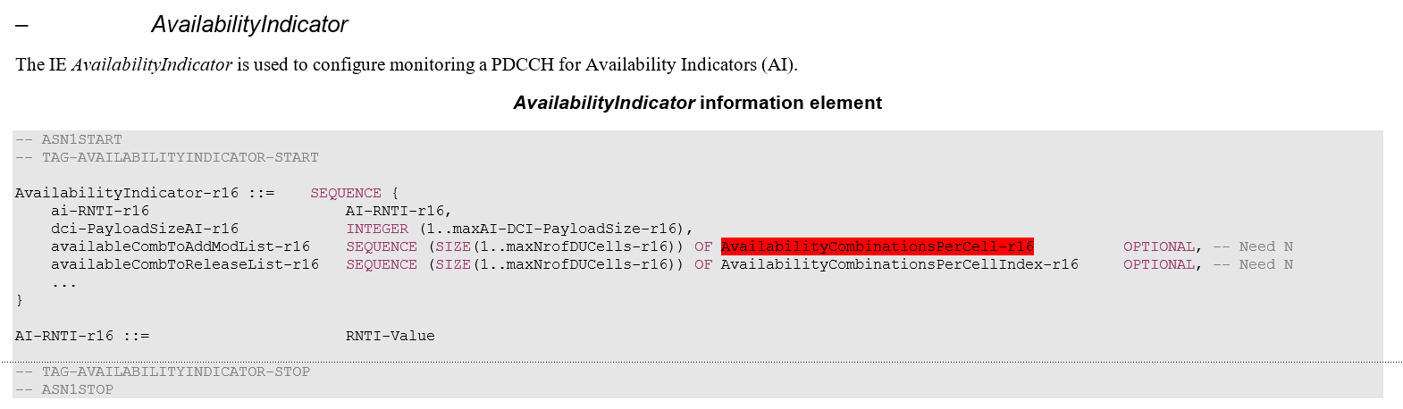

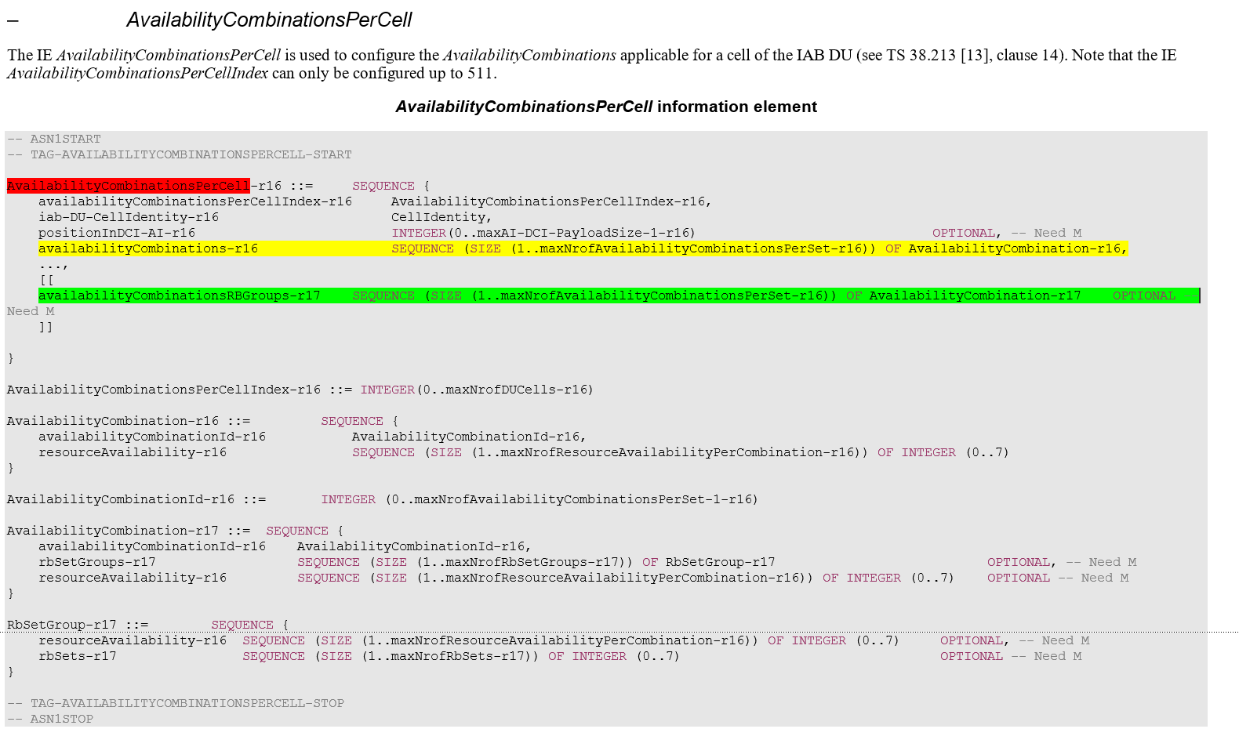

From the above ASN1 excerpt, the legacy availabilityCombinations-r16 table, and the new Rel.17 availabilityCombinationsRBGroups are configured separately within the AvailabilityCombinationsPerCell-r16 which is configured per DU cell. In particular, th new Rel-17 availabilityCombinationsRBGroups-r17 is included as an optional configuration within the legacy Rel.16 AvailabilityCombinationsPerCell.

In the RIL v222, it is proposed to decouple from the AvailabilityCombinationsPerCell-r16, the new Rel-17 availabilityCombinationsRBGroups and the legacy Rel.16 AvailabilityCombinationsPerCell. The solution for this RIL would imply introducing a new AvailabilityCombinationsPerCell-r17 in the form of a Add/ReleaseModList structure within the AvailabilityIndicator IE. Then we would need to create a new AvailabilityCombinationPerCell type, e.g. AvailabilityCombinationPerCellExt, which would basically have the same structure as the AvailabilityCombinationPerCell-r16, and also a lot of parameters in common with the legacy AvailabilityCombinationPerCell-r16, e.g. the availability combination ID, the cell ID, the position in DCI, etc.

Rapporteur also highlights that the following was just agreed in RAN1, and no concern were specifically raised on this RAN2 design:

|  |
| --- |
| **RAN1 agreement from this meeting:**  An IAB node can be configured with two availabilityCombinations tables, one for TDM and one for FDM |

Hence, RAN2 should discuss whether there is a strong need to pursue the change in RIL v222, considering the potential ASN.1 impact.

* **Q1: [v222] Do you see the need to decouple from the legacy AvailabilityCombinationsPerCell-r16, the new Rel-17 availabilityCombinationsRBGroups and the legacy Rel.16 AvailabilityCombinationsPerCell?**
  + **This change would imply introducing a new AvailabilityCombinationsPerCell-r17 (which would include the new Rel-17 availabilityCombinationsRBGroups) in the form of a Add/ReleaseModList structure within the AvailabilityIndicator**

|  |  |  |
| --- | --- | --- |
| **Company** | **Yes, need to decouple**  **No need to decouple** | **Comments** |
| QCOM | Prefer not to decouple unless the majority prefers it that way.  See comment. | Yes, it might look nicer if they both were decoupled. Apart from that, there seems to be no technical reason to go the extra mile. One might actually ask why the AvailabilityCombinationPerCell-r16 IE was made extensible if not for the purpose of extending it, e.g., in Rel-17. |
| LGE | No need to decouple | We prefer to keep the structure as it is unless RAN1 request to make it separate, but no strong view, if majority want, we can follow as a compromise. |
| Huawei, HiSilicon | No | See no big issue with current shared combination ID, since anyway the DCI does not change in R1 compared to R16. |
| Apple | Prefer not to decouple | Similar view as QCOM, LGE and HW |
| Intel | No need to decouple | Since an IAB node can be configured with two separate availabilityCombinations tables, it is not necessary to duplicate the common IEs in two AvailabilityCombinationsPerCell IEs (one for r16, one for r17). |
| vivo | Ok to follow majority |  |
| Ericsson | No need to decouple | Agree with previous views, it is simpler and still fulfilling the RAN1 agreements to keep the current specification. |
|  |  |  |
|  |  |  |
|  |  |  |
|  |  |  |

## 2.2 RIL H044

In the current implementation two resourceAvailability IEs are included, one within the AvailabilityCombination-r17 (green entry below), the other within the RBSetGroup-r17 within the AvailabilityCombination-r17 (yellow entry). The field description clarifies that the one within the AvailabilityCombination-r17 (green entry) is only used in case the one in the RBSetGroup-r17 (yellow entry) is not configured.

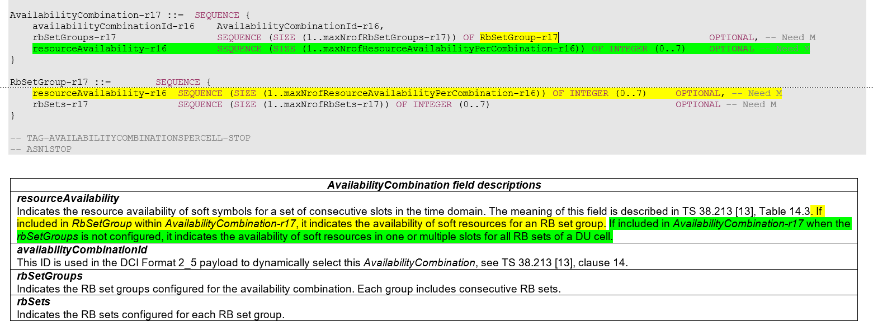

The reason for this implementation originates from the following RAN1 agreements indicated in the RAN1 LS:

1) "each resourceAvailaibity-Rel17 indicates the availability of soft resources in one or multiple slots for each configured RB set group in sequence."

2) "If an RB set group is not provided, only one resourceAvailablity-Rel17 is included in AvailabilityCombination-Rel17 to indicate availability of soft resources in one or multiple slots for all RB sets of a DU cell."

In Rapporteur´s view, the agreement in yellow above is represented by the resourceAvailability in the RBSetGroup-r17 within the AvailabilityCombination-r17 (yellow entry in the ASN1 code above), whereas the agreement in green is represented by the resourceAvailability included within the AvailabilityCombination-r17 (green entry in the ASN1 code above).

The RIL H044 claims that the resourceAvailability-r16 in AvailabilityCombination-r17 is redundant with the one in RbSetGroup-r17, and it should be deleted. Rapporteur believes that the current implementation seems to reflect the RAN1 agreements cited above.

* **Q2: [H044] Do you believe that the resourceAvailability-r16 in AvailabilityCombination-r17 should be deleted from the ASN1?** 
  + **If yes, please clarify how you would represent in the ASN.1 the case in which the RB set group in not provided (which is considered in the above cited RAN1 agreement)**

|  |  |  |
| --- | --- | --- |
| **Company** | **Yes, should be deleted**  **No (keep current spec)** | **Comments** |
| QCOM | No (keep current spec) |  |
| LGE | No |  |
| Huawei, HiSilicon | Yes | See our comment box.  1) "each resourceAvailaibity-Rel17 indicates the availability of soft resources in one or multiple slots for each configured RB set group in sequence."  2) "If an RB set group is not provided, only one resourceAvailablity-Rel17 is included in AvailabilityCombination-Rel17 to indicate availability of soft resources in one or multiple slots for all RB sets of a DU cell."  Our point is the green bullet 2) should be configured by legacy R16 field AvailabilityCombination-r16. In the current ASN.1 design, in R17, AvailabilityCombination-r16 becomes useless. |
| vivo | yes | Agree with the comments of Huawei. For resource availability indication in case of TDM, the legacy R16 field AvailabilityCombination-r16 can be reused. |
| Ericsson | No (keep current spec) | RAN1 did not agree that if no RB set group is provided the Rel-17 *resourceAvailability* is based on any Rel-16 *resourceAvailability*. It is also difficult to do so, since it would not be clear what Rel-16 *resourceAvailability* in the sequence of *availabilityCombinations-r16* to choose for that. At the same time RAN1 has agreed  Agreement  An IAB node can be configured with two availabilityCombinations tables, one for TDM and one for FDM  This means that *availabilityCombinations* tables for TDM and for FDM can be independent, which is not the case if by default Rel-17 *resourceAvailability* would be based on falling back to (any) Rel-16 *resourceAvailability*.  The legacy Rel.16 availabilityCombinations and the new AvailabilityCombinationRBGroups-r17 are two separate tables used for different purposes and their content should be not be mixed up.  The second comment from Huawei is addressed in the field description, i.e the green configuration is only applicable when the RBSetGroups are not configured, i.e. the yellow configuration is not provided. Hence, it seems the current spec correctly capture the wanted NW behaviour. |
|  |  |  |
|  |  |  |
|  |  |  |
|  |  |  |
|  |  |  |
|  |  |  |

## 2.3 RIL H045

In the current Rapporteur CR, the rbSets is represented as a sequence of RB set indexes, one for each RB set configured in one RB set group. See the ASN.1 code below:

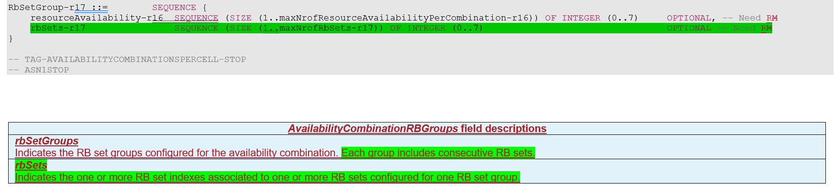

This design choice was motivated by the following RAN1 agreement in the RAN1 LS:

|  |
| --- |
| From RAN1 LS:  The RB set groups are configured in availabilityCombinationsPerCell-r17  for all availabilityCombinationId(s)  with the following parameters   * Number of RB set groups.   Number of RB sets for each group. Each group includes consecutive RB sets. |

Hence, from the above agreement, it seems that in RAN2 we should represent a sequence of consecutive RB sets within each RB set group. This seems in line with what currently implemented in the ASN.1.

The RIL H045 claims that based on the R3 signalling, we can just use the index of RbSetGroup without the need of SEQUENCE, i.e. “rbSets-r17 ~~SEQUENCE (SIZE (1..maxNrofRbSets-r17)) OF~~ INTEGER (0..7)”. Rapporteur notes that in the RAN3 F1AP signalling there is no RBSetGroup defined, because the RBSetGroup configuration is only related to the availabilityCombinationsPerCell defined in RAN2.

* **Q3: [H045] Do you believe that the rbSets configuration should not be a sequence of consecutive RB set?** 
  + **If yes, please clarify how you would represent in the ASN.1 this consecutive RB sets within each RB set group, as indicated by RAN1?**

|  |  |  |
| --- | --- | --- |
| **Company** | **Yes, change needed**  **No (keep current spec)** | **Comments** |
| QCOM | No (keep current spec) | RAN3 signaling only has RB set, no RB set groups. |
| LGE | No |  |
| Huawei, HiSilicon | Yes | rbSets-r17 SEQUENCE (SIZE (1..maxNrofRbSets-r17)) OF INTEGER (0..7)  Our key point is on the 7.  If we don’t go with our proposal to consider this rbSets-r17 as the index of RB set group, then it means the “INTEGER (0..7)” is one index of RB set. Apparently 7 is not the max number of RB set.  We are also fine if change 7 to the correct max number of RB set.  Note, the max number of RB set group is 7. |
| vivo | No |  |
| Ericsson | No (keep current spec) | In F1AP, the rbSet will be given indexing from 0 to 7.  In RRC, we need to group such RB sets. Hence, we need to have RBSetGroup x: rbset_index i, …, j, where i , j = {0,…,7}  Hence the current design seems ok. Please also note that the maximum number of RB sets in a group is 8, not 7, i.e.  maxNrofRbSets-r17 INTEGER ::= 8 -- Maximum number of RB sets |
|  |  |  |
|  |  |  |
|  |  |  |
|  |  |  |
|  |  |  |
|  |  |  |

## 2.4 RIL F005

In the RIL F005, it is proposed to clarify in the field description of *iab-donor-DU-BAP-Address*, that for a boundary IAB node’s descendant node, this field may be a pseudo BAP address. RAN2 should discuss the need of addressing this issue.  
Rapporteur notes that RRC procedures are currently agnostic with respect to whether the IAB node is boundary IAB node or descendant IAB node, and that the IAB-MT operations of the descendant IAB node may not be affected by inter-topology routing at the boundary IAB node. Whether the *iab-donor-DU-BAP-Address* configured at the descendant IAB node is a pseudo BAP address seems to be more an implementation aspect in the IAB donor (or a stage-2 detail, if needed), rather than an RRC-specific issue.

* **Q4: [F005] Do you see the need to to clarify in the field description of iab-donor-DU-BAP-Address, that for the descendant node of a boundary IAB node, this field may be a pseudo BAP address?**

|  |  |  |
| --- | --- | --- |
| **Company** | **Yes, see the need**  **No need** | **Comments** |
| QCOM | No | The term “pseudo BAP address” was only used by companies in a colloquial manner during discussion. It has never been used in the spec. It has not been defined anywhere. Introducing such a term would add confusion rather than clarification. |
| LGE | No | Agree with rapporteur’s analysis that RRC procedures should be agnostic. |
| Fujitsu | Yes | We think a clarification is needed to avoid misinterpreting the iab-donor-DU-BAP-Address as the real BAP address of the target donor-DU in the topology redundancy scenario. We understand that companies do not like the word “pseudo”. We have revised the sentence into the following:  For a boundary IAB node’s descendant node, this field may be a BAP address configured by the boundary IAB node’s F1-terminating donor while referring to an IAB-donor-DU where the IP address is anchored underneath the boundary IAB node’s non-F1-terminating donor-CU. |
| Huawei, HiSilicon | Seem no | There is no concept in spec on “pseudo BAP address”.  This can be F1-terminating CU implementation, to avoid any confusion on IP address selection. |
| Apple | No |  |
| Intel | No | Based on our understanding, the descendant IAB-nodes are transparent to BAP header rewriting, i.e. BAP header added in the descendant IAB-nodes are still the original IAB-donor DU’s BAP address. Therefore, the IE *iab-donor-DU-BAP-Address* carried in the RRC message towards descendant IAB-node are the real IAB-donor DU’s BAP address, rather than pseudo BAP address of target IAB-donor DU. Hence, we think [F005] is not correct and no need to update the description. |
| vivo | No |  |
| Ericsson | No | Agrees with previous views. |
|  |  |  |
|  |  |  |
|  |  |  |

## 2.5 RIL H046

In the RIL H046, it is proposed to clarify that the *f1c-TransferPathNRDC* is only used for CP/UP separation (not for topology redundancy). RAN2 could clarify in the field description that the *f1c-TransferPathNRDC* is used only when the IAB-MT is configured with NR-DC with one non-donor CU (i.e. no BH RLC channels in one leg).

* **Q5: [H046] Do you see the need to clarify that f1c-TransferPathNRDC is only used for CP/UP separation, i.e. when the IAB-MT is configured with NR-DC with one non-donor CU (no BH RLC channels in one leg)?**

|  |  |  |
| --- | --- | --- |
| **Company** | **Yes, see the need**  **No need** | **Comments** |
| QCOM | No need | RAN2 never restricted F1C -based transfer to CP-UP separation.  RAN2 solely agreed:   * F1-C over RRC and F1-C over BAP should not be supported simultaneously on the same parent link.   To comply with this agreement, F1-C-over-BAP could be restricted to only one leg via configuration, e.g., by only providing one UL mapping for F1-C, even if the IAB-node has both legs configured with BAP. |
| LGE | No | This restriction may not be needed and anyway it is up to NW implementation which decides whether this should be transferred via the non-donor CU or not. |
| Fujitsu | No need | Agree with QC. |
| Huawei, HiSIlicon | Yes | To QOCM comment, this is only about the f1c-TransferPathNRDC parameter, not restriction to F1C transfer.  The F1-over-BAP is controlled by UL mapping F1AP configuration, as also said by QCOM. So, in topology redundancy (no F1-C over RRC), f1c-TransferPathNRDC has no impact/should no impact on the F1-C transfer path.  The proposal is more like  “**clarify that f1c-TransferPathNRDC is only used to control the F1-C leg for CP/UP separation scenario, i.e. when the IAB-MT is configured with NR-DC with one non-donor CU (no BH RLC channels in one leg)?**” |
| Apple | No |  |
| Intel | Yes, see the need | We tend to agree with HW that discussion of CP/UP separation focuses on the scenario where one link is connected to IAB-donor via BAP, while another link is connected to gNB via RRC. The two scenarios were agreed in RAN3 as below:  **In Rel-17 eIAB, the following two scenarios are supported for CP-UP separation:**  **- Scenario 1: F1-C uses NR access link via M-NG-RAN node (non-donor node) + F1-U uses backhaul link via S-NG-RAN node (donor node)**  **- Scenario 2: F1-U uses backhaul link via M-NG-RAN node (donor node) + F1-C uses NR access link via S-NG-RAN node (non-donor node)**  Hence, we think the clarification in [046] is needed. |
| vivo | See comments | Agree with Huawei and Intel. The current description covers more than CP-UP separation scenario. We may need to check with RAN3 if it is necessary to apply **f1c-TransferPathNRDC** for all DC cases. |
| Ericsson | Yes | We agree to clarify in the field description that the usage of this field is for the specific CP/UP separation feature in scenario 1 and 2, i.e. BH RLC channels only in one leg of the NR-DC. |
|  |  |  |
|  |  |  |
|  |  |  |

## 2.6 RIL Z632

In the RIL Z632, it is proposed that if the *f1c-TransferPathNRDC* is configured with ”both”, it should not be left to the IAB-MT to select the MCG or the SCG for F1-C transfer, rather the IAB-MT should prioritize F1-C transmission over the CG with configured BH RLC CH.   
Rapporteur notes that RAN2 just agreed that if the IAB node selects a leg where there is a BH RLC channel, then the IAB-MT should use F1-C over BAP, otherwise F1-C over RRC. But we did not agree that when “both” is configured the IAB-MT should prioritize F1-C over BAP. Additionally, if the network wants the IAB node selects F1-over BAP, it would be just enough for the network to configure the *f1c-TransferPathNRDC* with “mcg” or “scg” depending on the leg in which BAP is configured.

* **Q6: [Z632] Do you see the need to introduce a rule for the f1c-TransferPathNRDC such that when the f1c-TransferPathNRDC is configured with ”both”, the IAB-MT should select F1-C transmission over the CG with configured BH RLC channels?**

|  |  |  |
| --- | --- | --- |
| **Company** | **Yes, need the change**  **No (keep current spec)** | **Comments** |
| QCOM | No (keep current spec) | To make it clear: If “both” is configured, the IAB-node can freely decide to use either path, i.e., via RRC or via BAP. There is no pre-defined priority.  This is the same behavior as we defined for ENDC in Rel-16. We should have common behavior for Rel-16 ENDC and Rel-17 NRDC.  RAN2 NEVER agreed to such a prioritized behavior for the “both” configuration.  If we restricted the IAB-node’s behavior for the “both” configuration, it wouldn’t make sense to even support the “both” configuration.  Note that the whole purpose of the “both” configuration is to provide robustness to the C-plane. This only works if the IAB-node can freely use either path. |
| LGE | No | Note that same issue is now discussing in “[AT118-e][068][eIAB] 37340 (vivo)”.  As indicated by the rapporteur and QC above, RAN2 never agreed to such prioritization for “both” configuration.  We think that they may misinterpret the below agreement. This agreement is for one Cell Group, not per UE. So, the current field description has no problem.   * As long as the BH RLC CH for F1-C on the indicated Cell Group is configured (the CG is indicated by the field *f1c-TransferPath-r17*), IAB node can be aware of whether to use F1-C transferring over BH or F1-C transferring over RRC, i.e. F1-C-over-BAP is selected as long as BH RLC CH for F1-C on the indicated CG is configured. |
| Fujitsu | No (keep current spec) | RAN2 agreement only says when that F1-C over BAP is not configured on a CG the UE sends F1-C over RRC on the CG.  When f1c-TransferPathNRDC is configured with ”both”, UE can select any CG to send F1-C relying on implementation, rather than select the CG with the configuration of F1-C over BAP. |
| Huawei, HiSilicon | No | “both” means implementation rather than any priority. Priority is a new feature |
| Apple | See comment | In our understanding the existing field description, regarding *f1c-TransferPathNRDC* is configured with ”both”, is correct.  TS 37.340 states: “When both MCG and SCG are configured to transfer the F1-AP message encapsulated in SCTP/IP or F1-C related (SCTP/)IP packet, it is up to the IAB implementation for path selection.”  However, the RAN2#116e agreement mentioned by LGE is only captured implicitly in the RRC spec. Perhaps it can be discussed if there is a better way to capture the agreement.  Secondly, the f1c-TransferPathNRDC IE is not just for DedicatedInfoF1c (which carries IAB-DU specific F1-C related information), it applies to F1C traffic as well. Therefore “F1-C related packets” should be replaced by “F1-C/F1-C related packets” in the CR, and TS 37.340 should be added as a reference. We have added a comment to the rapporteur CR to capture this aspect. |
| Intel | No (keep current spec) |  |
| vivo | No | Prioritization to select the leg configured with F1-C over BAP is a new feature not discussed yet. |
| Ericsson | No (keep current spec) | Agree with previous comments, no clear the benefits of this functionality. |
|  |  |  |
|  |  |  |
|  |  |  |

## 2.7 RIL S733

In the S733, it is proposed that the *logicalChannelGroup* configuration for IAB should go from 0 to 255, rather than from 8 to 255. The reason for specifying it from 8 to 255 was that in case the network does not want to configure the extended LCGs, it can simply configure the legacy logicalChannelGroup with 0 to 7 LCGs. Companies that see the need for this change argue that the extended short BSR allows 8bits buffer size, rather than 5bits buffer size as the legacy short BSR.   
Rapporteur´s view is that the network can configure the IAB-MT with the new extend logicalChannelGroup if more granularity in the short BSR is required.

* **Q7: [S733] Do you see the need to define the logicalChannelGroup-IAB-Ext-r17 from 0 to 255, rather than from 8 to 255 (as it is in the current spec)?**

|  |  |  |
| --- | --- | --- |
| **Company** | **Yes, need the change**  **No (keep current spec)** | **Comments** |
| QCOM | No strong view. |  |
| LGE | Yes. | We think that this causes a potential issue in BSR procedure and the related discussion is undergoing in “[AT118-e][065][eIAB] MAC (Samsung)”.  For the rapporteur’s comment above, i.e., “**Rapporteur´s view is that the network can configure the IAB-MT with the new extend logicalChannelGroup if more granularity in the short BSR is required.**”, the problem is that even though the network wants more granularity in the short BSR for the logical channel 0 to 7, the IAB-node cannot report the extended Short BSR for the logical channel 0 to 7 because logicalChannelGroup-IAB-Ext-r17 starts from 8 to 255. We think that this is unnecessary restriction to the extended BSR procedure and it should be resolved.  Also note that considering that 5bits buffer size field in the Legacy Short BSR is designed only for one UE, not for backhaul traffic from many UEs, the IAB node should use an extended Short BSR if the IAB node support extended BSR format.  Based on these reasons, the MAC discussion rapporteur’s suggestion in “[AT118-e][065][eIAB] MAC (Samsung)” on this issue is to update the extended BSR procedure in MAC spec and he mentioned that the logicalChannelGroup-IAB-Ext-r17 should start from 0 to 255 in RRC offline discussion. We think that just changing start from 0 is very simple from RRC spec change perspective and this also removes all concerns and problems. |
| Fujitsu | No strong view. | Slightly prefer 8 to 255 (no change). |
| Huawei, HiSilicon | No strong view | The impact is both on MAC And RRC. |
| Apple | Tend to say “No” | We agree with observation 3 and 4 in R2-2205287: Extended Short BSR would be more appropriate for backhaul traffic and helpful for resource scheduling in the IAB node because this has same length of buffer size field as Long BSR and can give more detailed buffer size status than the legacy Short BSR.  However, the extended formats were introduced to facilitate a higher number of LCGs. If an IAB node operates with the same number of LCGs as a UE in legacy (which is unlikely, actually), then there might be no need to use the extended formats. Besides RAN2 agreed not to introduce new triggering conditions for BSR/Extended BSR as there should be no imbalance between normal UEs and IAB-MT.  The *logicalChannelGroup-IAB-Ext* is used at multiple other places in the MAC spec to distinguish between different modes of operation depending on the number of LCGs. If we change this, then these places will be affected. Maybe another parameter would be needed for these places then. More importantly, the proposed solution brings back the issue that Extended Long Truncated BSR could be used when there are less than 8 LCGs with data available (even though more are configured), which seems like a waste. |
| Intel | No (keep current spec) | As discussed in [066] MAC email discussion, it was agreed in previous RAN2 meeting that legacy short BSR formats are used when max configured LCG ID is less than 8. Additionally, if an IAB-node is configured with less than 8 LCG IDs, it also indicates that this IAB-node is far from IAB-donor (i.e. more closer to the accessed UE). For such scenario, the buffer size is not expected to be large, and 8 bits are not necessary. Hence, we don’t think this change should be pursued. |
| vivo | No strong view |  |
| Ericsson | No | Agree with previous comments. The issue can be solved by implementation, by configuring more LCGs. Additionally has mentioned by Apple, the issue of overhead of the Extended Long BSR that we have discussed during the past meetings will be even more critical, since we will use the long BSR also when the IAB node has less than 8 LCGs. |
|  |  |  |
|  |  |  |
|  |  |  |

## 2.8 RIL F008

In the RIL F008, it is proposed that if the iab-IP-AddressConfigurationList was received within an RRCReconfiguration message generated by the non-F1-terminating donor-CU of the boundary IAB node, the boundary IAB node considers the IAB IP address configuration is for the non-F1-terminating topology. Whereas, if the iab-IP-AddressConfigurationList was received within an RRCReconfiguration message generated by the F1-terminating donor-CU of the boundary IAB node, the boundary IAB node considers the IAB IP address configuration is for the F1-terminating topology

Rapporteur notes that in the rapporteur CR, it has been clarified that the IAB-IP-AddressConfigurationList can be included in the SCG configuration (besides the MCG). Hence it seems clear, without further clarifications, that the IAB node should use the received IAB-IP-AddressConfigurationList in the respective CG.

* **Q8: [F008] Do you see the need to clarify, e.g. in a note, that the IAB node should use the *iab-IP-AddressConfigurationList* configured in the SCG for communication towards the SCG, and the iab-IP-AddressConfigurationList configured in the MCG for communication towards the MCG?**

|  |  |  |
| --- | --- | --- |
| **Company** | **Yes, need to clarify**  **No (keep current spec)** | **Comments** |
| QCOM | No (keep current spec) | Obviously, all configurations received in the SCG apply to the SCG leg and all configurations received in the MCG apply to the MCG leg. It is not clear why we would need such a clarification just for IP address configurations. |
| LGE | No | Agree with rapporteur and QC. |
| Fujitsu | Yes, need to clarify | We think it needs to be clarified.  IP-AddressConfigurationList is different from BAP-config or other configurations.  According to TS38.401, the F1-terminating CU can request the IP addresses to the non-F1-terminating CU and receive the IP address allocation for the boundary node from the non-F1-terminating CU.  Thus, it is possible the IP addresses allocated by the non-F1-terminating CU (e.g., SN) but is configured by the F1-terminating CU (e.g., configured outside *nr-scg* by MN), which means the SN’s IP address allocation may not use *nr-scg*. In that case the boundary node cannot derive the IP addresses received are pertaining to the non-F1-terminating topology or F1-terminating topology.  That’s the reason why the clarification is needed. With the clarification, the MN is restricted to configure the IP addresses for SN’s topology using *nr-scg*, so that the boundary node can derive each IP address configuration is for the topology of which donor (MN/SN).  To simplify the note, following text is proposed:  *Note: The boundary IAB-node can determine which IAB-donor topology the IP address configuration belongs to by who provides the RRCReconfiguration message.* |
| Huawei, HiSilicon | Yes | In R16, the source IP address in header is selected by IAB-node based on the associated iab-donor-DU-BAP-Address, which should be the one to be added in BAP header. This is to avoid the source IP filer issue.  But, in R17 at boundary node, the BAP address in BAP header could be same, for the data to CU1 topology and CU2 topology. This could cause ambiguity.  So, the boundary node should firs the check the UL mapping to determine the BAP address to be added in the header, and the egress topology (via R17 F1AP UL mapping config). Then the IP address is selected only from the corresponding topology, since the BAP address could be same among the two topology. Then, it is important to clarify that the MN/SN of each IP address or the topology of each IP address. |
| Apple | Yes, need to clarify | Looks reasonable. Capturing a note helps remember details later. That is, unless someone sees a restriction by putting this, because there might be other ways to identify based on NW implementation. A clarification is preferred. |
| Intel | No (keep current spec) |  |
| vivo | No (keep current spec) |  |
| Ericsson | No | The expected network behaviour mentioned by the proponents can be achieved by the network implementation. The network knows that the IAB node would only be able to use the IP addresses needed for communications towards the SCG, if those addresses are received via nr-SCG. Other network actions would confuse the IAB node, and the network should not obviously do it. This is a network implementation aspect that we do not need to clarify. |
|  |  |  |
|  |  |  |

# Conclusion

[To be updated]