3GPP TSG RAN WG2#118 R2-22xxxxx
e-Meeting, May, 2022

Title: Draft LS on TCI state signalling for SRS resource
Response to:
Release: Release 17
Work Item: NR_feMIMO-Core

Source: OPPO (To be RAN2)
To: RAN1
Cc:

Contact Person:

Name: Zhongda Du

E-mail Address: duzhongda@oppo.com

Send any reply LS to: 3GPP Liaisons Coordinator, mailto:3GPPLiaison@etsi.org

Attachments:

- Overall Description:
In current Rel-17 38.331 the parameter followUnifiedTCIstateSRS-r17 could be configured to indicate whether aperiodic SRS for BM or SRS of any time-domain for codebook, non-codebook, and antenna switching should follow the "indicated" Rel-17 DL only or joint TCI state.
It is found that the following RAN1’s agreements in RAN1#108-e imply that, when followUnifiedTCIstateSRS-r17 is not configured while the Rel-17 TCI framework is configured, SRS resources may need to be indicated via RRC configuration only (e.g. for periodic resources) or using MAC CE (e.g. for SP and aperiodic SRS).
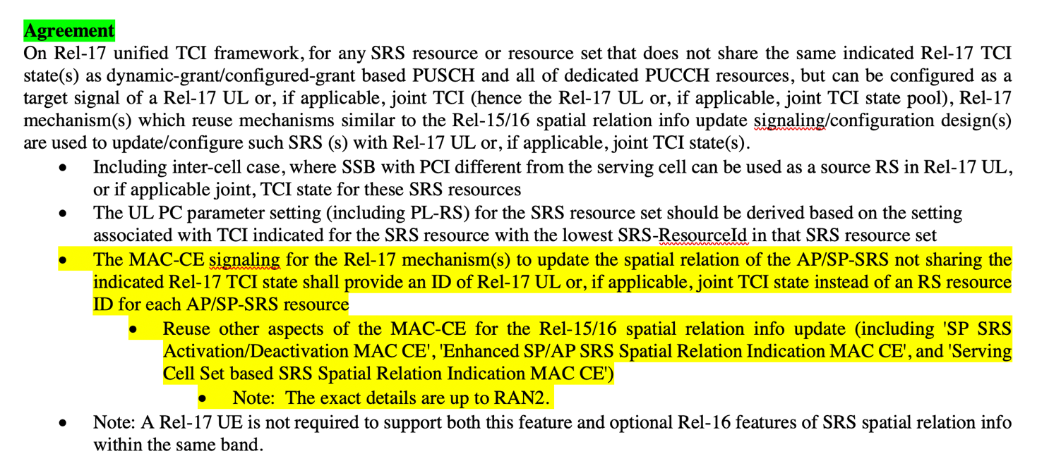

RAN2 is considering to configure DL or joint TCI state for those cases via RRC signalling but not sure whether it is sufficient since RAN2 has not received any guidance on this from RAN1 LS. At the same time, RAN2 would like to emphasize that RAN2 will complete all the stage-3 open issues as soon as possible and hence, the intention and the detail to shorten the subsequent R2 discussion on the new MAC CE design is requested immediately in this meeting.
2. Actions:
To RAN1:
RAN2 respectfully asks RAN1 to answer following questions immediately:
Question 1:
Which cases are not addressed by current RRC specification (i.e. v17.0.0, written according to RAN1 parameter list provided to RAN2) and hence new solution (i.e. new RRC parameter or MAC CE based signaling) is needed?
Question 2:
Whether configuration of DL or joint TCI state via RRC signalling is sufficient to address those potential cases? That is to add only RRC parameter to configure UL or DLJoint TCI state to a SRSResource. If not, could RAN1 recommend solution direction so that RAN2 can specify the detail during this meeting?
Question 3:
If MAC CE based solution is necessary, please respond to below set of questions. Note that in order to have specification support for MAC operation the RAN2 response needs to be detailed and clear enough for RAN2 to specify the needed support in RAN2#118. Hence the response is needed before second week of RAN2#118.
- What information should be included in the MAC CE (please indicate each parameter that should be included in MAC CE assuming a new MAC CE is designed from scratch).
- How can MAC CE indication be used? Is it one-shot configuration (as same as unified TCI state update MAC CE) or is it required to define activation/deactivation of concerned SRS resource with the associated TCI state (as same as SP SRS Activation/Deactivation MAC CE or enhanced SP/AP SRS Spatial Relation Indication MAC CE) ?
- Is it for one serving cell or should we also apply simultaneousSpatial-UpdatedList that are configured for unified TCI state list if the list is configured?

3. Date of Next TSG-RAN WG2 Meetings:
3GPP RAN2#119e August 22~26 [Electronic] Meeting

