3GPP TSG-RAN WG2 Meeting #117 R2-220xxxx
Electronic, 21st Feb– 3rd Mar, 2022

Agenda item: 5.5
Source: Huawei, HiSilicon
Title: Summary of [AT117-e][624][POS] Agenda Item 5.5 (Huawei)
Document for: Discussion and Decision

Introduction
This email discussion is based on the following arrangement
- [AT117-e][624][POS] Agenda item 5.5 (Huawei)
Scope: Treat documents R2-2202597, R2-2202598, and R2-2202599 and conclude on the CRs.
Intended outcome: Agreed CRs (without CB)
Deadline: Wednesday 2022-03-02 1000 UTC

1.1 Contacts
Company | Person | Email
Qualcomm | Sven Fischer | sfischer@qti.qualcomm.com
CATT | Jianxiang Li | lijianxiang@catt.cn
ZTE | Yu Pan | pan.yu24@zte.com.cn
vivo | Xiang Pan | panxiang@vivo.com
Ericsson | Ritesh Shreevastav | Ritesh.shreevastav@ericsson.com

Discussion
In the current LPP spec, in the LPP PDU definition, the following has been defined for the organization identifier for the LPP ASN.1
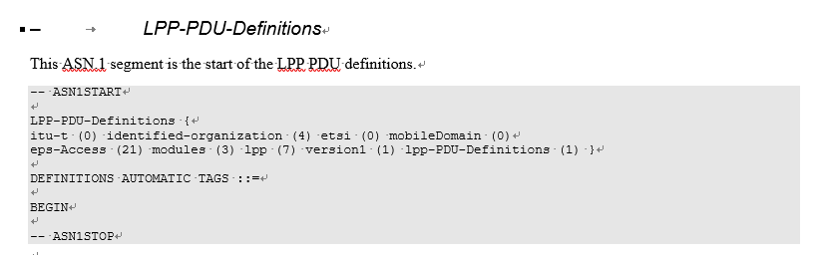

While back in R15, with the introduction of Option5 (LTE connected to 5GC), LPP spec has already been a spec shared by the EPC and 5GS, the above object id is outdated since it is still under the branch of “eps-Access”.
For the object identifier currently maintained by ETSI, the following tree can be seen under the following URL https://webapp.etsi.org/ASN1ObjectTree/ASN1.asp

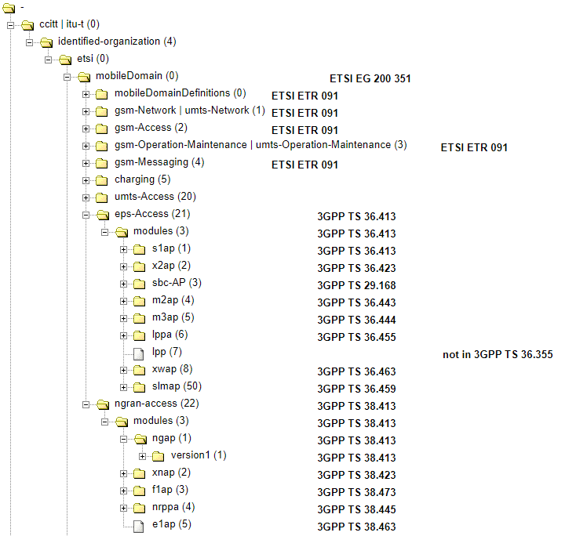
With the issue above, we think there are generally two options for us to address the issue
- Option1: Send a message to 3GPP specification manger to add an object identifier and revise the LPP spec for R15 and R16
- Option2: Remove the object identifier in the LPP spec for R15 and R16
From the above two options, we think that Option2 should be adopted since object identifier is not that useful in the LPP spec. The other spec in the air interface (e.g., RRC spec) does not have object identifier either in their declarations and no issues have been identified.
Question: Do companies agree to remove the object identifier in the LPP spec for R15 and R16?
Company | Yes/No | Comments
Qualcomm |  | We do not see any issues - either with leaving in or removal. If the preference is to remove the OID from Rel-15, would be O.K.
CATT | Yes | Although we don’t see any issues, we slightly prefer to remove the OID from Rel-15.
ZTE | Yes | Not essential change
vivo | Yes | Referring to ASN.1 in RRC, the object identifier seems not essential. Thus can be removed if out of date.  -- ASN1START  -- TAG-NR-RRC-DEFINITIONS-START  NR-RRC-Definitions DEFINITIONS AUTOMATIC TAGS ::=  BEGIN  -- TAG-NR-RRC-DEFINITIONS-STOP  -- ASN1STOP
Ericsson | Not essential correction | Same view as QC

Summary
TBD

References

