3GPP TSG-RAN WG2 #116-e R2-2111427
Online, 1 – 12 November 2021

Agenda item: 6.2.3
Source: LG Electronics Inc. (Rapporteur)
Title: Summary [AT116-e][708][V2X/SL] Miscellaneous CR on 38.321
Document for: Discussion and decision

Introduction
This document summarizes the offline discussion as:
- [AT116-e][708][V2X/SL] Miscellaneous CR on 38.321 (LG)
Scope: Discuss CRs in R2-2110159, R2-2109597, R2-2110058, R2-2110829, R2-2109534, R2-2111138, and R2-2110832, and merge the agreeable changes. Note agreements from discussion in R2-2109417, R2-2109418/R2-2109598, and R2-2110152 are also captured.
Intended outcome: 38.321 CR in R2-2111426 and discussion summary in R2-211427 (if need)
Deadline: 11/9, 10:00am UTC
Company | Name | E-mail
LG | Giwon Park | giwon.park@lge.com
Apple | Zhibin Wu | zhibin_wu@apple.com
MediaTek | Guanyu Lin | guanyu.lin@mediatek.com
OPPO | Qianxi Lu | Qianxi.lu@oppo.com
CATT | Hao Xu | xuhao@catt.cn
Qualcomm | Dan Vassilovski | dvassilo@qti.qualcomm.com
Huawei, HiSilicon | Tao Cai | tao.cai@huawei.com
vivo | Jing Liang | liangjing@vivo.com
Ericsson | Wang Min | min.w.wang@ericsson.com
Nokia | Jakob | Jakob.buthler@nokia.com
ASUSTeK | Xinra | Xinra_Kung@asus.com

Correction CRs
Table 1: Correction CRs: R2-2111138, R2-2100159
Tdoc | Title | Company | Summary of changes/proposals | Rapporteur’s view
R2-2111138  /R2-2100159 | Corrections on Parameter Description of the Formula for Computing CG slots | CATT | - Add ‘logical’ in definition of T'max.  - Change to  Change to  Proposed change:  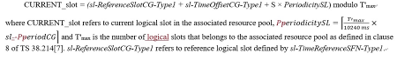 | 1st change (add ‘logical’): Rapporteur doesn't think there is a need for correction because the sentence in the clause is referring to the RAN1 specification.  2nd change is an editorial change.

Q1: On the above CR in R2-2111138/R2-2100159 in Table 1, do you agree on the change as proposed?
Company | Agree/disagree on the proposed change | Wording change (suggestion) if needed | Further comments
ZTE | Disagree 1st change  Agree 2nd change. |  | Agree rapporteur that 1st change is not needed. Slots that belongs to the associated resource pool means that this slot is a logical slot.
APPLE | 2nd chnge is fine
MediaTek | Agree 1st and 2nd change |  | For the first change, we think there is no harm to emphasize “logical”.
OPPO | 2nd change is fine
LG | 2nd change is fine
Samsung | 2nd change is fine. |  | Agree with rapporteur.
CATT | Agree both changes(Proponent) |  | 1, Refer to the description in the current MAC spec, it is recorded that sl-ReferenceSlotCG-Type1 refers to reference logical slot. That’s to say, our clarification can be considered.  2, We agree with Rapp that the sentence in the clause is referring to the RAN1 specification. But if check the RAN1 spec for this parameter, you may still confuse that whether we treat this parameter ( T’max) as physical slots that belongs to the associated resource pool or logical slots. Because in RAN1’s spec, it is not recorded anywhere.  We sincerely ask you to accept the 1st change. But we also would like to follow the majority’s view.
Qualcomm | 1st change: Disagree  2nd change: Agree |  | Agree with rapporteur  First change (additional of “logical”) seems unnecessary.  Fine with second change
Huawei, HiSilicon | 1st change not needed, 2nd change is fine. |  | For first change, there is reference back to RAN1 TS
Intel | Ok with 2nd change
vivo | 2nd change is fine |  | For the 1st change, share the same view as ZTE.
Ericsson | 2nd change is fine
Nokia | 1st change: disagree  2nd change: agree, but editorial
ASUSTeK | 2nd change is fine

Table 2: Correction CRs: R2-2109597
Tdoc | Title | Company | Summary of changes/proposals | Rapporteur’s view
R2-2109597 | Correction on the dynamic sidelink grants | Huawei, HiSilicon | Proposal. Add the descriptions that a sidelink grant addressed to SL-RNTI is considered as dynamic sidelink grant.  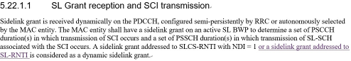 | It is missing and needs to be added.
Q2: On the above CR in R2-2109597 in Table 2, do you agree on the change as proposed?
Company | Agree/disagree on the proposed change | Wording change (suggestion) if needed | Further comments
ZTE | Disagree |  | We do not see the necessary to capture it explicitly. What we can do with this sentence?
Apple | No | I think the intention of the sentence is listed a special case for dynamic grant. There is no need to add the normal case in the same sentence. If it is not clear, we can say “is also considered as a dynamical Sidelink grant”
MediaTek | Agree |  | Fine to us for this sentence to cover all cases of dynamic sidelink grant.
OPPO | Agree |  | We have raised this proposal previously but rejected by R2.. yet still good to see there are also interest from others to correct this – if there is no usage for this, we can remove this sentence (actually there is), otherwise, good to cover all cases.
LG | Agree
Samsung | Agree
CATT | Agree
Qualcomm | Disagree |  | Can go with majority view
Huawei, HiSilicon | Agree (proponent) |  | Even until last meeting, there seems lack of consensus among companies on what dynamic sidelink grant means, which is frustrating when discussing grant related issues. This clarification would be beneficial at least to facilitate similar discussions.
Intel | No strong view | If we do want to add this, it would be better to say “A sidelink grant addressed to SL-RNTI, or addressed to SLCS-RNTI with NDI = 1 is considered as a dynamic sidelink grant” | Not sure what is the relevance of adding it here, but we are fine in case majority want to support this.
vivo | Disagree |  | We also have raised this issue before, but not endorsed by RAN2 as companies think it is ok for current text.  If we would like to correct it now, it is good to clarify that the main intention here is to address a special case for dynamic grant. From this perspective, Apple’s wording suggestion is fine to us.
Ericsson | disagree |  | We think current text is ok, no need to further clarify.
Nokia | Disagree |  | We see no reason to explicitly have this change
ASUSTeK | Agree

Table 3: Correction CRs: R2-2110058
Tdoc | Title | Company | Summary of changes/proposals | Rapporteur’s view
R2-2110058 | Correction on the usage of sl-ReselectAfter | Apple, OPPO, Qualcomm Incorporated, Huawei, HiSilicon | 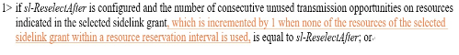 | Proposed change may be merged in Rapporteur CR as a reflection of the result of the RAN1’s discussion (RAN1 LS R1-2108438).
Q3: On the above CR in R2-2100058 in Table 3, do you agree on the change as proposed?
Company | Agree/disagree on the proposed change | Wording change (suggestion) if needed | Further comments
ZTE | Agree
Apple | Agree (Proponent)
MediaTek | Agree
OPPO | Agree (Proponent)
LG | Agree
Samsung | Agree
CATT | Agree
Qualcomm | Agree
Huawei, HiSilicon | Agree (proponent)
Intel | Agree
vivo | Agree
Ericsson | Agree
Nokia | Agree
ASUSTeK | Agree

Table 4: Correction CRs: R2-2110829
Tdoc | Title | Company | Summary of changes/proposals | Rapporteur’s view
R2-2110829 | Correction on TX parameters selection | ZTE Corporation, Sanechips | Reason for change: In 38.331, both sl-PSSCH-TxConfigList and sl-CBR-PriorityTxConfigList are optional IE, however, how to handle the case that sl-PSSCH-TxConfigList is not configured is missing in the MAC specification.  Proposed change:  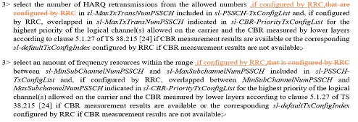 | Proposed change is reasonable.
Q4: On the above CR in R2-2110829 in Table 4, do you agree on the change as proposed?
Company | Agree/disagree on the proposed change | Wording change (suggestion) if needed | Further comments
ZTE | Agree
Apple | Agree
MediaTek | Agree
OPPO | Agree
LG | Agree
Samsung | Agree
CATT | Agree
Qualcomm | Agree
Huawei, HiSilicon | Disagree |  | Spec is though not broken as there is level 3 condition below starting with “else”, so the case when not configured by RRC is actually covered.
Intel | Agree
vivo | Agree
Ericsson | Agree
Nokia | Disagree, but won’t object |  | Spec is not broken
ASUSTeK | Agree

Table 5: Correction CRs: R2-2109534
Tdoc | Title | Company | Summary of changes/proposals | Rapporteur’s view
R2-2109534 | Corrections to Sidelink BWP operation | Samsung | Proposal. Added the following:  - transmission/reception for S-PSS and S-SSS and BSR triggering only if SL BWP is active.  - Cancellation of SL CSI reporting, SL BSR reporting and SR reporting upon BWP deactivation.  1st change  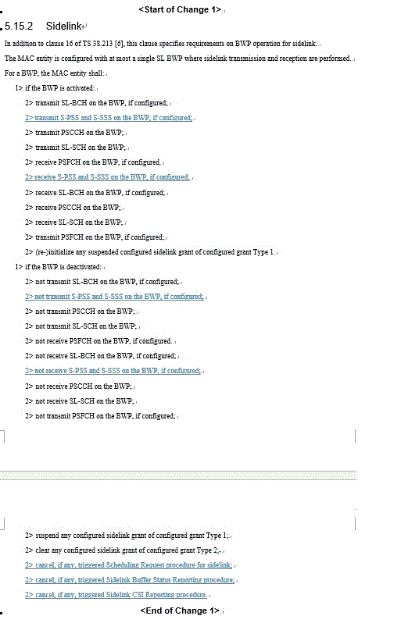  2nd change  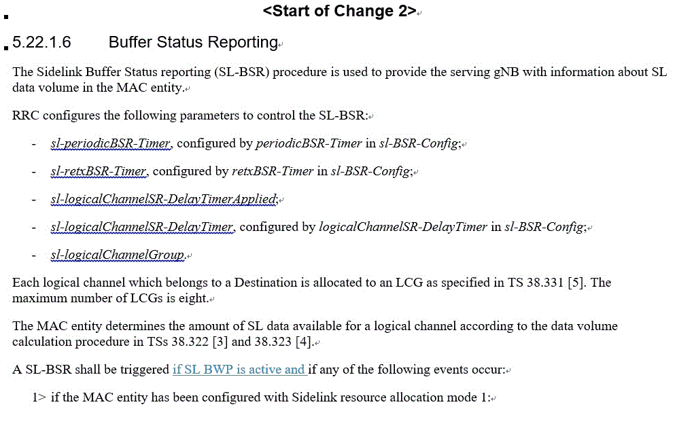 | The intention of the proposal is understandable. However, from the Rapporteur point of view, we are not sure whether these changes are really critical at this late timing of the maintenance phase, but we can check other companies’ views.
Q5: On the above CR in R2-2109534 in Table 5, do you agree on the change as proposed?
Company | Agree/disagree on the proposed change | Wording change (suggestion) if needed | Further comments
ZTE | Agree for canceling SR and BSR.  Disagree for others |  | Considering that S-PSS and S-SSS are transmitted together with SL-BCH(i.e. sidelink MIB message), and current spec captures that SL-BCH is not transmitted if BWP is deactived , we think PHY layer will handle this case.  For canceling CSI report procedure, we do not see the necessary to do this.  [Samsung] As Uu, S-PSS, S-SSS and SL-BCH are separate ones. So we think S-PSS, S-SSS should be clarified as SL-BCH is specified in current MAC specification. Indeed, the transmission of SL-BCH is also handled by PHY layer.
Apple | 1st change is fine. 2nd change is not needed. |  | We have concern that if we agree with 2nd chang, then there are many maore places need to be fixed by add “if SL BWP is active”
MediaTek | Fine with the first change. Second change is not needed.
OPPO | Fine with the first change. Second change is not needed.
LG | Disagree |  | If the numerology (e.g., sub-carrier spacing, CP length) of the activated UL BWP does not match the numerology of the SL BWP in the legacy procedure, the SL BWP is deactivated.  Uu’s UL BWP can be dynamically changed (e.g., activation) through DCI, and if the above conditions are satisfied, SL BWP can be momentarily deactivated.  Therefore, we do not think it is critical to introduce additional optimization in the maintenance phase now.  [Samsung] We do not think that the proposed change is a kind of optimization. This is to clarify the missing part from UE’s operation on activated/deactivated SL BWP.
Samsung | Agree with the first change and second change (Proponent)
CATT | Agree both
Qualcomm | 1st change: Agree  2nd change: Disagree |  | We do not see the need for the 2nd change at this stage of the release
Huawei, HiSilicon | Neutral for both changes |  | Both changes are not essential and there is no ambiguity without.
Intel | Ok to support the first change. No strong view on 2nd change
vivo | Agree with the 1st change  2nd change is not needed.
Ericsson | Fine with 1st change, 2nd change is not needed.
Nokia | Neutral
ASUSTeK | Neutral |  | Since there will be only one SL BWP configured for now, not sure if it’s needed to emphasize on BWP-active operation, but we can follow majority’s view.

Table 6: Correction CRs: R2-2110832
Tdoc | Title | Company | Summary of changes/proposals | Rapporteur’s view
R2-2110832 | Correction on HARQ information indication | ZTE Corporation, Sanechips | This CR is an addition of description according to the RAN1’s agreement (RAN1 CR R1-2108376).  We can hear the opinions of other companies whether it can be captured like the suggestion below:  Proposed change:  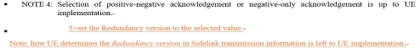 | It would be enough for this parameter to be in the RAN1 specification.
Q6: On the above CR in R2-2110832 in Table 6, do you agree on the change as proposed?
Company | Agree/disagree on the proposed change | Wording change (suggestion) if needed | Further comments
ZTE | Agree |  | For the necessity of the note, it can be seen that current spec also describes it’s up to UE implementation to select the positive-negative or negative-only acknowledgement, we think it’s better to clarify how UE set the RV value.  Additionally, according to RAN1’s modification, the RV value is indicated to PHY layer together with other HARQ information, like HARQ process number, NDI field,etc. And according to MAC spec, RV is one of HARQ information that will be indicated from MAC to PHY as shown in following:  There, the RV value is indicated from MAC to PHY.
  Sidelink transmission information: Sidelink transmission information included in a SCI for a SL-SCH transmission as specified in clause 8.3 and 8.4 of TS 38.212 [9] consists of Sidelink HARQ information including NDI, RV, Sidelink process ID, HARQ feedback enabled/disabled indicator, Sidelink identification information including cast type indicator, Source Layer-1 ID and Destination Layer-1 ID, and Sidelink other information including CSI request, a priority, a communication range requirement and Zone ID.
Apple | Agree with the intention, but the NOTE is not needed.
MediaTek | Agree
OPPO | Agree with the intention, but the NOTE is not needed.
Samsung | Agree
CATT | Agree with the intention, but the NOTE is not needed.
Qualcomm | Agree
Huawei, HiSilicon | Agree with the intention, but the NOTE is not needed.
Intel | Slightly prefer supporting the change |  | We do not see any issue having this captured in MAC explicitly
vivo | Agree
Ericsson | Agree with the intention, but the NOTE is not needed.
Nokia | Neutral
ASUSTeK | Agree

Table 7: Correction CRs: R2-2109417
Tdoc | Title | Company | Summary of changes/proposals | Rapporteur’s view
R2-2109417 | Left issue on maxTransNum | OPPO, Apple, Ericsson, Lenovo, Motorola Mobility | RAN2 agreements in this e-meeting  - Proposal 1 RAN2 confirm the revised WA that “UE assumes that next retransmission(s) of the MAC PDU is required when FB is disabled (and PUCCH is configured), for CG, if sl-CG-MaxTransNumList is configured with a value not larger than the number of CG resources available, when sl-CG-MaxTransNum is not reached”.  → Agreed. Will be captured as normative text and wordings will be discussed in [AT116-e][708].  - Proposal 2 When FB is disabled (and PUCCH is configured), if sl-CG-MaxTransNumList is configured with a value larger than the number of CG resources available, when CG resource is exhausted and sl-CG-MaxTransNum is not reached, UE assumes that next retransmission(s) of the MAC PDU is required and thus reporting NACK.  →Agreed. Will be captured as normative text and wordings will be discussed in [AT116-e][708]. | Rapporteur thinks that the condition that sl-MaxTransNum is set smaller/larger than the number of CG resources does not need to be specified in the specification. Thus, I made a text that can be commonly applied to P1/P2 as below.  Rapporteur suggestion on correction CR  5.22.1.3.1a Sidelink process  1> if sl-MaxTransNum corresponding to the highest priority of the logical channel(s) in the MAC PDU has been configured in sl-CG-MaxTransNumList for the sidelink grant by RRC and the number of transmissions of the MAC PDU has been reached to sl-MaxTransNum; or  - if a positive acknowledgement to this transmission of the MAC PDU was received according to clause 5.22.1.3.2; or  - if negative-only acknowledgement was enabled in the SCI and no negative acknowledgement was received for this transmission of the MAC PDU according to clause 5.22.1.3.2:  2> flush the HARQ buffer of the associated Sidelink process.  - if HARQ feedback has been disabled for the MAC PDU and sl-MaxTransNum corresponding to the highest priority of the logical channel(s) in the MAC PDU has been configured in sl-CG-MaxTransNumList for the sidelink grant by RRC and the number of transmissions of the MAC PDU has not reached sl-MaxTransNum after all PSSCH duration(s) in a sl-PeriodCG for the sidelink grant:  - instruct the physical layer to signal a negative acknowledgement on the PUCCH according to clause 16.5 of TS 38.213 [6].
Q7: On the above proposal in R2-2109417 in Table 7, do you agree on the Rapporteur’s suggestion for CR correction?
Company | Agree/disagree on the proposed change | Wording change (suggestion) if needed | Further comments
ZTE | Agree | sl-CG-MaxTransNumList,sl-MaxTransNum should be in italics
Apple | Agree with the intention , but we have comments | “if sl-PUCCH-Config is configured” is missing as one of the conditions. But in overlal, we think thte change is better done in 5.22.1.3.2 along with other PUCCH transmissions, insead of in 5.22.1.3.1a
MediaTek | Agree
OPPO | Agree with the intention, but the change is to be rephased | Firstly, we should change on 5.22.1.3.2, where the pucch reporting is described, instead of creating a new paragragh in 5.22.1.3.1a.  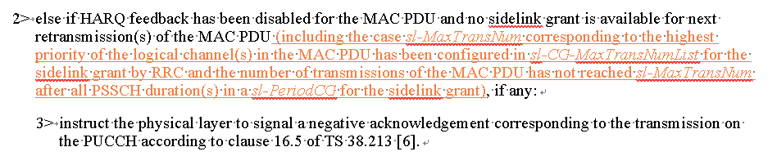
LG | Agree | Agree with Apple/OPPO’s suggestion.
Samsung | Agree
CATT | Agree
Huawei, HiSilicon | Can follow majority
Intel | Agree
vivo | Agree
Ericsson | agree | We agree with Apple and OPPO suggested changes.
Nokia | Agree
ASUSTeK | Agree

Table 8: Correction CRs: R2-2109418, R2-2109598
Tdoc | Title | Company | Summary of changes/proposals | Rapporteur’s view
R2-2109418 | Correction on UL-SL prioritization | OPPO, Apple, MediaTek, CATT | #116-e agreement:  - Cross reference issue needs to be removed.  - Detailed wording/update will be further discussed in [AT116-e][708]. | At this meeting, it was agreed that only the cross-reference would be removed, so Rapporteur doesn't think any other modifications other than the ones (R2-2109418) below are necessary.  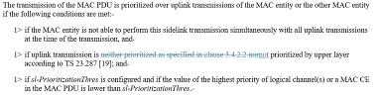
R2-2109598 | Clarification on the UL and NR SL prioritization | Huawei, HiSilicon
Q8: On the above CR in R2-2109418, R2-2109598 in Table 8, do you agree on the change as proposed?
Company | Agree/disagree on the proposed change | Wording change (suggestion) if needed | Further comments
ZTE | Agree
Apple | Agree with R2-2109418
MediaTek | Agree with R2-2109418
OPPO | Agree (proponent)
LG | Agree
Samsung | Disagree | With this change, for SL prioritization, UL priority comparison is not considered, then it is not aligned with the following RAN2 agreement.  ““For between SL-data and UL-data/SRB, the SL transmission is prioritized if the highest priority value of UL LCH(s) with available data is larger than the UL priority threshold and the highest priority value of SL LCH(s) with available data is lower than the SL priority threshold. Otherwise the UL transmission is prioritized.”
CATT | Agree (proponent)
Qualcomm | Agree with removal for cross reference
Huawei, HiSilicon | Not acceptable | Wording can be improved with addition below (plus one relocation):  The transmission of the MAC PDU is prioritized over uplink transmissions of the MAC entity or the other MAC entity if the following conditions are met:  1> if the MAC entity is not able to perform this sidelink transmission simultaneously with all uplink transmissions at the time of the transmission, and  1> if sl-PrioritizationThres is configured and if the value of the highest priority of logical channel(s) or a MAC CE in the MAC PDU is lower than sl-PrioritizationThres, and  1> if uplink transmission is NR uplink transmission and none of the value of the highest priority of logic channel(s) in the uplink MAC PDU is lower than ul-PrioritizationThres if ul-PrioritizationThres is configured, and neither the uplink MAC PDU includes any MAC CE prioritized as described in clause 5.4.3.1.3 nor the uplink transmission is prioritized by upper layer according to TS 23.287 [19]; or  1> If uplink transmission is LTE uplink transmission and the uplink transmission is not prioritized by upper layer according to TS 24.386 [X]. | We agree with Samsung that the current change in 9418 would violate the agreement on prioritization between SL-data and UL-data. This would be technically problematic and difficult to accept.  Please be aware this section is on conditions for “The transmission of the MAC PDU is prioritized over uplink transmissions”, which shall consider all priority comparison including “cross comparison acc clause 5.4.3.1.3”, “self comparison against threshold” and “prioritization by high layer”. That SL is prioritized over UL is one “narrow” case for which all prioritization aspects have to be considered.  We would insist to use change in 9598. Regarding online comments on the impact on inter-RAT comparison, we propose to add one condition for LTE UL transmission prioritization.
Intel | Support change in R2-2109418
vivo | Agree |  | The inter-RAT issue can be further discussed separately. We only need to simply remove Cross reference here.
Ericsson | Agree
Nokia | Neutral
ASUSTeK | Neutral |  | If 9418 is adopted, by looking at 5.22.1.3.1a alone, the UE does not consider UL threshold and prioritize SL transmission based on SL threshold only, which may lead to a behaviour against the agreement in the scenario when “UL MAC PDU has low priority value LCH and SL MAC PDU has low priority value LCH”, where UL MAC PDU should have been prioritized.  On the other hand, by looking into 5.4.2.2, the UL MAC PDU is prioritized correctly :  The transmission of the MAC PDU is prioritized over sidelink transmission or can be performed simultaneously with sidelink transmission if one of the following conditions is met:  […]  - if there is only a sidelink grant for transmission of NR sidelink communication at the time of the transmission, and if the MAC PDU includes any MAC CE prioritized as described in clause 5.4.3.1.3, or the transmission of NR sidelink communication is not prioritized as described in clause 5.22.1.3.1a, or the value of the highest priority of the logical channel(s) in the MAC PDU is lower than ul-PrioritizationThres if ul-PrioritizationThres is configured, or there is a sidelink grant for transmission of NR sidelink communication at the time of the transmission and the MAC entity is able to perform this UL transmission simultaneously with the transmission of NR sidelink communication; or  If the majority of companies think that the UE behaviour will be correct based on 5.4.2.2, we are ok with 9418; otherwise addition made in 9598 is needed.

Table 9: Correction CRs: R2-2110152
Tdoc | Title | Company | Summary of changes/proposals | Rapporteur’s view
R2-2110152 | Clarification on exceptional pool configuration | LG | #116-e agreement  - At least one sl-TxPoolExceptional pool is always a resource pool in which PSFCH is configured  - Will be captured as the note in MAC. Detailed wordings will be discussed in [AT116-e][708].  Proposed change:  NOTE 2: The MAC entity expects that PSFCH is always configured by RRC for at least one pool of resources in sl-TxPoolSelectedNormal and for the resource pool in sl-TxPoolExceptional in case that at least a logical channel configured with sl-HARQ-FeedbackEnabled is set to enabled.
Q9: On the above proposal in R2-2110152 in Table 9, do you agree on the suggestion for CR correction?
Company | Agree/disagree on the proposed change | Wording change (suggestion) if needed | Further comments
ZTE | Agree
Apple | Agree
MediaTek | Agree
OPPO | Agree with wording suggestion | NOTE 2: The MAC entity expects that PSFCH is always configured by RRC for at least one resource pool of resources in sl-TxPoolSelectedNormal and for the resource pool in sl-TxPoolExceptional in case that at least a logical channel configured with sl-HARQ-FeedbackEnabled is set to enabled.
LG | Agree
Samsung | Agree
CATT | Agree
Qualcomm | Agree
Huawei, HiSilicon | Agree
Intel | Agree | If the intention is to say that at least one pool EACH in sl- TxPoolSelectedNormal AND sl-TxPoolExceptional is configured with PSFCH, we can perhaps simplify the note as:  NOTE 2: The MAC entity expects that PSFCH is always configured by RRC for at least one pool of resources in sl-TxPoolSelectedNormal and in sl-TxPoolExceptional, in case that at least a logical channel configured with sl-HARQ-FeedbackEnabled is set to enabled.
vivo | Agree with wording suggestion | Some wording suggestion on top of OPPO’s comments.  NOTE 2: The MAC entity expects that PSFCH is always configured by RRC for at least one resource pool of resources in sl-TxPoolSelectedNormal and for the resource pool in sl-TxPoolExceptional respectively in case that at least a logical channel configured with sl-HARQ-FeedbackEnabled is set to enabled.
Ericsson | agree
Nokia | Disagree, but no strong view |  | We don’t see any reason to explicitly write this
ASUSTeK | Agree

Conclusion

