#### 6.1.3.x SCell Activation/Deactivation MAC CEs with TRS

The SCell Activation/Deactivation MAC CE with TRS of two octets is identified by a MAC subheader with eLCID as specified in Table 6.2.1-1b. It has a fixed size and consists of two octets containing seven C-fields, one R-field and one octet to indicate the TRS configuration index for activations of SCell(s). The SCell Activation/Deactivation MAC CE with TRS and two octets is defined as follows (Figure 6.1.3.x-1).

- Ci: If there is an SCell configured for the MAC entity with *SCellIndex* i as specified in TS 38.331 [5], this field indicates the activation/deactivation status of the SCell with *SCellIndex* i, else the MAC entity shall ignore the Ci field. The Ci field is set to 1 to indicate that the SCell with *SCellIndex* i shall be activated. The Ci field is set to 0 to indicate that the SCell with *SCellIndex* i shall be deactivated;

- R: Reserved bit, set to 0.

- TRS configuration index: This field indicates which element in the *aperiodicTRS-TriggerStateList* is triggered for SCell activation.

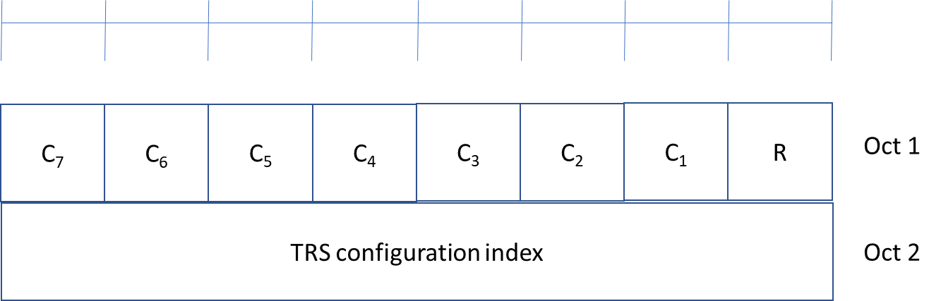

Figure 6.1.3.x-1: SCell Activation/Deactivation MAC CE with TRS of two octets