3GPP TSG-RAN WG2 Meeting #115 Electronic R2-210xxxx

Elbonia, 16 – 27 August 2021

**Agenda item: 8.16.1**

**Source: Nokia (Rapporteur)**

**Title: [Pre115-e][009][eNPN] Summary 8.16.2 ext credentials + 8.16.3 onboarding**

**WID/SID: NG_RAN_PRN_enh - Release 17**

**Document for: Discussion and Decision**

# 1 Introduction

This document is the report of the following email discussion:

* [Pre115-e][009][eNPN] Summary 8.16.2 ext credentials + 8.16.3 onboarding (Nokia)

The papers considered in this summary are listed in the References section.



# 2 Discussion

## 2.1 Maximum number of GINs

At the previous RAN2 meeting it was agreed that

* GIN is broadcasted by new SIB

There has been no agreement in the maximum number of GINs, and whether the maximum number of GINs are specified per cell or per SNPN. There are input contributions with proposals on these open issues, but company inputs do not show a consensus on this issue. Please consider that the format of the GINs is open. RAN2 sent an LS with this question (R2-2106545) and RAN2 is waiting for the reply LS form SA2 to clarify it.

**[Discussion] Proposal 1: RAN2 selects among the options below how the maximum number of GINs should be specified**

**Option A: per cell**

**Option B: per SNPN**

**Option C: both per cell and per SPNP**



## 2.2 Separate list for onboarding GINs

There has been no agreement whether a common list of GINs should be used for onboarding and SNPN access using external CHs. RAN2 has sent an LS on this issue to SA2 (R2-2106545), but no answer has been received.

Rapporteur's comment: based on the input proposals there is no clear consensus on this issue in RAN2, therefore RAN2 should wait for the answer from SA2.

**[Easy] Proposal 2: Wait for SA2 reply LS on the issue whether a common list of GINs used for onboarding and SNPN access using external credentials.**

## 2.3 Structure of the new SIB for GINs

At the previous RAN2 meeting it was agreed that

* GIN is broadcasted by new SIB

One of the important issues is how to add the GINs into the new SIB. The following has been agreed at RAN2#113bis:

* GIDs are broadcasted per SNPN in network sharing scenarios.

Rapporteur's comment: Based on the proposals for this meeting, companies' view is that this agreement should not limit the structure of the new SIB.

Two basic approaches are depicted in the proposals submitted to this meeting:

**Option A:** GINs are listed per SNPN  
In this approach there is a separate list of GINs for each SNPNs. The SNPN assignment can be implicit without adding references to SNPNs in the new SIB. If a GIN can be used with more than one SNPN, then it is listed more than once.

**Option B:** Single list of GINs with explicit assignment to SNPNs.  
In this approach there is a single list of GINs and there is an explicit assignment to SNPNs for each GINs. If the same GIN can be used with more than one SNPN, then it is listed only once.

Figure below (copied from R2-2108612) illustrates the differences between the approaches. Both approaches can be used independently whether there is a common GIN list for external CHs and onboarding or not.

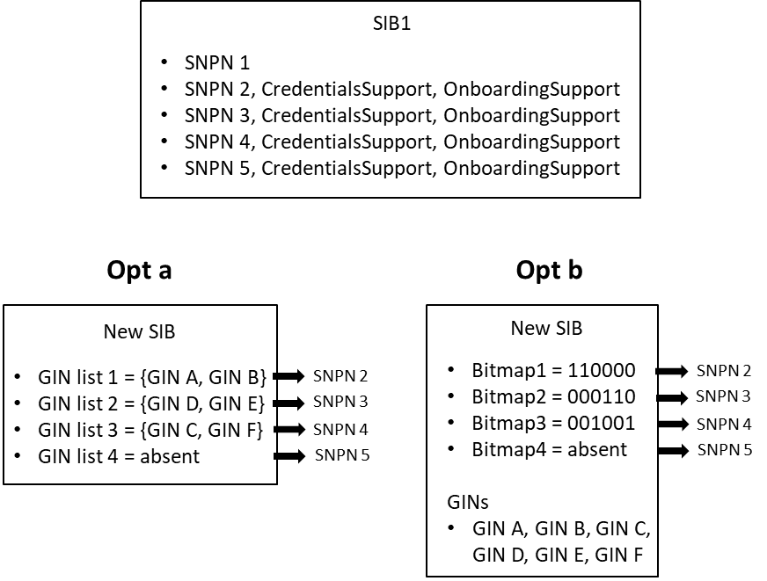

**[Discussion] Proposal 3: RAN2 selects between approaches below on the structure of the new SIB specified to broadcast GINs**

**Option A: GINs are listed per SNPN**

**Option B: Single list of GINs with explicit assignment to SNPNs**



## 2.4 Addition of new indicators to SIB1

The following agreements have been on the new information elements to be added to SIB1:

* A new indicator that "access using credentials from a separate entity is supported" is broadcasted, and the indicator is broadcasted per SNPN in network sharing scenarios.
* RAN2 assumes that the new indicator that "access using credentials from a separate entity is supported" is broadcasted in SIB1.
* A new indicator that "whether the SNPN allows registration attempts from UEs that are not explicitly configured to select the SNPN" is broadcasted, and the indicator is broadcasted per SNPN in network sharing scenario.
* RAN2 assumes that the new indicator that "whether the SNPN allows registration attempts from UEs that are not explicitly configured to select the SNPN" is broadcasted in SIB1.
* Broadcast a 1-bit indication for onboarding per O-SNPN.
* R2 assumes that the 1-bit indication for onboarding is in SIB1.

There are proposals how to add these new indicators to SIB1. In principle the following approaches are proposed:

**Option A: introducethe new indicators parallel with *npn-IdentityInfoList* in *CellAccessRelatedInfo***An example how this can be done is presented below (copied from R2-2107803). This example is just to present the structure; details are to be further discussed.

CellAccessRelatedInfo ::= SEQUENCE {

plmn-IdentityList PLMN-IdentityInfoList,

cellReservedForOtherUse ENUMERATED {true} OPTIONAL, -- Need R

...,

[[

cellReservedForFutureUse-r16 ENUMERATED {true} OPTIONAL, -- Need R

npn-IdentityInfoList-r16 NPN-IdentityInfoList-r16 OPTIONAL -- Need R

]]

[[

infoForVisitSNPNList-r17 ::= SEQUENCE (SIZE (1..maxNPN-r16)) OF InfoForVisitSNPNList-r17

OPTIONAL

InfoForVisitSNPNList-r17 ::= SEQUENCE {

externalCredentialsSupport-r17 ENUMERATED {true} OPTIONAL,

opportunisticRegAttemptsAllowed-r17ENUMERATED {true} OPTIONAL,

}

]]

}

**Option B: introducethe new indicators in *npn-IdentityInfo***An example how this can be done is presented below (copied from R2-2107803). This example is just to present the structure; details are to be further discussed.

NPN-IdentityInfoList-r16 ::= SEQUENCE (SIZE (1..maxNPN-r16)) OF NPN-IdentityInfo-r16

NPN-IdentityInfo-r16 ::= SEQUENCE {

npn-IdentityList-r16 SEQUENCE (SIZE (1..maxNPN-r16)) OF NPN-Identity-r16,

trackingAreaCode-r16 TrackingAreaCode,

ranac-r16 RAN-AreaCode OPTIONAL, -- Need R

cellIdentity-r16 CellIdentity,

cellReservedForOperatorUse-r16 ENUMERATED {reserved, notReserved},

iab-Support-r16 ENUMERATED {true} OPTIONAL, -- Need R

...

[[

externalCredentialsSupport-r17 ENUMERATED {true} OPTIONAL,

opportunisticRegAttemptsAllowed-r17ENUMERATED {true} OPTIONAL,

]]

}

**Option C: introducea new list for the new indicators in *npn-IdentityInfo***An example how this can be done is presented below (copied from R2-2107803). This example is just to present the structure; details are to be further discussed.

NPN-IdentityInfoList-r16 ::= SEQUENCE (SIZE (1..maxNPN-r16)) OF NPN-IdentityInfo-r16

NPN-IdentityInfo-r16 ::= SEQUENCE {

npn-IdentityList-r16 SEQUENCE (SIZE (1..maxNPN-r16)) OF NPN-Identity-r16,

trackingAreaCode-r16 TrackingAreaCode,

ranac-r16 RAN-AreaCode OPTIONAL, -- Need R

cellIdentity-r16 CellIdentity,

cellReservedForOperatorUse-r16 ENUMERATED {reserved, notReserved},

iab-Support-r16 ENUMERATED {true} OPTIONAL, -- Need R

...

[[

infoForVisitSNPNList-r17 ::= SEQUENCE (SIZE (1..maxNPN-r16)) OF InfoForVisitSNPNList-r17

OPTIONAL

InfoForVisitSNPNList-r17 ::= SEQUENCE {

externalCredentialsSupport-r17 ENUMERATED {true} OPTIONAL,

opportunisticRegAttemptsAllowed-r17ENUMERATED {true} OPTIONAL,

}

]]

}

**[Discussion] Proposal 4: RAN2 select among the options below how the new indicators ("access using external credentials is supported", "SNPN allows registration from UEs that are not explicitly configured to select the SNPN", "onboarding support") are added to SIB1.**

**Option A: introducethe new indicators parallel with *npn-IdentityInfoList* in *CellAccessRelatedInfo***

**Option B: introducethe new indicators in *npn-IdentityInfo***

**Option C: introducea new list for the new indicators in *npn-IdentityInfo***



## 2.5 Access control

The current UAC procedure enables access control at SNPN level. There was an access control related agreement at RAN2#114:

* Toggling the 1-bit onboarding indication in SIB1 allows to control congestion due to onboarding request.

There are a number papers with proposals related to access control for support of external CHs, and for onboarding. Company inputs does not show a consensus whether there is a need to enhance the current UAC procedures due to support of external CHs and onboarding.

Rapporteur's Comment: As access control (e.g. introduction of a new access category) is not fully in the scope of RAN2, asking the relevant WGs (SA2/CT1) whether there is need to enhance access control due to support of external CHs and onboarding may be the easiest way to progress these issues in RAN2.

**[Easy] Proposal 5.1: RAN2 asks SA2/CT1 whether there is a need to enhance access control for CHs.**

**[Easy] Proposal 5.2: RAN2 asks SA2/CT1 whether there is a need to enhance access control for onboarding.**



## 2.6 Impacts to cell selection and reselection

At the previous RAN2 meetings the following agreements were made:

* To supporting SNPN with subscription or credentials by a separate entity, R2 assumes that there is no impact on cell (re)selection (e.g. no need to change suitable cell criteria).
* R2 assumes that onboarding will not impact cell reselection.
* RAN2 assumes that NAS does not send selected GINs and two indications related to external credentials to AS.
* There is no impact on cell (re)selection to support SNPN with subscription or credentials by a separate entity.
* RAN2 confirms that onboarding does not impact the cell reselection procedure.

It remained open if the onboarding has any impact on cell selection, especially considering that onboarding is not uniformly supported in all cells of an O-SNPN. Company inputs does not show a consensus on this issue.

**[Discussion] Proposal 6.1: Onboarding flag should be considered during initial cell selection.**



Another cell selection related proposal that was not fully clarified during the previous meetings is whether AS should all the time provide the GINs to the NAS during network selection or only when NAS requests them.

**[Discussion] Proposal 6.2: AS acquires the new SIB with GINs and provide the available GINs to NAS only when NAS requests the GINs from AS.**



## 2.7 Other issues

Proposals on Human Readable Network Names for GINs have been submitted for a couple meetings, but there has been no discussion or agreements on HRNNs

**[Easy] Proposal 7.1: There is no need to enable the broadcast of HRNNs for GINs.**



Proposals to start discussion on ANR related enhancements for eNPN has been submitted for a couple meetings, but there has been no discussion or agreements on this area.

Rapporteur's comment: It is difficult to start discussing ANR issues before getting a solid view on the additional information elements broadcast.

**[Postpone] Proposal 7.2: Postpone the discussion on ANR issues.**

There are proposals to start discussions in RAN2 on UE capabilities for supporting external CHs, and onboarding.

Rapporteur's comment: Usually the UE capabilities are discussed as a last step for this type of feature.

**[Postpone] Proposal 7.3: Postpone the discussion on UE capabilities for eNPN.**







# 3 Conclusion

TBD.

# References

R2-2107029 Support SNPN with subscription or credentials by a separate entity OPPO

R2-2107323 Further Consideration on Subscription or Credentials by CH CATT

R2-2107458 Discussion of GIN design for NPN China Telecommunication

R2-2107743 On Supporting Visited SNPN with Credentials Samsung R&D Institute India

R2-2107803 Remaining issue on support SNPN by a separate entity vivo

R2-2107954 Proposals for open issues of the support of Credential Holders Nokia, Nokia Shanghai Bell

R2-2108046 Consideration on the Separate Entity Supporting ZTE Corporation, Sanechips

R2-2108229 RAN2 impact to support SNPN with credentials by a separate entity MediaTek Inc.

R2-2108254 SNPN access using external credentials Ericsson

R2-2108545 Left Issues on Supporting SNPN with Credentials by a Separate Entity CMCC

R2-2108612 Accessing SNPN with credentials owned by a Credentials Holder Huawei, HiSilicon

R2-2108659 Open issues on access with external Credential Holder LG Electronics

R2-2107030 Support UE onboarding and provisioning for NPN OPPO

R2-2107324 Open Issues on UE Onboarding and Provisioning for NPN CATT

R2-2107347 UE onboarding and provisioning Qualcomm Incorporated

R2-2107442 Remaining issues in support UE onboarding for SNPN Intel Corporation

R2-2107744 On Supporting Onboarding SNPN Samsung R&D Institute India

R2-2107804 Remaining issue on support UE onboarding for NPN vivo

R2-2107955 Proposals for open issues of the support of onboarding Nokia, Nokia Shanghai Bell

R2-2108047 Consideration on the Onboarding and Provisioning for NPN ZTE Corporation, Sanechips

R2-2108255 UE onboarding Ericsson

R2-2108517 Discussion the left issues to support UE on-boarding and remote provisioning CMCC

R2-2108613 UE onboarding and remote provisioning for SNPN Huawei, HiSilicon

R2-2108660 Open issues for UE Onboarding LG Electronics