3GPP TSG-RAN WG2 Meeting #113 electronic draft R2-2102062
25th January – 5th February 2021

Agenda Item: 7.2.2
Source: ZTE (email discussion rapporteur)
Title: Report of [AT113-e][402][eMTC R16] SIB change notification in RRC_INACTIVE (ZTE)
Document for: Discussion and Decision

Scope of the offline email discussion
This document contains the summary of the offline email discussion “[AT113-e][402][eMTC R16] System information change notification in RRC_INACTIVE”, as indicated below:
- [AT113-e][402][eMTC R16] System information change notification in RRC_INACTIVE (ZTE)
Status: Started
Scope:
Week 1: Check whether the intention is agreeable and there is sufficient support in principle; collect initial comments.
Week 2: Agreeable CR, if there is sufficient support
Intended outcome:
Week 1: Report in R2-2102062
Week 2: Agreeable 36.331 CR in R2-210XXXX (to be announced later)
Deadline: Thursday 2021-01-28 11:00 UTC

Offline email discussion

2.1 Solutions
In last RAN2#112-e meeting, based on the contributions, the issue of system information change notification for UE in RRC_INACTIVE was discussed but no agreement was achieved.
In the current RRC specification, the SIB acquisition/update procedure only mentions the UEs in RRC_IDLE and RRC_CONNECTED state, no description for UE in RRC_INACTIVE. As there is a high level description that the UE in RRC_INACTIVE applies RRC _IDLE procedures unless specified otherwise, one possible assumption is that SIB acquisition/update for UE in RRC_INACTIVE would follow the current procedures for UE in RRC_IDLE. That means, if eDRX is configured and the Paging eDRX cycle is longer than BCCH modification period, the UE in RRC_INACTIVE would always detect system information change with systemInfoModification-eDRX IE during eDRX acquisition period, if transmitted.
Considering that the maximal DRX cycle for eMTC UE in RRC_INACTIVE would be the maximum value of the RAN paging cycle, e.g., rf1024, which can be far less than the eDRX acquisition period (e.g. hf256), if simply reusing the system information acquisition principles as that for UE in RRC_IDLE, the system information acquisition will be not timely when DRX cycle is longer than the BCCH modification period. However, during the discussion in RAN2#112-e meeting [1], some companies thought this issue doesn’t matter much. The only need is to clarify what does the “DRX cycle” in RRC spec which is used to compare with modification period mean to UE in RRC_INACTIVE.

In current RAN2#113 e-meeting, several contributions are submitted with the following proposals:
Contribution (Company) | Proposals
R2-2100932 (ZTE) | Proposal 1: It’s suggested to clarify that RRC_INACTIVE UE should detect system information change via Paging message with the same indicator as used in RRC_IDLE mode.
R2-2101038  (Huawei) | Proposal 1: UEs in RRC_INACTIVE follow systemInfoModification-eDRX notification if the used DRX Cycle is larger than the BCCH modification period.  Proposal 2: UEs in RRC_INACTIVE use the eDRX cycle for monitoring system information change.
R2-2101155  (Qualcomm) | Proposal 1: UE in RRC_INACTIVE state follows same system modification indication as it does in RRC_IDLE.
R2-2101467  (Ericsson) | Addition of a NOTE in 5.2.1.3 to clarify that UE in RRC_INACTIVE compares the configured RAN paging cycle length to the configured modification period, to determine whether it follows the eDRX acquisition period.  Addition of RRC_INACTIVE in 5.2.1.3 so that UE in RRC_INACTIVE monitors for system information update notification, and compares the paging cycle length to modication period.
In [R2-2101038], even company has the Observation 4 “In RRC_INACTIVE, if the UEs is not configured with idle eDRX or if the UE is configured with idle eDRX and its RAN paging cyle is shorter than or equal to the BCCH modification period, following systemInfoModification notification is more efficient for power consumption.”, based on the following further observation:
Observation 7: Having to read the MIB before resuming an RRC connection in RRC_INACTIVE may be an acceptable trade off to keep the UE behaviour identical in RRC_IDLE and RRC_INACTIVE.
They still suggest UEs in RRC_INACTIVE to follow systemInfoModification-eDRX notification.
In [R2-2101155], based on the following observations, company gives a similar proposal as that in [R2-2100932] and [R2-2101038].
Observation 4: All UEs will use the new system information before access regardless of whether UE follows systemInfoModification or systemInfoModification-eDRX.
Observation 5: UE in RRC_IDLE or RRC_INACTIVE state can receive either of the two system information modification indications regardless of whether UE follows systemInfoModification or systemInfoModification-eDRX.

It seems more companies prefer that UE in RRC_INACTIVE follows same system modification indication as it does in RRC_IDLE. But there is still different opinion. Therefore, we have the following question:
Q1: Companies are invited to indicate which option is preferred for clarification on SIB change notification for UE in RRC_INACTIVE?
- Option 1: UE in RRC_INACTIVE follows same system modification indication as it does in RRC_IDLE. E.g., to clarify that the “DRX cycle” in TS 36.331 section 5.2 which is used to compare with modification period is the idle mode eDRX cycle.
- Option 2: To clarify that, for UE in RRC_INACTIVE, the “DRX cycle” in TS 36.331 section 5.2 which is used to compare with modification period is the configured RAN paging cycle.

Company | Preference | Detailed comments
ZTE | Option 1
Qualcomm | Option 1
Huawei, HiSilicon | Option 1 | No strong option. We are also fine with option 2 as we think it does not really matter system wise and power consumption wise.
Ericsson | Option 2 | Slight preference for option 2. The UE in RRC_INACTIVE would regardless monitor using the RAN paging cycle outside of PTW, thus, it can detect the SI change indication (systemInfoModification) in case the RAN paging cycle is shorter than the BCCH modification period, i.e., in practice there is no benefit in such case to only monitor systemInfoModication-eDRX.  If RAN paging cycle and the idle eDRX cycle are longer than the BCCH modification period, there is no need for any clarification in any case.
Nokia | Option 1
LGE | Option 1 | No strong view
Summary:
5 companies prefer option 1 while 3 companies (Ericsson, Huawei and LGE) are fine with option 2. Rapporteur suggests to have a short discussion online.
Proposal:
Proposal 1: RAN2 to discuss which option for clarification on SIB change notification for UE in RRC_INACTIVE is agreeable:
- Option 1: UE in RRC_INACTIVE follows same system modification indication as it does in RRC_IDLE. To clarify that, if idle mode eDRX cycle is configured and longer than modification period, the UE in RRC_INACTIVE would follow systemInfoModification-eDRX indication.
- Option 2: To clarify that, if configured RAN paging cycle is longer than modification period, the UE in RRC_INACTIVE would follow systemInfoModification-eDRX indication.

2.2 Possible changes for solutions
Rapporteur quote the main changes from different CRs as following for comparison:
R2-2100936 (ZTE) | TS 36.331 (5.2.1, 5.2.2) , For example:  5.2.1.3 System information validity and notification of changes  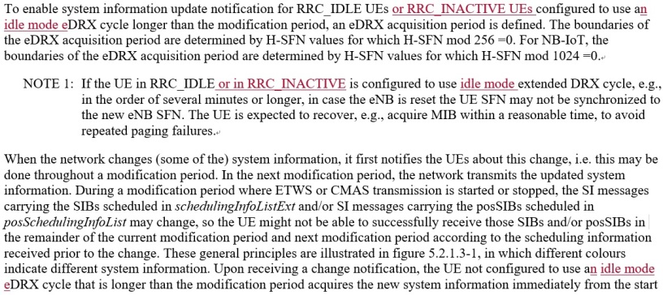
R2-2101036  (Huawei) | TS 36.331 (5.2.1.3, 5.2.2.4), For example:  5.2.1.3 System information validity and notification of changes  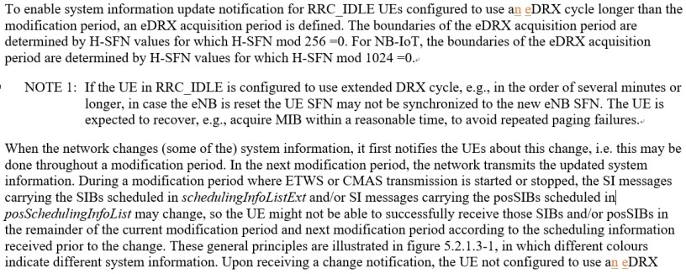
R2-2101467  (Ericsson) | TS 36.331 (5.2.1.3)  5.2.1.3 System information validity and notification of changes  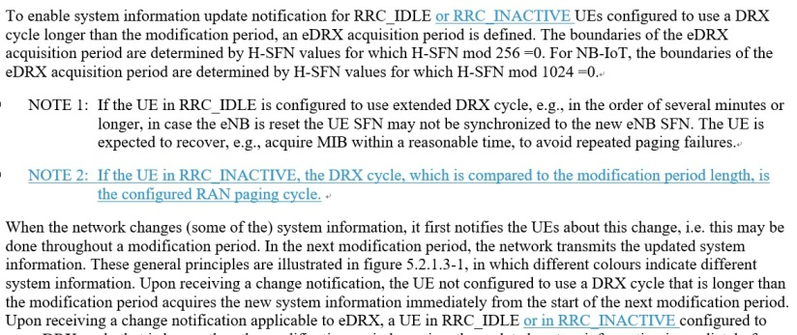

Q2: Companies are invited to provide their detailed suggestions or comments for the corresponding CRs.
Company | Preferred CR changes | Comments
ZTE | Slightly prefer changes in R2-2100936. | It’s clearer to mention RRC_INACTIVE and to use the wording “idle mode eDRX cycle”.
Qualcomm | None | - Changing DRX to eDRX is not right as this may not be backwards compatible. This has been in specification since Release 13.  - We don’t think it is right to add clarification as to which modification period applies to RRC_INACTIVE because this will only diminish the purpose of the following sentence in the existing specification:  - The UE:  - Applies RRC_IDLE procedures unless specified otherwise;
Huawei, HiSilicon | R2-2100936 | We think a clarification is needed as, per the discussion, companies have different understanding of which “configured” DRX cycle is used to monitor system information, as it is specified as the eMTC UE in RRC_INACTIVE is configured with the RAN paging cycle.  We think R2-2100936 is simple and we do not think there is any backward compatibility issues as there is only one configured DRX cycle in RRC_IDLE. We are open to other way to clarify.
Ericsson | R2-2101467 | Agree with ZTE and HW that something needs to be clarified w.r.t. the monitored cycles as RAN paging cycle is not covered adequately, and the RAN paging cycle can be either “normal DRX” or “eDRX” (i.e. beyond 2.56 s).  There is no “RRC_IDLE procedure” when it comes to RAN paging cycles as UEs in RRC_IDLE would not listen to RAN paging, thus we think this aspect is unclear at the moment.
Nokia | Part of R2-2101467 | First part of 2101467 is sufficient. Use of new term ‘eDRX’ will also impact spec for existing UE. DRX cycle longer than modification period already covers this. NOTE 2 : Not required, If the UE is monitoring regular DRX cycle, the modification period needs to be always based
ZTE2 |  | In yesterday LTE session, the CR R2-2100936 has been briefly discussed. The Chair minutes are copied here for reference:  R2-2101036 Clarification to the DRX cycle in RRC_IDLE and RRC_INACTIVE Huawei, HiSilicon  - Huawei clarifies that this was discussed in eMTC session in RAN2#112e.  - QC thinks there could be inconsistencies with using "eDRX" everywhere since we could have DRX period longer than modification period. Should be handled in eMTC session. Huawei is fine.  - QC is fine with referencing 36.304 but not changing all "DRX" to "eDRX".  - LGE has concern on handling this in MTC session and using "eDRX".  Do not use "eDRX cycle" to replace "DRX cycle".  Move the topic to eMTC session (in this meeting - there are related contributions in that session) and CR can be decided there (i.e. it's not brought back to general LTE session)  Firstly, we want to clarify the comment from QC “QC thinks there could be inconsistencies with using "eDRX" everywhere since we could have DRX period longer than modification period”. Per our understanding, normal DRX cycle is always equal to or less than defaultPagingCycle. At the same time, the BCCH modification period is expressed in number of radio frames = modificationPeriodCoeff * defaultPagingCycle and the minimum value for modificationPeriodCoeff is n2 (for eMTC). Therefore, the normal DRX cycle would not be longer than BCCH modification period.  Secondly, we agree with HW and also think even we use "eDRX cycle" to replace "DRX cycle", there is no backward compatibility issues. As in legacy:  - There is only one normal DRX cycle in RRC_IDLE, e.g., DRX cycle (T) in TS 36.304. In RRC_IDLE, either normal DRX cycle or extended DRX cycle would be used to compare with BCCH modification period.  - For eLTE, it doesn’t support extended DRX cycle in RRC_INACTIVE.  Therefore, in legacy spec, when it says “…a DRX cycle longer than the modification period”, here the “DRX cycle” of “DRX cycle longer than the modification period” can only be a meaning of “idle mode eDRX cycle”, no other way for understanding. So for legacy spec, no matter change to “eDRX” or not, there is no understanding ambiguity. But for eMTC UE in RRC_INACTIVE, if NO any clarification, the meaning of “DRX cycle” in “DRX cycle longer than the modification period” is not clear.  Anyway, we can understand the concern about impacts on a wording from R13. So maybe we can consider no any changes to the current text and only a note for explicit process for UE in RRC_INACTIVE is added (wording can be improved later):  For Option 1:  NOTE 1: If the UE in RRC_IDLE is configured to use extended DRX cycle, e.g., in the order of several minutes or longer, in case the eNB is reset the UE SFN may not be synchronized to the new eNB SFN. The UE is expected to recover, e.g., acquire MIB within a reasonable time, to avoid repeated paging failures.  NOTE 2: if the UE in RRC_INACTVE and the idle mode extended DRX cycle is configured, the DRX cycle, which is compared to the modification period, is the idle mode extended DRX cycle.  For Option 2:  NOTE 1: If the UE in RRC_IDLE is configured to use extended DRX cycle, e.g., in the order of several minutes or longer, in case the eNB is reset the UE SFN may not be synchronized to the new eNB SFN. The UE is expected to recover, e.g., acquire MIB within a reasonable time, to avoid repeated paging failures.  NOTE 2: if the UE in RRC_INACTVE, the DRX cycle, which is compared to the modification period, is the configured RAN paging cycle.  The main difference between Option 1 and Option 2 may be: when idle mode extended DRX cycle is longer than modification period while configured RAN paging cycle is shorter than modification period, the UE with option 1 still monitors systemInfoModification-eDRX while UE with option 2 monitors systemInfoModification. It seems option 2 a bit better in this case. Companies may take this into account.
LGE | R2-2101467 | The current text is clear without changing “DRX” to “eDRX”.  We are fine with the first change in R2-2101467.
Summary:
LTE session has agreed not to use "eDRX cycle" to replace "DRX cycle" in the existing text. More companies agree a clarification is needed and think a note sufficient.
Proposal:
Proposal 2: To add a note in TS 36.331 section 5.2.1.3 to reflect the agreed clarification from proposal 1.

Q3: Is there any other issue or comments, e.g., whether the CR needs to be approved in LTE main session? (with consideration that idle mode eDRX is not supported for eLTE)
Company | Comments
Summary: None
Proposal: None

Summary
Proposal 1: RAN2 to discuss which option for clarification on SIB change notification for UE in RRC_INACTIVE is agreeable:
- Option 1: UE in RRC_INACTIVE follows same system modification indication as it does in RRC_IDLE. To clarify that, if idle mode eDRX cycle is configured and longer than modification period, the UE in RRC_INACTIVE would follow systemInfoModification-eDRX indication.
- Option 2: To clarify that, if configured RAN paging cycle is longer than modification period, the UE in RRC_INACTIVE would follow systemInfoModification-eDRX indication.

Proposal 2: To add a note in TS 36.331 section 5.2.1.3 to reflect the agreed clarification from proposal 1.

References
[1] 3GPP, R2-2010816, Report of R16 SIB acquisition for UEs in RRC_INACTIVE, RAN2#112-e, November 2020
[2] 3GPP, R2-2100932 Discussion for clarification on SIB acquisition for UE in RRC_INACTIVE ZTE Corporation, Sanechips, discussion, RAN2#113-e, January 2021
[3] 3GPP, R2-2100936 Clarification on SIB acquisition for UE in RRC_INACTIVE ZTE Corporation, Sanechips CR Rel-16 36.331 16.3.0 4555, RAN2#113-e, January 2021
[4] 3GPP, R2-2101038 System information change notification in RRC_INACTIVE Huawei, HiSilicon, discussion, RAN2#113-e, January 2021
[5] 3GPP, R2-2101036 Clarification to the DRX cycle in RRC_IDLE and RRC_INACTIVE, Huawei, HiSilicon, RAN2#113-e, January 2021
[6] 3GPP, R2-2101155 SIB acquisition by eMTC UE in RRC-INACTIVE Qualcomm Incorporated, discussion, RAN2#113-e, January 2021
[7] 3GPP, R2-2101467 Clarification of SI acquisition for UEs configured with eDRX in RRC_INACTIVE Ericsson LM CR Rel-16 36.331 16.3.0 4578, RAN2#113-e, January 2021

Annex – Contact Points
Respondents to the email discussion are kindly asked to fill in the following table.
Company | Name | Email Address
ZTE (Rapporteur) | Ting Lu | lu.ting@zte.com.cn
Qualcomm | Mungal Dhanda | mdhanda@qti.qualcomm.com
Ericsson | Tuomas Tirronen | tuomas.tirronen@ericsson.com

