3GPP TSG-RAN WG2 Meeting #113 electronic R2-21xxxxx
25th January – 5th February 2021

Agenda Item: 7.2.2
Source: ZTE (email discussion rapporteur)
Title: Report of [AT113-e][402][eMTC R16] SIB change notification in RRC_INACTIVE (ZTE)
Document for: Discussion and Decision

Scope of the offline email discussion
This document contains the summary of the offline email discussion “[AT113-e][402][eMTC R16] System information change notification in RRC_INACTIVE”, as indicated below:
- [AT113-e][402][eMTC R16] System information change notification in RRC_INACTIVE (ZTE)
Status: Started
Scope:
Week 1: Check whether the intention is agreeable and there is sufficient support in principle; collect initial comments.
Week 2: Agreeable CR, if there is sufficient support
Intended outcome:
Week 1: Report in R2-2102062
Week 2: Agreeable 36.331 CR in R2-210XXXX (to be announced later)
Deadline: Wednesday 2021-01-27 4:45 UTC

Offline email discussion

2.1 Solutions
In last RAN2#112-e meeting, based on the contributions, the issue of system information change notification for UE in RRC_INACTIVE was discussed but no agreement was achieved.
In the current RRC specification, the SIB acquisition/update procedure only mentions the UEs in RRC_IDLE and RRC_CONNECTED state, no description for UE in RRC_INACTIVE. As there is a high level description that the UE in RRC_INACTIVE applies RRC _IDLE procedures unless specified otherwise, one possible assumption is that SIB acquisition/update for UE in RRC_INACTIVE would follow the current procedures for UE in RRC_IDLE. That means, if eDRX is configured and the Paging eDRX cycle is longer than BCCH modification period, the UE in RRC_INACTIVE would always detect system information change with systemInfoModification-eDRX IE during eDRX acquisition period, if transmitted.
Considering that the maximal DRX cycle for eMTC UE in RRC_INACTIVE would be the maximum value of the RAN paging cycle, e.g., rf1024, which can be far less than the eDRX acquisition period (e.g. hf256), if simply reusing the system information acquisition principles as that for UE in RRC_IDLE, the system information acquisition will be not timely when DRX cycle is longer than the BCCH modification period. However, during the discussion in RAN2#112-e meeting [1], some companies thought this issue doesn’t matter much. The only need is to clarify what does the “DRX cycle” in RRC spec which is used to compare with modification period mean to UE in RRC_INACTIVE.

In current RAN2#113 e-meeting, several contributions are submitted with the following proposals:
Contribution (Company) | Proposals
R2-2100932 (ZTE) | Proposal 1: It’s suggested to clarify that RRC_INACTIVE UE should detect system information change via Paging message with the same indicator as used in RRC_IDLE mode.
R2-2101038  (Huawei) | Proposal 1: UEs in RRC_INACTIVE follow systemInfoModification-eDRX notification if the used DRX Cycle is larger than the BCCH modification period.  Proposal 2: UEs in RRC_INACTIVE use the eDRX cycle for monitoring system information change.
R2-2101155  (Qualcomm) | Proposal 1: UE in RRC_INACTIVE state follows same system modification indication as it does in RRC_IDLE.
R2-2101467  (Ericsson) | Addition of a NOTE in 5.2.1.3 to clarify that UE in RRC_INACTIVE compares the configured RAN paging cycle length to the configured modification period, to determine whether it follows the eDRX acquisition period.  Addition of RRC_INACTIVE in 5.2.1.3 so that UE in RRC_INACTIVE monitors for system information update notification, and compares the paging cycle length to modication period.
In [R2-2101038], even company has the Observation 4 “In RRC_INACTIVE, if the UEs is not configured with idle eDRX or if the UE is configured with idle eDRX and its RAN paging cyle is shorter than or equal to the BCCH modification period, following systemInfoModification notification is more efficient for power consumption.”, based on the following further observation:
Observation 7: Having to read the MIB before resuming an RRC connection in RRC_INACTIVE may be an acceptable trade off to keep the UE behaviour identical in RRC_IDLE and RRC_INACTIVE.
They still suggest UEs in RRC_INACTIVE to follow systemInfoModification-eDRX notification.
In [R2-2101155], based on the following observations, company gives a similar proposal as that in [R2-2100932] and [R2-2101038].
Observation 4: All UEs will use the new system information before access regardless of whether UE follows systemInfoModification or systemInfoModification-eDRX.
Observation 5: UE in RRC_IDLE or RRC_INACTIVE state can receive either of the two system information modification indications regardless of whether UE follows systemInfoModification or systemInfoModification-eDRX.

It seems more companies prefer that UE in RRC_INACTIVE follows same system modification indication as it does in RRC_IDLE. But there is still different opinion. Therefore, we have the following question:
Q1: Companies are invited to indicate which option is preferred for clarification on SIB change notification for UE in RRC_INACTIVE?
- Option 1: UE in RRC_INACTIVE follows same system modification indication as it does in RRC_IDLE. E.g., to clarify that the “DRX cycle” in TS 36.331 section 5.2 which is used to compare with modification period is the idle mode eDRX cycle.
- Option 2: To clarify that, for UE in RRC_INACTIVE, the “DRX cycle” in TS 36.331 section 5.2 which is used to compare with modification period is the configured RAN paging cycle.

Company | Preference | Detailed comments
ZTE | Option 1
Conclusion:
Proposal:

2.2 Possible changes for solutions
Rapporteur quote the main changes from different CRs as following for comparison:
R2-2100936 (ZTE) | TS 36.331 (5.2.1, 5.2.2) , For example:  5.2.1.3 System information validity and notification of changes  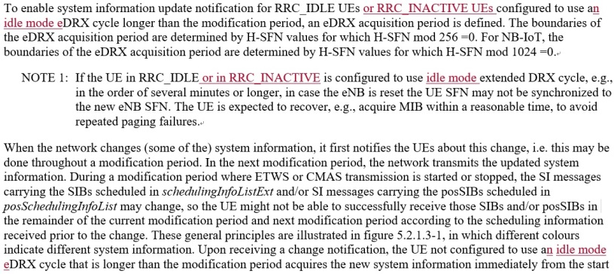
R2-2101036  (Huawei) | TS 36.331 (5.2.1.3, 5.2.2.4), For example:  5.2.1.3 System information validity and notification of changes  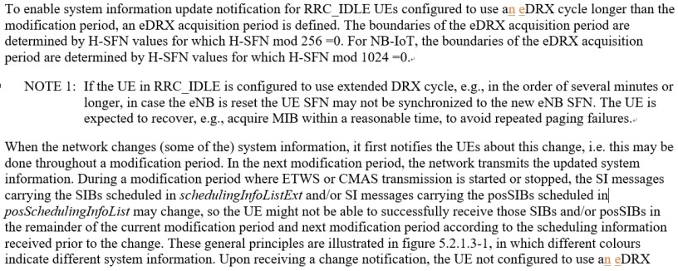
R2-2101467  (Ericsson) | TS 36.331 (5.2.1.3)  5.2.1.3 System information validity and notification of changes  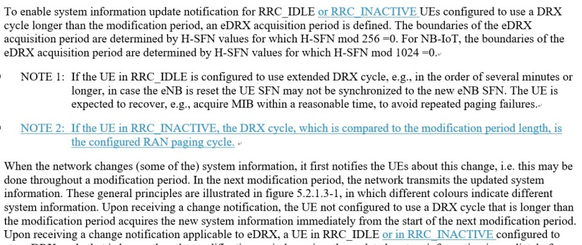

Q2: Companies are invited to provide their detailed suggestions or comments for the corresponding CRs.
Company | Preferred CR changes | Comments
ZTE | Slightly prefer changes in R2-2100936. | It’s clearer to mention RRC_INACTIVE and to use the wording “idle mode eDRX cycle”.
Conclusion:
Proposal:

Q3: Is there any other issue or comments, e.g., whether the CR needs to be approved in LTE main session? (with consideration that idle mode eDRX is not supported for eLTE)
Company | Comments
Conclusion:
Proposal:

Summary
Conclusion:

Updated CRs:

References
[1] 3GPP, R2-2010816, Report of R16 SIB acquisition for UEs in RRC_INACTIVE, RAN2#112-e, November 2020
[2] 3GPP, R2-2100932 Discussion for clarification on SIB acquisition for UE in RRC_INACTIVE ZTE Corporation, Sanechips, discussion, RAN2#113-e, January 2021
[3] 3GPP, R2-2100936 Clarification on SIB acquisition for UE in RRC_INACTIVE ZTE Corporation, Sanechips CR Rel-16 36.331 16.3.0 4555, RAN2#113-e, January 2021
[4] 3GPP, R2-2101038 System information change notification in RRC_INACTIVE Huawei, HiSilicon, discussion, RAN2#113-e, January 2021
[5] 3GPP, R2-2101036 Clarification to the DRX cycle in RRC_IDLE and RRC_INACTIVE, Huawei, HiSilicon, RAN2#113-e, January 2021
[6] 3GPP, R2-2101155 SIB acquisition by eMTC UE in RRC-INACTIVE Qualcomm Incorporated, discussion, RAN2#113-e, January 2021
[7] 3GPP, R2-2101467 Clarification of SI acquisition for UEs configured with eDRX in RRC_INACTIVE Ericsson LM CR Rel-16 36.331 16.3.0 4578, RAN2#113-e, January 2021

Annex – Contact Points
Respondents to the email discussion are kindly asked to fill in the following table.
Company | Name | Email Address
ZTE (Rapporteur) | Ting Lu | lu.ting@zte.com.cn

