3GPP TSG-RAN WG2 Meeting #113-e R2-210xxxx

Online, January 25th – February 5th 2021

Agenda item: 6.14.1
Source: Apple
Title: Summary of [AT113-e][111][eMIMO] Corrections (Apple)
Document for: Discussion and Decision

Introduction
This document contains the summary of documents from agenda item 6.14.1 (“eMIMO - SpCell BFR”, and “eMIMO – other”) as per below excerpt from the session chair minutes:

- [AT113-e][111][eMIMO] Corrections (Apple)
Scope:
- Discuss revisions of R2-2101365, R2-2101366, R2-2101367 and reply LS to RAN1
- Discuss revision of R2-2101485
Intended outcome: rapporteur's summary in R2-2102025 and agreeable CRs in R2-2102026, R2-2102027, R2-2102028 and R2-2102030; draft reply LS in R2-2102029
Deadline (for companies' feedback): Tuesday 2021-02-02 11:00 UTC
Deadline (for summary, CRs and LS): Tuesday 2021-02-02 17:00 UTC
CRs listed as "can be agreed as is" in R2-2102025 and not challenged until Wednesday 2021-02-03 11:00 UTC will be declared as agreed by the session chair. For the other ones, the discussion will continue online.

Contact Points
Respondents to the email discussion are kindly asked to fill in the following table.
Company | Name | Email Address
Nokia | Tero Henttonen | tero.henttonen@nokia.com
Ericsson | Mats Folke | mats.folke@ericsson.com

Discussion

Topic 1: SpCell BFR
Following agreements were made online, and the corresponding CRs and draft LS need to be discussed offline.
Agreements:
- Introduce the dedicated UE capability for the R16 SpCell BFR enhancement.
- The capability of R16 enhanced SpCell BFR is UE specific capability.
- New configuration should be introduced to enable/disable the enhanced SpCell BFR procedure.

38.306 CR
R2-2101365 38.306 CR on SpCell BFR Apple CR Rel-16 38.306 16.3.0 0506 - F NR_eMIMO-Core
- Ericsson supports the CR but has some comments on the ASN.1 aspect, e.g. for the naming convention. Same view from Xiaomi
- Revised in R2-2102026
- Continue in offline 111
R2-2102026 38.306 CR on SpCell BFR Apple CR Rel-16 38.306 16.3.0 0506 1 F NR_eMIMO-Core

The change in the draft CR is updated as below.

4.2.6 MAC parameters
spCellBFREnh-r16  Indicates whether the UE supports to use BFR MAC CE to indicate the SpCell BFR via the SpCell CBRA-BFR procedure as specified in TS 38.321 [8]. | UE | No | No | No

Q1: Do you agree with the change and the draft 38.306 CR?
Company | Agree? (Yes or No) | Comments
OPPO | Yes
Nokia, Nokia Shanghai Bell | Agree with changes | Two comments:  - The field name should be changed (see comments to RRC below)  - The description is a bit repetitive and could be improved: We have two alternative proposals for this:  1) "Indicates whether the UE supports sending BFR MAC CE via MsgA or Msg3 for SpCell BFR procedure using CBRA as specified in TS 38.321 [8]."  OR  2) " Indicates whether the UE supports being configured with spCell-BFR-CBRA-r16"
LG | Agree with changes | We think the field name should be descriptive and intuitive, as like Nokia's suggestion. Regarding the description, we prefer 1) in Nokia's suggestion.
Ericsson | Agree with changes | Same comments as Nokia with slight preference for alternative 2.  The title of the CR should not contain the name of the specification.

38.331 CR
R2-2101366 RRC CR on SpCell BFR Apple CR Rel-16 38.331 16.3.1 2407 - F NR_eMIMO-Core
- Revised in R2-2102027
- Continue in offline 111
R2-2102027 RRC CR on SpCell BFR Apple CR Rel-16 38.331 16.3.1 2407 1 F NR_eMIMO-Core

The changes in the draft CR are updated as below.
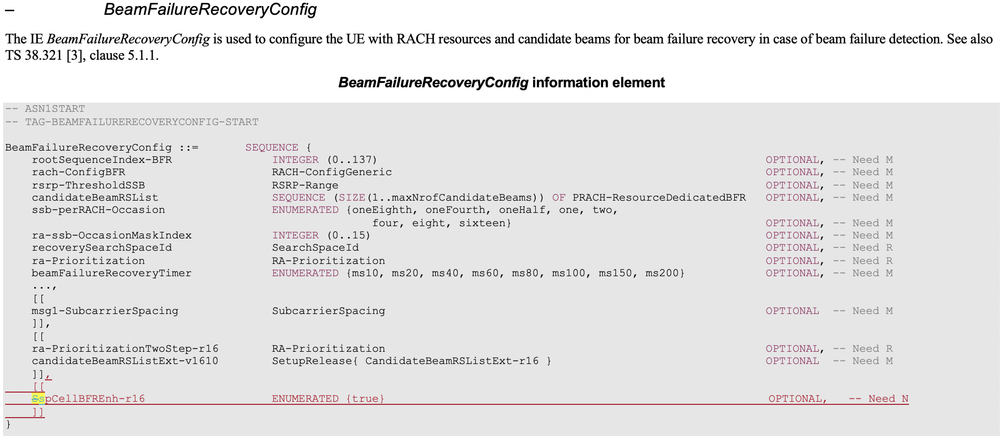
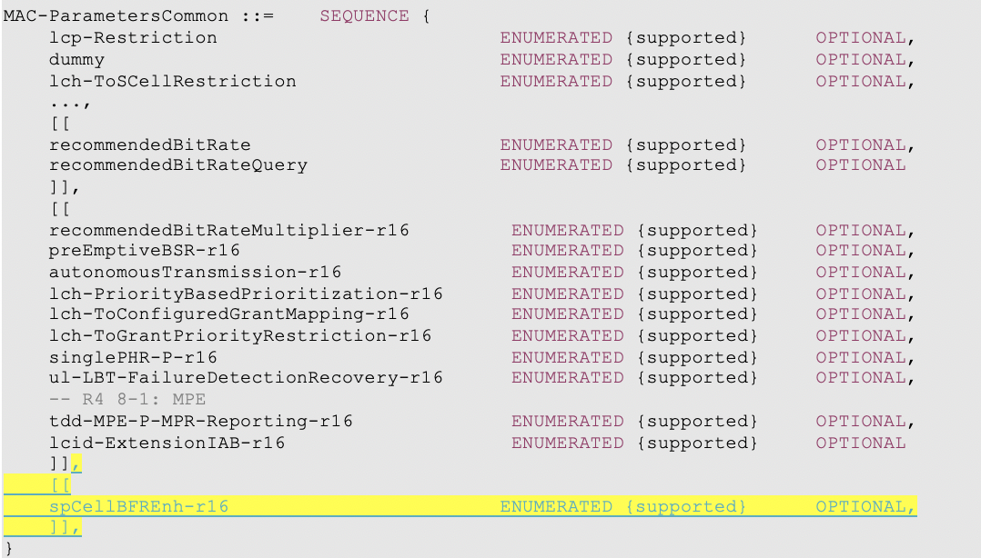

Q2: Do you agree with the change and the draft 38.331 CR?
Company | Agree? (Yes or No) | Comments
OPPO | Yes
Nokia, Nokia Shanghai Bell | Agree with changes | Three comments:  - The field name spCellBFREnh-r16 does not follow RRC naming conventions (hyphen is needed after acronyms) and the "Enh" in the name is really non-descriptive, so better use (e.g.) spCell-BFR-CBRA-r16 instead (for both configuration and capability)  - The need code should be Need R, otherwise the field is used once and then discarded (and it's not possible to release it, either)  - The field description should align with what is put to 38.306:  "Indicates that UE is configured to send BFR MAC CE via MsgA or Msg3 to indicate the SpCell BFR for the BFR procedure using CBRA as specified in TS38.321 [3]."
LG | Agree with changes | We think the field name should be descriptive and intuitive and the description should be aligned with the description in 38.306.
Ericsson | Agree with changes | Agree with Nokia's comments.  The title of the CR should not contain the name of the specification.

38.321 CR
R2-2101367 MAC CR on SpCell BFR Apple CR Rel-16 38.321 16.3.0 1030 - F NR_eMIMO-Core
- Revised in R2-2102028
- Continue in offline 111
R2-2102028 MAC CR on SpCell BFR Apple CR Rel-16 38.321 16.3.0 1030 1 F NR_eMIMO-Core

The changes in the draft CR are updated as below.

5.1.3a MSGA transmission
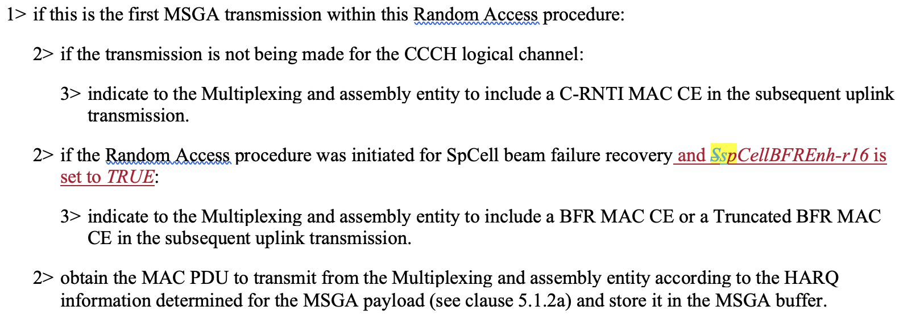

5.1.4 Random Access Response reception
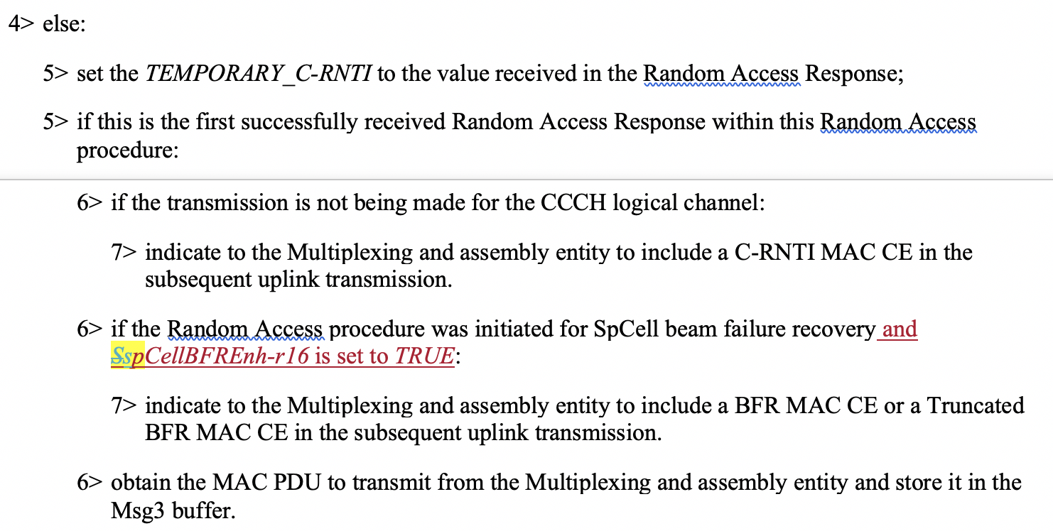

Q3: Do you agree with the change and the draft 38.321 CR?
Company | Agree? (Yes or No) | Comments
OPPO | No | Not sure whether this capability needs to be reflected in MAC, the field description is clear enough i.e., if UE does not support this feature, it will not be executed.
Nokia, Nokia Shanghai Bell | Agree with changes | Some small comments:  - Field name should be aligned with RRC (see above)  - The value is "true" and not "TRUE" and text could just say "spCell-BFR-CBRA-r16 with value true is configured" (to align with other similar text in MAC). Note also that this is the configuration parameter, not the capability (i.e. OPPO is correct that we don't refer to capabilities in MAC but can refer to configurations)
LG | Agree with changes | In the MAC specification, the release number, i.e., "-r16", is not specified for parameter. "-r16" should be removed.
Ericsson | Agree with changes | Agree with Nokia's and LG's comments.  The title of the CR should not contain the name of the specification.  Regarding Oppo's comment: We should indeed refer to the RRC parameter and not the capability. There is no need to mention the capability as the network will not configure the parameter to true unless the UE has signalled the capability.

Draft LS Reply
R2-2101856 DRAFT LS Reply to RAN1 on CBRA based Beam Failure Recovery Apple LS out Rel-16 NR_eMIMO-Core To:RAN1
- Revised in R2-2102029
- Continue in offline 111
R2-2102029 DRAFT LS Reply to RAN1 on CBRA based Beam Failure Recovery Apple LS out Rel-16 NR_eMIMO-Core To:RAN1

The draft LS Reply is updated as below:
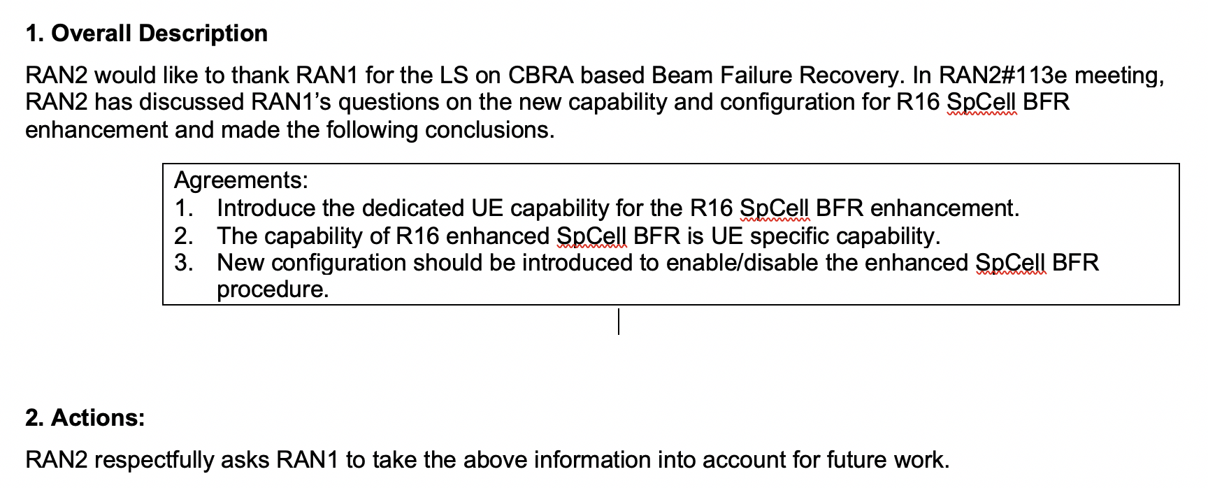

Q4: Do you agree with the content of the draft LS reply?
Company | Agree? (Yes or No) | Comments
OPPO | Yes
Nokia, Nokia Shanghai Bell | Partly | Instead of just sending the RAN 2 agreements without explanations, it would be better to make the text clearer e.g. as follows:  "...made the following conclusions:  - The R16 SpCell BFR procedure is configured to be used by the UE (via field spCell-BFR-CBRA-r16)  - A new per-UE capability spCell-BFR-CBRA-r16 is introduced for indicating support for the R16 SpCell BFR enhancement.
LG | Yes
Ericsson | Well... | Not sure an LS is needed, but if we agree to send it, Nokia's comments should be taken into account.

Topic 2: Correction on PUCCH group for enhanced PUCCH Spatial Relation
R2-2101485 Correction on PUCCH group for enhanced PUCCH Spatial Relation Huawei, HiSilicon CR Rel-16 38.321 16.3.0 1034 - F NR_eMIMO-Core
- Nokia thinks we could refer to actual IE in RRC. Huawei is fine
- Intel thinks we also need to check the coversheet
- Revised in R2-2102030
- Continue in offline 111
R2-2102030 Correction on PUCCH group for enhanced PUCCH Spatial Relation Huawei, HiSilicon CR Rel-16 38.321 16.3.0 1034 1 F NR_eMIMO-Core

Summary of change: Correct “PUCCH group” in the description of enhanced PUCCH spatial relation activation/deactivation MAC CE to “PUCCH resource group”.
And the change is copied below.
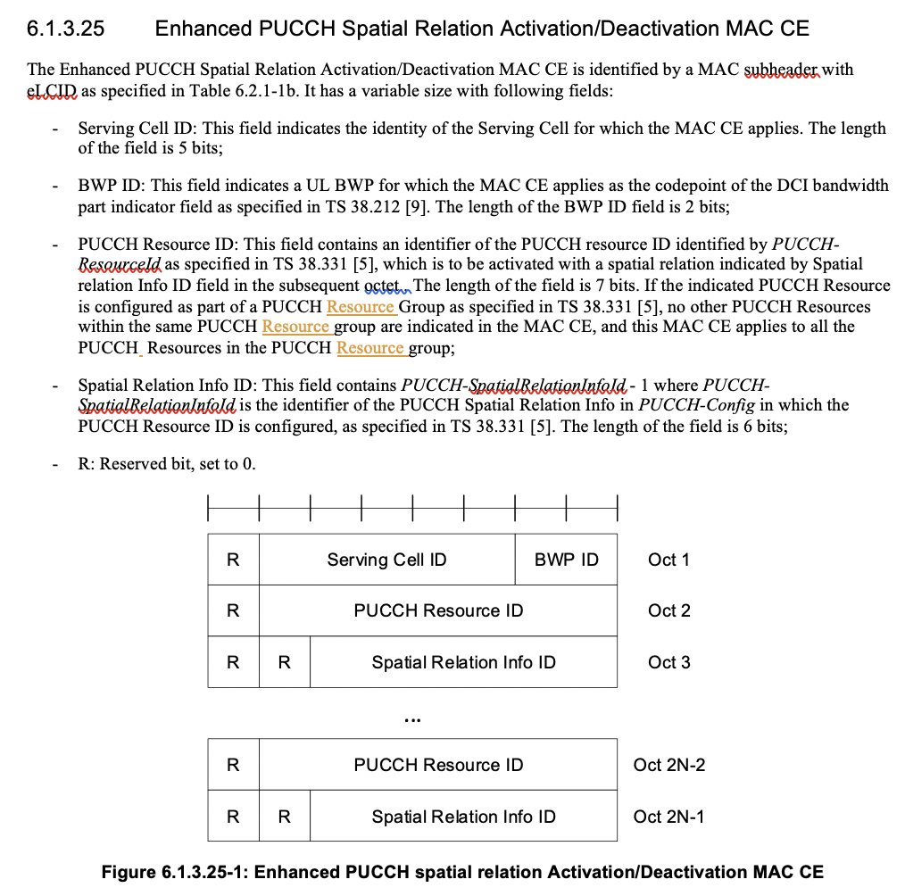

Q5: Do you agree with the change and the draft CR?
Company | Agree? (Yes or No) | Comments
OPPO | No | We would suggest to directly use the IE in 38.331
Nokia, Nokia Shanghai Bell | Partly | Content: The comment we made online was that the reference could be to the actual RRC field name, e.g. like this:  "If the indicated PUCCH Resource is configured as part of a PUCCH Resource Group (configured via resourceGroupToAddModList-r16 as specified in TS 38.331 [5])  Inter-operability analysis: Please don't use "if not agreed, consequences if not approved remain" - that usually just hides what really happens. E.g. this would make the consequences clearer:  If UE is implemented according to this CR and network is not, the UE may use different PUCCH resources that network assumes after the UE has received the enhanced PUCCH spatial relation activation/deactivation MAC CE.  If network is implemented according to this CR and UE is not, the UE may use different PUCCH resources that network assumes after the UE has received the enhanced PUCCH spatial relation activation/deactivation MAC CE.
LG | No | We think the actual RRC IE should be used, i.e., pucch-ResourceGroupId.
Ericsson | Agree

Conclusions

