3GPP TSG-RAN WG2 Meeting #113-e R2-210xxxx

Online, January 25th – February 5th 2021

Agenda item: 6.14.1
Source: Apple
Title: Summary of [AT113-e][111][eMIMO] Corrections (Apple)
Document for: Discussion and Decision

Introduction
This document contains the summary of documents from agenda item 6.14.1 (“eMIMO - SpCell BFR”, and “eMIMO – other”) as per below excerpt from the session chair minutes:

- [AT113-e][111][eMIMO] Corrections (Apple)
Scope:
- Discuss revisions of R2-2101365, R2-2101366, R2-2101367 and reply LS to RAN1
- Discuss revision of R2-2101485
Intended outcome: rapporteur's summary in R2-2102025 and agreeable CRs in R2-2102026, R2-2102027, R2-2102028 and R2-2102030; draft reply LS in R2-2102029
Deadline (for companies' feedback): Tuesday 2021-02-02 11:00 UTC
Deadline (for summary, CRs and LS): Tuesday 2021-02-02 17:00 UTC
CRs listed as "can be agreed as is" in R2-2102025 and not challenged until Wednesday 2021-02-03 11:00 UTC will be declared as agreed by the session chair. For the other ones, the discussion will continue online.

Contact Points
Respondents to the email discussion are kindly asked to fill in the following table.
Company | Name | Email Address

Discussion

Topic 1: SpCell BFR
Following agreements were made online, and the corresponding CRs and draft LS need to be discussed offline.
Agreements:
- Introduce the dedicated UE capability for the R16 SpCell BFR enhancement.
- The capability of R16 enhanced SpCell BFR is UE specific capability.
- New configuration should be introduced to enable/disable the enhanced SpCell BFR procedure.

38.306 CR
R2-2101365 38.306 CR on SpCell BFR Apple CR Rel-16 38.306 16.3.0 0506 - F NR_eMIMO-Core
- Ericsson supports the CR but has some comments on the ASN.1 aspect, e.g. for the naming convention. Same view from Xiaomi
- Revised in R2-2102026
- Continue in offline 111
R2-2102026 38.306 CR on SpCell BFR Apple CR Rel-16 38.306 16.3.0 0506 1 F NR_eMIMO-Core

The change in the draft CR is updated as below.

4.2.6 MAC parameters
spCellBFREnh-r16  Indicates whether the UE supports to use BFR MAC CE to indicate the SpCell BFR via the SpCell CBRA-BFR procedure as specified in TS 38.321 [8]. | UE | No | No | No

Q2: Do you agree with the change and the draft 38.306 CR?
Company | Agree? (Yes or No) | Comments

38.331 CR
R2-2101366 RRC CR on SpCell BFR Apple CR Rel-16 38.331 16.3.1 2407 - F NR_eMIMO-Core
- Revised in R2-2102027
- Continue in offline 111
R2-2102027 RRC CR on SpCell BFR Apple CR Rel-16 38.331 16.3.1 2407 1 F NR_eMIMO-Core

The changes in the draft CR are updated as below.
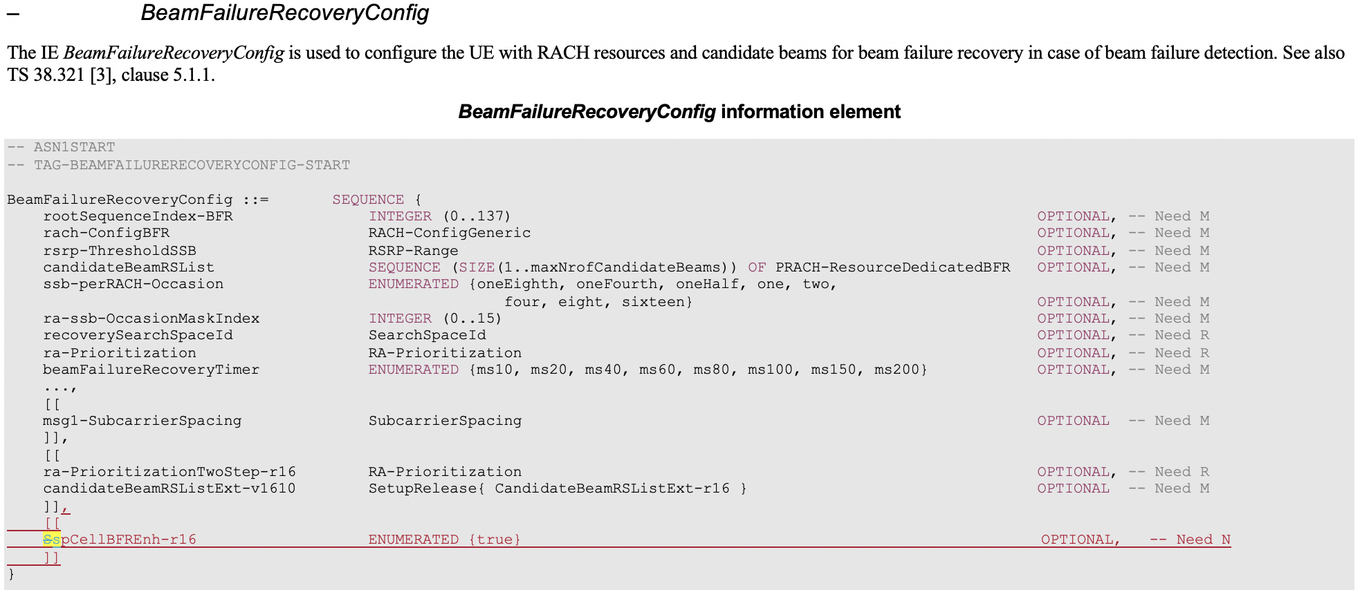
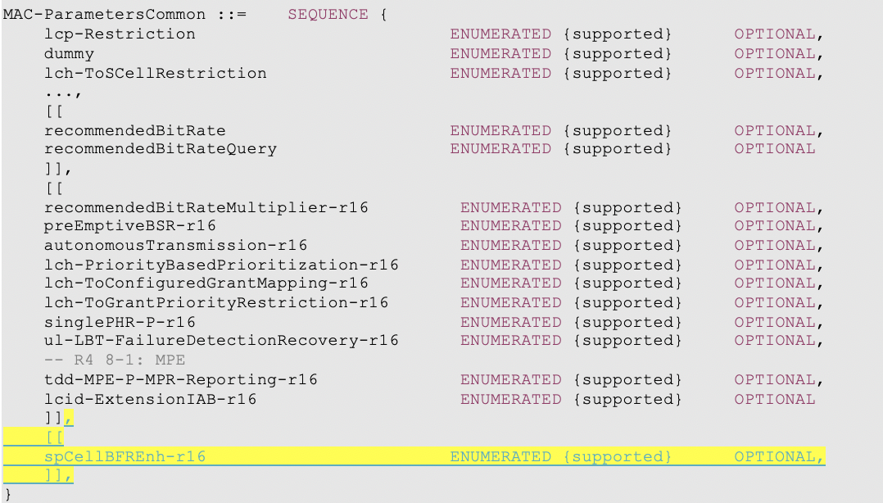

Q2: Do you agree with the change and the draft 38.331 CR?
Company | Agree? (Yes or No) | Comments

38.321 CR
R2-2101367 MAC CR on SpCell BFR Apple CR Rel-16 38.321 16.3.0 1030 - F NR_eMIMO-Core
- Revised in R2-2102028
- Continue in offline 111
R2-2102028 MAC CR on SpCell BFR Apple CR Rel-16 38.321 16.3.0 1030 1 F NR_eMIMO-Core

The changes in the draft CR are updated as below.

5.1.3a MSGA transmission
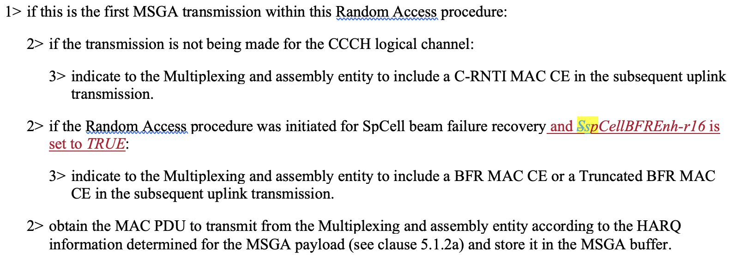

5.1.4 Random Access Response reception
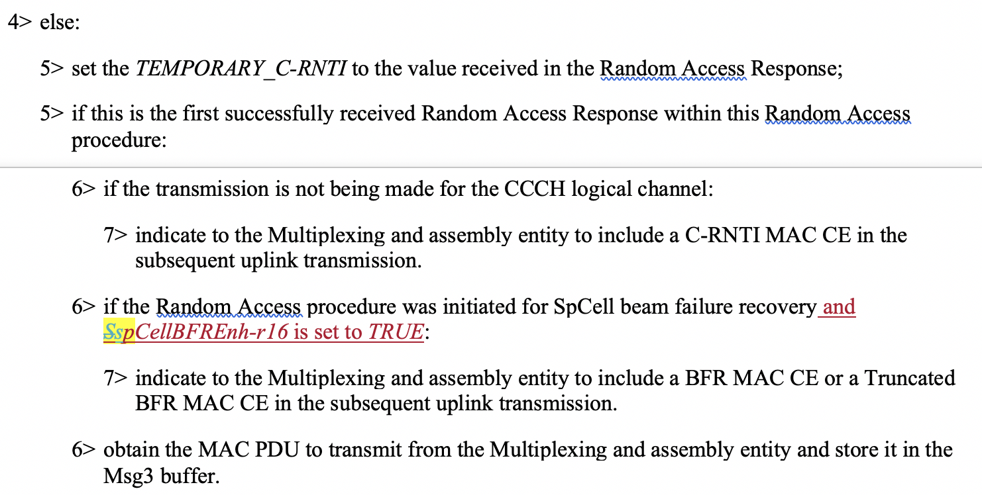

Q3: Do you agree with the change and the draft 38.321 CR?
Company | Agree? (Yes or No) | Comments

Draft LS Reply
R2-2101856 DRAFT LS Reply to RAN1 on CBRA based Beam Failure Recovery Apple LS out Rel-16 NR_eMIMO-Core To:RAN1
- Revised in R2-2102029
- Continue in offline 111
R2-2102029 DRAFT LS Reply to RAN1 on CBRA based Beam Failure Recovery Apple LS out Rel-16 NR_eMIMO-Core To:RAN1

The draft LS Reply is updated as below:
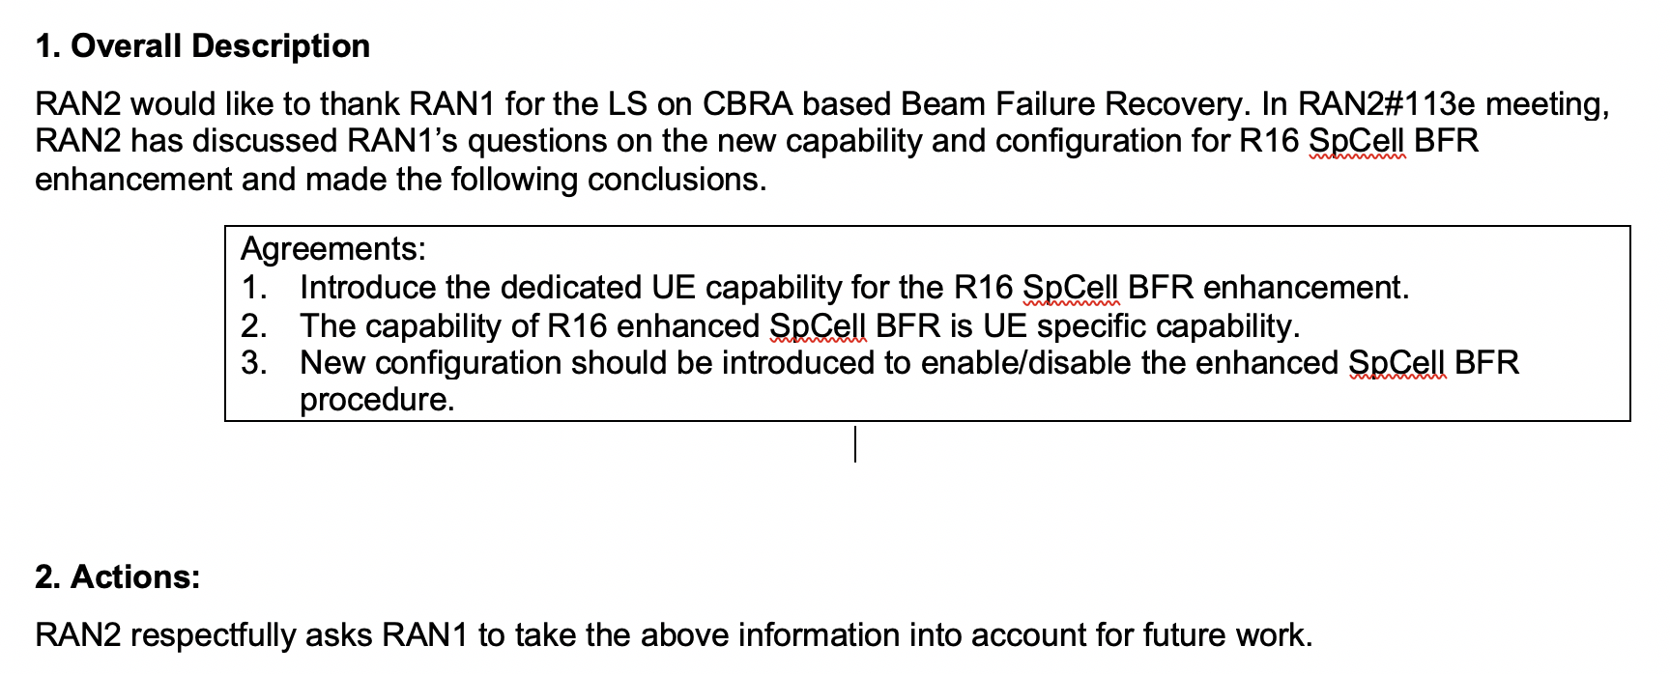

Q4: Do you agree with the content of the draft LS reply?
Company | Agree? (Yes or No) | Comments

Topic 2: Correction on PUCCH group for enhanced PUCCH Spatial Relation
R2-2101485 Correction on PUCCH group for enhanced PUCCH Spatial Relation Huawei, HiSilicon CR Rel-16 38.321 16.3.0 1034 - F NR_eMIMO-Core
- Nokia thinks we could refer to actual IE in RRC. Huawei is fine
- Intel thinks we also need to check the coversheet
- Revised in R2-2102030
- Continue in offline 111
R2-2102030 Correction on PUCCH group for enhanced PUCCH Spatial Relation Huawei, HiSilicon CR Rel-16 38.321 16.3.0 1034 1 F NR_eMIMO-Core

Summary of change: Correct “PUCCH group” in the description of enhanced PUCCH spatial relation activation/deactivation MAC CE to “PUCCH resource group”.
And the change is copied below.
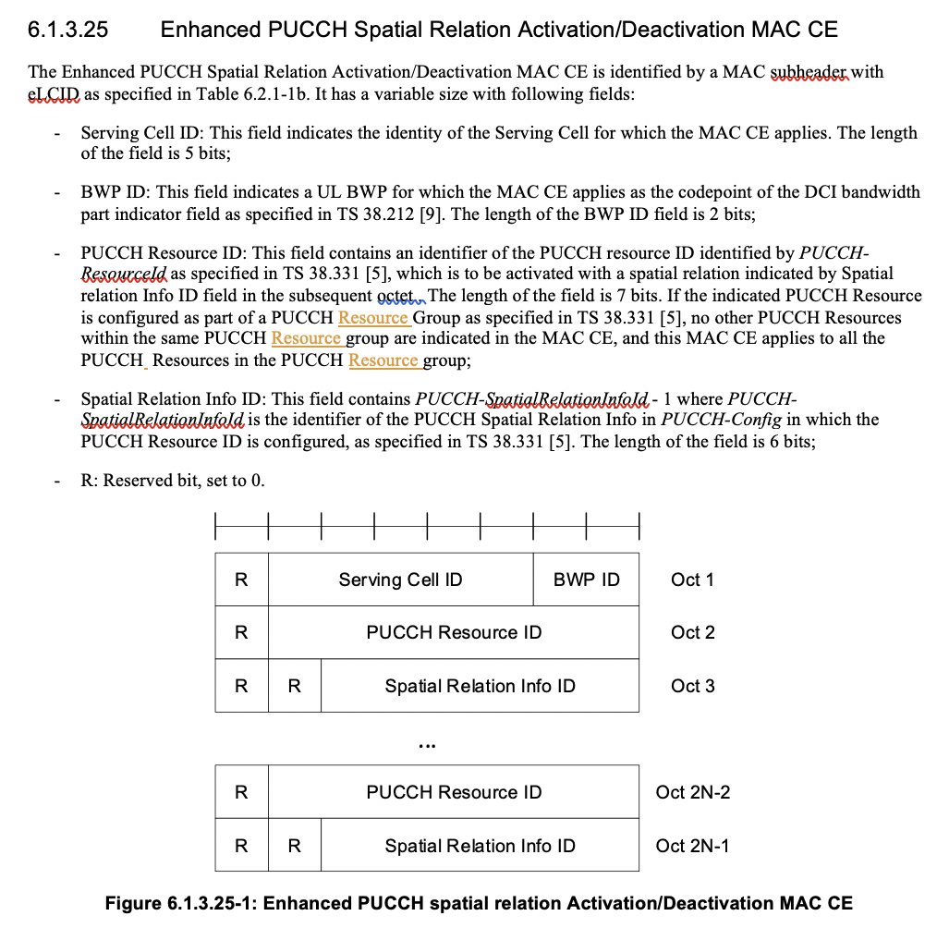

Q5: Do you agree with the change and the draft CR?
Company | Agree? (Yes or No) | Comments

Conclusions

