3GPP TSG-RAN WG2 Meeting #113-e R2-2102014

Electronic, Jan 25th – Feb 5th, 2021

Agenda Item: 8.10.3.1

Source: CMCC

Title: Summary of email discussion [AT113-e][104][NTN] TAC update (CMCC)

Document for: Discussion and Decision

# 1 Introduction

This document is for the following offline discussion, particularly for topics in 8.10.3.1:

* [AT113-e][104][NTN] TAC update (CMCC)

Scope: Discuss TAC update procedure, based on R2-2101607, R2-2100259, R2-2100742, R2-2100820, R2-2101406

Initial intended outcome: Summary of the offline discussion with e.g.:

§ List of proposals for agreement (if any)

§ List of proposals that require online discussions

Initial deadline (for companies' feedback): Monday 2021-02-01 11:00 UTC

Initial deadline (for rapporteur's summary in R2-2102014): Monday 2021-02-01 17:00 UTC

Proposals marked "for agreement" in R2-2102014 not challenged until Tuesday 2020-02-02 11:00 UTC will be declared as agreed by the session chair. For the rest the discussion will continue online.

To address this issue of frequent TAU procedure triggered by the satellite motion, the “fixed tracking area” concept is proposed and has been captured in TR 38.821 (section 7.3.1.3) [1], in which the tracking area code (TAC) is fixed on ground while the cells is sweeping on the ground. And it means that while the cells sweep on the ground, the tracking area code (i.e. TAC) broadcasted is changed when the cell arrives to the area of next planned earth fixed tracking area. Two approaches were discussed during the study item on how to effectively update the TACs that the cells/satellites are broadcasting they move across TAs, one is hard TAC update, another is soft TAC update, which is summarized in TR 38.821 [1] and previous email discussion [2] before RAN2#112 meeting:

**Hard TAI update** means that each cell can broadcast only on tracking area code. When this is combined with Earth fixed tracking area, it will create fluctuation at the border areas of these Earth fixed tracking areas, as depicted in Figure 1.

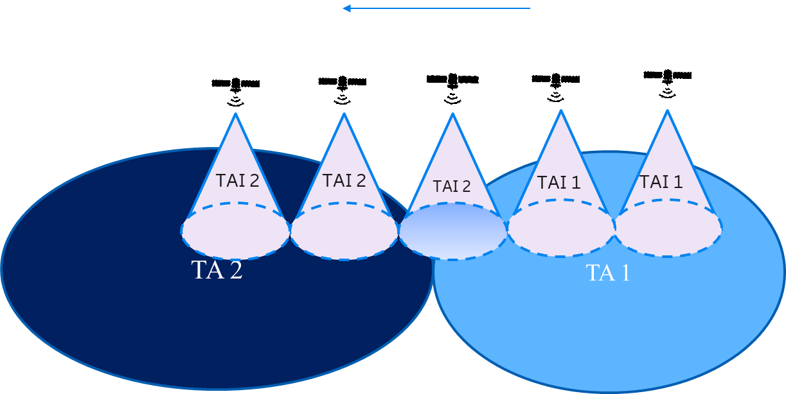

Figure 1 Tracking area update for Earth moving beams with hard TAI update

**Soft TAI update** requires the network to broadcast more than one TAI for a cell and PLMN. The cell adds the new TAC in its system information in addition to the old and removes the old a bit later. If there is a chain of TAs, the TA list adds one TA more and removes one old while the cell sweeps the ground. This also reduces the amount of TAUs for UEs that happen to be located at the border area, as depicted in Figure 2.

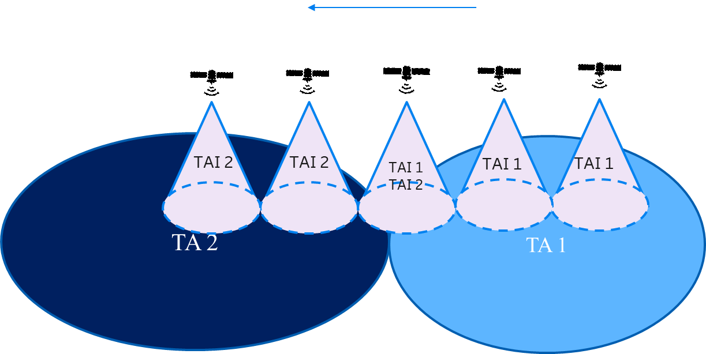

Figure 2 Tracking area update for Earth moving beams with soft TAI update

In [1][2][3][4][5][6][7], the pros and cons of the two approached are illustrated. In a summary, Soft TAI update solution can mitigate the increasing TAI update signaling with the problem of paging overhead, while the hard TAI update option has the problem of signaling overhead and boundary fluctuation, as shown in figure3. From another perspective, we could say that this issue mainly requires a compromise between paging load and signaling overhead actually.



Figure 3: TAC fluctuation at the border area

To progress the topic, this document provides questions with respect to the two approaches and companies are requested to provide their views on those.

# 2 Discussion

As mentioned in [1][2][3][4][5], although there is the concern about the increasing paging load resulting from a cell broadcasting multiple TAIs. However, the satellite/cell will remove the old TAC once the satellite/cell cover the most geography area corresponding to the new TAC after it adds the new TAC in its system information in addition to the old one. And considering the short duration for the transition stage of the satellite passing over the boundary area, the increasing paging signaling only occurs in a short period. On the other hand, as VDF mentioned, how the MNOs and Satellite service providers jointly arrive at a suitable and practical Tracking Areas to suit their networks’ needs is up to deployment and implementation, not a standards issue.

**Question 1: Do companies assumes that in soft TAI update approach, the multiple TACs only broadcasted just during the transition stage of the satellite passing over the boundary area, or up to deployment and implementation? This means the paging load caused by multiple TACs broadcasted in one cell is limited and is under controlled.**

|  |  |  |
| --- | --- | --- |
| **Company** | **Yes/No** | **Comment / alternative proposal** |
| Panasonic | No | There is always a satellite/cell passing through the boundary of TAs at any time, and hence there is always a satellite/cell broadcasting multiple TACs and having increased paging overheads. Therefore, the impact is always there that impacts different satellite/cell at different time. |
| Huawei, HiSilicon | Yes | It depends on NW implementation to decide the size of one TAC, and for one satellite multiple TACs are only broadcasted during the transition stage. |
| OPPO | No | Agree with Panasonic. For a certain satellite, multiple TACs’ broadcasting applies to each satellite/cell passing through the TA boundary. |
| MediaTek | Yes | While this is left to implementation, we assume that multiple TACs are only broadcasted just during the transition stage of the satellite passing over the boundary area. This will limit the paging load caused by multiple TACs. |
| Samsung | Yes/No- pl. see comment | Each NTN cell that covers multiple TAIs at an instant needs to broadcast TAIs that are relevant at that instant.  A huge problem with the soft TAI approach is that an NTN beam and a TA boundary cannot be matched in practice. Large beams and beam overlap will necessitate sudden and aperiodic changes in SI, significantly degrading the reliability of SIB detection at the UE. The gNB processing load would increase due to the need to frequently change the TAI related SIB content to reflect the TAIs covered by the cell. If the SIB is not changed to reflect the covered TAIs, a UE may be in the “TAI hole” (like a coverage hole), where no cell is covering the geographic area of such UE. |
| Lenovo | Yes | For earth-fixed cell the transition stage can be the time when the current cell of a satellite is geographically across the boundary area, and for earth-moving cell the transition stage can be the time when the edge of a satellite cell is crossing the boundary area. This can be appropriately controlled by network e.g. satellite can adjust its beam to avoid too large cell near or in the boundary area. |
| Spreadtrum | Yes | The broadcast of TAC is due to gNB implementation. If multiple TACs are broadcasted only when the satellite passes over the boundary area, the paging load will not increase obviously. However, the modification of TAC information in SIB will introduce additional paging to RAN. |
| ZTE | See comments | We understand that both earth fixed and moving cell scenario should be taken into consideration with the general principle that TA is fixed on earth.  Also it is worthwhile to highlight that a TA usually refers to an area with a lot of cells deployed.   * For Earth fixed cell, as shown below, we understand NW can broadcast the same TAC even after the new satellite takes in charge, in which case there would be no TAU due to satellite movement when UE does not move. And in this case, we do not see need for broadcasting more than one TAC as the paging overhead will be increased while the NTN cell has already been quite large in size.      * For earth moving cell, we are actually wondering what is the difference between soft TAU (i.e. broadcasting more than one TAC per PLMN in SIB1) and broadcasting a TAC covering a larger area. As shown below, the frequency of TAU would be quite similar for the “soft TAU” and the “larger TA deployment” and NW does not need to broadcast extra TAC in SIB1. |
| APT | Yes | Up to NW implementation. Otherwise, it increases non-necessary paging load. |
| Xiaomi | Yes | We think it can be used for earth moving beam scenario, for earth fixed beam scenario, there may be no boundary areas and only broadcasting one TAC is enough. |
| NEC | No | Each satellite temporarily passing through a boundary of TAs broadcasts both TAs entirely. As Panasonic mentioned, this temporary phase happens any time a satellite is at a boundary, which may be very frequent, therefore it cannot be regarded as temporary |
| InterDigital | Yes | Up to NW implementation, but like MTK assume that multiple TACs only broadcast at boundary to minimize paging load. |
| Qualcomm | It depends | It depends on network deployment how fixed TA is realized. The fixed TA may be smaller than resulting cell size in case the beam coverage is extended due to earth curvature and antenna angle. |
| BT | Yes | Up to network implementation for fixed and moving cells. |

**Regarding hard TAI update,** sinceonly one TAC per PLMN ID is broadcasted in SI, when gNB switches its TAC during satellite’s cell sweep on the ground, a stationary UE may need to perform TAU because of the different TAs at different timings, which results in signalling-intensive situation and increases the UE’s power consumption.

**Question 2: Do companies agree that hard TAI update will result in frequent TAU signalling overhead and increases the UE’s power consumption?**

|  |  |  |
| --- | --- | --- |
| **Company** | **Yes/No** | **Comment / alternative proposal** |
| Panasonic | Maybe | With some enhancements, such frequent TAU signaling overhead can be avoided even in the hard TAI update approach. For instance, the network can configure multiple TAs to the UE that is closed to the boundary of multiple TAs. Then this UE will not trigger TAI update even if the broadcasted TAC changes. For another instance, if we can prevent the satellite from performing paging (i.e., SI update procedure) due to the TAC update, such frequent TAU signaling overhead can be prevented as well. |
| Huawei, HiSilicon | Yes | For the UE on the TAC list edge, frequent TAU is inevitable. |
| OPPO | Yes | TAC update from network will lead to TAU signaling from lots of UEs. |
| MediaTek | Yes | If the UE is required to check Tracking Area changes, then there will be increase in TAU signalling load and UE’s power consumption. |
| Samsung | Yes |  |
| Lenovo | Yes | At least UE will experience frequency TAU. |
| Spreadtrum | Yes | If UE is located in the boundary area of TACs, the frequent TAU shall lead power consuming. |
| ZTE | See comments | * For Earth fixed cell, we understand NW can broadcast the same TAC even after the new satellite takes in charge, in which case there would be no TAU due to satellite movement when UE does not move. * For earth moving cell, as shown below, we are actually wondering what is the difference between soft TAU (i.e. broadcasting more than one TAC per PLMN in SIB1) and broadcasting a TAC covering a larger area. As shown below, the frequency of TAU would be quite similar for the “soft TAU” and the “larger TA deployment” and NW does not need to broadcast extra TAC in SIB1. |
| APT | Yes |  |
| Xiaomi | Yes |  |
| NEC | Yes, but | We agree that one of the main disadvantages of a hard TAI update will be those mentioned in this question. However, as explained in our TDoc [7] and as argued by Panasonic, configuring multiple TAs for UEs as part of a legacy Registration Area for boundary UEs would solve most TAU and battery consumption problems |
| InterDigital | Yes |  |
| Qualcomm | Yes | SI update procedure needs to be triggered once a cell updates its TAC as UEs need to be aware of the new TAC. SI update procedure will increase UE power consumption.  If a UE is not configured with (one or multiple) adjacent TAs, the UE will have to trigger registration updates frequently. If a UE is configured with multiple TAs to avoid frequent TAU, paging may be less efficient, though paging impact should be left to RAN3.  For the case extended radio cell coverage becoming than TA (see our answer to Q1), hard TAI update may not work. |
| BT | Maybe for moving beams.  No for fixed beams | For moving beams, seems that this is the case but not clear at this point on time a network optimization will mitigate this.  For fixed beams on Earth, one satellite/cell transmits a single TAC therefore, it’s never modified for the UE. |

In section 1, the pros and cons of the two approaches illustrated in [1][2][3][4][5][6][7] was summarized. Based on the comparison, companies are invited to answer this Question:

**Question 3: Do companies have a preference on supporting either hard or soft TAI update, or both?**

|  |  |  |
| --- | --- | --- |
| **Company** | **Yes/No** | **Comment / alternative proposal** |
| Panasonic | Both | We think both hard and soft TAI update approaches should be supported. More specifically. Hard TAI update is just the special case (i.e., subset) of the soft TAI update. |
| Huawei, HiSilicon | Yes | We prefer soft TAC update. |
| OPPO |  | We prefer soft TAC update. |
| MediaTek | Yes | Soft update is preferred |
| Samsung | New Proposal: Hybrid Hard and Soft TAI Update (“Virtual Tracking Area” Approach) | In our view, both the soft TAI update and the hard TAI update are challenging to implement in practice. We suggest combining the soft TAI approach and hard TAI approach to implement Earth-fixed Tracking Areas called Virtual Tracking Areas (VTAs). The proposed VTA approach transmits only one TAI in a cell like the hard TAI approach. Furthermore, the UE processes multiple TAIs to determine whether to perform a registration update or note like the soft TAI approach. We have summarized the key concept below. More details can be found in Section 2.3 of R2-2008915.  A VTA corresponds to an Earth-fixed Tracking Area. In the VTA approach, the gNB transmits a single TAI in a cell like R16 and this TAI does not change from one instant to another in the cell. The UE and the AMF are aware of the mapping between the VTA and TAIs in different time windows. Predictable platform movements (e.g., movement of LEO satellites) can be used to easily determine such mapping. The AMF registers the UE in a Virtual Registration Area (VRA) that consists of VTAs. The VRA is equivalent to the R16 TAI List. The UE compares the TAI broadcast in SIB1 with the applicable set of TAIs associated with the VRA at the current instant. The UE does not send a Registration Request (Update) to the AMF as long as the TAI broadcast in SIB1 is in the VRA.  We further observe that paging in multiple cells and beams would likely be required in any approach in case of Earth-moving cells and quasi-Earth-fixed cells, because the AMF would likely create a TAI list containing multiple TAIs due to cell overlap and cell mobility for low-delay and reliable paging. The AMF can use the location reported by the UE location to reduce the size of the TAI List. The good news is that the paging capacity is not a concern according to TR38.821. |
| Lenovo | Yes | We prefer soft TAC update. |
| Spreadtrum | Yes | Soft update is preferred.  The paging indication may be enhanced when the TAI update happens. |
| ZTE | / | As commented under Q1 and Q2, we are wondering what is the difference between soft TAU (i.e. broadcasting more than one TAC per PLMN in SIB1) and broadcasting a TAC covering a larger area.  The frequency of TAU would be quite similar for the “soft TAU” and the “larger TA deployment” and NW does not need to broadcast extra TAC in SIB1. And the drawback for both “soft TAU” and the “larger TA deployment” is the increased paging overhead.  Further enhancement, e.g. UE determine the current TA based on its own location and trigger TAU should be considered to address these drawbacks:   * Increased paging overhead. * Unnecessary TAU caused by satellite movement when UE does not move. |
| APT | Yes | Soft TAC update |
| Xiaomi | Yes | We prefer soft TAC update, but we think even if soft TAC is introduced, the network also can broadcast only one TAC based on network implementation. |
| NEC | Yes | We prefer hard TAI update |
| InterDigital | Yes | Prefer soft TAC update |
| Qualcomm | Yes | We prefer soft TAI update if SA2/CT has no concern. We also agree with Panasonic that supporting soft TAI update will allow hard TAI update as a special case. |
| BT | Both  Soft TAI update for moving beams.  Not sure for fix beams. | It is not clear that for fixed beams two TAC needs to be broadcasted. |

Additionally, in NTN, to avoid having TAU performed frequently by the UE triggered by the satellite motion, as indicated in TR 38.821, the tracking area may be designed to be fixed on ground. As mentioned in [1][3][6], a relative issue is how does the UE determine the TA it is currently located, which can be categorized into two groups:

1. **current TA is determined based on the broadcasted radio coverage,**
2. **current TA is determined based on UE’s geographical location and satellite’s ephemeris’ information.**

**Question 4: which option is companies’ preference, option 1 or option 2?**

|  |  |  |
| --- | --- | --- |
| **Company** | **Yes/No** | **Comment / alternative proposal** |
| Panasonic | Option 1 | As mentioned in our paper R2-2100820, option 1 should be the baseline and option 2 can be considered later if time allows. |
| Huawei, HiSilicon | Partially option 1 | UE can determine the TA based on UE location and the broadcasted radio coverage.  For option 2, we don’t know how satellite ephemeris maps to geographical area. |
| OPPO | Option 1 | Option 1 is the existing approach, in our understanding. |
| MediaTek | Option 1 | This is aligned with TN behavior. |
| Samsung | None | Option 1 Challenge: The radio coverage overlap among neighboring cells and continuously changing cell coverage in Earth-moving beams make it difficult to reliably define the TAI coverage (“broadcast radio coverage”). The TAIs would not usually match with the elliptical beams. When the same beam covers multiple TAIs in the soft TAI approach, the UEs would not know the exact TAI it is in.  Option 2 Challenge: The UE’s location and satellite ephemeris are inadequate to determine the TAI. |
| Lenovo | Option 1 | Option 1 is legacy and baseline aligning with that in TN. Option 2 can be for further enhancement if necessary. |
| Spreadtrum | Option 1 | Option 1 is simple.  For option2, the mapping between geographical location and TA shall be preconfigured to UE. This pre-configuration information is complex, and difficult to update. |
| ZTE | Option 2 | As commented under Q1 and Q2, we are wondering what is the difference between soft TAU (i.e. broadcasting more than one TAC per PLMN in SIB1) and broadcasting a TAC covering a larger area.  The frequency of TAU would be quite similar for the “soft TAU” and the “larger TA deployment” and NW does not need to broadcast extra TAC in SIB1. And the drawback for both “soft TAU” and the “larger TA deployment” is the increased paging overhead.  Further enhancement, e.g. UE determine the current TA based on its own location and trigger TAU should be considered to address these drawbacks:   * Increased paging overhead. * Unnecessary TAU caused by satellite movement when UE does not move. |
| APT | Opton1 | Support legacy. |
| Xiaomi | Option 1 | Option 1 is the existing solution and is simple. |
| NEC | Option 1 | We prefer the existing approach |
| InterDigital | Option 1 | Support legacy |
| Qualcomm | Option 1 | With soft TAI update, we think the UE can determine to be in one of the TAs broadcast by the cell. We do not think the UE needs to know TA boundary. The implications of this to mobility support by the 5GCN (e.g. Registration) can be considered by SA2 and CT1 which is why we suggest an LS to get feedback. |
| BT | None | Agree with Samsung. |

As mentioned in [3][6], in the soft TAI update scheme, it is beneficial to allow gNB to not trigger the SI update when the list of broadcast TACs changed, since it is not necessary for the UE staying in the same cell to know whether a new TAC is added or an existing TAC is deleted from the TAC list due to the satellite movement. UE will have to check the TAC list only when it just enters into a new cell. Moreover, if the option 2 in question 4 is adopted, it is straightforward that there is no necessity of SI update due to satellite motion.

**Question 5: do companies agree that such kind of TAC change in SI caused by satellite motion will not trigger paging for system information change?**

|  |  |  |
| --- | --- | --- |
| **Company** | **Yes/No** | **Comment / alternative proposal** |
| Panasonic | Yes | This is to avoid consuming UE’s power in acquiring SI due to the TAC change caused by the satellite motion, which might in turn consume more UE’s power in performing the TAU procedure. |
| Huawei, HiSilicon | Yes | Paging for system information change is not needed, as for one specific UE the key SI information is unchanged. |
| OPPO | Yes |  |
| MediaTek | Yes |  |
| Samsung | Yes | The TAC change in SI due to the platform’s movement should not trigger paging for SI change. |
| Lenovo | Yes |  |
| Spreadtrum | Yes | This paging shall not be triggered. |
| ZTE | / | * We would like to understand the difference between “soft TAU” and the “larger TA deployment” as well as the benefits of “soft TAI” first. * If soft TAI update is supported, NW has to update the broadcast TAC and UE should also be aware of the change to trigger TAU appropriately so that NW is aware of the latest RA of the UE and knows where to page UE. |
| APT | Yes | Good feature. |
| Xiaomi | Yes |  |
| NEC | Yes | The standard should take into account this specifity of NTN to preserve UE battery |
| InterDigital | Yes |  |
| Qualcomm | Yes if TA deletion times are provided | If a new TAC is added to the TACs broadcast by a cell, no paging is needed for SI change.  But if an existing TAC is deleted and if no other information is provided, paging is needed because some UEs may have to perform a TAU (if none of the remaining broadcast TACs are part of their registration areas).  To avoid paging when an existing TAC is deleted, a time indication can be broadcast for each TAC to indicate when that TAC will be deleted. This time can be known by a gNB in advance from cell and/or satellite OAM information. A UE which accesses a cell for the first time can then know at what time the cell will no longer support any of the TACs in the UE registration area. The UE can then plan ahead to change cell or look at the new set of TACs for the current cell at that time. |
| BT | Yes | It’s important to avoid to trigger a paging in this situation |

In [5], the paper have pointed out that soft TAC update procedure has some NAS impact. For example, AS reports multiple TACs per PLMN to NAS for cell selection and NAS has to determine whether to trigger registration update based on reported multiple TACs per PLMN (unlike today where only one reported TAC per PLMN is used). The RAN can determine and report one TAC for a UE in the NG ULI as for TN.

Question 6: Do compaines agree that the soft TAC update has NAS impact and LS to CT1 and SA2 asking for any concern on soft TAC update mechanism is needed.

|  |  |  |
| --- | --- | --- |
| **Company** | **Yes/No** | **Comment / alternative proposal** |
| Panasonic | Yes | There could be NAS impact but it is not difficult to resolve. For instance, it can be further specified that once the registered TAC is still within the list of TACs reported from RRC, UE will not trigger the registration update. |
| Huawei, HiSilicon | No | UE can determine which TA it belongs to, as mentioned in Q4. Then as legacy only one TA is reported to NAS. In this way no LS is needed. |
| OPPO | Yes | We are ok to send LS to CT1/SA2. |
| MediaTek | Yes | During registration procedure the NAS should select one of the several broadcasted TACs for the UE. While this is left to implementation, it would make sense for the network to choose the TAC that the satellite is moving into. This is because a UE that has reselected to the new cell and performing the registration procedure is located at the leading edge of the cell. We are open to send an LS to SA2 for this. |
| Samsung | Pl. see “Comment” | It is premature to send an LS to other groups at this time. We request that RAN2 consider hard TAI approach, soft TAI approach, the VTA approach, and any other candidate solutions brought to RAN2’s attention to endure Earth-fixed Tracking Areas. Once we have settled on a specific approach, we can determine what LSs (if any) need to be sent to other groups. |
| Lenovo | Neutral | For now we see no severe issues. We can send an LS to inform CT1/SA2 after decision for TAC update is made, so they may see if there is NAS impact. |
| Spreadtrum | Yes | Based on the UE’s TA information, AMF determines the gNB list to trigger paging, so, if TAC information of gNB is updated, AMF shall be indicated as soon as possible. |
| ZTE | Yes, of course. | The condition to trigger TAU and related UE behavior has always been discussed and decided in SA2 and CT1and specified in their specs afterwards.  All RAN2 has done in R15 and R16 is to broadcast the TAC and ask UE AS layer to forward the received TAC to NAS layer. |
| APT | Yes | Support an LS after soft TAC update has been agreed. |
| Xiaomi | Yes | There may be the case that only part of TAC broadcasted by network is in the UE’s TAI list, this case should be discussed. |
| NEC | Yes | We are fine with sending an LS to CT1/SA2 |
| InterDigital | Yes | Okay to send LS to CT1/SA2 |
| Qualcomm | Yes | The potential NAS impact arises if a UE is not always aware of its TA since, in that case, a UE could enter a TA not in the UE registration area but not be aware. So it seems better to let SA2 and CT1 consider this and provide feedback. |
| BT | Yes | It’s better to inform CT1/SA2 |

# **3 Conclusion**

TBD

# 4 References

1. R2-2001627 Impact of CG/SPS with periodicities non dividing HF length Sequans Communications3GPP TR 38.821 Solutions for NR to support non-terrestrial networks (NTN), version 16.0.0
2. R2-209820, [POST111e][910][NTN] Impacts of earth fixed and moving beams (Ericsson)
3. R2-2101607 Considerations on Soft TAI Update CMCC discussion Rel-17
4. R2-2100259 Improving Tracking Area Updates in NR-NTN MediaTek Inc. discussion
5. R2-2100742 TAC update procedure Qualcomm Incorporated discussion Rel-17
6. R2-2100820 Fixed Tracking Area and the Tracking Area Code in NTN PANASONIC R&D Center Germany discussion R2-2009120
7. R2-2101406 TAI update for earth moving cell NEC Telecom MODUS Ltd. discussion

# **6 Proposals in summary contribution**