3GPP TSG-RAN WG2 #113e Tdoc DocNumber

Electronic meeting, 2021-01-25 - 2021-02-05

Agenda Item: 6.16

Source: Ericsson

Title: Summary of [AT113-e][029][TEI16] Miscellaneous II (Ericsson)

Document for: Discussion

# 1 Introduction

This is the summary of the following email discussion:

* [AT113-e][029][TEI16] Miscellaneous II (Ericsson)

Scope: R2-2100560, R2-2100561, R2-2100562, R2-2100484, R2-2101288, R2-2101243, R2-2101734

Phase 1: determine agreeable parts, Phase 2: for agreeable parts Work on CRs.

Intended outcome: Report and Agreed CRs if any agreeable.

Deadline: Schedule A

Please take note of the following deadlines (i.e. Schedule A):

Deadline for Phase 1: **Thursday Jan 28 12:00 UTC**

Deadline for Phase 2: **Thursday Feb 4 12:00 UTC**

# 2 Contact Information

|  |  |
| --- | --- |
| Company | Email |
| Ericsson | oscar.ohlsson@ericsson.com |
| Lenovo | hchoi5@lenovo.com |
| ZTE | liu.jing30@zte.com.cn |
| Apple | zhibin_wu@apple.com |

# 3 Discussion

## 3.1 Voice Fallback Indication

Voice Fallback Indication – Postponed from last meeting

[R2-2100560](https://www.3gpp.org/ftp/tsg_ran/WG2_RL2//TSGR2_113-e/Docs/R2-2100560.zip) Further discuss the usage of voiceFallbackIndication for Emergency Service Fallback ZTE Corporation, Sanechips discussion Rel-16 TEI16

[R2-2100561](https://www.3gpp.org/ftp/tsg_ran/WG2_RL2//TSGR2_113-e/Docs/R2-2100561.zip) CR to clarify the usage of voiceFallbackIndication for Emergency Services Fallback ZTE Corporation, Sanechips CR Rel-16 38.331 16.3.1 2048 1 F TEI16 R2-2009241

[R2-2100562](https://www.3gpp.org/ftp/tsg_ran/WG2_RL2//TSGR2_113-e/Docs/R2-2100562.zip) CR to introduce new capability for Emergency Services Fallback ZTE Corporation, Sanechips CR Rel-16 38.306 16.3.0 0492 - F TEI16

[R2-2100484](https://www.3gpp.org/ftp/tsg_ran/WG2_RL2//TSGR2_113-e/Docs/R2-2100484.zip) Clarify the usage of voiceFallbackIndication for emergency service Ericsson discussion Rel-16 TEI16

There are two ways to support emergency calls when IMS voice is not supported in 5GS:

* EPS fallback for IMS voice: The gNB redirects or handovers the UE to EPS when receiving QoS flow setup request from CN. And this may be triggered also for emergency QoS flow.
* Emergency service fallback: When the UE wants to initiate an emergency call it sends an emergency services fallback request to 5GC which in turn notifies NG-RAN which will redirect or handover the UE to EPS.

As can be seen, a main difference between the two approaches is that EPS fallback for IMS voice is network triggered while Emergency services fallback is UE triggered.

During RAN2#112 it was discussed whether the *voiceFallbackIndication* should be included in the redirect or handover message also for Emergency services fallback. In the redirect case the UE needs to set the establishment cause to “emergency” in the subsequent connection setup and it was concluded that this can be done without the indication since the UE is aware of the ongoing emergency call. Hence the *voiceFallbackIndication* is not included in the redirect message for Emergency services fallback. For the handover case the UE should prioritize E-UTRA cells in case the handover fails and there were different views whether the indication is needed for this purpose:

* [029] Regarding how to support “first attempt E-UTRAN cell upon HO failure” in case of emergency service fallback, postpone the discussion to next meeting. Following options can be considered:

Opt 1: leave it to UE implemetation;

Opt 2: reuse voiceFallbackIndication-r16 sent by network (FFS on new capability).

Basically [R2-2100484](https://www.3gpp.org/ftp/tsg_ran/WG2_RL2//TSGR2_113-e/Docs/R2-2100484.zip) argues for the first option while [R2-2100560](https://www.3gpp.org/ftp/tsg_ran/WG2_RL2//TSGR2_113-e/Docs/R2-2100560.zip) argues for the second option.

**Issue 1:** Which option do you prefer?

|  |  |  |
| --- | --- | --- |
| **Company** | **Which option?** | **Comments** |
| Ericsson | Option 1 | The UE is aware of the ongoing emergency call and knows that it should prioritize E-UTRA cells in case the handover fails. Therefore, no indication is needed. This is also consistent with the agreement made for the redirect case. If needed, we can capture that the UE should prioritize E-UTRA cells in a requirement or informative note in the handover failure section in the RRC specification. |
| Lenovo | Option 1 | Referring to TS 23.502 we understand that it’s up to NW to include the voiceFallbackIndication in the redirect or handover message for Emergency services fallback depending on UE capability. However, from UE perspective this indication does not matter and we can leave it to UE implementation to prioritize E-UTRA cells when handover failure happens. We are fine with an informative note in RRC to capture this case. |
| ZTE | Option 2, Option 1 is acceptable | As long as all UE vendors confirm Option 1 is feasible and already be supported by UE implementation, we are fine to go for it.  Otherwise, we would prefer to do the same as for “EPS fallback for IMS service” case (Option 2 with new capability). |
| Apple | Optino 1 | We support to left this to UE implementation. |
|  |  |  |
|  |  |  |
|  |  |  |
|  |  |  |
|  |  |  |
|  |  |  |

## 3.2 HO to EN-DC

[R2-2101288](https://www.3gpp.org/ftp/tsg_ran/WG2_RL2//TSGR2_113-e/Docs/R2-2101288.zip) Complete message at handover NR to EN-DC Ericsson CR Rel-16 38.331 16.3.1 2401 - F TEI16

Reason for change:

CR 1948r1 ([R2-2008509](https://www.3gpp.org/ftp/TSG_RAN/WG2_RL2/TSGR2_111-e/Docs/R2-2008509.zip)) introduced missing procedure text for the transmission of RRCReconfigurationComplete for case of HO from NR to EN-DC.

But the procedure text was introduced at a position for the case “UE in EN-DC”. This makes the existing procedure text confusing. At HO from NR to EN-DC, UE will not be in EN-DC until after the procedure is completed. Further, existing procedure text gives the impression that conditional reconfiguration is applicable for handover NR to EN-DC. This is not true.

**Issue 2a:** Do companies agree with the reason for change?

|  |  |  |
| --- | --- | --- |
| **Company** | **Yes/No** | **Comments (e.g. other comments on the cover page)** |
| Ericsson | Yes |  |
| ZTE | See comments | In our understanding, the UE generates RRCReconfigruationComplete message only after applying the RRCReconfiguration message. So at that moment, the UE is already in EN-DC.  We think the below paragraph also applies to the case when EN-DC is setup (e.g. SN addition), so that is why we use “was” in the sentences, right?  1> if the UE is configured with E-UTRA *nr-SecondaryCellGroupConfig* (UE in (NG)EN-DC):  2> if the *RRCReconfiguration* message was received via E-UTRA SRB1 as specified in TS 36.331 [10]; |
| Apple | Yes |  |
|  |  |  |
|  |  |  |
|  |  |  |
|  |  |  |
|  |  |  |
|  |  |  |
|  |  |  |

**Issue 2b:** Do companies agree with the proposed correction in sections 5.3.5.3 in 38.331?

|  |  |  |
| --- | --- | --- |
| **Company** | **Yes/No** | **Comments** |
| Ericsson | Yes |  |
| ZTE | No | See comments to Q2a. |
| Apple | Yes |  |
|  |  |  |
|  |  |  |
|  |  |  |
|  |  |  |
|  |  |  |
|  |  |  |
|  |  |  |

## 3.3 Aperiodic CSI with secondary DRX

[R2-2101243](https://www.3gpp.org/ftp/tsg_ran/WG2_RL2//TSGR2_113-e/Docs/R2-2101243.zip) Consideration on aperiodic CSI with secondary DRX CATT discussion Rel-16

[R2-2101734](https://www.3gpp.org/ftp/tsg_ran/WG2_RL2//TSGR2_113-e/Docs/R2-2101734.zip) Secondary DRX and aperiodic CSI Ericsson discussion Rel-16 TEI16 R2-2009948

This topic was discussed during RAN2#112-e in offline #028 ([R2-2011214](https://www.3gpp.org/ftp/tsg_ran/WG2_RL2//TSGR2_112-e/Docs/R2-2011214.zip)), where it was discussed, but not concluded:

1. There is power consumption impact
2. There is RAN1 impact to support aperiodic CSI with secondary DRX
3. Aperiodic CSI is cross carrier scheduling which is not supported with secondary DRX
4. Aperiodic CSI with secondary DRX is an enhancement

These topics are again discussed in both [R2-2101243](https://www.3gpp.org/ftp/tsg_ran/WG2_RL2//TSGR2_113-e/Docs/R2-2101243.zip) and [R2-2101734](https://www.3gpp.org/ftp/tsg_ran/WG2_RL2//TSGR2_113-e/Docs/R2-2101734.zip).

During offline #028 there was some confusion how aperiodic CSI with secondary DRX would work, which is clarified in [R2-2101734](https://www.3gpp.org/ftp/tsg_ran/WG2_RL2//TSGR2_113-e/Docs/R2-2101734.zip):

* There is no change to the CSI measurement requirements, i.e. the UE is only required to measure during Active Time.
* The UE reports the latest measurement on FR2, when CSI is triggered on FR1 for FR2, and FR2 is outside Active Time.
* The aperiodic CSI trigger and CSI report on PUSH are configured on the same carrier, i.e. not on different carriers/FRs.

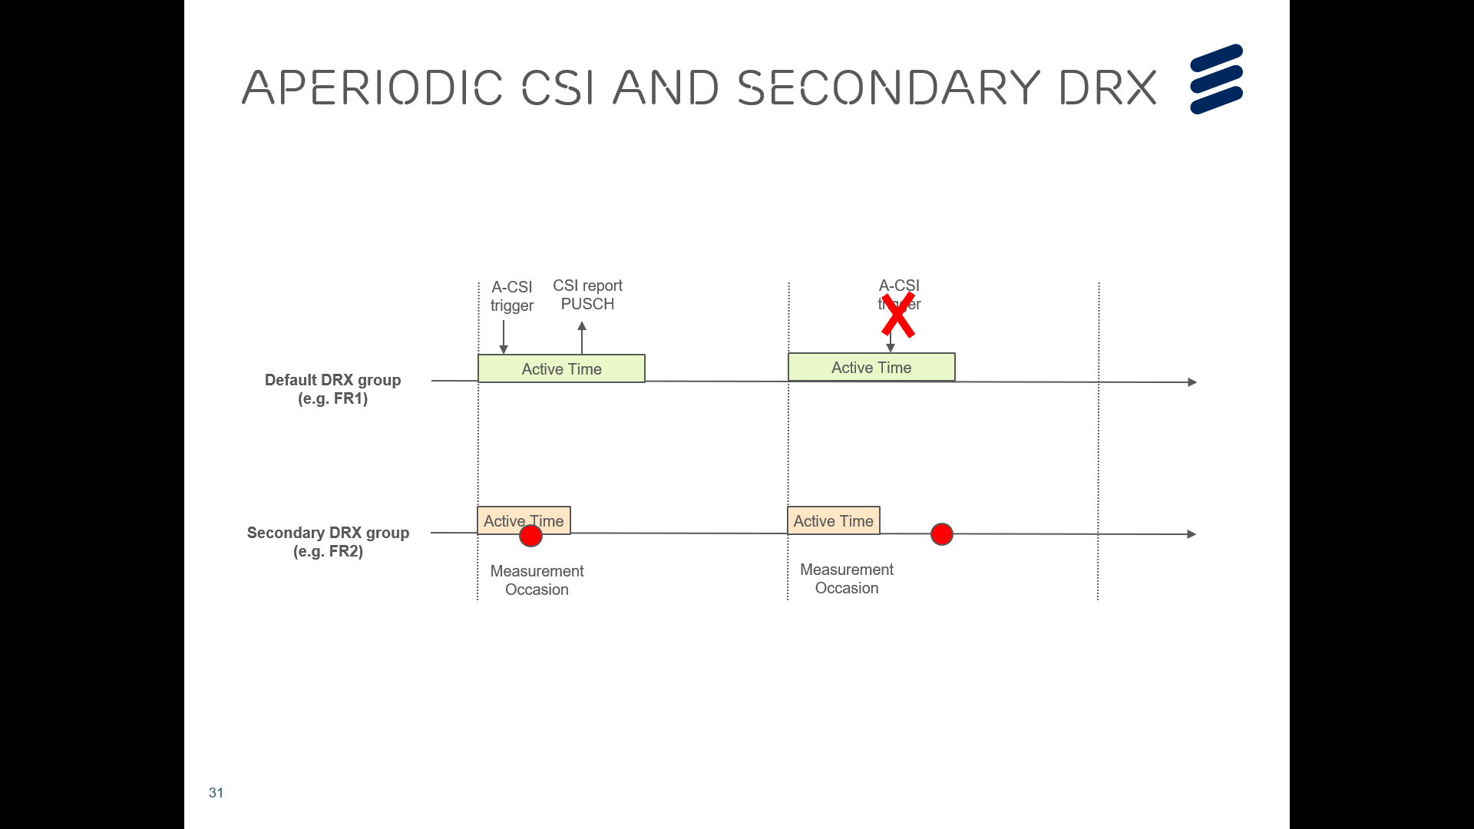

**Issue 3a:** Do companies think there is power consumption impact to support aperiodic CSI with secondary DRX?

|  |  |  |
| --- | --- | --- |
| **Company** | **Yes/No** | **Comments (e.g. other comments on the cover page)** |
| Ericsson | No | The UE is not required to measure outside Active Time, and the UE reports the latest measurement on FR2 when FR2 is outside Active Time. |
| Apple | Yes | For the proposal to let UE report the latest measurement on FR2, when CSI is triggered on FR1 for FR2, and FR2 is outside Active Time, we think there still power consumption impact. UE reporting CSI in FR1, but there is no active traffic in FR2 carrier. The CSI reporting itself wastes UE power. |
|  |  |  |
|  |  |  |
|  |  |  |
|  |  |  |
|  |  |  |
|  |  |  |
|  |  |  |
|  |  |  |

**Issue 3b:** Do companies think there is RAN1 impact to support aperiodic CSI with secondary DRX?

|  |  |  |
| --- | --- | --- |
| **Company** | **Yes/No** | **Comments (e.g. other comments on the cover page)** |
| Ericsson | No | Aperiodic CSI and cross slot scheduling are two different features, i.e. CSI trigger is not a scheduling DCI. Furthermore the aperiodic CSI trigger and CSI report on PUSH are on the same carrier. |
| Apple | Yes | Need to check RAN1 |
|  |  |  |
|  |  |  |
|  |  |  |
|  |  |  |
|  |  |  |
|  |  |  |
|  |  |  |
|  |  |  |

**Issue 3c:** Do companies think that aperiodic CSI is cross carrier scheduling?

|  |  |  |
| --- | --- | --- |
| **Company** | **Yes/No** | **Comments (e.g. other comments on the cover page)** |
| Ericsson | No | RAN1 introduced aperiodic CSI across different SCS in REL-16, i.e. there is no further RAN1 impact |
| Apple | Yes | This is similar to cross-carrier scheduling. |
|  |  |  |
|  |  |  |
|  |  |  |
|  |  |  |
|  |  |  |
|  |  |  |
|  |  |  |
|  |  |  |

**Issue 3d:** Do companies think that aperiodic CSI with secondary DRX is an enhancement?

|  |  |  |
| --- | --- | --- |
| **Company** | **Yes/No** | **Comments (e.g. other comments on the cover page)** |
| Ericsson | No | Similar as periodic CSI and secondary DRX it is not an optimization |
| Apple | Yes | Compared with the baseline cross-carrier CSI reporting, this is an optimization, |
|  |  |  |
|  |  |  |
|  |  |  |
|  |  |  |
|  |  |  |
|  |  |  |
|  |  |  |
|  |  |  |

**Issue 3e:** Clarify in 38.331 that the aperiodic CSI trigger and CSI report on PUSCH on the same carrier is supported when secondary DRX is configured?

|  |  |  |
| --- | --- | --- |
| **Company** | **Yes/No** | **Comments** |
| Ericsson | Yes | Based on CR discussed in RAN2#112-e ([R2-2009948](https://www.3gpp.org/ftp/tsg_ran/WG2_RL2//TSGR2_112-e/Docs/R2-2009948.zip)) the following draft text is provided for information:  ***schedulingCellId***  Indicates which cell signals the downlink allocations and uplink grants, if applicable, for the concerned SCell. In case the UE is configured with DC, the scheduling cell is part of the same cell group (i.e. MCG or SCG) as the scheduled cell. If *drx-ConfigSecondaryGroup* is configured in the *MAC-CellGroupConfig* associated with this serving cell, the scheduling cell and the scheduled cell belong to the same Frequency Range. If *drx-ConfigSecondaryGroup* is configured in the *MAC-CellGroupConfig* associated with this serving cell, the serving cell with the aperiodic CSI trigger and PUSCH configured for reporting on the same carrier, the cell for which CSI is reported may belong to the same or different Frequency Range. |
| Apple | No | As we do not support to cross-carrier CSI reporting when 2nd DRX is configured. in the TP provided by Ericsson, we should also restrict the measured cells to be in the same DRX group |
|  |  |  |
|  |  |  |
|  |  |  |
|  |  |  |
|  |  |  |
|  |  |  |
|  |  |  |
|  |  |  |

# Conclusion

TBA

# References