**3GPP TSG RAN WG2#112-e R2-2010xxx**

**, Nov 2-13, 2020**

**Title:** LS on service link switch for Earth fixed beams LEO NTN

**Response to: -**

**Release:** Release 17

**Work Item:** NR_eMIMO-Core

**Source:** Ericsson (to be RAN WG2)

**To:** RAN WG1

**Contact Person:**

**Name:** Helka-Liina Määttänen

**E-mail Address:** Helka-liina.maattanen@ericsson.com

**Attachments:** None

# Overall Description:

RAN2 has discussed the service link switch for Earth fixed beams LEO NTN as shown in Figure 1. Due to the movement of the non-GEO satellites in relation to the surface of the earth, at some point in time one satellite leaves and is not able to serve a certain geographical area.

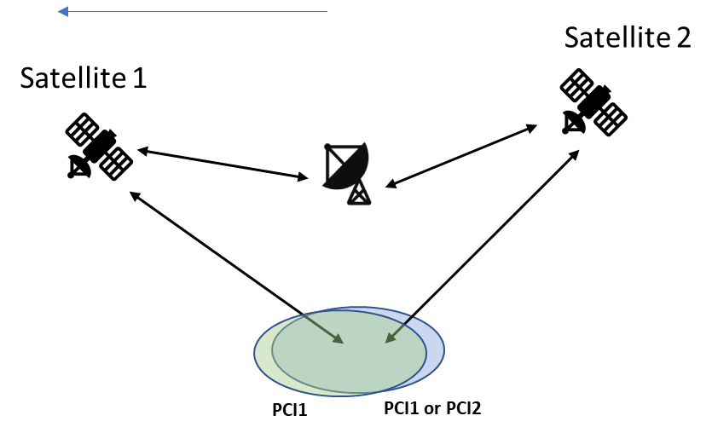

Figure 1 Service link switch for Earth fixed beams

It is possible to consider that the PCI via satellite 1 and satellite 2 can be the same or different, and that these SSBs may be on same or different sync raster points. If the SSBs are on different sync raster point, the mobility during the service link switch is L3 mobility from RAN2 perspective regardless whether the PCI is same or different. If these SSBs are on the same sync raster point and PCI are different, the switch is again L3 mobility. RAN2 has concluded that at least these scenarios should be supported and RAN2 is working further for the RAN2 solutions.

However, if these SSBs have same PCI and are on the same sync raster point, the switch can be L1 switch if this option proves viable. However, this would require that the gNB would either repeat the SSB beams(1 to L_max) of the SSB burst via satellite 1 and satellite 2, or use only part of SSB beams(1 to K) via satellite 1 and part(K+1 to L_max) via satellite 2. Whether this is feasible in practice would require RAN1 expertice as the delay difference between the feeder+service link for satellite 1 and 2 may cause difficulties for the UE to receive all the 1-L_max SSB beams in their corresponding nominal locations with respect to time and delay.

**Question:** Is it feasible to support the same SSBset (cell/PCI) simultaneously via two different satellites?

# Actions to RAN WG2

RAN2 respectfully ask RAN1 to take provide input

# Date of next TSG-RAN WG2 meetings:

TSG-RAN WG2 Meeting#113 Q1 2021