3GPP TSG-RAN WG2 Meeting #112-e R2-200xxxx
Online, November 2 - 13, 2020

Agenda Item: 5.3.3
Source: Apple
Title: Report of [AT112-e][004][NR15] PDCP (Apple)
Document for: Discussion and Decision

1 Introduction
This is to report the result of the following email discussion in RAN2#112-e Meeting [1].
- [AT112-e][004][NR15] PDCP (Apple)
Treat R2-2009481, R2-2010559. R2-2010560, R2-2010667, R2-2010668
Intended outcome: Intermediate: Determine agreeable parts. Final: For agreeable parts, agreed CRs.
Deadline: Intermediate deadline(s) by Rapporteur, Final: Discussion stop at Wed Nov 11, 1200 UTC

2 Contact Information
Company | Contact: Name (E-mail)
Apple | Fangli XU (fangli_xu@apple.com)
MediaTek | Ming-Yuan Cheng (ming-yuan.cheng@mediatek.com)
OPPO | Qianxi Lu (qianxi.lu@oppo.com)

3 Discussion

3.1 NW configuration on PDCP recovery
R2-2009481 NW configuration on PDCP recovery Apple discussion Rel-15 NR_newRAT-Core

According to R2-2009481, the problematic scenario and NW implementation for the clarification is:
For the uplink split DRB, network may select the primary leg based on the radio quality in uplink direction, and decides to keep or delete the SCG link based on the radio link quality in downlink direction.
Based on such network implementation, the following procedure in Figure-1 may happen:
- NW configures the UE in MR-DC and uplink split DRB with primary path = SCG leg;
- NW detects the UE’s SCG uplink is in poor radio quality, and keeps the SCG link but triggers the primary path switch of the split DRB from SCG to MCG via the normal RRCReconfiguration;
Upon the primary leg switching, UE will transmit the new PDCP PDUs to NW via the new primary path (MCG). But for the PDCP PDUs (e.g. the PDCP PDU with SN=3) which have been transmitted via the SCG link but not acknowledged, the RLC retransmission continues on the SCG link.
- Upon the RLC retransmission number reaching the max number, UE detects the RLC failure and trigger the SCG failure recovery, and NW may trigger the RRCReconfiguration to delete the SCG and reconfigure the split DRB to MCG DRB.
Upon the bearer type change, UE will trigger the PDCP recovery procedure, and retransmit the PDCP PDU which did not transmit successfully via the SCG link (e.g. the PDCP PDU with the SN=3) to the NW via the MCG.
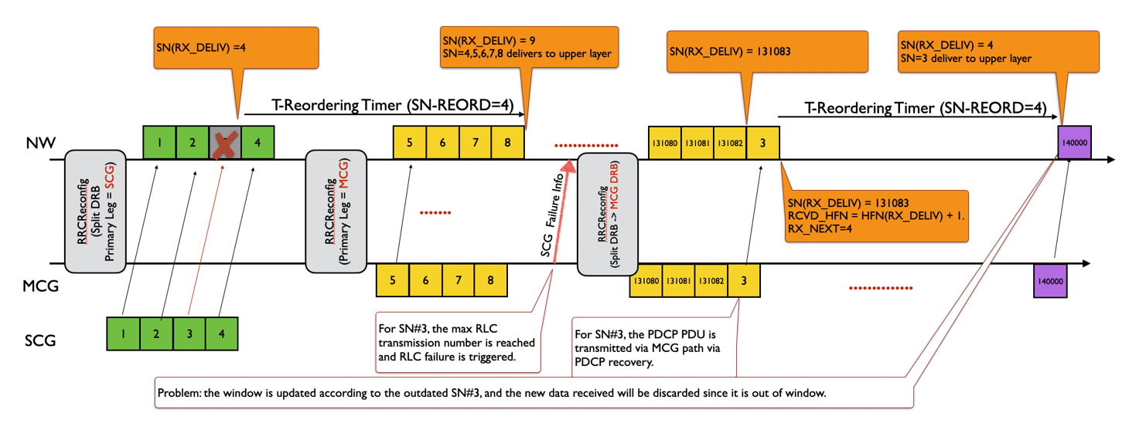
Figure-1. The problem triggered by the late PDCP recovery
As described in Figure-1, since the SCG failure recovery is triggered long time later after the primary leg switching (it’s dependent on the configured RLC retransmission number), there may be huge numbers of PDCP PDUs delivered to NW via MCG link successfully during this period, and the late PDCP recovery may trigger the outdated PDCP PDU (e.g. SN=3) to NW and lead to the mess in the NW PDCP receiving side, and UE throughout decrease.
Observation 1: The late PDCP recovery triggered by the RRCReconfiguration for bearer type change as shown in Figure-1 leads to mess in NW PDCP receiving side.
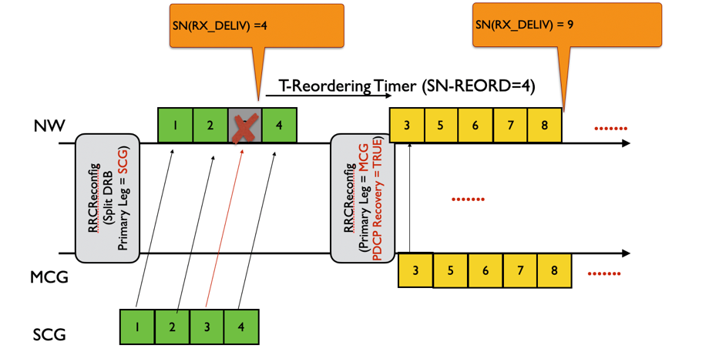
Figure-2. PDCP recovery triggered upon the primary path switching
If the PDCP recovery can be triggered upon the primary leg switching or NW can explicitly indicate UE to perform the PDCP recovery via the normal reconfiguration for any case, the unacknowledged PDCP PDUs can be transmitted to NW earlier and such problem can be avoided as showed in Figure-2.
Observation 2: If PDCP recovery is triggered when NW reconfigures the primary path, the problem indicated in Figure-1 can be avoided.

Q1: Do you agree the observation 1 and 2 ( i.e. the PDCP recovery upon the primary path swiching can resolve the problem of the UE throughput decrease) ?
Company | Yes/No | Comments
MediaTek | Yes
OPPO | Yes

The understanding on the current RRC spec is:
According to current RRC spec description as below, there is no restriction to configure recoverPDCP = TRUE which triggers UE to perform the PDCP recovery. Therefore, current RRC spec can support NW to trigger the PDCP recovery any time.
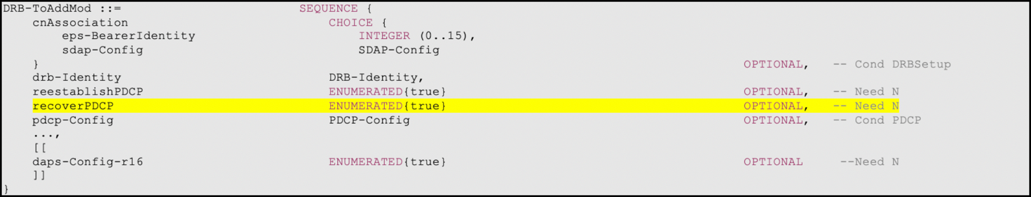
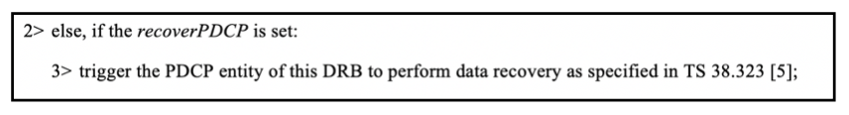
Observation 3: There is no ASN.1 impact if NW is allowed to trigger the PDCP recovery via normal reconfiguration which is for the primary path switching mode.

Q2: Do you agree the observation 3 ( i.e. NW can indicate UE to perform the PDCP recovery when reconfiguring the primary path) ?
Company | Yes/No | Comments
MediaTek | Yes
OPPO | Yes

And the corresponding spec clarification is:
Proposal: NW can explicitly configure UE to perform the PDCP recovery procedure via the normal RRCReconfiguration, not restricted by the following three cases:
- Handover without security change;
- bearer type change;
- reconfiguration after re-establishment.

Q3: Do you agree the proposal and the clarification ?
Company | Yes/No | Comments
MediaTek | Yes, but | Based on current spec, there is no such limitation at all.
OPPO | Same view as MTK

Q4: Do you agree to capture the clarification in the spec ?
Company | Yes/No | Comments
MediaTek | No | Clarification is OK, but seems no need to capture related change.
OPPO | No | Same view as MTK

The corresponding text proposal is:

Q5: Do you agree the text proposal ?
Company | Yes/No | Comments
MediaTek | No | Same as Q3 and Q4
OPPO | No

Conclusion:
TBD

3.2 PDCP status report
R2-2010559 PDCP status report Qualcomm Incorporated CR Rel-15 38.323 15.7.0 0058 - F NR_newRAT-Core
R2-2010560 PDCP status report Qualcomm Incorporated CR Rel-16 38.323 16.2.0 0059 - A NR_newRAT-Core

According to R2-2010559 and R2-2010560, the reason for the change is:
Receiving PDCP entity triggers PDCP status report when upper layer requests PDCP re-establishment/recovery. RRC Connection Resume is one of the reasons for PDCP re-establishment. For suspended PDCP entities, RX_NEXT, RX_DELIV are set to initial values. Hence the resulting PDCP status report serves no purpose.
When upper layers request a PDCP entity suspend, the receiving PDCP entity shall:
- if t-Reordering is running:
- stop and reset t-Reordering;
- deliver all stored PDCP SDUs to the upper layers in ascending order of associated COUNT values after performing header decompression;
- set RX_NEXT and RX_DELIV to the initial value.

And corresponding spec change is:

5.4.1 Transmit operation
For AM DRBs configured by upper layers to send a PDCP status report in the uplink (statusReportRequired in TS 38.331 [3]), the receiving PDCP entity shall trigger a PDCP status report when:
- upper layer requests a PDCP entity re-establishment;
- upper layer requests a PDCP data recovery.
If a PDCP status report is triggered, the receiving PDCP entity shall:
- compile a PDCP status report as indicated below by:
- setting the FMC field to RX_DELIV;
- if RX_DELIV < RX_NEXT:
- allocating a Bitmap field of length in bits equal to the number of COUNTs from and not including the first missing PDCP SDU up to and including the last out-of-sequence PDCP SDUs, rounded up to the next multiple of 8, or up to and including a PDCP SDU for which the resulting PDCP Control PDU size is equal to 9000 bytes, whichever comes first;
- setting in the bitmap field as '0' for all PDCP SDUs that have not been received, and optionally PDCP SDUs for which decompression have failed;
- setting in the bitmap field as '1' for all PDCP SDUs that have been received;
- submit the PDCP status report to lower layers as the first PDCP PDU for transmission via the transmitting PDCP entity as specified in clause 5.2.1.
Note: If the PDCP re-establishment is triggered due to the PDCP entity being resumed after PDCP entity suspend, the receiving PDCP entity may omit the PDCP status report.

Q5: Do you agree the intention and the spec change in Rel-15/Rel-16 CR R2-2010559 and R2-2010560?
Company | Yes/No | Comments
MediaTek | Yes
OPPO | Yes | With a NOTE and the word “may”, we assume it is backwards compatible.

Conclusion:
TBD

3.3 Corrections on PDCP functionalities
R2-2010667 Corrections on PDCP functionalities Huawei, HiSilicon CR Rel-15 38.323 15.7.0 0060 - F NR_newRAT-Core
R2-2010668 Corrections on PDCP functionalities Huawei, HiSilicon CR Rel-16 38.323 16.2.0 0061 - A NR_newRAT-Core

According to R2-2010667 and R2-2010668, the reason for the change is:
In the PDCP function list in 4.4, the function of PDCP status reporting is missing:

4.4 Functions
The PDCP layer supports the following functions:
- transfer of data (user plane or control plane);
- maintenance of PDCP SNs;
- header compression and decompression using the ROHC protocol;
- ciphering and deciphering;
- integrity protection and integrity verification;
- timer based SDU discard;
- for split bearers, routing;
- duplication;
- reordering and in-order delivery;
- out-of-order delivery;
- duplicate discarding.

And corresponding spec change is:

4.4 Functions
The PDCP layer supports the following functions:
- transfer of data (user plane or control plane);
- maintenance of PDCP SNs;
- header compression and decompression using the ROHC protocol;
- ciphering and deciphering;
- integrity protection and integrity verification;
- timer based SDU discard;
- for split bearers, routing;
- duplication;
- reordering and in-order delivery;
- out-of-order delivery;
- duplicate discarding.
- status reporting.

Q6: Do you agree the intention and the spec change in Rel-15/Rel-16 CR R2-2010667 and R2-2010668?
Company | Yes/No | Comments
MediaTek | Yes
OPPO | Yes

Conclusion:
TBD

4 Conclusion
TBD

5 References
[1] RAN2 112-e Chairman Notes 2020-11-02 0800 UTC.docx

