**3GPP TSG-RAN WG2 Meeting #111-eR2-200xxxx**

Electronic Meeting, 17th – 28th August 2020

**Agenda item: 5.4.3**

**Source: vivo**

**Title: Report of ‎[AT111-e][011][NR15]** **UE cap Additions (vivo)**

**Document for: Discussion and Agreement**

# 1 Introduction

This is to report the result of the following email discussion in RAN2#111-e Meeting [1].

* [AT111-e][011][NR15] UE cap Additions (vivo)

Scope: Treat R2-2007303, R2-2007304, R2-2007305, R2-2007306, R2-2007212, R2-2007213, (proponents to drive)

Part 1: Decision whether to make corrections, identify agreeable parts. Identify Controversial issues for on-line treatment (if any).

Deadline: Aug 20, 0900 UTC.

Part 2: For agreeable parts, continuation to agree CRs.

Deadline: Aug 26, 0900 UTC.

The remainder of this document is organized as the following. The discussions are in Section 2 and the conclusions are summaried in Section 3.

# 2 Discussion

To make it easier to find the correct contact delegate in each company for potential follow-up questions, the rapporteur encourages the delegates who provide input to provide their contact information in this table:

|  |  |
| --- | --- |
| Company | Delegate contact |
| Ericsson | Mattias Bergström (mattias.a.bergstrom@ericsson.com) |
| ZTE | Wenting Li (li.wenting@zte.com.cn) |
| MediaTek | Chun-Fan (Felix) Tsai (Chun-Fan.Tsai@mediatek.com) |
| CATT | Erlin Zeng (erlin.zeng@catt.cn) |
| Qualcomm Incorporated | Masato Kitazoe (mkitazoe [at] qti.qualcomm.com) |
| Apple | Naveen Palle (naveen.palle@apple.com) |
| OPPO | Qianxi Lu (qianxi.lu@oppo.com) |
| Samsung | Soenghun Kim (kimsh23@samsung.com) |
| vivo | Wen Ming (ming.wen@vivo.com) |

## 2.1 Corrections on UE capability constraints

Companies are invited to provide their views/comments on the following CRs in the following table.

R2-2007303 Corrections on UE capability constraints vivo CR Rel-15 36.331 15.10.0 4377 - F NR_newRAT-Core

R2-2007304 Corrections on UE capability constraints vivo CR Rel-15 38.306 15.10.0 0377 - F NR_newRAT-Core

R2-2007305 Corrections on UE capability constraints vivo CR Rel-16 36.331 16.1.1 4378 - A NR_newRAT-Core

R2-2007306 Corrections on UE capability constraints vivo CR Rel-16 38.306 16.1.0 0378 - A NR_newRAT-Core

|  |  |  |
| --- | --- | --- |
| Company | **Agree as is;**  **Agree with changes;**  Disagree | Comments |
| Lenovo | 7303/7305: Disagree  7304/7306: Agree with changes | To 7303/7305: The need of #minCellperMeasObjectNR = 32 was already discussed in RAN2#109bis-e in the context of Google CR R2-2003684 and as part of offline discussion [059], see summary in R2-2004102. Conclusion was that there is no need to specify such a requirement. The reason is that for NR only detected cells are supported, i.e. UE will not be configured by MeasObjectNR with a list of NR cells to measure.  To 7304/7306: In NR MeasObjectEUTRA a list of E-UTRA black cells can be configured by blackCellsToAddModListEUTRAN = SEQUENCE (SIZE (1..maxCellMeasEUTRA)) OF EUTRA-BlackCell and thus, not ranges of black cells. Therefore, it’s ok to define #minBlackCellperMeasObjectEUTRA = 32 but not #minBlackCellRangesperMeasObjectEUTRA = 32 as proposed.  Furthermore, cover page issues need to be fixed: i) impact analysis is not complete, ii) in “Other specs affected” the box “N” to “Other core specs” needs to be ticked and the entry to “Other core specs” needs to be removed as it does not apply to shadow CRs. |
| Nokia | Agree with Lenovo’s feedback | Agree with Lenovo’s feedback |
| Huawei, HiSilicon | Agree with Lenovo’s feedback | Agree with Lenovo’s feedback |
| Ericsson | Agree with Lenovo’s feedback | Agree with Lenovo’s feedback |
| ZTE | Agree with Lenovo’s feedback | Agree with Lenovo’s feedback |
| MediaTek | Agree with Lenovo’s feedback | Agree with Lenovo’s feedback |
| CATT | Agree with Lenovo’s feedback | Agree with Lenovo’s feedback |
| Qualcomm Incorporated | Agree with Lenovo’s feedback | Agree with Lenovo’s feedback |
| Apple | Agree with Lenovo’s feedback |  |
| OPPO | Agree with Lenovo’s feedback | Agree with Lenovo’s feedback |
| Samsung | Agree with Lenovo’s feedback |  |

**Summary:** All companies acknowledge that the constraint #minBlackCellperMeasObjectEUTRA is missing in TS 38.306, but the constranit #minCellperMeasObjectNR is unnecessary as this was discussed in RAN2#109bie-e (summarized in R2-2004102). Therefore, the CRs in R2-2007303/2007305 are not needed. Further, as pointed by one company that there are some issues to be fixed with the CRs in R2-2007304/2007306, so the rapporteur suggests to agree the CRs in R2-2007304/2007306 with modifications.

1. The CRs in R2-2007304 and R2-2007306 are considered as baseline to update the cover page issues and the additional editorial corrections.

## 2.2 On support of 35MHz and 45MHz channel bandwidth

Companies are invited to provide their views/comments on the following CRs in the following table.

R2-2007212 CR on support of 35MHz and 45MHz channel bandwidth (R15) ZTE Corporation, Sanechips CR Rel-15 38.306 15.10.0 0374 - F NR_newRAT-Core

R2-2007213 CR on support of 35MHz and 45MHz channel bandwidth (R16) ZTE Corporation, Sanechips CR Rel-16 38.306 16.1.0 0375 - A NR_newRAT-Core

|  |  |  |
| --- | --- | --- |
| Company | **Agree as is;**  **Agree with changes;**  Disagree | Comments |
| Lenovo | Disagree | It is too early to introduce the new channel BWs, RAN2 can wait until RAN4 completed their work and sent LS to RAN2 on the signalling support acc. to the note below as stated in the WID RP-201321.  *NOTE: Once RAN4 introduced the new channel bandwidth, the LS for related signalling will be sent to RAN2. So no RAN2 TU needs be requested.* |
| Nokia | Disagree | Agree with Lenovo’s feedback |
| Huawei, HiSilicon | Disagree | Agree with Lenovo’s feedback, it is too early. |
| Ericsson | Disagree | The CRs are technically fine to us (could consider to add a “respectively” as below), but we agree with the comments by other companies and wait for RAN4 LS.  For FR1, the first three bits in *channelBWs-DL-v1590* starting from the leading / leftmost bit indicate 70, 35, 45 MHz, respectively, and all the remaining bits in *channelBWs-DL-v1590* shall be set to 0. |
| ZTE |  | OK,Thanks E///’s comments and we can wait for the RAN4’s feedback |
| MediaTek | Could wait for RAN4 | We also suggest to wait RAN4 LS before concluding the CR. |
| CATT |  | Agree with Lenovo that this is a bit too early |
| Qualcomm Incorporated |  | It indeed makes sense to wait for RAN4. |
| Apple | Wair for RAN4 | We also want to bring to RAN2’s attention and confirm it is the common understanding in RAN2 that that the fallback BW support does not apply to these “special” BWs. Meaning the support of 45MHz does not imply the support of 35MHz by default even in non-CA case. 90MHz was an exception, but RAN4 has been bringing newer ones, and we want to confirm that each BW is denoted by a bit and it’s a stand-alone capability. |
| OPPO | Disagree | As commented above |
| Samsung | Disagree | It is strange to include R17 WI change in R15/16 |

**Summary:** All companies agree that now it’s too early to deal with the signalling support on 35MHz and 45MHz channel bandwidth, as RAN4 has not started the work yet. The consensus is to wait for the RAN4 feedback before RAN2 makes any decision on these CRs. So the rapporteur suggests postponing the discussion on the CRs R2-2007212/2007213.

1. The CRs in R2-2007212 and R2-2007213 are postponed until RAN2 receives LS from RAN4.

## 2.3 On CGI reporting in EN-DC and NE-DC

R2-2007084 Clarification on CGI reporting in EN-DC and NE-DC Apple discussion Rel-15 NR_newRAT-Core

This paper discusses the UE capabilities on supporting CGI reporting in case that MN and SN are configured with unaligned or aligned DRX pattern. The current specs only support the DRX alignment differentiation capabilities on MN/SN for NR-DC and EN-DC (on UTRA/GERAN/LTE), below is a summary from R2-2007084 on CGI reporting for EN-DC, NE-DC and NR-DC.

Table 1 - CGI reporting for EN-DC/NE-DC/NR-DC

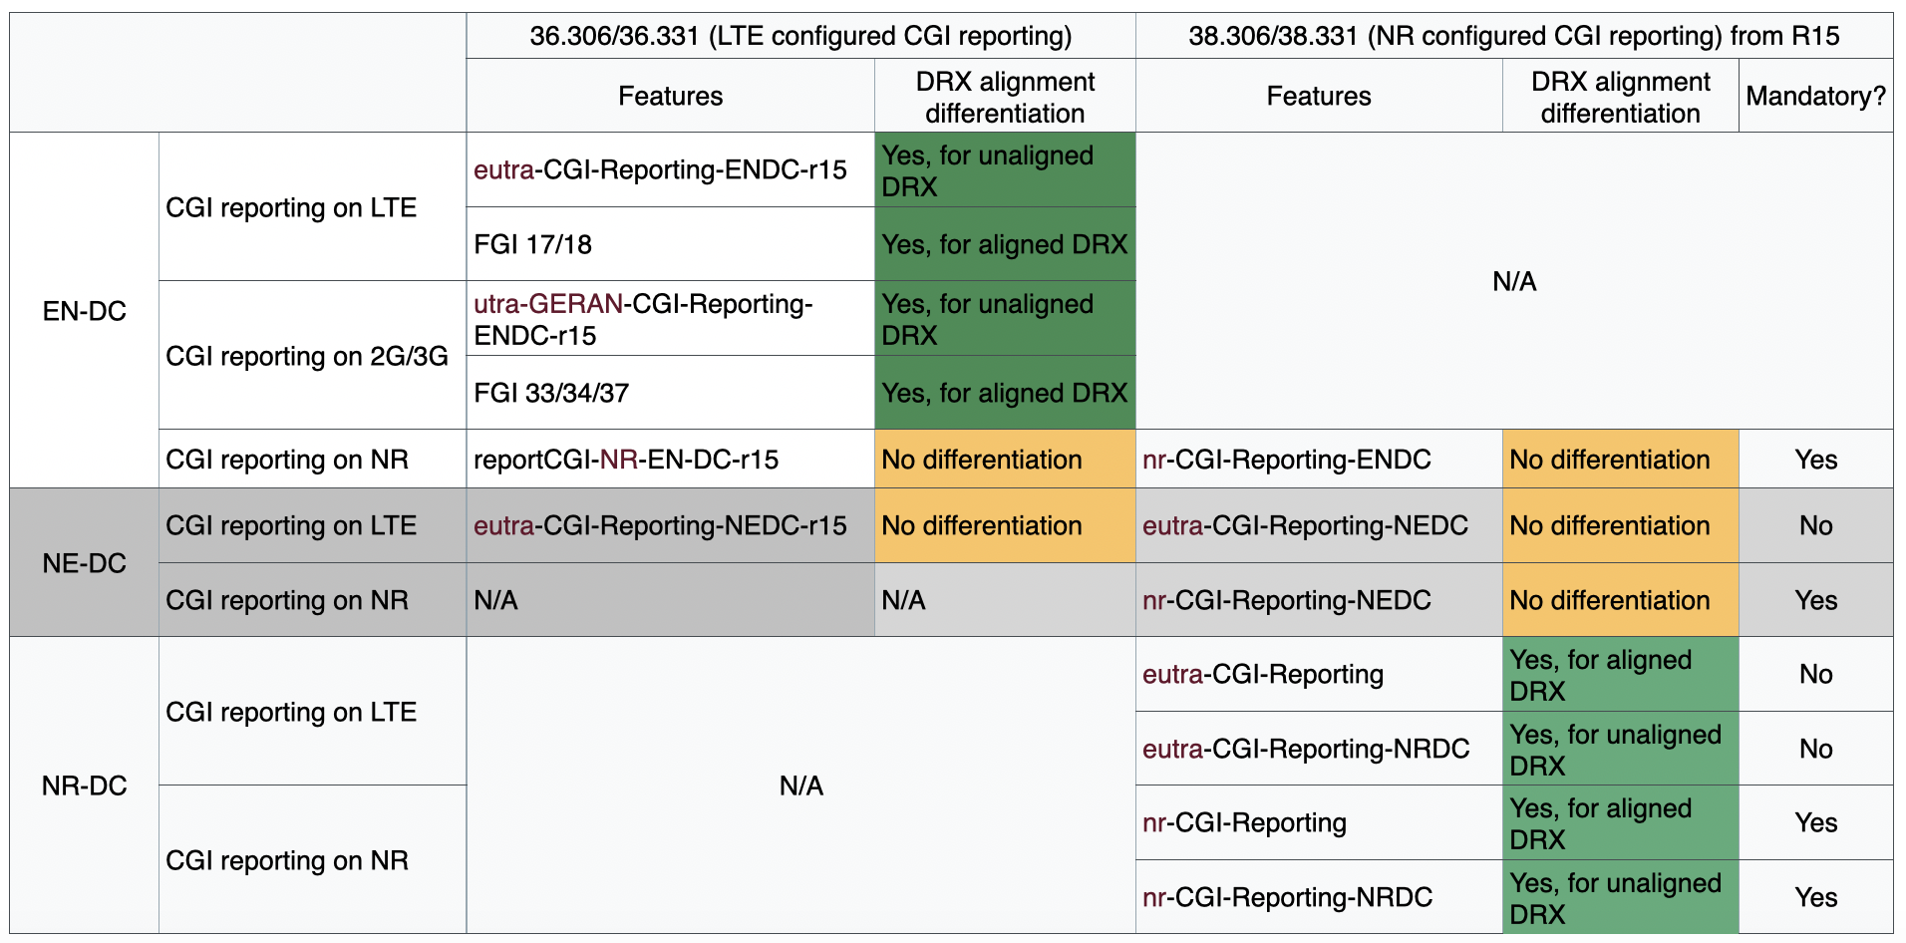

The DRX alignment differentiation capabilities can be applicable to other scenarios, but whether to enable such a flexibility for other scenarios can be further considered. Thus, companies are invited to provide their views/comments on the following questions in the following tables.

**Question 1: Should the DRX alignment differentiation on MN/SN for CGI reporting on NR in EN-DC be introduced for both LTE and NR spec?**

|  |  |  |
| --- | --- | --- |
| Company | **Agree?**  (Yes or No) | Comments |
| Nokia | No | Rel-15 changes are not acceptable as the use case is not really clear and what is broken in the specification. Enhancements in general are not okay for Rel-15. |
| Huawei, HiSilicon | No | It is a NBC change and it is unacceptable. |
| Ericsson | - | Not agreed online. |
| ZTE | - | Not agreed online. |
| CATT | No |  |
| Qualcomm Incorporated | No | For the reasons as we commented online. |
| Apple |  | Accoring to online discussion, multiple companies presented sympathy on our analysis to CGI reporting status shown in the table. The major reason why it is not agreed is change to Rel-15 spec is not preferred.  For now we are fine to follow the online decision made by chair. |
| OPPO | - | Not agreed online |
| Samsung | No | Agree with other companies that R15 change is not acceptable |

**Question 2: Should the DRX alignment differentiation on MN/SN for CGI reporting on LTE and NR in NE-DC be introduced for both LTE and NR spec?**

|  |  |  |
| --- | --- | --- |
| Company | **Agree?**  (Yes or No) | Comments |
| Nokia | No | Same as above. |
| Huawei, HiSilicon | No | This capability was discussed in last meeting, it seems there is no need of having such differentiation. |
| Ericsson | - | Not agreed online. |
| ZTE | - | Not agreed online. |
| CATT | No |  |
| Qualcomm Incorporated | No | For the reasons as we commented online. |
| Apple |  | Same resp as to Q1 above |
| OPPO | - | Not agreed online. |
| Samsung | No | Agree with other companies that R15 change is not acceptable |

**Summary:** This paper was discussed at the online meeting [2], and the following note was made:

|  |
| --- |
| DISCUSSION on-line  - QC think the current status is a result of conscious decisions. There is no change required. Ericsson agrees, and think introducing a new capability will just cause issues.  - Huawei think for EN-DC the change is nbc.  - Apple think we can now take into account R4 outcomes.  - Apple think tht from test point of view it is preferable to test aligned / non-aliged DRX separately and we should have different capabilities.  - MTK have some sympathy, e.g. for the requirement to have separate testing, and think an additional capability could be considered for R16.  - LG have some sympaty but think there is nothing broken and this is R15 and don’t support.  - Chair: not much support   * Not agreed |

Therefore the discussion for the paper is closed accordingly.

# 3 Conclusion

Based on the discussion in the previous sections we propose the following:

**Proposal 1 The CRs in R2-2007304 and R2-2007306 are considered as baseline to update the cover page issues and the additional editorial corrections.**

**Proposal 2 The CRs in R2-2007212 and R2-2007213 are postponed until RAN2 receives LS from RAN4.**

# 4 References

[1] R2-111e Chair Notes 2020-08-17 1000 UTC.docx

[2] R2-111e Chair Notes 2020-08-20 0900 UTC.docx