**3GPP TSG-RAN WG2 Meeting #111-eR2-200xxxx**

Electronic Meeting, 17th – 28th August 2020

**Agenda item: 5.4.3**

**Source: vivo**

**Title: Report of ‎[AT111-e][011][NR15]** **UE cap Additions (vivo)**

**Document for: Discussion and Agreement**

# 1 Introduction

This is to report the result of the following email discussion in RAN2#111-e Meeting [1].

* [AT111-e][011][NR15] UE cap Additions (vivo)

Scope: Treat R2-2007303, R2-2007304, R2-2007305, R2-2007306, R2-2007212, R2-2007213, R2-2007084 (proponents to drive)

Part 1: Decision whether to make corrections, identify agreeable parts. Identify Controversial issues for on-line treatment (if any).

Deadline: Aug 20, 0900 UTC.

Part 2: For agreeable parts, continuation to agree CRs.

Deadline: Aug 26, 0900 UTC.

The remainder of this document is organized as the following. The discussions are in Section 2 and the conclusions are summaried in Section 3.

# 2 Discussion

To make it easier to find the correct contact delegate in each company for potential follow-up questions, the rapporteur encourages the delegates who provide input to provide their contact information in this table:

|  |  |
| --- | --- |
| Company | Delegate contact |
| Ericsson | Mattias Bergström (mattias.a.bergstrom@ericsson.com) |
| ZTE | Wenting Li (li.wenting@zte.com.cn) |
| MediaTek | Chun-Fan (Felix) Tsai (Chun-Fan.Tsai@mediatek.com) |
| CATT | Erlin Zeng (erlin.zeng@catt.cn) |
| Qualcomm Incorporated | Masato Kitazoe (mkitazoe [at] qti.qualcomm.com) |
| Apple | Naveen Palle (naveen.palle@apple.com) |
| Samsung | Soenghun Kim (kimsh23@samsung.com) |

## 2.1 Corrections on UE capability constraints

Companies are invited to provide their views/comments on the following CRs in the following table.

R2-2007303 Corrections on UE capability constraints vivo CR Rel-15 36.331 15.10.0 4377 - F NR_newRAT-Core

R2-2007304 Corrections on UE capability constraints vivo CR Rel-15 38.306 15.10.0 0377 - F NR_newRAT-Core

R2-2007305 Corrections on UE capability constraints vivo CR Rel-16 36.331 16.1.1 4378 - A NR_newRAT-Core

R2-2007306 Corrections on UE capability constraints vivo CR Rel-16 38.306 16.1.0 0378 - A NR_newRAT-Core

|  |  |  |
| --- | --- | --- |
| Company | **Agree as is;**  **Agree with changes;**  Disagree | Comments |
| Lenovo | 7303/7305: Disagree  7304/7306: Agree with changes | To 7303/7305: The need of #minCellperMeasObjectNR = 32 was already discussed in RAN2#109bis-e in the context of Google CR R2-2003684 and as part of offline discussion [059], see summary in R2-2004102. Conclusion was that there is no need to specify such a requirement. The reason is that for NR only detected cells are supported, i.e. UE will not be configured by MeasObjectNR with a list of NR cells to measure.  To 7304/7306: In NR MeasObjectEUTRA a list of E-UTRA black cells can be configured by blackCellsToAddModListEUTRAN = SEQUENCE (SIZE (1..maxCellMeasEUTRA)) OF EUTRA-BlackCell and thus, not ranges of black cells. Therefore, it’s ok to define #minBlackCellperMeasObjectEUTRA = 32 but not #minBlackCellRangesperMeasObjectEUTRA = 32 as proposed.  Furthermore, cover page issues need to be fixed: i) impact analysis is not complete, ii) in “Other specs affected” the box “N” to “Other core specs” needs to be ticked and the entry to “Other core specs” needs to be removed as it does not apply to shadow CRs. |
| Nokia | Agree with Lenovo’s feedback | Agree with Lenovo’s feedback |
| Huawei, HiSilicon | Agree with Lenovo’s feedback | Agree with Lenovo’s feedback |
| Ericsson | Agree with Lenovo’s feedback | Agree with Lenovo’s feedback |
| ZTE | Agree with Lenovo’s feedback | Agree with Lenovo’s feedback |
| MediaTek | Agree with Lenovo’s feedback | Agree with Lenovo’s feedback |
| CATT | Agree with Lenovo’s feedback | Agree with Lenovo’s feedback |
| Qualcomm Incorporated | Agree with Lenovo’s feedback | Agree with Lenovo’s feedback |
| Apple | Agree with Lenovo’s feedback |  |
| Samsung | Agree with Lenovo’s feedback |  |

**Proposed conclusion:**

TBD

## 2.2 On support of 35MHz and 45MHz channel bandwidth

Companies are invited to provide their views/comments on the following CRs in the following table.

R2-2007212 CR on support of 35MHz and 45MHz channel bandwidth (R15) ZTE Corporation, Sanechips CR Rel-15 38.306 15.10.0 0374 - F NR_newRAT-Core

R2-2007213 CR on support of 35MHz and 45MHz channel bandwidth (R16) ZTE Corporation, Sanechips CR Rel-16 38.306 16.1.0 0375 - A NR_newRAT-Core

|  |  |  |
| --- | --- | --- |
| Company | **Agree as is;**  **Agree with changes;**  Disagree | Comments |
| Lenovo | Disagree | It is too early to introduce the new channel BWs, RAN2 can wait until RAN4 completed their work and sent LS to RAN2 on the signalling support acc. to the note below as stated in the WID RP-201321.  *NOTE: Once RAN4 introduced the new channel bandwidth, the LS for related signalling will be sent to RAN2. So no RAN2 TU needs be requested.* |
| Nokia | Disagree | Agree with Lenovo’s feedback |
| Huawei, HiSilicon | Disagree | Agree with Lenovo’s feedback, it is too early. |
| Ericsson | Disagree | The CRs are technically fine to us (could consider to add a “respectively” as below), but we agree with the comments by other companies and wait for RAN4 LS.  For FR1, the first three bits in *channelBWs-DL-v1590* starting from the leading / leftmost bit indicate 70, 35, 45 MHz, respectively, and all the remaining bits in *channelBWs-DL-v1590* shall be set to 0. |
| ZTE |  | OK,Thanks E///’s comments and we can wait for the RAN4’s feedback |
| MediaTek | Could wait for RAN4 | We also suggest to wait RAN4 LS before concluding the CR. |
| CATT |  | Agree with Lenovo that this is a bit too early |
| Qualcomm Incorporated |  | It indeed makes sense to wait for RAN4. |
| Apple | Wair for RAN4 | We also want to bring to RAN2’s attention and confirm it is the common understanding in RAN2 that that the fallback BW support does not apply to these “special” BWs. Meaning the support of 45MHz does not imply the support of 35MHz by default even in non-CA case. 90MHz was an exception, but RAN4 has been bringing newer ones, and we want to confirm that each BW is denoted by a bit and it’s a stand-alone capability. |
| Samsung | Disagree | It is strange to include R17 WI change in R15/16 |

**Proposed conclusion:**

TBD

## 2.3 On CGI reporting in EN-DC and NE-DC

R2-2007084 Clarification on CGI reporting in EN-DC and NE-DC Apple discussion Rel-15 NR_newRAT-Core

This paper discusses the UE capabilities on supporting CGI reporting in case that MN and SN are configured with unaligned or aligned DRX pattern. The current specs only support the DRX alignment differentiation capabilities on MN/SN for NR-DC and EN-DC (on UTRA/GERAN/LTE), below is a summary from R2-2007084 on CGI reporting for EN-DC, NE-DC and NR-DC.

Table 1 - CGI reporting for EN-DC/NE-DC/NR-DC

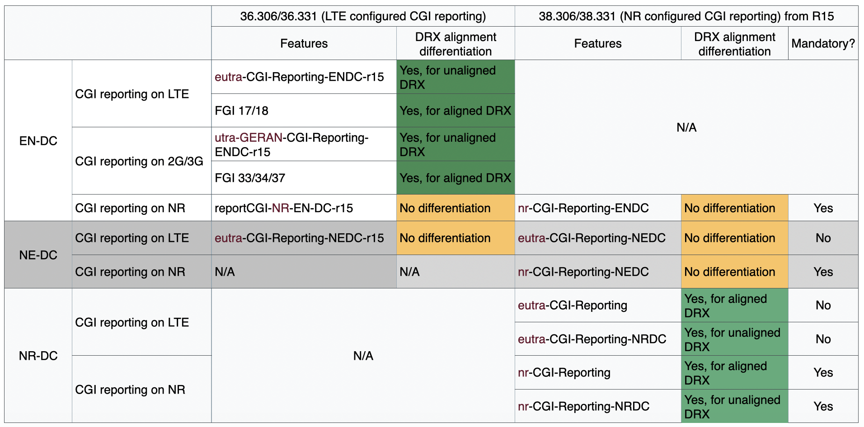

The DRX alignment differentiation capabilities can be applicable to other scenarios, but whether to enable such a flexibility for other scenarios can be further considered. Thus, companies are invited to provide their views/comments on the following questions in the following tables.

**Question 1: Should the DRX alignment differentiation on MN/SN for CGI reporting on NR in EN-DC be introduced for both LTE and NR spec?**

|  |  |  |
| --- | --- | --- |
| Company | **Agree?**  (Yes or No) | Comments |
| Nokia | No | Rel-15 changes are not acceptable as the use case is not really clear and what is broken in the specification. Enhancements in general are not okay for Rel-15. |
| Huawei, HiSilicon | No | It is a NBC change and it is unacceptable. |
| Ericsson | - | Not agreed online. |
| ZTE | - | Not agreed online. |
| CATT | No |  |
| Qualcomm Incorporated | No | For the reasons as we commented online. |
| Apple |  | Accoring to online discussion, multiple companies presented sympathy on our analysis to CGI reporting status shown in the table. The major reason why it is not agreed is change to Rel-15 spec is not preferred.  For now we are fine to follow the online decision made by chair. |
| Samsung | No | Agree with other companies that R15 change is not acceptable |

**Question 2: Should the DRX alignment differentiation on MN/SN for CGI reporting on LTE and NR in NE-DC be introduced for both LTE and NR spec?**

|  |  |  |
| --- | --- | --- |
| Company | **Agree?**  (Yes or No) | Comments |
| Nokia | No | Same as above. |
| Huawei, HiSilicon | No | This capability was discussed in last meeting, it seems there is no need of having such differentiation. |
| Ericsson | - | Not agreed online. |
| ZTE | - | Not agreed online. |
| CATT | No |  |
| Qualcomm Incorporated | No | For the reasons as we commented online. |
| Apple |  | Same resp as to Q1 above |
| Samsung | No | Agree with other companies that R15 change is not acceptable |

**Proposed conclusion:**

TBD

# 3 Conclusion

In the previous sections we made the following observations:

TBD

Based on the discussion in the previous sections we propose the following:

TBD

# 4 References

[1] R2-111e Chair Notes 2020-08-17 1000 UTC.docx