**3GPP TSG-RAN WG2 Meeting #111-eR2-200xxxx**

Electronic Meeting, 17th – 28th August 2020

**Agenda item: 5.4.3**

**Source: vivo**

**Title: Report of ‎[AT111-e][011][NR15]** **UE cap Additions (vivo)**

**Document for: Discussion and Agreement**

# 1 Introduction

This is to report the result of the following email discussion in RAN2#111-e Meeting [1].

* [AT111-e][011][NR15] UE cap Additions (vivo)

Scope: Treat R2-2007303, R2-2007304, R2-2007305, R2-2007306, R2-2007212, R2-2007213, R2-2007084 (proponents to drive)

Part 1: Decision whether to make corrections, identify agreeable parts. Identify Controversial issues for on-line treatment (if any).

Deadline: Aug 20, 0900 UTC.

Part 2: For agreeable parts, continuation to agree CRs.

Deadline: Aug 26, 0900 UTC.

The remainder of this document is organized as the following. The discussions are in Section 2 and the conclusions are summaried in Section 3.

# 2 Discussion

## 2.1 Corrections on UE capability constraints

Companies are invited to provide their views/comments on the following CRs in the following table.

R2-2007303 Corrections on UE capability constraints vivo CR Rel-15 36.331 15.10.0 4377 - F NR_newRAT-Core

R2-2007304 Corrections on UE capability constraints vivo CR Rel-15 38.306 15.10.0 0377 - F NR_newRAT-Core

R2-2007305 Corrections on UE capability constraints vivo CR Rel-16 36.331 16.1.1 4378 - A NR_newRAT-Core

R2-2007306 Corrections on UE capability constraints vivo CR Rel-16 38.306 16.1.0 0378 - A NR_newRAT-Core

|  |  |  |
| --- | --- | --- |
| Company | **Agree as is;**  **Agree with changes;**  Disagree | Comments |
|  |  |  |
|  |  |  |
|  |  |  |
|  |  |  |
|  |  |  |
|  |  |  |

**Proposed conclusion:**

TBD

## 2.2 On support of 35MHz and 45MHz channel bandwidth

Companies are invited to provide their views/comments on the following CRs in the following table.

R2-2007212 CR on support of 35MHz and 45MHz channel bandwidth (R15) ZTE Corporation, Sanechips CR Rel-15 38.306 15.10.0 0374 - F NR_newRAT-Core

R2-2007213 CR on support of 35MHz and 45MHz channel bandwidth (R16) ZTE Corporation, Sanechips CR Rel-16 38.306 16.1.0 0375 - A NR_newRAT-Core

|  |  |  |
| --- | --- | --- |
| Company | **Agree as is;**  **Agree with changes;**  Disagree | Comments |
|  |  |  |
|  |  |  |
|  |  |  |
|  |  |  |
|  |  |  |
|  |  |  |

**Proposed conclusion:**

TBD

## 2.3 On CGI reporting in EN-DC and NE-DC

R2-2007084 Clarification on CGI reporting in EN-DC and NE-DC Apple discussion Rel-15 NR_newRAT-Core

This paper discusses the UE capabilities on supporting CGI reporting in case that MN and SN are configured with unaligned or aligned DRX pattern. The current specs only support the DRX alignment differentiation capabilities on MN/SN for NR-DC and EN-DC (on UTRA/GERAN/LTE), below is a summary from R2-2007084 on CGI reporting for EN-DC, NE-DC and NR-DC.

Table 1 - CGI reporting for EN-DC/NE-DC/NR-DC

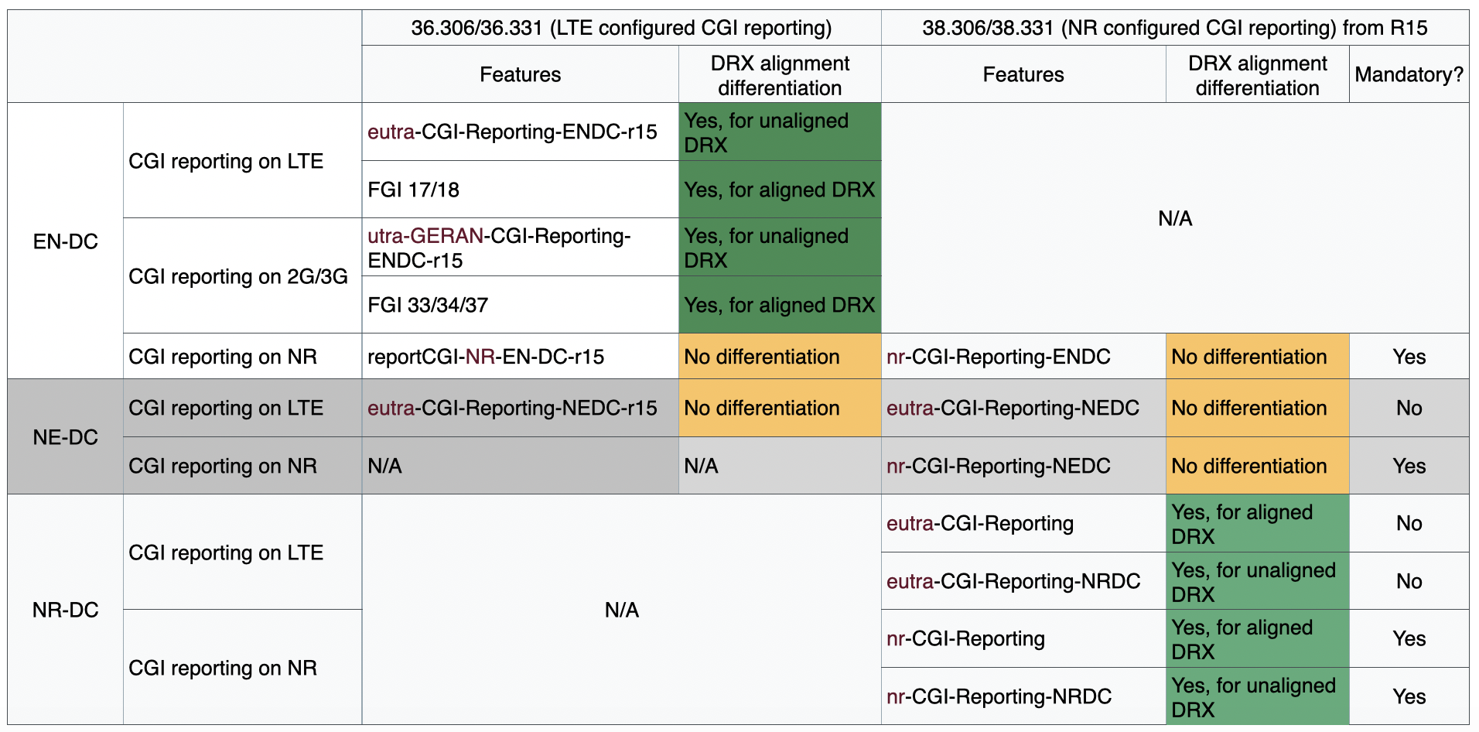

The DRX alignment differentiation capabilities can be applicable to other scenarios, but whether to enable such a flexibility for other scenarios can be further considered. Thus, companies are invited to provide their views/comments on the following questions in the following tables.

**Question 1: Should the DRX alignment differentiation on MN/SN for CGI reporting on NR in EN-DC be introduced for both LTE and NR spec?**

|  |  |  |
| --- | --- | --- |
| Company | **Agree?**  (Yes or No) | Comments |
|  |  |  |
|  |  |  |
|  |  |  |
|  |  |  |
|  |  |  |
|  |  |  |

**Question 2: Should the DRX alignment differentiation on MN/SN for CGI reporting on LTE and NR in NE-DC be introduced for both LTE and NR spec?**

|  |  |  |
| --- | --- | --- |
| Company | **Agree?**  (Yes or No) | Comments |
|  |  |  |
|  |  |  |
|  |  |  |
|  |  |  |
|  |  |  |
|  |  |  |

**Proposed conclusion:**

TBD

# 3 Conclusion

In the previous sections we made the following observations:

TBD

Based on the discussion in the previous sections we propose the following:

TBD

# 4 References

[1] R2-111e Chair Notes 2020-08-17 1000 UTC.docx