3GPP TSG-RAN2 Meeting #110 E-meeting R2-2005791
1- 12 Jun 2020
Agenda item: 6.15.1
Source LG Electronics Inc.
Title Report on RRC and UE capabilities aspects
Document for Discussion and Decision

Introduction
  [AT110e][101][CLI] RRC and UE capabilities aspects (LG)
Scope: Discuss the 38.331 and 38.306 CR on UE capabilities for CLI based on R2-2005695, R2-2005730 and R2-2004430. Also discuss the changes suggested by RAN1 in R2-2004347 and the new proposal in R2-2005309.
Initial intended outcome: summary of the offline discussion with e.g.:
- Set of proposals with full consensus, if any (agreeable over email)
- Set of proposals to discuss in the follow up conference call
Initial deadline (for companies' feedback): Wednesday 2020-06-03 10:00 UTC
Initial deadline (for rapporteur's summary in R2-2005791): Wednesday 2020-06-03 22:00 UTC

Discussion

TS38.331 CR
Two 38.331 CRs have been submitted to implement the UE features list for CLI in [1]:
 |  |  |  |  |  | Need of FR1/FR2 differentiation
17. NR_CLI_RIM | 17-1 | CLI-RSSI measurement | 1. Support CLI-RSSI measurement. The max number of resources across all CCs configured to measure RSSI simultaneously shall not exceed 64.  2. Maximum number of measurement resources configured for CLI-RSSI measurement | Per UE | TDD only | Yes | Candidate values for component 2 are {8, 16, 32, 64}.  FFS: whether or how to handle licensed/unlicensed differentiation | Optional with capability signalling
17. NR_CLI_RIM | 17-2 | SRS-RSRP measurement | 1. Support SRS-RSRP measurement. The max number of SRS resources across all CCs configured to measure SRS-RSRP simultaneously shall not exceed 32.  2. Maximum number of measurement resources configured for SRS-RSRP measurement  3. Maximum number of measurement resources configured for SRS-RSRP measurement within a slot | Per UE | TDD only | Yes | Candidate values for component 2 are {4, 8, 16, 32}.  Candidate values for component 3 are {2, 4, 8}.  FFS: whether or how to handle licensed/unlicensed differentiation | Optional with capability signalling

Option 1: In the first CR [2], above capabilities capture as follows:
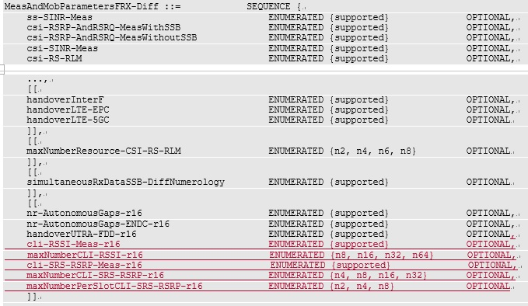
The cli-RSSI-Meas-r16 and cli-SRS-RSRP-Meas-r16 are already defined in TS38.306 v16.0.0. To minimize the impact on current spec, new capabilities defined by RAN1 have been added separately (maxNumberCLI-RSSI-r16, maxNumberCLI-SRS-RSRP-r16 and maxNumberPerSlotCLI-SRS-RSRP-r16).
Please note that this option requires some restrictions in TS38.306, e.g. If UE sets maxNumberCLI-RSSI-r16, the UE shall set cli-RSSI-Meas-r16, to prevent UE from reporting maxNumberCLI-RSSI-r16 without cli-RSSI-Meas-r16.

Option 2: In [3], such restrictions are not needed because it is structurally impossible to report maxNumberCLI-RSSI-r16 without cli-RSSI-Meas-r16.
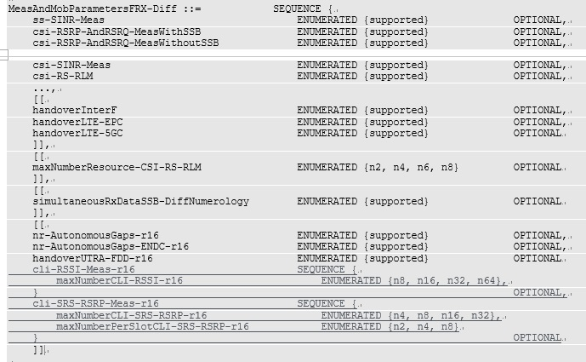
Companies are requested to provide input:
Company | Preferred option | Comments
Ericsson | 2 | Both options work, but from a specification quality point of view, option 2 has these benefits:  - The relation between the parameters are clear already from ASN.1. I.e. one wouldn’t have to read 306 in parallel to 331 to understand the relation of these parameters.  - 306 can be made simpler/less wordy by not require us to add the relation between the parameters in 306. As shown for example by the following question.  - Since it will be impossible to implement it wrong with option 2 (since ASN.1 ensures correct behaviour of the UE) there is zero risk of misunderstanding.  It is mentioned above "To minimize the impact on current spec". We don’t know if this is intended to say that option 1 brings less change to 306 compared to option 2? Either way, we don’t see why this would be the case. And even if that would be the case (which we haven't understood yet), we think that it is now (before ASN.1 freeze) that RAN2 can freely decide which option to take and to us option 1 has some drawbacks compared to option 2.
ZTE | slightly prefer 2 | We agree that both options work.  Looking into other capabilities in MeasAndMobParameters, the “function switch” and “maximum number of resources” are defined separately mainly because a given maxNum-XX can be associated with multiple functions. For instance, maxNumberCSI-RS-RRM-RS-SINR is associated with csi-RSRP-AndRSRQ-MeasWithSSB, csi-RSRP-AndRSRQ-MeasWithoutSSB, and csi-SINR-Meas; And maxNumberResource-CSI-RS-RLM is associated with csi-RS-RLM and ssb-AndCSI-RS-RLM.  For CLI, we don’t have such requirement so far, thus Option 2 looks cleaner.
Qualcomm | 1 | While we recognize the benefits explained by Ericsson, there are following issues:  - It was discussed and agreed in RAN2 that FR1/FR2 differentiation would be needed at least for the capabilities already captured in 36.306.  - RAN1 feature list also says one “Yes” in that column but does not clearly mention whether that “Yes” applies to each indicated capabilities (#1, #2, #3) within each feature group 17-1 and 17-2.  - We are not sure what it means to have FR1/FR2 diff for components #2 in both 17-1/17-2 and #3 in 17-2. While the UE should be able to indicate FR1/FR2 for component #1, the #2 (and #3) should be total across FR1+FR2 with no FR1/FR2 diff. Otherwise it is unclear how the UE sets those values. E.g., if the UE supports 32 in FR1 and 16 in FR2 (just for example), then does this mean UE may need to support 48 simultaneously in some scenarios? If yes, then why not report 48 for FR1 or FR2? Or does this mean, in case of FR1+FR2 operation, the minimum reported, i.e., 32 applies? This is not clear just setting all “Yes” without clarifying.  - CR option 1 is similar to what has been done for csi-SINR-Meas+ maxNumberCSI-RS-RRM-RS-SINR where FR1/FR2 diff is possible for the main flag, but for the maxNumber, it would not make sense to differentiate. This seems not possible with option 2.
Nokia | Option 2 | Agree with Ericsson that ZTE. This is cleaner option and the relation between parameter and capability is clear from the definition.
CATT | 2 | We reckon that both options work but option2 is cleaner for us.
Samsung | Option 2 | We agree with the view from Ericsson and ZTE.
OPPO | Option 2

Proposal 1: (from the e-mail discussion) For maxNumberCLI-RSSI-r16, maxNumberCLI-SRS-RSRP-r16 and maxNumberPerSlotCLI-SRS-RSRP-r16, “FR1/FR2 DIFF” is set to “NO”.
Conclusion: Most companies agree that both options work and prefer option 2. However, option 2 cannot support Proposal 1.
Proposal 2: Move maxNumberCLI-RSSI-r16, maxNumberCLI-SRS-RSRP-r16 and maxNumberPerSlotCLI-SRS-RSRP-r16 to MeasAndMobParametersCommon.
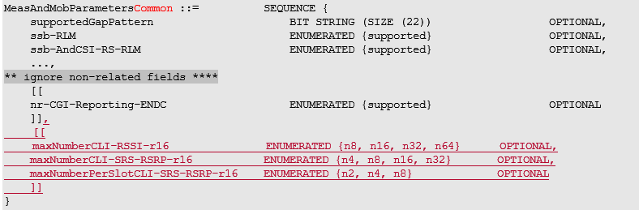
Proposal 3: Keep cli-RSSI-Meas-r16 and cli-SRS-RSRP-Meas-r16 in MeasAndMobParametersFRX-Diff.

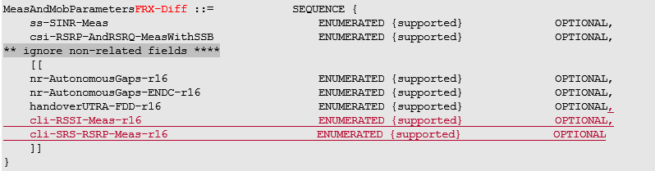

TS38.306 CR
The 38.306 CR [4] coincides with option 1 and include some restrictions as bellow:
cli-RSSI-Meas-r16
Indicates whether the UE can perform CLI RSSI measurements as specified in TS 38.215 [13] and supports periodical reporting and measurement event triggering as specified in TS 38.331 [9]. If the UE supports this feature, the UE needs to report maxNumberCLI-RSSI-r16.
cli-SRS-RSRP-Meas-r16
Indicates whether the UE can perform SRS RSRP measurements as specified in TS 38.215 [13] and supports periodical reporting and measurement event triggering based on SRS-RSRP as specified in TS 38.331 [9]. If the UE supports this feature, the UE needs to report maxNumberCLI-SRS-RSRP-r16 and maxNumberPerSlotCLI-SRS-RSRP-r16.
maxNumberCLI-RSSI-r16
Indicates the maximum number of CLI-RSSI measurement resources that can be configured for the UE. If the UE supports cli-RSSI-Meas-r16, the UE shall report this capability.
maxNumberCLI-SRS-RSRP-r16
Indicates the maximum number of SRS-RSRP measurement resources that can be configured for the UE. If the UE supports cli-SRS-RSRP-Meas-r16, the UE shall report this capability.
maxNumberPerSlotCLI-SRS-RSRP-r16
Indicates the maximum number of SRS-RSRP measurement resources within a slot that can be configured for the UE. If the UE supports cli-SRS-RSRP-Meas-r16, the UE shall report this capability.

If companies prefer to take the option 1, additional restriction needs to be added in TS38.306 as mentioned above. If option 2 is chosen, the restrictions in the current CR can be deleted.
Do you have any comments on TS38.306 CR?
Company | Comments
Ericsson | If we would end up with option 1:  “needs to” is not wording we usually use for UE requirements. It should have been “shall”, we assume?
ZTE | If option 1 is adopted, then such restriction is required.  I believe “needs to” is inherited from the field description of other capabilities, so we are ok to keep it for consistency.
Qualcomm | Agree with ZTE’s comment above. There are other several examples of “needs to” in 4.2.9 alone already. Is the suggestion to change all of them to “UE shall report”?
Nokia | We are ok to keep “need to” as already used in other places.
CATT | Agree with Nokia.
Samsung | No strong view on the wording, but we slightly prefer to use “shall” instead of “need to”.
OPPO | Agree with ZTE.

Proposal 4: No change in TS 38.306 CR, R2-2004430.

Subcarrier spacing for CLI-RSSI measurement
RAN1 sent an LS [5] and asked RAN2 to update the description of the parameter rssi-SCS-r16 in the IE MeasObjectCLI in TS38.331 as below:
rssi-scs-r16
Reference subcarrier spacing for CLI-RSSI measurement. Only the values 15, 30 kHz or 60 kHz (FR1), and 60 or 120 kHz (FR2) are applicable. UE performs CLI-RSSI measurement with the SCS of the active bandwidth part within the configured CLI-RSSI resource in the active BWP regardless of the reference SCS of the measurement resource.

In [3], Ericsson suggests the description slightly changed as below:
rssi-scs-r16
Reference subcarrier spacing for CLI-RSSI measurement. Only the values 15, 30 kHz or 60 kHz (FR1), and 60 or 120 kHz (FR2) are applicable. The UE performs CLI-RSSI measurements with the subcarrier spacing of the active bandwidth part within the configured CLI-RSSI resource in the active BWP, regardless of the reference subcarrier spacing of the measurement resource.

Question: Is it OK if the field description is updated as suggested by Ericsson?
Company | Comments
LG | OK with the Ericsson`s suggestion.
Ericsson | Agree with LG.  Additional input in response to ZTE's comment: We are OK to use SCS if companies want that. But the existing sentence in this field description uses "subcarrier spacing", hence we thought we could align. We could align the other way around to change the existing "subcarrier spacing" to "SCS", either way is fine.
ZTE | Seems the main difference is to replace “SCS” with “subcarrier spacing”? In fact, the abbreviation “SCS” is widely used in TS 38.331 (including field descriptions), so it is ok to keep using SCS.
Qualcomm | Suggested text is basically same as in the LS with some editorials.
Nokia | We need not use the full term sub-carrier spacing in all the sentences. It should be ok to have it in first sentence. If required we can add (SCS) in the first existing sentence.
CATT | Agree with ZTE.
Samsung | Either way is fine for us.
OPPO | Both are fine.

Impact of DRX on CLI SRS-RSRP measurement
In [6], Huawei analysed the impact of DRX on CLI SRS-RSRP measurement and proposed followings:
Proposal 1: Specify that the SRS used as CLI measurement resources are transmitted regardless of whether the MAC entity is in DRX active time or not when the DRX function is set up.
Proposal 2: Introduce a method for the UE to distinguish SRSs for CLI measurement from other SRSs. Potential options are:
- Option 1: define a new field in the SRS resource configuration IE (i.e., SRS-Resource) or the SRS resource set configuration IE (i.e., SRS-ResourceSet) indicating whether this SRS resource or SRS resource set is used for CLI measurement.
- Option 2: define a new SRS resource set IE (e.g., SRS-CLIResourceSet-r16) configuring the SRS resources used as CLI measurement resources.
- Option 3: the network explicitly notifies the UE which SRS resource(s) or SRS resource set(s) is used for CLI measurement.

Companies are requested to provide input on proposals in [6]:
Company | Support? | Comments
LG | No | Just an optimization and not essential to work.
Ericsson | No | Agree with LG.
ZTE | No | We understand the issue identified in [6] maybe valid. However, we agree with others that this is kind of optimization, asking UE to send SRS during DRX off period violates the intention of DRX (reduce power consumption). So we see no need to do big change at the late stage, one alternative solution can be the network simply disable the victim UE’s DRX whose SRS is used for CLI measurement.
Qualcomm | No | Tend to agree with comment above. This should be handled by network configuration.  P1 also means the power consumption of the UE would go up (contrary to the very objective of DRX).
Nokia | No | In general making changes to the transmission side behaviour for measurements is not preferred. Moreover this will impact the power consumption of transmission side.
CATT | No | We reckon the issue is valid, but due to the current stage, it is clear we do not have time to consider this optimization work.
Samsung | No
OPPO | NO

Conclusion

Reference
[1] R2-2004358 LS on Rel-16 RAN1 UE features lists for NR (R1-2003072; contact: NTT DOCOMO, AT&T) RAN1 LS in Rel-16 NR_2step_RACH-Core, NR_unlic-Core, NR_IAB-Core, 5G_V2X_NRSL-Core, NR_L1enh_URLLC-Core, NR_IIOT-Core, NR_eMIMO-Core, NR_UE_pow_sav-Core, NR_pos-Core, NR_Mob_enh-Core, LTE_NR_DC_CA_enh-Core, TEI16, NR_CLI_RIM-Core To:RAN2, RAN4
[2] R2-2005695 TS 38.331 CR LG
[3] R2-2005730 TS 38.331 CR Ericsson
[4] R2-2004430 TS 38.306 CR Qualcomm
[5] R2-2004347
[6] R2-2005309 On the impact of DRX on CLI SRS-RSRP measurement Huawei

