3GPP TSG-RAN2 Meeting #110 E-meeting R2-2005791
1- 12 Jun 2020
Agenda item: 6.15.1
Source LG Electronics Inc.
Title Report on RRC and UE capabilities aspects
Document for Discussion and Decision

Introduction
  [AT110e][101][CLI] RRC and UE capabilities aspects (LG)
Scope: Discuss the 38.331 and 38.306 CR on UE capabilities for CLI based on R2-2005695, R2-2005730 and R2-2004430. Also discuss the changes suggested by RAN1 in R2-2004347 and the new proposal in R2-2005309.
Initial intended outcome: summary of the offline discussion with e.g.:
- Set of proposals with full consensus, if any (agreeable over email)
- Set of proposals to discuss in the follow up conference call
Initial deadline (for companies' feedback): Wednesday 2020-06-03 10:00 UTC
Initial deadline (for rapporteur's summary in R2-2005791): Wednesday 2020-06-03 22:00 UTC

Discussion

TS38.331 CR
Two 38.331 CRs have been submitted to implement the UE features list for CLI in [1]:
17. NR_CLI_RIM | 17-1 | CLI-RSSI measurement | 1. Support CLI-RSSI measurement. The max number of resources across all CCs configured to measure RSSI simultaneously shall not exceed 64.  2. Maximum number of measurement resources configured for CLI-RSSI measurement | Per UE | TDD only | Candidate values for component 2 are {8, 16, 32, 64}.  FFS: whether or how to handle licensed/unlicensed differentiation | Optional with capability signalling
17. NR_CLI_RIM | 17-2 | SRS-RSRP measurement | 1. Support SRS-RSRP measurement. The max number of SRS resources across all CCs configured to measure SRS-RSRP simultaneously shall not exceed 32.  2. Maximum number of measurement resources configured for SRS-RSRP measurement  3. Maximum number of measurement resources configured for SRS-RSRP measurement within a slot | Per UE | TDD only | Candidate values for component 2 are {4, 8, 16, 32}.  Candidate values for component 3 are {2, 4, 8}.  FFS: whether or how to handle licensed/unlicensed differentiation | Optional with capability signalling

Option 1: In the first CR [2], above capabilities capture as follows:
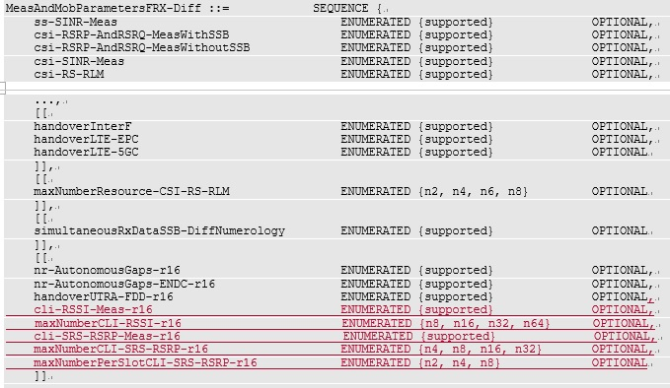
The cli-RSSI-Meas-r16 and cli-SRS-RSRP-Meas-r16 are already defined in TS38.306 v16.0.0. To minimize the impact on current spec, new capabilities defined by RAN1 have been added separately (maxNumberCLI-RSSI-r16, maxNumberCLI-SRS-RSRP-r16 and maxNumberPerSlotCLI-SRS-RSRP-r16).
Please note that this option requires some restrictions in TS38.306, e.g. If UE sets maxNumberCLI-RSSI-r16, the UE shall set cli-RSSI-Meas-r16, to prevent UE from reporting maxNumberCLI-RSSI-r16 without cli-RSSI-Meas-r16.

Option 2: In [3], such restrictions are not needed because it is structurally impossible to report maxNumberCLI-RSSI-r16 without cli-RSSI-Meas-r16.
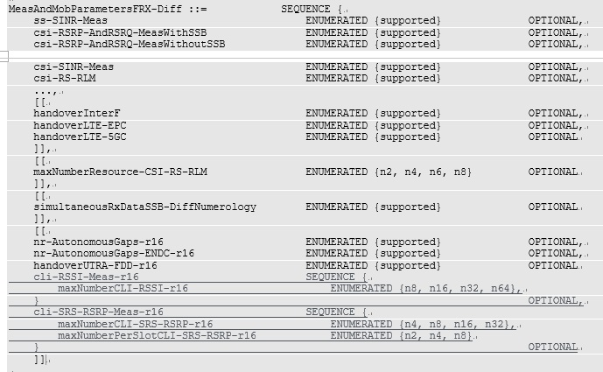
Companies are requested to provide input:
Company | Preferred option | Comments

TS38.306 CR
The 38.306 CR [4] coincides with option 1 and include some restrictions as bellow:
cli-RSSI-Meas-r16
Indicates whether the UE can perform CLI RSSI measurements as specified in TS 38.215 [13] and supports periodical reporting and measurement event triggering as specified in TS 38.331 [9]. If the UE supports this feature, the UE needs to report maxNumberCLI-RSSI-r16.
cli-SRS-RSRP-Meas-r16
Indicates whether the UE can perform SRS RSRP measurements as specified in TS 38.215 [13] and supports periodical reporting and measurement event triggering based on SRS-RSRP as specified in TS 38.331 [9]. If the UE supports this feature, the UE needs to report maxNumberCLI-SRS-RSRP-r16 and maxNumberPerSlotCLI-SRS-RSRP-r16.

If companies prefer to take the option 1, additional restriction needs to be added in TS38.306 as mentioned above. If option 2 is chosen, the restrictions in the current CR can be deleted.
Do you have any comments on TS38.306 CR?
Company | Comments

Subcarrier spacing for CLI-RSSI measurement
RAN1 sent an LS [5] and asked RAN2 to update the description of the parameter rssi-SCS-r16 in the IE MeasObjectCLI in TS38.331 as below:
rssi-scs-r16
Reference subcarrier spacing for CLI-RSSI measurement. Only the values 15, 30 kHz or 60 kHz (FR1), and 60 or 120 kHz (FR2) are applicable. UE performs CLI-RSSI measurement with the SCS of the active bandwidth part within the configured CLI-RSSI resource in the active BWP regardless of the reference SCS of the measurement resource.

In [3], Ericsson suggests the description slightly changed as below:
rssi-scs-r16
Reference subcarrier spacing for CLI-RSSI measurement. Only the values 15, 30 kHz or 60 kHz (FR1), and 60 or 120 kHz (FR2) are applicable. The UE performs CLI-RSSI measurements with the subcarrier spacing of the active bandwidth part within the configured CLI-RSSI resource in the active BWP, regardless of the reference subcarrier spacing of the measurement resource.

Question: Is it OK if the field description is updated as suggested by Ericsson?
Company | Comments
LG | OK with the Ericsson`s suggestion.

Impact of DRX on CLI SRS-RSRP measurement
In [6], Huawei analysed the impact of DRX on CLI SRS-RSRP measurement and proposed followings:
Proposal 1: Specify that the SRS used as CLI measurement resources are transmitted regardless of whether the MAC entity is in DRX active time or not when the DRX function is set up.
Proposal 2: Introduce a method for the UE to distinguish SRSs for CLI measurement from other SRSs. Potential options are:
- Option 1: define a new field in the SRS resource configuration IE (i.e., SRS-Resource) or the SRS resource set configuration IE (i.e., SRS-ResourceSet) indicating whether this SRS resource or SRS resource set is used for CLI measurement.
- Option 2: define a new SRS resource set IE (e.g., SRS-CLIResourceSet-r16) configuring the SRS resources used as CLI measurement resources.
- Option 3: the network explicitly notifies the UE which SRS resource(s) or SRS resource set(s) is used for CLI measurement.

Companies are requested to provide input on proposals in [6]:
Company | Support? | Comments
LG | No | Just an optimization and not essential to work.

Conclusion

Reference
[1] R2-2004358 LS on Rel-16 RAN1 UE features lists for NR (R1-2003072; contact: NTT DOCOMO, AT&T) RAN1 LS in Rel-16 NR_2step_RACH-Core, NR_unlic-Core, NR_IAB-Core, 5G_V2X_NRSL-Core, NR_L1enh_URLLC-Core, NR_IIOT-Core, NR_eMIMO-Core, NR_UE_pow_sav-Core, NR_pos-Core, NR_Mob_enh-Core, LTE_NR_DC_CA_enh-Core, TEI16, NR_CLI_RIM-Core To:RAN2, RAN4
[2] R2-2005695 TS 38.331 CR LG
[3] R2-2005730 TS 38.331 CR Ericsson
[4] R2-2004430 TS 38.306 CR Qualcomm
[5] R2-2004347
[6] R2-2005309 On the impact of DRX on CLI SRS-RSRP measurement Huawei

