# 7 Coverage evaluations

## 7.0 General descriptions

## 7.1 Link budget for D1T1

### 7.1.1 Device 1

#### 7.1.1.1 [1kbps]

**Key Assumptions:**

**Notes:**

* xxx

Figure 7.1.1.1 - 1

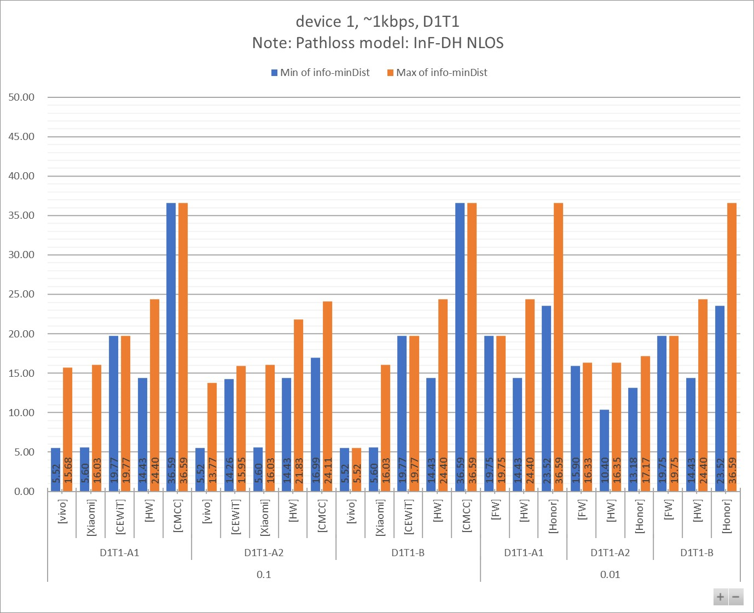

Table 7.1.1.1 - 1

|  |  |  |  |  |  |  |  |  |  |  |  |
| --- | --- | --- | --- | --- | --- | --- | --- | --- | --- | --- | --- |
| info-D2R-datarate-range | ~1kbps |  |  |  |  |  |  |  |  |  |  |
| info-device-type | device 1 |  | **Distance (m)** | |  |  |  |  |  |  |  |
| info-D1T1/D2T2 | D1T1 |  |  |  |  |  |  |  |  |  |  |
| info-pathloss | InF-DH NLOS |  |  |  |  |  |  |  |  |  |  |
|  |  |  |  |  |  |  |  |  |  |  |  |
| **info-D2R_BLER** | **info-DxTx** | **info-Company** | **Min:info-R2D[4B]** | **Max:info-R2D[4B]** | **Min:info-D2R[4B]** | **Max:info-D2R[4B]** | **Min:min(Dist_R2D, Dist_D2R)** | **Max:min(Dist_R2D, Dist_D2R)** | **Min of info-D2R-datarate** | **Max of info-D2R-datarate** | **Count of No.** |
| **0.1** | **D1T1-A1** | [vivo] | 5.52 | 16.57 | 10.14 | 15.68 | 5.52 | 15.68 | 1.06 | 1.07 | 4 |
| [Xiaomi] | 5.60 | 16.03 | 38.70 | 65.50 | 5.60 | 16.03 | 1.14 | 1.14 | 3 |
| [CEWiT] | 19.77 | 19.77 | 45.95 | 86.87 | 19.77 | 19.77 | 1.00 | 1.00 | 6 |
| [HW] | 14.43 | 24.40 | 27.19 | 36.60 | 14.43 | 24.40 | 0.43 | 1.02 | 6 |
| [CMCC] | 36.59 | 36.59 | 58.29 | 135.85 | 36.59 | 36.59 | 0.80 | 0.80 | 4 |
| **D1T1-A2** | [vivo] | 5.52 | 16.57 | 9.73 | 13.77 | 5.52 | 13.77 | 1.06 | 1.07 | 4 |
| [CEWiT] | 19.77 | 19.77 | 14.26 | 15.95 | 14.26 | 15.95 | 1.00 | 1.00 | 6 |
| [Xiaomi] | 5.60 | 16.03 | 23.00 | 23.50 | 5.60 | 16.03 | 1.14 | 1.14 | 3 |
| [HW] | 14.43 | 24.40 | 16.26 | 21.83 | 14.43 | 21.83 | 0.43 | 1.02 | 6 |
| [CMCC] | 36.59 | 36.59 | 16.99 | 24.11 | 16.99 | 24.11 | 0.80 | 0.80 | 4 |
| **D1T1-B** | [vivo] | 5.52 | 5.52 | 12.96 | 14.95 | 5.52 | 5.52 | 1.06 | 1.07 | 2 |
| [Xiaomi] | 5.60 | 16.03 | 184.70 | 184.70 | 5.60 | 16.03 | 1.14 | 1.14 | 2 |
| [CEWiT] | 19.77 | 19.77 | 232.31 | 289.91 | 19.77 | 19.77 | 1.00 | 1.00 | 3 |
| [HW] | 14.43 | 24.40 | 25.29 | 36.39 | 14.43 | 24.40 | 0.43 | 1.02 | 6 |
| [CMCC] | 36.59 | 36.59 | 288.31 | 541.90 | 36.59 | 36.59 | 0.80 | 0.80 | 2 |
| **0.01** | **D1T1-A1** | [FW] | 19.75 | 19.75 | 26.58 | 27.36 | 19.75 | 19.75 | 1.00 | 1.00 | 4 |
| [HW] | 14.43 | 24.40 | 17.39 | 27.41 | 14.43 | 24.40 | 0.43 | 1.02 | 6 |
| [Honor] | 23.52 | 36.59 | 27.58 | 72.69 | 23.52 | 36.59 | 1.10 | 1.10 | 4 |
| **D1T1-A2** | [FW] | 19.75 | 19.75 | 15.90 | 16.33 | 15.90 | 16.33 | 1.00 | 1.00 | 4 |
| [HW] | 14.43 | 24.40 | 10.40 | 16.35 | 10.40 | 16.35 | 0.43 | 1.02 | 6 |
| [Honor] | 23.52 | 36.59 | 13.18 | 17.17 | 13.18 | 17.17 | 1.10 | 1.10 | 4 |
| **D1T1-B** | [FW] | 19.75 | 19.75 | 25.66 | 26.34 | 19.75 | 19.75 | 1.00 | 1.00 | 2 |
| [HW] | 14.43 | 24.40 | 16.18 | 27.25 | 14.43 | 24.40 | 0.43 | 1.02 | 6 |
| [Honor] | 23.52 | 36.59 | 66.97 | 155.89 | 23.52 | 36.59 | 1.10 | 1.10 | 2 |
| **Grand Total** | | | **5.52** | **36.59** | **9.73** | **541.90** | **5.52** | **36.59** | **0.43** | **1.14** | **99** |

Table 7.1.1.1 - 2

|  |  |  |  |  |  |  |  |  |  |
| --- | --- | --- | --- | --- | --- | --- | --- | --- | --- |
| info-D2R-datarate-range | ~1kbps |  |  |  |  |  |  |  |  |
| info-device-type | device 1 |  | **MPL (dB)** | |  |  |  |  |  |
| info-D1T1/D2T2 | D1T1 |  |  |  |  |  |  |  |  |
| info-pathloss | InF-DH NLOS |  |  |  |  |  |  |  |  |
|  |  |  |  |  |  |  |  |  |  |
| **info-D2R_BLER** | **info-DxTx** | **info-Company** | **Min of info-R2D[4A]** | **Max of info-R2D[4A]** | **Min of info-D2R[4A]** | **Max of info-D2R[4A]** | **Min of info-minMPL** | **Max of info-minMPL** | **Count of No.** |
| **0.1** | **D1T1-A1** | [Xiaomi] | 49.10 | 59.10 | 67.48 | 72.48 | 49.10 | 59.10 | 3 |
| [vivo] | 53.10 | 60.10 | 56.38 | 59.65 | 53.10 | 59.65 | 4 |
| [CEWiT] | 61.10 | 61.10 | 69.12 | 75.17 | 61.10 | 61.10 | 6 |
| [HW] | 58.10 | 63.10 | 64.13 | 66.95 | 58.10 | 63.10 | 6 |
| [CMCC] | 67.10 | 67.10 | 71.44 | 79.44 | 67.10 | 67.10 | 4 |
| **D1T1-A2** | [vivo] | 53.10 | 60.10 | 56.11 | 58.61 | 53.10 | 58.61 | 4 |
| [CEWiT] | 61.10 | 61.10 | 57.99 | 59.05 | 57.99 | 59.05 | 6 |
| [Xiaomi] | 49.10 | 59.10 | 62.52 | 62.73 | 49.10 | 59.10 | 3 |
| [HW] | 58.10 | 63.10 | 59.24 | 62.04 | 58.10 | 62.04 | 6 |
| [CMCC] | 67.10 | 67.10 | 60.31 | 63.32 | 60.31 | 63.32 | 4 |
| **D1T1-B** | [vivo] | 53.10 | 53.10 | 58.15 | 59.26 | 53.10 | 53.10 | 2 |
| [Xiaomi] | 49.10 | 59.10 | 82.35 | 82.35 | 49.10 | 59.10 | 2 |
| [CEWiT] | 61.10 | 61.10 | 84.53 | 86.63 | 61.10 | 61.10 | 3 |
| [HW] | 58.10 | 63.10 | 63.44 | 66.90 | 58.10 | 63.10 | 6 |
| [CMCC] | 67.10 | 67.10 | 86.59 | 92.59 | 67.10 | 67.10 | 2 |
| **0.01** | **D1T1-A1** | [FW] | 61.10 | 61.10 | 63.92 | 64.20 | 61.10 | 61.10 | 4 |
| [HW] | 58.10 | 63.10 | 59.88 | 64.20 | 58.10 | 63.10 | 6 |
| [Honor] | 63.10 | 67.10 | 64.52 | 73.52 | 63.10 | 67.10 | 4 |
| **D1T1-A2** | [FW] | 61.10 | 61.10 | 59.04 | 59.29 | 59.04 | 59.29 | 4 |
| [HW] | 58.10 | 63.10 | 54.99 | 59.29 | 54.99 | 59.29 | 6 |
| [Honor] | 63.10 | 67.10 | 58.27 | 60.39 | 58.27 | 60.39 | 4 |
| **D1T1-B** | [FW] | 61.10 | 61.10 | 63.59 | 63.84 | 61.10 | 61.10 | 2 |
| [HW] | 58.10 | 63.10 | 59.19 | 64.15 | 58.10 | 63.10 | 6 |
| [Honor] | 63.10 | 67.10 | 72.75 | 80.75 | 63.10 | 67.10 | 2 |
| **Grand Total** | | | **49.10** | **67.10** | **54.99** | **92.59** | **49.10** | **67.10** | **99** |

**Observations**

#### 7.1.1.2 [5-7kbps]

Figure 7.1.1.2 - 1

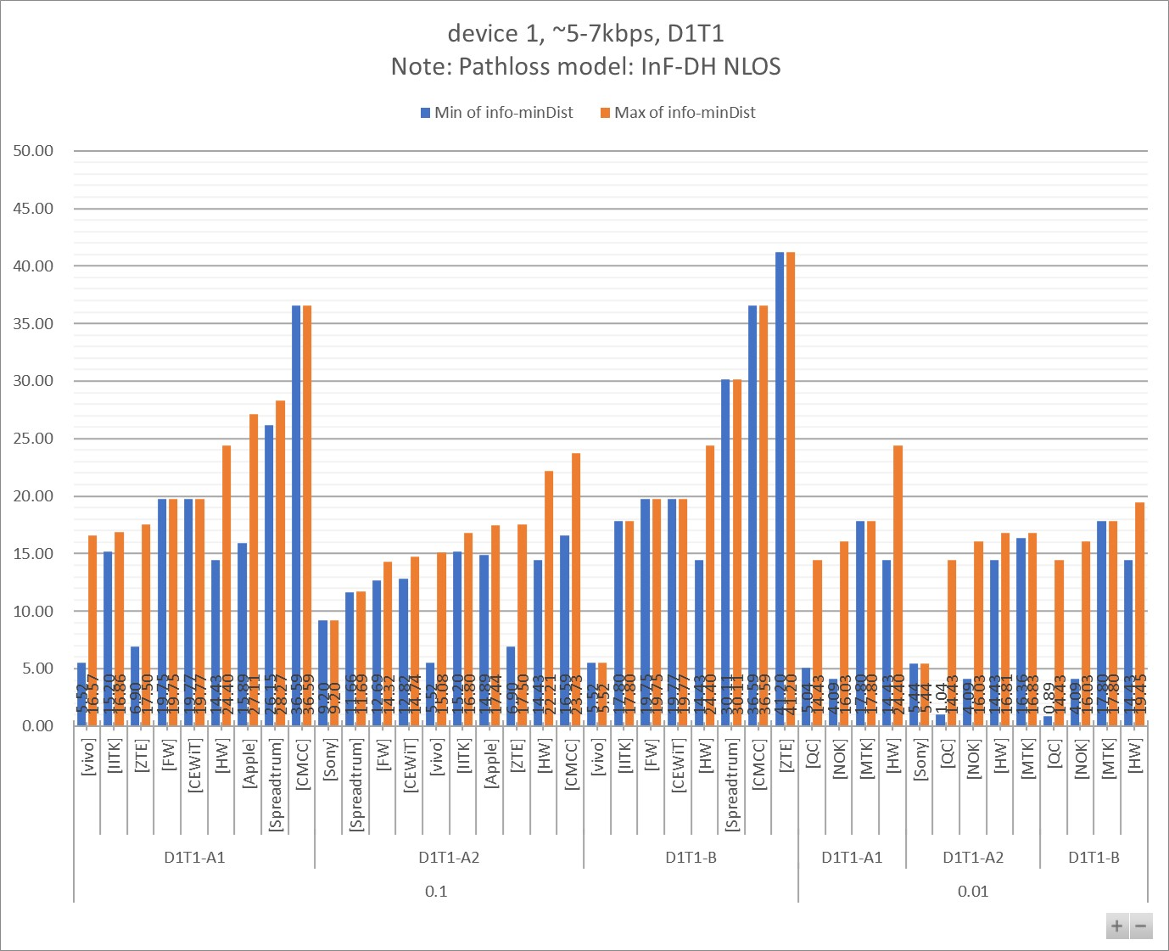

Table 7.1.1.2 - 1

|  |  |  |  |  |  |  |  |  |  |  |  |
| --- | --- | --- | --- | --- | --- | --- | --- | --- | --- | --- | --- |
| info-D2R-datarate-range | ~5-7kbps |  |  |  |  |  |  |  |  |  |  |
| info-device-type | device 1 |  | **Distance (m)** | |  |  |  |  |  |  |  |
| info-D1T1/D2T2 | D1T1 |  |  |  |  |  |  |  |  |  |  |
| info-pathloss | InF-DH NLOS |  |  |  |  |  |  |  |  |  |  |
|  |  |  |  |  |  |  |  |  |  |  |  |
| **info-D2R_BLER** | **info-DxTx** | **info-Company** | **Min:info-R2D[4B]** | **Max:info-R2D[4B]** | **Min:info-D2R[4B]** | **Max:info-D2R[4B]** | **Min:min(Dist_R2D, Dist_D2R)** | **Max:min(Dist_R2D, Dist_D2R)** | **Min of info-D2R-datarate** | **Max of info-D2R-datarate** | **Count of No.** |
| **0.1** | **D1T1-A1** | [vivo] | 5.52 | 16.57 | 8.72 | 16.61 | 5.52 | 16.57 | 5.08 | 5.36 | 4 |
| [IITK] | 17.80 | 17.80 | 15.20 | 16.86 | 15.20 | 16.86 | 7.00 | 7.00 | 4 |
| [ZTE] | 6.90 | 36.60 | 17.20 | 17.50 | 6.90 | 17.50 | 7.00 | 7.00 | 4 |
| [FW] | 19.75 | 19.75 | 21.21 | 23.99 | 19.75 | 19.75 | 6.00 | 6.00 | 3 |
| [CEWiT] | 19.77 | 19.77 | 41.32 | 80.28 | 19.77 | 19.77 | 5.00 | 5.00 | 6 |
| [HW] | 14.43 | 24.40 | 32.32 | 34.85 | 14.43 | 24.40 | 3.00 | 5.80 | 6 |
| [Apple] | 27.11 | 27.11 | 15.89 | 39.62 | 15.89 | 27.11 | 5.00 | 7.00 | 6 |
| [Spreadtrum] | 30.11 | 30.11 | 26.15 | 28.27 | 26.15 | 28.27 | 5.00 | 5.00 | 2 |
| [CMCC] | 36.59 | 36.59 | 37.85 | 88.83 | 36.59 | 36.59 | 6.00 | 6.00 | 4 |
| **D1T1-A2** | [Sony] | 9.47 | 9.47 | 9.20 | 9.20 | 9.20 | 9.20 | 7.50 | 7.50 | 1 |
| [Spreadtrum] | 30.11 | 30.11 | 11.66 | 11.69 | 11.66 | 11.69 | 5.00 | 5.00 | 2 |
| [FW] | 19.75 | 19.75 | 12.69 | 14.32 | 12.69 | 14.32 | 6.00 | 6.00 | 3 |
| [CEWiT] | 19.77 | 19.77 | 12.82 | 14.74 | 12.82 | 14.74 | 5.00 | 5.00 | 6 |
| [vivo] | 5.52 | 16.57 | 8.51 | 15.08 | 5.52 | 15.08 | 5.08 | 5.36 | 4 |
| [IITK] | 17.80 | 17.80 | 15.20 | 16.80 | 15.20 | 16.80 | 7.00 | 7.00 | 4 |
| [Apple] | 27.11 | 27.11 | 14.89 | 17.44 | 14.89 | 17.44 | 5.00 | 7.00 | 2 |
| [ZTE] | 6.90 | 36.60 | 17.20 | 17.50 | 6.90 | 17.50 | 7.00 | 7.00 | 4 |
| [HW] | 14.43 | 24.40 | 20.91 | 22.21 | 14.43 | 22.21 | 3.00 | 5.80 | 6 |
| [CMCC] | 36.59 | 36.59 | 16.59 | 23.73 | 16.59 | 23.73 | 6.00 | 6.00 | 4 |
| **D1T1-B** | [vivo] | 5.52 | 5.52 | 9.89 | 12.40 | 5.52 | 5.52 | 5.08 | 5.36 | 2 |
| [IITK] | 17.80 | 17.80 | 51.10 | 56.60 | 17.80 | 17.80 | 7.00 | 7.00 | 2 |
| [FW] | 19.75 | 19.75 | 20.47 | 23.10 | 19.75 | 19.75 | 6.00 | 6.00 | 2 |
| [CEWiT] | 19.77 | 19.77 | 187.74 | 247.60 | 19.77 | 19.77 | 5.00 | 5.00 | 3 |
| [HW] | 14.43 | 24.40 | 24.25 | 33.55 | 14.43 | 24.40 | 3.00 | 5.80 | 6 |
| [Spreadtrum] | 30.11 | 30.11 | 34.19 | 34.19 | 30.11 | 30.11 | 5.00 | 5.00 | 1 |
| [CMCC] | 36.59 | 36.59 | 123.52 | 232.34 | 36.59 | 36.59 | 6.00 | 6.00 | 2 |
| [ZTE] | 36.60 | 36.60 | 41.20 | 41.20 | 41.20 | 41.20 | 7.00 | 7.00 | 1 |
| **0.01** | **D1T1-A1** | [QC] | 5.60 | 27.11 | 5.04 | 31.72 | 5.04 | 14.43 | 7.50 | 7.50 | 16 |
| [NOK] | 4.09 | 16.03 | 12.54 | 61.03 | 4.09 | 16.03 | 6.43 | 6.43 | 12 |
| [MTK] | 17.80 | 17.80 | 26.05 | 44.06 | 17.80 | 17.80 | 4.67 | 4.67 | 2 |
| [HW] | 14.43 | 24.40 | 23.95 | 26.38 | 14.43 | 24.40 | 3.00 | 5.80 | 6 |
| **D1T1-A2** | [Sony] | 9.47 | 9.47 | 5.44 | 5.44 | 5.44 | 5.44 | 7.50 | 7.50 | 1 |
| [QC] | 5.60 | 27.11 | 1.04 | 31.72 | 1.04 | 14.43 | 7.50 | 7.50 | 16 |
| [NOK] | 4.09 | 16.03 | 18.77 | 36.19 | 4.09 | 16.03 | 6.43 | 6.43 | 12 |
| [HW] | 14.43 | 24.40 | 15.49 | 16.81 | 14.43 | 16.81 | 3.00 | 5.80 | 6 |
| [MTK] | 17.80 | 17.80 | 16.36 | 16.83 | 16.36 | 16.83 | 4.67 | 4.67 | 2 |
| **D1T1-B** | [QC] | 5.60 | 27.11 | 0.89 | 18.71 | 0.89 | 14.43 | 7.50 | 7.50 | 8 |
| [NOK] | 4.09 | 16.03 | 38.76 | 138.32 | 4.09 | 16.03 | 6.43 | 6.43 | 6 |
| [MTK] | 17.80 | 17.80 | 33.92 | 33.92 | 17.80 | 17.80 | 4.67 | 4.67 | 1 |
| [HW] | 14.43 | 24.40 | 17.97 | 25.39 | 14.43 | 19.45 | 3.00 | 5.80 | 6 |
| **Grand Total** | | | **4.09** | **36.60** | **0.89** | **247.60** | **0.89** | **41.20** | **3.00** | **7.50** | **188** |

Table 7.1.1.2 - 2

|  |  |  |  |  |  |  |  |  |  |
| --- | --- | --- | --- | --- | --- | --- | --- | --- | --- |
| info-D2R-datarate-range | ~5-7kbps |  |  |  |  |  |  |  |  |
| info-device-type | device 1 |  | **MPL (dB)** | |  |  |  |  |  |
| info-D1T1/D2T2 | D1T1 |  |  |  |  |  |  |  |  |
| info-pathloss | InF-DH NLOS |  |  |  |  |  |  |  |  |
|  |  |  |  |  |  |  |  |  |  |
| **info-D2R_BLER** | **info-DxTx** | **info-Company** | **Min of info-R2D[4A]** | **Max of info-R2D[4A]** | **Min of info-D2R[4A]** | **Max of info-D2R[4A]** | **Min of info-minMPL** | **Max of info-minMPL** | **Count of No.** |
| **0.1** | **D1T1-A1** | [IITK] | 60.10 | 60.10 | 58.58 | 59.64 | 58.58 | 59.64 | 4 |
| [vivo] | 53.10 | 60.10 | 55.41 | 60.12 | 53.10 | 60.10 | 4 |
| [ZTE] | 54.10 | 67.10 | 59.78 | 60.57 | 60.40 | 60.57 | 4 |
| [FW] | 61.10 | 61.10 | 61.77 | 62.95 | 61.10 | 61.10 | 3 |
| [CEWiT] | 61.10 | 61.10 | 68.11 | 74.42 | 61.10 | 61.10 | 6 |
| [HW] | 58.10 | 63.10 | 65.77 | 66.49 | 58.10 | 63.10 | 6 |
| [Apple] | 64.10 | 64.10 | 59.02 | 67.71 | 59.02 | 64.10 | 6 |
| [Spreadtrum] | 65.10 | 65.10 | 63.76 | 64.50 | 63.76 | 64.50 | 2 |
| [CMCC] | 67.10 | 67.10 | 67.41 | 75.41 | 67.10 | 67.10 | 4 |
| **D1T1-A2** | [Sony] | 54.10 | 54.10 | 53.82 | 53.82 | 53.82 | 53.82 | 1 |
| [Spreadtrum] | 65.10 | 65.10 | 56.08 | 56.10 | 56.08 | 56.10 | 2 |
| [FW] | 61.10 | 61.10 | 56.89 | 58.04 | 56.89 | 58.04 | 3 |
| [CEWiT] | 61.10 | 61.10 | 56.97 | 58.30 | 56.97 | 58.30 | 6 |
| [vivo] | 53.10 | 60.10 | 55.26 | 59.33 | 53.10 | 59.33 | 4 |
| [IITK] | 60.10 | 60.10 | 58.58 | 59.64 | 58.58 | 59.64 | 4 |
| [Apple] | 64.10 | 64.10 | 58.40 | 59.90 | 58.40 | 59.90 | 2 |
| [ZTE] | 54.10 | 67.10 | 59.78 | 60.57 | 60.40 | 60.57 | 4 |
| [HW] | 58.10 | 63.10 | 61.63 | 62.20 | 58.10 | 62.20 | 6 |
| [CMCC] | 67.10 | 67.10 | 60.11 | 63.18 | 60.11 | 63.18 | 4 |
| **D1T1-B** | [vivo] | 53.10 | 53.10 | 56.22 | 57.82 | 53.10 | 53.10 | 2 |
| [IITK] | 60.10 | 60.10 | 70.13 | 71.10 | 60.10 | 60.10 | 2 |
| [FW] | 61.10 | 61.10 | 61.44 | 62.59 | 61.10 | 61.10 | 2 |
| [CEWiT] | 61.10 | 61.10 | 82.50 | 85.13 | 61.10 | 61.10 | 3 |
| [HW] | 58.10 | 63.10 | 63.04 | 66.13 | 58.10 | 63.10 | 6 |
| [Spreadtrum] | 65.10 | 65.10 | 66.31 | 66.31 | 65.10 | 65.10 | 1 |
| [ZTE] | 67.10 | 67.10 | 68.20 | 68.20 | 67.10 | 67.10 | 1 |
| [CMCC] | 67.10 | 67.10 | 78.54 | 84.54 | 67.10 | 67.10 | 2 |
| **0.01** | **D1T1-A1** | [QC] | 49.10 | 64.10 | 48.09 | 65.59 | 48.09 | 58.10 | 16 |
| [NOK] | 46.10 | 59.10 | 56.77 | 71.82 | 46.10 | 59.10 | 12 |
| [MTK] | 60.10 | 60.10 | 63.72 | 68.72 | 60.10 | 60.10 | 2 |
| [HW] | 58.10 | 63.10 | 62.92 | 63.84 | 58.10 | 63.10 | 6 |
| **D1T1-A2** | [Sony] | 54.10 | 54.10 | 48.82 | 48.82 | 48.82 | 48.82 | 1 |
| [QC] | 49.10 | 64.10 | 33.10 | 65.59 | 33.10 | 58.10 | 16 |
| [NOK] | 46.10 | 59.10 | 60.60 | 66.85 | 46.10 | 59.10 | 12 |
| [HW] | 58.10 | 63.10 | 58.78 | 59.55 | 58.10 | 59.55 | 6 |
| [MTK] | 60.10 | 60.10 | 59.30 | 59.57 | 59.30 | 59.57 | 2 |
| **D1T1-B** | [QC] | 49.10 | 64.10 | 31.58 | 60.57 | 31.58 | 58.10 | 8 |
| [NOK] | 46.10 | 59.10 | 67.50 | 79.60 | 46.10 | 59.10 | 6 |
| [MTK] | 60.10 | 60.10 | 66.23 | 66.23 | 60.10 | 60.10 | 1 |
| [HW] | 58.10 | 63.10 | 60.19 | 63.48 | 58.10 | 60.94 | 6 |
| **Grand Total** | | | **46.10** | **67.10** | **31.58** | **85.13** | **31.58** | **67.10** | **188** |

#### 7.1.1.3 other data rate

Figure 7.1.1.3 - 1

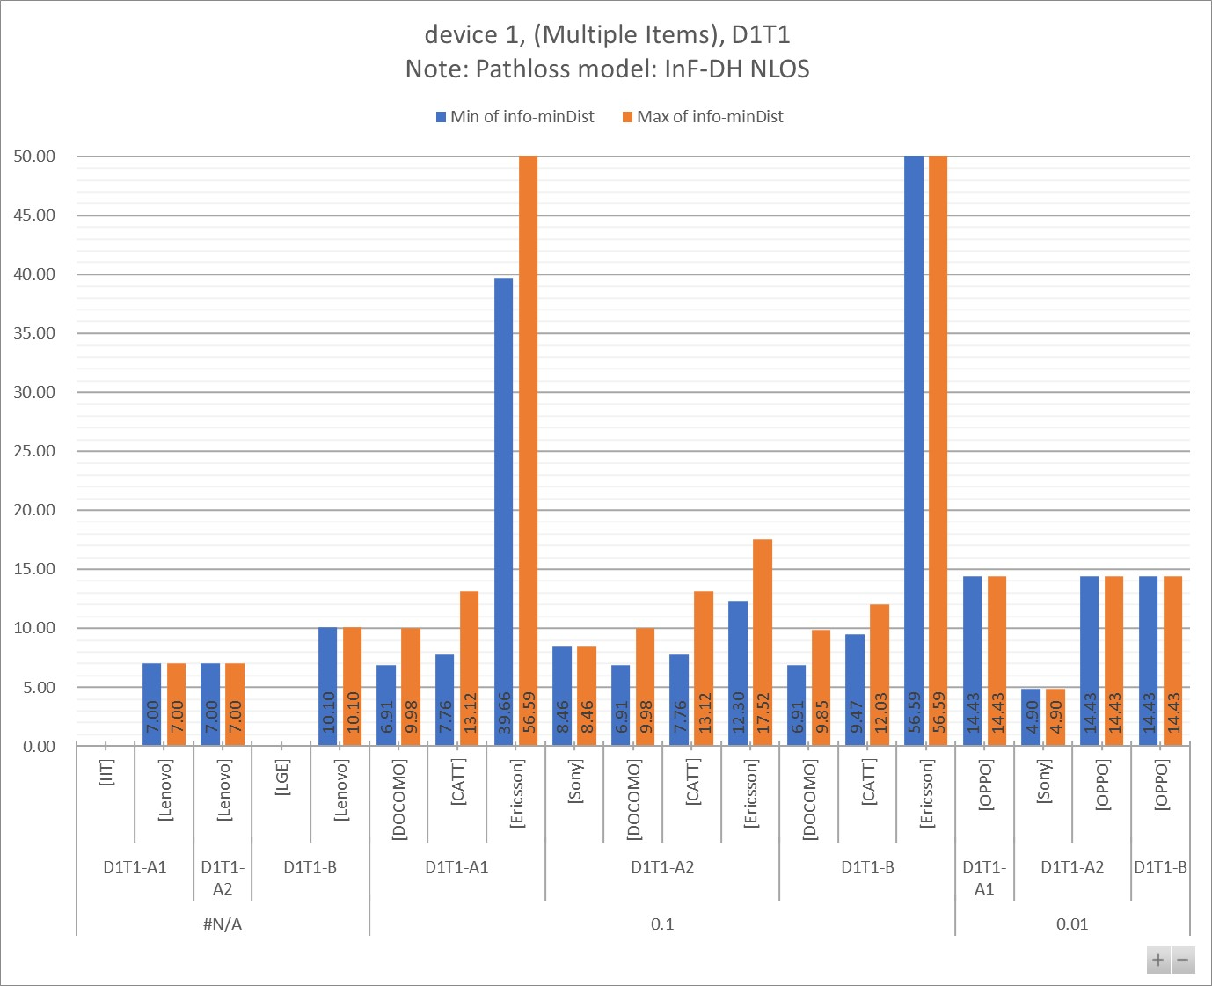

Table 7.1.1.3 - 1

|  |  |  |  |  |  |  |  |  |  |  |  |
| --- | --- | --- | --- | --- | --- | --- | --- | --- | --- | --- | --- |
| info-D2R-datarate-range | (Multiple Items) |  |  |  |  |  |  |  |  |  |  |
| info-device-type | device 1 |  | **Distance (m)** | |  |  |  |  |  |  |  |
| info-D1T1/D2T2 | D1T1 |  |  |  |  |  |  |  |  |  |  |
| info-pathloss | InF-DH NLOS |  |  |  |  |  |  |  |  |  |  |
|  |  |  |  |  |  |  |  |  |  |  |  |
| **info-D2R_BLER** | **info-DxTx** | **info-Company** | **Min:info-R2D[4B]** | **Max:info-R2D[4B]** | **Min:info-D2R[4B]** | **Max:info-D2R[4B]** | **Min:min(Dist_R2D, Dist_D2R)** | **Max:min(Dist_R2D, Dist_D2R)** | **Min of info-D2R-datarate** | **Max of info-D2R-datarate** | **Count of No.** |
| **#N/A** | **D1T1-A1** | [IIT] |  |  |  |  |  |  | #N/A | #N/A | 1 |
| [Lenovo] | 7.00 | 7.00 | 19.60 | 39.10 | 7.00 | 7.00 | #N/A | #N/A | 2 |
| **D1T1-A2** | [Lenovo] | 7.00 | 7.00 | 7.10 | 7.10 | 7.00 | 7.00 | #N/A | #N/A | 1 |
| **D1T1-B** | [LGE] | #VALUE! | #VALUE! |  |  |  |  | #N/A | #N/A | 2 |
| [Lenovo] | 10.10 | 10.10 | 24.00 | 93.10 | 10.10 | 10.10 | #N/A | #N/A | 2 |
| **0.1** | **D1T1-A1** | [DOCOMO] | 6.91 | 17.80 | 7.45 | 9.98 | 6.91 | 9.98 | 28.00 | 28.00 | 8 |
| [CATT] | 9.47 | 27.11 | 7.76 | 13.12 | 7.76 | 13.12 | 44.80 | 44.80 | 2 |
| [Ericsson] | 56.59 | 56.59 | 39.66 | 95.43 | 39.66 | 56.59 | 16.00 | 48.00 | 12 |
| **D1T1-A2** | [Sony] | 9.47 | 9.47 | 8.46 | 8.46 | 8.46 | 8.46 | 15.00 | 15.00 | 1 |
| [DOCOMO] | 6.91 | 17.80 | 7.45 | 9.98 | 6.91 | 9.98 | 28.00 | 28.00 | 8 |
| [CATT] | 9.47 | 27.11 | 7.76 | 13.12 | 7.76 | 13.12 | 44.80 | 44.80 | 2 |
| [Ericsson] | 56.59 | 56.59 | 12.30 | 17.52 | 12.30 | 17.52 | 16.00 | 48.00 | 12 |
| **D1T1-B** | [DOCOMO] | 6.91 | 17.80 | 7.34 | 9.85 | 6.91 | 9.85 | 28.00 | 28.00 | 4 |
| [CATT] | 9.47 | 27.11 | 12.03 | 12.03 | 9.47 | 12.03 | 44.80 | 44.80 | 2 |
| [Ericsson] | 56.59 | 56.59 | 157.32 | 318.21 | 56.59 | 56.59 | 16.00 | 48.00 | 6 |
| **0.01** | **D1T1-A1** | [OPPO] | 14.43 | 14.43 | 29.92 | 29.92 | 14.43 | 14.43 | 0.00 | 0.00 | 1 |
| **D1T1-A2** | [Sony] | 9.47 | 9.47 | 4.90 | 4.90 | 4.90 | 4.90 | 15.00 | 15.00 | 1 |
| [OPPO] | 14.43 | 14.43 | 17.79 | 17.79 | 14.43 | 14.43 | 0.00 | 0.00 | 1 |
| **D1T1-B** | [OPPO] | 14.43 | 14.43 | 25.32 | 25.32 | 14.43 | 14.43 | 0.00 | 0.00 | 1 |
| **Grand Total** | | | **#VALUE!** | **#VALUE!** | **4.90** | **318.21** | **4.90** | **56.59** | **#N/A** | **#N/A** | **69** |

Table 7.1.1.3 - 2

|  |  |  |  |  |  |  |  |  |  |
| --- | --- | --- | --- | --- | --- | --- | --- | --- | --- |
| info-D2R-datarate-range | (Multiple Items) |  |  |  |  |  |  |  |  |
| info-device-type | device 1 |  | **MPL (dB)** | |  |  |  |  |  |
| info-D1T1/D2T2 | D1T1 |  |  |  |  |  |  |  |  |
| info-pathloss | InF-DH NLOS |  |  |  |  |  |  |  |  |
|  |  |  |  |  |  |  |  |  |  |
| **info-D2R_BLER** | **info-DxTx** | **info-Company** | **Min of info-R2D[4A]** | **Max of info-R2D[4A]** | **Min of info-D2R[4A]** | **Max of info-D2R[4A]** | **Min of info-minMPL** | **Max of info-minMPL** | **Count of No.** |
| **#N/A** | **D1T1-A1** | [IIT] |  |  |  |  |  |  | 1 |
| [Lenovo] | 60.30 | 60.30 | 55.50 | 61.50 |  |  | 2 |
| **D1T1-A2** | [Lenovo] | 60.30 | 60.30 | 47.00 | 47.00 |  |  | 1 |
| **D1T1-B** | [LGE] | 44.10 | 48.10 |  |  |  |  | 2 |
| [Lenovo] | 64.00 | 64.00 | 62.90 | 74.90 |  |  | 2 |
| **0.1** | **D1T1-A1** | [DOCOMO] | 51.10 | 60.10 | 51.81 | 54.59 | 51.10 | 54.59 | 8 |
| [CATT] | 54.10 | 64.10 | 52.20 | 57.20 | 52.20 | 57.20 | 2 |
| [Ericsson] | 71.10 | 71.10 | 67.72 | 76.07 | 67.72 | 71.10 | 12 |
| **D1T1-A2** | [Sony] | 54.10 | 54.10 | 53.02 | 53.02 | 53.02 | 53.02 | 1 |
| [DOCOMO] | 51.10 | 60.10 | 51.81 | 54.59 | 51.10 | 54.59 | 8 |
| [CATT] | 54.10 | 64.10 | 52.20 | 57.20 | 52.20 | 57.20 | 2 |
| [Ericsson] | 71.10 | 71.10 | 56.59 | 59.95 | 56.59 | 59.95 | 12 |
| **D1T1-B** | [DOCOMO] | 51.10 | 60.10 | 51.67 | 54.47 | 51.10 | 54.47 | 4 |
| [CATT] | 54.10 | 64.10 | 56.38 | 56.38 | 54.10 | 56.38 | 2 |
| [Ericsson] | 71.10 | 71.10 | 80.82 | 87.52 | 71.10 | 71.10 | 6 |
| **0.01** | **D1T1-A1** | [OPPO] | 58.10 | 58.10 | 65.04 | 65.04 | 58.10 | 58.10 | 1 |
| **D1T1-A2** | [Sony] | 54.10 | 54.10 | 47.82 | 47.82 | 47.82 | 47.82 | 1 |
| [OPPO] | 58.10 | 58.10 | 60.09 | 60.09 | 58.10 | 58.10 | 1 |
| **D1T1-B** | [OPPO] | 58.10 | 58.10 | 63.45 | 63.45 | 58.10 | 58.10 | 1 |
| **Grand Total** | | | **44.10** | **71.10** | **47.00** | **87.52** | **47.82** | **71.10** | **69** |

### 7.1.2 Device 2a

#### 7.1.2.1 [1kbps]

Figure 7.1.2.1 - 1

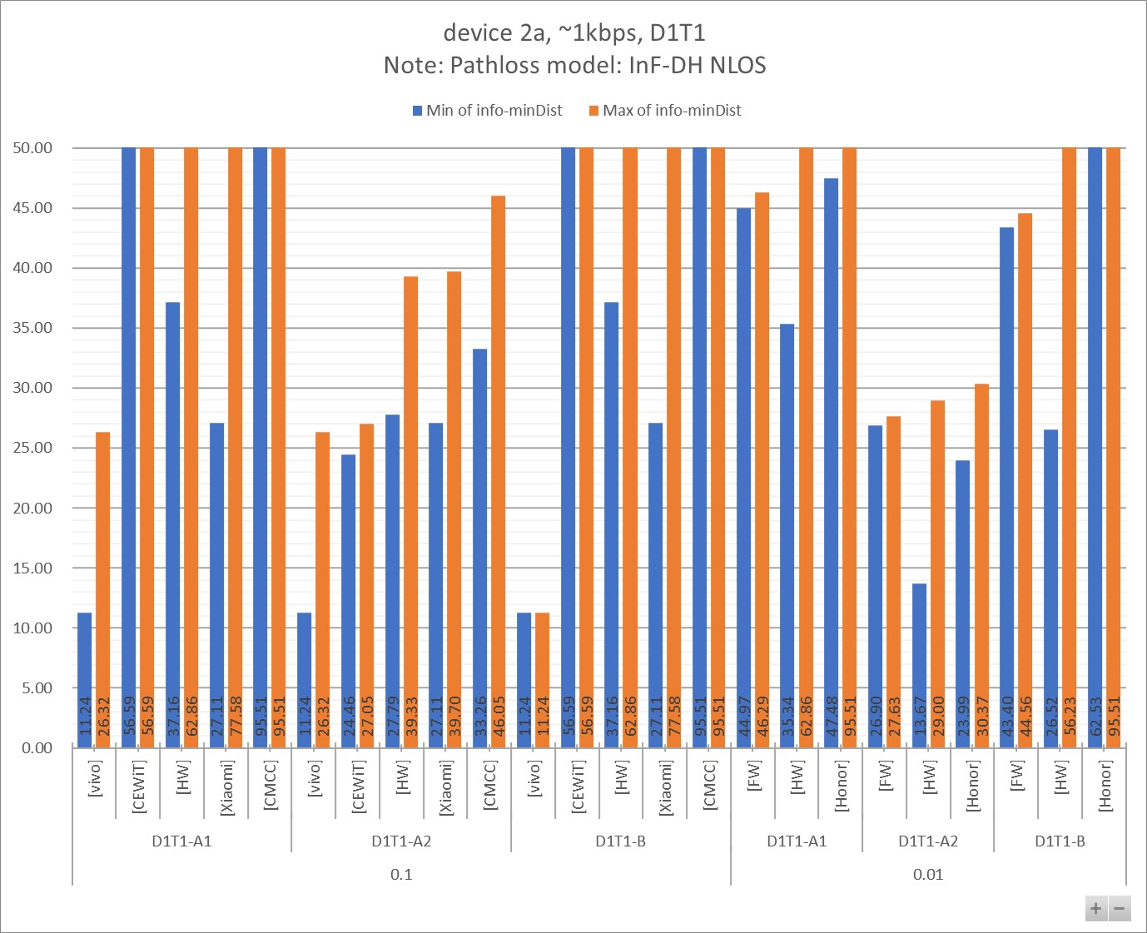

Table 7.1.2.1 - 1

|  |  |  |  |  |  |  |  |  |  |  |  |
| --- | --- | --- | --- | --- | --- | --- | --- | --- | --- | --- | --- |
| info-D2R-datarate-range | ~1kbps |  |  |  |  |  |  |  |  |  |  |
| info-device-type | device 2a |  | **Distance (m)** | |  |  |  |  |  |  |  |
| info-D1T1/D2T2 | D1T1 |  |  |  |  |  |  |  |  |  |  |
| info-pathloss | InF-DH NLOS |  |  |  |  |  |  |  |  |  |  |
|  |  |  |  |  |  |  |  |  |  |  |  |
| **info-D2R_BLER** | **info-DxTx** | **info-Company** | **Min:info-R2D[4B]** | **Max:info-R2D[4B]** | **Min:info-D2R[4B]** | **Max:info-D2R[4B]** | **Min:min(Dist_R2D, Dist_D2R)** | **Max:min(Dist_R2D, Dist_D2R)** | **Min of info-D2R-datarate** | **Max of info-D2R-datarate** | **Count of No.** |
| **0.1** | **D1T1-A1** | [vivo] | 11.24 | 26.32 | 21.53 | 31.02 | 11.24 | 26.32 | 1.06 | 1.07 | 4 |
| [CEWiT] | 56.59 | 56.59 | 78.86 | 147.34 | 56.59 | 56.59 | 1.00 | 1.00 | 6 |
| [HW] | 37.16 | 62.86 | 71.86 | 103.48 | 37.16 | 62.86 | 0.43 | 1.02 | 6 |
| [Xiaomi] | 27.11 | 77.58 | 65.50 | 110.70 | 27.11 | 77.58 | 1.14 | 1.14 | 3 |
| [CMCC] | 95.51 | 95.51 | 109.04 | 253.22 | 95.51 | 95.51 | 0.80 | 0.80 | 4 |
| **D1T1-A2** | [vivo] | 11.24 | 26.32 | 20.86 | 27.68 | 11.24 | 26.32 | 1.06 | 1.07 | 4 |
| [CEWiT] | 56.59 | 56.59 | 24.46 | 27.05 | 24.46 | 27.05 | 1.00 | 1.00 | 6 |
| [HW] | 37.16 | 62.86 | 27.79 | 39.33 | 27.79 | 39.33 | 0.43 | 1.02 | 6 |
| [Xiaomi] | 27.11 | 77.58 | 38.80 | 39.70 | 27.11 | 39.70 | 1.14 | 1.14 | 3 |
| [CMCC] | 95.51 | 95.51 | 33.26 | 46.05 | 33.26 | 46.05 | 0.80 | 0.80 | 4 |
| **D1T1-B** | [vivo] | 11.24 | 11.24 | 50.15 | 51.96 | 11.24 | 11.24 | 1.06 | 1.07 | 2 |
| [CEWiT] | 56.59 | 56.59 | 683.67 | 834.00 | 56.59 | 56.59 | 1.00 | 1.00 | 3 |
| [HW] | 37.16 | 62.86 | 53.92 | 99.60 | 37.16 | 62.86 | 0.43 | 1.02 | 6 |
| [Xiaomi] | 27.11 | 77.58 | 528.70 | 528.70 | 27.11 | 77.58 | 1.14 | 1.14 | 2 |
| [CMCC] | 95.51 | 95.51 | 1000.34 | 1879.87 | 95.51 | 95.51 | 0.80 | 0.80 | 2 |
| **0.01** | **D1T1-A1** | [FW] | 56.53 | 56.53 | 44.97 | 46.29 | 44.97 | 46.29 | 1.00 | 1.00 | 4 |
| [HW] | 37.16 | 62.86 | 35.34 | 76.28 | 35.34 | 62.86 | 0.43 | 1.02 | 6 |
| [Honor] | 62.53 | 95.51 | 47.48 | 123.29 | 47.48 | 95.51 | 1.10 | 1.10 | 4 |
| **D1T1-A2** | [FW] | 56.53 | 56.53 | 26.90 | 27.63 | 26.90 | 27.63 | 1.00 | 1.00 | 4 |
| [HW] | 37.16 | 62.86 | 13.67 | 29.00 | 13.67 | 29.00 | 0.43 | 1.02 | 6 |
| [Honor] | 62.53 | 95.51 | 23.99 | 30.37 | 23.99 | 30.37 | 1.10 | 1.10 | 4 |
| **D1T1-B** | [FW] | 56.53 | 56.53 | 43.40 | 44.56 | 43.40 | 44.56 | 1.00 | 1.00 | 2 |
| [HW] | 37.16 | 62.86 | 26.52 | 73.42 | 26.52 | 56.23 | 0.43 | 1.02 | 6 |
| [Honor] | 62.53 | 95.51 | 192.43 | 446.45 | 62.53 | 95.51 | 1.10 | 1.10 | 2 |
| **Grand Total** | | | **11.24** | **95.51** | **13.67** | **1879.87** | **11.24** | **95.51** | **0.43** | **1.14** | **99** |

Table 7.1.2.1 - 2

|  |  |  |  |  |  |  |  |  |  |
| --- | --- | --- | --- | --- | --- | --- | --- | --- | --- |
| info-D2R-datarate-range | ~1kbps |  |  |  |  |  |  |  |  |
| info-device-type | device 2a |  | **MPL (dB)** | |  |  |  |  |  |
| info-D1T1/D2T2 | D1T1 |  |  |  |  |  |  |  |  |
| info-pathloss | InF-DH NLOS |  |  |  |  |  |  |  |  |
|  |  |  |  |  |  |  |  |  |  |
| **info-D2R_BLER** | **info-DxTx** | **info-Company** | **Min of info-R2D[4A]** | **Max of info-R2D[4A]** | **Min of info-D2R[4A]** | **Max of info-D2R[4A]** | **Min of info-minMPL** | **Max of info-minMPL** | **Count of No.** |
| **0.1** | **D1T1-A1** | [vivo] | 57.10 | 64.10 | 62.32 | 65.59 | 57.10 | 64.10 | 4 |
| [CEWiT] | 71.10 | 71.10 | 74.25 | 80.20 | 71.10 | 71.10 | 6 |
| [HW] | 67.10 | 72.10 | 73.37 | 76.84 | 67.10 | 72.10 | 6 |
| [Xiaomi] | 64.10 | 74.10 | 72.48 | 77.48 | 64.10 | 74.10 | 3 |
| [CMCC] | 76.10 | 76.10 | 77.35 | 85.35 | 76.10 | 76.10 | 4 |
| **D1T1-A2** | [CEWiT] | 71.10 | 71.10 | 63.12 | 64.08 | 63.12 | 64.08 | 6 |
| [vivo] | 57.10 | 64.10 | 62.05 | 64.55 | 57.10 | 64.10 | 4 |
| [HW] | 67.10 | 72.10 | 64.34 | 67.64 | 64.34 | 67.64 | 6 |
| [Xiaomi] | 64.10 | 74.10 | 67.52 | 67.73 | 64.10 | 67.73 | 3 |
| [CMCC] | 76.10 | 76.10 | 66.22 | 69.23 | 66.22 | 69.23 | 4 |
| **D1T1-B** | [vivo] | 57.10 | 57.10 | 70.03 | 70.36 | 57.10 | 57.10 | 2 |
| [CEWiT] | 71.10 | 71.10 | 94.79 | 96.68 | 71.10 | 71.10 | 3 |
| [HW] | 67.10 | 72.10 | 70.64 | 76.48 | 67.10 | 72.10 | 6 |
| [Xiaomi] | 64.10 | 74.10 | 92.35 | 92.35 | 64.10 | 74.10 | 2 |
| [CMCC] | 76.10 | 76.10 | 98.42 | 104.42 | 76.10 | 76.10 | 2 |
| **0.01** | **D1T1-A1** | [FW] | 71.10 | 71.10 | 68.92 | 69.20 | 68.92 | 69.20 | 4 |
| [HW] | 67.10 | 72.10 | 66.62 | 73.94 | 66.62 | 72.10 | 6 |
| [Honor] | 72.10 | 76.10 | 69.52 | 78.52 | 69.52 | 76.10 | 4 |
| **D1T1-A2** | [FW] | 71.10 | 71.10 | 64.04 | 64.29 | 64.04 | 64.29 | 4 |
| [HW] | 67.10 | 72.10 | 57.59 | 64.74 | 57.59 | 64.74 | 6 |
| [Honor] | 72.10 | 76.10 | 63.27 | 65.39 | 63.27 | 65.39 | 4 |
| **D1T1-B** | [FW] | 71.10 | 71.10 | 68.59 | 68.84 | 68.59 | 68.84 | 2 |
| [HW] | 67.10 | 72.10 | 63.89 | 73.58 | 63.89 | 71.04 | 6 |
| [Honor] | 72.10 | 76.10 | 82.75 | 90.75 | 72.10 | 76.10 | 2 |
| **Grand Total** | | | **57.10** | **76.10** | **57.59** | **104.42** | **57.10** | **76.10** | **99** |

#### 7.1.2.2 [5-7kbps]

Figure 7.1.2.2 - 1

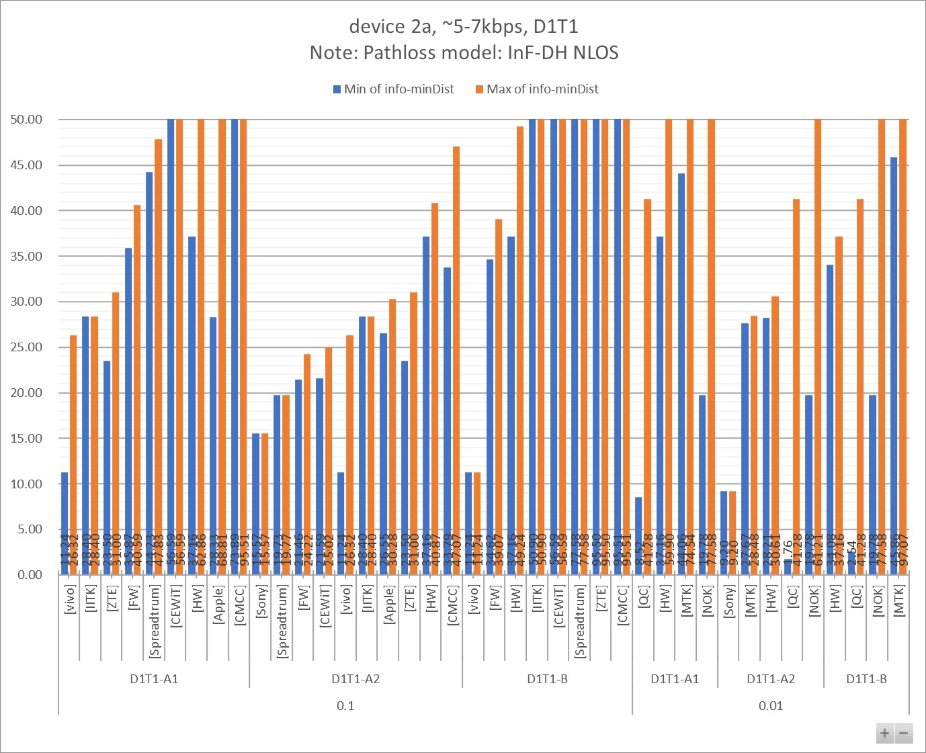

Table 7.1.2.2 - 1

|  |  |  |  |  |  |  |  |  |  |  |  |
| --- | --- | --- | --- | --- | --- | --- | --- | --- | --- | --- | --- |
| info-D2R-datarate-range | ~5-7kbps |  |  |  |  |  |  |  |  |  |  |
| info-device-type | device 2a |  | **Distance (m)** | |  |  |  |  |  |  |  |
| info-D1T1/D2T2 | D1T1 |  |  |  |  |  |  |  |  |  |  |
| info-pathloss | InF-DH NLOS |  |  |  |  |  |  |  |  |  |  |
|  |  |  |  |  |  |  |  |  |  |  |  |
| **info-D2R_BLER** | **info-DxTx** | **info-Company** | **Min:info-R2D[4B]** | **Max:info-R2D[4B]** | **Min:info-D2R[4B]** | **Max:info-D2R[4B]** | **Min:min(Dist_R2D, Dist_D2R)** | **Max:min(Dist_R2D, Dist_D2R)** | **Min of info-D2R-datarate** | **Max of info-D2R-datarate** | **Count of No.** |
| **0.1** | **D1T1-A1** | [vivo] | 11.24 | 26.32 | 17.53 | 29.63 | 11.24 | 26.32 | 5.08 | 5.36 | 4 |
| [IITK] | 50.90 | 50.90 | 27.00 | 28.50 | 28.40 | 28.40 | 7.00 | 7.00 | 4 |
| [ZTE] | 23.50 | 95.50 | 28.40 | 31.00 | 23.50 | 31.00 | 7.00 | 7.00 | 4 |
| [FW] | 56.53 | 56.53 | 35.87 | 40.59 | 35.87 | 40.59 | 6.00 | 6.00 | 4 |
| [Spreadtrum] | 77.58 | 77.58 | 44.23 | 47.83 | 44.23 | 47.83 | 5.00 | 5.00 | 2 |
| [CEWiT] | 56.59 | 56.59 | 69.61 | 136.28 | 56.59 | 56.59 | 5.00 | 5.00 | 6 |
| [HW] | 37.16 | 62.86 | 70.00 | 79.98 | 37.16 | 62.86 | 3.00 | 5.80 | 6 |
| [Apple] | 69.83 | 69.83 | 28.33 | 68.81 | 28.33 | 68.81 | 5.00 | 7.00 | 6 |
| [CMCC] | 95.51 | 95.51 | 73.89 | 171.89 | 73.89 | 95.51 | 6.00 | 6.00 | 4 |
| **D1T1-A2** | [Sony] | 27.11 | 27.11 | 15.57 | 15.57 | 15.57 | 15.57 | 7.50 | 7.50 | 1 |
| [Spreadtrum] | 77.58 | 77.58 | 19.73 | 19.77 | 19.73 | 19.77 | 5.00 | 5.00 | 2 |
| [FW] | 56.53 | 56.53 | 21.46 | 24.22 | 21.46 | 24.22 | 6.00 | 6.00 | 4 |
| [CEWiT] | 56.59 | 56.59 | 21.59 | 25.02 | 21.59 | 25.02 | 5.00 | 5.00 | 6 |
| [vivo] | 11.24 | 26.32 | 17.21 | 27.15 | 11.24 | 26.32 | 5.08 | 5.36 | 4 |
| [IITK] | 50.90 | 50.90 | 27.00 | 28.50 | 28.40 | 28.40 | 7.00 | 7.00 | 4 |
| [Apple] | 69.83 | 69.83 | 26.55 | 30.28 | 26.55 | 30.28 | 5.00 | 7.00 | 2 |
| [ZTE] | 23.50 | 95.50 | 28.40 | 31.00 | 23.50 | 31.00 | 7.00 | 7.00 | 4 |
| [HW] | 37.16 | 62.86 | 37.28 | 40.87 | 37.16 | 40.87 | 3.00 | 5.80 | 6 |
| [CMCC] | 95.51 | 95.51 | 33.79 | 47.07 | 33.79 | 47.07 | 6.00 | 6.00 | 4 |
| **D1T1-B** | [vivo] | 11.24 | 11.24 | 34.34 | 39.96 | 11.24 | 11.24 | 5.08 | 5.36 | 2 |
| [FW] | 56.53 | 56.53 | 34.62 | 39.07 | 34.62 | 39.07 | 6.00 | 6.00 | 2 |
| [HW] | 37.16 | 62.86 | 45.03 | 73.14 | 37.16 | 49.24 | 3.00 | 5.80 | 6 |
| [IITK] | 50.90 | 50.90 | 160.20 | 160.20 | 50.90 | 50.90 | 7.00 | 7.00 | 2 |
| [CEWiT] | 56.59 | 56.59 | 532.71 | 713.41 | 56.59 | 56.59 | 5.00 | 5.00 | 3 |
| [Spreadtrum] | 77.58 | 77.58 | 97.83 | 97.83 | 77.58 | 77.58 | 5.00 | 5.00 | 1 |
| [ZTE] | 95.50 | 95.50 | 119.20 | 119.20 | 95.50 | 95.50 | 7.00 | 7.00 | 1 |
| [CMCC] | 95.51 | 95.51 | 461.29 | 866.91 | 95.51 | 95.51 | 6.00 | 6.00 | 2 |
| **0.01** | **D1T1-A1** | [QC] | 16.03 | 69.83 | 8.52 | 53.66 | 8.52 | 41.28 | 7.50 | 7.50 | 16 |
| [HW] | 37.16 | 62.86 | 52.98 | 59.90 | 37.16 | 59.90 | 3.00 | 5.80 | 6 |
| [MTK] | 45.86 | 485.75 | 44.06 | 74.54 | 44.06 | 74.54 | 4.67 | 4.67 | 4 |
| [NOK] | 19.78 | 77.58 | 21.21 | 103.24 | 19.78 | 77.58 | 6.43 | 6.43 | 12 |
| **D1T1-A2** | [Sony] | 27.11 | 27.11 | 9.20 | 9.20 | 9.20 | 9.20 | 7.50 | 7.50 | 1 |
| [MTK] | 45.86 | 485.75 | 27.67 | 28.48 | 27.67 | 28.48 | 4.67 | 4.67 | 4 |
| [HW] | 37.16 | 62.86 | 28.21 | 30.61 | 28.21 | 30.61 | 3.00 | 5.80 | 6 |
| [QC] | 16.03 | 69.83 | 1.76 | 53.66 | 1.76 | 41.28 | 7.50 | 7.50 | 16 |
| [NOK] | 19.78 | 77.58 | 31.75 | 61.21 | 19.78 | 61.21 | 6.43 | 6.43 | 12 |
| **D1T1-B** | [HW] | 37.16 | 62.86 | 34.08 | 54.78 | 34.08 | 37.16 | 3.00 | 5.80 | 6 |
| [QC] | 16.03 | 69.83 | 2.54 | 53.55 | 2.54 | 41.28 | 7.50 | 7.50 | 8 |
| [NOK] | 19.78 | 77.58 | 110.92 | 395.83 | 19.78 | 77.58 | 6.43 | 6.43 | 6 |
| [MTK] | 45.86 | 485.75 | 97.07 | 97.07 | 45.86 | 97.07 | 4.67 | 4.67 | 2 |
| **Grand Total** | | | **11.24** | **485.75** | **1.76** | **866.91** | **1.76** | **97.07** | **3.00** | **7.50** | **195** |

Table 7.1.2.2 - 2

|  |  |  |  |  |  |  |  |  |  |
| --- | --- | --- | --- | --- | --- | --- | --- | --- | --- |
| info-D2R-datarate-range | ~5-7kbps |  |  |  |  |  |  |  |  |
| info-device-type | device 2a |  | **MPL (dB)** | |  |  |  |  |  |
| info-D1T1/D2T2 | D1T1 |  |  |  |  |  |  |  |  |
| info-pathloss | InF-DH NLOS |  |  |  |  |  |  |  |  |
|  |  |  |  |  |  |  |  |  |  |
| **info-D2R_BLER** | **info-DxTx** | **info-Company** | **Min of info-R2D[4A]** | **Max of info-R2D[4A]** | **Min of info-D2R[4A]** | **Max of info-D2R[4A]** | **Min of info-minMPL** | **Max of info-minMPL** | **Count of No.** |
| **0.1** | **D1T1-A1** | [vivo] | 57.10 | 64.10 | 60.56 | 65.17 | 57.10 | 64.10 | 4 |
| [IITK] | 70.10 | 70.10 | 64.05 | 64.55 | 64.55 | 64.55 | 4 |
| [ZTE] | 63.10 | 76.10 | 64.78 | 65.57 | 63.10 | 65.57 | 4 |
| [FW] | 71.10 | 71.10 | 66.77 | 67.95 | 66.77 | 67.95 | 4 |
| [Spreadtrum] | 74.10 | 74.10 | 68.76 | 69.50 | 68.76 | 69.50 | 2 |
| [CEWiT] | 71.10 | 71.10 | 73.07 | 79.45 | 71.10 | 71.10 | 6 |
| [HW] | 67.10 | 72.10 | 73.12 | 74.39 | 67.10 | 72.10 | 6 |
| [Apple] | 73.10 | 73.10 | 64.52 | 72.96 | 64.52 | 72.96 | 6 |
| [CMCC] | 76.10 | 76.10 | 73.67 | 81.67 | 73.67 | 76.10 | 4 |
| **D1T1-A2** | [Sony] | 64.10 | 64.10 | 58.82 | 58.82 | 58.82 | 58.82 | 1 |
| [Spreadtrum] | 74.10 | 74.10 | 61.08 | 61.10 | 61.08 | 61.10 | 2 |
| [FW] | 71.10 | 71.10 | 61.89 | 63.04 | 61.89 | 63.04 | 4 |
| [CEWiT] | 71.10 | 71.10 | 61.93 | 63.33 | 61.93 | 63.33 | 6 |
| [vivo] | 57.10 | 64.10 | 60.41 | 64.38 | 57.10 | 64.10 | 4 |
| [IITK] | 70.10 | 70.10 | 64.05 | 64.55 | 64.55 | 64.55 | 4 |
| [Apple] | 73.10 | 73.10 | 63.90 | 65.15 | 63.90 | 65.15 | 2 |
| [ZTE] | 63.10 | 76.10 | 64.78 | 65.57 | 63.10 | 65.57 | 4 |
| [HW] | 67.10 | 72.10 | 67.13 | 68.00 | 67.10 | 68.00 | 6 |
| [CMCC] | 76.10 | 76.10 | 66.37 | 69.44 | 66.37 | 69.44 | 4 |
| **D1T1-B** | [vivo] | 57.10 | 57.10 | 66.52 | 67.92 | 57.10 | 57.10 | 2 |
| [FW] | 71.10 | 71.10 | 66.44 | 67.59 | 66.44 | 67.59 | 2 |
| [HW] | 67.10 | 72.10 | 68.93 | 73.54 | 67.10 | 69.78 | 6 |
| [IITK] | 70.10 | 70.10 | 81.00 | 81.00 | 70.10 | 70.10 | 2 |
| [CEWiT] | 71.10 | 71.10 | 92.42 | 95.20 | 71.10 | 71.10 | 3 |
| [Spreadtrum] | 74.10 | 74.10 | 76.31 | 76.31 | 74.10 | 74.10 | 1 |
| [ZTE] | 76.10 | 76.10 | 78.20 | 78.20 | 76.10 | 76.10 | 1 |
| [CMCC] | 76.10 | 76.10 | 91.06 | 97.06 | 76.10 | 76.10 | 2 |
| **0.01** | **D1T1-A1** | [QC] | 59.10 | 73.10 | 53.09 | 70.59 | 53.09 | 68.10 | 16 |
| [HW] | 67.10 | 72.10 | 70.47 | 71.64 | 67.10 | 71.64 | 6 |
| [MTK] | 69.10 | 91.55 | 68.72 | 73.72 | 68.72 | 73.72 | 4 |
| [NOK] | 61.10 | 74.10 | 61.77 | 76.82 | 61.10 | 74.10 | 12 |
| **D1T1-A2** | [Sony] | 64.10 | 64.10 | 53.82 | 53.82 | 53.82 | 53.82 | 1 |
| [MTK] | 69.10 | 91.55 | 64.30 | 64.57 | 64.30 | 64.57 | 4 |
| [HW] | 67.10 | 72.10 | 64.48 | 65.25 | 64.48 | 65.25 | 6 |
| [QC] | 59.10 | 73.10 | 38.10 | 70.59 | 38.10 | 68.10 | 16 |
| [NOK] | 61.10 | 74.10 | 65.60 | 71.85 | 61.10 | 71.85 | 12 |
| **D1T1-B** | [HW] | 67.10 | 72.10 | 66.28 | 70.79 | 66.28 | 67.10 | 6 |
| [QC] | 59.10 | 73.10 | 41.58 | 70.57 | 41.58 | 68.10 | 8 |
| [NOK] | 61.10 | 74.10 | 77.50 | 89.60 | 61.10 | 74.10 | 6 |
| [MTK] | 69.10 | 91.55 | 76.23 | 76.23 | 69.10 | 76.23 | 2 |
| **Grand Total** | | | **57.10** | **91.55** | **38.10** | **97.06** | **38.10** | **76.23** | **195** |

#### 7.1.2.3 other data rate

Figure 7.1.2.3 - 1

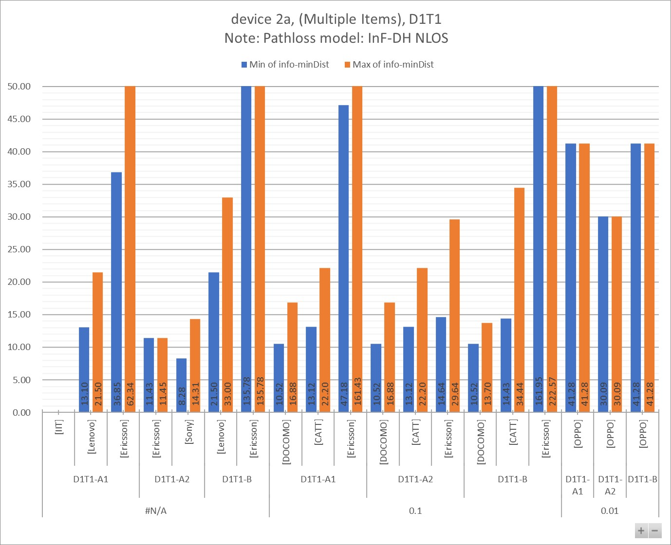

Table 7.1.2.3 - 1

|  |  |  |  |  |  |  |  |  |  |  |  |
| --- | --- | --- | --- | --- | --- | --- | --- | --- | --- | --- | --- |
| info-D2R-datarate-range | (Multiple Items) |  |  |  |  |  |  |  |  |  |  |
| info-device-type | device 2a |  | **Distance (m)** | |  |  |  |  |  |  |  |
| info-D1T1/D2T2 | D1T1 |  |  |  |  |  |  |  |  |  |  |
| info-pathloss | InF-DH NLOS |  |  |  |  |  |  |  |  |  |  |
|  |  |  |  |  |  |  |  |  |  |  |  |
| **info-D2R_BLER** | **info-DxTx** | **info-Company** | **Min:info-R2D[4B]** | **Max:info-R2D[4B]** | **Min:info-D2R[4B]** | **Max:info-D2R[4B]** | **Min:min(Dist_R2D, Dist_D2R)** | **Max:min(Dist_R2D, Dist_D2R)** | **Min of info-D2R-datarate** | **Max of info-D2R-datarate** | **Count of No.** |
| **#N/A** | **D1T1-A1** | [IIT] |  |  |  |  |  |  | #N/A | #N/A | 1 |
| [Lenovo] | 21.50 | 21.50 | 13.10 | 69.10 | 13.10 | 21.50 | #N/A | #N/A | 3 |
| [Ericsson] | 709.24 | 709.24 | 36.85 | 62.34 | 36.85 | 62.34 | #N/A | #N/A | 2 |
| **D1T1-A2** | [Ericsson] | 709.24 | 709.24 | 11.43 | 11.45 | 11.43 | 11.45 | #N/A | #N/A | 2 |
| [Sony] | 27.11 | 27.11 | 8.28 | 14.31 | 8.28 | 14.31 | #N/A | #N/A | 2 |
| **D1T1-B** | [Lenovo] | 21.50 | 33.00 | 61.00 | 292.00 | 21.50 | 33.00 | #N/A | #N/A | 4 |
| [Ericsson] | 709.24 | 709.24 | 135.78 | 135.78 | 135.78 | 135.78 | #N/A | #N/A | 1 |
| **0.1** | **D1T1-A1** | [DOCOMO] | 10.52 | 27.11 | 12.60 | 16.88 | 10.52 | 16.88 | 28.00 | 28.00 | 8 |
| [CATT] | 14.43 | 41.28 | 13.12 | 22.20 | 13.12 | 22.20 | 44.80 | 44.80 | 2 |
| [Ericsson] | 161.95 | 2557.84 | 47.18 | 161.43 | 47.18 | 161.43 | 16.00 | 48.00 | 14 |
| **D1T1-A2** | [DOCOMO] | 10.52 | 27.11 | 12.60 | 16.88 | 10.52 | 16.88 | 28.00 | 28.00 | 8 |
| [CATT] | 14.43 | 41.28 | 13.12 | 22.20 | 13.12 | 22.20 | 44.80 | 44.80 | 2 |
| [Ericsson] | 161.95 | 2557.84 | 14.64 | 29.64 | 14.64 | 29.64 | 16.00 | 48.00 | 14 |
| **D1T1-B** | [DOCOMO] | 10.52 | 27.11 | 12.41 | 15.09 | 10.52 | 13.70 | 28.00 | 28.00 | 4 |
| [CATT] | 14.43 | 41.28 | 34.44 | 34.44 | 14.43 | 34.44 | 44.80 | 44.80 | 2 |
| [Ericsson] | 161.95 | 2557.84 | 222.57 | 910.61 | 161.95 | 222.57 | 16.00 | 48.00 | 7 |
| **0.01** | **D1T1-A1** | [OPPO] | 41.28 | 41.28 | 50.62 | 50.62 | 41.28 | 41.28 | 0.00 | 0.00 | 1 |
| **D1T1-A2** | [OPPO] | 41.28 | 41.28 | 30.09 | 30.09 | 30.09 | 30.09 | 0.00 | 0.00 | 1 |
| **D1T1-B** | [OPPO] | 41.28 | 41.28 | 42.84 | 42.84 | 41.28 | 41.28 | 0.00 | 0.00 | 1 |
| **Grand Total** | | | **10.52** | **2557.84** | **8.28** | **910.61** | **8.28** | **222.57** | **#N/A** | **#N/A** | **79** |

Table 7.1.2.3 - 2

|  |  |  |  |  |  |  |  |  |  |
| --- | --- | --- | --- | --- | --- | --- | --- | --- | --- |
| info-D2R-datarate-range | (Multiple Items) |  |  |  |  |  |  |  |  |
| info-device-type | device 2a |  | **MPL (dB)** | |  |  |  |  |  |
| info-D1T1/D2T2 | D1T1 |  |  |  |  |  |  |  |  |
| info-pathloss | InF-DH NLOS |  |  |  |  |  |  |  |  |
|  |  |  |  |  |  |  |  |  |  |
| **info-D2R_BLER** | **info-DxTx** | **info-Company** | **Min of info-R2D[4A]** | **Max of info-R2D[4A]** | **Min of info-D2R[4A]** | **Max of info-D2R[4A]** | **Min of info-minMPL** | **Max of info-minMPL** | **Count of No.** |
| **#N/A** | **D1T1-A1** | [Lenovo] | 70.30 | 70.30 | 51.70 | 66.50 |  |  | 3 |
| [IIT] |  |  |  |  |  |  | 1 |
| [Ericsson] | 95.15 | 95.15 | 67.02 | 72.02 | 67.02 | 72.02 | 2 |
| **D1T1-A2** | [Ericsson] | 95.15 | 95.15 | 55.89 | 55.90 | 55.89 | 55.90 | 2 |
| [Sony] | 64.10 | 64.10 | 52.82 | 58.02 | 52.82 | 58.02 | 2 |
| **D1T1-B** | [Lenovo] | 70.30 | 74.00 | 65.30 | 84.90 |  |  | 4 |
| [Ericsson] | 95.15 | 95.15 | 79.42 | 79.42 | 79.42 | 79.42 | 1 |
| **0.1** | **D1T1-A1** | [DOCOMO] | 55.10 | 64.10 | 56.81 | 59.59 | 55.10 | 59.59 | 8 |
| [CATT] | 58.10 | 68.10 | 57.20 | 62.20 | 57.20 | 62.20 | 2 |
| [Ericsson] | 81.10 | 107.35 | 69.37 | 81.07 | 69.37 | 81.07 | 14 |
| **D1T1-A2** | [DOCOMO] | 55.10 | 64.10 | 56.81 | 59.59 | 55.10 | 59.59 | 8 |
| [CATT] | 58.10 | 68.10 | 57.20 | 62.20 | 57.20 | 62.20 | 2 |
| [Ericsson] | 81.10 | 107.35 | 58.24 | 64.95 | 58.24 | 64.95 | 14 |
| **D1T1-B** | [DOCOMO] | 55.10 | 64.10 | 56.67 | 58.53 | 55.10 | 57.61 | 4 |
| [CATT] | 58.10 | 68.10 | 66.38 | 66.38 | 58.10 | 66.38 | 2 |
| [Ericsson] | 81.10 | 107.35 | 84.12 | 97.52 | 81.10 | 84.12 | 7 |
| **0.01** | **D1T1-A1** | [OPPO] | 68.10 | 68.10 | 70.04 | 70.04 | 68.10 | 68.10 | 1 |
| **D1T1-A2** | [OPPO] | 68.10 | 68.10 | 65.09 | 65.09 | 65.09 | 65.09 | 1 |
| **D1T1-B** | [OPPO] | 68.10 | 68.10 | 68.45 | 68.45 | 68.10 | 68.10 | 1 |
| **Grand Total** | | | **55.10** | **107.35** | **51.70** | **97.52** | **52.82** | **84.12** | **79** |

### 7.1.3 Device 2b

#### 7.1.3.1 [1kbps]

Figure 7.1.3.1 - 1

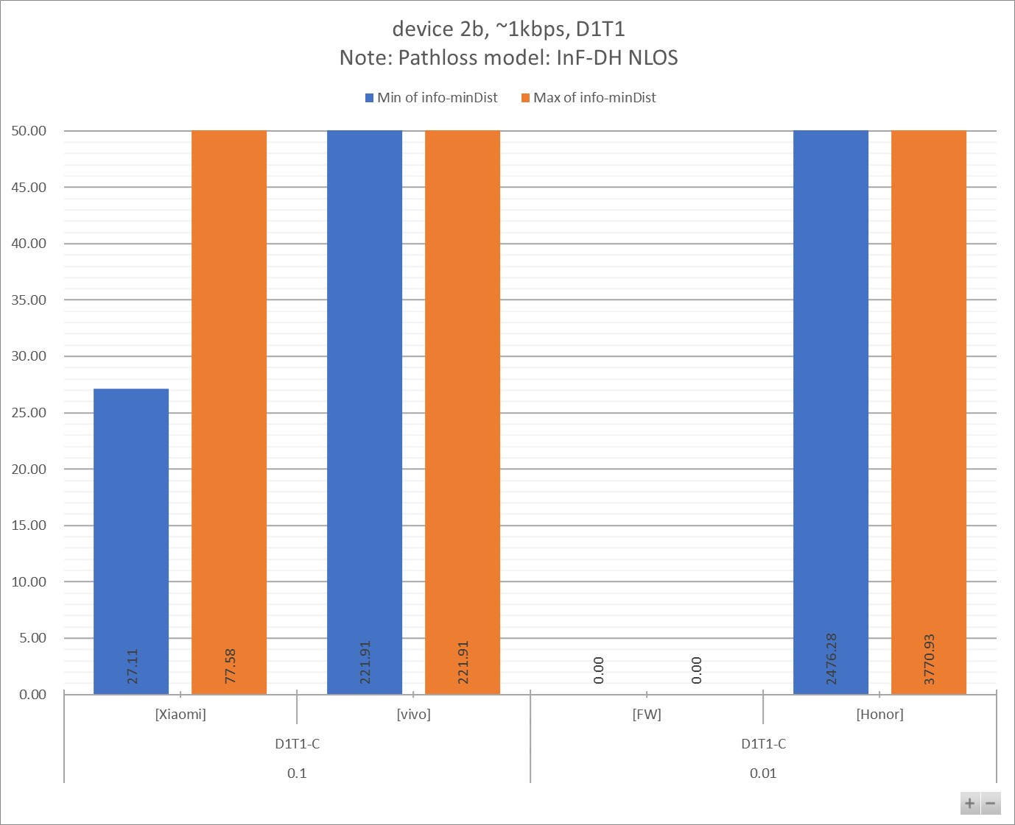

Table 7.1.3.1 - 1

|  |  |  |  |  |  |  |  |  |  |  |  |
| --- | --- | --- | --- | --- | --- | --- | --- | --- | --- | --- | --- |
| info-D2R-datarate-range | ~1kbps |  |  |  |  |  |  |  |  |  |  |
| info-device-type | device 2b |  | **Distance (m)** | |  |  |  |  |  |  |  |
| info-D1T1/D2T2 | D1T1 |  |  |  |  |  |  |  |  |  |  |
| info-pathloss | InF-DH NLOS |  |  |  |  |  |  |  |  |  |  |
|  |  |  |  |  |  |  |  |  |  |  |  |
| **info-D2R_BLER** | **info-DxTx** | **info-Company** | **Min:info-R2D[4B]** | **Max:info-R2D[4B]** | **Min:info-D2R[4B]** | **Max:info-D2R[4B]** | **Min:min(Dist_R2D, Dist_D2R)** | **Max:min(Dist_R2D, Dist_D2R)** | **Min of info-D2R-datarate** | **Max of info-D2R-datarate** | **Count of No.** |
| **0.1** | **D1T1-C** | [Xiaomi] | 27.11 | 77.58 | 1774.20 | 1774.20 | 27.11 | 77.58 | 1.14 | 1.14 | 2 |
| [vivo] | 221.91 | 221.91 | 337.26 | 363.35 | 221.91 | 221.91 | 1.06 | 1.07 | 2 |
| **0.01** | [FW] | 0.00 | 0.00 | 0.00 | 0.00 | 0.00 | 0.00 | 1.00 | 1.00 | 2 |
| [Honor] | 3580.89 | 5453.06 | 2476.28 | 3770.93 | 2476.28 | 3770.93 | 1.10 | 1.10 | 2 |
| **Grand Total** | | | **27.11** | **5453.06** | **337.26** | **3770.93** | **27.11** | **3770.93** | **1.00** | **1.14** | **8** |

Table 7.1.3.1 - 2

|  |  |  |  |  |  |  |  |  |  |
| --- | --- | --- | --- | --- | --- | --- | --- | --- | --- |
| info-D2R-datarate-range | ~1kbps |  |  |  |  |  |  |  |  |
| info-device-type | device 2b |  | **MPL (dB)** | |  |  |  |  |  |
| info-D1T1/D2T2 | D1T1 |  |  |  |  |  |  |  |  |
| info-pathloss | InF-DH NLOS |  |  |  |  |  |  |  |  |
|  |  |  |  |  |  |  |  |  |  |
| **info-D2R_BLER** | **info-DxTx** | **info-Company** | **Min of info-R2D[4A]** | **Max of info-R2D[4A]** | **Min of info-D2R[4A]** | **Max of info-D2R[4A]** | **Min of info-minMPL** | **Max of info-minMPL** | **Count of No.** |
| **0.1** | **D1T1-C** | [Xiaomi] | 64.10 | 74.10 | 103.87 | 103.87 | 64.10 | 74.10 | 2 |
| [vivo] | 84.10 | 84.10 | 88.08 | 88.79 | 84.10 | 84.10 | 2 |
| **0.01** | [FW] | 129.45 | 129.45 | 105.24 | 105.74 | 105.24 | 105.74 | 2 |
| [Honor] | 110.55 | 114.55 | 107.04 | 111.04 | 107.04 | 111.04 | 2 |
| **Grand Total** | | | **64.10** | **129.45** | **88.08** | **111.04** | **64.10** | **111.04** | **8** |

#### 7.1.3.2 [5~7kbps]

Figure 7.1.3.2 - 1

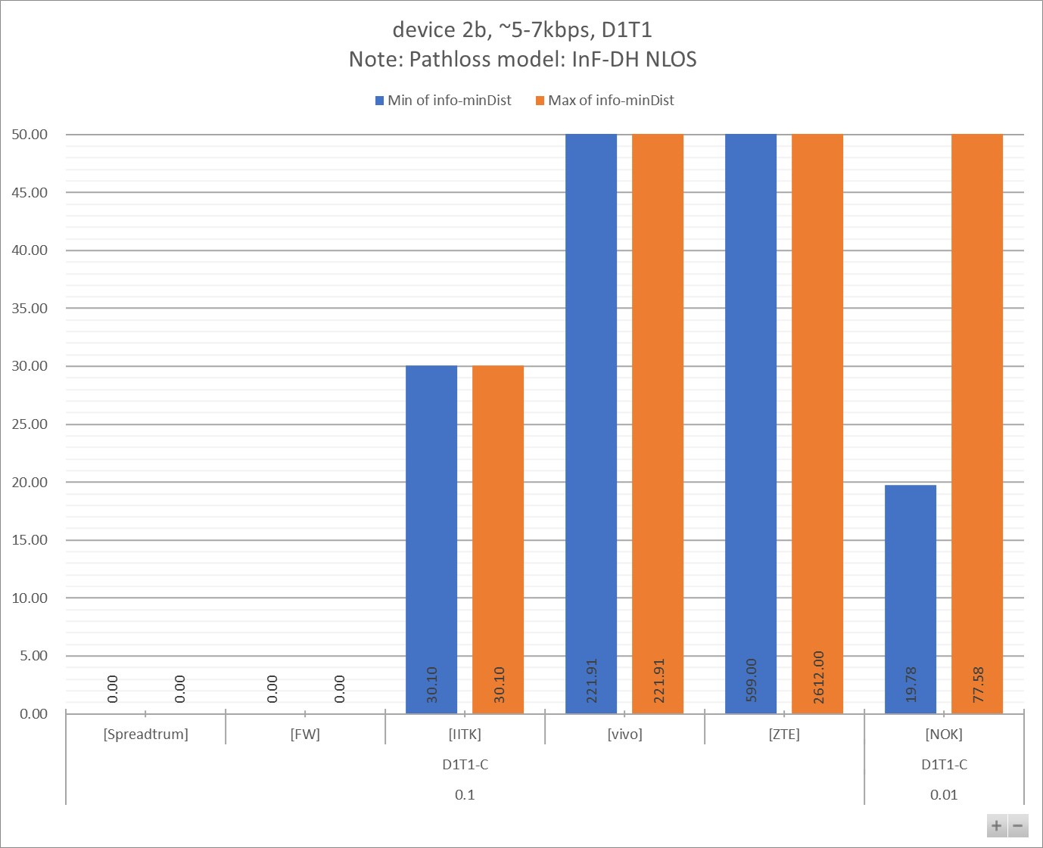

Table 7.1.3.2 - 1

|  |  |  |  |  |  |  |  |  |  |  |  |
| --- | --- | --- | --- | --- | --- | --- | --- | --- | --- | --- | --- |
| info-D2R-datarate-range | ~5-7kbps |  |  |  |  |  |  |  |  |  |  |
| info-device-type | device 2b |  | **Distance (m)** | |  |  |  |  |  |  |  |
| info-D1T1/D2T2 | D1T1 |  |  |  |  |  |  |  |  |  |  |
| info-pathloss | InF-DH NLOS |  |  |  |  |  |  |  |  |  |  |
|  |  |  |  |  |  |  |  |  |  |  |  |
| **info-D2R_BLER** | **info-DxTx** | **info-Company** | **Min:info-R2D[4B]** | **Max:info-R2D[4B]** | **Min:info-D2R[4B]** | **Max:info-D2R[4B]** | **Min:min(Dist_R2D, Dist_D2R)** | **Max:min(Dist_R2D, Dist_D2R)** | **Min of info-D2R-datarate** | **Max of info-D2R-datarate** | **Count of No.** |
| **0.1** | **D1T1-C** | [Spreadtrum] | 0.00 | 0.00 | 0.00 | 0.00 | 0.00 | 0.00 | 5.00 | 5.00 | 1 |
| [FW] | 0.00 | 0.00 | 0.00 | 0.00 | 0.00 | 0.00 | 6.00 | 6.00 | 2 |
| [IITK] | 30.10 | 30.10 | 698.00 | 2070.00 | 30.10 | 30.10 | 7.00 | 7.00 | 2 |
| [vivo] | 221.91 | 221.91 | 225.64 | 261.46 | 221.91 | 221.91 | 5.08 | 5.36 | 2 |
| [ZTE] | 0.00 | 0.00 | 599.00 | 2612.00 | 599.00 | 2612.00 | 7.00 | 7.00 | 6 |
| **0.01** | [NOK] | 19.78 | 77.58 | 1477.70 | 2992.21 | 19.78 | 77.58 | 6.43 | 6.43 | 6 |
| **Grand Total** | | | **19.78** | **221.91** | **225.64** | **2992.21** | **19.78** | **2612.00** | **5.00** | **7.00** | **19** |

Table 7.1.3.2 - 2

|  |  |  |  |  |  |  |  |  |  |
| --- | --- | --- | --- | --- | --- | --- | --- | --- | --- |
| info-D2R-datarate-range | ~5-7kbps |  |  |  |  |  |  |  |  |
| info-device-type | device 2b |  | **MPL (dB)** | |  |  |  |  |  |
| info-D1T1/D2T2 | D1T1 |  |  |  |  |  |  |  |  |
| info-pathloss | InF-DH NLOS |  |  |  |  |  |  |  |  |
|  |  |  |  |  |  |  |  |  |  |
| **info-D2R_BLER** | **info-DxTx** | **info-Company** | **Min of info-R2D[4A]** | **Max of info-R2D[4A]** | **Min of info-D2R[4A]** | **Max of info-D2R[4A]** | **Min of info-minMPL** | **Max of info-minMPL** | **Count of No.** |
| **0.1** | **D1T1-C** | [IITK] | 65.10 | 65.10 | 95.00 | 105.40 | 65.10 | 65.10 | 2 |
| [vivo] | 84.10 | 84.10 | 84.26 | 85.66 | 84.10 | 84.10 | 2 |
| [Spreadtrum] | 124.55 | 124.55 | 99.34 | 99.34 | 99.34 | 99.34 | 1 |
| [FW] | 129.45 | 129.45 | 100.94 | 103.24 | 100.94 | 103.24 | 2 |
| [ZTE] | 111.95 | 124.95 | 93.55 | 107.55 | 93.55 | 107.55 | 6 |
| **0.01** | [NOK] | 61.10 | 74.10 | 102.13 | 108.84 | 61.10 | 74.10 | 6 |
| **Grand Total** | | | **61.10** | **129.45** | **84.26** | **108.84** | **61.10** | **107.55** | **19** |

#### 7.1.3.3 other data rate

Figure 7.1.3.3 - 1

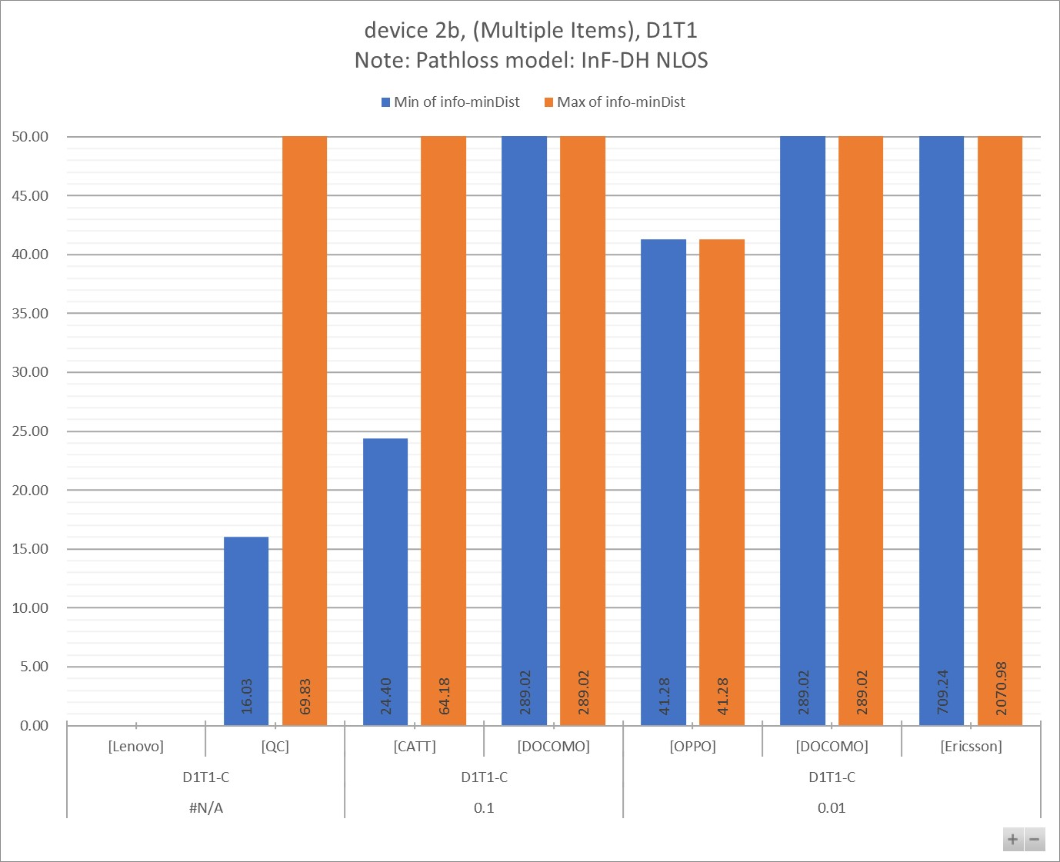

Table 7.1.3.3 - 1

|  |  |  |  |  |  |  |  |  |  |  |  |
| --- | --- | --- | --- | --- | --- | --- | --- | --- | --- | --- | --- |
| info-D2R-datarate-range | (Multiple Items) |  |  |  |  |  |  |  |  |  |  |
| info-device-type | device 2b |  | **Distance (m)** | |  |  |  |  |  |  |  |
| info-D1T1/D2T2 | D1T1 |  |  |  |  |  |  |  |  |  |  |
| info-pathloss | InF-DH NLOS |  |  |  |  |  |  |  |  |  |  |
|  |  |  |  |  |  |  |  |  |  |  |  |
| **info-D2R_BLER** | **info-DxTx** | **info-Company** | **Min:info-R2D[4B]** | **Max:info-R2D[4B]** | **Min:info-D2R[4B]** | **Max:info-D2R[4B]** | **Min:min(Dist_R2D, Dist_D2R)** | **Max:min(Dist_R2D, Dist_D2R)** | **Min of info-D2R-datarate** | **Max of info-D2R-datarate** | **Count of No.** |
| **#N/A** | **D1T1-C** | [Lenovo] |  |  |  |  |  |  | #N/A | #N/A | 4 |
| [QC] | 16.03 | 69.83 | 133.88 | 199.63 | 16.03 | 69.83 | #N/A | #N/A | 8 |
| **0.1** | [CATT] | 24.40 | 69.83 | 64.18 | 64.18 | 24.40 | 64.18 | 44.80 | 44.80 | 2 |
| [DOCOMO] | 5783.77 | 5783.77 | 289.02 | 289.02 | 289.02 | 289.02 | 28.00 | 28.00 | 1 |
| **0.01** | [OPPO] | 41.28 | 41.28 | 1251.33 | 1251.33 | 41.28 | 41.28 | 0.00 | 0.00 | 1 |
| [DOCOMO] | 3261.01 | 3261.01 | 289.02 | 289.02 | 289.02 | 289.02 | 28.00 | 28.00 | 1 |
| [Ericsson] | 709.24 | 3795.16 | 1224.23 | 2070.98 | 709.24 | 2070.98 | 16.00 | 48.00 | 4 |
| **Grand Total** | | | **16.03** | **5783.77** | **64.18** | **2070.98** | **16.03** | **2070.98** | **#N/A** | **#N/A** | **21** |

Table 7.1.3.3 - 2

|  |  |  |  |  |  |  |  |  |  |
| --- | --- | --- | --- | --- | --- | --- | --- | --- | --- |
| info-D2R-datarate-range | (Multiple Items) |  |  |  |  |  |  |  |  |
| info-device-type | device 2b |  | **MPL (dB)** | |  |  |  |  |  |
| info-D1T1/D2T2 | D1T1 |  |  |  |  |  |  |  |  |
| info-pathloss | InF-DH NLOS |  |  |  |  |  |  |  |  |
|  |  |  |  |  |  |  |  |  |  |
| **info-D2R_BLER** | **info-DxTx** | **info-Company** | **Min of info-R2D[4A]** | **Max of info-R2D[4A]** | **Min of info-D2R[4A]** | **Max of info-D2R[4A]** | **Min of info-minMPL** | **Max of info-minMPL** | **Count of No.** |
| **#N/A** | **D1T1-C** | [Lenovo] |  |  |  |  |  |  | 4 |
| [QC] | 59.10 | 73.10 | 79.29 | 83.09 | 59.10 | 73.10 | 8 |
| **0.1** | [CATT] | 63.10 | 73.10 | 72.30 | 72.30 | 63.10 | 72.30 | 2 |
| [DOCOMO] | 115.11 | 115.11 | 86.61 | 86.61 | 86.61 | 86.61 | 1 |
| **0.01** | [OPPO] | 68.10 | 68.10 | 100.55 | 100.55 | 68.10 | 68.10 | 1 |
| [DOCOMO] | 109.66 | 109.66 | 86.61 | 86.61 | 86.61 | 86.61 | 1 |
| [Ericsson] | 95.15 | 111.10 | 100.34 | 105.34 | 95.15 | 105.34 | 4 |
| **Grand Total** | | | **59.10** | **115.11** | **72.30** | **105.34** | **59.10** | **105.34** | **21** |

## 7.2 Link Budget for D2T2

### 7.2.1 Device 1

#### 7.2.1.1 [1kbps]

Figure 7.2.1.1 - 1

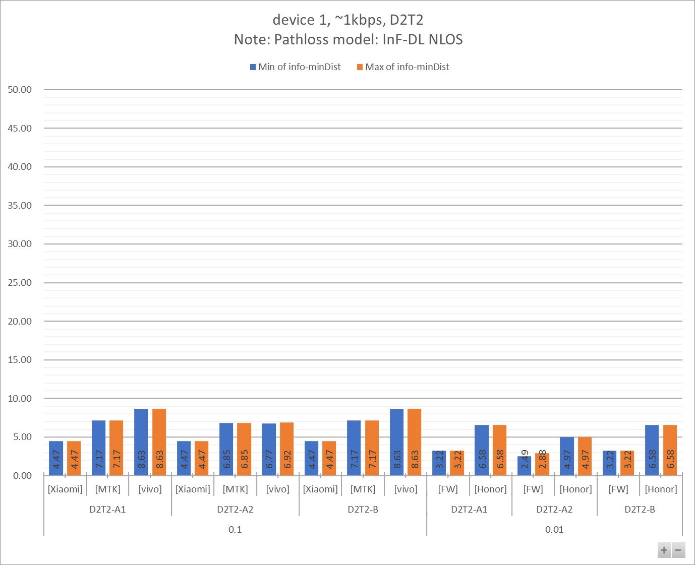

Figure 7.2.1.1 - 2

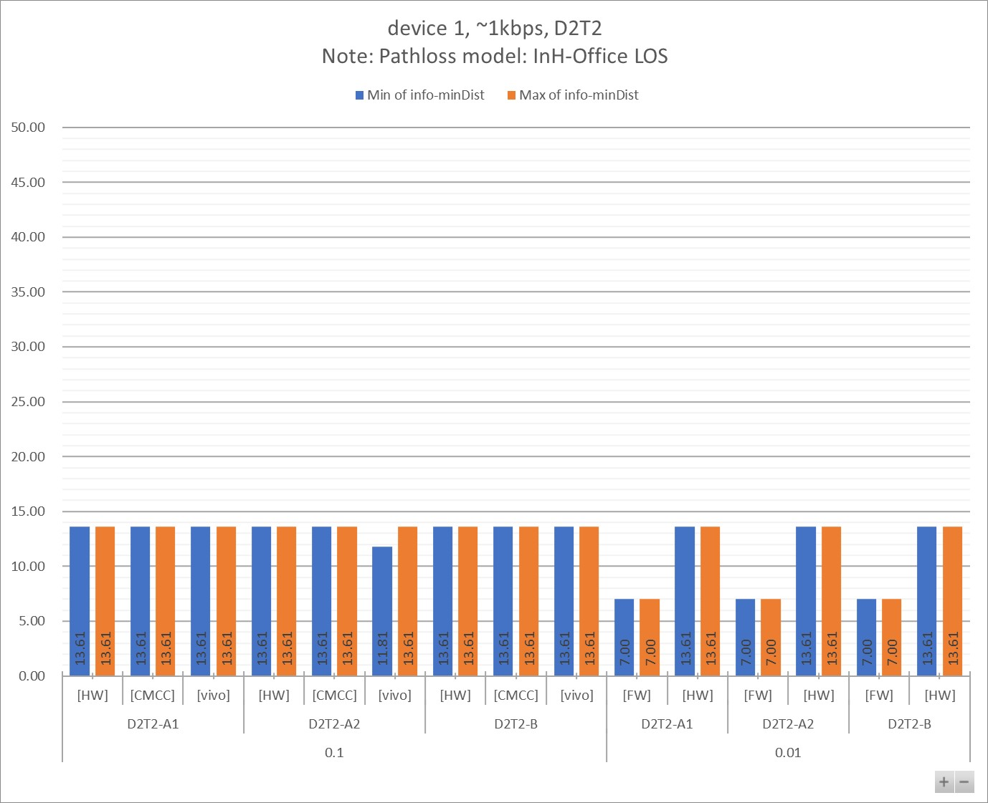

Table 7.2.1.1 - 1a

|  |  |  |  |  |  |  |  |  |  |  |  |
| --- | --- | --- | --- | --- | --- | --- | --- | --- | --- | --- | --- |
| info-D2R-datarate-range | ~1kbps |  |  |  |  |  |  |  |  |  |  |
| info-device-type | device 1 |  | **Distance (m)** | |  |  |  |  |  |  |  |
| info-D1T1/D2T2 | D2T2 |  |  |  |  |  |  |  |  |  |  |
| info-pathloss | InF-DL NLOS |  |  |  |  |  |  |  |  |  |  |
|  |  |  |  |  |  |  |  |  |  |  |  |
| **info-D2R_BLER** | **info-DxTx** | **info-Company** | **Min:info-R2D[4B]** | **Max:info-R2D[4B]** | **Min:info-D2R[4B]** | **Max:info-D2R[4B]** | **Min:min(Dist_R2D, Dist_D2R)** | **Max:min(Dist_R2D, Dist_D2R)** | **Min of info-D2R-datarate** | **Max of info-D2R-datarate** | **Count of No.** |
| **0.1** | **D2T2-A1** | [Xiaomi] | 4.47 | 4.47 | 10.50 | 11.40 | 4.47 | 4.47 | 0.95 | 1.14 | 2 |
| [MTK] | 7.17 | 7.17 | 25.66 | 25.66 | 7.17 | 7.17 | 0.58 | 0.58 | 1 |
| [vivo] | 8.63 | 8.63 | 12.28 | 12.81 | 8.63 | 8.63 | 1.06 | 1.07 | 2 |
| **D2T2-A2** | [Xiaomi] | 4.47 | 4.47 | 5.10 | 5.50 | 4.47 | 4.47 | 0.95 | 1.14 | 2 |
| [MTK] | 7.17 | 7.17 | 6.85 | 6.85 | 6.85 | 6.85 | 0.58 | 0.58 | 1 |
| [vivo] | 8.63 | 8.63 | 6.77 | 6.92 | 6.77 | 6.92 | 1.06 | 1.07 | 2 |
| **D2T2-B** | [Xiaomi] | 4.47 | 4.47 | 15.00 | 33.80 | 4.47 | 4.47 | 0.95 | 1.14 | 4 |
| [MTK] | 7.17 | 7.17 | 50.38 | 90.02 | 7.17 | 7.17 | 0.58 | 0.58 | 2 |
| [vivo] | 8.63 | 8.63 | 28.38 | 32.14 | 8.63 | 8.63 | 1.06 | 1.07 | 4 |
| **0.01** | **D2T2-A1** | [FW] | 3.22 | 3.22 | 4.26 | 4.26 | 3.22 | 3.22 | 1.00 | 1.00 | 2 |
| [Honor] | 6.58 | 6.58 | 12.36 | 12.36 | 6.58 | 6.58 | 1.10 | 1.10 | 1 |
| **D2T2-A2** | [FW] | 3.22 | 3.22 | 2.49 | 2.88 | 2.49 | 2.88 | 1.00 | 1.00 | 2 |
| [Honor] | 6.58 | 6.58 | 4.97 | 4.97 | 4.97 | 4.97 | 1.10 | 1.10 | 1 |
| **D2T2-B** | [FW] | 3.22 | 3.22 | 4.26 | 4.92 | 3.22 | 3.22 | 1.00 | 1.00 | 4 |
| [Honor] | 6.58 | 6.58 | 12.80 | 35.94 | 6.58 | 6.58 | 1.10 | 1.10 | 5 |
| **Grand Total** | | | **3.22** | **8.63** | **2.49** | **90.02** | **2.49** | **8.63** | **0.58** | **1.14** | **35** |

Table 7.2.1.1 - 1b

|  |  |  |  |  |  |  |  |  |  |
| --- | --- | --- | --- | --- | --- | --- | --- | --- | --- |
| info-D2R-datarate-range | ~1kbps |  |  |  |  |  |  |  |  |
| info-device-type | device 1 |  | **MPL (dB)** | |  |  |  |  |  |
| info-D1T1/D2T2 | D2T2 |  |  |  |  |  |  |  |  |
| info-pathloss | InF-DL NLOS |  |  |  |  |  |  |  |  |
|  |  |  |  |  |  |  |  |  |  |
| **info-D2R_BLER** | **info-DxTx** | **info-Company** | **Min of info-R2D[4A]** | **Max of info-R2D[4A]** | **Min of info-D2R[4A]** | **Max of info-D2R[4A]** | **Min of info-minMPL** | **Max of info-minMPL** | **Count of No.** |
| **0.1** | **D2T2-A1** | [Xiaomi] | 40.90 | 40.90 | 54.13 | 55.43 | 40.90 | 40.90 | 2 |
| [vivo] | 51.10 | 51.10 | 56.57 | 57.23 | 51.10 | 51.10 | 2 |
| [MTK] | 53.90 | 53.90 | 68.02 | 68.02 | 53.90 | 53.90 | 1 |
| **D2T2-A2** | [Xiaomi] | 40.90 | 40.90 | 42.89 | 44.19 | 40.90 | 40.90 | 2 |
| [vivo] | 51.10 | 51.10 | 47.33 | 47.68 | 47.33 | 47.68 | 2 |
| [MTK] | 53.90 | 53.90 | 53.40 | 53.40 | 53.40 | 53.40 | 1 |
| **D2T2-B** | [Xiaomi] | 40.90 | 40.90 | 59.65 | 72.25 | 40.90 | 40.90 | 4 |
| [vivo] | 51.10 | 51.10 | 69.56 | 71.49 | 51.10 | 51.10 | 4 |
| [MTK] | 53.90 | 53.90 | 78.45 | 87.45 | 53.90 | 53.90 | 2 |
| **0.01** | **D2T2-A1** | [FW] | 41.90 | 41.90 | 44.50 | 44.50 | 41.90 | 41.90 | 2 |
| [Honor] | 46.90 | 46.90 | 56.67 | 56.67 | 46.90 | 46.90 | 1 |
| **D2T2-A2** | [FW] | 41.90 | 41.90 | 39.50 | 40.85 | 39.50 | 40.85 | 2 |
| [Honor] | 46.90 | 46.90 | 42.55 | 42.55 | 42.55 | 42.55 | 1 |
| **D2T2-B** | [FW] | 41.90 | 41.90 | 44.50 | 45.85 | 41.90 | 41.90 | 4 |
| [Honor] | 46.90 | 46.90 | 57.22 | 73.22 | 46.90 | 46.90 | 5 |
| **Grand Total** | | | **40.90** | **53.90** | **39.50** | **87.45** | **39.50** | **53.90** | **35** |

Table 7.2.1.1 - 2a

|  |  |  |  |  |  |  |  |  |  |  |  |
| --- | --- | --- | --- | --- | --- | --- | --- | --- | --- | --- | --- |
| info-D2R-datarate-range | ~1kbps |  |  |  |  |  |  |  |  |  |  |
| info-device-type | device 1 |  | **Distance (m)** | |  |  |  |  |  |  |  |
| info-D1T1/D2T2 | D2T2 |  |  |  |  |  |  |  |  |  |  |
| info-pathloss | InH-Office LOS |  |  |  |  |  |  |  |  |  |  |
|  |  |  |  |  |  |  |  |  |  |  |  |
| **info-D2R_BLER** | **info-DxTx** | **info-Company** | **Min:info-R2D[4B]** | **Max:info-R2D[4B]** | **Min:info-D2R[4B]** | **Max:info-D2R[4B]** | **Min:min(Dist_R2D, Dist_D2R)** | **Max:min(Dist_R2D, Dist_D2R)** | **Min of info-D2R-datarate** | **Max of info-D2R-datarate** | **Count of No.** |
| **0.1** | **D2T2-A1** | [HW] | 13.61 | 13.61 | 52.93 | 61.28 | 13.61 | 13.61 | 0.43 | 1.10 | 3 |
| [CMCC] | 13.61 | 13.61 | 91.10 | 135.81 | 13.61 | 13.61 | 0.80 | 0.80 | 2 |
| [vivo] | 13.61 | 13.61 | 38.55 | 61.47 | 13.61 | 13.61 | 1.06 | 1.07 | 2 |
| **D2T2-A2** | [HW] | 13.61 | 13.61 | 29.02 | 33.59 | 13.61 | 13.61 | 0.43 | 1.10 | 3 |
| [CMCC] | 13.61 | 13.61 | 15.88 | 23.67 | 13.61 | 13.61 | 0.80 | 0.80 | 2 |
| [vivo] | 13.61 | 13.61 | 11.81 | 16.46 | 11.81 | 13.61 | 1.06 | 1.07 | 2 |
| **D2T2-B** | [HW] | 13.61 | 13.61 | 280.17 | 375.48 | 13.61 | 13.61 | 0.43 | 1.10 | 3 |
| [CMCC] | 13.61 | 13.61 | 829.93 | 13007.38 | 13.61 | 13.61 | 0.80 | 0.80 | 6 |
| [vivo] | 13.61 | 13.61 | 297.18 | 819.44 | 13.61 | 13.61 | 1.06 | 1.07 | 4 |
| **0.01** | **D2T2-A1** | [FW] | 7.00 | 7.00 | 17.63 | 22.41 | 7.00 | 7.00 | 1.00 | 1.00 | 2 |
| [HW] | 13.61 | 13.61 | 38.97 | 46.96 | 13.61 | 13.61 | 0.43 | 1.10 | 3 |
| **D2T2-A2** | [FW] | 7.00 | 7.00 | 9.07 | 11.52 | 7.00 | 7.00 | 1.00 | 1.00 | 2 |
| [HW] | 13.61 | 13.61 | 21.37 | 25.74 | 13.61 | 13.61 | 0.43 | 1.10 | 3 |
| **D2T2-B** | [FW] | 7.00 | 7.00 | 17.63 | 22.41 | 7.00 | 7.00 | 1.00 | 1.00 | 4 |
| [HW] | 13.61 | 13.61 | 151.89 | 220.48 | 13.61 | 13.61 | 0.43 | 1.10 | 3 |
| **Grand Total** | | | **7.00** | **13.61** | **9.07** | **13007.38** | **7.00** | **13.61** | **0.43** | **1.10** | **44** |

Table 7.2.1.1 - 2b

|  |  |  |  |  |  |  |  |  |  |
| --- | --- | --- | --- | --- | --- | --- | --- | --- | --- |
| info-D2R-datarate-range | ~1kbps |  |  |  |  |  |  |  |  |
| info-device-type | device 1 |  | **MPL (dB)** | |  |  |  |  |  |
| info-D1T1/D2T2 | D2T2 |  |  |  |  |  |  |  |  |
| info-pathloss | InH-Office LOS |  |  |  |  |  |  |  |  |
|  |  |  |  |  |  |  |  |  |  |
| **info-D2R_BLER** | **info-DxTx** | **info-Company** | **Min of info-R2D[4A]** | **Max of info-R2D[4A]** | **Min of info-D2R[4A]** | **Max of info-D2R[4A]** | **Min of info-minMPL** | **Max of info-minMPL** | **Count of No.** |
| **0.1** | **D2T2-A1** | [vivo] | 51.10 | 51.10 | 58.92 | 62.43 | 51.10 | 51.10 | 2 |
| [CMCC] | 51.10 | 51.10 | 65.38 | 68.38 | 51.10 | 51.10 | 2 |
| [HW] | 51.10 | 51.10 | 61.31 | 62.41 | 51.10 | 51.10 | 3 |
| **D2T2-A2** | [vivo] | 51.10 | 51.10 | 50.04 | 52.53 | 50.04 | 51.10 | 2 |
| [CMCC] | 51.10 | 51.10 | 52.26 | 55.26 | 51.10 | 51.10 | 2 |
| [HW] | 51.10 | 51.10 | 56.79 | 57.89 | 51.10 | 51.10 | 3 |
| **D2T2-B** | [vivo] | 51.10 | 51.10 | 74.27 | 81.89 | 51.10 | 51.10 | 4 |
| [CMCC] | 51.10 | 51.10 | 81.98 | 102.66 | 51.10 | 51.10 | 6 |
| [HW] | 51.10 | 51.10 | 73.83 | 76.03 | 51.10 | 51.10 | 3 |
| **0.01** | **D2T2-A1** | [FW] | 46.10 | 46.10 | 53.05 | 54.85 | 46.10 | 46.10 | 2 |
| [HW] | 51.10 | 51.10 | 59.01 | 60.41 | 51.10 | 51.10 | 3 |
| **D2T2-A2** | [FW] | 46.10 | 46.10 | 48.05 | 49.85 | 46.10 | 46.10 | 2 |
| [HW] | 51.10 | 51.10 | 54.49 | 55.89 | 51.10 | 51.10 | 3 |
| **D2T2-B** | [FW] | 46.10 | 46.10 | 53.05 | 54.85 | 46.10 | 46.10 | 4 |
| [HW] | 51.10 | 51.10 | 69.23 | 72.03 | 51.10 | 51.10 | 3 |
| **Grand Total** | | | **46.10** | **51.10** | **48.05** | **102.66** | **46.10** | **51.10** | **44** |

#### 7.2.1.2 [5~7kbps]

Figure 7.2.1.2 - 1

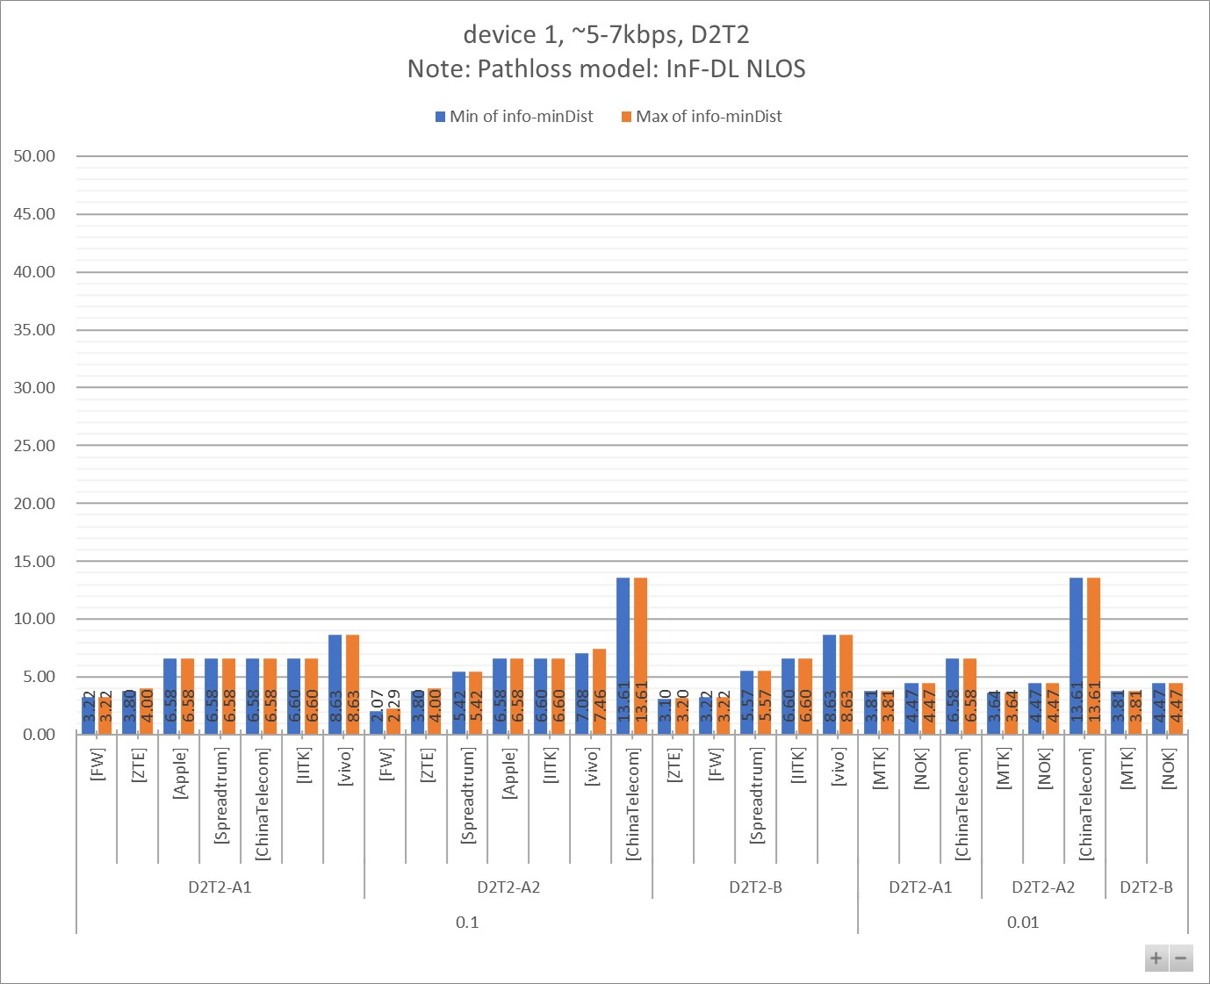

Figure 7.2.1.2 - 2

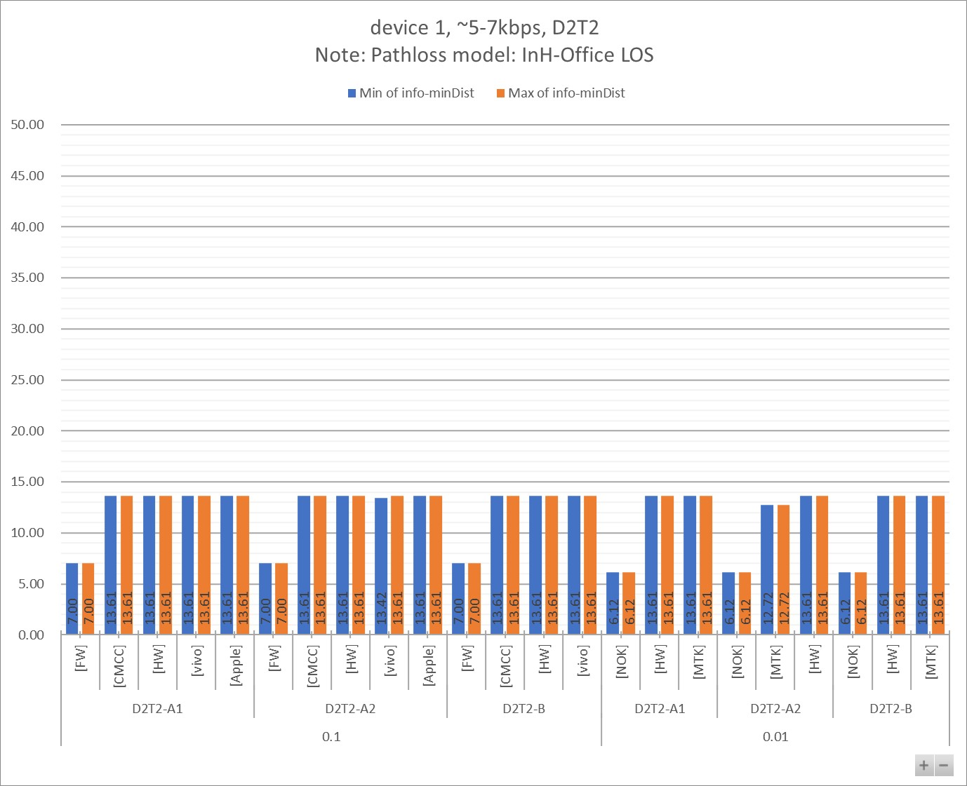

Table 7.2.1.2 - 1a

|  |  |  |  |  |  |  |  |  |  |  |  |
| --- | --- | --- | --- | --- | --- | --- | --- | --- | --- | --- | --- |
| info-D2R-datarate-range | ~5-7kbps |  |  |  |  |  |  |  |  |  |  |
| info-device-type | device 1 |  | **Distance (m)** | |  |  |  |  |  |  |  |
| info-D1T1/D2T2 | D2T2 |  |  |  |  |  |  |  |  |  |  |
| info-pathloss | InF-DL NLOS |  |  |  |  |  |  |  |  |  |  |
|  |  |  |  |  |  |  |  |  |  |  |  |
| **info-D2R_BLER** | **info-DxTx** | **info-Company** | **Min:info-R2D[4B]** | **Max:info-R2D[4B]** | **Min:info-D2R[4B]** | **Max:info-D2R[4B]** | **Min:min(Dist_R2D, Dist_D2R)** | **Max:min(Dist_R2D, Dist_D2R)** | **Min of info-D2R-datarate** | **Max of info-D2R-datarate** | **Count of No.** |
| **0.1** | **D2T2-A1** | [FW] | 3.22 | 3.22 | 3.91 | 3.91 | 3.22 | 3.22 | 6.00 | 6.00 | 1 |
| [ZTE] | 3.80 | 5.00 | 3.90 | 4.00 | 3.80 | 4.00 | 7.00 | 7.00 | 2 |
| [Apple] | 6.58 | 6.58 | 9.76 | 10.75 | 6.58 | 6.58 | 5.00 | 7.00 | 2 |
| [Spreadtrum] | 6.58 | 6.58 | 7.46 | 7.46 | 6.58 | 6.58 | 5.00 | 5.00 | 1 |
| [ChinaTelecom] | 6.58 | 6.58 | 9.40 | 12.80 | 6.58 | 6.58 | 5.63 | 5.63 | 6 |
| [IITK] | 6.60 | 6.60 | 11.53 | 12.10 | 6.60 | 6.60 | 7.00 | 7.00 | 2 |
| [vivo] | 8.63 | 8.63 | 11.47 | 12.08 | 8.63 | 8.63 | 5.08 | 5.36 | 2 |
| **D2T2-A2** | [FW] | 3.22 | 3.22 | 2.07 | 2.29 | 2.07 | 2.29 | 6.00 | 6.00 | 2 |
| [ZTE] | 3.80 | 5.00 | 3.90 | 4.00 | 3.80 | 4.00 | 7.00 | 7.00 | 2 |
| [Spreadtrum] | 6.58 | 6.58 | 5.42 | 5.42 | 5.42 | 5.42 | 5.00 | 5.00 | 1 |
| [Apple] | 6.58 | 6.58 | 7.17 | 8.39 | 6.58 | 6.58 | 5.00 | 7.00 | 2 |
| [IITK] | 6.60 | 6.60 | 11.53 | 12.10 | 6.60 | 6.60 | 7.00 | 7.00 | 2 |
| [vivo] | 8.63 | 8.63 | 7.08 | 7.46 | 7.08 | 7.46 | 5.08 | 5.36 | 2 |
| [ChinaTelecom] | 13.61 | 13.61 | 15.88 | 15.88 | 13.61 | 13.61 | 5.63 | 5.63 | 6 |
| **D2T2-B** | [ZTE] | 3.80 | 5.00 | 3.10 | 3.20 | 3.10 | 3.20 | 7.00 | 7.00 | 2 |
| [FW] | 3.22 | 3.22 | 3.53 | 3.91 | 3.22 | 3.22 | 6.00 | 6.00 | 3 |
| [Spreadtrum] | 6.58 | 6.58 | 5.57 | 5.57 | 5.57 | 5.57 | 5.00 | 5.00 | 1 |
| [IITK] | 6.60 | 6.60 | 26.61 | 29.30 | 6.60 | 6.60 | 7.00 | 7.00 | 4 |
| [vivo] | 8.63 | 8.63 | 24.77 | 29.05 | 8.63 | 8.63 | 5.08 | 5.36 | 4 |
| **0.01** | **D2T2-A1** | [MTK] | 3.81 | 3.81 | 11.91 | 11.91 | 3.81 | 3.81 | 4.67 | 4.67 | 1 |
| [NOK] | 4.47 | 4.47 | 10.31 | 16.19 | 4.47 | 4.47 | 6.43 | 6.43 | 3 |
| [ChinaTelecom] | 6.58 | 6.58 | 6.70 | 8.92 | 6.58 | 6.58 | 5.63 | 5.63 | 6 |
| **D2T2-A2** | [MTK] | 3.81 | 3.81 | 3.64 | 3.64 | 3.64 | 3.64 | 4.67 | 4.67 | 1 |
| [NOK] | 4.47 | 4.47 | 4.64 | 7.29 | 4.47 | 4.47 | 6.43 | 6.43 | 3 |
| [ChinaTelecom] | 13.61 | 13.61 | 15.88 | 15.88 | 13.61 | 13.61 | 5.63 | 5.63 | 6 |
| **D2T2-B** | [MTK] | 3.81 | 3.81 | 14.18 | 36.49 | 3.81 | 3.81 | 4.67 | 4.67 | 2 |
| [NOK] | 4.47 | 4.47 | 10.63 | 27.39 | 4.47 | 4.47 | 6.43 | 6.43 | 6 |
| **Grand Total** | | | **3.22** | **13.61** | **2.07** | **36.49** | **2.07** | **13.61** | **4.67** | **7.00** | **75** |

Table 7.2.1.2 - 1b

|  |  |  |  |  |  |  |  |  |  |
| --- | --- | --- | --- | --- | --- | --- | --- | --- | --- |
| info-D2R-datarate-range | ~5-7kbps |  |  |  |  |  |  |  |  |
| info-device-type | device 1 |  | **MPL (dB)** | |  |  |  |  |  |
| info-D1T1/D2T2 | D2T2 |  |  |  |  |  |  |  |  |
| info-pathloss | InF-DL NLOS |  |  |  |  |  |  |  |  |
|  |  |  |  |  |  |  |  |  |  |
| **info-D2R_BLER** | **info-DxTx** | **info-Company** | **Min of info-R2D[4A]** | **Max of info-R2D[4A]** | **Min of info-D2R[4A]** | **Max of info-D2R[4A]** | **Min of info-minMPL** | **Max of info-minMPL** | **Count of No.** |
| **0.1** | **D2T2-A1** | [FW] | 41.90 | 41.90 | 43.70 | 43.70 | 41.90 | 41.90 | 1 |
| [Apple] | 46.90 | 46.90 | 53.00 | 54.51 | 46.90 | 46.90 | 2 |
| [Spreadtrum] | 46.90 | 46.90 | 48.85 | 48.85 | 46.90 | 46.90 | 1 |
| [ChinaTelecom] | 46.90 | 46.90 | 52.42 | 57.21 | 46.90 | 46.90 | 6 |
| [IITK] | 46.90 | 46.90 | 55.60 | 56.32 | 46.90 | 46.90 | 2 |
| [ZTE] | 46.90 | 49.90 | 47.28 | 47.34 | 46.90 | 47.34 | 2 |
| [vivo] | 51.10 | 51.10 | 55.51 | 56.31 | 51.10 | 51.10 | 2 |
| **D2T2-A2** | [FW] | 41.90 | 41.90 | 37.75 | 38.70 | 37.75 | 38.70 | 2 |
| [Spreadtrum] | 46.90 | 46.90 | 43.89 | 43.89 | 43.89 | 43.89 | 1 |
| [Apple] | 46.90 | 46.90 | 51.45 | 52.95 | 46.90 | 46.90 | 2 |
| [IITK] | 46.90 | 46.90 | 55.60 | 56.32 | 46.90 | 46.90 | 2 |
| [ZTE] | 46.90 | 49.90 | 47.28 | 47.34 | 46.90 | 47.34 | 2 |
| [vivo] | 51.10 | 51.10 | 48.03 | 48.83 | 48.03 | 48.83 | 2 |
| [ChinaTelecom] | 51.10 | 51.10 | 52.26 | 52.26 | 51.10 | 51.10 | 6 |
| **D2T2-B** | [FW] | 41.90 | 41.90 | 42.75 | 43.70 | 41.90 | 41.90 | 3 |
| [Spreadtrum] | 46.90 | 46.90 | 44.31 | 44.31 | 44.31 | 44.31 | 1 |
| [ZTE] | 46.90 | 49.90 | 44.78 | 44.84 | 44.78 | 44.84 | 2 |
| [IITK] | 46.90 | 46.90 | 68.56 | 70.06 | 46.90 | 46.90 | 4 |
| [vivo] | 51.10 | 51.10 | 67.45 | 69.92 | 51.10 | 51.10 | 4 |
| **0.01** | **D2T2-A1** | [NOK] | 40.90 | 40.90 | 53.86 | 60.86 | 40.90 | 40.90 | 3 |
| [MTK] | 46.90 | 46.90 | 59.52 | 59.52 | 46.90 | 46.90 | 1 |
| [ChinaTelecom] | 46.90 | 46.90 | 47.18 | 51.61 | 46.90 | 46.90 | 6 |
| **D2T2-A2** | [NOK] | 40.90 | 40.90 | 41.49 | 48.49 | 40.90 | 40.90 | 3 |
| [MTK] | 46.90 | 46.90 | 46.39 | 46.39 | 46.39 | 46.39 | 1 |
| [ChinaTelecom] | 51.10 | 51.10 | 52.26 | 52.26 | 51.10 | 51.10 | 6 |
| **D2T2-B** | [NOK] | 40.90 | 40.90 | 54.33 | 69.01 | 40.90 | 40.90 | 6 |
| [MTK] | 46.90 | 46.90 | 61.45 | 73.45 | 46.90 | 46.90 | 2 |
| **Grand Total** | | | **40.90** | **51.10** | **37.75** | **73.45** | **37.75** | **51.10** | **75** |

Table 7.2.1.2 - 2a

|  |  |  |  |  |  |  |  |  |  |  |  |
| --- | --- | --- | --- | --- | --- | --- | --- | --- | --- | --- | --- |
| info-D2R-datarate-range | ~5-7kbps |  |  |  |  |  |  |  |  |  |  |
| info-device-type | device 1 |  | **Distance (m)** | |  |  |  |  |  |  |  |
| info-D1T1/D2T2 | D2T2 |  |  |  |  |  |  |  |  |  |  |
| info-pathloss | InH-Office LOS |  |  |  |  |  |  |  |  |  |  |
|  |  |  |  |  |  |  |  |  |  |  |  |
| **info-D2R_BLER** | **info-DxTx** | **info-Company** | **Min:info-R2D[4B]** | **Max:info-R2D[4B]** | **Min:info-D2R[4B]** | **Max:info-D2R[4B]** | **Min:min(Dist_R2D, Dist_D2R)** | **Max:min(Dist_R2D, Dist_D2R)** | **Min of info-D2R-datarate** | **Max of info-D2R-datarate** | **Count of No.** |
| **0.1** | **D2T2-A1** | [FW] | 7.00 | 7.00 | 14.83 | 16.61 | 7.00 | 7.00 | 6.00 | 6.00 | 2 |
| [CMCC] | 13.61 | 13.61 | 55.48 | 82.71 | 13.61 | 13.61 | 6.00 | 6.00 | 2 |
| [HW] | 13.61 | 13.61 | 43.73 | 45.52 | 13.61 | 13.61 | 3.00 | 5.80 | 3 |
| [vivo] | 13.61 | 13.61 | 36.33 | 41.42 | 13.61 | 13.61 | 5.08 | 5.36 | 2 |
| [Apple] | 13.61 | 13.61 | 47.61 | 54.03 | 13.61 | 13.61 | 5.00 | 7.00 | 2 |
| **D2T2-A2** | [FW] | 7.00 | 7.00 | 7.63 | 8.54 | 7.00 | 7.00 | 6.00 | 6.00 | 2 |
| [CMCC] | 13.61 | 13.61 | 16.18 | 24.12 | 13.61 | 13.61 | 6.00 | 6.00 | 2 |
| [HW] | 13.61 | 13.61 | 30.87 | 32.13 | 13.61 | 13.61 | 3.00 | 5.80 | 3 |
| [vivo] | 13.61 | 13.61 | 13.42 | 15.30 | 13.42 | 13.61 | 5.08 | 5.36 | 2 |
| [Apple] | 13.61 | 13.61 | 36.68 | 43.90 | 13.61 | 13.61 | 5.00 | 7.00 | 2 |
| **D2T2-B** | [FW] | 7.00 | 7.00 | 14.83 | 16.61 | 7.00 | 7.00 | 6.00 | 6.00 | 4 |
| [CMCC] | 13.61 | 13.61 | 307.83 | 4824.66 | 13.61 | 13.61 | 6.00 | 6.00 | 6 |
| [HW] | 13.61 | 13.61 | 191.27 | 207.17 | 13.61 | 13.61 | 3.00 | 5.80 | 3 |
| [vivo] | 13.61 | 13.61 | 263.97 | 385.26 | 13.61 | 13.61 | 5.08 | 5.36 | 4 |
| **0.01** | **D2T2-A1** | [NOK] | 6.12 | 6.12 | 39.73 | 88.88 | 6.12 | 6.12 | 6.43 | 6.43 | 3 |
| [HW] | 13.61 | 13.61 | 32.63 | 34.65 | 13.61 | 13.61 | 3.00 | 5.80 | 3 |
| [MTK] | 13.61 | 13.61 | 72.99 | 72.99 | 13.61 | 13.61 | 4.67 | 4.67 | 1 |
| **D2T2-A2** | [NOK] | 6.12 | 6.12 | 20.55 | 45.97 | 6.12 | 6.12 | 6.43 | 6.43 | 3 |
| [MTK] | 13.61 | 13.61 | 12.72 | 12.72 | 12.72 | 12.72 | 4.67 | 4.67 | 1 |
| [HW] | 13.61 | 13.61 | 23.04 | 24.46 | 13.61 | 13.61 | 3.00 | 5.80 | 3 |
| **D2T2-B** | [NOK] | 6.12 | 6.12 | 157.82 | 792.12 | 6.12 | 6.12 | 6.43 | 6.43 | 6 |
| [HW] | 13.61 | 13.61 | 106.49 | 120.04 | 13.61 | 13.61 | 3.00 | 5.80 | 3 |
| [MTK] | 13.61 | 13.61 | 532.79 | 2631.45 | 13.61 | 13.61 | 4.67 | 4.67 | 2 |
| **Grand Total** | | | **6.12** | **13.61** | **7.63** | **4824.66** | **6.12** | **13.61** | **3.00** | **7.00** | **64** |

Table 7.2.1.2 - 2b

|  |  |  |  |  |  |  |  |  |  |
| --- | --- | --- | --- | --- | --- | --- | --- | --- | --- |
| info-D2R-datarate-range | ~5-7kbps |  |  |  |  |  |  |  |  |
| info-device-type | device 1 |  | **MPL (dB)** | |  |  |  |  |  |
| info-D1T1/D2T2 | D2T2 |  |  |  |  |  |  |  |  |
| info-pathloss | InH-Office LOS |  |  |  |  |  |  |  |  |
|  |  |  |  |  |  |  |  |  |  |
| **info-D2R_BLER** | **info-DxTx** | **info-Company** | **Min of info-R2D[4A]** | **Max of info-R2D[4A]** | **Min of info-D2R[4A]** | **Max of info-D2R[4A]** | **Min of info-minMPL** | **Max of info-minMPL** | **Count of No.** |
| **0.1** | **D2T2-A1** | [FW] | 46.10 | 46.10 | 51.75 | 52.60 | 46.10 | 46.10 | 2 |
| [vivo] | 51.10 | 51.10 | 58.48 | 59.46 | 51.10 | 51.10 | 2 |
| [HW] | 51.10 | 51.10 | 59.87 | 60.17 | 51.10 | 51.10 | 3 |
| [CMCC] | 51.10 | 51.10 | 61.66 | 64.66 | 51.10 | 51.10 | 2 |
| [Apple] | 51.10 | 51.10 | 60.51 | 61.46 | 51.10 | 51.10 | 2 |
| **D2T2-A2** | [FW] | 46.10 | 46.10 | 46.75 | 47.60 | 46.10 | 46.10 | 2 |
| [vivo] | 51.10 | 51.10 | 51.00 | 51.98 | 51.00 | 51.10 | 2 |
| [HW] | 51.10 | 51.10 | 57.26 | 57.56 | 51.10 | 51.10 | 3 |
| [CMCC] | 51.10 | 51.10 | 52.40 | 55.40 | 51.10 | 51.10 | 2 |
| [Apple] | 51.10 | 51.10 | 58.95 | 59.90 | 51.10 | 51.10 | 2 |
| **D2T2-B** | [FW] | 46.10 | 46.10 | 51.75 | 52.60 | 46.10 | 46.10 | 4 |
| [CMCC] | 51.10 | 51.10 | 74.53 | 95.21 | 51.10 | 51.10 | 6 |
| [vivo] | 51.10 | 51.10 | 73.38 | 76.22 | 51.10 | 51.10 | 4 |
| [HW] | 51.10 | 51.10 | 70.96 | 71.56 | 51.10 | 51.10 | 3 |
| **0.01** | **D2T2-A1** | [NOK] | 45.10 | 45.10 | 59.15 | 65.20 | 45.10 | 45.10 | 3 |
| [HW] | 51.10 | 51.10 | 57.67 | 58.12 | 51.10 | 51.10 | 3 |
| [MTK] | 51.10 | 51.10 | 63.72 | 63.72 | 51.10 | 51.10 | 1 |
| **D2T2-A2** | [NOK] | 45.10 | 45.10 | 54.19 | 60.24 | 45.10 | 45.10 | 3 |
| [MTK] | 51.10 | 51.10 | 50.59 | 50.59 | 50.59 | 50.59 | 1 |
| [HW] | 51.10 | 51.10 | 55.06 | 55.51 | 51.10 | 51.10 | 3 |
| **D2T2-B** | [NOK] | 45.10 | 45.10 | 69.51 | 81.63 | 45.10 | 45.10 | 6 |
| [HW] | 51.10 | 51.10 | 66.56 | 67.46 | 51.10 | 51.10 | 3 |
| [MTK] | 51.10 | 51.10 | 78.65 | 90.65 | 51.10 | 51.10 | 2 |
| **Grand Total** | | | **45.10** | **51.10** | **46.75** | **95.21** | **45.10** | **51.10** | **64** |

#### 7.2.1.3 other data rate

Figure 7.2.1.3 - 1

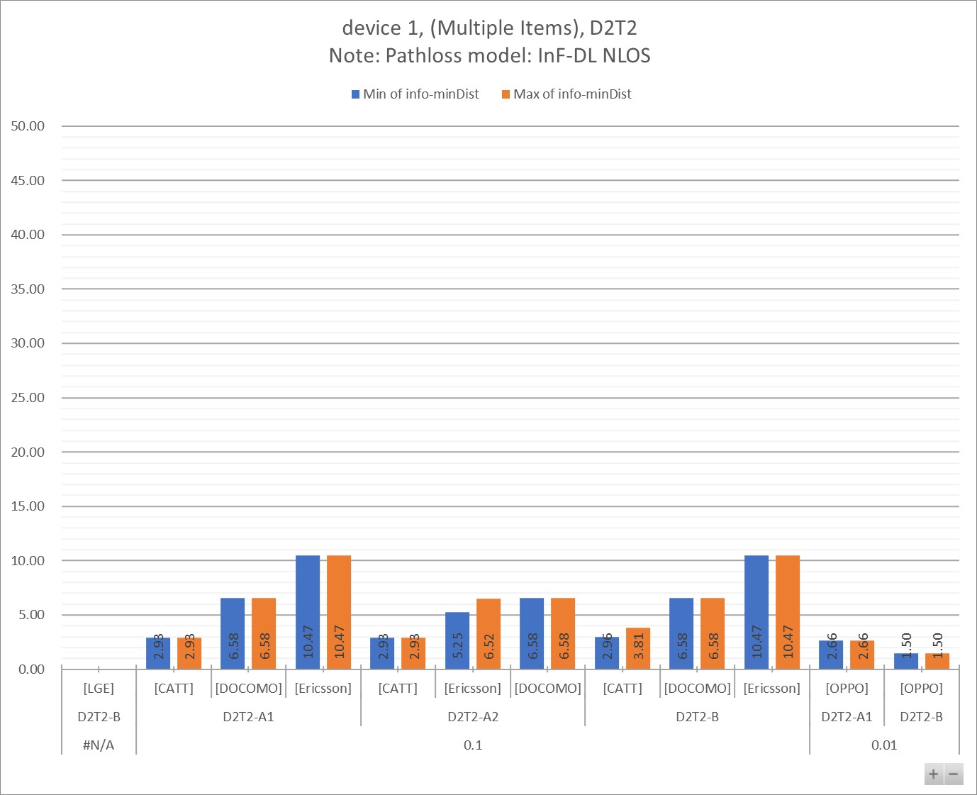

Figure 7.2.1.3 - 2

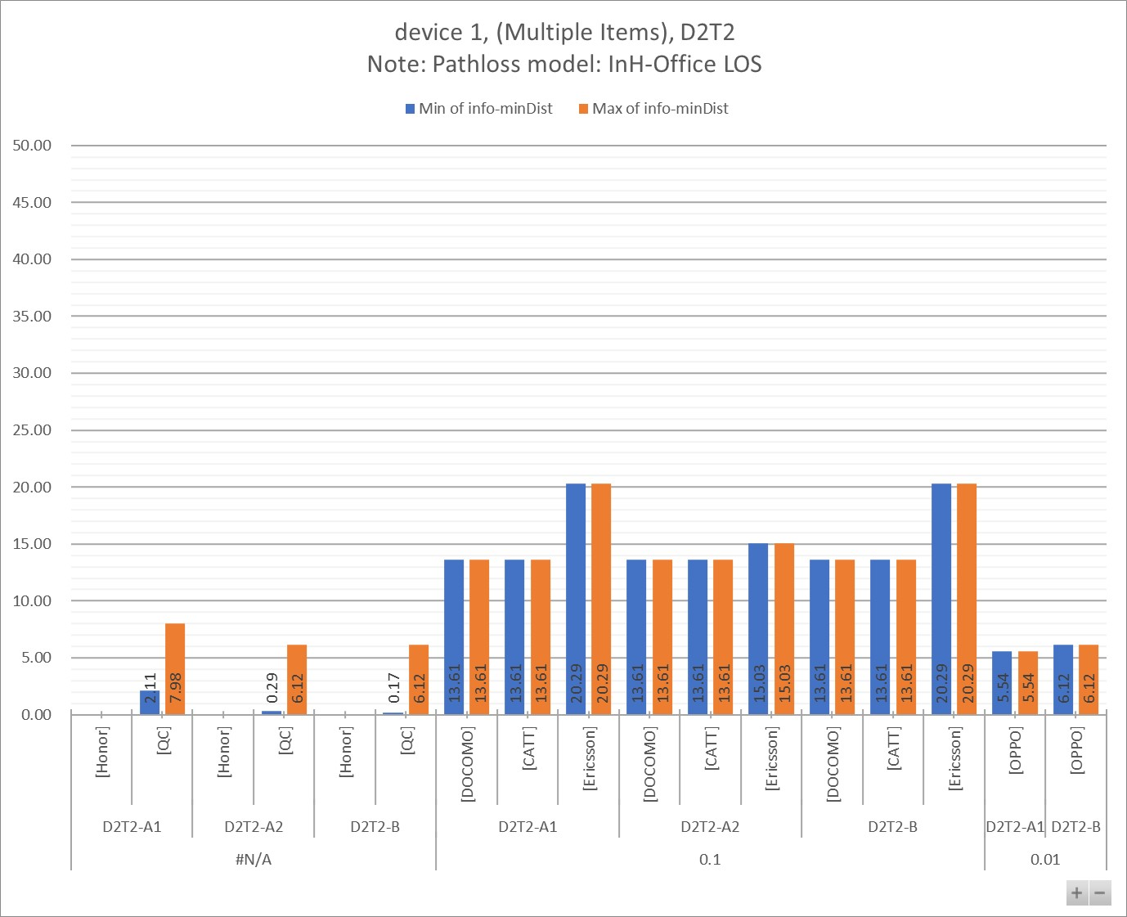

Table 7.2.1.3 - 1a

|  |  |  |  |  |  |  |  |  |  |  |  |
| --- | --- | --- | --- | --- | --- | --- | --- | --- | --- | --- | --- |
| info-D2R-datarate-range | (Multiple Items) |  |  |  |  |  |  |  |  |  |  |
| info-device-type | device 1 |  | **Distance (m)** | |  |  |  |  |  |  |  |
| info-D1T1/D2T2 | D2T2 |  |  |  |  |  |  |  |  |  |  |
| info-pathloss | InF-DL NLOS |  |  |  |  |  |  |  |  |  |  |
|  |  |  |  |  |  |  |  |  |  |  |  |
| **info-D2R_BLER** | **info-DxTx** | **info-Company** | **Min:info-R2D[4B]** | **Max:info-R2D[4B]** | **Min:info-D2R[4B]** | **Max:info-D2R[4B]** | **Min:min(Dist_R2D, Dist_D2R)** | **Max:min(Dist_R2D, Dist_D2R)** | **Min of info-D2R-datarate** | **Max of info-D2R-datarate** | **Count of No.** |
| **#N/A** | **D2T2-B** | [LGE] | 4.47 | 4.47 |  |  |  |  | #N/A | #N/A | 3 |
| **0.1** | **D2T2-A1** | [CATT] | 3.81 | 3.81 | 2.93 | 2.93 | 2.93 | 2.93 | 44.80 | 44.80 | 1 |
| [DOCOMO] | 6.58 | 6.58 | 7.21 | 7.21 | 6.58 | 6.58 | 28.00 | 28.00 | 1 |
| [Ericsson] | 10.47 | 10.47 | 12.24 | 15.19 | 10.47 | 10.47 | 16.00 | 48.00 | 6 |
| **D2T2-A2** | [CATT] | 3.81 | 3.81 | 2.93 | 2.93 | 2.93 | 2.93 | 44.80 | 44.80 | 1 |
| [Ericsson] | 10.47 | 10.47 | 5.25 | 6.52 | 5.25 | 6.52 | 16.00 | 48.00 | 6 |
| [DOCOMO] | 6.58 | 6.58 | 7.21 | 7.21 | 6.58 | 6.58 | 28.00 | 28.00 | 1 |
| **D2T2-B** | [CATT] | 3.81 | 3.81 | 2.96 | 7.29 | 2.96 | 3.81 | 44.80 | 44.80 | 2 |
| [DOCOMO] | 6.58 | 6.58 | 7.21 | 7.74 | 6.58 | 6.58 | 28.00 | 28.00 | 2 |
| [Ericsson] | 10.47 | 10.47 | 14.98 | 43.99 | 10.47 | 10.47 | 16.00 | 48.00 | 12 |
| **0.01** | **D2T2-A1** | [OPPO] | 4.47 | 4.47 | 2.66 | 2.66 | 2.66 | 2.66 | 0.00 | 0.00 | 1 |
| **D2T2-B** | [OPPO] | 4.47 | 4.47 | 1.50 | 1.50 | 1.50 | 1.50 | 0.00 | 0.00 | 1 |
| **Grand Total** | | | **3.81** | **10.47** | **1.50** | **43.99** | **1.50** | **10.47** | **#N/A** | **#N/A** | **37** |

Table 7.2.1.3 - 1b

|  |  |  |  |  |  |  |  |  |  |
| --- | --- | --- | --- | --- | --- | --- | --- | --- | --- |
| info-D2R-datarate-range | (Multiple Items) |  |  |  |  |  |  |  |  |
| info-device-type | device 1 |  | **MPL (dB)** | |  |  |  |  |  |
| info-D1T1/D2T2 | D2T2 |  |  |  |  |  |  |  |  |
| info-pathloss | InF-DL NLOS |  |  |  |  |  |  |  |  |
|  |  |  |  |  |  |  |  |  |  |
| **info-D2R_BLER** | **info-DxTx** | **info-Company** | **Min of info-R2D[4A]** | **Max of info-R2D[4A]** | **Min of info-D2R[4A]** | **Max of info-D2R[4A]** | **Min of info-minMPL** | **Max of info-minMPL** | **Count of No.** |
| **#N/A** | **D2T2-B** | [LGE] | 40.90 | 40.90 |  |  |  |  | 3 |
| **0.1** | **D2T2-A1** | [CATT] | 46.90 | 46.90 | 44.00 | 44.00 | 44.00 | 44.00 | 1 |
| [DOCOMO] | 46.90 | 46.90 | 48.31 | 48.31 | 46.90 | 46.90 | 1 |
| [Ericsson] | 54.10 | 54.10 | 56.52 | 59.87 | 54.10 | 54.10 | 6 |
| **D2T2-A2** | [CATT] | 46.90 | 46.90 | 44.00 | 44.00 | 44.00 | 44.00 | 1 |
| [Ericsson] | 54.10 | 54.10 | 43.39 | 46.74 | 43.39 | 46.74 | 6 |
| [DOCOMO] | 46.90 | 46.90 | 48.31 | 48.31 | 46.90 | 46.90 | 1 |
| **D2T2-B** | [DOCOMO] | 46.90 | 46.90 | 48.31 | 49.41 | 46.90 | 46.90 | 2 |
| [CATT] | 46.90 | 46.90 | 44.09 | 54.09 | 44.09 | 46.90 | 2 |
| [Ericsson] | 54.10 | 54.10 | 59.65 | 76.35 | 54.10 | 54.10 | 12 |
| **0.01** | **D2T2-A1** | [OPPO] | 40.90 | 40.90 | 32.85 | 32.85 | 32.85 | 32.85 | 1 |
| **D2T2-B** | [OPPO] | 40.90 | 40.90 | 23.96 | 23.96 | 23.96 | 23.96 | 1 |
| **Grand Total** | | | **40.90** | **54.10** | **23.96** | **76.35** | **23.96** | **54.10** | **37** |

Table 7.2.1.3 - 2a

|  |  |  |  |  |  |  |  |  |  |  |  |
| --- | --- | --- | --- | --- | --- | --- | --- | --- | --- | --- | --- |
| info-D2R-datarate-range | (Multiple Items) |  |  |  |  |  |  |  |  |  |  |
| info-device-type | device 1 |  | **Distance (m)** | |  |  |  |  |  |  |  |
| info-D1T1/D2T2 | D2T2 |  |  |  |  |  |  |  |  |  |  |
| info-pathloss | InH-Office LOS |  |  |  |  |  |  |  |  |  |  |
|  |  |  |  |  |  |  |  |  |  |  |  |
| **info-D2R_BLER** | **info-DxTx** | **info-Company** | **Min:info-R2D[4B]** | **Max:info-R2D[4B]** | **Min:info-D2R[4B]** | **Max:info-D2R[4B]** | **Min:min(Dist_R2D, Dist_D2R)** | **Max:min(Dist_R2D, Dist_D2R)** | **Min of info-D2R-datarate** | **Max of info-D2R-datarate** | **Count of No.** |
| **#N/A** | **D2T2-A1** | [Honor] | 13.61 | 13.61 |  |  |  |  | #N/A | #N/A | 1 |
| [QC] | 3.69 | 13.61 | 2.11 | 32.30 | 2.11 | 7.98 | #N/A | #N/A | 8 |
| **D2T2-A2** | [Honor] | 13.61 | 13.61 |  |  |  |  | #N/A | #N/A | 1 |
| [QC] | 3.69 | 13.61 | 0.29 | 32.30 | 0.29 | 6.12 | #N/A | #N/A | 8 |
| **D2T2-B** | [Honor] | 13.61 | 13.61 |  |  |  |  | #N/A | #N/A | 2 |
| [QC] | 3.69 | 13.61 | 0.17 | 150.72 | 0.17 | 6.12 | #N/A | #N/A | 8 |
| **0.1** | **D2T2-A1** | [DOCOMO] | 13.61 | 13.61 | 16.42 | 16.42 | 13.61 | 13.61 | 28.00 | 28.00 | 1 |
| [CATT] | 13.61 | 13.61 | 13.70 | 13.70 | 13.61 | 13.61 | 44.80 | 44.80 | 1 |
| [Ericsson] | 20.29 | 20.29 | 86.20 | 86.20 | 20.29 | 20.29 | 48.00 | 48.00 | 1 |
| **D2T2-A2** | [DOCOMO] | 13.61 | 13.61 | 16.42 | 16.42 | 13.61 | 13.61 | 28.00 | 28.00 | 1 |
| [CATT] | 13.61 | 13.61 | 13.70 | 13.70 | 13.61 | 13.61 | 44.80 | 44.80 | 1 |
| [Ericsson] | 20.29 | 20.29 | 15.03 | 15.03 | 15.03 | 15.03 | 48.00 | 48.00 | 1 |
| **D2T2-B** | [DOCOMO] | 13.61 | 13.61 | 16.42 | 19.01 | 13.61 | 13.61 | 28.00 | 28.00 | 2 |
| [CATT] | 13.61 | 13.61 | 83.39 | 315.62 | 13.61 | 13.61 | 44.80 | 44.80 | 2 |
| [Ericsson] | 20.29 | 20.29 | 743.13 | 2812.53 | 20.29 | 20.29 | 48.00 | 48.00 | 2 |
| **0.01** | **D2T2-A1** | [OPPO] | 6.12 | 6.12 | 5.54 | 5.54 | 5.54 | 5.54 | 0.00 | 0.00 | 1 |
| **D2T2-B** | [OPPO] | 6.12 | 6.12 | 6.92 | 6.92 | 6.12 | 6.12 | 0.00 | 0.00 | 1 |
| **Grand Total** | | | **3.69** | **20.29** | **0.17** | **2812.53** | **0.17** | **20.29** | **#N/A** | **#N/A** | **42** |

Table 7.2.1.3 - 2b

|  |  |  |  |  |  |  |  |  |  |
| --- | --- | --- | --- | --- | --- | --- | --- | --- | --- |
| info-D2R-datarate-range | (Multiple Items) |  |  |  |  |  |  |  |  |
| info-device-type | device 1 |  | **MPL (dB)** | |  |  |  |  |  |
| info-D1T1/D2T2 | D2T2 |  |  |  |  |  |  |  |  |
| info-pathloss | InH-Office LOS |  |  |  |  |  |  |  |  |
|  |  |  |  |  |  |  |  |  |  |
| **info-D2R_BLER** | **info-DxTx** | **info-Company** | **Min of info-R2D[4A]** | **Max of info-R2D[4A]** | **Min of info-D2R[4A]** | **Max of info-D2R[4A]** | **Min of info-minMPL** | **Max of info-minMPL** | **Count of No.** |
| **#N/A** | **D2T2-A1** | [Honor] | 51.10 | 51.10 |  |  |  |  | 1 |
| [QC] | 41.30 | 51.10 | 37.10 | 57.59 | 37.10 | 47.09 | 8 |
| **D2T2-A2** | [Honor] | 51.10 | 51.10 |  |  |  |  | 1 |
| [QC] | 41.30 | 51.10 | 22.10 | 57.59 | 22.10 | 45.10 | 8 |
| **D2T2-B** | [Honor] | 51.10 | 51.10 |  |  |  |  | 2 |
| [QC] | 41.30 | 51.10 | 18.18 | 69.17 | 18.18 | 45.10 | 8 |
| **0.1** | **D2T2-A1** | [DOCOMO] | 51.10 | 51.10 | 52.51 | 52.51 | 51.10 | 51.10 | 1 |
| [CATT] | 51.10 | 51.10 | 51.15 | 51.15 | 51.10 | 51.10 | 1 |
| [Ericsson] | 54.10 | 54.10 | 64.97 | 64.97 | 54.10 | 54.10 | 1 |
| **D2T2-A2** | [DOCOMO] | 51.10 | 51.10 | 52.51 | 52.51 | 51.10 | 51.10 | 1 |
| [CATT] | 51.10 | 51.10 | 51.15 | 51.15 | 51.10 | 51.10 | 1 |
| [Ericsson] | 54.10 | 54.10 | 51.84 | 51.84 | 51.84 | 51.84 | 1 |
| **D2T2-B** | [DOCOMO] | 51.10 | 51.10 | 52.51 | 53.61 | 51.10 | 51.10 | 2 |
| [CATT] | 51.10 | 51.10 | 64.72 | 74.72 | 51.10 | 51.10 | 2 |
| [Ericsson] | 54.10 | 54.10 | 81.15 | 91.15 | 54.10 | 54.10 | 2 |
| **0.01** | **D2T2-A1** | [OPPO] | 45.10 | 45.10 | 44.35 | 44.35 | 44.35 | 44.35 | 1 |
| **D2T2-B** | [OPPO] | 45.10 | 45.10 | 46.02 | 46.02 | 45.10 | 45.10 | 1 |
| **Grand Total** | | | **41.30** | **54.10** | **18.18** | **91.15** | **18.18** | **54.10** | **42** |

### 7.2.2 Device 2a

#### 7.2.2.1 [1kbps]

Figure 7.2.2.1 - 1

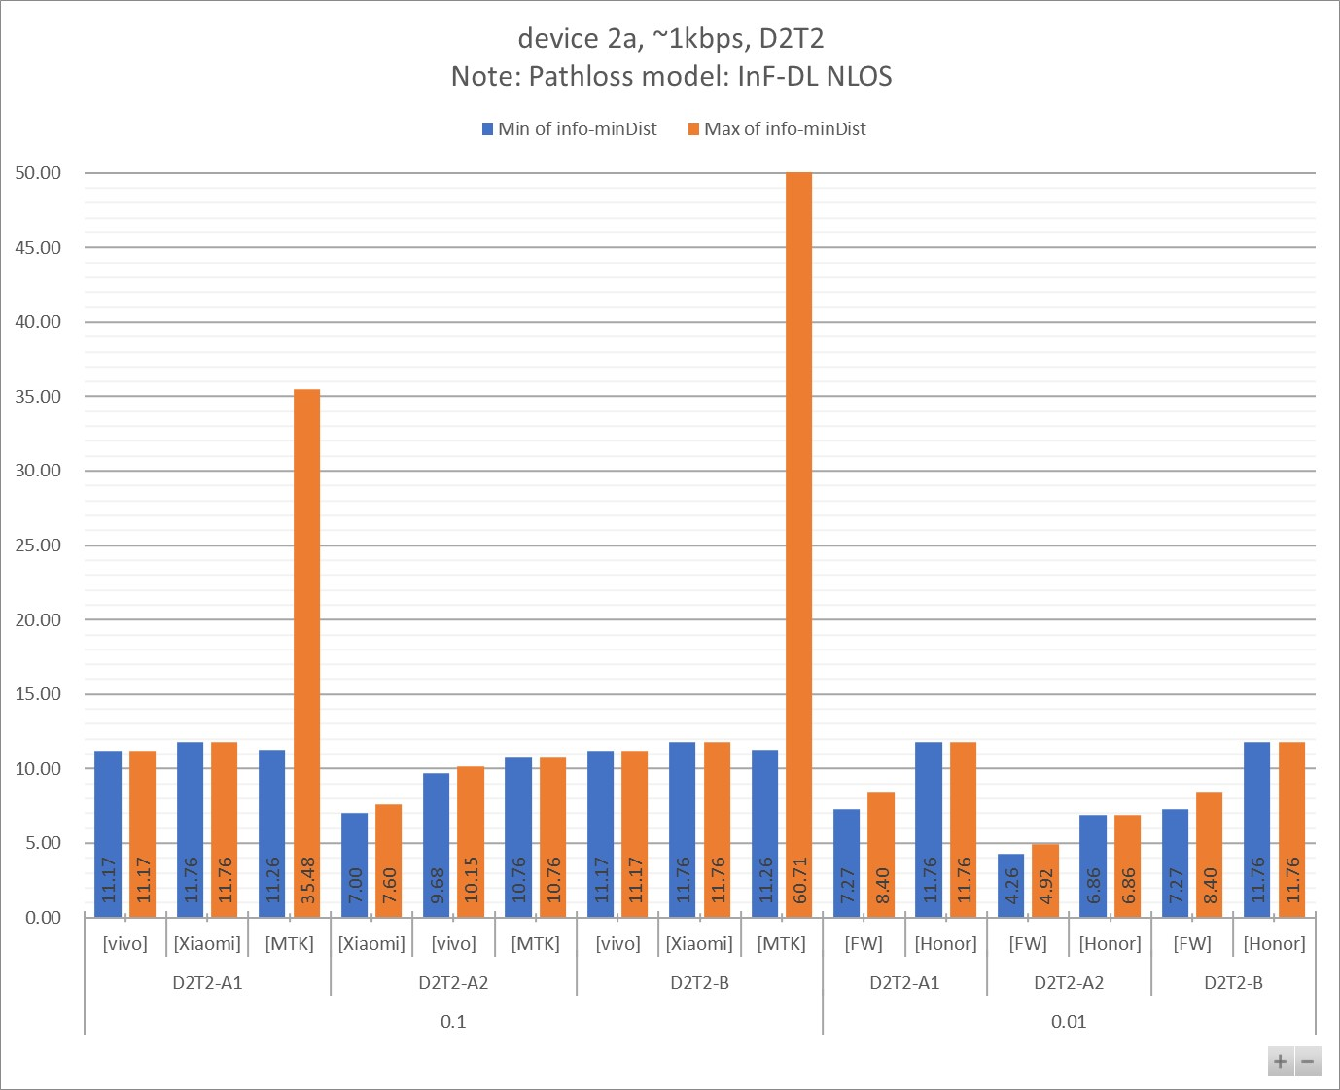

Figure 7.2.2.1 - 2

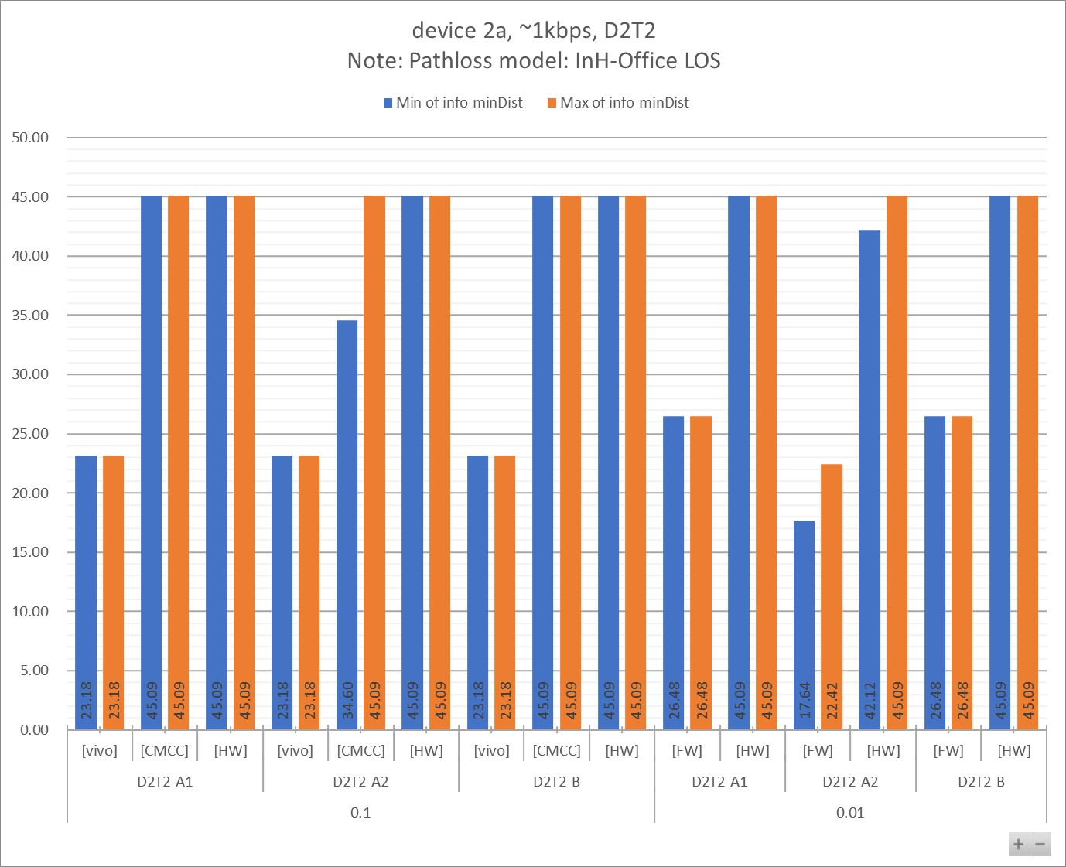

Table 7.2.2.1 - 1a

|  |  |  |  |  |  |  |  |  |  |  |  |
| --- | --- | --- | --- | --- | --- | --- | --- | --- | --- | --- | --- |
| info-D2R-datarate-range | ~1kbps |  |  |  |  |  |  |  |  |  |  |
| info-device-type | device 2a |  | **Distance (m)** | |  |  |  |  |  |  |  |
| info-D1T1/D2T2 | D2T2 |  |  |  |  |  |  |  |  |  |  |
| info-pathloss | InF-DL NLOS |  |  |  |  |  |  |  |  |  |  |
|  |  |  |  |  |  |  |  |  |  |  |  |
| **info-D2R_BLER** | **info-DxTx** | **info-Company** | **Min:info-R2D[4B]** | **Max:info-R2D[4B]** | **Min:info-D2R[4B]** | **Max:info-D2R[4B]** | **Min:min(Dist_R2D, Dist_D2R)** | **Max:min(Dist_R2D, Dist_D2R)** | **Min of info-D2R-datarate** | **Max of info-D2R-datarate** | **Count of No.** |
| **0.1** | **D2T2-A1** | [vivo] | 11.17 | 11.17 | 18.01 | 18.33 | 11.17 | 11.17 | 1.06 | 1.07 | 2 |
| [Xiaomi] | 11.76 | 11.76 | 14.50 | 15.80 | 11.76 | 11.76 | 0.95 | 1.14 | 2 |
| [MTK] | 11.26 | 60.71 | 35.48 | 35.48 | 11.26 | 35.48 | 0.58 | 0.58 | 2 |
| **D2T2-A2** | [Xiaomi] | 11.76 | 11.76 | 7.00 | 7.60 | 7.00 | 7.60 | 0.95 | 1.14 | 2 |
| [vivo] | 11.17 | 11.17 | 9.68 | 10.15 | 9.68 | 10.15 | 1.06 | 1.07 | 2 |
| [MTK] | 11.26 | 60.71 | 10.76 | 10.76 | 10.76 | 10.76 | 0.58 | 0.58 | 2 |
| **D2T2-B** | [vivo] | 11.17 | 11.17 | 61.07 | 65.77 | 11.17 | 11.17 | 1.06 | 1.07 | 4 |
| [Xiaomi] | 11.76 | 11.76 | 28.60 | 64.40 | 11.76 | 11.76 | 0.95 | 1.14 | 4 |
| [MTK] | 11.26 | 60.71 | 96.01 | 171.57 | 11.26 | 60.71 | 0.58 | 0.58 | 4 |
| **0.01** | **D2T2-A1** | [FW] | 9.09 | 9.09 | 7.27 | 8.40 | 7.27 | 8.40 | 1.00 | 1.00 | 2 |
| [Honor] | 11.76 | 11.76 | 17.06 | 17.06 | 11.76 | 11.76 | 1.10 | 1.10 | 1 |
| **D2T2-A2** | [FW] | 9.09 | 9.09 | 4.26 | 4.92 | 4.26 | 4.92 | 1.00 | 1.00 | 2 |
| [Honor] | 11.76 | 11.76 | 6.86 | 6.86 | 6.86 | 6.86 | 1.10 | 1.10 | 1 |
| **D2T2-B** | [FW] | 9.09 | 9.09 | 7.27 | 8.40 | 7.27 | 8.40 | 1.00 | 1.00 | 4 |
| [Honor] | 11.76 | 11.76 | 24.41 | 68.50 | 11.76 | 11.76 | 1.10 | 1.10 | 5 |
| **Grand Total** | | | **9.09** | **60.71** | **4.26** | **171.57** | **4.26** | **60.71** | **0.58** | **1.14** | **39** |

Table 7.2.2.1 - 1b

|  |  |  |  |  |  |  |  |  |  |
| --- | --- | --- | --- | --- | --- | --- | --- | --- | --- |
| info-D2R-datarate-range | ~1kbps |  |  |  |  |  |  |  |  |
| info-device-type | device 2a |  | **MPL (dB)** | |  |  |  |  |  |
| info-D1T1/D2T2 | D2T2 |  |  |  |  |  |  |  |  |
| info-pathloss | InF-DL NLOS |  |  |  |  |  |  |  |  |
|  |  |  |  |  |  |  |  |  |  |
| **info-D2R_BLER** | **info-DxTx** | **info-Company** | **Min of info-R2D[4A]** | **Max of info-R2D[4A]** | **Min of info-D2R[4A]** | **Max of info-D2R[4A]** | **Min of info-minMPL** | **Max of info-minMPL** | **Count of No.** |
| **0.1** | **D2T2-A1** | [vivo] | 55.10 | 55.10 | 62.51 | 62.78 | 55.10 | 55.10 | 2 |
| [Xiaomi] | 55.90 | 55.90 | 59.13 | 60.43 | 55.90 | 55.90 | 2 |
| [MTK] | 58.90 | 81.35 | 73.02 | 73.02 | 58.90 | 73.02 | 2 |
| **D2T2-A2** | [Xiaomi] | 55.90 | 55.90 | 47.89 | 49.19 | 47.89 | 49.19 | 2 |
| [vivo] | 55.10 | 55.10 | 52.88 | 53.62 | 52.88 | 53.62 | 2 |
| [MTK] | 58.90 | 81.35 | 58.40 | 58.40 | 58.40 | 58.40 | 2 |
| **D2T2-B** | [vivo] | 55.10 | 55.10 | 81.44 | 82.59 | 55.10 | 55.10 | 4 |
| [Xiaomi] | 55.90 | 55.90 | 69.65 | 82.35 | 55.90 | 55.90 | 4 |
| [MTK] | 58.90 | 81.35 | 88.45 | 97.45 | 58.90 | 81.35 | 4 |
| **0.01** | **D2T2-A1** | [FW] | 51.90 | 51.90 | 49.50 | 50.85 | 49.50 | 50.85 | 2 |
| [Honor] | 55.90 | 55.90 | 61.67 | 61.67 | 55.90 | 55.90 | 1 |
| **D2T2-A2** | [FW] | 51.90 | 51.90 | 44.50 | 45.85 | 44.50 | 45.85 | 2 |
| [Honor] | 55.90 | 55.90 | 47.55 | 47.55 | 47.55 | 47.55 | 1 |
| **D2T2-B** | [FW] | 51.90 | 51.90 | 49.50 | 50.85 | 49.50 | 50.85 | 4 |
| [Honor] | 55.90 | 55.90 | 67.22 | 83.22 | 55.90 | 55.90 | 5 |
| **Grand Total** | | | **51.90** | **81.35** | **44.50** | **97.45** | **44.50** | **81.35** | **39** |

Table 7.2.2.1 - 2a

|  |  |  |  |  |  |  |  |  |  |  |  |
| --- | --- | --- | --- | --- | --- | --- | --- | --- | --- | --- | --- |
| info-D2R-datarate-range | ~1kbps |  |  |  |  |  |  |  |  |  |  |
| info-device-type | device 2a |  | **Distance (m)** | |  |  |  |  |  |  |  |
| info-D1T1/D2T2 | D2T2 |  |  |  |  |  |  |  |  |  |  |
| info-pathloss | InH-Office LOS |  |  |  |  |  |  |  |  |  |  |
|  |  |  |  |  |  |  |  |  |  |  |  |
| **info-D2R_BLER** | **info-DxTx** | **info-Company** | **Min:info-R2D[4B]** | **Max:info-R2D[4B]** | **Min:info-D2R[4B]** | **Max:info-D2R[4B]** | **Min:min(Dist_R2D, Dist_D2R)** | **Max:min(Dist_R2D, Dist_D2R)** | **Min of info-D2R-datarate** | **Max of info-D2R-datarate** | **Count of No.** |
| **0.1** | **D2T2-A1** | [vivo] | 23.18 | 23.18 | 84.65 | 121.99 | 23.18 | 23.18 | 1.06 | 1.07 | 2 |
| [CMCC] | 45.09 | 45.09 | 198.46 | 295.86 | 45.09 | 45.09 | 0.80 | 0.80 | 2 |
| [HW] | 45.09 | 45.09 | 105.05 | 128.26 | 45.09 | 45.09 | 0.43 | 1.10 | 3 |
| **D2T2-A2** | [vivo] | 23.18 | 23.18 | 25.94 | 32.67 | 23.18 | 23.18 | 1.06 | 1.07 | 2 |
| [CMCC] | 45.09 | 45.09 | 34.60 | 51.57 | 34.60 | 45.09 | 0.80 | 0.80 | 2 |
| [HW] | 45.09 | 45.09 | 57.59 | 70.32 | 45.09 | 45.09 | 0.43 | 1.10 | 3 |
| **D2T2-B** | [vivo] | 23.18 | 23.18 | 1433.05 | 3227.69 | 23.18 | 23.18 | 1.06 | 1.07 | 4 |
| [CMCC] | 45.09 | 45.09 | 3938.59 | 61729.17 | 45.09 | 45.09 | 0.80 | 0.80 | 6 |
| [HW] | 45.09 | 45.09 | 1103.55 | 1645.14 | 45.09 | 45.09 | 0.43 | 1.10 | 3 |
| **0.01** | **D2T2-A1** | [FW] | 26.48 | 26.48 | 34.31 | 43.59 | 26.48 | 26.48 | 1.00 | 1.00 | 2 |
| [HW] | 45.09 | 45.09 | 76.83 | 96.99 | 45.09 | 45.09 | 0.43 | 1.10 | 3 |
| **D2T2-A2** | [FW] | 26.48 | 26.48 | 17.64 | 22.42 | 17.64 | 22.42 | 1.00 | 1.00 | 2 |
| [HW] | 45.09 | 45.09 | 42.12 | 53.17 | 42.12 | 45.09 | 0.43 | 1.10 | 3 |
| **D2T2-B** | [FW] | 26.48 | 26.48 | 34.31 | 43.60 | 26.48 | 26.48 | 1.00 | 1.00 | 4 |
| [HW] | 45.09 | 45.09 | 590.36 | 940.65 | 45.09 | 45.09 | 0.43 | 1.10 | 3 |
| **Grand Total** | | | **23.18** | **45.09** | **17.64** | **61729.17** | **17.64** | **45.09** | **0.43** | **1.10** | **44** |

Table 7.2.2.1 - 2b

|  |  |  |  |  |  |  |  |  |  |
| --- | --- | --- | --- | --- | --- | --- | --- | --- | --- |
| info-D2R-datarate-range | ~1kbps |  |  |  |  |  |  |  |  |
| info-device-type | device 2a |  | **MPL (dB)** | |  |  |  |  |  |
| info-D1T1/D2T2 | D2T2 |  |  |  |  |  |  |  |  |
| info-pathloss | InH-Office LOS |  |  |  |  |  |  |  |  |
|  |  |  |  |  |  |  |  |  |  |
| **info-D2R_BLER** | **info-DxTx** | **info-Company** | **Min of info-R2D[4A]** | **Max of info-R2D[4A]** | **Min of info-D2R[4A]** | **Max of info-D2R[4A]** | **Min of info-minMPL** | **Max of info-minMPL** | **Count of No.** |
| **0.1** | **D2T2-A1** | [vivo] | 55.10 | 55.10 | 64.83 | 67.58 | 55.10 | 55.10 | 2 |
| [CMCC] | 60.10 | 60.10 | 71.23 | 74.23 | 60.10 | 60.10 | 2 |
| [HW] | 60.10 | 60.10 | 66.46 | 67.96 | 60.10 | 60.10 | 3 |
| **D2T2-A2** | [vivo] | 55.10 | 55.10 | 55.95 | 57.68 | 55.10 | 55.10 | 2 |
| [CMCC] | 60.10 | 60.10 | 58.11 | 61.11 | 58.11 | 60.10 | 2 |
| [HW] | 60.10 | 60.10 | 61.94 | 63.44 | 60.10 | 60.10 | 3 |
| **D2T2-B** | [vivo] | 55.10 | 55.10 | 86.09 | 92.19 | 55.10 | 55.10 | 4 |
| [CMCC] | 60.10 | 60.10 | 93.68 | 114.36 | 60.10 | 60.10 | 6 |
| [HW] | 60.10 | 60.10 | 84.13 | 87.13 | 60.10 | 60.10 | 3 |
| **0.01** | **D2T2-A1** | [FW] | 56.10 | 56.10 | 58.05 | 59.85 | 56.10 | 56.10 | 2 |
| [HW] | 60.10 | 60.10 | 64.11 | 65.86 | 60.10 | 60.10 | 3 |
| **D2T2-A2** | [FW] | 56.10 | 56.10 | 53.05 | 54.85 | 53.05 | 54.85 | 2 |
| [HW] | 60.10 | 60.10 | 59.59 | 61.34 | 59.59 | 60.10 | 3 |
| **D2T2-B** | [FW] | 56.10 | 56.10 | 58.05 | 59.85 | 56.10 | 56.10 | 4 |
| [HW] | 60.10 | 60.10 | 79.43 | 82.93 | 60.10 | 60.10 | 3 |
| **Grand Total** | | | **55.10** | **60.10** | **53.05** | **114.36** | **53.05** | **60.10** | **44** |

#### 7.2.2.2 [5~7kbps]

Figure 7.2.2.2 - 1

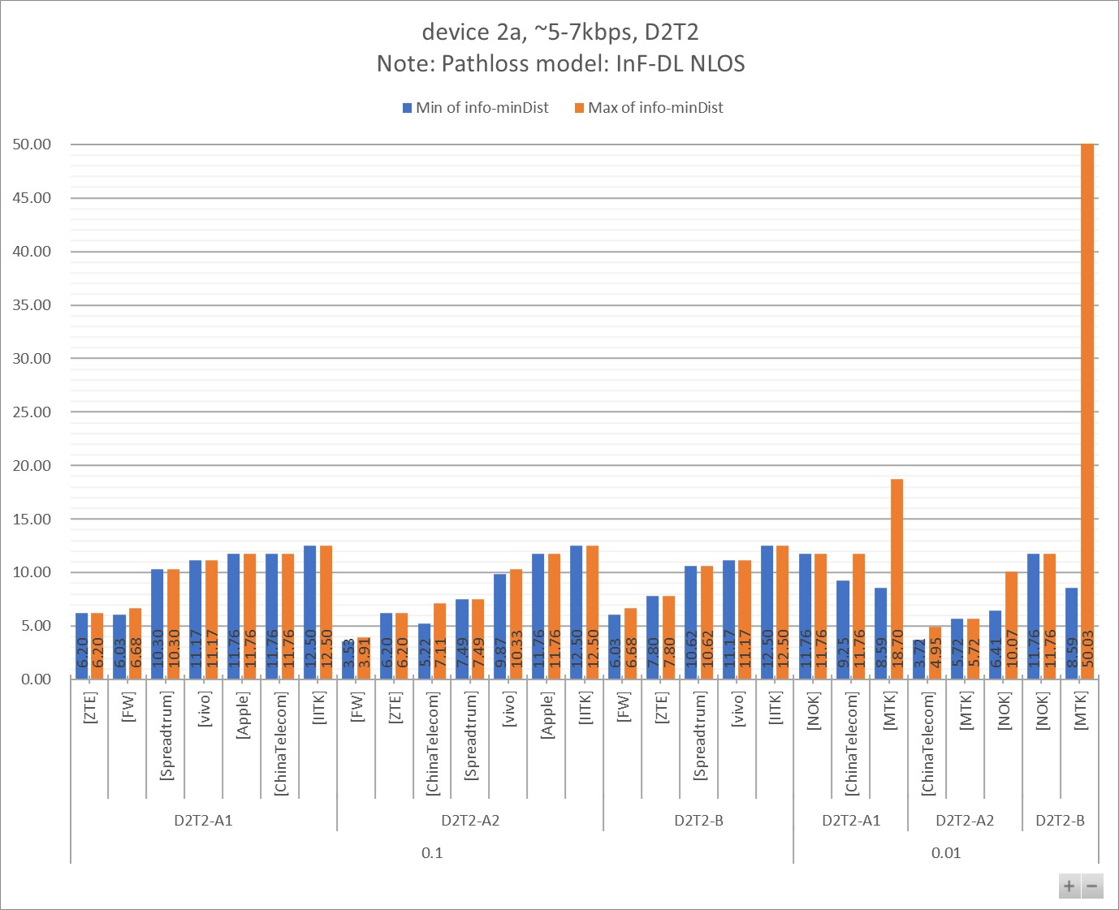

Figure 7.2.2.2 - 2

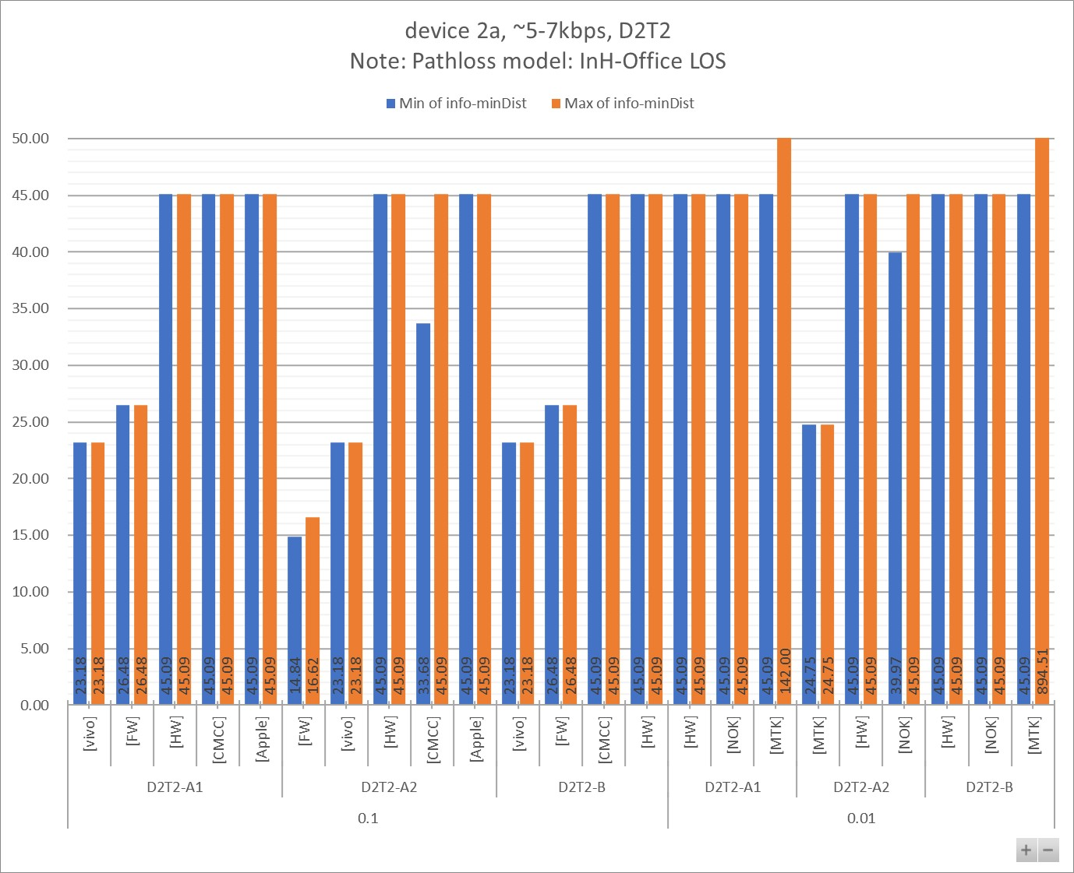

Table 7.2.2.2 - 1a

|  |  |  |  |  |  |  |  |  |  |  |  |
| --- | --- | --- | --- | --- | --- | --- | --- | --- | --- | --- | --- |
| info-D2R-datarate-range | ~5-7kbps |  |  |  |  |  |  |  |  |  |  |
| info-device-type | device 2a |  | **Distance (m)** | |  |  |  |  |  |  |  |
| info-D1T1/D2T2 | D2T2 |  |  |  |  |  |  |  |  |  |  |
| info-pathloss | InF-DL NLOS |  |  |  |  |  |  |  |  |  |  |
|  |  |  |  |  |  |  |  |  |  |  |  |
| **info-D2R_BLER** | **info-DxTx** | **info-Company** | **Min:info-R2D[4B]** | **Max:info-R2D[4B]** | **Min:info-D2R[4B]** | **Max:info-D2R[4B]** | **Min:min(Dist_R2D, Dist_D2R)** | **Max:min(Dist_R2D, Dist_D2R)** | **Min of info-D2R-datarate** | **Max of info-D2R-datarate** | **Count of No.** |
| **0.1** | **D2T2-A1** | [ZTE] | 8.60 | 11.30 | 6.20 | 6.20 | 6.20 | 6.20 | 7.00 | 7.00 | 2 |
| [FW] | 9.09 | 9.09 | 6.03 | 6.68 | 6.03 | 6.68 | 6.00 | 6.00 | 2 |
| [Spreadtrum] | 11.76 | 11.76 | 10.30 | 10.30 | 10.30 | 10.30 | 5.00 | 5.00 | 1 |
| [vivo] | 11.17 | 11.17 | 15.99 | 16.73 | 11.17 | 11.17 | 5.08 | 5.36 | 2 |
| [Apple] | 11.76 | 11.76 | 13.92 | 15.08 | 11.76 | 11.76 | 5.00 | 7.00 | 2 |
| [ChinaTelecom] | 11.76 | 11.76 | 12.97 | 17.67 | 11.76 | 11.76 | 5.63 | 5.63 | 6 |
| [IITK] | 12.50 | 12.50 | 15.93 | 17.50 | 12.50 | 12.50 | 7.00 | 7.00 | 2 |
| **D2T2-A2** | [FW] | 9.09 | 9.09 | 3.53 | 3.91 | 3.53 | 3.91 | 6.00 | 6.00 | 2 |
| [ZTE] | 8.60 | 11.30 | 6.20 | 6.20 | 6.20 | 6.20 | 7.00 | 7.00 | 2 |
| [ChinaTelecom] | 11.76 | 11.76 | 5.22 | 7.11 | 5.22 | 7.11 | 5.63 | 5.63 | 6 |
| [Spreadtrum] | 11.76 | 11.76 | 7.49 | 7.49 | 7.49 | 7.49 | 5.00 | 5.00 | 1 |
| [vivo] | 11.17 | 11.17 | 9.87 | 10.33 | 9.87 | 10.33 | 5.08 | 5.36 | 2 |
| [Apple] | 11.76 | 11.76 | 12.78 | 14.57 | 11.76 | 11.76 | 5.00 | 7.00 | 2 |
| [IITK] | 12.50 | 12.50 | 15.93 | 17.50 | 12.50 | 12.50 | 7.00 | 7.00 | 2 |
| **D2T2-B** | [FW] | 9.09 | 9.09 | 6.03 | 6.68 | 6.03 | 6.68 | 6.00 | 6.00 | 4 |
| [ZTE] | 8.60 | 11.30 | 7.80 | 7.80 | 7.80 | 7.80 | 7.00 | 7.00 | 2 |
| [Spreadtrum] | 11.76 | 11.76 | 10.62 | 10.62 | 10.62 | 10.62 | 5.00 | 5.00 | 1 |
| [vivo] | 11.17 | 11.17 | 48.13 | 55.72 | 11.17 | 11.17 | 5.08 | 5.36 | 4 |
| [IITK] | 12.50 | 12.50 | 50.72 | 56.00 | 12.50 | 12.50 | 7.00 | 7.00 | 4 |
| **0.01** | **D2T2-A1** | [NOK] | 11.76 | 11.76 | 14.23 | 22.35 | 11.76 | 11.76 | 6.43 | 6.43 | 3 |
| [ChinaTelecom] | 11.76 | 11.76 | 9.25 | 12.31 | 9.25 | 11.76 | 5.63 | 5.63 | 6 |
| [MTK] | 8.59 | 50.03 | 18.70 | 18.70 | 8.59 | 18.70 | 4.67 | 4.67 | 2 |
| **D2T2-A2** | [ChinaTelecom] | 11.76 | 11.76 | 3.72 | 4.95 | 3.72 | 4.95 | 5.63 | 5.63 | 6 |
| [MTK] | 8.59 | 50.03 | 5.72 | 5.72 | 5.72 | 5.72 | 4.67 | 4.67 | 2 |
| [NOK] | 11.76 | 11.76 | 6.41 | 10.07 | 6.41 | 10.07 | 6.43 | 6.43 | 3 |
| **D2T2-B** | [NOK] | 11.76 | 11.76 | 20.26 | 52.21 | 11.76 | 11.76 | 6.43 | 6.43 | 6 |
| [MTK] | 8.59 | 50.03 | 32.07 | 69.55 | 8.59 | 50.03 | 4.67 | 4.67 | 4 |
| **Grand Total** | | | **8.59** | **50.03** | **3.53** | **69.55** | **3.53** | **50.03** | **4.67** | **7.00** | **81** |

Table 7.2.2.2 - 1b

|  |  |  |  |  |  |  |  |  |  |
| --- | --- | --- | --- | --- | --- | --- | --- | --- | --- |
| info-D2R-datarate-range | ~5-7kbps |  |  |  |  |  |  |  |  |
| info-device-type | device 2a |  | **MPL (dB)** | |  |  |  |  |  |
| info-D1T1/D2T2 | D2T2 |  |  |  |  |  |  |  |  |
| info-pathloss | InF-DL NLOS |  |  |  |  |  |  |  |  |
|  |  |  |  |  |  |  |  |  |  |
| **info-D2R_BLER** | **info-DxTx** | **info-Company** | **Min of info-R2D[4A]** | **Max of info-R2D[4A]** | **Min of info-D2R[4A]** | **Max of info-D2R[4A]** | **Min of info-minMPL** | **Max of info-minMPL** | **Count of No.** |
| **0.1** | **D2T2-A1** | [FW] | 51.90 | 51.90 | 47.75 | 48.70 | 47.75 | 48.70 | 2 |
| [ZTE] | 55.90 | 58.90 | 52.28 | 52.34 | 52.28 | 52.34 | 2 |
| [Spreadtrum] | 55.90 | 55.90 | 53.85 | 53.85 | 53.85 | 53.85 | 1 |
| [vivo] | 55.10 | 55.10 | 60.66 | 61.36 | 55.10 | 55.10 | 2 |
| [ChinaTelecom] | 55.90 | 55.90 | 57.42 | 62.21 | 55.90 | 55.90 | 6 |
| [Apple] | 55.90 | 55.90 | 58.51 | 59.76 | 55.90 | 55.90 | 2 |
| [IITK] | 56.90 | 56.90 | 60.60 | 62.10 | 56.90 | 56.90 | 2 |
| **D2T2-A2** | [FW] | 51.90 | 51.90 | 42.75 | 43.70 | 42.75 | 43.70 | 2 |
| [ChinaTelecom] | 55.90 | 55.90 | 43.30 | 48.09 | 43.30 | 48.09 | 6 |
| [Spreadtrum] | 55.90 | 55.90 | 48.89 | 48.89 | 48.89 | 48.89 | 1 |
| [ZTE] | 55.90 | 58.90 | 52.28 | 52.34 | 52.28 | 52.34 | 2 |
| [vivo] | 55.10 | 55.10 | 53.18 | 53.88 | 53.18 | 53.88 | 2 |
| [Apple] | 55.90 | 55.90 | 56.95 | 58.19 | 55.90 | 55.90 | 2 |
| [IITK] | 56.90 | 56.90 | 60.60 | 62.10 | 56.90 | 56.90 | 2 |
| **D2T2-B** | [FW] | 51.90 | 51.90 | 47.75 | 48.70 | 47.75 | 48.70 | 4 |
| [Spreadtrum] | 55.90 | 55.90 | 54.31 | 54.31 | 54.31 | 54.31 | 1 |
| [ZTE] | 55.90 | 58.90 | 54.78 | 54.84 | 54.78 | 54.84 | 2 |
| [vivo] | 55.10 | 55.10 | 77.75 | 80.02 | 55.10 | 55.10 | 4 |
| [IITK] | 56.90 | 56.90 | 78.56 | 80.10 | 56.90 | 56.90 | 4 |
| **0.01** | **D2T2-A1** | [NOK] | 55.90 | 55.90 | 58.86 | 65.86 | 55.90 | 55.90 | 3 |
| [ChinaTelecom] | 55.90 | 55.90 | 52.18 | 56.61 | 52.18 | 55.90 | 6 |
| [MTK] | 55.90 | 78.35 | 64.52 | 64.52 | 55.90 | 64.52 | 2 |
| **D2T2-A2** | [ChinaTelecom] | 55.90 | 55.90 | 38.06 | 42.48 | 38.06 | 42.48 | 6 |
| [MTK] | 55.90 | 78.35 | 51.39 | 51.39 | 51.39 | 51.39 | 2 |
| [NOK] | 55.90 | 55.90 | 46.49 | 53.49 | 46.49 | 53.49 | 3 |
| **D2T2-B** | [NOK] | 55.90 | 55.90 | 64.33 | 79.01 | 55.90 | 55.90 | 6 |
| [MTK] | 55.90 | 78.35 | 71.45 | 83.45 | 55.90 | 78.35 | 4 |
| **Grand Total** | | | **51.90** | **78.35** | **38.06** | **83.45** | **38.06** | **78.35** | **81** |

Table 7.2.2.2 - 2a

|  |  |  |  |  |  |  |  |  |  |  |  |
| --- | --- | --- | --- | --- | --- | --- | --- | --- | --- | --- | --- |
| info-D2R-datarate-range | ~5-7kbps |  |  |  |  |  |  |  |  |  |  |
| info-device-type | device 2a |  | **Distance (m)** | |  |  |  |  |  |  |  |
| info-D1T1/D2T2 | D2T2 |  |  |  |  |  |  |  |  |  |  |
| info-pathloss | InH-Office LOS |  |  |  |  |  |  |  |  |  |  |
|  |  |  |  |  |  |  |  |  |  |  |  |
| **info-D2R_BLER** | **info-DxTx** | **info-Company** | **Min:info-R2D[4B]** | **Max:info-R2D[4B]** | **Min:info-D2R[4B]** | **Max:info-D2R[4B]** | **Min:min(Dist_R2D, Dist_D2R)** | **Max:min(Dist_R2D, Dist_D2R)** | **Min of info-D2R-datarate** | **Max of info-D2R-datarate** | **Count of No.** |
| **0.1** | **D2T2-A1** | [vivo] | 23.18 | 23.18 | 72.73 | 80.85 | 23.18 | 23.18 | 5.08 | 5.36 | 2 |
| [FW] | 26.48 | 26.48 | 28.86 | 32.31 | 26.48 | 26.48 | 6.00 | 6.00 | 2 |
| [HW] | 45.09 | 45.09 | 89.74 | 99.16 | 45.09 | 45.09 | 3.00 | 5.80 | 3 |
| [CMCC] | 45.09 | 45.09 | 115.52 | 172.21 | 45.09 | 45.09 | 6.00 | 6.00 | 2 |
| [Apple] | 45.09 | 45.09 | 98.34 | 108.66 | 45.09 | 45.09 | 5.00 | 7.00 | 2 |
| **D2T2-A2** | [FW] | 26.48 | 26.48 | 14.84 | 16.62 | 14.84 | 16.62 | 6.00 | 6.00 | 2 |
| [vivo] | 23.18 | 23.18 | 26.87 | 29.87 | 23.18 | 23.18 | 5.08 | 5.36 | 2 |
| [HW] | 45.09 | 45.09 | 63.35 | 70.00 | 45.09 | 45.09 | 3.00 | 5.80 | 3 |
| [CMCC] | 45.09 | 45.09 | 33.68 | 50.21 | 33.68 | 45.09 | 6.00 | 6.00 | 2 |
| [Apple] | 45.09 | 45.09 | 79.88 | 88.29 | 45.09 | 45.09 | 5.00 | 7.00 | 2 |
| **D2T2-B** | [vivo] | 23.18 | 23.18 | 1057.91 | 1467.86 | 23.18 | 23.18 | 5.08 | 5.36 | 4 |
| [FW] | 26.48 | 26.48 | 28.86 | 32.31 | 26.48 | 26.48 | 6.00 | 6.00 | 4 |
| [CMCC] | 45.09 | 45.09 | 1334.48 | 20915.14 | 45.09 | 45.09 | 6.00 | 6.00 | 6 |
| [HW] | 45.09 | 45.09 | 805.24 | 983.18 | 45.09 | 45.09 | 3.00 | 5.80 | 3 |
| **0.01** | **D2T2-A1** | [HW] | 45.09 | 45.09 | 67.40 | 75.98 | 45.09 | 45.09 | 3.00 | 5.80 | 3 |
| [NOK] | 45.09 | 45.09 | 77.29 | 172.91 | 45.09 | 45.09 | 6.43 | 6.43 | 3 |
| [MTK] | 45.09 | 894.51 | 142.00 | 142.00 | 45.09 | 142.00 | 4.67 | 4.67 | 2 |
| **D2T2-A2** | [MTK] | 45.09 | 894.51 | 24.75 | 24.75 | 24.75 | 24.75 | 4.67 | 4.67 | 2 |
| [HW] | 45.09 | 45.09 | 47.58 | 53.64 | 45.09 | 45.09 | 3.00 | 5.80 | 3 |
| [NOK] | 45.09 | 45.09 | 39.97 | 89.42 | 39.97 | 45.09 | 6.43 | 6.43 | 3 |
| **D2T2-B** | [HW] | 45.09 | 45.09 | 454.33 | 577.32 | 45.09 | 45.09 | 3.00 | 5.80 | 3 |
| [NOK] | 45.09 | 45.09 | 597.31 | 2997.95 | 45.09 | 45.09 | 6.43 | 6.43 | 6 |
| [MTK] | 45.09 | 894.51 | 2016.46 | 9959.34 | 45.09 | 894.51 | 4.67 | 4.67 | 4 |
| **Grand Total** | | | **23.18** | **894.51** | **14.84** | **20915.14** | **14.84** | **894.51** | **3.00** | **7.00** | **68** |

Table 7.2.2.2 - 2b

|  |  |  |  |  |  |  |  |  |  |
| --- | --- | --- | --- | --- | --- | --- | --- | --- | --- |
| info-D2R-datarate-range | ~5-7kbps |  |  |  |  |  |  |  |  |
| info-device-type | device 2a |  | **MPL (dB)** | |  |  |  |  |  |
| info-D1T1/D2T2 | D2T2 |  |  |  |  |  |  |  |  |
| info-pathloss | InH-Office LOS |  |  |  |  |  |  |  |  |
|  |  |  |  |  |  |  |  |  |  |
| **info-D2R_BLER** | **info-DxTx** | **info-Company** | **Min of info-R2D[4A]** | **Max of info-R2D[4A]** | **Min of info-D2R[4A]** | **Max of info-D2R[4A]** | **Min of info-minMPL** | **Max of info-minMPL** | **Count of No.** |
| **0.1** | **D2T2-A1** | [vivo] | 55.10 | 55.10 | 63.69 | 64.49 | 55.10 | 55.10 | 2 |
| [FW] | 56.10 | 56.10 | 56.75 | 57.60 | 56.10 | 56.10 | 2 |
| [HW] | 60.10 | 60.10 | 65.27 | 66.02 | 60.10 | 60.10 | 3 |
| [CMCC] | 60.10 | 60.10 | 67.17 | 70.17 | 60.10 | 60.10 | 2 |
| [Apple] | 60.10 | 60.10 | 65.96 | 66.71 | 60.10 | 60.10 | 2 |
| **D2T2-A2** | [FW] | 56.10 | 56.10 | 51.75 | 52.60 | 51.75 | 52.60 | 2 |
| [vivo] | 55.10 | 55.10 | 56.21 | 57.01 | 55.10 | 55.10 | 2 |
| [HW] | 60.10 | 60.10 | 62.66 | 63.41 | 60.10 | 60.10 | 3 |
| [CMCC] | 60.10 | 60.10 | 57.91 | 60.91 | 57.91 | 60.10 | 2 |
| [Apple] | 60.10 | 60.10 | 64.39 | 65.15 | 60.10 | 60.10 | 2 |
| **D2T2-B** | [vivo] | 55.10 | 55.10 | 83.81 | 86.27 | 55.10 | 55.10 | 4 |
| [FW] | 56.10 | 56.10 | 56.75 | 57.60 | 56.10 | 56.10 | 4 |
| [CMCC] | 60.10 | 60.10 | 85.55 | 106.23 | 60.10 | 60.10 | 6 |
| [HW] | 60.10 | 60.10 | 81.76 | 83.26 | 60.10 | 60.10 | 3 |
| **0.01** | **D2T2-A1** | [NOK] | 60.10 | 60.10 | 64.15 | 70.20 | 60.10 | 60.10 | 3 |
| [HW] | 60.10 | 60.10 | 63.12 | 64.02 | 60.10 | 60.10 | 3 |
| [MTK] | 60.10 | 82.55 | 68.72 | 68.72 | 60.10 | 68.72 | 2 |
| **D2T2-A2** | [MTK] | 60.10 | 82.55 | 55.59 | 55.59 | 55.59 | 55.59 | 2 |
| [NOK] | 60.10 | 60.10 | 59.19 | 65.24 | 59.19 | 60.10 | 3 |
| [HW] | 60.10 | 60.10 | 60.51 | 61.41 | 60.10 | 60.10 | 3 |
| **D2T2-B** | [NOK] | 60.10 | 60.10 | 79.51 | 91.63 | 60.10 | 60.10 | 6 |
| [HW] | 60.10 | 60.10 | 77.46 | 79.26 | 60.10 | 60.10 | 3 |
| [MTK] | 60.10 | 82.55 | 88.65 | 100.65 | 60.10 | 82.55 | 4 |
| **Grand Total** | | | **55.10** | **82.55** | **51.75** | **106.23** | **51.75** | **82.55** | **68** |

#### 7.2.2.3 other data rate

Figure 7.2.2.3 - 1

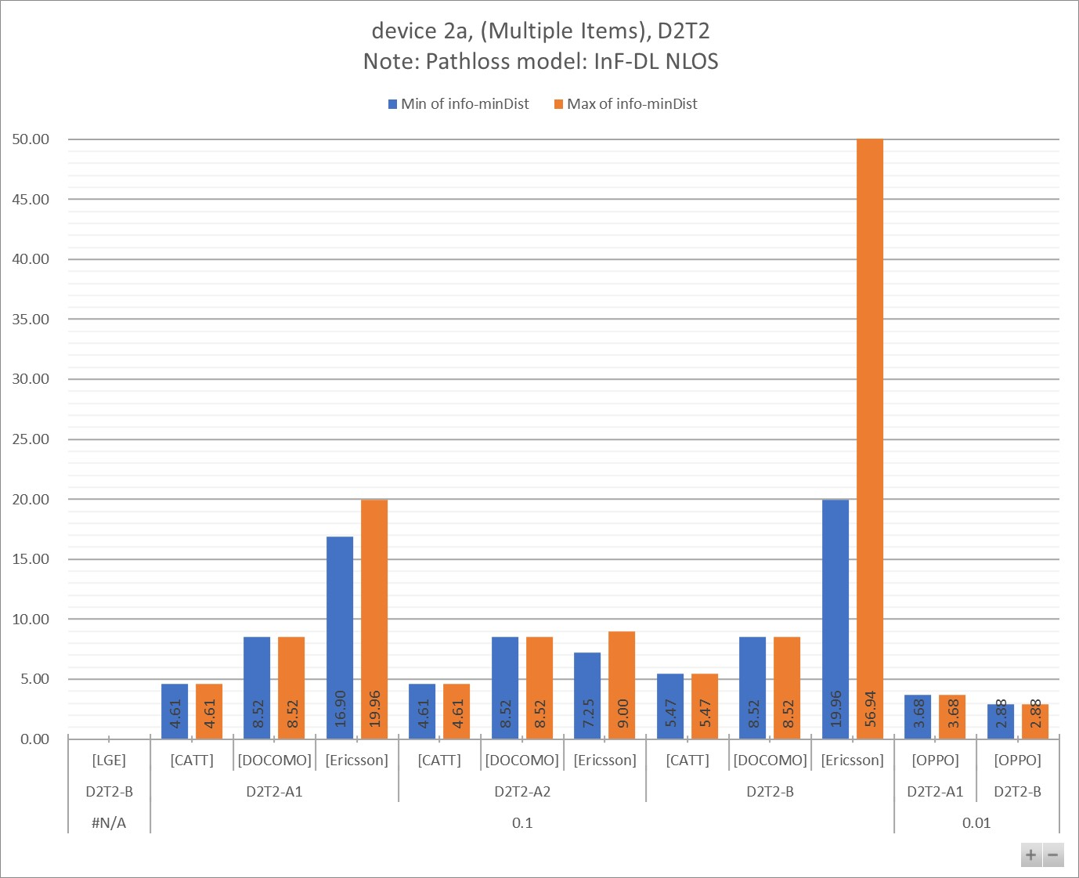

Figure 7.2.2.3 - 2

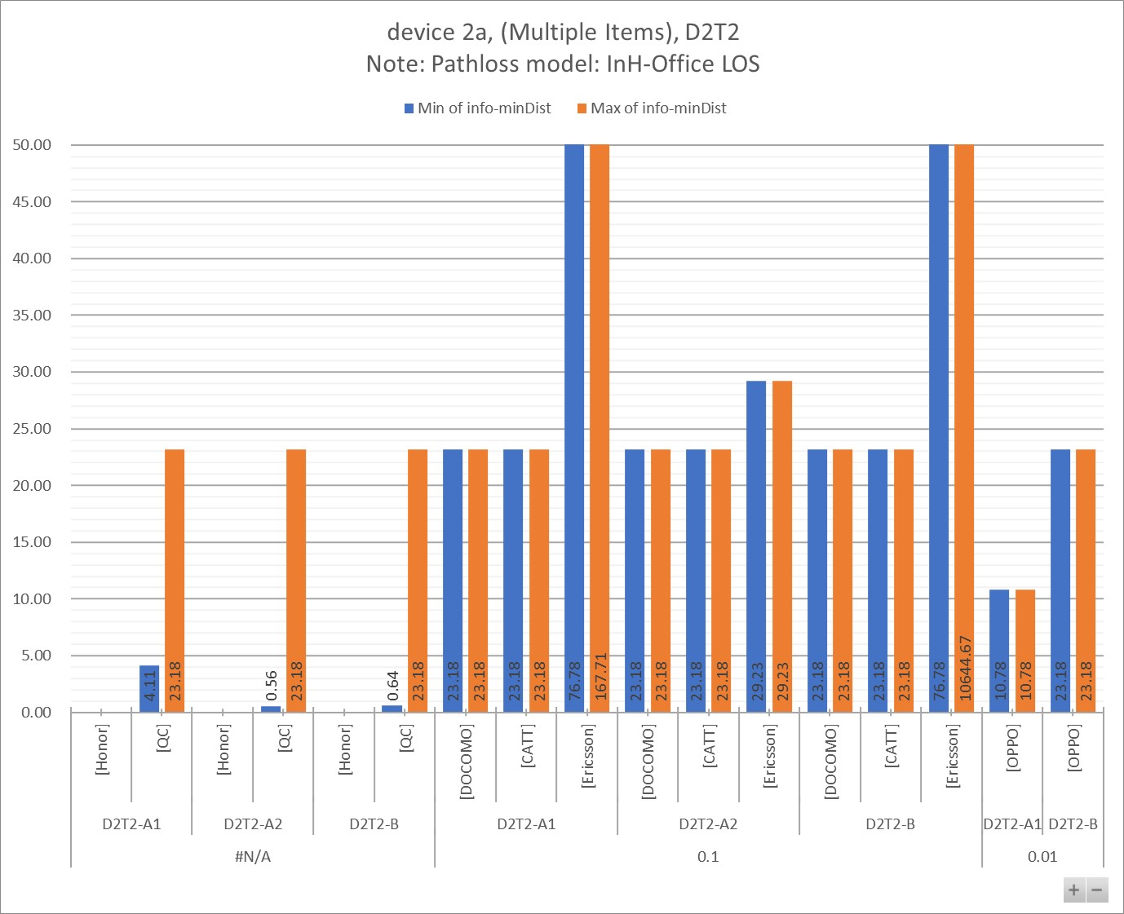

Table 7.2.2.3 - 1a

|  |  |  |  |  |  |  |  |  |  |  |  |
| --- | --- | --- | --- | --- | --- | --- | --- | --- | --- | --- | --- |
| info-D2R-datarate-range | (Multiple Items) |  |  |  |  |  |  |  |  |  |  |
| info-device-type | device 2a |  | **Distance (m)** | |  |  |  |  |  |  |  |
| info-D1T1/D2T2 | D2T2 |  |  |  |  |  |  |  |  |  |  |
| info-pathloss | InF-DL NLOS |  |  |  |  |  |  |  |  |  |  |
|  |  |  |  |  |  |  |  |  |  |  |  |
| **info-D2R_BLER** | **info-DxTx** | **info-Company** | **Min:info-R2D[4B]** | **Max:info-R2D[4B]** | **Min:info-D2R[4B]** | **Max:info-D2R[4B]** | **Min:min(Dist_R2D, Dist_D2R)** | **Max:min(Dist_R2D, Dist_D2R)** | **Min of info-D2R-datarate** | **Max of info-D2R-datarate** | **Count of No.** |
| **#N/A** | **D2T2-B** | [LGE] | 8.52 | 8.52 |  |  |  |  | #N/A | #N/A | 3 |
| **0.1** | **D2T2-A1** | [CATT] | 5.47 | 5.47 | 4.61 | 4.61 | 4.61 | 4.61 | 44.80 | 44.80 | 1 |
| [DOCOMO] | 8.52 | 8.52 | 9.95 | 9.95 | 8.52 | 8.52 | 28.00 | 28.00 | 1 |
| [Ericsson] | 19.96 | 108.48 | 16.90 | 20.97 | 16.90 | 19.96 | 16.00 | 48.00 | 7 |
| **D2T2-A2** | [CATT] | 5.47 | 5.47 | 4.61 | 4.61 | 4.61 | 4.61 | 44.80 | 44.80 | 1 |
| [DOCOMO] | 8.52 | 8.52 | 9.95 | 9.95 | 8.52 | 8.52 | 28.00 | 28.00 | 1 |
| [Ericsson] | 19.96 | 108.48 | 7.25 | 9.00 | 7.25 | 9.00 | 16.00 | 48.00 | 7 |
| **D2T2-B** | [CATT] | 5.47 | 5.47 | 7.29 | 17.99 | 5.47 | 5.47 | 44.80 | 44.80 | 2 |
| [DOCOMO] | 8.52 | 8.52 | 9.95 | 10.69 | 8.52 | 8.52 | 28.00 | 28.00 | 2 |
| [Ericsson] | 19.96 | 108.48 | 28.56 | 83.85 | 19.96 | 56.94 | 16.00 | 48.00 | 14 |
| **0.01** | **D2T2-A1** | [OPPO] | 8.52 | 8.52 | 3.68 | 3.68 | 3.68 | 3.68 | 0.00 | 0.00 | 1 |
| **D2T2-B** | [OPPO] | 8.52 | 8.52 | 2.88 | 2.88 | 2.88 | 2.88 | 0.00 | 0.00 | 1 |
| **Grand Total** | | | **5.47** | **108.48** | **2.88** | **83.85** | **2.88** | **56.94** | **#N/A** | **#N/A** | **41** |

Table 7.2.2.3 - 1b

|  |  |  |  |  |  |  |  |  |  |
| --- | --- | --- | --- | --- | --- | --- | --- | --- | --- |
| info-D2R-datarate-range | (Multiple Items) |  |  |  |  |  |  |  |  |
| info-device-type | device 2a |  | **MPL (dB)** | |  |  |  |  |  |
| info-D1T1/D2T2 | D2T2 |  |  |  |  |  |  |  |  |
| info-pathloss | InF-DL NLOS |  |  |  |  |  |  |  |  |
|  |  |  |  |  |  |  |  |  |  |
| **info-D2R_BLER** | **info-DxTx** | **info-Company** | **Min of info-R2D[4A]** | **Max of info-R2D[4A]** | **Min of info-D2R[4A]** | **Max of info-D2R[4A]** | **Min of info-minMPL** | **Max of info-minMPL** | **Count of No.** |
| **#N/A** | **D2T2-B** | [LGE] | 50.90 | 50.90 |  |  |  |  | 3 |
| **0.1** | **D2T2-A1** | [CATT] | 50.90 | 50.90 | 49.00 | 49.00 | 49.00 | 49.00 | 1 |
| [DOCOMO] | 50.90 | 50.90 | 53.31 | 53.31 | 50.90 | 50.90 | 1 |
| [Ericsson] | 64.10 | 90.35 | 61.52 | 64.87 | 61.52 | 64.10 | 7 |
| **D2T2-A2** | [CATT] | 50.90 | 50.90 | 49.00 | 49.00 | 49.00 | 49.00 | 1 |
| [DOCOMO] | 50.90 | 50.90 | 53.31 | 53.31 | 50.90 | 50.90 | 1 |
| [Ericsson] | 64.10 | 90.35 | 48.39 | 51.74 | 48.39 | 51.74 | 7 |
| **D2T2-B** | [DOCOMO] | 50.90 | 50.90 | 53.31 | 54.41 | 50.90 | 50.90 | 2 |
| [CATT] | 50.90 | 50.90 | 54.09 | 64.09 | 50.90 | 50.90 | 2 |
| [Ericsson] | 64.10 | 90.35 | 69.65 | 86.35 | 64.10 | 80.35 | 14 |
| **0.01** | **D2T2-A1** | [OPPO] | 50.90 | 50.90 | 37.90 | 37.90 | 37.90 | 37.90 | 1 |
| **D2T2-B** | [OPPO] | 50.90 | 50.90 | 34.06 | 34.06 | 34.06 | 34.06 | 1 |
| **Grand Total** | | | **50.90** | **90.35** | **34.06** | **86.35** | **34.06** | **80.35** | **41** |

Table 7.2.2.3 - 2a

|  |  |  |  |  |  |  |  |  |  |  |  |
| --- | --- | --- | --- | --- | --- | --- | --- | --- | --- | --- | --- |
| info-D2R-datarate-range | (Multiple Items) |  |  |  |  |  |  |  |  |  |  |
| info-device-type | device 2a |  | **Distance (m)** | |  |  |  |  |  |  |  |
| info-D1T1/D2T2 | D2T2 |  |  |  |  |  |  |  |  |  |  |
| info-pathloss | InH-Office LOS |  |  |  |  |  |  |  |  |  |  |
|  |  |  |  |  |  |  |  |  |  |  |  |
| **info-D2R_BLER** | **info-DxTx** | **info-Company** | **Min:info-R2D[4B]** | **Max:info-R2D[4B]** | **Min:info-D2R[4B]** | **Max:info-D2R[4B]** | **Min:min(Dist_R2D, Dist_D2R)** | **Max:min(Dist_R2D, Dist_D2R)** | **Min of info-D2R-datarate** | **Max of info-D2R-datarate** | **Count of No.** |
| **#N/A** | **D2T2-A1** | [Honor] | 45.09 | 45.09 |  |  |  |  | #N/A | #N/A | 1 |
| [QC] | 13.98 | 45.09 | 4.11 | 62.84 | 4.11 | 23.18 | #N/A | #N/A | 8 |
| **D2T2-A2** | [Honor] | 45.09 | 45.09 |  |  |  |  | #N/A | #N/A | 1 |
| [QC] | 13.98 | 45.09 | 0.56 | 62.84 | 0.56 | 23.18 | #N/A | #N/A | 8 |
| **D2T2-B** | [Honor] | 45.09 | 45.09 |  |  |  |  | #N/A | #N/A | 2 |
| [QC] | 13.98 | 45.09 | 0.64 | 570.45 | 0.64 | 23.18 | #N/A | #N/A | 8 |
| **0.1** | **D2T2-A1** | [DOCOMO] | 23.18 | 23.18 | 31.94 | 31.94 | 23.18 | 23.18 | 28.00 | 28.00 | 1 |
| [CATT] | 23.18 | 23.18 | 26.65 | 26.65 | 23.18 | 23.18 | 44.80 | 44.80 | 1 |
| [Ericsson] | 76.78 | 11068.04 | 167.71 | 167.71 | 76.78 | 167.71 | 48.00 | 48.00 | 2 |
| **D2T2-A2** | [DOCOMO] | 23.18 | 23.18 | 31.94 | 31.94 | 23.18 | 23.18 | 28.00 | 28.00 | 1 |
| [CATT] | 23.18 | 23.18 | 26.65 | 26.65 | 23.18 | 23.18 | 44.80 | 44.80 | 1 |
| [Ericsson] | 76.78 | 11068.04 | 29.23 | 29.23 | 29.23 | 29.23 | 48.00 | 48.00 | 2 |
| **D2T2-B** | [DOCOMO] | 23.18 | 23.18 | 31.94 | 36.99 | 23.18 | 23.18 | 28.00 | 28.00 | 2 |
| [CATT] | 23.18 | 23.18 | 315.62 | 1194.55 | 23.18 | 23.18 | 44.80 | 44.80 | 2 |
| [Ericsson] | 76.78 | 11068.04 | 2812.53 | 10644.67 | 76.78 | 10644.67 | 48.00 | 48.00 | 4 |
| **0.01** | **D2T2-A1** | [OPPO] | 23.18 | 23.18 | 10.78 | 10.78 | 10.78 | 10.78 | 0.00 | 0.00 | 1 |
| **D2T2-B** | [OPPO] | 23.18 | 23.18 | 26.20 | 26.20 | 23.18 | 23.18 | 0.00 | 0.00 | 1 |
| **Grand Total** | | | **13.98** | **11068.04** | **0.56** | **10644.67** | **0.56** | **10644.67** | **#N/A** | **#N/A** | **46** |

Table 7.2.2.3 - 2b

|  |  |  |  |  |  |  |  |  |  |
| --- | --- | --- | --- | --- | --- | --- | --- | --- | --- |
| info-D2R-datarate-range | (Multiple Items) |  |  |  |  |  |  |  |  |
| info-device-type | device 2a |  | **MPL (dB)** | |  |  |  |  |  |
| info-D1T1/D2T2 | D2T2 |  |  |  |  |  |  |  |  |
| info-pathloss | InH-Office LOS |  |  |  |  |  |  |  |  |
|  |  |  |  |  |  |  |  |  |  |
| **info-D2R_BLER** | **info-DxTx** | **info-Company** | **Min of info-R2D[4A]** | **Max of info-R2D[4A]** | **Min of info-D2R[4A]** | **Max of info-D2R[4A]** | **Min of info-minMPL** | **Max of info-minMPL** | **Count of No.** |
| **#N/A** | **D2T2-A1** | [Honor] | 60.10 | 60.10 |  |  |  |  | 1 |
| [QC] | 51.30 | 60.10 | 42.10 | 62.59 | 42.10 | 55.10 | 8 |
| **D2T2-A2** | [Honor] | 60.10 | 60.10 |  |  |  |  | 1 |
| [QC] | 51.30 | 60.10 | 27.10 | 62.59 | 27.10 | 55.10 | 8 |
| **D2T2-B** | [Honor] | 60.10 | 60.10 |  |  |  |  | 2 |
| [QC] | 51.30 | 60.10 | 28.18 | 79.17 | 28.18 | 55.10 | 8 |
| **0.1** | **D2T2-A1** | [DOCOMO] | 55.10 | 55.10 | 57.51 | 57.51 | 55.10 | 55.10 | 1 |
| [CATT] | 55.10 | 55.10 | 56.15 | 56.15 | 55.10 | 55.10 | 1 |
| [Ericsson] | 64.10 | 101.45 | 69.97 | 69.97 | 64.10 | 69.97 | 2 |
| **D2T2-A2** | [DOCOMO] | 55.10 | 55.10 | 57.51 | 57.51 | 55.10 | 55.10 | 1 |
| [CATT] | 55.10 | 55.10 | 56.15 | 56.15 | 55.10 | 55.10 | 1 |
| [Ericsson] | 64.10 | 101.45 | 56.84 | 56.84 | 56.84 | 56.84 | 2 |
| **D2T2-B** | [DOCOMO] | 55.10 | 55.10 | 57.51 | 58.61 | 55.10 | 55.10 | 2 |
| [CATT] | 55.10 | 55.10 | 74.72 | 84.72 | 55.10 | 55.10 | 2 |
| [Ericsson] | 64.10 | 101.45 | 91.15 | 101.15 | 64.10 | 101.15 | 4 |
| **0.01** | **D2T2-A1** | [OPPO] | 55.10 | 55.10 | 49.35 | 49.35 | 49.35 | 49.35 | 1 |
| **D2T2-B** | [OPPO] | 55.10 | 55.10 | 56.02 | 56.02 | 55.10 | 55.10 | 1 |
| **Grand Total** | | | **51.30** | **101.45** | **27.10** | **101.15** | **27.10** | **101.15** | **46** |

### 7.2.3 Device 2b

#### 7.2.3.1 [1kbps]

Figure 7.2.3.1 - 1

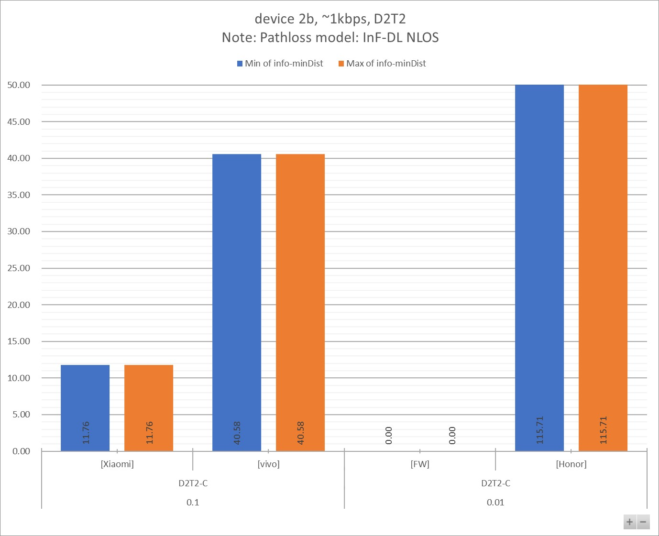

Figure 7.2.3.1 - 2

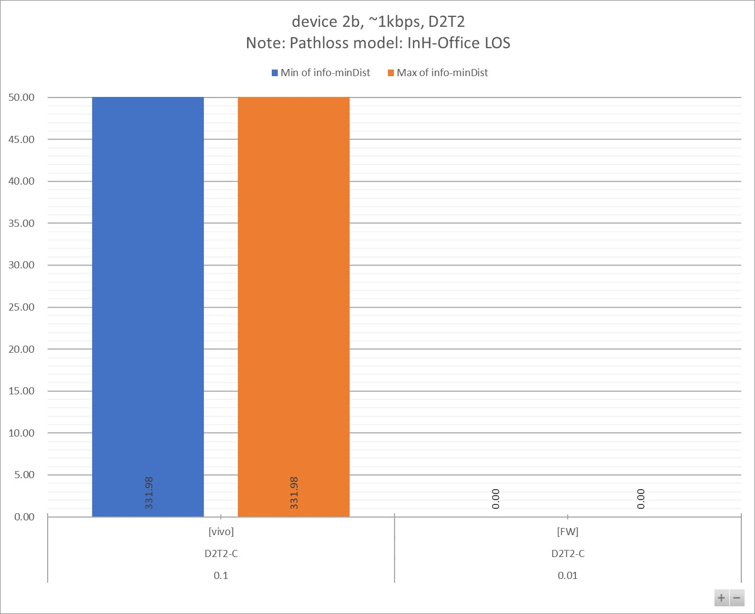

Table 7.2.3.1 - 1a

|  |  |  |  |  |  |  |  |  |  |  |  |
| --- | --- | --- | --- | --- | --- | --- | --- | --- | --- | --- | --- |
| info-D2R-datarate-range | ~1kbps |  |  |  |  |  |  |  |  |  |  |
| info-device-type | device 2b |  | **Distance (m)** | |  |  |  |  |  |  |  |
| info-D1T1/D2T2 | D2T2 |  |  |  |  |  |  |  |  |  |  |
| info-pathloss | InF-DL NLOS |  |  |  |  |  |  |  |  |  |  |
|  |  |  |  |  |  |  |  |  |  |  |  |
| **info-D2R_BLER** | **info-DxTx** | **info-Company** | **Min:info-R2D[4B]** | **Max:info-R2D[4B]** | **Min:info-D2R[4B]** | **Max:info-D2R[4B]** | **Min:min(Dist_R2D, Dist_D2R)** | **Max:min(Dist_R2D, Dist_D2R)** | **Min of info-D2R-datarate** | **Max of info-D2R-datarate** | **Count of No.** |
| **0.1** | **D2T2-C** | [Xiaomi] | 11.76 | 11.76 | 73.80 | 87.20 | 11.76 | 11.76 | 0.95 | 1.14 | 2 |
| [vivo] | 40.58 | 40.58 | 85.67 | 87.87 | 40.58 | 40.58 | 1.06 | 1.07 | 2 |
| **0.01** | [FW] | 0.00 | 0.00 | 0.00 | 0.00 | 0.00 | 0.00 | 1.00 | 1.00 | 2 |
| [Honor] | 115.71 | 115.71 | 161.73 | 161.73 | 115.71 | 115.71 | 1.10 | 1.10 | 1 |
| **Grand Total** | | | **11.76** | **115.71** | **73.80** | **161.73** | **11.76** | **115.71** | **0.95** | **1.14** | **7** |

Table 7.2.3.1 - 1b

|  |  |  |  |  |  |  |  |  |  |
| --- | --- | --- | --- | --- | --- | --- | --- | --- | --- |
| info-D2R-datarate-range | ~1kbps |  |  |  |  |  |  |  |  |
| info-device-type | device 2b |  | **MPL (dB)** | |  |  |  |  |  |
| info-D1T1/D2T2 | D2T2 |  |  |  |  |  |  |  |  |
| info-pathloss | InF-DL NLOS |  |  |  |  |  |  |  |  |
|  |  |  |  |  |  |  |  |  |  |
| **info-D2R_BLER** | **info-DxTx** | **info-Company** | **Min of info-R2D[4A]** | **Max of info-R2D[4A]** | **Min of info-D2R[4A]** | **Max of info-D2R[4A]** | **Min of info-minMPL** | **Max of info-minMPL** | **Count of No.** |
| **0.1** | **D2T2-C** | [Xiaomi] | 55.90 | 55.90 | 84.37 | 86.97 | 55.90 | 55.90 | 2 |
| [vivo] | 75.10 | 75.10 | 86.69 | 87.08 | 75.10 | 75.10 | 2 |
| **0.01** | [Honor] | 91.35 | 91.35 | 96.54 | 96.54 | 91.35 | 91.35 | 1 |
| [FW] | 110.25 | 110.25 | 94.04 | 111.34 | 94.04 | 110.25 | 2 |
| **Grand Total** | | | **55.90** | **110.25** | **84.37** | **111.34** | **55.90** | **110.25** | **7** |

Table 7.2.3.1 - 2a

|  |  |  |  |  |  |  |  |  |  |  |  |
| --- | --- | --- | --- | --- | --- | --- | --- | --- | --- | --- | --- |
| info-D2R-datarate-range | ~1kbps |  |  |  |  |  |  |  |  |  |  |
| info-device-type | device 2b |  | **Distance (m)** | |  |  |  |  |  |  |  |
| info-D1T1/D2T2 | D2T2 |  |  |  |  |  |  |  |  |  |  |
| info-pathloss | InH-Office LOS |  |  |  |  |  |  |  |  |  |  |
|  |  |  |  |  |  |  |  |  |  |  |  |
| **info-D2R_BLER** | **info-DxTx** | **info-Company** | **Min:info-R2D[4B]** | **Max:info-R2D[4B]** | **Min:info-D2R[4B]** | **Max:info-D2R[4B]** | **Min:min(Dist_R2D, Dist_D2R)** | **Max:min(Dist_R2D, Dist_D2R)** | **Min of info-D2R-datarate** | **Max of info-D2R-datarate** | **Count of No.** |
| **0.1** | **D2T2-C** | [vivo] | 331.98 | 331.98 | 3036.17 | 6447.73 | 331.98 | 331.98 | 1.06 | 1.07 | 2 |
| **0.01** | [FW] | 0.00 | 0.00 | 0.00 | 0.00 | 0.00 | 0.00 | 1.00 | 1.00 | 2 |
| **Grand Total** | | | **331.98** | **331.98** | **3036.17** | **6447.73** | **331.98** | **331.98** | **1.00** | **1.07** | **4** |

Table 7.2.3.1 - 2b

|  |  |  |  |  |  |  |  |  |  |
| --- | --- | --- | --- | --- | --- | --- | --- | --- | --- |
| info-D2R-datarate-range | ~1kbps |  |  |  |  |  |  |  |  |
| info-device-type | device 2b |  | **MPL (dB)** | |  |  |  |  |  |
| info-D1T1/D2T2 | D2T2 |  |  |  |  |  |  |  |  |
| info-pathloss | InH-Office LOS |  |  |  |  |  |  |  |  |
|  |  |  |  |  |  |  |  |  |  |
| **info-D2R_BLER** | **info-DxTx** | **info-Company** | **Min of info-R2D[4A]** | **Max of info-R2D[4A]** | **Min of info-D2R[4A]** | **Max of info-D2R[4A]** | **Min of info-minMPL** | **Max of info-minMPL** | **Count of No.** |
| **0.1** | **D2T2-C** | [vivo] | 75.10 | 75.10 | 91.73 | 97.39 | 75.10 | 75.10 | 2 |
| **0.01** | [FW] | 114.45 | 114.45 | 107.84 | 124.24 | 107.84 | 114.45 | 2 |
| **Grand Total** | | | **75.10** | **114.45** | **91.73** | **124.24** | **75.10** | **114.45** | **4** |

#### 7.2.3.2 [5~7kbps]

Figure 7.2.3.2 - 1

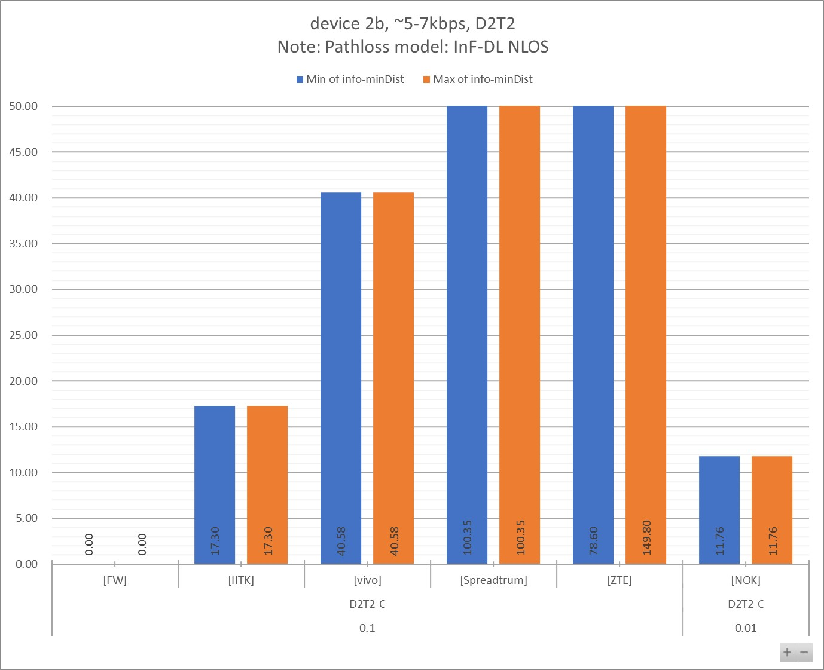

Figure 7.2.3.2 - 2

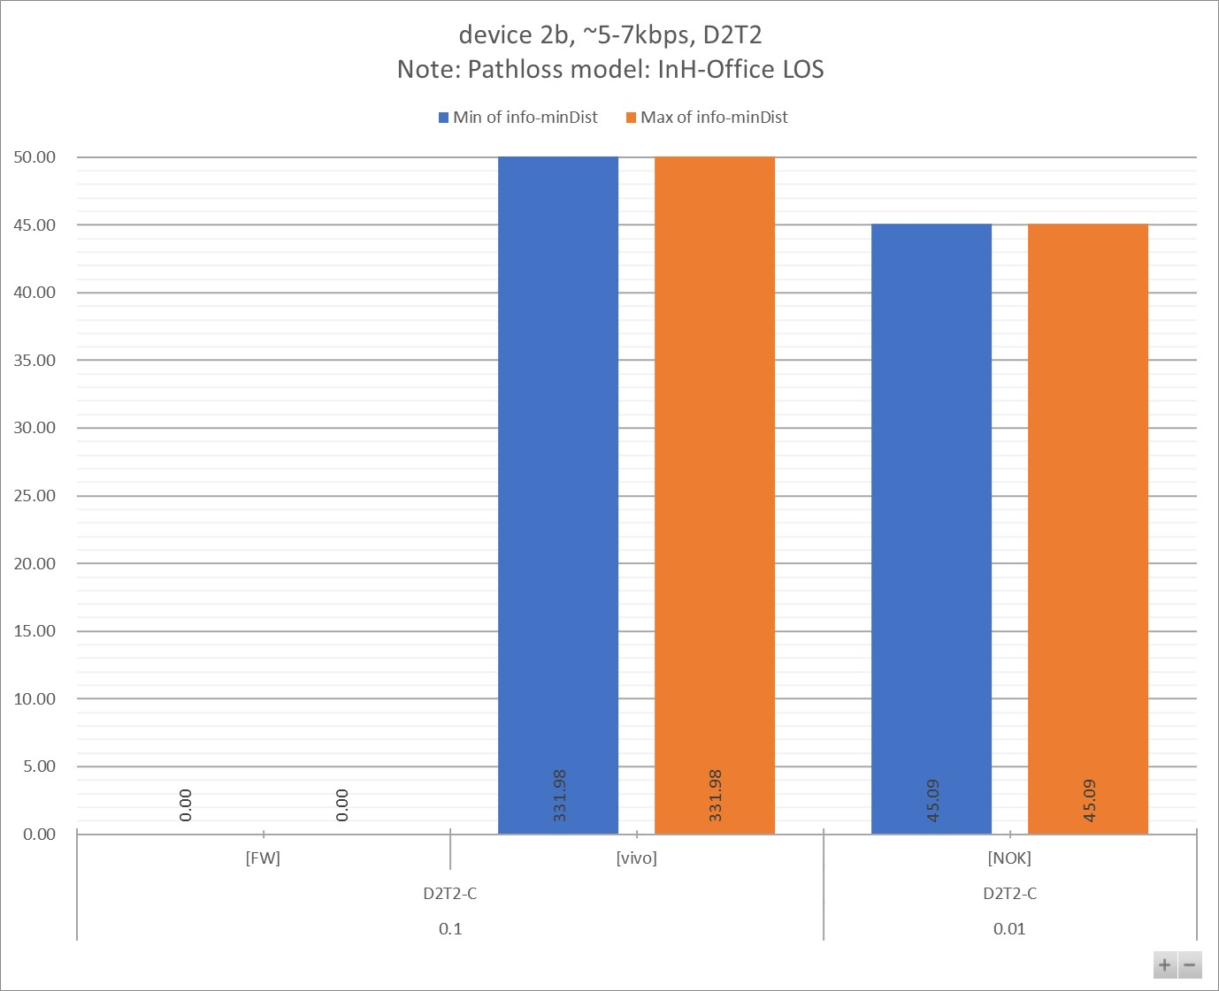

Table 7.2.3.2 - 1a

|  |  |  |  |  |  |  |  |  |  |  |  |
| --- | --- | --- | --- | --- | --- | --- | --- | --- | --- | --- | --- |
| info-D2R-datarate-range | ~5-7kbps |  |  |  |  |  |  |  |  |  |  |
| info-device-type | device 2b |  | **Distance (m)** | |  |  |  |  |  |  |  |
| info-D1T1/D2T2 | D2T2 |  |  |  |  |  |  |  |  |  |  |
| info-pathloss | InF-DL NLOS |  |  |  |  |  |  |  |  |  |  |
|  |  |  |  |  |  |  |  |  |  |  |  |
| **info-D2R_BLER** | **info-DxTx** | **info-Company** | **Min:info-R2D[4B]** | **Max:info-R2D[4B]** | **Min:info-D2R[4B]** | **Max:info-D2R[4B]** | **Min:min(Dist_R2D, Dist_D2R)** | **Max:min(Dist_R2D, Dist_D2R)** | **Min of info-D2R-datarate** | **Max of info-D2R-datarate** | **Count of No.** |
| **0.1** | **D2T2-C** | [FW] | 0.00 | 0.00 | 0.00 | 0.00 | 0.00 | 0.00 | 6.00 | 6.00 | 2 |
| [IITK] | 17.30 | 17.30 | 73.44 | 204.10 | 17.30 | 17.30 | 7.00 | 7.00 | 2 |
| [vivo] | 40.58 | 40.58 | 68.68 | 75.17 | 40.58 | 40.58 | 5.08 | 5.36 | 2 |
| [Spreadtrum] | 267.62 | 267.62 | 100.35 | 100.35 | 100.35 | 100.35 | 5.00 | 5.00 | 1 |
| [ZTE] | 275.00 | 333.00 | 78.60 | 149.80 | 78.60 | 149.80 | 7.00 | 7.00 | 4 |
| **0.01** | [NOK] | 11.76 | 11.76 | 73.63 | 123.35 | 11.76 | 11.76 | 6.43 | 6.43 | 3 |
| **Grand Total** | | | **11.76** | **333.00** | **68.68** | **204.10** | **11.76** | **149.80** | **5.00** | **7.00** | **14** |

Table 7.2.3.2 - 1b

|  |  |  |  |  |  |  |  |  |  |
| --- | --- | --- | --- | --- | --- | --- | --- | --- | --- |
| info-D2R-datarate-range | ~5-7kbps |  |  |  |  |  |  |  |  |
| info-device-type | device 2b |  | **MPL (dB)** | |  |  |  |  |  |
| info-D1T1/D2T2 | D2T2 |  |  |  |  |  |  |  |  |
| info-pathloss | InF-DL NLOS |  |  |  |  |  |  |  |  |
|  |  |  |  |  |  |  |  |  |  |
| **info-D2R_BLER** | **info-DxTx** | **info-Company** | **Min of info-R2D[4A]** | **Max of info-R2D[4A]** | **Min of info-D2R[4A]** | **Max of info-D2R[4A]** | **Min of info-minMPL** | **Max of info-minMPL** | **Count of No.** |
| **0.1** | **D2T2-C** | [IITK] | 61.90 | 61.90 | 84.30 | 100.14 | 61.90 | 61.90 | 2 |
| [vivo] | 75.10 | 75.10 | 83.26 | 84.66 | 75.10 | 75.10 | 2 |
| [Spreadtrum] | 104.35 | 104.35 | 89.14 | 89.14 | 89.14 | 89.14 | 1 |
| [ZTE] | 104.75 | 107.75 | 85.35 | 95.35 | 85.35 | 95.35 | 4 |
| [FW] | 110.25 | 110.25 | 89.74 | 107.84 | 89.74 | 107.84 | 2 |
| **0.01** | [NOK] | 55.90 | 55.90 | 84.34 | 92.34 | 55.90 | 55.90 | 3 |
| **Grand Total** | | | **55.90** | **110.25** | **83.26** | **107.84** | **55.90** | **107.84** | **14** |

Table 7.2.3.2 - 2a

|  |  |  |  |  |  |  |  |  |  |  |  |
| --- | --- | --- | --- | --- | --- | --- | --- | --- | --- | --- | --- |
| info-D2R-datarate-range | ~5-7kbps |  |  |  |  |  |  |  |  |  |  |
| info-device-type | device 2b |  | **Distance (m)** | |  |  |  |  |  |  |  |
| info-D1T1/D2T2 | D2T2 |  |  |  |  |  |  |  |  |  |  |
| info-pathloss | InH-Office LOS |  |  |  |  |  |  |  |  |  |  |
|  |  |  |  |  |  |  |  |  |  |  |  |
| **info-D2R_BLER** | **info-DxTx** | **info-Company** | **Min:info-R2D[4B]** | **Max:info-R2D[4B]** | **Min:info-D2R[4B]** | **Max:info-D2R[4B]** | **Min:min(Dist_R2D, Dist_D2R)** | **Max:min(Dist_R2D, Dist_D2R)** | **Min of info-D2R-datarate** | **Max of info-D2R-datarate** | **Count of No.** |
| **0.1** | **D2T2-C** | [FW] | 0.00 | 0.00 | 0.00 | 0.00 | 0.00 | 0.00 | 6.00 | 6.00 | 2 |
| [vivo] | 331.98 | 331.98 | 2202.94 | 2722.14 | 331.98 | 331.98 | 5.08 | 5.36 | 2 |
| **0.01** | [NOK] | 45.09 | 45.09 | 16459.35 | 42972.73 | 45.09 | 45.09 | 6.43 | 6.43 | 3 |
| **Grand Total** | | | **45.09** | **331.98** | **2202.94** | **42972.73** | **45.09** | **331.98** | **5.08** | **6.43** | **7** |

Table 7.2.3.2 - 2b

|  |  |  |  |  |  |  |  |  |  |
| --- | --- | --- | --- | --- | --- | --- | --- | --- | --- |
| info-D2R-datarate-range | ~5-7kbps |  |  |  |  |  |  |  |  |
| info-device-type | device 2b |  | **MPL (dB)** | |  |  |  |  |  |
| info-D1T1/D2T2 | D2T2 |  |  |  |  |  |  |  |  |
| info-pathloss | InH-Office LOS |  |  |  |  |  |  |  |  |
|  |  |  |  |  |  |  |  |  |  |
| **info-D2R_BLER** | **info-DxTx** | **info-Company** | **Min of info-R2D[4A]** | **Max of info-R2D[4A]** | **Min of info-D2R[4A]** | **Max of info-D2R[4A]** | **Min of info-minMPL** | **Max of info-minMPL** | **Count of No.** |
| **0.1** | **D2T2-C** | [vivo] | 75.10 | 75.10 | 89.32 | 90.91 | 75.10 | 75.10 | 2 |
| [FW] | 114.45 | 114.45 | 103.34 | 121.64 | 103.34 | 114.45 | 2 |
| **0.01** | [NOK] | 60.10 | 60.10 | 104.43 | 111.64 | 60.10 | 60.10 | 3 |
| **Grand Total** | | | **60.10** | **114.45** | **89.32** | **121.64** | **60.10** | **114.45** | **7** |

#### 7.2.3.3 other data rate

Figure 7.2.3.3 - 1

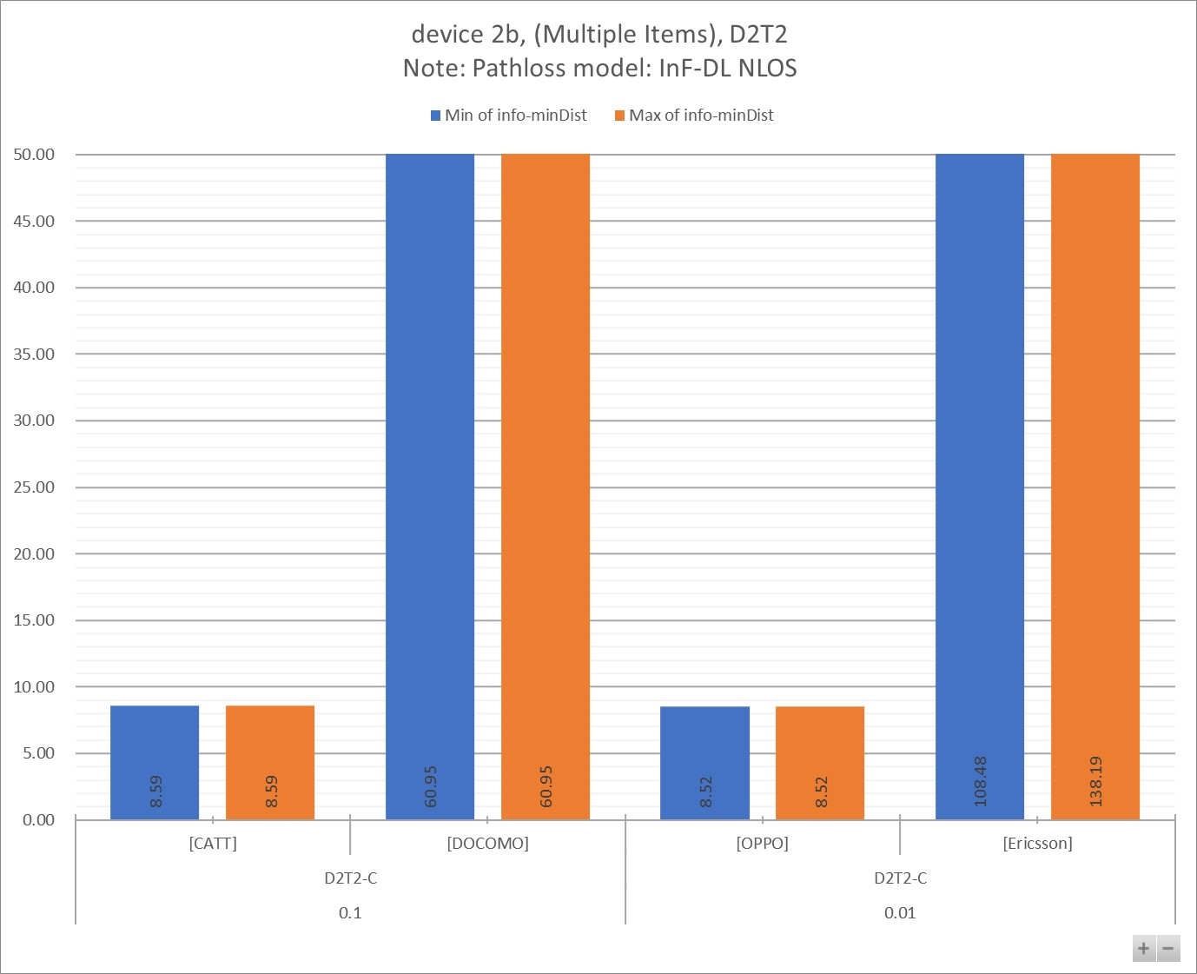

Figure 7.2.3.3 - 2

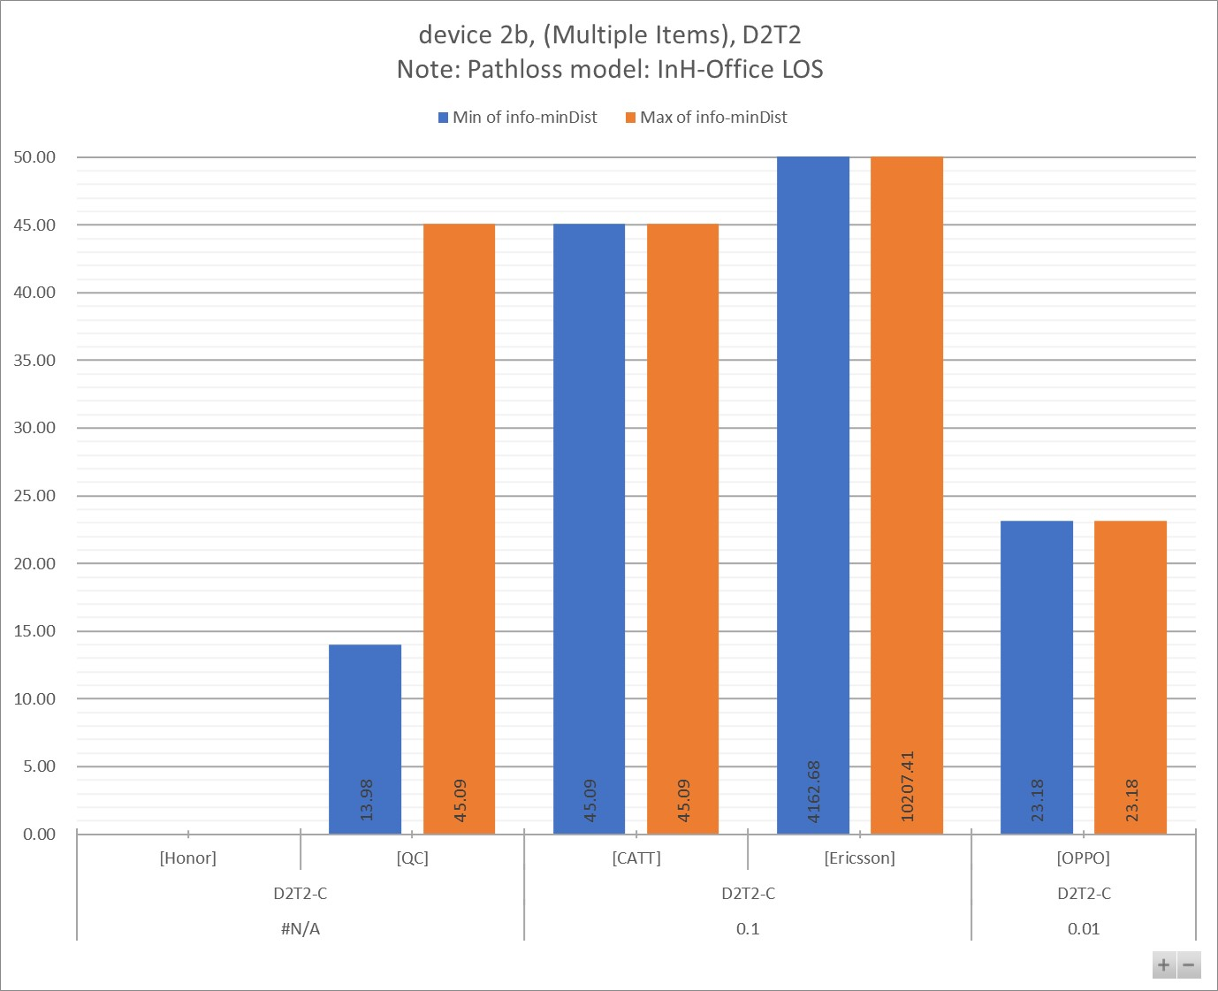

Table 7.2.3.3 - 1a

|  |  |  |  |  |  |  |  |  |  |  |  |
| --- | --- | --- | --- | --- | --- | --- | --- | --- | --- | --- | --- |
| info-D2R-datarate-range | (Multiple Items) |  |  |  |  |  |  |  |  |  |  |
| info-device-type | device 2b |  | **Distance (m)** | |  |  |  |  |  |  |  |
| info-D1T1/D2T2 | D2T2 |  |  |  |  |  |  |  |  |  |  |
| info-pathloss | InF-DL NLOS |  |  |  |  |  |  |  |  |  |  |
|  |  |  |  |  |  |  |  |  |  |  |  |
| **info-D2R_BLER** | **info-DxTx** | **info-Company** | **Min:info-R2D[4B]** | **Max:info-R2D[4B]** | **Min:info-D2R[4B]** | **Max:info-D2R[4B]** | **Min:min(Dist_R2D, Dist_D2R)** | **Max:min(Dist_R2D, Dist_D2R)** | **Min of info-D2R-datarate** | **Max of info-D2R-datarate** | **Count of No.** |
| **0.1** | **D2T2-C** | [CATT] | 8.59 | 8.59 | 16.45 | 16.45 | 8.59 | 8.59 | 44.80 | 44.80 | 1 |
| [DOCOMO] | 408.58 | 408.58 | 60.95 | 60.95 | 60.95 | 60.95 | 28.00 | 28.00 | 1 |
| **0.01** | [OPPO] | 8.52 | 8.52 | 78.58 | 78.58 | 8.52 | 8.52 | 0.00 | 0.00 | 1 |
| [Ericsson] | 108.48 | 138.19 | 123.35 | 170.30 | 108.48 | 138.19 | 16.00 | 48.00 | 3 |
| **Grand Total** | | | **8.52** | **408.58** | **16.45** | **170.30** | **8.52** | **138.19** | **0.00** | **48.00** | **6** |

Table 7.2.3.3 - 1b

|  |  |  |  |  |  |  |  |  |  |
| --- | --- | --- | --- | --- | --- | --- | --- | --- | --- |
| info-D2R-datarate-range | (Multiple Items) |  |  |  |  |  |  |  |  |
| info-device-type | device 2b |  | **MPL (dB)** | |  |  |  |  |  |
| info-D1T1/D2T2 | D2T2 |  |  |  |  |  |  |  |  |
| info-pathloss | InF-DL NLOS |  |  |  |  |  |  |  |  |
|  |  |  |  |  |  |  |  |  |  |
| **info-D2R_BLER** | **info-DxTx** | **info-Company** | **Min of info-R2D[4A]** | **Max of info-R2D[4A]** | **Min of info-D2R[4A]** | **Max of info-D2R[4A]** | **Min of info-minMPL** | **Max of info-minMPL** | **Count of No.** |
| **0.1** | **D2T2-C** | [CATT] | 55.90 | 55.90 | 63.10 | 63.10 | 55.90 | 55.90 | 1 |
| [DOCOMO] | 110.91 | 110.91 | 81.41 | 81.41 | 81.41 | 81.41 | 1 |
| **0.01** | [OPPO] | 50.90 | 50.90 | 85.35 | 85.35 | 50.90 | 50.90 | 1 |
| [Ericsson] | 90.35 | 94.10 | 92.34 | 97.34 | 90.35 | 94.10 | 3 |
| **Grand Total** | | | **50.90** | **110.91** | **63.10** | **97.34** | **50.90** | **94.10** | **6** |

Table 7.2.3.3 - 2a

|  |  |  |  |  |  |  |  |  |  |  |  |
| --- | --- | --- | --- | --- | --- | --- | --- | --- | --- | --- | --- |
| info-D2R-datarate-range | (Multiple Items) |  |  |  |  |  |  |  |  |  |  |
| info-device-type | device 2b |  | **Distance (m)** | |  |  |  |  |  |  |  |
| info-D1T1/D2T2 | D2T2 |  |  |  |  |  |  |  |  |  |  |
| info-pathloss | InH-Office LOS |  |  |  |  |  |  |  |  |  |  |
|  |  |  |  |  |  |  |  |  |  |  |  |
| **info-D2R_BLER** | **info-DxTx** | **info-Company** | **Min:info-R2D[4B]** | **Max:info-R2D[4B]** | **Min:info-D2R[4B]** | **Max:info-D2R[4B]** | **Min:min(Dist_R2D, Dist_D2R)** | **Max:min(Dist_R2D, Dist_D2R)** | **Min of info-D2R-datarate** | **Max of info-D2R-datarate** | **Count of No.** |
| **#N/A** | **D2T2-C** | [Honor] | 28475.77 | 28475.77 |  |  |  |  | #N/A | #N/A | 1 |
| [QC] | 13.98 | 45.09 | 579.81 | 961.48 | 13.98 | 45.09 | #N/A | #N/A | 8 |
| **0.1** | [CATT] | 45.09 | 45.09 | 257.71 | 257.71 | 45.09 | 45.09 | 44.80 | 44.80 | 1 |
| [Ericsson] | 4162.68 | 11068.04 | 10207.41 | 21796.92 | 4162.68 | 10207.41 | 16.00 | 48.00 | 3 |
| **0.01** | [OPPO] | 23.18 | 23.18 | 15644.43 | 15644.43 | 23.18 | 23.18 | 0.00 | 0.00 | 1 |
| **Grand Total** | | | **13.98** | **28475.77** | **257.71** | **21796.92** | **13.98** | **10207.41** | **#N/A** | **#N/A** | **14** |

Table 7.2.3.3 - 2b

|  |  |  |  |  |  |  |  |  |  |
| --- | --- | --- | --- | --- | --- | --- | --- | --- | --- |
| info-D2R-datarate-range | (Multiple Items) |  |  |  |  |  |  |  |  |
| info-device-type | device 2b |  | **MPL (dB)** | |  |  |  |  |  |
| info-D1T1/D2T2 | D2T2 |  |  |  |  |  |  |  |  |
| info-pathloss | InH-Office LOS |  |  |  |  |  |  |  |  |
|  |  |  |  |  |  |  |  |  |  |
| **info-D2R_BLER** | **info-DxTx** | **info-Company** | **Min of info-R2D[4A]** | **Max of info-R2D[4A]** | **Min of info-D2R[4A]** | **Max of info-D2R[4A]** | **Min of info-minMPL** | **Max of info-minMPL** | **Count of No.** |
| **#N/A** | **D2T2-C** | [Honor] | 108.55 | 108.55 |  |  |  |  | 1 |
| [QC] | 51.30 | 60.10 | 79.29 | 83.09 | 51.30 | 60.10 | 8 |
| **0.1** | [CATT] | 60.10 | 60.10 | 73.20 | 73.20 | 60.10 | 60.10 | 1 |
| [Ericsson] | 94.10 | 101.45 | 100.84 | 106.54 | 94.10 | 100.84 | 3 |
| **0.01** | [OPPO] | 55.10 | 55.10 | 104.05 | 104.05 | 55.10 | 55.10 | 1 |
| **Grand Total** | | | **51.30** | **108.55** | **73.20** | **106.54** | **51.30** | **100.84** | **14** |

## 7.3 Link performance for D2R

### 7.3.1 Device 1

#### 7.3.1.1 …

*<Editor’s Note: the following assumptions are for example>*

**Key Assumptions:**

Reference data rate [0m]

* around 1kbps, 5-7kbps

Message size [0n]

* {20,96,400}

Antenna configuration:

* For TDL-D, 1Tx1Rx for D2T2
* For TDL-A, 1Tx2Rx for D1T1, 1Tx1Rx for D2T2

SFO assumption:

* Randomly select a value from the range of [0.1 ~ 1] * 10^5 ppm

**Figure 7.3.1.1 - 1**

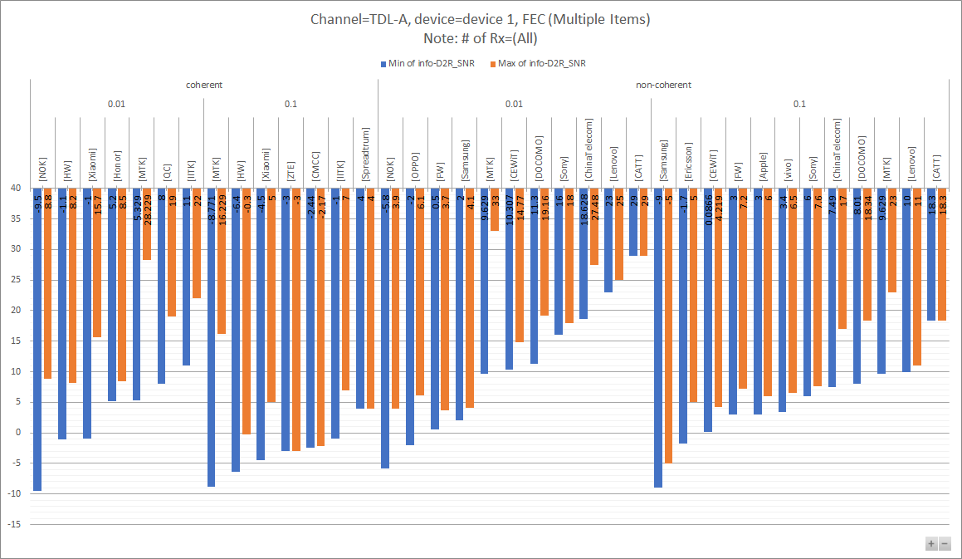

**Table 7.3.1.1 - 1**

|  |  |  |  |  |  |
| --- | --- | --- | --- | --- | --- |
| info-Channel | TDL-A |  |  |  |  |
| info-device-type | device 1 |  |  |  |  |
| FEC? | (Multiple Items) |  |  |  |  |
| info-#ofRx | (All) |  |  |  |  |
|  |  |  |  |  |  |
|  |  |  | **Values** |  |  |
| **coherent/non-coherent** | **info-D2R_BLER** | **info-Company** | **Min of info-D2R_SNR** | **Max of info-D2R_SNR** | **Count of No.** |
| **coherent** | **0.01** | [NOK] | -9.5 | 8.8 | 4 |
| [HW] | -1.1 | 8.2 | 6 |
| [Xiaomi] | -1 | 15.7 | 7 |
| [Honor] | 5.2 | 8.5 | 2 |
| [MTK] | 5.329 | 28.229 | 11 |
| [QC] | 8 | 19 | 8 |
| [IITK] | 11 | 22 | 5 |
| **0.1** | [MTK] | -8.771 | 16.229 | 12 |
| [HW] | -6.4 | -0.3 | 6 |
| [Xiaomi] | -4.5 | 5 | 7 |
| [ZTE] | -3 | -3 | 2 |
| [CMCC] | -2.44 | -2.17 | 2 |
| [IITK] | -1 | 7 | 5 |
| [Spreadtrum] | 4 | 4 | 2 |
| **non-coherent** | **0.01** | [NOK] | -5.8 | 3.9 | 2 |
| [OPPO] | -2 | 6.1 | 2 |
| [FW] | 0.5 | 3.7 | 3 |
| [Samsung] | 2 | 4.1 | 3 |
| [MTK] | 9.629 | 33 | 9 |
| [CEWiT] | 10.307 | 14.77 | 6 |
| [DOCOMO] | 11.3 | 19.16 | 5 |
| [Sony] | 16 | 18 | 2 |
| [ChinaTelecom] | 18.628 | 27.48 | 6 |
| [Lenovo] | 23 | 25 | 2 |
| [CATT] | 29 | 29 | 1 |
| **0.1** | [Samsung] | -9 | -5 | 3 |
| [Ericsson] | -1.7 | 5 | 6 |
| [CEWiT] | 0.0866 | 4.219 | 6 |
| [FW] | 3 | 7.2 | 3 |
| [Apple] | 3 | 6 | 2 |
| [vivo] | 3.4 | 6.5 | 8 |
| [Sony] | 6 | 7.6 | 2 |
| [ChinaTelecom] | 7.49 | 17 | 6 |
| [DOCOMO] | 8.01 | 18.34 | 6 |
| [MTK] | 9.629 | 23 | 9 |
| [Lenovo] | 10 | 11 | 2 |
| [CATT] | 18.3 | 18.3 | 1 |
| **Grand Total** | | | **-9.5** | **33** | **174** |

**Figure 7.3.1.1 - 2**

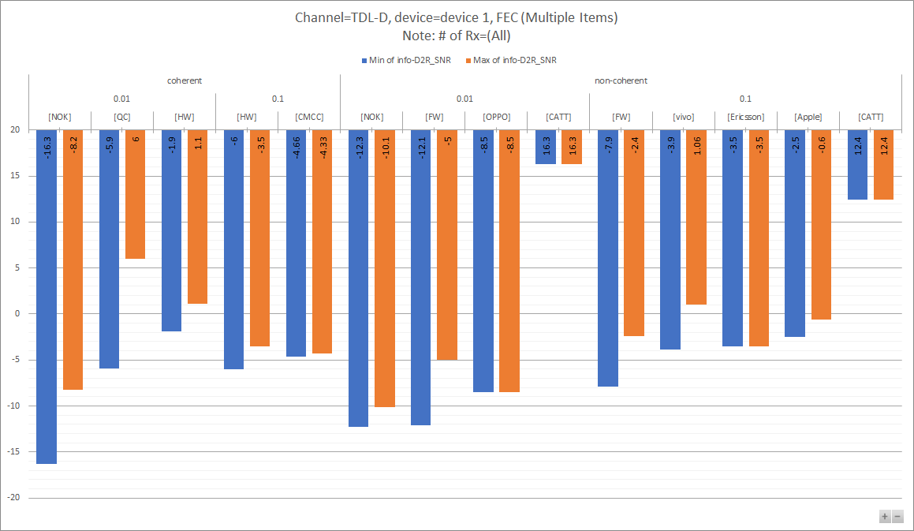

**Table 7.3.1.1 - 2**

|  |  |  |  |  |  |
| --- | --- | --- | --- | --- | --- |
| info-Channel | TDL-D |  |  |  |  |
| info-device-type | device 1 |  |  |  |  |
| FEC? | (Multiple Items) |  |  |  |  |
| info-#ofRx | (All) |  |  |  |  |
|  |  |  |  |  |  |
|  |  |  | **Values** |  |  |
| **coherent/non-coherent** | **info-D2R_BLER** | **info-Company** | **Min of info-D2R_SNR** | **Max of info-D2R_SNR** | **Count of No.** |
| **coherent** | **0.01** | [NOK] | -16.3 | -8.2 | 4 |
| [QC] | -5.9 | 6 | 9 |
| [HW] | -1.9 | 1.1 | 6 |
| **0.1** | [HW] | -6 | -3.5 | 6 |
| [CMCC] | -4.66 | -4.33 | 2 |
| **non-coherent** | **0.01** | [NOK] | -12.3 | -10.1 | 2 |
| [FW] | -12.1 | -5 | 3 |
| [OPPO] | -8.5 | -8.5 | 1 |
| [CATT] | 16.3 | 16.3 | 1 |
| **0.1** | [FW] | -7.9 | -2.4 | 3 |
| [vivo] | -3.9 | 1.06 | 4 |
| [Ericsson] | -3.5 | -3.5 | 1 |
| [Apple] | -2.5 | -0.6 | 2 |
| [CATT] | 12.4 | 12.4 | 1 |
| **Grand Total** | | | **-16.3** | **16.3** | **45** |

**Notes:**

* xxx
* xxx

**Observations**

### 7.3.2 Device 2a

#### 7.3.2.1 …

*<Editor’s Note: the following assumptions are for example>*

Reference data rate [0m]

* around 1kbps, 5-7kbps

Message size [0n]

* {20,96,400}

Antenna configuration:

* For TDL-D, 1Tx1Rx for D2T2
* For TDL-A, 1Tx2Rx for D1T1, 1Tx1Rx for D2T2

SFO assumption:

* Randomly select a value from the range of [0.1 ~ 1] * 10^4 ppm

**Figure 7.3.2.1 - 1**

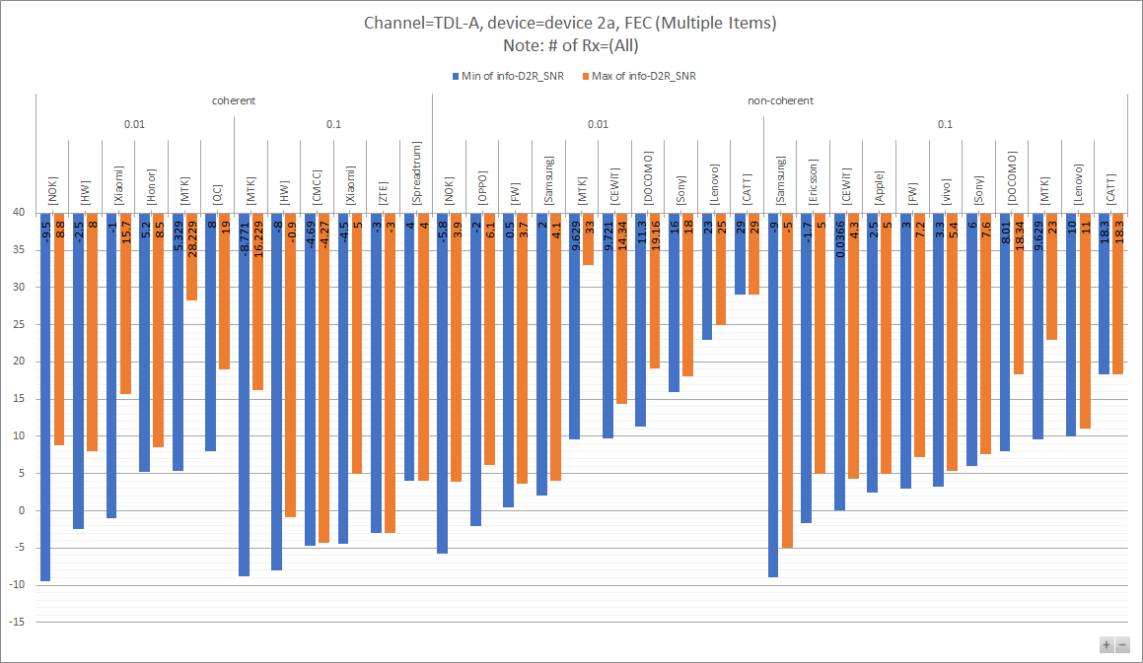

**Table 7.3.2.1 - 1**

|  |  |  |  |  |  |
| --- | --- | --- | --- | --- | --- |
| info-Channel | TDL-A |  |  |  |  |
| info-device-type | device 2a |  |  |  |  |
| FEC? | (Multiple Items) |  |  |  |  |
| info-#ofRx | (All) |  |  |  |  |
|  |  |  |  |  |  |
|  |  |  | **Values** |  |  |
| **coherent/non-coherent** | **info-D2R_BLER** | **info-Company** | **Min of info-D2R_SNR** | **Max of info-D2R_SNR** | **Count of No.** |
| **coherent** | **0.01** | [NOK] | -9.5 | 8.8 | 4 |
| [HW] | -2.5 | 8 | 6 |
| [Xiaomi] | -1 | 15.7 | 7 |
| [Honor] | 5.2 | 8.5 | 2 |
| [MTK] | 5.329 | 28.229 | 11 |
| [QC] | 8 | 19 | 8 |
| **0.1** | [MTK] | -8.771 | 16.229 | 12 |
| [HW] | -8 | -0.9 | 6 |
| [CMCC] | -4.69 | -4.27 | 2 |
| [Xiaomi] | -4.5 | 5 | 7 |
| [ZTE] | -3 | -3 | 2 |
| [Spreadtrum] | 4 | 4 | 2 |
| **non-coherent** | **0.01** | [NOK] | -5.8 | 3.9 | 2 |
| [OPPO] | -2 | 6.1 | 2 |
| [FW] | 0.5 | 3.7 | 3 |
| [Samsung] | 2 | 4.1 | 3 |
| [MTK] | 9.629 | 33 | 9 |
| [CEWiT] | 9.721 | 14.34 | 6 |
| [DOCOMO] | 11.3 | 19.16 | 5 |
| [Sony] | 16 | 18 | 2 |
| [Lenovo] | 23 | 25 | 2 |
| [CATT] | 29 | 29 | 1 |
| **0.1** | [Samsung] | -9 | -5 | 3 |
| [Ericsson] | -1.7 | 5 | 6 |
| [CEWiT] | 0.0366 | 4.3 | 6 |
| [Apple] | 2.5 | 5 | 2 |
| [FW] | 3 | 7.2 | 3 |
| [vivo] | 3.3 | 5.4 | 8 |
| [Sony] | 6 | 7.6 | 2 |
| [DOCOMO] | 8.01 | 18.34 | 6 |
| [MTK] | 9.629 | 23 | 9 |
| [Lenovo] | 10 | 11 | 2 |
| [CATT] | 18.3 | 18.3 | 1 |
| **Grand Total** | | | **-9.5** | **33** | **152** |

**Figure 7.3.2.1 - 2**

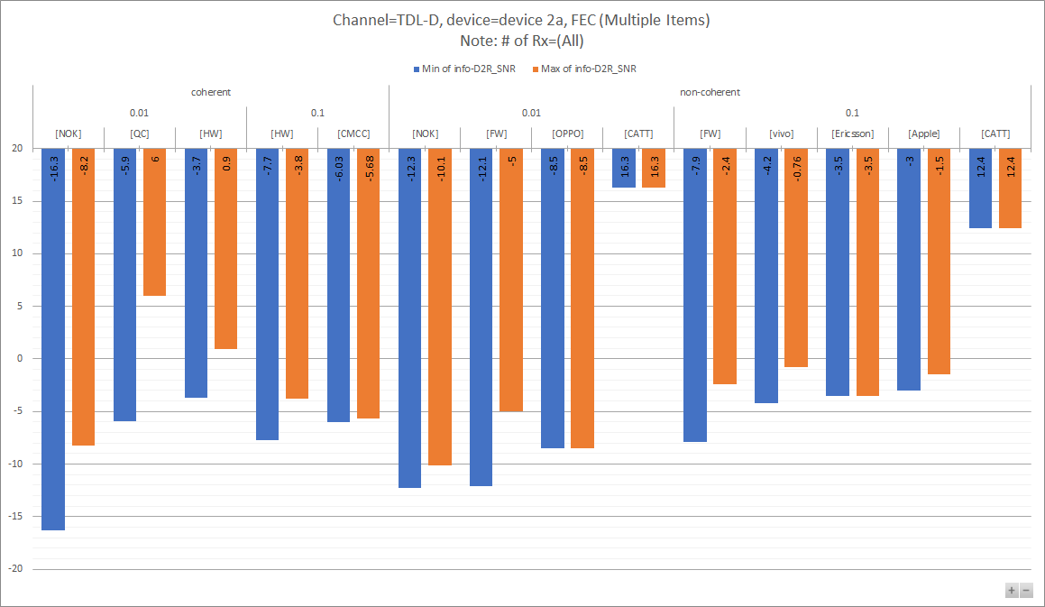

**Table 7.3.2.1 - 2**

|  |  |  |  |  |  |
| --- | --- | --- | --- | --- | --- |
| info-Channel | TDL-D |  |  |  |  |
| info-device-type | device 2a |  |  |  |  |
| FEC? | (Multiple Items) |  |  |  |  |
| info-#ofRx | (All) |  |  |  |  |
|  |  |  |  |  |  |
|  |  |  | **Values** |  |  |
| **coherent/non-coherent** | **info-D2R_BLER** | **info-Company** | **Min of info-D2R_SNR** | **Max of info-D2R_SNR** | **Count of No.** |
| **coherent** | **0.01** | [NOK] | -16.3 | -8.2 | 4 |
| [QC] | -5.9 | 6 | 9 |
| [HW] | -3.7 | 0.9 | 6 |
| **0.1** | [HW] | -7.7 | -3.8 | 6 |
| [CMCC] | -6.03 | -5.68 | 2 |
| **non-coherent** | **0.01** | [NOK] | -12.3 | -10.1 | 2 |
| [FW] | -12.1 | -5 | 3 |
| [OPPO] | -8.5 | -8.5 | 1 |
| [CATT] | 16.3 | 16.3 | 1 |
| **0.1** | [FW] | -7.9 | -2.4 | 3 |
| [vivo] | -4.2 | -0.76 | 4 |
| [Ericsson] | -3.5 | -3.5 | 1 |
| [Apple] | -3 | -1.5 | 2 |
| [CATT] | 12.4 | 12.4 | 1 |
| **Grand Total** | | | **-16.3** | **16.3** | **45** |

### 7.3.3 Device 2b

*<Editor’s Note: the following assumptions are for example>*

Reference data rate [0m]

* around 1kbps, 5-7kbps

Message size [0n]

* {20,96,400}

Antenna configuration:

* For TDL-D, 1Tx1Rx for D2T2
* For TDL-A, 1Tx2Rx for D1T1, 1Tx1Rx for D2T2

SFO assumption:

* Randomly select a value from the range of [0.1 ~ 1] * 10^4 ppm

CFO assumption:

* [100ppm/200ppm/1000ppm, 0.1ppm/s]

**Figure 7.3.3.1 - 1**

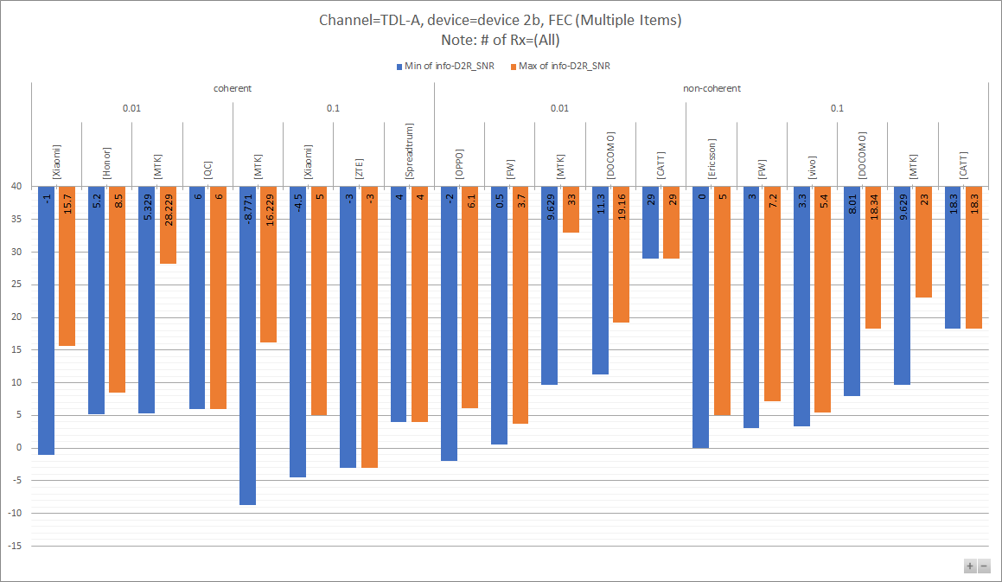

**Table 7.3.3.1 - 1**

|  |  |  |  |  |  |
| --- | --- | --- | --- | --- | --- |
| info-Channel | TDL-A |  |  |  |  |
| info-device-type | device 2b |  |  |  |  |
| FEC? | (Multiple Items) |  |  |  |  |
| info-#ofRx | (All) |  |  |  |  |
|  |  |  |  |  |  |
|  |  |  | **Values** |  |  |
| **coherent/non-coherent** | **info-D2R_BLER** | **info-Company** | **Min of info-D2R_SNR** | **Max of info-D2R_SNR** | **Count of No.** |
| **coherent** | **0.01** | [Xiaomi] | -1 | 15.7 | 7 |
| [Honor] | 5.2 | 8.5 | 2 |
| [MTK] | 5.329 | 28.229 | 11 |
| [QC] | 6 | 6 | 1 |
| **0.1** | [MTK] | -8.771 | 16.229 | 12 |
| [Xiaomi] | -4.5 | 5 | 7 |
| [ZTE] | -3 | -3 | 2 |
| [Spreadtrum] | 4 | 4 | 2 |
| **non-coherent** | **0.01** | [OPPO] | -2 | 6.1 | 2 |
| [FW] | 0.5 | 3.7 | 3 |
| [MTK] | 9.629 | 33 | 9 |
| [DOCOMO] | 11.3 | 19.16 | 5 |
| [CATT] | 29 | 29 | 1 |
| **0.1** | [Ericsson] | 0 | 5 | 2 |
| [FW] | 3 | 7.2 | 3 |
| [vivo] | 3.3 | 5.4 | 8 |
| [DOCOMO] | 8.01 | 18.34 | 6 |
| [MTK] | 9.629 | 23 | 9 |
| [CATT] | 18.3 | 18.3 | 1 |
| **Grand Total** | | | **-8.771** | **33** | **93** |

**Figure 7.3.3.1 - 2**

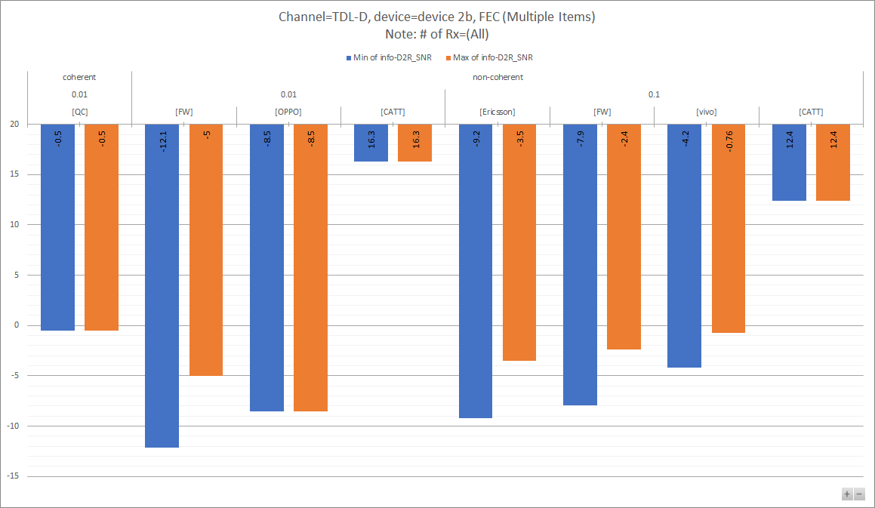

**Table 7.3.3.1 - 2**

|  |  |  |  |  |  |
| --- | --- | --- | --- | --- | --- |
| info-Channel | TDL-D |  |  |  |  |
| info-device-type | device 2b |  |  |  |  |
| FEC? | (Multiple Items) |  |  |  |  |
| info-#ofRx | (All) |  |  |  |  |
|  |  |  |  |  |  |
|  |  |  | **Values** |  |  |
| **coherent/non-coherent** | **info-D2R_BLER** | **info-Company** | **Min of info-D2R_SNR** | **Max of info-D2R_SNR** | **Count of No.** |
| **coherent** | **0.01** | [QC] | -0.5 | -0.5 | 1 |
| **non-coherent** | [FW] | -12.1 | -5 | 3 |
| [OPPO] | -8.5 | -8.5 | 1 |
| [CATT] | 16.3 | 16.3 | 1 |
| **0.1** | [Ericsson] | -9.2 | -3.5 | 2 |
| [FW] | -7.9 | -2.4 | 3 |
| [vivo] | -4.2 | -0.76 | 4 |
| [CATT] | 12.4 | 12.4 | 1 |
| **Grand Total** | | | **-12.1** | **16.3** | **16** |

## 7.4 Link performance for R2D

### [7.4.1 Device 1]

**Figure 7.4.1.1 - 1**

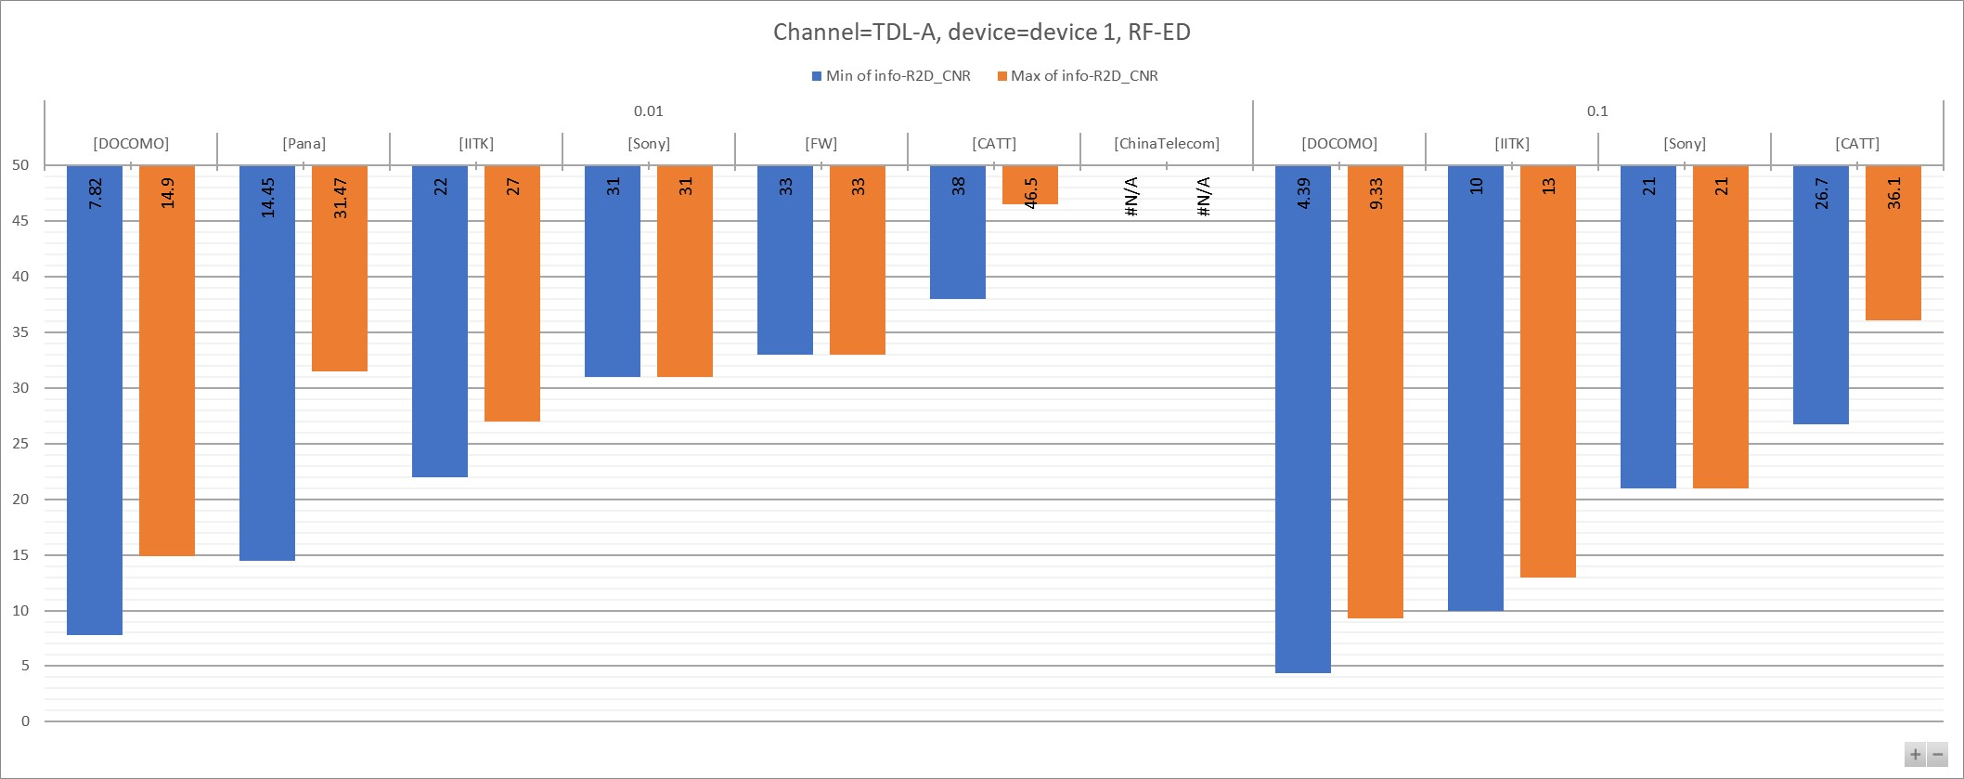

**Table 7.4.1.1 - 1**

|  |  |  |  |  |
| --- | --- | --- | --- | --- |
| info-Channel | TDL-A |  |  |  |
| info-device-type | device 1, RF-ED |  |  |  |
|  |  |  |  |  |
|  |  | **Values** |  |  |
| **info-R2D_BLER** | **info-Company** | **Min of info-R2D_CNR** | **Max of info-R2D_CNR2** | **Count of No.** |
| **0.01** | [DOCOMO] | 7.82 | 14.9 | 2 |
| [Pana] | 14.45 | 31.47 | 21 |
| [IITK] | 22 | 27 | 2 |
| [Sony] | 31 | 31 | 1 |
| [FW] | 33 | 33 | 1 |
| [CATT] | 38 | 46.5 | 8 |
| [ChinaTelecom] | #VALUE! | #VALUE! | 4 |
| **0.1** | [DOCOMO] | 4.39 | 9.33 | 2 |
| [IITK] | 10 | 13 | 2 |
| [Sony] | 21 | 21 | 1 |
| [CATT] | 26.7 | 36.1 | 8 |
| **Grand Total** | | **#VALUE!** | **#VALUE!** | **52** |

**Figure 7.4.1.1 - 2**

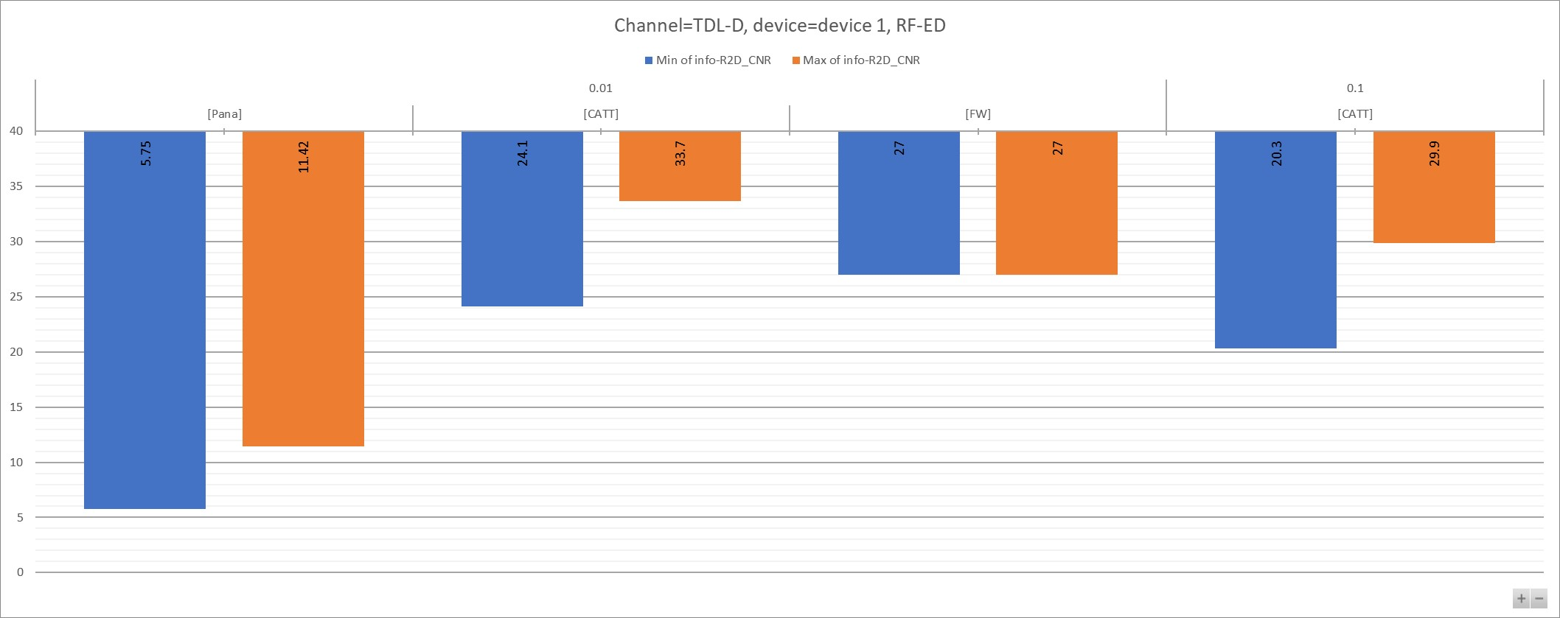

**Table 7.4.1.1 - 2**

|  |  |  |  |  |
| --- | --- | --- | --- | --- |
| info-Channel | TDL-D |  |  |  |
| info-device-type | device 1, RF-ED |  |  |  |
|  |  |  |  |  |
|  |  | **Values** |  |  |
| **info-R2D_BLER** | **info-Company** | **Min of info-R2D_CNR** | **Max of info-R2D_CNR2** | **Count of No.** |
| **0.01** | [Pana] | 5.75 | 11.42 | 3 |
| [CATT] | 24.1 | 33.7 | 8 |
| [FW] | 27 | 27 | 1 |
| **0.1** | [CATT] | 20.3 | 29.9 | 8 |
| **Grand Total** | | **5.75** | **33.7** | **20** |

### 7.4.2 Device 2a

**Figure 7.4.2.1 - 1**

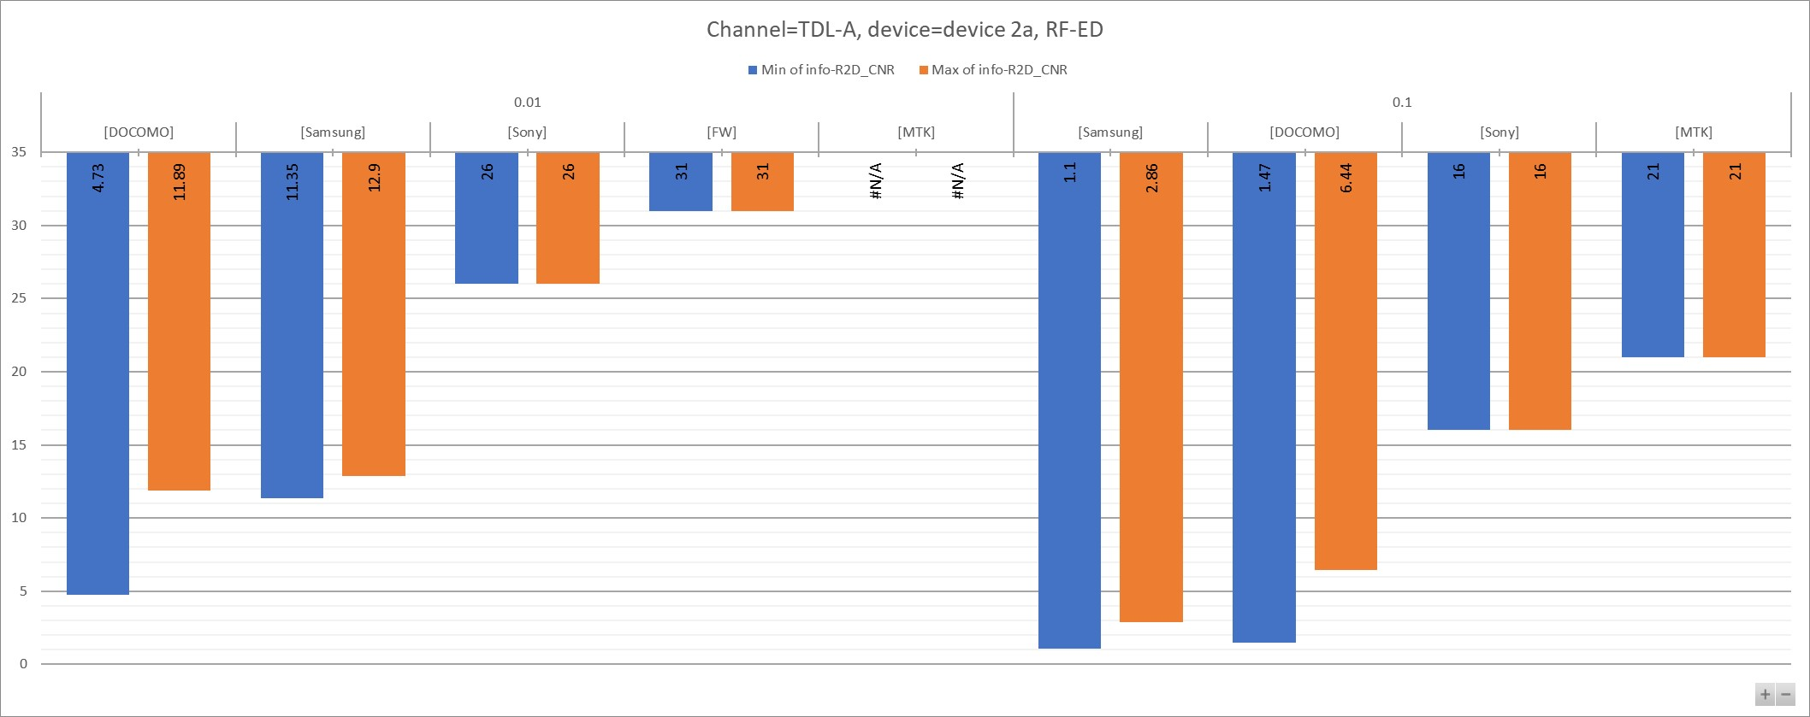

**Table 7.4.2.1 - 1**

|  |  |  |  |  |
| --- | --- | --- | --- | --- |
| info-Channel | TDL-A |  |  |  |
| info-device-type | device 2a, RF-ED |  |  |  |
|  |  |  |  |  |
|  |  | **Values** |  |  |
| **info-R2D_BLER** | **info-Company** | **Min of info-R2D_CNR** | **Max of info-R2D_CNR2** | **Count of No.** |
| **0.01** | [DOCOMO] | 4.73 | 11.89 | 2 |
| [Samsung] | 11.35 | 12.9 | 2 |
| [Sony] | 26 | 26 | 1 |
| [FW] | 31 | 31 | 1 |
| [MTK] | #VALUE! | #VALUE! | 7 |
| **0.1** | [Samsung] | 1.1 | 2.86 | 2 |
| [DOCOMO] | 1.47 | 6.44 | 2 |
| [Sony] | 16 | 16 | 1 |
| [MTK] | 21 | 21 | 2 |
| **Grand Total** | | **#VALUE!** | **#VALUE!** | **20** |

**Figure 7.4.2.1 - 2**

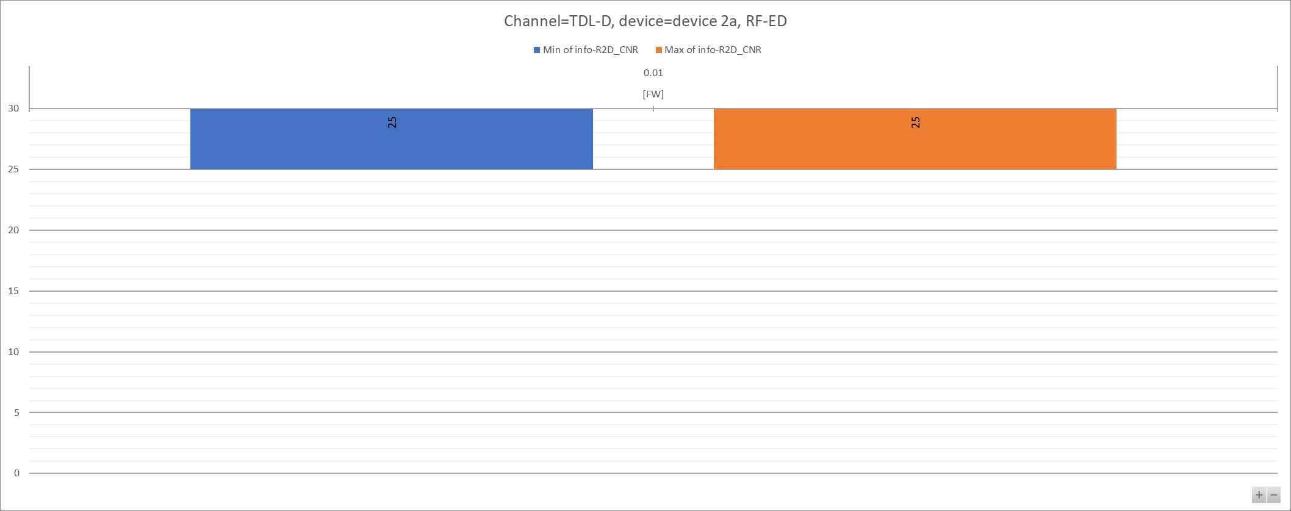

**Table 7.4.2.1 - 2**

|  |  |  |  |  |
| --- | --- | --- | --- | --- |
| info-Channel | TDL-D |  |  |  |
| info-device-type | device 2a, RF-ED |  |  |  |
|  |  |  |  |  |
|  |  | **Values** |  |  |
| **info-R2D_BLER** | **info-Company** | **Min of info-R2D_CNR** | **Max of info-R2D_CNR2** | **Count of No.** |
| **0.01** | [FW] | 25 | 25 | 1 |
| **Grand Total** | | **25** | **25** | **1** |

### 7.4.3 Device 2b

**Figure 7.4.3.1 - 1**

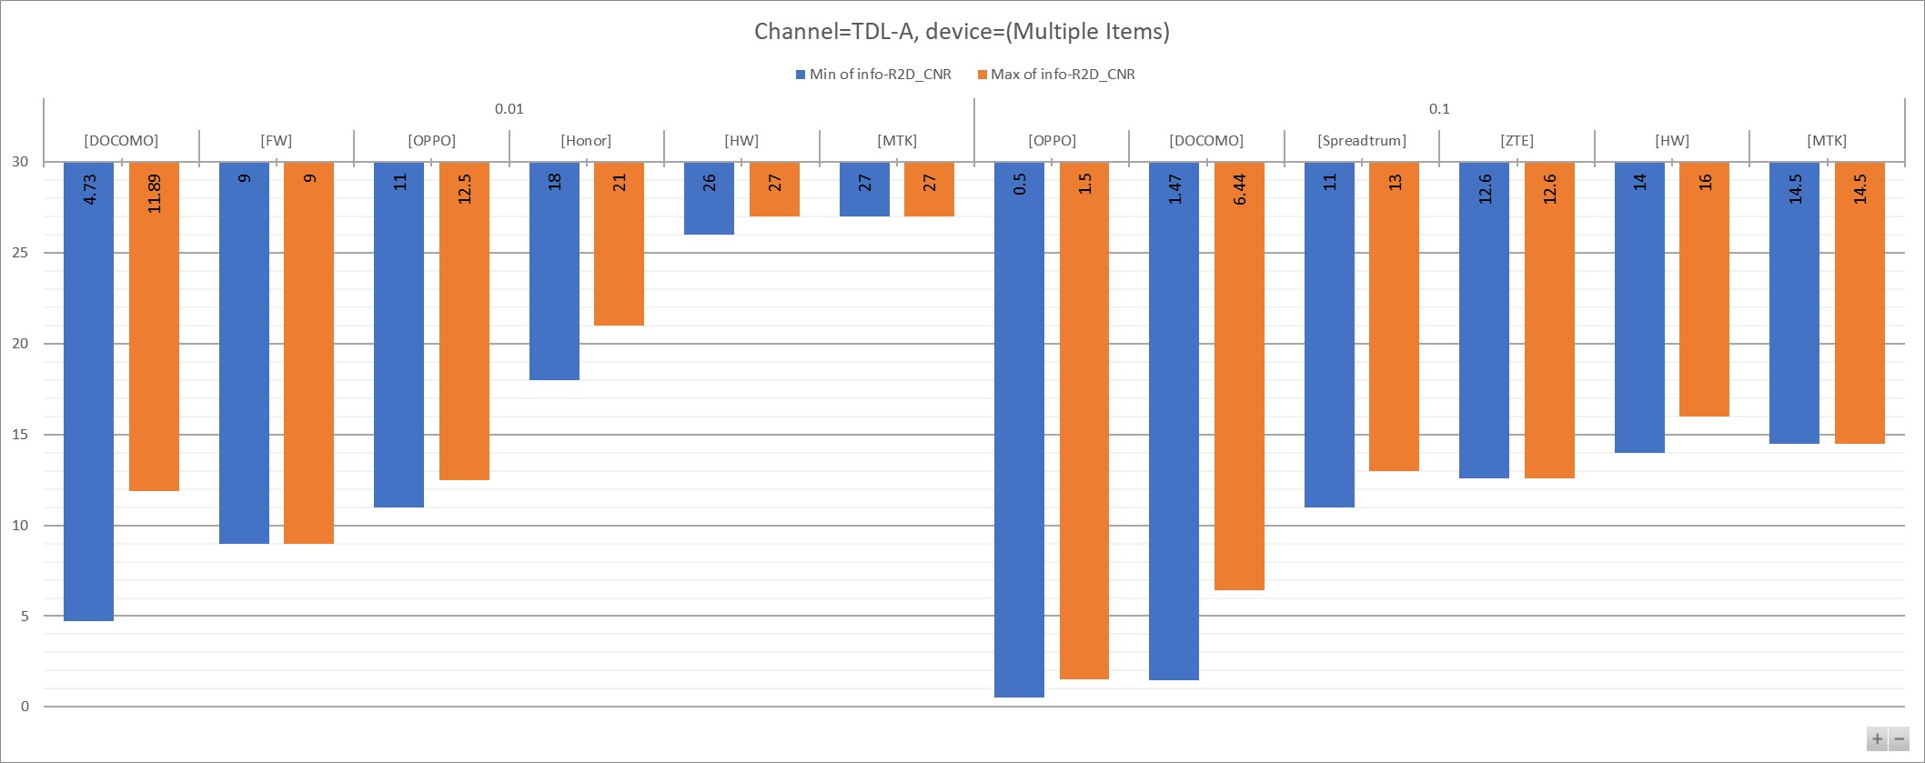

**Table 7.4.3.1 - 1**

|  |  |  |  |  |
| --- | --- | --- | --- | --- |
| info-Channel | TDL-A |  |  |  |
| info-device-type | (Multiple Items) |  |  |  |
|  |  |  |  |  |
|  |  | **Values** |  |  |
| **info-R2D_BLER** | **info-Company** | **Min of info-R2D_CNR** | **Max of info-R2D_CNR2** | **Count of No.** |
| **0.01** | [DOCOMO] | 4.73 | 11.89 | 2 |
| [FW] | 9 | 9 | 1 |
| [OPPO] | 11 | 12.5 | 2 |
| [Honor] | 18 | 21 | 2 |
| [HW] | 26 | 27 | 3 |
| [MTK] | 27 | 27 | 2 |
| **0.1** | [OPPO] | 0.5 | 1.5 | 2 |
| [DOCOMO] | 1.47 | 6.44 | 2 |
| [Spreadtrum] | 11 | 13 | 2 |
| [ZTE] | 12.6 | 12.6 | 2 |
| [HW] | 14 | 16 | 3 |
| [MTK] | 14.5 | 14.5 | 2 |
| **Grand Total** | | **0.5** | **27** | **25** |

**Figure 7.4.3.1 - 2**

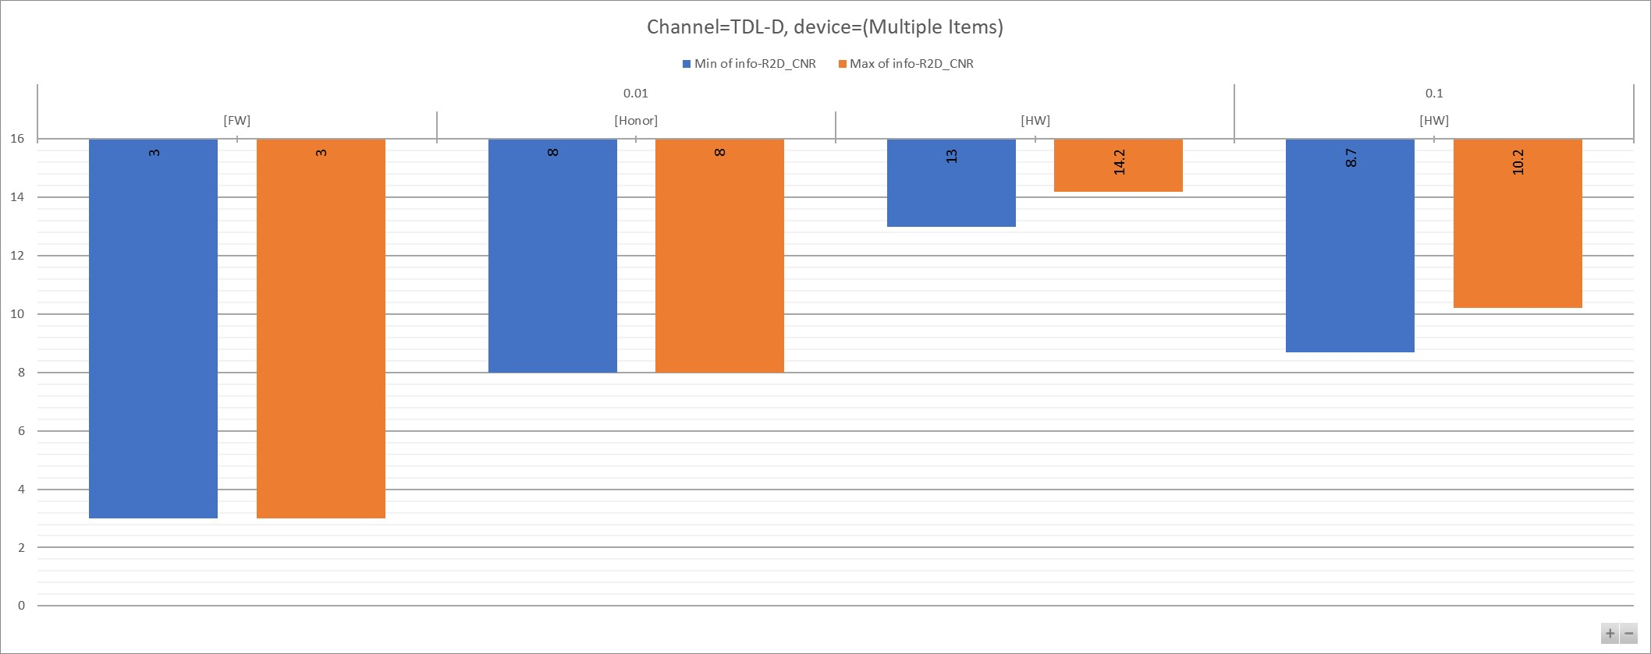

**Table 7.4.3.1 - 2**

|  |  |  |  |  |
| --- | --- | --- | --- | --- |
| info-Channel | TDL-D |  |  |  |
| info-device-type | (Multiple Items) |  |  |  |
|  |  |  |  |  |
|  |  | **Values** |  |  |
| **info-R2D_BLER** | **info-Company** | **Min of info-R2D_CNR** | **Max of info-R2D_CNR2** | **Count of No.** |
| **0.01** | [FW] | 3 | 3 | 1 |
| [Honor] | 8 | 8 | 1 |
| [HW] | 13 | 14.2 | 3 |
| **0.1** | [HW] | 8.7 | 10.2 | 3 |
| **Grand Total** | | **3** | **14.2** | **8** |