|  |  |
| --- | --- |
| 3GPP TR 38.769 V0.1.0 (2024-08) | |
| Technical Report | |
| 3rd Generation Partnership Project;  Technical Specification Group Radio Access Network;  Study on solutions for ambient IoT (Internet of Things)  (Release 19) | |
|  | |
|  |  |
| The present document has been developed within the 3rd Generation Partnership Project (3GPP TM) and may be further elaborated for the purposes of 3GPP. The present document has not been subject to any approval process by the 3GPPOrganizational Partners and shall not be implemented. This Specification is provided for future development work within 3GPPonly. The Organizational Partners accept no liability for any use of this Specification. Specifications and Reports for implementation of the 3GPP TM system should be obtained via the 3GPP Organizational Partners' Publications Offices. | |

|  |
| --- |
|  |
| ***3GPP***  Postal address  3GPP support office address  650 Route des Lucioles - Sophia Antipolis  Valbonne - FRANCE  Tel.: +33 4 92 94 42 00 Fax: +33 4 93 65 47 16  Internet  https://www.3gpp.org |
| ***Copyright Notification***  No part may be reproduced except as authorized by written permission. The copyright and the foregoing restriction extend to reproduction in all media.  © 2024, 3GPP Organizational Partners (ARIB, ATIS, CCSA, ETSI, TSDSI, TTA, TTC).  All rights reserved.  UMTS™ is a Trade Mark of ETSI registered for the benefit of its members  3GPP™ is a Trade Mark of ETSI registered for the benefit of its Members and of the 3GPP Organizational Partners LTE™ is a Trade Mark of ETSI registered for the benefit of its Members and of the 3GPP Organizational Partners  GSM® and the GSM logo are registered and owned by the GSM Association |

Contents

Foreword 5

Introduction 6

1 Scope 7

2 References 7

3 Definitions of terms, symbols and abbreviations 7

3.1 Terms 7

3.2 Symbols 8

3.3 Abbreviations 8

4 Evaluation methodology 8

4.1 Remaining details of RAN design targets 9

4.2 Evaluation scenarios and assumptions 9

4.2.1 Evaluation scenarios 9

4.2.2 Evaluation assumptions 12

4.3 Link budget 15

4.3.1 Receiver sensitivity 15

4.3.2 Link budget template 16

4.4 R2D waveform generation 21

5 Ambient IoT device architectures 22

5.1 ~1 *µ*W devices (Device 1) 22

5.2 ≤a few hundred µW devices (Device 2) 23

5.2.1 External carrier wave (Device 2a) 23

5.2.1.1 Reflection amplifier 24

5.2.1.2 Large frequency shifter 25

5.2.2 Internally-generated carrier wave (Device 2b) 25

5.2.2.1 RF envelope detector receiver 25

5.2.2.2 IF envelope detector receiver 26

5.2.2.3 ZIF receiver 28

5.2.3 Clock(s) 29

6 Solutions for ambient IoT 30

6.1 Physical layer 30

6.1.0 General 30

6.1.1 R2D 30

6.1.1.x R2D waveform, modulation and numerology 30

6.1.1.x R2D line coding 31

6.1.1.x R2D channel coding, CRC 31

6.1.1.x R2D bandwidths 31

6.1.1.x PRDCH 31

6.1.1.x R2D start timing 31

6.1.1.x R2D end timing 31

6.1.2 D2R 31

6.1.2.x Waveform and modulation 31

6.1.2.x D2R line coding 32

6.1.2.x D2R channel coding, repetition, CRC 32

6.1.2.x D2R bandwidths 32

6.1.2.x PDRCH 32

6.1.2.x D2R start timing 32

6.1.2.x D2R end timing 32

6.1.2.x D2R midamble 33

6.1.2.x D2R multiple access 33

6.1.3 Timing relationships 33

6.1.4 Random access 33

6.2 Protocol stack and signalling procedures 33

6.3 Impacts on CN-RAN interface 33

6.4 RAN architecture aspects 33

6.5 Coexistence of ambient IoT and NR/LTE 33

6.6 RF requirements study 34

6.7 Characteristics of carrier-wave waveform 34

6.7.1 CW transmission 34

6.7.2 CW characteristics 34

6.8 Locating ambient IoT devices 35

6.8.x Proximity determination 35

7 Coverage evaluations 35

8 Conclusions and recommendations 35

Annex <x> (informative): Change history 36

# Foreword

This Technical Report has been produced by the 3rd Generation Partnership Project (3GPP).

The contents of the present document are subject to continuing work within the TSG and may change following formal TSG approval. Should the TSG modify the contents of the present document, it will be re-released by the TSG with an identifying change of release date and an increase in version number as follows:

Version x.y.z

where:

x the first digit:

1 presented to TSG for information;

2 presented to TSG for approval;

3 or greater indicates TSG approved document under change control.

y the second digit is incremented for all changes of substance, i.e. technical enhancements, corrections, updates, etc.

z the third digit is incremented when editorial only changes have been incorporated in the document.

In the present document, modal verbs have the following meanings:

**shall** indicates a mandatory requirement to do something

**shall not** indicates an interdiction (prohibition) to do something

The constructions "shall" and "shall not" are confined to the context of normative provisions, and do not appear in Technical Reports.

The constructions "must" and "must not" are not used as substitutes for "shall" and "shall not". Their use is avoided insofar as possible, and they are not used in a normative context except in a direct citation from an external, referenced, non-3GPP document, or so as to maintain continuity of style when extending or modifying the provisions of such a referenced document.

**should** indicates a recommendation to do something

**should not** indicates a recommendation not to do something

**may** indicates permission to do something

**need not** indicates permission not to do something

The construction "may not" is ambiguous and is not used in normative elements. The unambiguous constructions "might not" or "shall not" are used instead, depending upon the meaning intended.

**can** indicates that something is possible

**cannot** indicates that something is impossible

The constructions "can" and "cannot" are not substitutes for "may" and "need not".

**will** indicates that something is certain or expected to happen as a result of action taken by an agency the behaviour of which is outside the scope of the present document

**will not** indicates that something is certain or expected not to happen as a result of action taken by an agency the behaviour of which is outside the scope of the present document

**might** indicates a likelihood that something will happen as a result of action taken by some agency the behaviour of which is outside the scope of the present document

**might not** indicates a likelihood that something will not happen as a result of action taken by some agency the behaviour of which is outside the scope of the present document

In addition:

**is** (or any other verb in the indicative mood) indicates a statement of fact

**is not** (or any other negative verb in the indicative mood) indicates a statement of fact

The constructions "is" and "is not" do not indicate requirements.

# Introduction

In recent years, IoT has attracted much attention in the wireless communication world. More 'things' are expected to be interconnected for improving productivity efficiency and increasing comforts of life. Further reduction of size, complexity, and power consumption of IoT devices can enable the deployment of tens or even hundreds of billions of IoT devices for various applications and provide added value across the entire value chain. It is impossible to power all the IoT devices by battery that needs to be replaced or recharged manually, which leads to high maintenance cost, serious environmental issues, and even safety hazards for some use cases, for example, wireless sensors in electrical power, and petroleum industries.

Most of the existing wireless communication devices are powered by batteries that need to be replaced or recharged manually. The automation and digitization of various industries opens numerous new markets requiring new IoT technologies of supporting batteryless devices with no energy storage capability or devices with energy storage that do not need to be replaced or recharged manually.

An example type of application is asset identification, which presently has to resort mainly to barcodes and RFID in most industries. The main advantage of these two technologies is the ultra-low complexity and small form factor of the tags. However, the limited reading range of a few meters usually requires handheld scanning which leads to labor intensive and time-consuming operations, or RFID portals/gates which leads to costly deployments. Moreover, the lack of interference management scheme results in severe interference between RFID readers and capacity problems, especially in case of dense deployment. It is hard to support a large-scale network with seamless coverage for RFID.

In contrast, this study investigates solutions for Ambient IoT, a new IoT technology to open new markets within 3GPP systems, whose number of connections and/or device density can be orders of magnitude higher than existing 3GPP IoT technologies, and which can provide complexity and power consumption orders-of-magnitude lower than existing 3GPP LPWA technologies such as NB-IoT and LTE-MTC. TSG RAN has completed a Rel-18 RAN-level SI on Ambient IoT, producing TR 38.848 which provides a terminological and scoping framework for future discussions of Ambient IoT. This has defined representative use cases, deployment scenarios, connectivity topologies, Ambient IoT devices, design targets, and required functionalities; it also conducted a preliminary feasibility assessment.

The SI reported in this present TR is now to investigate solutions in detail at RAN-WG level for Ambient IoT in 3GPP.

# 1 Scope

The overall objective of the SI is to study a harmonized air interface design with minimized differences (where necessary) for Ambient IoT to enable the following devices:

i. ~1 *µ*W peak power consumption, has energy storage, initial sampling frequency offset (SFO) up to 10*X* ppm, neither DL nor UL amplification in the device. The device’s UL transmission is backscattered on a carrier wave provided externally.

ii. ≤ a few hundred *µ*W peak power consumption has energy storage, initial sampling frequency offset (SFO) up to 10*X* ppm, both DL and/or UL amplification in the device. The device’s UL transmission may be generated internally by the device, or be backscattered on a carrier wave provided externally.

Referring to the definitions in [2, TR 38.848], this is done in the context of:

- Deployment scenario 1 (indoor-to-indoor) with Topology 1, and indoor microcell basestation.

- Deployment scenario 2 (indoor-to-outdoor) with Topology 2 and indoor UE as intermediate node under network control, and outdoor macrocell basestation.

The spectrum considered is FR1 licensed spectrum in FDD, which can be in-band to NR, in guard-band to NR, or in standalone band(s). The traffic types considered are DO-DTT and DT, focusing on indoor inventory and indoor command representative use cases. The study also assesses whether the harmonized air interface can address the DO-A use case.

Study of the design of energy harvesting signal/waveform is out of scope in Rel-19.

# 2 References

The following documents contain provisions which, through reference in this text, constitute provisions of the present document.

- References are either specific (identified by date of publication, edition number, version number, etc.) or non‑specific.

- For a specific reference, subsequent revisions do not apply.

- For a non-specific reference, the latest version applies. In the case of a reference to a 3GPP document (including a GSM document), a non-specific reference implicitly refers to the latest version of that document *in the same Release as the present document*.

[1] 3GPP TR 21.905: "Vocabulary for 3GPP Specifications".

[2] 3GPP TR 38.848: "Study on Ambient IoT (Internet of Things) in RAN".

[3] RP-240826: " Revised SID: Study on solutions for Ambient IoT (Internet of Things) in NR".

[4] 3GPP TR 38.869: "Study on low-power Wake-up Signal and Receiver for NR".

[5] 3GPP TS 38.212: "NR; Multiplexing and channel coding".

# 3 Definitions of terms, symbols and abbreviations

This clause and its three (sub) clauses are mandatory. The contents shall be shown as "void" if the TS/TR does not define any terms, symbols, or abbreviations.

## 3.1 Terms

For the purposes of the present document, the terms given in TR 21.905 [1] and the following apply. A term defined in the present document takes precedence over the definition of the same term, if any, in TR 21.905 [1].

For the purposes of the study, RAN1 uses the following terms:

**Device 1:** ~1 µW peak power consumption, has energy storage, initial sampling frequency offset (SFO) up to 10*X* ppm, neither DL nor UL amplification in the device. The device's UL transmission is backscattered on a carrier wave provided externally.

**Device 2a:** ≤ a few hundred µW peak power consumption, has energy storage, initial sampling frequency offset (SFO) up to 10*X* ppm, both DL and/or UL amplification in the device. The device’s UL transmission is backscattered on a carrier wave provided externally.

**Device 2b:** ≤ a few hundred µW peak power consumption, has energy storage, initial sampling frequency offset (SFO) up to 10*X* ppm, both DL and/or UL amplification in the device. The device’s UL transmission is generated internally by the device.

**D1T1:** Deployment scenario 1 with connectivity topology 1, according to TR 38.848.

**D2T2:** Deployment scenario 2 with connectivity topology 2, according to TR 38.848.

## 3.2 Symbols

For the purposes of the present document, the following symbols apply:

<symbol> <Explanation>

## 3.3 Abbreviations

For the purposes of the present document, the abbreviations given in TR 21.905 [1] and the following apply. An abbreviation defined in the present document takes precedence over the definition of the same abbreviation, if any, in TR 21.905 [1].

A-IoT Ambient IoT

CP Cyclic prefix

CW Carrier-wave

CW2D Carrier-wave, or carrier-wave node, to device

DO-A Device-originated autonomous

DO-DTT Device-originated by device-terminated trigger

DT Device-terminated

ED Envelope detector

FR Frequency Range

FEC Forward error-correction code

IF Intermediate frequency

IoT Internet of Things

LPWA Low-power, wide-area

LTE-MTC Long Term Evolution – Machine Type Communication

NB-IoT Narrowband IoT

OOK On-off keying

PIE Pulse interval encoding

PRDCH Physical reader-to-device channel

PDRCH Physical device-to-reader channel

R2D Reader to device

D2R Device to reader

RF Radio frequency

RFID Radio frequency identification

SFO Sampling frequency offset

ZIF Zero IF

# 4 Evaluation methodology

*Editor’s note: These sub-clauses correspond to Objective 1a, 1b, 1d, respectively.*

## 4.1 Remaining details of RAN design targets

TR 38.848 [2] sets a number of RAN design targets. In [3], in particular three aspects of design targets beyond those in TR 38.848 are to be studied:

- Applicable maximum distance target value(s): The maximum distance targets are set separately for device 1, device 2a, device 2b, respectively.

- Refined definition of latency:

- 2D distribution of devices: A-IoT devices are dropped uniformly distributed over the horizontal area. See Table 4.2.2-2.

## 4.2 Evaluation scenarios and assumptions

### 4.2.1 Evaluation scenarios

The following scenarios are defined for the purpose of potential evaluation.

Table 4.2.1-1: Evaluation scenarios

|  |  |  |  |  |  |  |  |
| --- | --- | --- | --- | --- | --- | --- | --- |
| **Scenario** | **CW Inside/outside topology** | **Diagram of the scenario** | **Description of the scenario** | **Device 1/2a/2b** | **CW spectrum** | **D2R spectrum** | **R2D spectrum** |
| **D1T1-A1** | CW inside topology |  | CW node inside topology 1  ‘CW’ in CW2D and ‘R2’ in D2R are different  ‘CW’ in CW2D and ‘R1’ in R2D are same  ‘R1’ in R2D and ‘R2’ in D2R are different | Device 1, 2a | Case 1-1 (inside topology, DL)  Case 1-2 (inside topology, UL) | Same as CW |  |
| **D1T1-A2** |  | CW node inside topology 1  Same ‘CW’ and ‘R’ node for CW2D, D2R and R2D | Same as D1T1-A1 | Same as CW |  |
| **D1T1-B** | CW outside topology |  | CW node outside topology 1  ‘CW’ in CW2D and ‘R’ in D2R are different  ‘CW’ in CW2D and ‘R’ in R2D are different  ‘R’ in R2D and ‘R’ in D2R are same | Case 1-4 (outside topology, UL) | Same as CW |  |
| **D1T1-C** | No CW |  | No CW Node. | Device 2b | N/A | UL |  |
| **D2T2-A1** | CW inside topology |  | CW node inside topology 2  ‘CW’ in CW2D and ‘R2’ in D2R are different  ‘CW’ in CW2D and ‘R1’ in R2D are same  ‘R1’ in R2D and ‘R2’ in D2R are different  BS communicates with R1 and R2 | Device 1, 2a | Case 2-2 (inside topology, UL) | Same as CW |  |
| **D2T2-A2** |  | CW node inside topology 2  Same ‘CW’ and ‘R’ node for CW2D, D2R and R2D  BS communicates with R | Same as D2T2-A1 | Same as CW |  |
| **D2T2-B** | CW outside topology |  | CW node outside topology 2  ‘CW’ in CW2D and ‘R’ in D2R are different  ‘CW’ in CW2D and ‘R’ in R2D are different  ‘R’ in R2D and ‘R’ in D2R are same  BS communicates with R | Case 2-3 (outside topology, DL)  Case 2-4 (outside topology, UL) | Same as CW |  |
| **D2T2-C** | No CW |  | No CW Node.  BS communicates with R | Device 2b | N/A | FFS |  |
| Note: This table is for the case where D2R is in the same spectrum as CW2D. | | | | | | | |

### 4.2.2 Evaluation assumptions

The following table of coverage evaluation assumptions for link-level simulation is considered. (M) indicates a value mandatory for evaluation, (O) indicates optional for evaluation. If there are any differences between devices, they are for evaluation purposes only.

Table 4.2.2-1: Coverage evaluation assumptions for link-level simulation

|  |  |  |  |
| --- | --- | --- | --- |
| **No.** | Parameters | | Assumptions |
| **R2D/D2R common parameters** | | | |
| **[0a]** | Carrier frequency | | Refer to link budget template |
| **[0b]** | SCS | | 15 kHz as baseline |
| **[0c]** | Block structure | | Blocks as agreed in 9.4.2.3, or other blocks reported by companies |
| **[0d]** | Channel model | | **R2D**:  For D2T2:  BS pathloss model is reused for intermediate UE with antenna height = 1.5 m  [0D]-Alt1: InF-DL NLOS, with TDL-A  [0D]-Alt2: InH-Office LOS, with TDL-D  For D1T1:  InF-DH NLOS, with TDL-A  **D2R:**  For D2T2:  BS pathloss model is reused for intermediate UE with antenna height = 1.5 m  [0D]-Alt1: InF-DL NLOS, with TDL-A  [0D]-Alt2: InH-Office LOS, with TDL-D  For D1T1:  InF-DH NLOS, with TDL-A |
| **[0e]** | Delay spread | | An RMS delay spread of 30 ns (M) and [150] ns (O) is considered for TDL-A channel model.  An RMS delay spread of 30 ns is considered for TDL-D channel model. |
| **[0f]** | Device velocity | | 3 km/h |
| **[0g]** | Number of Tx/Rx chains for Ambient IoT device | | 1 |
| **[0h1]** | BS | Number of antenna elements | 2 or 4 |
| **[0h2]** | Number of TXRUs | 2 or 4 |
| **[0j1]** | Intermediate UE | Number of antenna elements | 1 or 2 |
| **[0j2]** | Number of TXRUs | 1 or 2 |
| **[0m]** | Reference data rate | | 1 kbps (M), 5 ~ 7 kbps (M), [large value] (O)  FFS:0.1 kbps (M)  Note 1: Companies to report the exact data rate.  Note 2: The exact data rate is close to the values listed above.  Note 3: The exact data rate is calculated by dividing the ~~total~~ message size (excluding CRC) by the total transmission time including applicable overheads(e.g., CRC, pre/mid/post-ambles if present).  Note 4: The exact data rate may be related to coding scheme, repetition and etc.  Note 5: All data rates considered are for evaluation purpose only |
| **[0n]** | Message size | | {20 bits, 96 bits, 400 bits} are considered for message size.  Note 1: companies to report the M value and chip length used for each message size  Note 2: CRC is not included for the message size |
| **[0p]** | BLER target | | 1%, 10% |
| **[0q]** | Sampling frequency | | As a working assumption:  Companies to report the Sampling frequency (e.g., 1.92Msps or other feasible values if any)  Initial SFO (Sampling Frequency Offset) (Fe):  (M) Randomly select a value from the range of [0.1 ~ 1] *10^4 ppm for device 2,  (M) Randomly select a value from the range of [0.1 ~ 1] * 10^5 ppm for device 1,  (O) Randomly select a value from the range of [0.1 ~ 1] *10^5 ppm for device 2,  FFS: Optionally evaluate a fixed value SFO for device 1 and 2  Note: For random selection, the value is randomly selected per simulation drop, according to a uniform distribution  Note: Above values are only for sampling purpose.  FFS other values  Note: Above assumptions are only for LLS evaluation purpose only for R2D and [D2R].  The timing drift ΔT over a time T is modelled as ΔT = ±Fe * T.  Note: Accuracy can be improved after clock calibration for at least device 2.  FFS applicable for device 1  Note: SFO after clock calibration can be applied to Fe.  FFS other models  CFO for device 2b.  [100ppm/200ppm/1000ppm, 0.1ppm/s]  Note: Above assumptions are for LLS evaluation purpose only |
| **[0r]** | Device 1/2a/2b | | Options are as follows,  Device 1, RF-ED  Device 2a, RF-ED  Device 2b, RF-ED/IF-ED/ZIF |
| **R2D specific parameters** | | | |
| **[1a]** | Transmission bandwidth | | 180 kHz as baseline. Other larger values are not precluded. |
| **[1b]** | ED bandwidth | | The ED bandwidth is the bandwidth for calculating the noise/interference (if any) power:  For evaluations, the value(s) of ED bandwidth is 20 MHz for RF-ED, [180] kHz for IF/ZIF receiver.  Note: this does not imply that a A-IoT device supports sampling clock rate as large as RF ED bandwidth. |
| **[1c]** | BB LPF | | [X]-order Butterworth/RC filter with cutoff frequency at half of R2D transmission bandwidth.  Companies to report X = {3, 5}. |
| **[1d]** | Waveform | | OOK waveform generated by OFDM modulator |
| **[1e]** | Modulation | | OOK  Companies to report, e.g., OOK-1, OOK-4 with M chips per OFDM symbol |
| **[1f]** | Line code | | Companies to report, e.g., Manchester, PIE |
| **[1g]** | FEC | | No FEC as baseline |
| **[1h]** | ADC bit width | | 1-bit for device 1  4-bit for device 2 |
| **[1j]** | Detection/decoding method for Line code | | Companies to report |
| **D2R specific parameters** | | | |
| **[2a1]** | Transmission bandwidth | | **[2a1]-Alt1 (M):**  DSB  X kHz is considered for D2R transmission bandwidth.  The value is for two sidebands, i.e., the total transmission bandwidth for DSB is X kHz  **[2a1]-Alt2:**  SSB  X kHz is considered for D2R transmission bandwidth.  The value is for one sideband, i.e., the total transmission bandwidth for SSB is X kHz.  For device 2b only, FFS for device 2a.  X = {[15 (M)], [180 (O)]}, other values are not precluded and reported by companies |
| **[2a2]** | [OOK/BPSK/BFSK chip rate] | | Companies to report |
| **[2a3]** | Receiver bandwidth | | D2R receiver bandwidth is the bandwidth used at the reader side to filter out the D2R signals for calculating noise and interference (if any) power.  Assume the receiver matches the transmitter's modulation, i.e., to receiver uses SSB when transmitter uses SSB, receiver uses DSB when transmitter uses DSB.  Companies to report the value, and further down-selection of the values and DSB/SSB is not precluded. |
| **[2b]** | Waveform (CW) | | Companies to report waveform, e.g., unmodulated single tone, multi-tone(multiple unmodulated single tone) |
| **[2d]** | Modulation | | Companies to report modulation, e.g., OOK, BPSK, BFSK |
| **[2e]** | Line code | | Companies to report, e.g., Manchester encoding, FM0 encoding, Miller encoding, no line coding |
| **[2g]** | FEC | | Companies to report, e.g., CC, No FEC |
| **[2h]** | ADC bit width | | Companies to report, e.g., 11-bit |
| **[2j]** | D2R receiver | | Companies to report, e.g., coherent receiver / non-coherent receiver |
|  | **Other assumptions** | | |
| **[3a]** | Other assumptions | | To be reported by company |
| **[3b]** | Note: Companies to report required SINR/SNR/CINR/CNR according to BLER target. | | |

The following layouts are used for evaluation purposes.

Table 4.2.2-2: Assumptions on layout for D1T1 and D2T2

|  |  |  |  |
| --- | --- | --- | --- |
| **Parameter** | **Assumptions for D1T1** | **Assumptions for D2T2** | |
| **Scenario** | InF-DH | InH-office | InF-DL |
| **Hall size** | 120x60 m | 120 x50 m | 300x150 m |
| **Room height** | 10 m | 3m | 10 m |
| **Sectorization** | None | | |
| **BS deployment / Intermediate UE dropping** | 18 BSs on a square lattice with spacing D, located D/2 from the walls.  L=120m x W=60m; D=20m  BS height = 8 m | L=120m x W=50m;  Intermediate UE height = 1.5 m  FFS: Intermediate UE dropping | L=300m x W=150m;  Intermediate UE height = 1.5 m  FFS: Intermediate UE dropping |
| **Device distribution** | Device Height= 1.5 m  AIoT devices drop uniformly distributed over the horizontal area | Device Height= 1.5 m  AIoT devices drop uniformly distributed over the horizontal area  FFS: which devices are involved in the evaluations | Device Height= 1.5m  AIoT devices drop uniformly distributed over the horizontal area  FFS: which devices are involved in the evaluations |
| **Device mobility (horizontal plane only)** | 3 kph | 3 kph | 3 kph |

## 4.3 Link budget

### 4.3.1 Receiver sensitivity

The study uses the following definitions for receiver sensitivity.

Budget-Alt1: Receiver sensitivity is derived by a predefined threshold and no link-level simulation is needed for link budget calculation

The results rely on the received sensitivity and maximum transmit power, and directly calculate the maximum distance / pathloss based on these values and other related parameters. The link-level simulation performances, such as required SINR, can be satisfied for such case and no link-level simulation is needed for link budget calculation.

Budget-Alt2: Receiver sensitivity is derived by required SINR which is given by LLS results

The results rely on link-level simulation results, e.g., required SINR which corresponds to detail LLS assumptions (e.g., BW, coding, data rate). And based on the required SINR, the received sensitivity can be calculated and then the maximum distance / pathloss can be derived.

Note: For noise power, a noise figure value needs to be provided.

### 4.3.2 Link budget template

Link budget is calculated according to the following Table 4.3.2-1. (M) denotes the value is mandatory to be evaluated. (O) denotes the value can be optionally evaluated.

Table 4.3.2-1: Link budget template

|  |  |  |  |
| --- | --- | --- | --- |
| **No.** | **Item** | **Reader-to-Device** | **Device-to-Reader** |
| **(0) System configuration** | | | |
| **[0A]** | Scenarios | D1T1-A1/A2/B/C  D2T2-A1/A2/B/C | D1T1-A1/A2/B/C  D2T2-A1/A2/B/C |
| **[0A1]** | CW case | N/A | 1-1/1-2/1-4/2-2/2-3/2-4 |
| **[0B]** | Device 1/2a/2b | Device 1/2a/2b | Device 1/2a/2b |
| **[0C]** | Center frequency (MHz) | 900MHz (M), 2GHz (O) | 900MHz (M), 2GHz (O) |
| **[0D]** | Topology/Pathloss model | For D2T2:  BS pathloss model is reused for intermediate UE with antenna height = 1.5 m  [0D]-Alt1: InF-DL NLOS  [0D]-Alt2: InH-Office LOS  For D1T1:  InF-DH NLOS | For D2T2:  BS pathloss model is reused for intermediate UE with antenna height = 1.5 m  [0D]-Alt1: InF-DL NLOS  [0D]-Alt2: InH-Office LOS  For D1T1:  InF-DH NLOS |
| **(1) Transmitter** | | | |
| **[1D]** | Number of Tx antenna elements / TxRU/ Tx chains modelled in LLS | For BS:  2(M) or 4(O) antenna elements for 0.9 GHz  For Intermediate UE:  1(M) or 2(O) | 1 |
| **[1E]** | Total Tx Power (dBm) | For BS in DL spectrum for indoor  - [1E]-R2D-Alt1: 33dBm(M),  - [1E]-R2D-Alt2: 38dBm(O),  - [1E]-R2D-Alt3: 24dBm(M)  - Companies to report if PSD constraints are imposed (company to report the condition for applying PSD constraints in Row [5A])  For UL spectrum for indoor,  - [1E]-R2D-Alt4:23dBm (M)  - [1E]-R2D-Alt5:26dBm(O) | For device 1/2a: (see note 1)  - [1E]-D2R-Alt1: For scenarios ‘B’, the device Tx Power is calculated by CW received power which can be derived by at least CW2D distance (m) value and other related factors.    - [1E]-D2R-Alt2: For scenarios ‘A1’ and ‘A2’, the device Tx Power is calculated by assuming CW2D pathloss = D2R pathloss.  For device 2b: For scenarios ‘C’  - [1E]-D2R-Alt3: -20 dBm(M)  - [1E]-D2R-Alt4: -10 dBm(O) |
| **[1E1]** | CW Tx power (dBm) | N/A | For scenario ‘A1’, ‘A2’ and ‘B’  - Report a value from the candidate values [1E]-R2D-Alt1 / [1E]-R2D-Alt2 / [1E]-R2D-Alt3 from [1E]-R2D if CW in DL spectrum  - Report a value from the candidate values [1E]-R2D-Alt4 / [1E]-R2D-Alt5 from [1E]-R2D if CW in UL spectrum.  Note: only applicable for device 1/2a |
| **[1E2]** | CW Tx antenna gain (dBi) | N/A | Company to report, the value equals:  - UE Tx ant gain, or  - BS Tx ant gain  Note: Only applicable for device 1/2a |
| **[1E3]** | CW2D distance (m) | N/A | For scenarios ‘B’  D1T1-B:  - 5m,  - 10m,  - 20m  - CW2D distance is derived assuming CW node is located with the same position as ‘R1’ in ‘A1’ scenario. (See note 1)  D2T2-B:  - 5m,  - 10m,  FFS other values  For scenarios ‘A1’ and ‘A2’:  Calculated (see note 1), (i.e., CW2D distance is calculated by assuming CW2D pathloss = D2R pathloss)  Note 1: Only applicable for device 1/2a.  Note 2: Companies to report which value(s) are evaluated. |
| **[1E4]** | CW2D pathloss (dB) | N/A | Calculated (see note1)  Note 1: Only applicable for device 1/2a  Note 2: For CW2D pathloss model, use the same pathloss model as used for R2D/D2R. |
| **[1E5]** | CW received power (dBm) | N/A | Calculated (see note1)  Note: Only applicable for device 1/2a |
| **[1F]** | Transmission Bandwidth used for the evaluated channel (Hz) | 180kHz(M),  360kHz(O),  1.08MHz(O) | Refer to LLS table [1a] |
| **[1G]** | Tx antenna gain (dBi) | For BS for indoor, 6 dBi(M), 2dBi(M)  For intermediate UE, 0 dBi | For A-IoT device, 0dBi |
| **[1H]** | Ambient IoT backscatter loss (dB) due to Modulation factor | N/A | OOK: 6 dB  PSK: 0 dB  FSK: Y dB  It is applicable for device 1 and 2a.  Companies to report and justify their assumptions for Y.  Companies to report in row 3D if they assume any additional related loss. |
| **[1J]** | Ambient IoT on-object antenna penalty | N/A | 0.9dB or 4.7dB |
| **[1K]** | Ambient IoT backscatter amplifier gain (dB) | N/A | 10 dB (M)  15 dB (O)  Note: Only for device 2a |
| **[1N]** | Cable, connector, combiner, body losses, etc. (dB) | For BS, X dB, X <=3 to be reported by companies with justification provided in row 5A  For intermediate UE, 1 dB | N/A |
| **[1M]** | EIRP (dBm) | Calculated (see Note 1)  FFS: any limitation of the EIRP subject to future discussion | Calculated (see Note 1) |
| **(2) Receiver** | | | |
| **[2A]** | Number of receive antenna elements / TxRU / chains modelled in LLS | Same as [1D]-D2R | Same as [1D]-R2D |
| **[2B]** | Bandwidth used for the evaluated channel (Hz) | Refer to LLS table [1b] ED bandwidth | Refer to LLS table [2a] [receiver bandwidth?] |
| **[2C]** | Receiver antenna gain (dBi) | same as [1G]-D2R | Same as [1G]-R2D |
| **[2X]** | Cable, connector, combiner, body losses, etc. (dB) | N/A | Same as [1N]-R2D |
| **[2D]** | Receiver Noise Figure (dB) | For RF-ED receiver  20dB, Device 2  FFS other values  For IF/ZIF receiver  15dB, Device 2 | For BS as reader: 5dB  For intermediate UE as reader: 7dB |
| **[2E]** | Thermal Noise power spectrum density (dBm/Hz) | -174 | -174 |
| **[2F]** | Noise Power (dBm) | Calculated (see Note 1) | Calculated (see Note 1) |
| **[2G]** | Required SNR/CNR | Reported by companies for Budget-Alt2 | Reported by companies for Budget-Alt2 |
| **[2H]** | Ambient IoT on-object antenna penalty | 0.9 dB or 4.7 dB | Not applicable |
| **[2J]** | Budget-Alt1/ Budget-Alt2 | Budget-Alt1/ Budget-Alt2 (see note1) | Budget-Alt2 |
| **[2K]** | CW cancellation (dB) | N/A | Companies to report for scenario A2/A1/B for BS and intermediate UE.  Notes:  - Only applicable for device 1/2a  - The value provided is for the unmodulated single-tone CW. The impact of a multi-tone CW, e.g., assuming an [X] dB difference, is FFS |
| **[2K1]** | Remaining CW interference (dB) | N/A | Calculated (see Note 1)  Note: only applicable for device 1/2a |
| **[2K2]** | Receiver sensitivity loss(dB) | N/A | Calculated (see Note 1)  Note: only applicable for device 1/2a |
| **[2L]** | Receiver Sensitivity (dBm) | For Budget-Alt1  For device 1 (RF-ED), for example:  {‑30 dBm, ‑36 dBm, ‑40 dBm, etc}  For device 2 (RF-ED), for example:  {-40 dBm, -45 dBm, etc}  For Budget-Alt2  Calculated (see note1) | Calculated (see Note 1)  Note 2L: the receiver sensitivity includes the receiver sensitivity loss [2K2], i.e. after CW cancellation at least if ‘A2’ scenario is used |
| **(3) System margins** | | | |
| **[3A]** | Shadow fading margin (dB) | For D1T1: 4 dB  For D2T2: 3dB for InH-LOS  7.2dB for InF-DL-NLOS | For D1T1: 4 dB  For D2T2: 3dB for InH-LOS  7.2dB for InF-DL-NLOS |
| **[3B]** | polarization mismatching loss (dB) | 3 dB | 3 dB |
| **[3C]** | BS selection/macro-diversity gain (dB) | 0 dB  FFS: other values are not precluded  Note: only applicable for D1T1 | 0 dB  FFS: other values are not precluded  Note: only applicable for D1T1 |
| **[3D]** | Other gains (dB) (if any please specify) | Reported by companies with justification | Reported by companies with justification |
| **(4) MPL / distance** | | | |
| **[4A]** | MPL (dB) | Calculated (see Note 1) | Calculated (see Note 1) |
| **[4B]** | Distance (m) | Calculated (see Note 1) | Calculated (see Note 1) |
| **（5）Other** | | | |
| **[5A]** | Other notes | Companies to report | Companies to report |

Note 1: Calculated values are derived according to the following.

[1E3]

- For scenarios where CW2D distance is calculated by assuming CW2D pathloss = D2R pathloss, [1E3] is derived by assuming pathloss is [1E4] and use the pathloss formula as agreed.

[1E4]

- For scenarios where CW2D distance is calculated by assuming CW2D pathloss = D2R pathloss

- [1E4] = 0.5* ( [1E1] + [1E2] - [1N](R2D) + [2C] (R2D) - [2H](R2D) - 2*[3A] - 2*[3B] +[3D](R2D) + [1K] - [1H] + [1G] - [1J] + [2C] - [2X] - [2L] + [3C] + [3D] )

- [1K] is only for device 2a

- Otherwise

- [1E4] is derived according to pathloss formula by assume distance is [1E3]

[1E5]

- [1E5] = [1E1] + [1E2] - [1N](R2D) - [1E4] + [2C] (R2D) - [2H](R2D) - [3A] - [3B] + [3D](R2D)

[1E]

- [1E] = [1E5]+ [1K] - [1H]

- [1K] is only for device 2a

[1M]:

- For R2D,

- [1M] = [1E] + [1G] - [1N]

- For D2R

- [1M] = [1E] + [1G] - [1J]

[2F]:

- [2F] = [2D] + [2E] +*lin2dB*([2B])

[2G]

- For the R2D LLS for ED, CINR/CNR is reported, where CINR/CNR is defined as the ratio of signal power spectral density in the transmission bandwidth to the noise and interference (if any) power spectral density in the device ED channel bandwidth.

- For R2D ZIF receiver, report the same metrics (i.e., CNR/CINR, signal transmission bandwidth, ED bandwidth) as agreed for RF-ED/IF receiver.

- For the D2R LLS, the SINR/SNR is reported and it is defined as the ratio of signal power to noise and interference (if any) power in the receiver bandwidth.

- On/off keying backscatter loss (including DC removal loss) is not taken into account in the LLS and is included in link budget table [1H].

[2J]

- For R2D link in the coverage evaluation, for device 1

- Budget-Alt1 is used (note: receiver architecture is RF ED)

- For R2D link in the coverage evaluation for device 2,

- Budget-Alt1 is used if receiver architecture is RF ED

- Budget-Alt2 is used if receiver architecture is IF/ZIF ED

Note A: this does not preclude to have LLS for device 1 and 2 R2D link with RF-ED if needed.

Note B: For device 2 R2D link with RF-ED, *Budget-Alt1* is mandatory, *Budget-Alt2* is optional.

Note C: this does not imply all M values are achievable with the sensitivity given by *Budget-Alt1* for RF ED

Note D: For device 2 with an RF ED-based receiver on the R2D link, if the receiver sensitivity derived from *Budget-Alt2*, assuming a noise figure of [X dB], exceeds the receiver sensitivity based on *Budget-Alt1*, then *Budget-Alt2* is applied.

[2K1]:

- [2K1] = [1E1] + [1E2] -[1N](R2D) + [2C] - [2X] - [2K]

[2K2]:

-

[2L]:

- For R2D and *Budget-Alt2*,

- [2L] = [2G] - lin2dB([2B] / [1F]) + [2F]

Note E: The term ‘lin2dB([2B] / [1F])’ is applied due to scaling from CNR/CINR to SNR/SINR.

- For D2R,

- [2L] = [2G] + [2F] + [2K2], device 1/2a

- [2L] = [2G] + [2F], device 2b

[4A]

- For R2D

- [4A] = [1M] + [2C] - [2H] - [2L] - [3A] - [3B] + [3C] + [3D]

- For D2R

- [4A] = [1M] + [2C] - [2X] - [2L] - [3A] - [3B] + [3C] + [3D]

[4B]

- [4B] is derived by assuming pathloss is [4A] and using the pathloss formula as agreed.

## 4.4 R2D waveform generation

With reference to the R2D waveform described in Clause 6.1.1.x, for evaluation purposes the waveform for DFT-s-OFDM is generated as follows:

1. The time domain OOK signal is the *M* chips of one OFDM symbol.

2. A chip is represented (e.g. upsampled) by *L* samples

- Companies to report *L*

3. An *N*’-points DFT is performed on the samples of one OFDM symbol to obtain the frequency domain signal.

- Companies to report *N*’, e.g. *N*’=128 or equal to *X*

4. Map the frequency domain signal obtained by N’-points DFT to the *X* subcarriers of *B*tx,R2D.

- Companies report how to map and report *X*

5. An *N*-points IDFT is performed to obtain the time domain signal.

- Companies to report *N*, and how value was selected

Note: Companies report whether/how CP samples are added.

# 5 Ambient IoT device architectures

## 5.1 ~1 *µ*W devices (Device 1)

The architecture of such a device is summarised in Figure 5.1-1, with the blocks described as follows.

**- Antenna** could be either shared or separate for RF energy harvester and receiver/transmitter.

**- Matching network** is to match impedance between antenna and other components (including RF energy harvester and receiver related blocks).

**- RF energy harvester** can include **rectifier** performing RF signal (AC) to DC conversion.

**- Energy storage** (e.g., capacitor) stores harvested energy from RF energy harvester.

**- Power management unit (PMU)** manages storing energy to energy storage from energy harvester and supplying power to active component blocks which needs power supply.

**- Digital BB logic** includes functional blocks like encoder, decoder, controller, etc.

**- Memory** caninclude two types of memory: 1) Non-Volatile Memory (NVM) such as EEPROM for permanently storing device ID, etc, and 2) registers for temporarily keeping any information required for its operation only while energy is available in energy storage.

**- Clock generator** provides required clock signal(s).

**- Reception related blocks**

**- RF BPF** for improving selectivity.

**-** Depending on implementation, it may not exist. RAN4 RF requirement (if any, e.g., ACS) and peak power consumption target also need to be considered.

**- RF Envelope Detector** converts RF signal to baseband.

**- BB LPF** can filter out harmonics and high frequency components to improve input signal quality to comparator.

**-** Depending on implementation, it may not exist. Presence of BB LPF is assumed for the study.

**Comparator** determines high/low of input signal.

**- Transmission related blocks**

**- Backscatter modulator** switches impedance to modulate backscattered signal with transmitted signal from BB logic. Waveform/modulation type is FFS.

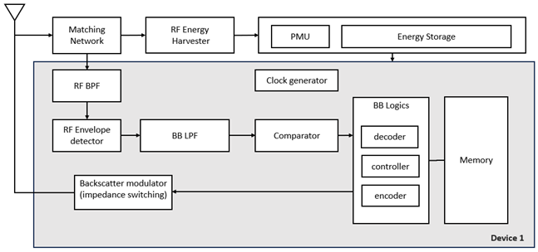

Figure 5.1-1: Architecture of device 1

## 5.2 ≤a few hundred µW devices (Device 2)

### 5.2.1 External carrier wave (Device 2a)

The architecture of device 2a is summarised in Figure 5.2.1-1, with the block described as follows.

**- Antenna** could be either shared or separate for RF energy harvester (if present) and receiver/transmitter.

**- Matching network** is to match impedance between antenna and other components (including RF energy harvester (if present) and receiver related blocks).

**- Energy harvester**.

**- Energy storage** (e.g., capacitor) stores harvested energy from energy harvester.

**- Power management unit (PMU)** manages storing energy to energy storage from energy harvester and suppling power to active component blocks which needs power supply.

**- Digital BB logic** includes functional blocks like encoder, decoder, controller, etc.

**- Memory** caninclude two types of memory: 1) Non-Volatile Memory (NVM) such as EEPROM for permanently storing device ID, etc, and 2) registers for temporarily keeping any information required for its operation only while energy is available in energy storage.

**- Clock generator** provides required clock signal(s).

**- Reflection amplifier** can amplify reflected backscattered signal.

**-** FFS study applicability of amplification of rx signal, power consumption.

**-** At least one of R2D/CW2D and D2R could be amplified by either reflection amplifier or LNA.

**- Reception related blocks**

**- RF BPF** filter for improving selectivity.

**-** Depending on implementation, it may not exist. RAN4 RF requirement (if any, e.g., ACS) and peak power consumption target also need to be considered.

**-** FFS: **LNA** for improving signal strength and sensitivity of receiver.

**-** At least one of R2D/CW2D and D2R could be amplified by either reflection amplifier or LNA.

**- RF envelope detector (RF-ED)** detects envelope from RF signal.

**- BB amplifier** amplifies BB signal to improve signal strength.

**- BB LPF** can filter out harmonics and high frequency components to improve input signal quality to comparator/ADC.

**-** Depending on implementation, it may not exist.

**- Comparator** or **N-bit ADC**

**- Transmission related blocks**

**- Backscatter modulator** switches impedance to modulate backscattered signal with tx signal from BB logics.

**-** FFS: **Large Frequency shifter (**e.g., tens of MHz**)** for shifting backscattered signal from one frequency (e.g., FDD-DL frequency) to another frequency (e.g., FDD-UL frequency).

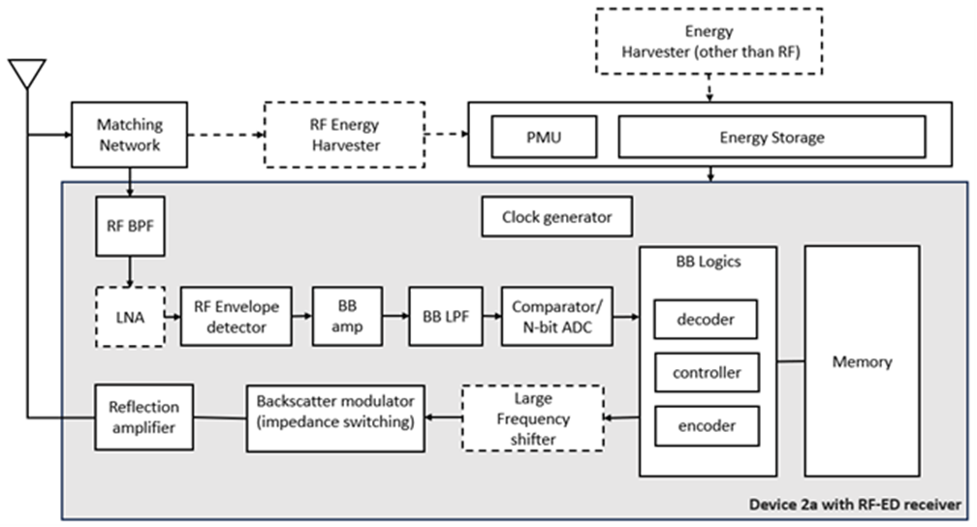

Figure 5.2.1-1: Architecture of device 2a

#### 5.2.1.1 Reflection amplifier

For the reflection amplifier block, the following characteristics are considered for device 2a:

- Direction of amplification

- Uni-directional reflection amplifier (baseline) can amplify backscattered signal in D2R which can improve D2R link budget.

- Bi-directional amplifier can amplify both signal in R2D and backscatter signal in D2R at least when R2D and D2R are in the same spectrum.

- Bi-directional amplifier has higher complexity, higher noise figure, and reduced isolation between tx and rx path.

- Amplification gain ranges from 10 to 20 dB.

- Power consumption of reflection amplifier is in the range of a tens of uW to 100s of uW.

- Reflection amplifier can operate in FDD frequency bands.

- Reflection amplifier bandwidth can support 10s of MHz.

- Note: reflection amplifier can get unstable when the input power exceeds a certain value, which may be frequency-dependent.

#### 5.2.1.2 Large frequency shifter

For the large frequency shifter block, it is observed that:

- Large frequency shift can be used in shifting reflected signal in tens of MHz, e.g., from FDD DL to FDD UL frequency or vice versa.

- Large frequency shift consumes 10s of uW to 100s of uW.

- Large frequency shift is not feasible for device 1.

- Large frequency shift requires a clock for IF generation which is accurate enough to avoid large guard band and interference to adjacent channels/bands.

- Large frequency shift requires image suppression and may require harmonics suppression

- Note: details of image suppression and harmonics suppression are not discussed in RAN1

- FFS: whether large frequency shift is necessary and feasible for device 2a

### 5.2.2 Internally-generated carrier wave (Device 2b)

#### 5.2.2.1 RF envelope detector receiver

The architecture of device 2b with an RF envelope detector receiver is summarised in Figure 5.2.2.1-1, with the blocks described as follows.

**- Antenna** could be either shared or separate for RF energy harvester (if present) and receiver/transmitter.

**- Matching network** is to match impedance between antenna and other components (including RF energy harvester (if present) and receiver related blocks).

**- Energy harvester** for harvesting energyfrom e.g., RF signal, solar, vibration/movement, temperature difference, etc

**- Energy storage** (e.g., capacitor) stores harvested energy from energy harvester.

**- Power management unit (PMU)** manages storing energy to energy storage from energy harvester and suppling power to active component blocks which needs power supply.

**- Digital BB logic** includes functional blocks like encoder, decoder, controller, etc.

**- Memory** caninclude two types of memory: 1) Non-Volatile Memory (NVM) such as EEPROM for permanently storing device ID, etc, and 2) registers for temporarily keeping any information required for its operation only while energy is available in energy storage.

**- Clock generator** provides required clock signal(s).

**- Reception related blocks**

**- RF BPF** filter for improving selectivity.

- Depending on implementation, it may not exist. RAN4 RF requirement (if any, e.g., ACS) and peak power consumption target also need to be considered.

**-** FFS: **LNA** for improving signal strength and sensitivity of receiver, if present

**- RF envelope detector (RF-ED)** detects envelope from RF signal.

**- BB amplifier** amplifies BB signal to improve signal strength.

**- BB LPF** can filter out harmonics and high frequency components to improve input signal quality to comparator/ADC.

**-** Depending on implementation, it may not exist.

**-** Comparator or N-bit ADC

**- Transmission related blocks**

**- Tx Modulator**: baseband bits are modulated according to modulation scheme. This block could be the part of BB logic.

**- Digital to Analog Converter (DAC)** converts digital signal to analog signal.

**- Low pass filter** for filtering out undesired signal

**- Mixer** performs up converting baseband signal to RF range.

**- Local oscillator (LO)** for carrier frequency generation

**-** FFS: PLL/FLL

**- FFS: Power amplifier (PA)** amplifies tx signal, if present

**-** Details on transmitter related blocks depends on tx waveform/modulation.

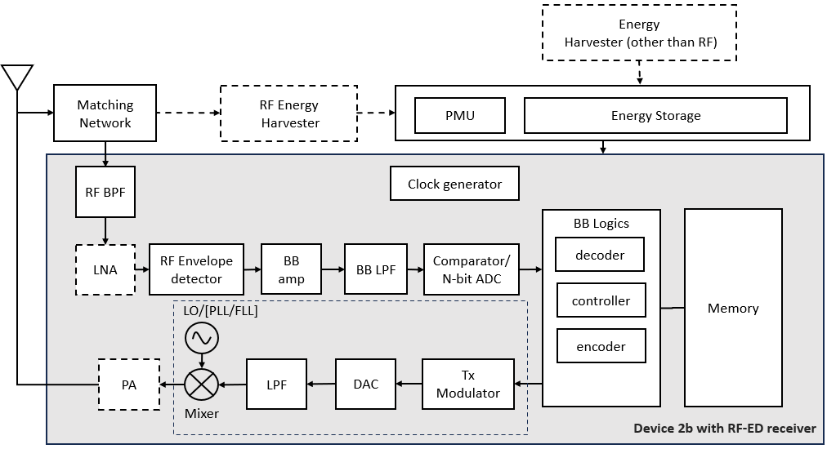

Figure 5.2.2.1-1: Architecture of device 2b with RF-ED receiver

#### 5.2.2.2 IF envelope detector receiver

The architecture of device 2b with an IF envelope detector receiver is summarised in Figure 5.2.2.2-1, with the blocks described as follows.

**- Antenna** could be either shared or separate for RF energy harvester (if present) and receiver/transmitter

**- Matching network** is to match impedance between antenna and other components (including RF energy harvester (if present) and receiver related blocks)

**- Energy harvester** for harvesting energyfrom e.g., RF signal, solar, vibration/movement, temperature difference, etc.

**- Energy storage** (e.g., capacitor) stores harvested energy from energy harvester

**- Power management unit (PMU)** manages storing energy to energy storage from energy harvester and suppling power to active component blocks which needs power supply

**- Digital BB logic** includes functional blocks like encoder, decoder, controller, etc.

**- Memory** caninclude two types of memory: 1) Non-Volatile Memory (NVM) such as EEPROM for permanently storing device ID, etc, and 2) registers for temporarily keeping any information required for its operation only **-** while energy is available in energy storage

**Clock generator** provides required clock signal(s).

**- Local oscillator (LO)** for generating carrier frequency for Tx, or for generating carrier frequency offset by the IF for Rx

**-** FFS: PLL/FLL

**-** FFS: one LO or separate LOs for Tx and Rx

**- Reception related blocks**

**- RF BPF** filter for improving selectivity

**-** Depending on implementation, it may not exist. RAN4 RF requirement (if any, e.g., ACS) and peak power consumption target also need to be considered

**-** FFS: **LNA** for improving signal strength and sensitivity of receiver, if present

**- Mixer** down converts RF signal to IF stage

**-** Depending on implementation, there could be one or two mixers for Rx and Tx

**- IF amplifier** amplifies IF signal

**- IF filter** for filtering out unwanted RF and LO signals

**- IF envelope detector (IF-ED)** detects envelope from IF signal.

**- BB amplifier**

**-** Depending on implementation, one or both of IF amplifier and BB amplifier may exist

**- BB LPF** can filter out harmonics and high frequency components to improve input signal quality to comparator/ADC

**-** Depending on implementation, it may not exist

**-** Comparator or N-bit ADC

**-** Note: image rejection is required

**- Transmission related blocks**

**- Tx Modulator**: baseband bits are modulated according to modulation scheme. This block could be the part of BB logic

**- Digital to Analog Converter (DAC)** converts digital signal to analog signal

**- Low pass filter** for filtering out undesired signal

**- Mixer** performs up converting baseband signal to RF range

**- FFS: Power amplifier (PA)** amplifies transmitted signal, if present

**-** Details of transmitter related blocks depends on e.g., waveform/modulation, etc.

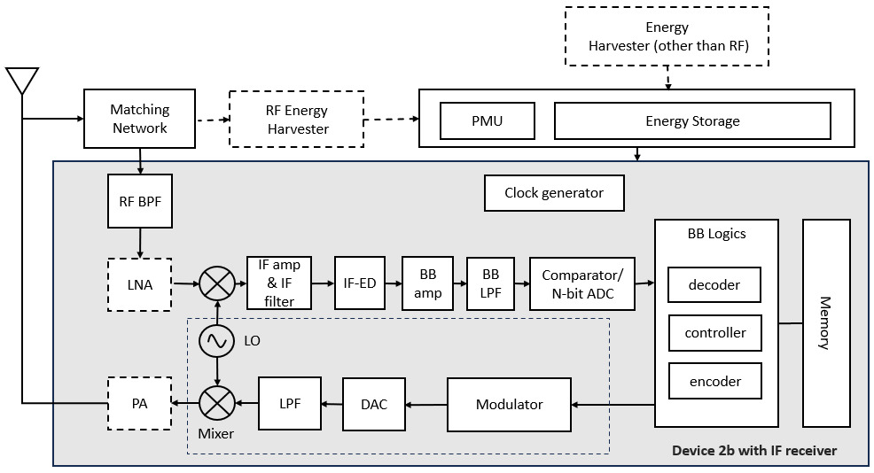

Figure 5.2.2.1-1: Architecture of device 2b with IF-ED receiver

#### 5.2.2.3 ZIF receiver

The architecture of device 2b with a ZIF receiver is summarised in Figure 5.2.2.3-1, with the blocks described as follows.

**- Antenna** could be either shared or separate for RF energy harvester (if present) and receiver/transmitter

**- Matching network** is to match impedance between antenna and other components (including RF energy harvester (if present) and receiver related blocks)

**- Energy harvester** for harvesting energyfrom e.g., RF signal, solar, vibration/movement, temperature difference, etc

**- Energy storage** (e.g., capacitor) stores harvested energy from energy harvester.

**- Power management unit (PMU)** manages storing energy to energy storage from energy harvester and suppling power to active component blocks which needs power supply

**- Digital BB logic** includes functional blocks like encoder, detector, decoder, controller, etc.

**- Memory** caninclude two types of memory: 1) Non-Volatile Memory (NVM) such as EEPROM for permanently storing device ID, etc, and 2) registers for temporarily keeping any information required for its operation only while energy is available in energy storage

**- Clock generator** provides required clock signal(s).

**- Local oscillator (LO)** for generating carrier frequency for Tx and Rx

- FFS: PLL/FLL

- FFS: one LO or separate LOs for Tx and Rx

**- Reception related blocks**

**- RF BPF** filter for improving selectivity

**-** Depending on implementation, it may not exist. RAN4 RF requirement (if any, e.g., ACS) and peak power consumption target also need to be considered

**-** FFS: **LNA** for improving signal strength and sensitivity of receiver

**- Mixer** down converts RF signal to BB stage

**-** Depending on implementation, there could be one or two mixers for Rx and Tx

**- BB amplifier** amplifies BB signal

**- BB LPF** can filter out undesired frequency components to improve input signal quality to comparator/ADC.

**-** Depending on implementation, it may not exist

- Comparator or N-bit ADC

**- Transmission related blocks**

**- Tx Modulator**: baseband bits are modulated according to modulation scheme. This block could be the part of BB logic.

**- Digital to Analog Converter (DAC)** converts digital signal to analog signal.

**- Low pass filter** for filtering out undesired signal

**- Mixer** performs up converting baseband signal to RF range.

**- FFS: Power amplifier (PA)** amplifies transmitted signal, if present

**-** Details of transmitter related blocks depend on e.g., waveform/modulation, etc.

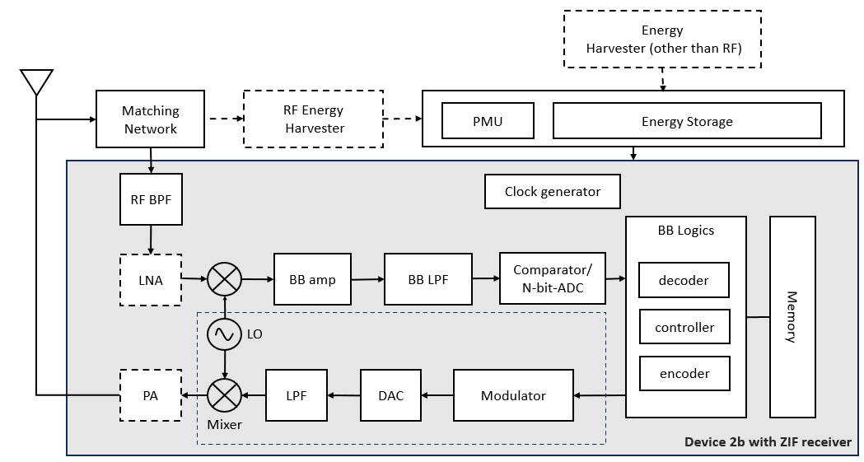

Figure 5.2.2.1-1: Architecture of device 2b with ZIF receiver

### 5.2.3 Clock(s)

*Editor’s note: To be added, in this or another sub-clause, once the structure and content of the table from RAN1#117 is clear.*

# 6 Solutions for ambient IoT

## 6.1 Physical layer

### 6.1.0 General

The names of physical channels and signals used in this TR are for the sake of the study.

The study assumes that an A-IoT device has a single antenna for both communication (transmission/reception) and RF energy harvesting purposes.

The study defines repetition types as follows:

Block level: All the bits received from higher layers and/or physical layer (according to what is present) after CRC attachment (if used) are blockwise repeated Rblock times

Bit level type 1: Each bit after CRC attachment (if used) is repeated Rbit times

Bit level type 2: Each bit after both CRC attachment (if used) and FEC (if used) is repeated Rbit times

Chip level: Each chip after line coding (if used) or after square wave modulation (if used) is repeated Rchip time. NOTE: This is equivalent to extending the duration of each chip by Rchip times.

### 6.1.1 R2D

A dedicated physical broadcast channel, e.g. PBCH-like, and reference signals including at least DMRS, PTRS, CSI-RS/TRS, are not considered for R2D.

#### 6.1.1.x R2D waveform, modulation and numerology

An OFDM-based OOK waveform with subcarrier spacing of 15 kHz is studied for R2D, with OOK-1 for single-chip per OFDM symbol transmission, and OOK-4 for *M*-chip per OFDM symbol transmission, starting from the definitions in TR 38.869 [4]. For this waveform, the start of R2D transmission from the reader perspective is assumed to be aligned with the boundary of an NR OFDM symbol (including the CP) for in-band/guard-band operation.

For CP handling, the following candidate methods are studied, on the basis of e.g., CP impact on R2D timing acquisition, and decoding & performance of PRDCH, reader and device implementation complexities, interference between R2D and NR DL/UL if in the same NR band, spectrum efficiency.

Method Type 1: Removal of CP at device without specified transmit-side.

Method Type 2: Ensure the CP insertion of OFDM-based waveform will not introduce false rising/falling edge between the last OOK chip in OFDM symbol (*n*-1) and the first OOK chip in OFDM symbol *n*.

For Method 1, two ways that CP location/length can be determined are studied:

Alt M1-1: Device assumes same CP length for each OFDM symbol, i.e. does not distinguish exact CP length among different OFDM symbols

Alt M1-2: Duration between transition edges is utilized by device to determine CP location/length, i.e. if the duration appears to be invalid based on known chip duration

For Method 2, two approaches regarding subcarrier orthogonality are studied:

Alt M2-1: Method Type 2 retains subcarrier orthogonality, i.e. CP is copied from the end of an OFDM symbol.

Alt M2-1-1: The first OOK chip(s) and the last OOK chip(s) in an OFDM symbol are the same.

Alt M2-1-2: Ensure a transition edge occurs only at the start or only at the end of the CP, and no transition edge occurs during the CP.

Alt M2-2: Method Type 2 does not retain subcarrier orthogonality.

#### 6.1.1.x R2D line coding

The line codes studied for R2D are Manchester encoding and PIE.

For Manchester encoding, the bit-to-chip mapping is: bit 0→chips{10}, bit 1→chips{01}.

#### 6.1.1.x R2D channel coding, CRC

PRDCH without FEC is studied as the baseline, with evaluations performed by comparison to this baseline. The study assumes PRDCH can attach a CRC, where the baseline design is using a 6-bit or 16-bit CRC with polynomials as per TS 38.212 [5]. A baseline of no CRC attachment is also included.

#### 6.1.1.x R2D bandwidths

The study defines the following bandwidths for R2D:

- Transmission bandwidth, Btx,R2D from a reader perspective: The frequency resources used for transmitting R2D. For an OFDM-based waveform with subcarrier spacing of 15 kHz, Btx,R2D ≤ [12] PRBs.

- Occupied bandwidth, Bocc,R2D from a reader perspective: The frequency resources used for transmitting R2D, and potential guard band.

- Bocc,R2D ≥ Btx,R2D.

#### 6.1.1.x PRDCH

For R2D, the only physical channel is PRDCH, which carries any higher-layer payload (including system information, if defined), and L1 R2D control information, if defined. PRDCH is studied via the blocks shown in Figure 6.1.1.x-1, where other sections give their detailed descriptions.



Figure 6.1.1.x-1: PRDCH generation

#### 6.1.1.x R2D start timing

An R2D timing acquisition signal (R-TAS), immediately preceding the transmission of PRDCH, is included at least for timing acquisition and indicating the start of R2D transmission in the time domain. An R-TAS structure using a preamble is studied, in which a start-indicator part provides the start of the R2D transmission, and immediately precedes a clock-acquisition part which is used to determine the OOK chip duration of the subsequent PRDCH transmission. The preamble is not part of PRDCH.

Two options for the R-TAS start indicator part design are studied:

Option 1: ON/OFF pattern, i.e. high/low voltage transmission.

Option 2: OFF pattern, i.e. low voltage transmission.

#### 6.1.1.x R2D end timing

To determine or derive the end of PRDCH transmission, the following options are studied:

Option 1: R2D postamble immediately follows the PRDCH to indicate the end of the PRDCH.

Option 2: Based on R2D control information.

### 6.1.2 D2R

Reference signals including DMRS, PTRS, SRS, are not considered for D2R. CSI feedback and autonomous SR are not considered for L1 D2R control information.

#### 6.1.2.x Waveform and modulation

For D2R by backscattering, the waveform is provided by the carrier wave, see Clause 6.7.

For all devices, the following D2R baseband modulations are studied:

- OOK

- Binary PSK

- Binary FSK

#### 6.1.2.x D2R line coding

The line codes studied for R2D are Manchester encoding FM0 encoding, Miller encoding, and no line coding.

For Manchester encoding, the bit-to-chip mapping is: bit 0→chips{10}, bit 1→chips{01}.

#### 6.1.2.x D2R channel coding, repetition, CRC

For D2R, convolutional codes are studied, with comparisons to the case of no FEC. The study assumes PDRCH can attach a CRC, where the baseline design is using a 6-bit or 16-bit CRC with polynomials as per TS 38.212 [5]. A baseline of no CRC attachment is also included.

For definitions of repetition types, see Clause 6.1.0. For D2R, at least block-level and bit-level repetition type 1 and type 2 are studied.

#### 6.1.2.x D2R bandwidths

The following bandwidths for D2R are defined for the purpose of the study:

- Transmission bandwidth, *B*tx,D2R: The frequency resources scheduled by a reader for a D2R transmission from one device.

- Occupied bandwidth, *B*occ,D2R: The transmission bandwidth plus the potential associated intra A-IoT guard-bands totalling *B*guard,D2R. Note: this guard band is not for coexistence with NR/LTE.

- *B*occ,D2R ≥ *B*tx,D2R.

#### 6.1.2.x PDRCH

For D2R, a physical channel PDRCH carries any higher-layer payload, the response transmitted from device to reader during the contention-based access procedure, and L1 D2R control information, if defined. PDRCH is studied via the blocks shown in Figure 6.1.2.x-1, where other sections give their detailed descriptions.



Figure 6.1.2.x-1: PDRCH generation

Scheduling information of PDRCH transmission is provided by a corresponding PRDCH.

#### 6.1.2.x D2R start timing

A D2R timing acquisition signal (D-TAS), preceding each PDRCH, is included at least for timing acquisition and for indicating the start of the D2R transmission in time domain. A D-TAS structure using a preamble is studied. The preamble is not part of PDRCH.

#### 6.1.2.x D2R end timing

For the reader to acquire the end of PDRCH transmission, the following options are studied:

Option 1: D2R postamble immediately follows the PDRCH

Option 2: Based on control information

#### 6.1.2.x D2R midamble

The necessity of a midamble is studied at least for the purpose of performing timing/frequency tracking or channel estimation or interference estimation.

#### 6.1.2.x D2R multiple access

Time-domain multiple access, and frequency domain multiple access at least by using a small frequency-shift in baseband are studied. Whether code-domain multiple access is feasible ad necessary for all devices is FFS.

### 6.1.3 Timing relationships

A-IoT processing time aspects are studied in terms of the following timing relationships:

*T*R2D_min: Minimum time between a R2D transmission and the corresponding D2R transmission following it.

*T*D2R_min: Minimum time between a D2R transmission and the corresponding R2D transmission following it.

*T*R2D_R2D_min: Minimum time between two different consecutive R2D transmissions to the same A-IoT device.

*T*D2R_D2R_min: Minimum time between two different consecutive D2R transmissions from the same A-IoT device.

For the time interval between a R2D transmission and the corresponding D2R transmission following it, there are two options studied:

Option 1: Define a maximum time *T*R2D_max between a R2D transmission and the corresponding D2R transmission following it, so that the device transmits D2R transmission within [*T*R2D_min, *T*R2D_max].

Option 2: The corresponding D2R transmission timing *T*R2D following a R2D transmission is determined based on the control information in the R2D transmission, where *T*R2D ≥ *T*R2D_min.

### 6.1.4 Random access

*Editor’s note: Whether to retain this clause in the RAN1 part, or merge it into Clause 6.2 with RAN2 is TBD, once further agreements and text are available.*

From the perspective of the physical layer, at least when a response is expected from multiple devices that are intended to be identified, an A-IoT contention-based access procedure initiated by the reader is used, for which at least slotted-ALOHA based access is studied. The response transmitted from the device to the reader during this procedure is transmitted on PDRCH.

## 6.2 Protocol stack and signalling procedures

*Editor’s note: Corresponds to the RAN2 objective in the SID.*

## 6.3 Impacts on CN-RAN interface

*Editor’s note: Corresponds to the first RAN3 objective in the SID.*

## 6.4 RAN architecture aspects

*Editor’s note: Corresponds to the second RAN3 objective in the SID.*

## 6.5 Coexistence of ambient IoT and NR/LTE

*Editor’s note: Corresponds to the first RAN4 objective in the SID.*

## 6.6 RF requirements study

*Editor’s note: Corresponds to the second RAN4 objective in the SID.*

## 6.7 Characteristics of carrier-wave waveform

### 6.7.1 CW transmission

For the case that D2R backscattering is transmitted in the same carrier as CW for D2R backscattering, and for topology 1, the following cases for CW transmission are studied:

Case 1-1: CW is transmitted from inside the topology, transmitted in DL spectrum

Case 1-2: CW is transmitted from inside the topology, transmitted in UL spectrum

Case 1-4: CW is transmitted from outside the topology, transmitted in UL spectrum

For the case that D2R backscattering is transmitted in the same carrier as CW for D2R backscattering, and for topology 2, the following cases for CW transmission are studied:

Case 2-2: CW is transmitted from inside the topology (i.e., intermediate UE), transmitted in UL spectrum

Case 2-3: CW is transmitted from outside the topology, transmitted in DL spectrum

Case 2-4: CW is transmitted from outside the topology, transmitted in UL spectrum

### 6.7.2 CW characteristics

Candidates for the CW for D2R backscattering are waveforms consisting of:

Waveform 1: A single-tone unmodulated sinusoid, also referred to as 'a single tone'.

Waveform 2: Two single tones.

Table 6.7.2-1 captures observations on the above CW waveform candidates.

Table 6.7.2-1: Observations and/or comparisons of CW waveform candidates

|  |  |  |
| --- | --- | --- |
| **CW waveform characteristics** | **Waveform 1 compared to Waveform 2**  **NOTE 1: Waveform 1 without frequency hopping**  **NOTE 2: Waveform 2 with both tones from the same CW node** | **…** |
| **D2R reception performance** | Waveform 2 provides [X Y] dB frequency diversity gain in a fading channel, at least depending on the gap between the two tones and the channel’s coherence bandwidth.  Note: The total transmission power is assumed the same for both waveforms. | … |
| **Spectrum utilization of backscattered signal corresponding to the CW waveforms** |  | … |
| **CW interference suppression at D2R receiver** | Waveform 2 requires additional complexity if RF interference cancellation is used at least with CW waveform reconstruction.  Note: RF interference cancellation is needed when the received CW interference power exceeds the blocking threshold of the receiver | … |
| **Relative complexity of CW generation** | Waveform 2 leads to higher PAPR of the generated CW, which impacts the implementation of the power amplifier in the CW node. | … |

## 6.8 Locating ambient IoT devices

### 6.8.x Proximity determination

*Editor’s note: Proximity determination may be in a 6.8.x sub-clause, or another arrangement, depending on how the study proceeds.*

The following schemes are studied for proximity determination:

Scheme 1: If reader receives D2R transmission from the device in response to R2D transmission, then device is determined as near.

Scheme 2: Device is determined to be near the reader based on measurements at the reader side.

Proximity determination based on device-side measurements is not considered.

# 7 Coverage evaluations

For an evaluation scenario:

- For each link *i*,

- Step 1: Obtain the required SINR for the physical channels under target scenarios and service/reliability requirements if Budget-Alt2 is used for this link *i*.

- Step 2: Obtain the receiver sensitivity using the method Budget-Alt1 (if a predefined threshold is assumed to derive the receiver sensitivity) or Budget-Alt2 (if no predefined threshold is assumed to derive the receiver sensitivity). See Clause 4.3.1 for the Budget definition.

- Step 3: Obtain the coverage performance for link *i* based on the receiver sensitivity from step 2 and link budget template.

- The coverage results for each link are provided.

# 8 Conclusions and recommendations

Annex <x> (informative):  
Change history

|  |  |  |  |  |  |  |  |
| --- | --- | --- | --- | --- | --- | --- | --- |
| Change history | | | | | | | |
| Date | Meeting | TDoc | CR | Rev | Cat | Subject/Comment | New version |
| 2024-02 | RAN1#116 | R1-2401795 |  |  |  | TR skeleton | 0.0.1 |
| 2024-08 | RAN1#118 | R1-2406752 |  |  |  | Inclusion of agreements up to RAN1#117 | 0.1.0 |