**3GPP TSG RAN WG1 #118 R1-24xxxxx**

**Maastricht, Netherlands, August 19th – August 23rd, 2024**

**Source: Moderator (MediaTek)**

**Title: [118-Pre-R18-NR] Summary of** **SSSG timer reset instant for R17 UE power saving**

**Agenda item: 7**

**Document for:** **Discussion and Decision**

Introduction

In RAN1#118 meeting, one contribution [1, MTK] is submitted to clarify the SSSG timer reset instant for R17 UE power saving.

As guided by the Chairman, this contribution provides summary of the submitted contributions (Section 4), discussion points (Section 2), and possible RAN1 consensus during this meeting (Section 3).

**Rel-17 UE power savings**

R1-2406761 Clarification on SSSG timer reset time instant for R17 UE power saving MediaTek Inc.

Discussion points

In [1, MTK], it is mentioned that

* The following spec from 38.213 V17.10.0 Clause 10.4 **seems to imply** that UE needs to reset the *searchSpaceSwitchTimer-r17* **at the symbol** receiving the **PDCCH monitoring adaptation DCI**:

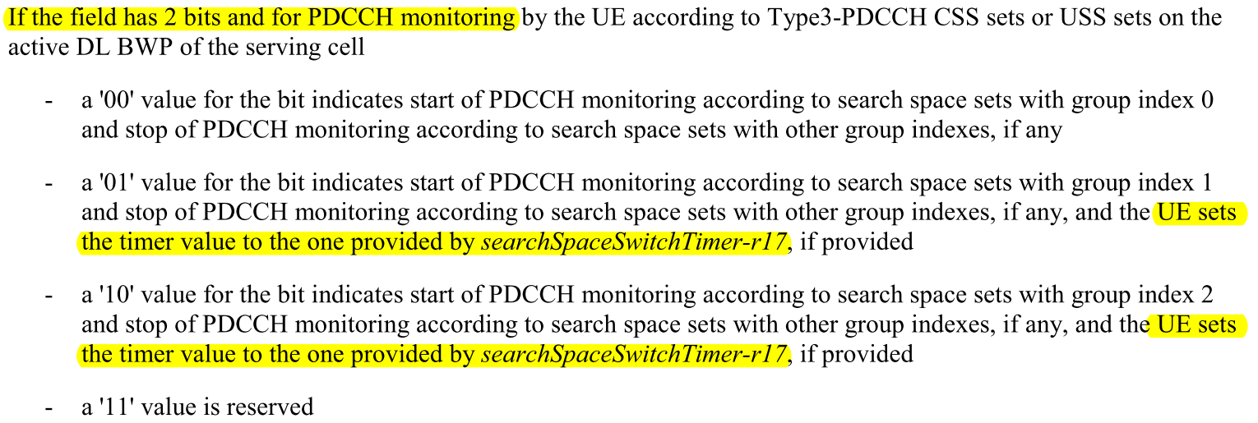

* The following spec from 38.213 V17.10.0 Clause 10.4 **specifies** that UE needs to reset the *searchSpaceSwitchTimer-r17* **at the next slot boundary** after receiving the **DCI with CRC scrambled by C-RNTI/CS-RNTI/MCS-C-RNTI/…** :

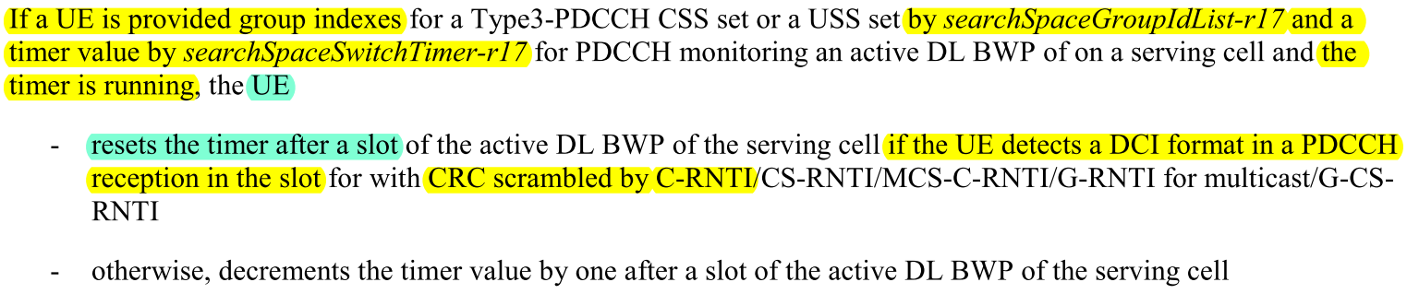

* The two paragraphs above would **introduce conflict**, for example, when UE receives **PDCCH monitoring adaptation DCI scrambled with C-RNTI** to **switch from SSSG 1 to SSSG 2 (PDCCH adaptation DCI scrambled with C-RNTI)**
  + Should UE reset the *searchSpaceSwitchTimer-r17* **at the DCI receiving symbol** or **at the next slot boundary**?

The following proposal is brought up by [1]:

**Proposal 1: RAN1 to draw the following conclusion (to have an aligned UE behavior):**

* **The DCI triggered *searchSpaceSwitchTimer-r17* timer reset should always happen at the next slot boundary.**

The following discussions points are devised to clarify the SSSG timer reset instant for R17 UE power saving.

**Discussion point 1:**

**To your understanding, when UE receives PDCCH monitoring adaptation DCI scrambled with C-RNTI to switch from SSSG 1 to SSSG 2 (PDCCH adaptation DCI scrambled with C-RNTI), should UE reset the *searchSpaceSwitchTimer-r17* at the DCI receiving symbol or at the next slot boundary?**

**Please assist to elaborate on the reasoning of your answer if possible.**

|  |  |
| --- | --- |
| **Company** | **Comment** |
| CATT | The timer should be reset the next slot boundary since the PDCCH processing time in a slot is different for different UE implementation. |
|  |  |
|  |  |

**Discussion point 2:**

**Do you agree with [1] to have the following RAN1 conclusion?**

* **The DCI triggered *searchSpaceSwitchTimer-r17* timer reset should always happen at the next slot boundary.**

**Please assist to elaborate on the reasoning of your answer if possible.**

|  |  |  |
| --- | --- | --- |
| **Company** | **Yes or No** | **Comment** |
| CATT | Yes. | Just the conclusion without any specification change for clarification |
|  |  |  |
|  |  |  |

Resulted RAN1 conclusion/agreement

TBD.

Summary of contribution inputs

**Summary for [1, MTK]:**

The following spec in Figure 1 from 38.213 V17.10.0 Clause 10.4 seems to imply that UE needs to reset the *searchSpaceSwitchTimer-r17* at the symbol receiving the PDCCH monitoring adaptation DCI:

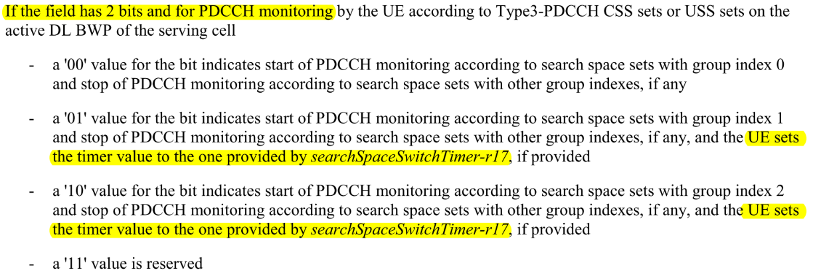

**Figure 1. Spec quote of (implicit) symbol-based timer reset instant from 38.213 V17.10.0 Clause 10.4**

An exemplary figure for this symbol-based timer reset instant is shown in Figure 2.

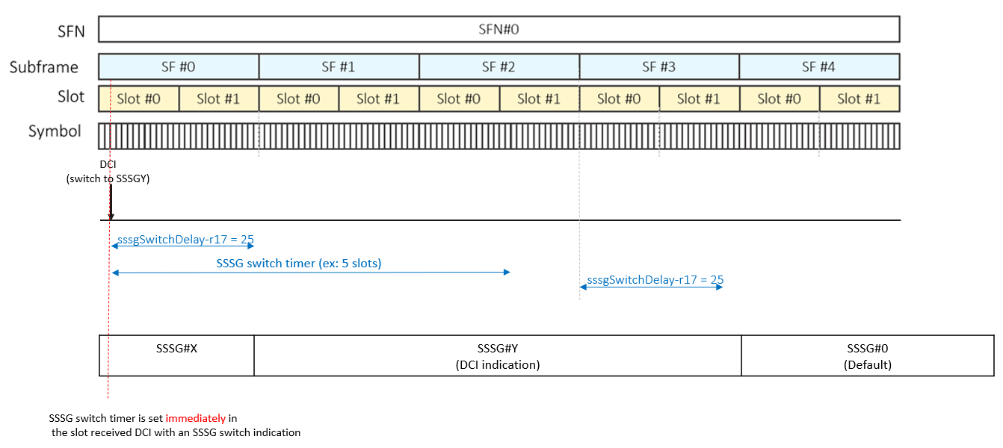

**Figure 2.** **An exemplary figure for symbol-based SSSG switch timer reset instant**

**Observation 1: The spec in Figure 1 from 38.213 V17.10.0 Clause 10.4 seems to imply that UE needs to reset the *searchSpaceSwitchTimer-r17* at the symbol receiving the PDCCH monitoring adaptation DCI.**

* **An exemplary figure is shown in Figure 2**

However, the following spec in Figure 2 from 38.213 V17.10.0 Clause 10.4 specifies that UE needs to reset the *searchSpaceSwitchTimer-r17* at the next slot boundary after receiving the DCI with CRC scrambled by C-RNTI/MCS-C-RNTI and some other RNTIs.

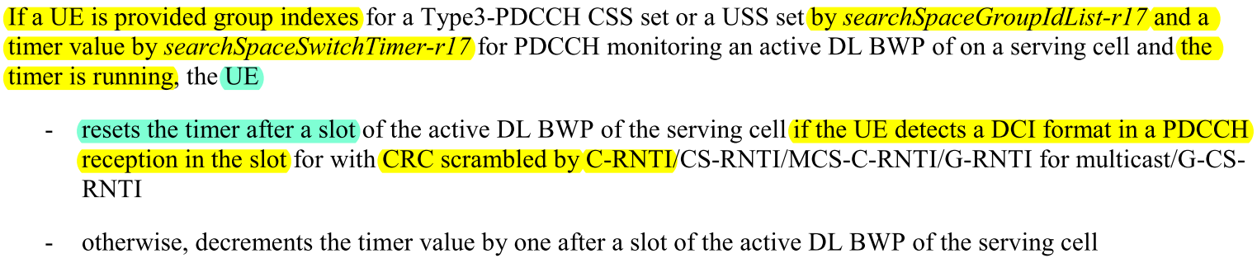

**Figure 3. Spec quote of slot-based timer reset instant from 38.213 V17.10.0 Clause 10.4**

An exemplary figure for this slot-based timer reset instant is shown in Figure 4.

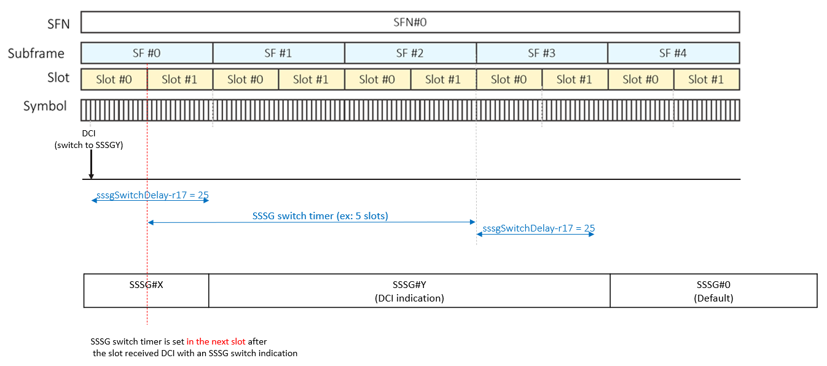

**Figure 4. An exemplary figure for slot-based SSSG switch timer reset instant**

**Observation 2: The spec in Figure 3 from 38.213 V17.10.0 Clause 10.4 specifies that UE needs to reset the *searchSpaceSwitchTimer-r17* at the next slot boundary after receiving the DCI with CRC scrambled by C-RNTI/MCS-C-RNTI and some other RNTIs.**

* **An exemplary figure is shown in Figure 4**

The two spec paragraphs in Figure 1 and Figure 2 above could introduce (potential) conflict, for example, when UE receives PDCCH monitoring adaptation DCI scrambled with C-RNTI to switch from SSSG 1 to SSSG 2

* Should UE reset the *searchSpaceSwitchTimer-r17* at the DCI receiving symbol or at the next slot boundary?

**Observation 3: The two spec paragraphs in Figure 1 and Figure 2 above could introduce (potential) conflict, for example, when UE receives PDCCH monitoring adaptation DCI scrambled with C-RNTI to switch from SSSG 1 to SSSG 2**

* **Should UE reset the *searchSpaceSwitchTimer-r17* at the DCI receiving symbol or at the next slot boundary?**

To resolve the issue in Observation 3, we have the following proposal.

**Proposal 1: RAN1 to draw the following conclusion (to have an aligned UE behavior):**

* **The DCI triggered *searchSpaceSwitchTimer-r17* timer reset should always happen at the next slot boundary.**

References

[1] R1-2406761, “Clarification on SSSG timer reset time instant for R17 UE power saving”, MediaTek Inc., RAN1 #118