Issue #1-5: Order of RO group determination
Draft TP #1-5
8.1 Random access preamble
< Unchanged parts are omitted >
Within a time period, for set(s) of $N_{preamble}^{rep}$ valid PRACH occasions associated with the same one or multiple SSB index(es), where each same SSB index is associated with the same preambles, for a PRACH transmission with $N_{preamble}^{rep}$ preamble repetitions
- the first valid PRACH occasion of the first set is the first valid PRACH occasion with the lowest frequency resource index
- the first valid PRACH occasion of subsequent sets, if any, is determined according to an ordering of valid PRACH occasions
- first, in increasing order of frequency resource indexes for frequency multiplexed PRACH occasions
- second, in increasing order of time resource indexes for time multiplexed PRACH occasions
and for each frequency resource index for frequency multiplexed PRACH occasions
- if TimeOffsetBetweenStartingRO is provided,
- the first valid PRACH occasion of subsequent sets, if any, is after TimeOffsetBetweenStartingRO consecutive valid PRACH occasions associated with the same given SSB index(es), where each same SSB index is associated with the same given preambles, in time from the first valid PRACH occasion of the previous set
- otherwise,
- the first valid PRACH occasion of subsequent sets, if any, is determined after the ROs determined for the previous set.
[- a set is not determined if the number of valid PRACH occasions after a first valid PRACH occasion is less than Npreamblerep-1.]

< Unchanged parts are omitted >

Reasons for changes: To capture the following agreements to Section 8.1, TS 38.213.
Agreement (RAN1 #114bis)
All ROs in one RO group are associated with the same SSB(s), which means:
- If each RO is associated with one SSB, all ROs in one RO group are associated with the same SSB index.
- If each RO is associated with multiple SSB, all ROs in one RO group are associated with the same SSB indexes and each same SSB index is associated with the same preambles.
Note: Potential spec. impact will be further investigated.

Agreement (RAN1 #114)
For a given number of N multiple PRACH transmissions, to determine the starting RO of all the RO groups within a time period X:
  - If a time offset is configured, then
    - the starting RO of the first RO group for each $n_{RA}$ is determined from the first valid RO within the time period X, first in increasing order of frequency resource index for frequency multiplexed PRACH occasions; second in increasing order of time resource index.
    - the starting RO of the n-th RO group for each $n_{RA}$ is determined as the RO at the time offset equal to a number of valid ROs from the starting RO of the (n-1)-th RO group for the same $n_{RA}$.
  - If time offset is not configured, then
    - the starting RO of the first RO group is the first valid RO within the time period X.
    - the starting RO of other RO groups are determined as the first valid RO after the previous RO group in the following order within the time period X: first, in increasing order of frequency resource indexes for frequency multiplexed PRACH occasions; second, in increasing order of time resource indexes.

Agreement (RAN1 #114)
Add the following notes to the above agreement:
Note1: “the starting RO of other RO groups are determined as the first valid RO after the previous RO group in the following order within the time period X: first, in increasing order of frequency resource indexes for frequency multiplexed PRACH occasions; second, in increasing order of time resource indexes.” is illustrated as in the following figure (N=2, for ROs associated with SSB#0). This works for both Alt.1 and Alt.2 for the starting RO determination.
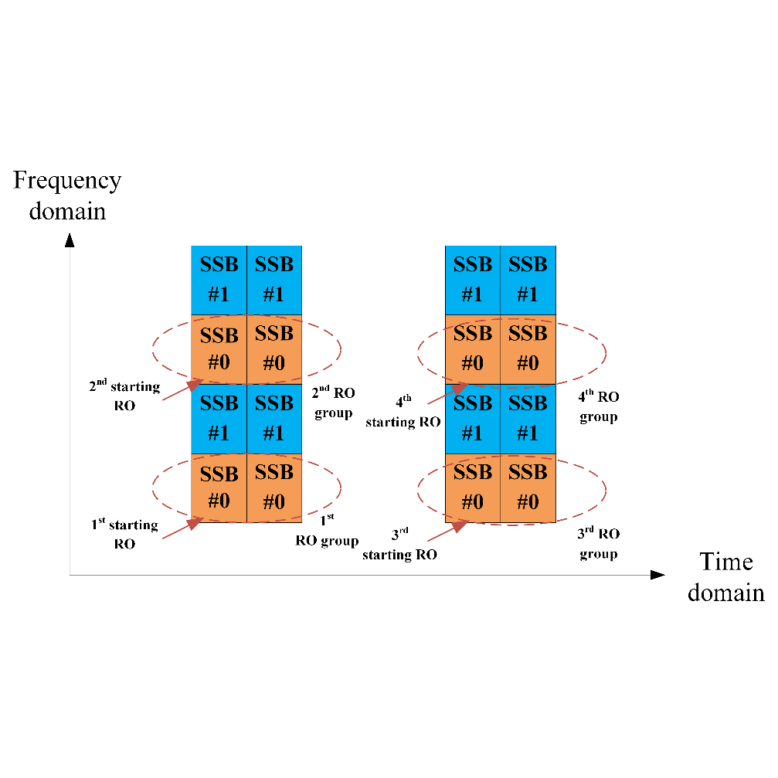
Note2: all the ROs mentioned in the agreement are valid ROs associated with the given same SSB(s) and all the RO groups mentioned in the agreement are RO groups consisting of valid ROs associated with the given same SSB(s).
Note3: $n_{RA}$ of an RO, frequency resource index of an RO, and the starting RB of an RO indicate the same meaning, i.e., locate in the same frequency position.
Summary of change:
- When time offset is provided, capture the ordering of RO group determination into the spec.
- When time offset is not provided, capture the agreed note to avoid ambiguity in RO group determination.
- In order to capture the above two aspects, the whole structure of related paragraph is adjusted.
- Clarification on RO associated with the same SSB(s).

Consequences if not approved:
- When time offset is provided, the ordering of RO group determination may be not aligned with the agreement.
- When time offset is not provided, there may be ambiguity for RO group determination.
- The counting of TimeOffsetBetweenStartingRO is incorrect.
- There is ambiguity for RO group determination.

Issue #1-2: The restriction on the number of valid ROs in a RO group
Draft TP #1-2
8.1 Random access preamble

*** Unchanged parts are omitted ***
Within a time period, for set(s) of $N_{preamble}^{rep}$ valid PRACH occasions associated with same SS/PBCH block index for a PRACH transmission with $N_{preamble}^{rep}$ preamble repetitions
- Option 1: A first PRACH occasion of a set is valid only if Npreamblerep-1 subsequent valid PRACH occasions of a set can be determined within the time period.
- Option 2: A PRACH occasion is a first PRACH occasion of a set only if Npreamblerep-1 subsequent valid PRACH occasions of a set can be determined within the time period.

*** Unchanged parts are omitted ***

Reasons for changes: The current spec. omits to mention that if an RO group cannot be created from a starting RO, e.g., the left ROs is not enough for forming another RO group, the RO group is not determined.
Related agreement:
Agreement (RAN1 #112bis)
- Multiple PRACH transmissions within one RACH attempt are only performed within one RO group.
  - The number of valid ROs in the RO group is equal to one of the configured number(s) of multiple PRACH transmissions.
    - Note1: If only one value is configured for multiple PRACH transmissions, then the number of valid ROs in the RO group is equal to this value.
    - Note2: If multiple values are configured for multiple PRACH transmissions, for each value, the number of valid ROs in the RO group is equal to the corresponding number of multiple PRACH transmissions.
    - Note 3: Valid RO(s) refers to what is defined in existing specification.
Summary of change: Capture the restriction that the number of valid ROs in one RO group is equal to the given configured number of multiple PRACH transmissions.
Consequences if not approved: Unexpected UE behaviors, e.g., a UE uses the remaining ROs for PRACH repetitions even if the number of such remaining ROs is less than the configured number of PRACH repetitions.

Issue: Rules causing to drop PRACH transmissions
Proposed TP #6-1
8.1 Random access preamble

*** Unchanged parts are omitted ***
For single cell operation or for operation with contiguous carrier aggregation in a same frequency band or for operation with non-contiguous carrier aggregation in a same frequency band if the UE is not provided with intraBandNC-PRACH-simulTx-r17, a UE does not transmit PRACH and PUSCH/PUCCH/SRS in a same slot with respect to the smallest SCS configuration between the SCS configuration for the UL BWP with the PRACH and the SCS configuration for the UL BWP with the PUSCH/PUCCH/SRS transmissions and a UE does not transmit PRACH and PUSCH/PUCCH/SRS/PRACH when a gap between the first or last symbol of a PRACH transmission in a first slot is separated by less than $N$ symbols from the last or first symbol, respectively, of a PUSCH/PUCCH/SRS/PRACH transmission in a second slot where $N=2$ for $μ=0$ or $μ=$1, $N=4$ for $μ=2$ or $μ=3$, $N=16$ for $μ=5$, $N=32$ for $μ=6$, and $μ$ is the smallest SCS configuration between the SCS configuration for the UL BWP with the PRACH and the SCS configuration for the UL BWP with the PUSCH/PUCCH/SRS transmissions. For a PUSCH transmission with repetition Type B, this applies to each actual repetition for PUSCH transmission [6, TS 38.214]. For a PRACH transmission with Npreamblerep preamble repetitions, this applies to each preamble repetitions.
*** Unchanged parts are omitted ***

Reasons for changes: Based on the existing agreement, the dropping rule of single PRACH transmission in existing spec. is reused for multiple PRACH transmissions. Further clarification is needed in the spec.
Related agreement:
Agreement (RAN1 #113)
If one or more PRACH transmission(s) of the multiple PRACH transmissions in one PRACH attempt are dropped based on the rules causing to drop PRACH transmission(s) in existing spec., the dropped PRACH transmission(s) is not postponed.
  - FFS: whether to introduce new rules causing to drop PRACH transmission.
  - FFS: whether there is standard impact if the dropped PRACH transmission affect the remaining PRACH transmission within the same RO group.

Summary of change: Add one sentence in 8.1 with respect to the dropping rule of multiple PRACH transmissions as “For a PRACH transmission with $N_{preamble}^{rep}$ preamble repetitions, this applies to each preamble repetitions.”.
Consequences if not approved: It may be not clear when applying existing dropping rule of single PRACH transmission to multiple PRACH transmissions.

PRACH mask
For multiple PRACH transmissions with indication of PRACH mask index, down-select one of the following options
- Option 1: UE applies PRACH mask in prior to RO group determination. RO group is determined based on the ROs indicated by the PRACH mask index.
- Option 2: UE applies PRACH mask after RO group determination. UE transmits PRACH with $N_{preamble}^{rep}$preamble repetitions only on a RO group consisting of ROs indicated by the mask.
- Option 3: UE applies PRACH mask after RO group determination. UE transmits PRACH with $N_{preamble}^{rep}$preamble repetitions only on a RO group consisting of starting Ros indicated by the mask.

