#### Issue #1-5: Order of RO group determination

Proposal

The following agreement is updated as: Draft TP #1-5-1 in section 6 of R1-2312274 is endorsed.

|  |
| --- |
| Agreement  Draft TP #1-5 in section 5 of R1-2312273 is endorsed. |

**Draft TP #1-5-1**

|  |
| --- |
| 8.1 Random access preamble  < Unchanged parts are omitted >  Within a time period, for set(s) of $N_{preamble}^{rep}$ valid PRACH occasions for a PRACH transmission with preamble repetitions, where each PRACH occasion within the set(s) is associated with the same one or multiple SSB index(es), and each same SSB index is associated with the same preambles, - the first valid PRACH occasion of the first set is the first valid PRACH occasion  - the first valid PRACH occasion of subsequent sets, if any, is determined according to an ordering of valid PRACH occasions,  - first, in increasing order of frequency resource indexes for frequency multiplexed PRACH occasions  - second, in increasing order of time resource indexes for time multiplexed PRACH occasions  and for each frequency resource index for frequency multiplexed PRACH occasions  - the first valid PRACH occasion of the first set for this frequency resource index is the first valid PRACH occasion  - if *TimeOffsetBetweenStartingRO* is provided,  - the first valid PRACH occasion of subsequent sets, if any, is after *TimeOffsetBetweenStartingRO* consecutive valid PRACH occasions in time from the first valid PRACH occasion of the previous set, where each PRACH occasion is associated with the same one or multiple SSB index(es), and each same SSB index is associated with the same preambles  - otherwise,  - the first valid PRACH occasion of subsequent sets, if any, is determined after the ROs determined for the previous set.  < Unchanged parts are omitted > |

**Reasons for changes**: To capture the following agreements to Section 8.1, TS 38.213.

|  |
| --- |
| Agreement (RAN1 #114bis)  All ROs in one RO group are associated with the same SSB(s), which means:   * If each RO is associated with one SSB, all ROs in one RO group are associated with the same SSB index. * If each RO is associated with multiple SSB, all ROs in one RO group are associated with the same SSB indexes and each same SSB index is associated with the same preambles.   Note: Potential spec. impact will be further investigated.  Agreement (RAN1 #114)  For a given number of *N* multiple PRACH transmissions, to determine the starting RO of all the RO groups within a time period X:   * + If a time offset is configured, then     - the starting RO of the first RO group for each $n_{RA}$ is determined from the first valid RO within the time period X, first in increasing order of frequency resource index for frequency multiplexed PRACH occasions; second in increasing order of time resource index.     - the starting RO of the *n*-th RO group for each $n_{RA}$ is determined as the RO at the time offset equal to a number of valid ROs from the starting RO of the (*n-1*)-th RO group for the same .   + If time offset is not configured, then     - the starting RO of the first RO group is the first valid RO within the time period X.     - the starting RO of other RO groups are determined as the first valid RO after the previous RO group in the following order within the time period X: first, in increasing order of frequency resource indexes for frequency multiplexed PRACH occasions; second, in increasing order of time resource indexes.   Agreement (RAN1 #114)  Add the following notes to the above agreement:  Note1: “the starting RO of other RO groups are determined as the first valid RO after the previous RO group in the following order within the time period X: first, in increasing order of frequency resource indexes for frequency multiplexed PRACH occasions; second, in increasing order of time resource indexes.” is illustrated as in the following figure (*N=2*, for ROs associated with SSB#0). This works for both Alt.1 and Alt.2 for the starting RO determination.  图片包含 图示  描述已自动生成  Note2: all the ROs mentioned in the agreement are valid ROs associated with the given same SSB(s) and all the RO groups mentioned in the agreement are RO groups consisting of valid ROs associated with the given same SSB(s).  Note3: $n_{RA}$ of an RO, frequency resource index of an RO, and the starting RB of an RO indicate the same meaning, i.e., locate in the same frequency position. |

**Summary of change:**

1. When time offset is provided, capture the ordering of RO group determination into the spec.
2. When time offset is not provided, capture the agreed note to avoid ambiguity in RO group determination.
3. In order to capture the above two aspects, the whole structure of related paragraph is adjusted.
4. Clarification on RO associated with the same SSB(s).

**Consequences if not approved:**

1. When time offset is provided, the ordering of RO group determination may be not aligned with the agreement.
2. When time offset is not provided, there may be ambiguity for RO group determination.
3. The counting of *TimeOffsetBetweenStartingRO* is incorrect.
4. There is ambiguity for RO group determination.

#### Proposed conclusion

Proposed conclusion

Within a time period, the first valid PRACH occasion of the first set ~~of the set(s)~~ for a PRACH transmission with $N_{preamble}^{rep}$ preamble repetitions, where each PRACH occasion within the set(s) is associated with the same one or multiple SSB index(es)~~,~~ and each same SSB index is associated with the same preambles, is the valid PRACH occasion at the earliest time instance, and with the lowest frequency resource index for frequency multiplexed PRACH occasions.

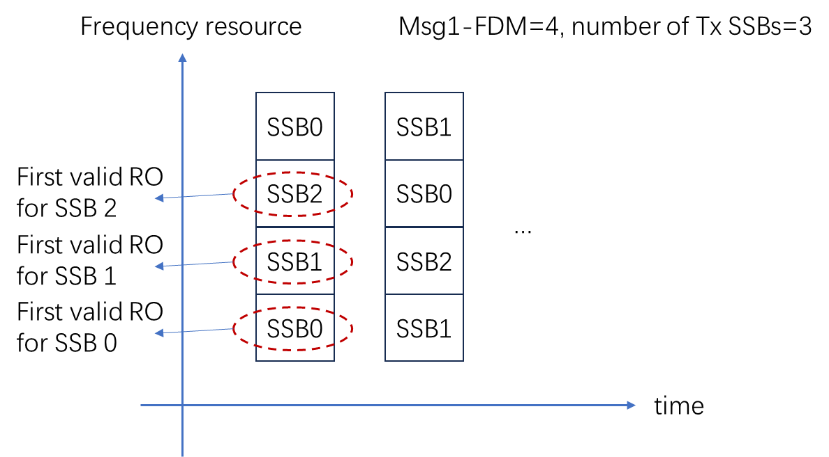

#### PRACH mask

Draft Proposal

For multiple PRACH transmissions with indication of PRACH mask index, down-select one of the following options

* **Option 1:** UE applies PRACH mask prior to RO group determination. RO group is determined based on the ROs indicated by the PRACH mask index.
* **Option 2:** UE applies PRACH mask after RO group determination. UE transmits PRACH with $N_{preamble}^{rep}$ preamble repetitions only on a RO group with all the ROs indicated by the mask.
* **Option 3:** UE applies PRACH mask after RO group determination. UE transmits PRACH with $N_{preamble}^{rep}$ preamble repetitions only on a RO group consisting of RO indicated by the mask, where the RO is the first RO of the RO group.
  + Note: this implies that if the RO indicated by the PRACH mask is the starting RO of an RO group, the RO group can be utilized for PRACH transmissions with $N_{preamble}^{rep}$ preamble repetitions.
* **Option 4:** UE applies PRACH mask after RO group determination. The PRACH mask index indicates one or multiple RO groups for multiple PRACH transmission.
  + Note: this implies the PRACH mask index indicates the RO group index(es) instead of RO index(es).

**Potential problem for Option 3 (point out by sharp)：**

For example, if SSB has 8 consecutive ROs per one mapping cycle but only 7 ROs are valid ROs (e.g. 8th RO is invalid),

first RO group of 4 repetitions consists of ROs with RO index 1~4 and second RO group consists of RO with RO index, 5, 6, 7, 1(for second mapping cycle),

then third RO group consists of ROs with RO index 2~5, and so on. (as shown in following figure)

In this case, it is not clear how the mask index works....

#### Issue #2-2: Calculation of pathloss

|  |
| --- |
|  |

Q1: Based on current spec., is that a common understanding that PL can be updated during multiple PRACH transmissions?

|  |
| --- |
| Conclusion (RAN1 #114bis)  For multiple PRACH transmission with the same Tx beam, the equation of Rel-17 NR PRACH as follows $P_{PRACH,b,f,c}\left(i\right)=min\left\{P_{CMAX,f,c}\left(i\right),P_{PRACH,target,f,c}+{PL}_{b,f,c}\right\}$ is reused for calculating the transmission power of each PRACH transmission, where $i$ stands for the corresponding transmission occasion of each of the multiple PRACH transmissions. |

Q2: Do we need a conclusion based on Q1?

#### Issue: Determination of number of multiple PRACH transmissions in the first attempt

Proposed conclusion

No further discussion for the determination of number of multiple PRACH transmissions in RAN1 in Rel-18.

#### Issue #2-1: Power ramping counter

**Draft Proposal 3-1**

For multiple PRACH transmissions,

* Layer 1 notifies higher layers to suspend the corresponding power ramping counter when PRACH transmission in all of PRACH occasions are dropped.
* Layer 1 may notify higher layers to suspend the corresponding power ramping counter when PRACH transmission in any of PRACH occasions are dropped or with reduced transmit power.