3GPP TSG RAN WG1 #115 R1-231xxxx

Chicago, USA, November 13th – November 17th, 2023

Agenda item: 6
Source: Moderator (Qualcomm Incorporated)
Title: Discussion on R1-2312308
Document for: Discussion and Decision

Issue #1: Applicability of UE-specific K-offset during random access in connected mode
The following change is proposed in several sections of TS 36.213 to address the issue of applicability of UE-specific kOffset during random access in connected mode:
<Unchanged parts are omitted>
- if the UE is configured with the higher layer parameter k-Offset,
- $K_{offset}= K_{cell_offset}-K_{UE_offset}$ where
$K_{cell_offset}$ is the parameter k-Offset provided by higher layers, and
$K_{UE_offset}$ is the parameter Differential Koffset provided by higher layers , otherwise $K_{UE_offset}=0$
- otherwise,
- $K_{offset}=0$.
If the UE is configured with higher layer parameter k-Offset, for a PUSCH (re)transmission associated with the TC-RNTI, Koffset= k-Offset.

During the online discussion, companies had some comments on the following points:
- Whether we should use “temporary C-RNTI” or “scheduled by RAR”.
- Whether the change was needed at all (which hopefully was resolved during the session).
Companies are encouraged to provide feedback on the draft CR above.
Company | Comment
Ericsson | We are ok with the current wording of the draft CR above.
ZTE | Fine with the proposed CR.
Qualcomm | Based on some offline discussion, we would like to provide the spec information that indeed the (N)PUSCH associated with MSG3 RAR during CBRA is using TC-RNTI (36.213, NB-IoT)  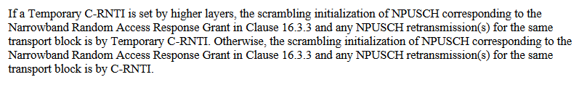  Note that the TC-RNTI is only set by higher layers if the UE initiates CBRA (36.321):  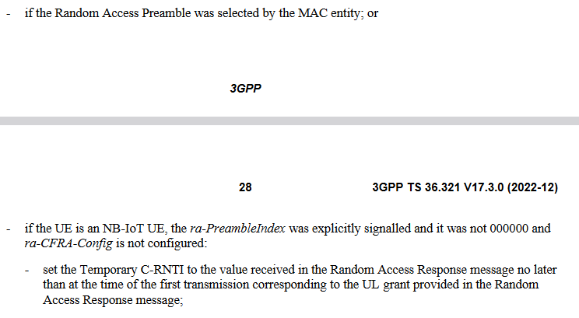
Skylo | We are OK with the proposed CR.  The proposed CR eliminates ambiguity and simplifies implementation complexity for the base station by removing the need to attempt decoding across all possible UE specific K-offset values.

