3GPP TSG RAN WG1 #115 R1-231xxxx

Chicago, USA, November 13th – November 17th, 2023

Agenda item: 6
Source: Moderator (Qualcomm Incorporated)
Title: Discussion on R1-2312308
Document for: Discussion and Decision

Issue #1: Applicability of UE-specific K-offset during random access in connected mode
The following change is proposed in several sections of TS 36.213 to address the issue of applicability of UE-specific kOffset during random access in connected mode:
<Unchanged parts are omitted>
- if the UE is configured with the higher layer parameter k-Offset,
- $K_{offset}= K_{cell_offset}-K_{UE_offset}$ where
$K_{cell_offset}$ is the parameter k-Offset provided by higher layers, and
$K_{UE_offset}$ is the parameter Differential Koffset provided by higher layers , otherwise $K_{UE_offset}=0$
- otherwise,
- $K_{offset}=0$.
If the UE is configured with higher layer parameter k-Offset, for a PUSCH (re)transmission associated with the TC-RNTI, Koffset= k-Offset.

During the online discussion, companies had some comments on the following points:
- Whether we should use “temporary C-RNTI” or “scheduled by RAR”.
- Whether the change was needed at all (which hopefully was resolved during the session).
Companies are encouraged to provide feedback on the draft CR above.
Company | Comment
Ericsson | We are ok with the current wording of the draft CR above.
Qualcomm | Based on some offline discussion, we would like to provide the spec information that indeed the (N)PUSCH associated with MSG3 RAR during CBRA is using TC-RNTI (36.213, NB-IoT)  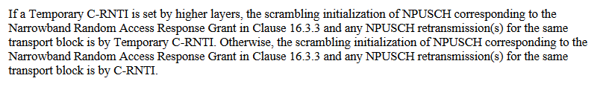  Note that the TC-RNTI is only set by higher layers if the UE initiates CBRA (36.321):  