3GPP TSG-RAN WG1 Meeting #112bis-e Tdoc R1-2304179

e-Meeting, April 17th – April 26th, 2023

Agenda Item: 7.1

Source: Moderator (Ericsson)

Title: Summary on email discussion [112bis-e-AI7.1-06] NR Rel-15/16 maintenance on TBS determination of a PUSCH retransmission

Document for: Discussion, Decision

# 1 Introduction

In RAN1#112bis-e meeting, a draft CR [1] on TBS determination is submitted. As guided by the Chairman, this contribution provides a summary to collect input from companies on this issue in phase 1 and the outcome of discussion in phase 2.

[112bis-e-AI7.1-06] NR Rel-15/16 maintenance on TBS determination of a PUSCH retransmission by April 21 – Jianwei (Ericsson)

R1-2302768 Draft CR on TBS determination of a PUSCH retransmission with initial PUSCH scheduled by RAR UL grant for CFRA Ericsson

# 2 Discussion

For contention free random access (CFRA), a MACCE UL grant can be sent in MSG2 to schedule an initial PUSCH transmission. For retransmission of this PUSCH scheduled by UL grant in MACCE, it is expected the retransmission transport block is the same as initial PUSCH. If the retransmission DCI content indicated a different transport block size, UE would consider it as an error case. Using reserved MCS values in a DCI for a PUSCH retransmission provides robustness and flexibility for retransmission schemes, it is commonly used in both NR and LTE deployment.

However, in NR using reserved MCS values for RAR UL grant retransmission is not supported. Note that similar functionality is yet supported in LTE. The spec text from 38.214 related to this functionality is quoted in Appendix A where RAR UL grant as initial transmission is not included for reserved MCS values, i.e., the MCS values with range .

1. Using reserved MCS values in a DCI for a PUSCH retransmission provides robustness and flexibility for retransmission schemes, it is commonly used in both NR and LTE deployment.
2. In RAN1 specification, using reserved MCS values for a PUSCH retransmission with initial PUSCH scheduled by RAR UL grant is not supported.

To achieve a robust CFRA performance on par with LTE, we should make it possible to use the reserved MCS values in association with the retransmission of a PUSCH with initial PUSCH scheduled by RAR UL grant for CFRA.

1. For CFRA, it is necessary to allow RAR UL grant retransmission using reserved MCS values to ensure the NR CFRA performance on par with LTE.

## 2.1 Phase 2 (by UTC 11:58pm 21 April)

After phase 1 discussion we’d like to converge on the scope of the CR. BTW, please fill in your contact info into the table that I put above the Appendix section.

Please add your company position into the table.

|  |  |
| --- | --- |
| **Option 1: CFRA only** | |
| **Support** | Ericsson, Qualcomm, Nokia, NSB |
| **Object** | CATT, Huawei, HiSilicon |
| **Option 2: CFRA + CBRA** | |
| **Support** | Ericsson, ZTE, CATT, Samsung, Huawei, HiSilicon, Qualcomm, Nokia, NSB |
| **Object** |  |

If you have strong concern on one of the options, please elaborate your view here.

|  |  |
| --- | --- |
| Company | Comments |
| CATT | The proposal is beneficial but not essential to us since the issue is for the first retransmission of PUSCH scheduled by RAR and explicit MCS can be used in this case. We are fine to apply the proposal for both CFRA and CBRA. But if it is for CFRA only, it further limits the use case and we do not see a need in that case. |
| Huawei, HiSilicon | As replied earlier, we don’t see the need to apply it CFRA only. If we go for a change, apply it for both CFRA and CBRA. |
| vivo | We still have concern regarding the NBC issue. I copy the Jianwei’s reply in the email discussion and have some comments in line.  *For CFRA, typically it is used in handover scenario. gNB knows if this UE is a legacy UE or a UE support this function. So for legacy UE, the gNB can avoid to schedule CFRA for those UEs or avoid using the reserved MCS values for retransmission.(vivo: how could gNB know this UE is a legacy UE or a UE support this function?) I agree with you if gNB doesn’t know the UE capability and using the reserved MCS values, there’s a risk what you described may happen. In my understanding a proper gNB implementation shall avoid such scenario. For CFRA I don’t think there’s NBC issue(vivo: As you say, if gNB doesn’t know the UE capability, there’s a risk. That the NBC issue, until now gNB has no solution to know whether a UE has such capability I think), for CBRA it is up to gNB to figure out what does this UE support. As far as I understand, no network implementation want to risk the initial access performance (vivo: I know that gNB wants to use the reserved MCS for retransmission to keep the same TBS as the initial transmission. It would be more flexible, but not essential. gNB can indicate other MCS index and keep the same TBS, e.g. use the same number of symbol. In addition, we think the retransmission for Msg3 PUSCH may not be very important.), so UEs shall be in good hands 😊.* |
| Xiaomi | I have the same question as vivo: How could the gNB know this UE is a legacy UE or a UE support this function? Does it mean a new UE capability signalling will be introduced? If so, we don’t support to introduce a new UE capability signalling to solve the NBC problem caused by this CR.  Besides, many companies think CFRA and CBRA should have a unified design. However, there is a NBC problem for CBRA case.  Based on above, we still have concerns on this proposed CR. |
| MTK | We support both Option 1 and Option 2. |
| Ericsson | @Xiaomi @vivo  This is a typical handover procedure for NR. UE capability is known at Source and at handover, UE information is exchanged between source gNB and Target gNB.    CFRA can be using for this UE to Switch to the New Cell. When CFRA is started, the UE sends a dedicated preamble to the Target gNB, the target gNB recognizes this UE by this dedicated preamble and knows the UE capability and release version. Therefore at the time the retransmission of the RAR UL grant happens, gNB can use the reserved MCS values if the UE support this CR. For UEs not supporting this CR, the UE may not get scheduled with CFRA for a quick handover.  On using reserved MCS values, as both ZTE and us have explained, the function is important for a real lift network. The number of symbols per slot may vary due to SRS configuration or DMRS pattern, we found for some cases few MCS values can give the TBS size of initial PUSCH, these are the number from real field implementation, and this is why we proposed this CR.  With that said, this CR fixes issue from real field implementation, it is essential for CFRA performance. Many chipset vendors and network vendors are supporting this CR, the issue is valid and need to be fixed.  @Xiaomi On UE capability signalling, we are open for the discussion, What is your concern on UE capability signalling? For CBRA the only difference is spec update, this shall not impact UE implementation. If a network uses the reserved MCS values but the UE does not support, that would be a bad network implementation. I think that shouldn’t be the reason to limit this CR to CFRA. |
| Vivo | @ Ericsson Thanks for your explaination.  Regarding the NBC issue, we don’t want to introduce a new UE capability signalling to solve the NBC problem caused by this CR, either.  In addition, we think the proposal is beneficial but not essential. If it is an issue from real field implementation and chipset vendor can accept the CR without concern on the NBC issue. We would not object the CR for the sake of progress. |

### 2.1.1 TP1 if CFRA only is supported

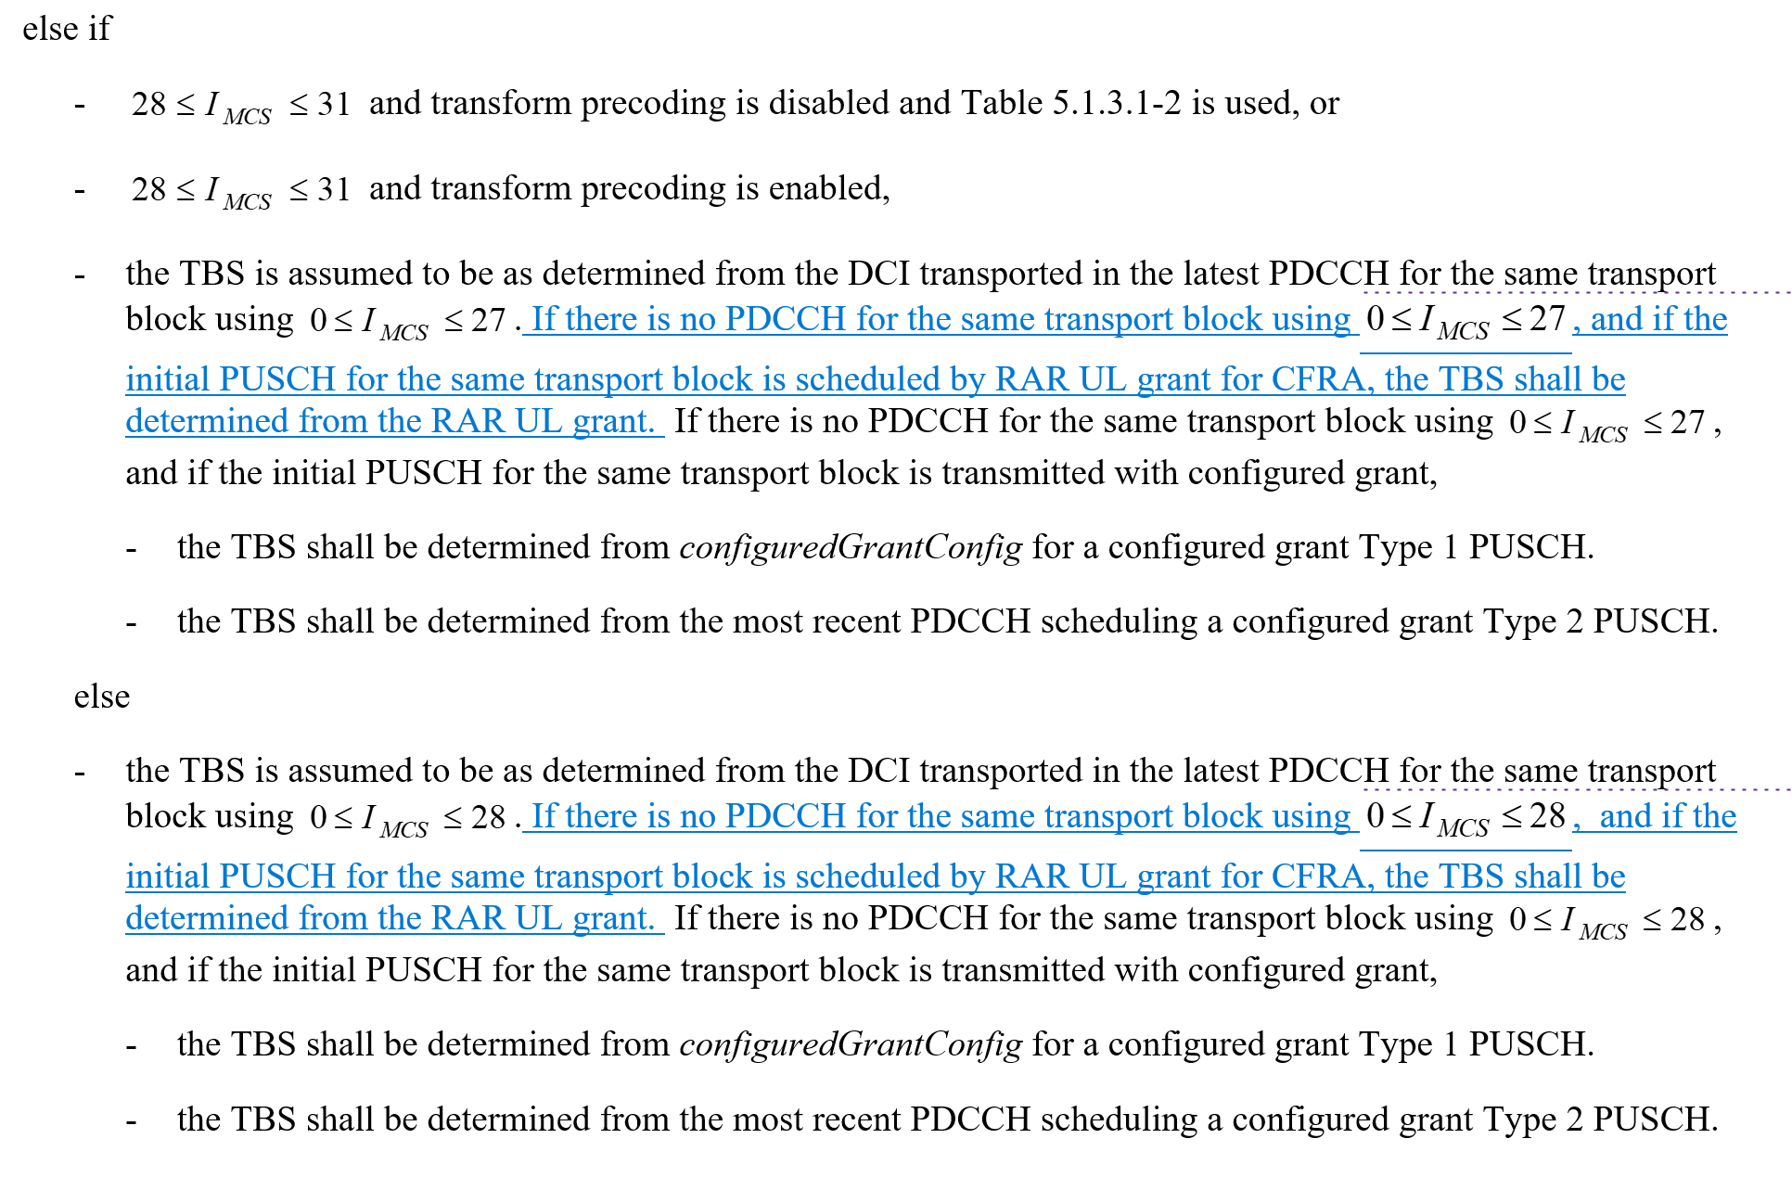

Please share your view on TP1, if any modification is needed.

|  |  |
| --- | --- |
| company | Comment on TP1 |
| ZTE | Ok with the TP if only CFRA is supported.  Just a minor editorial suggestion: ‘….for the same transport block is scheduled by a RAR UL grant for CFRA,….’ |
| Samsung | As mentioned in phase 1 discussion. This is a nice-to-have feature, we don’t see TP is necessary. |
| Qualcomm | Slightly prefer this TP. |
| vivo | Same as Samsung, this is a nice-to-have feature, we don’t see TP is necessary. What’s more, we think the NBC issue needs to be considered. |
| MTK | Fine with the TP. |
| vivo2 | If the proposal is to be adopted, we prefer to adopt it for CFRA only as it does not create problem of initial access of legacy UEs (i.e. UEs which does not implement this change)  And if it is for CFRA only, we need to introduce UE capability signalling. |

### 2.1.2 TP2 if CFRA + CBRA is supported

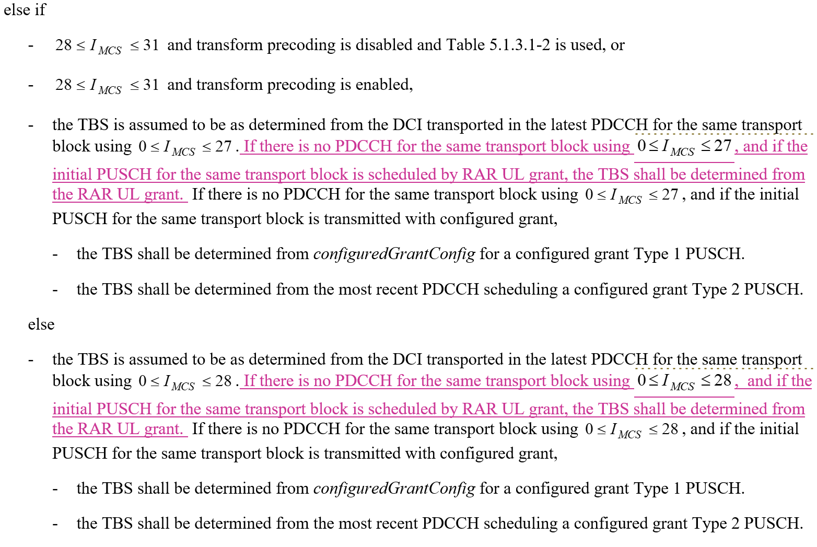

Please share your view on TP2 if any modification is needed.

|  |  |
| --- | --- |
| Company | Comments on TP2 |
| ZTE | Ok with the TP.  Just a minor editorial suggestion: ‘….for the same transport block is scheduled by a RAR UL grant for CFRA,….’ |
| Samsung | See our comment above. |
| Qualcomm | We are fine with the CR if majority wants to go this route. As we commented earlier, some legacy UEs may not follow the CR for CBRA. Therefore, the CR may not be usable for CBRA. |
| vivo | See our comment in section 2.1. |
| MTK | Fine with the TP. |
| vivo2 | We have concern to introduce this change for CBRA due to legacy UE impact, similar as Qualcomm.  During CBRA, gNB is not able to distinguish if the UE implemented the change or not and if the reserved MCS entry is indicated, the legacy UE behaviour is unpredictable, not sure if UE may terminate the initial access procedure if it see the RAR UL grant which it does not understand, and if so this becomes an serious problem. |

## 2.2 Phase 1 discussion (by UTC 4:59pm 18th April)

In phase 1 we would like to invite companies to share your view on this issue and the CR.

### 2.2.1 Do you agree with the statement of observation 1,2,3?

Using reserved MCS values in a DCI for a PUSCH retransmission provides robustness and flexibility for retransmission schemes, it is commonly used in both NR and LTE deployment.

|  |  |  |
| --- | --- | --- |
| **Company** | **Yes/No** | **Comment** |
| Ericsson | Yes |  |
| CATT |  | We agree using reserved MCS values provides flexibility but it is not clear to us why using reserved MCS values provides robustness. |
| Xiaomi | Yes |  |
| MTK | Yes |  |
| vivo |  | Same question as CATT. |
| ZTE | Yes | It is difficult to make sure the TBS of re-transmission the same as initial transmission if reserved MCS values are not used, especially for the case when the PUSCH payload size is large or different number of symbols are used for re-transmission due to different SRS transmissions in different slots. So, it improves not only the flexibility but also the robustness by allowing scheduling of a re-transmission for all cases.  This is a common issue for both CFRA and CBRA. |
| Ericsson |  | @CATT, @vivo: Thanks for the question. In our understanding the robustness means gNB and UE can follow the TBS determination using reserved MCS values, in some sense the simplicity in signalling for both gNB and UE provides robustness. |
| Qualcomm | Yes |  |
| Samsung | Yes |  |
| Huawei, HiSilicon | Yes |  |
| Nokia, NSB | Irrelevant | The point of this question is not clear.  The DCI must have the MCS field set to some value. Whether it is set to a value indicating an MCS or a reserved MCS is just as robust. Whether or not it is commonly used in LTE and NR is also not something we need to discuss or agree to. |
| Intel | Yes | Share similar view as ZTE |
|  |  |  |

In RAN1 specification, using reserved MCS values for a PUSCH retransmission with initial PUSCH scheduled by RAR UL grant is not supported.

|  |  |  |
| --- | --- | --- |
| **Company** | **Agree/Disagree** | **Comment** |
| Ericsson | Agree |  |
| CATT |  | It is only true for the first retransmission. For subsequent retransmission(s), reserved MCS values can be used because the first retransmission is scheduled by PDCCH. |
| Xiaomi |  | For Rel-17 PUSCH repetition type A for Msg3 of CBRA, the 2 MSBs MCS field in the DCI is also used for PUSCH retransmission with initial scheduled by UL RAR grant, as specified in Clause 8.3 of TS38.213, “ If the UE requests repetitions for the PUSCH transmission [11, TS 38.321], the UE transmits the PUSCH over $N_{\text{PUSCH}}^{\text{repeat}}$ slots, where $N_{\text{PUSCH}}^{\text{repeat}}$ is indicated by the 2 MSBs of the MCS field in the RAR UL grant or in the DCI format 0_0 from a set of four values provided by *numberOfMsg3-RepetitionsList* or from {1, 2, 3, 4} if *numberOfMsg3-RepetitionsList* is not provided”. So, MCS values with range  can’t be obtained in this case. That is, the reserved MCS value can’t be used for an Msg3 PUSCH retransmission with initial PUSCH scheduled by RAR UL grant to provide robustness and flexibility for retransmission schemes.  Of course, the Rel-17 Msg3 repetitions mechanism is not applicable for CFRA PUSCH. But, CFRA PUSCH also suffers a coverage limitation as Msg3 PUSCH and maybe coverage enhancement is needed in future release by using the similar mechanism as Rel-17 Msg3 repetitions. So, we are not fine with this CR.  Besides, for the TBS determination, we think Msg3 PUSCH and CFRA PUSCH share the similar situation, It is confused for us why this CR only focuses on CFRA case. |
| MTK | Agree | Without this proposed CR, the reserved MCS values () for a PUSCH retransmission with initial PUSCH scheduled by RAR UL grant seems not supported according to the quoted spec in Appendix A.  We can also support to include the CBRA case if companies think so. |
| vivo |  | Agree with CATT. |
| ZTE | Agree |  |
| Ericsson |  | @Xiaomi  Thanks for sharing the information on Rel-17 Msg3 repetition. I understand your concern if Msg3 repetition is configured, there’s no MCS value range . In our understanding this CR shall not get applied if Msg3 repetition is configured, because the actual MCS range is 3 bits. Please feel free to address your further comments if you still have concern.  I understand your confusion that we only focus on CFRA, the intension was make the discussion simpler. |
| Qualcomm | Agree |  |
| Samsung | - | Agree with CATT |
| Huawei, HiSilicon | Agree |  |
| Xiaomi |  | @Ericsson, Thank you for your clarification. We think it is better that CFRA and CBRA, as well as Msg3 repetition enabling and Msg3 repetition disabling have a unified design for TBS determination. |
| Nokia, NSB | Agree | Agree (for the 1st retransmission attempt as pointed out by CATT), the specification omits this case, most likely because the MSG3 case was simply not thought of at the time. |
| Intel |  | Agree with CATT that it is only for retransmission of initial transmission. |

For CFRA, it is necessary to allow RAR UL grant retransmission using reserved MCS values to ensure the NR CFRA performance on par with LTE.

|  |  |  |
| --- | --- | --- |
| **Company** | **Yes/No** | **Comment** |
| Ericsson | Yes |  |
| CATT |  | Similar as above comments to observation 1, it is not clear to us why using reserved MCS values improves performance. In addition, it is not clear to us why it is specific to CFRA. We think common solution should be applied to both CBRA and CFRA. |
| Xiaomi |  | Similar as above comments to observation 2 |
| MTK | Yes | We see no reason why RAR UL grant retransmission using reserved MCS values should not be allowed. |
| vivo |  | The reason to have such observation is not clear to us. |
| ZTE | Yes | We support for both CBRA and CFRA, as the reasons we commented in Q1. |
| Qualcomm | Yes |  |
| Samsung |  | This seem to be a nice-to-have feature.  We understand the motivation of the draft CR, but it provides flexibility only for the first retransmission. The performance gain is unclear to us. Without adopting the draft CR, we cannot see any system broken. |
| Huawei, HiSilicon | Yes |  |
| Nokia, NSB | No | The point of this assertion is not clear, and as ithappens, the formulation is more than a bit loaded, making it difficult to agree with.  No, it is not necessary, and it is hard to see what the delta in performance is or even where the performance difference would originate from.  That said, we would be OK to introducing this both for CBRA and CFRA as in our understanding it should have been there in Rel-15 already. |
| Intel | Yes |  |
|  |  |  |
|  |  |  |
|  |  |  |

### 2.2.2 View on the draft CR

In [1], a TP is provided to allow CFRA RAR UL grant retransmission using reserved MCS values as below.



Please provide your view on this draft CR:

|  |  |
| --- | --- |
| **Company** | **Comment** |
| CATT | We think it is beneficial to support reserved MCS for the first retransmission of PUSCH scheduled by RAR from gNB scheduling flexibility perspective and we think if allowed, it should be applicable to both CBRA and CFRA. So we are open to discuss relaxation of the scheduling restriction.  On the other hand, considering that gNB can use explicit MCS values to indicate the same TBS and the restriction is only applied to the first retransmissions, we are also fine to keep the spec as it is and leave it to gNB implementation. |
| Xiaomi | Similar as above comments to observation 2 |
| MTK | We support the draft CR, according to the discussions we have in 2.1.1. |
| vivo | Agree with CATT that gNB can use explicit MCS values to indicate the same TBS. In addition, the change for Rel-16 at this stage may be not backward compatible. |
| ZTE | Support |
| Ericsson | @vivo  We don’t see NBC issue. If network uses those MCS values but UE may interpret to a different behaviour according to the legacy implementation, that is NBC. For this CR we don’t see this would happen. |
| Qualcomm | Support |
| Samsung | See our comment above. This is a nice-to-have feature. |
| Huawei, HiSilicon | The CR clarifies a missing case in the current spec, which typically will be seen as NBC. However, we can be open to this particular case assuming the proposed change can be applied to CBRA as well. We don't see the reason to apply it to CFRA only. |
| Nokia, NSB | Similar view as Huawei, this is fixing a missing case that should have been there to begin with. We’d be OK with the CR as it is, or extending it to CBRA as well. |
| Intel | Support. |
|  |  |
|  |  |
|  |  |

### 2.2.3 Comment(s) on CBRA (Optional)

There’s a desire to apply the reserved MCS values also for CBRA, i.e., MSG3 retransmission and avoid separate handing of retransmission initiated by RAR grant. Please share your view on CBRA here, especially if you have concern to support using reserved MCS values also for CBRA.

|  |  |
| --- | --- |
| **Company** | **Comment(s)** |
| Ericsson | Our major interest is on CFRA. We would be happy to support this retransmission also for CBRA.  From gNB implementation perspective there’s no impact if this retransmission behaviour is supported only for CFRA or both CBRA and CFRA, as it is up to gNB to decide whether to use reserved MCS values in retransmission associated with CBRA.  In our understanding, by just removing the “for CFRA” from the proposed TP in the CR, we could support this retransmission behaviour for both CBRA and CFRA. |
| CATT | See our comments above. |
| Xiaomi | See our comments above |
| MTK | We support both CFRA and CBRA (similar view as mentioned in the first row by Ericsson). |
| vivo | We think the issue is similar for CBRA and CFRA. |
| ZTE | Support. This could also align gNB’s scheduling for all PUSCHs scheduled by UL RAR grants, regardless of CBRA or CFRA. |
| Qualcomm | The proposal works well for CFRA.  For CBRA, the CR may not be useful since the gNB does not know whether a UE is a legacy UE or new UE with the proposed CR. |
| Samsung | We prefer a common solution for CBRA and CFRA, if possible. |
| Huawei, HiSilicon | We would like to apply the CR for both CFRA and CBRA. Otherwise, we are fine to keep the current spec as it is. |
| Nokia, NSB | Would be fine with CFRA only, although have a slight preference to extend to CBRA as well. It is true, though that with CBRA there is a risk that the behaviour is not supported by some UEs and thus it might not be possible to use it for CBRA. |
| Intel | We prefer to only keep for CFRA for now. For CBRA, the issue raised by Xiaomi for Msg3 repetition may need further discussions. |
|  |  |
|  |  |
|  |  |

### 2.2.4 Additional comment(s) if any:

Please address your additional comments and input here.

|  |  |
| --- | --- |
| **Company** | **Comment(s)** |
|  |  |
|  |  |
|  |  |
|  |  |
|  |  |
|  |  |
|  |  |
|  |  |
|  |  |
|  |  |
|  |  |
|  |  |
|  |  |

## 2.3 Outcome of phase 1 discussion

Summary on 2.2.1:

All companies confirmed the observations that using the reserved MCS values for the first retransmission of RAR UL grant is not supported in NR specification. On the necessity to support this for NR, the view is split between the companies. Companies may have different understanding of use case scenarios.

Summary on 2.2.2:

Most of the companies are supporting this CR for CFRA.

Summary on 2.2.3:

Most of the companies are supporting the CR for both CFRA and CBRA.

Summary on 2.2.4:

NA

# 3 Outcome of the CR discussion

**Agreement**

Text proposal on TBS determination of a PUSCH retransmission with initial PUSCH scheduled by RAR UL grant is agreed. Final CRs in R1-230XXXX (Rel-16, 38.214, Cat F) and R1-230XXXX (Rel-17, 38.214, Cat A).

CR0421 Rel-16

|  |  |
| --- | --- |
| R1-2304228 | CR on TBS determination of a PUSCH retransmission with initial PUSCH scheduled by RAR UL grant |

CR0422 Rel-17

|  |  |
| --- | --- |
| R1-2304229 | CR on TBS determination of a PUSCH retransmission with initial PUSCH scheduled by RAR UL grant |

Proposal:

For TBS determination of a PUSCH retransmission with initial PUSCH scheduled by a RAR UL grant:

·       support using reserved MCS values  for both CFRA and CBRA.

·       The following text proposal is endorsed for release 16 CR for TR38.214:

·        Note:  It is current RAN1 understanding the chipset implementations may have been already aligned with this proposed CR

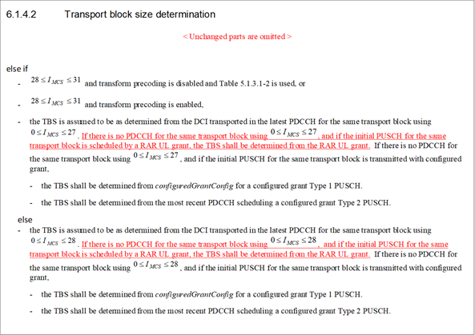

# References

1. R1-2302768 Draft CR on TBS determination of a PUSCH retransmission with initial PUSCH scheduled by RAR UL grant for CFRA, Ericsson, RAN1#112bis-e
2. 38.214, 16.13.0

# Contact info

|  |  |  |
| --- | --- | --- |
| Company name | Delegate name | Email address |
| Ericsson | Jianwei Zhang | jianwei.zhang@ericsson.com |
| ZTE | Xianghui Han | han.xianghui@zte.com.cn |
| CATT | Yanping Xing | xingyanping@catt.cn |
| Xiaomi | Xuemei Qiao | qiaoxuemei@xiaomi.com |
|  |  |  |
|  |  |  |
|  |  |  |
|  |  |  |
|  |  |  |
|  |  |  |

# Appendix A. TS 38.214 6.1.4.2

#### 6.1.4.2 Transport block size determination

For a PUSCH scheduled by RAR UL grant or

for a PUSCH scheduled by fallbackRAR UL grant or

for a PUSCH scheduled by a DCI format 0_0 with CRC scrambled by C-RNTI, MCS-C-RNTI, TC-RNTI, CS-RNTI, or

for a PUSCH scheduled by a DCI format 0_1 or DCI format 0_2 with CRC scrambled by C-RNTI, MCS-C-RNTI, CS-RNTI, or

for a PUSCH transmission with configured grant, or

for a MsgA PUSCH transmission,

if

- and transform precoding is disabled and Table 5.1.3.1-2 is used, or

-  and transform precoding is disabled and a table other than Table 5.1.3.1-2 is used, or

-  and transform precoding is enabled, the UE shall first determine the TBS as specified below:

1. The UE shall first determine the number of REs (*NRE*) within the slot:

- A UE first determines the number of REs allocated for PUSCH within a PRB  by

- , where is the number of subcarriers in the frequency domain in a physical resource block, $N_{symb}^{slot}$ is the number of symbols *L* of the PUSCH allocation according to Clause 6.1.2.1 for scheduled PUSCH or Clause 6.1.2.3 for configured PUSCH,  is the number of REs for DM-RS per PRB in the allocated duration including the overhead of the DM-RS CDM groups without data, as described for PUSCH with a configured grant in Clause 6.1.2.3 or as indicated by DCI format 0_1 or DCI format 0_2 or as described for DCI format 0_0 in Clause 6.2.2, and  is the overhead configured by higher layer parameter *xOverhead* in *PUSCH-ServingCellConfig*. If the  is not configured (a value from 6, 12, or 18), the  is assumed to be 0. For Msg3 or MsgA PUSCH transmission the  is always set to 0. In case of PUSCH repetition Type B,  is determined assuming a nominal repetition with the duration of *L* symbols without segmentation.

- A UE determines the total number of REs allocated for PUSCH  by where  is the total number of allocated PRBs for the UE.

- Next, proceed with steps 2-4 as defined in Clause 5.1.3.2

- For a PUSCH scheduled by fallbackRAR UL grant, UE assumes the TB size determined by the UL grant in the fallbackRAR shall be the same as the TB size used in the corresponding MsgA PUSCH transmission.

else if

-  and transform precoding is disabled and Table 5.1.3.1-2 is used, or

-  and transform precoding is enabled,

- the TBS is assumed to be as determined from the DCI transported in the latest PDCCH for the same transport block using .If there is no PDCCH for the same transport block using , and if the initial PUSCH for the same transport block is transmitted with configured grant,

- the TBS shall be determined from *configuredGrantConfig* for a configured grant Type 1 PUSCH.

- the TBS shall be determined from the most recent PDCCH scheduling a configured grant Type 2 PUSCH.

else

- the TBS is assumed to be as determined from the DCI transported in the latest PDCCH for the same transport block using . If there is no PDCCH for the same transport block using , and if the initial PUSCH for the same transport block is transmitted with configured grant,

- the TBS shall be determined from *configuredGrantConfig* for a configured grant Type 1 PUSCH.

- the TBS shall be determined from the most recent PDCCH scheduling a configured grant Type 2 PUSCH.