3GPP TSG RAN WG1 #104-e R1-20xxxxx
e-Meeting, January 25th – February 5th, 2021

Agenda Item: 7.2.11
Source: Moderator (AT&T)
Title: Summary of email discussion/approval [104-e-NR-UEFeatures-eMIMO-01]
Document for: Discussion/Decision

Introduction
This document presents the summary of email discussion/approval [104-e-NR-UEFeatures-eMIMO-01] during RAN1 #104-e. According to the Chairman’s Notes:
[104-e-NR-UEFeatures-eMIMO-01] Email discussion/approval of whether/how to address that UEs that support multi-DCI multi-TRP are not mandated to support PDSCH retransmission scheduled by different TRP, till 1/29 (Ralf, AT&T)
The following was discussed and agreed during RAN1 #104-e within the scope of [104-e-NR-UEFeatures-eMIMO-01]. All proposals are based on the latest RAN1 UE features list for Rel-16 NR in Error: Reference source not found.

Summary of email discussion/approval [104-e-NR-UEFeatures-eMIMO-01]
In [2], Apple observes the following:

For multi-DCI multi-TRP operation, one of the most feasible UE implementation is to use CA architecture to support multi-DCI multi-TRP, i.e., PDSCH reception of each TRP is handled by independent CC. Current multi-DCI multi-TRP design allows the HARQ retransmission to be scheduled by a different TRP, i.e., CORESETPoolIndex. In NR CA, there is no requirement, or the gNB is not allowed to schedule HARQ reception in one CC that is a retransmission of the HARQ process in another CC. In other words, in the current NR-CA operation/implementation, UE is not expected to combine HARQ processes from two different CCs to decode a TB. Figure below further illustrates the problem
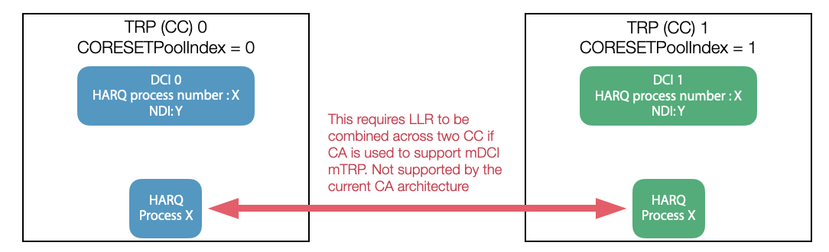
As an example illustrated in Figure 1, for HARQ process X, initially TRP0 (CORESETPoolIndex = 0) schedules a new transmission. Later, for the same HARQ process X, TRP1 (CORESETPoolIndex = 1) schedules a retransmission by indicating the same HARQ process ID and the same NDI. When UE uses CA architecture to support multi-DCI multi-TRP, this requires UE to obtain the LLR buffer from TRP0 (CC0) to be used for combining for the PDSCH processing in TRP1 (CC1) which is never required in the current CA design. This can put unnecessary complexity on the UE implementation especially considering the amount of LLR buffer needed to be exchanged between different CCs at high data rate.

Based on the above explanation, it is important that, at least for some UE that is capable of multi-DCI multi-TRP, we do not mandate UE to support HARQ retransmission scheduled by different TRP.

Apple in [2] also provides possible solutions, namely,
- Reuse existing UE capability
- Modifying the specification
- Introduce a new UE capability
16-2a-8 | Support PDSCH HARQ retransmission scheduled by a different TRP (CORESETPoolIndex) for multi-DCI multi-TRP | For multi-DCI multi-TRP operation, UE supports the PDSCH HARQ retransmission scheduled by a different TRP, i.e., for the same HARQ process ID, DCI from a different CORESETPoolIndex schedules the PDSCH retransmission, i.e., NDI not flipped. | 16-2a | Yes | N/A |  | Per UE | N/A | N/A | N/A |  | Optional with capability signalling

The following is proposed in [2].

Proposal: At least, for some UEs that support multi-DCI multi-TRP, those UEs are not mandated to support PDSCH retransmission scheduled by different TRP.

Companies are invited to express their views in the table below. Specifically, companies should answer whether they agree with the proposal and if so, how to implement the proposal. Regardless the solution, companies shall provide a detailed text proposal, e.g., for a specification change, a change of an existing feature group, or a possible new feature group.

Company | Comments/Questions/Suggestions
Apple | We support the proposal.  We are flexible with the solution. A cleaner solution is to introduce a new UE FG to address this issue as proposed below  With the new FG, there will be no RAN1 specification change, the change will be in 38.306 and 38.331 due to the introduction of a new FG
  16-2a-8 | Support PDSCH HARQ retransmission scheduled by a different TRP (CORESETPoolIndex) for multi-DCI multi-TRP | For multi-DCI multi-TRP operation, UE supports the PDSCH HARQ retransmission scheduled by a different TRP, i.e., for the same HARQ process ID, DCI from a different CORESETPoolIndex schedules the PDSCH retransmission, i.e., NDI not flipped. | 16-2a | Yes | N/A |  | Per UE | N/A | N/A | N/A |  | Optional with capability signalling

Conclusion
…

References
- R1-2009585, Updated RAN1 UE features list for Rel-16 NR, Moderators (AT&T, NTT DOCOMO, INC.)
- R1-2101342, Discussions on NR Rel-16 UE features, Apple

