3GPP TSG RAN WG1 #104-e R1-210xxxx

e-Meeting, January 25th – February 5th, 2021

**Agenda item:** 7.1

**Source:** Moderator (Qualcomm Incorporated)

**Title:** [104-e-NR-7.1CRs-13]

**Document for:** Discussion and Decision

# Background

In R1-2101432, it is proposed to define timelines for SRS carrier switching. The contribution highlights that, for priority rules related to SRS carrier switching, there are no timelines specified. For example, in the case of collision between PUCCH with HARQ-ACK and SRS, the following timeline is missing:

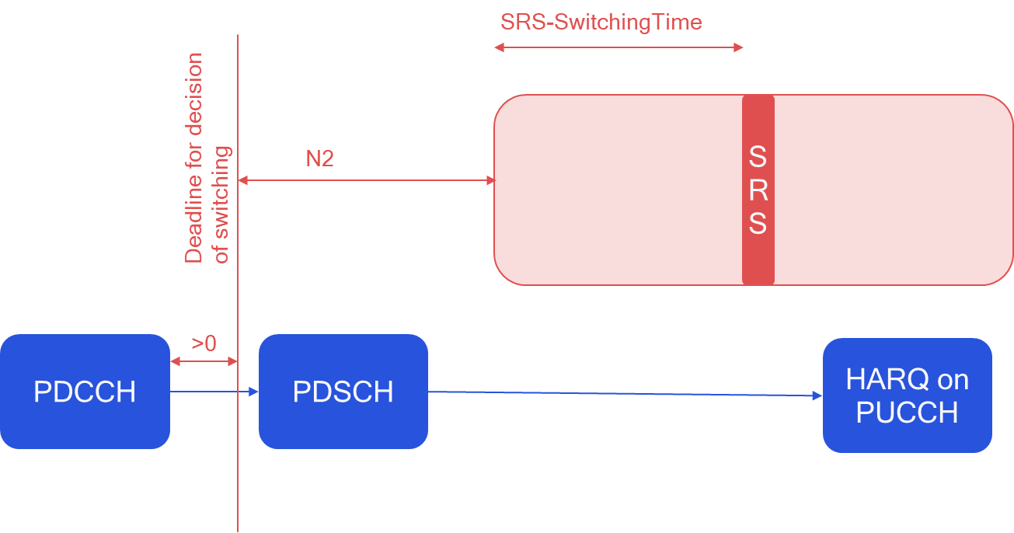

To solve this issue, the following text proposal is provided:

**<TP1, 38.214>**

6.2.1.3 UE sounding procedure between component carriers

For an SRS transmission starting in symbol of a carrier with slot formats comprised of DL and UL symbols, not configured for PUSCH/PUCCH transmission, and with carrier the UE is configured to switch from according to higher layer parameters *srs-SwitchFromServCellIndex* and *srs-SwitchFromCarrier*, for a conflicting transmission in starting in symbol the UE shall apply the rules in the remaining of this subclause based on:

* DCI(s) for which the time interval between the last symbol of PDCCH and is at leastsymbols and an additional time duration , and the time interval between the last symbol of PDCCH and is at least symbols*;* and
* semi-persistent CSI reports or SRS for which the HARQ-ACK information on PUCCH in response to the activation command would be transmitted in slot , and being the first symbol of the first slot which is after slot , and the time interval between and is at least symbols and an additional time duration , and the time interval between and is at least symbols, where is the SCS configuration of the PUCCH.

where , and the time interval unit of OFDM symbol is counted based on the minimum subcarrier spacing given by , with the SCS configuration for the PDCCH carrying the triggering commands for the SRS in , the SCS configuration for SRS in , the SCS configuration for the PDCCH that schedules PUSCH in , and the SCS configuration for the PUSCH in .

For a carrier of a serving cell with slot formats comprised of DL and UL symbols, not configured for PUSCH/PUCCH transmission, the UE shall not transmit SRS whenever SRS transmission (including any interruption due to uplink or downlink RF retuning time [11, TS 38.133] as defined by higher layer parameters *switchingTimeUL* and *switchingTimeDL* of *srs-SwitchingTimeNR)* on the carrier of the serving cell and PUSCH/PUCCH transmission carrying HARQ-ACK/positive SR/RI/CRI and/or PRACH happen to overlap in the same symbol and that can result in uplink transmissions beyond the UE's indicated uplink carrier aggregation capability included in [13, TS 38.306].

For a carrier of a serving cell with slot formats comprised of DL and UL symbols, not configured for PUSCH/PUCCH transmission, the UE shall not transmit a periodic/semi-persistent SRS whenever periodic/semi-persistent SRS transmission (including any interruption due to uplink or downlink RF retuning time [11, TS 38.133] as defined by higher layer parameters *switchingTimeUL* and *switchingTimeDL* of *srs-SwitchingTimeNR)* on the carrier of the serving cell and PUSCH transmission carrying aperiodic CSI happen to overlap in the same symbol and that can result in uplink transmissions beyond the UE's indicated uplink carrier aggregation capability included in [13, TS 38.306].

For a carrier of a serving cell with slot formats comprised of DL and UL symbols, not configured for PUSCH/PUCCH transmission, the UE shall drop PUCCH/PUSCH transmission carrying periodic CSI comprising only CQI/PMI, and/or SRS transmission on another serving cell configured for PUSCH/PUCCH transmission whenever the transmission and SRS transmission (including any interruption due to uplink or downlink RF retuning time [11, TS 38.133] as defined by higher layer parameters *switchingTimeUL* and *switchingTimeDL* of *srs-SwitchingTimeNR)* on the serving cell happen to overlap in the same symbol and that can result in uplink transmissions beyond the UE's indicated uplink carrier aggregation capability included in [13, TS 38.306].

For a carrier of a serving cell with slot formats comprised of DL and UL symbols, not configured for PUSCH/PUCCH transmission, the UE shall drop PUSCH transmission carrying aperiodic CSI comprising only CQI/PMI whenever the transmission and aperiodic SRS transmission (including any interruption due to uplink or downlink RF retuning time [11, TS 38.133]) as defined by higher layer parameters *switchingTimeUL* and *switchingTimeDL* of *srs-SwitchingTimeNR)* on the carrier of the serving cell happen to overlap in the same symbol and that can result in uplink transmissions beyond the UE's indicated uplink carrier aggregation capability included in [13, TS 38.306].

For an aperiodic SRS triggered in DCI format 2_3 and if the UE is configured with higher layer parameter *srs-TPC-PDCCH-Group* set to 'typeA', and given by *SRS-CarrierSwitching,* without PUSCH/PUCCH transmission, the order of the triggered SRS transmission on the serving cells follow the order of the serving cells in the indicated set of serving cells configured by higher layers, where the UE in each serving cell transmits the configured one or two SRS resource set(s) with higher layer parameter *usage* set to 'antennaSwitching' and higher layer parameter *resourceType* in *SRS-ResourceSet* set to 'aperiodic'.

For an aperiodic SRS triggered in DCI format 2_3 and if the UE is configured with higher layer parameter *srs-TPC-PDCCH-Group* set to 'typeB' without PUSCH/PUCCH transmission, the order of the triggered SRS transmission on the serving cells follow the order of the serving cells with aperiodic SRS triggered in the DCI, and the UE in each serving cell transmits the configured one or two SRS resource set(s) with higher layer parameter *usage* set to 'antennaSwitching' and higher layer parameter *resourceType* in *SRS-ResourceSet* set to 'aperiodic'.

A UE can be configured with SRS resource(s) on a carrier *c1* with slot formats comprised of DL and UL symbols and not configured for PUSCH/PUCCH transmission. For carrier *c1*, the UE is configured with higher layer parameter *srs-SwitchFromServCellIndex* and *srs-SwitchFromCarrier* the switching from carrier *c2* which is configured for PUSCH/PUCCH transmission. During SRS transmission on carrier *c1* (including any interruption due to uplink or downlink RF retuning time [11, TS 38.133] as defined by higher layer parameters *switchingTimeUL* and *switchingTimeDL* of *srs-SwitchingTimeNR*), the UE temporarily suspends the uplink transmission on carrier *c2*.

If the UE is not configured for PUSCH/PUCCH transmission on carrier *c1* with slot formats comprised of DL and UL symbols, and if the UE is not capable of simultaneous reception and transmission on carrier *c1*and serving cell *c2*, the UE is not expected to be configured or indicated with SRS resource(s) such that SRS transmission on carrier *c1* (including any interruption due to uplink or downlink RF retuning time [11, TS 38.133] as defined by higher layer parameters *switchingTimeUL* and *switchingTimeDL* of *srs-SwitchingTimeNR*) would collide with the REs corresponding to the SS/PBCH blocks configured for the UE or the slots belonging to a control resource set indicated by *MIB* or *SIB1* on serving cell *c2*.

**</TP1>**

In the following, we try to collect views from companies on the following two questions: whether the change is needed (and if not, what is the UE behavior), and any comments on the provided TP:

# Discussion

**Q1: Do you agree that the timelines for SRS carrier switching dropping rules are not specified and, therefore, a correction is needed?**

* **If you do not agree, please provide a spec reference / justification on what is the UE behavior.**

|  |  |  |
| --- | --- | --- |
| Company name | Answer (Yes/no) | If the answer is no, please provide reference / justification |
| Qualcomm | Yes |  |
| Ericsson | Yes, although it is not clear that the feature is broken without a fix. |  |
| Samsung | No | We think that this CR is not essential in Rel-15. This problematic issue can be avoided by gNB implementation. |
| Nokia | OK to have an update | As long as the specification update is such that all existing UEs are compliant with the CR |
| HW | Partially Yes | We think that this CR is NBC in Rel1-15 so that gNB can avoid that by longer gap. If it is needed, we are open to address this in Rel-16 TEI. With possible different SCS, proposed spec may not be straightforward. |
| FUTUREWEI | Yes | This can be largely solved by gNB implementation though may be with some drawback and have to be conservative. To address this issue with newly introduced UE behavior (clearly UE timeline) and UE capability (for example for N_2) will cause NCB issue. Therefore, we think this is an enhancement, a valid and useful one. |
| OPPO | Yes |  |
| ZTE | Yes | But we think it can be an error case if the timeline issue happens. So gNB can avoid this situation by implementation. |

**Q1: • Do you have any comments on the provided TP in 2101432?**

|  |  |
| --- | --- |
| Company name | Comments on TP |
| Ericsson | To be honest, I’m having trouble parsing the TP. Some initial questions for my understanding:   * Are the conflicting transmissions in response to the DCI(s)? If so, where is this stated? * Does ‘at least N_2 symbols and an additional time duration T_SRS_CS’ mean ‘N_2 + T_SRS_CS’? * When does either one or the other of the DCIs related to Nc1 and Nc2 apply in the remainder of the subclause? |
| Nokia | Have some difficulties with the TP as well  What type of carrier does this refer to, a TDD carrier only, or is this meant to rule out SUL and SDL? a carrier with slot formats comprised of DL and UL symbols  What is a conflicting transmission? I suppose the intention is to say something like “for an uplink transmission in carrier C2 starting in symbol Nc2 that is to overlap with the SRS transmission, the…”?  What is done if the rules are not satisfied? |
| FUTUREWEI | We prefer to treat this as a TEI and investigate a good approach to amend the spec. |
| OPPO | Understanding the intention of this TP. However, the TP seems not touching the case where different CCs are with different numerologies. |
| ZTE | Prefer to get a conclusion, such as UE does not expect .... |

# Discussion (Phase 2)

Given the outcome of phase 1, a majority of companies are supportive of correcting this issue in Rel-16.

In the following, we try to explain the different parts of the TP, trying to answer the questions raised during the first phase.

|  |  |
| --- | --- |
| For an SRS transmission starting in symbol of a carrier with slot formats comprised of DL and UL symbols, not configured for PUSCH/PUCCH transmission, and with carrier the UE is configured to switch from according to higher layer parameters *srs-SwitchFromServCellIndex* and *srs-SwitchFromCarrier*, for a conflicting transmission in starting in symbol the UE shall apply the rules in the remaining of this subclause based on: | This part just means a TDD carrier without uplink (the same term is used in every paragraph of 6.2.1.3).  This part means the source CC (i.e., the carrier that is interrupted). The same text is also used in 6.2.1.3.  This is just to define the time instants that will be reference in the rest of the change.  This means that, the rules that are in the previous 6.2.1.3 are applied only taking into account the information known by a given deadline. If some additional information is received not meeting the deadline, the UE behavior is not specified.  (I copied the rest of the section into Section 1, for completeness) |
| * DCI(s) for which the time interval between the last symbol of PDCCH and is at leastsymbols and an additional time duration , and the time interval between the last symbol of PDCCH and is at least symbols*;* and | This means that we only take into account DCIs that arrive N2 + T_SRS before the SRS transmission. E.g., in the following figure, the DCI has to arrive before the deadline:    This means that we only take into account DCIs that arrive N2 before the other channel. I.e., in the following example, the DCI scheduling the SRS (HP in this case) has to arrive N2 before the PUSCH: |
| * semi-persistent CSI reports or SRS for which the HARQ-ACK information on PUCCH in response to the activation command would be transmitted in slot , and being the first symbol of the first slot which is after slot , and the time interval between and is at least symbols and an additional time duration , and the time interval between and is at least symbols, where is the SCS configuration of the PUCCH. | This part is just to define that N_slot is the instant where the SPS is activated.  This text is the same as in the previous row, just changing “last symbol of PDCCH” with the activation instant for SP-CSI or SP-SRS.  (essentially, this bullet says that you only take into account SP-CSI and SP-SRS that are activated N2 / N2 + T_switch before the transmission) |
| where , and the time interval unit of OFDM symbol is counted based on the minimum subcarrier spacing given by , with the SCS configuration for the PDCCH carrying the triggering commands for the SRS in , the SCS configuration for SRS in , the SCS configuration for the PDCCH that schedules PUSCH in , and the SCS configuration for the PUSCH in . | This defines the interruption time based on RRC parameters  This intends to cover the cross-carrier scheduling and different numerology cases. A total of 4 carriers may be involved: the source and target cells, plus the corresponding scheduling cells. The worst case numerology is considered among the four of them. |

So, in summary, the proposal is to have introduce a timeline of N2 / N2 + SRSSwitchingTime.

**Q2.1: • Comments about the TP?**

|  |  |
| --- | --- |
| Company name | Comments on TP |
|  |  |
|  |  |
|  |  |
|  |  |
|  |  |

# Conclusion