3GPP TSG RAN WG1 #104-e R1-210xxxx

e-Meeting, January 25th – February 5th, 2021

**Agenda item:** 7.1

**Source:** Moderator (Qualcomm Incorporated)

**Title:** [104-e-NR-7.1CRs-13]

**Document for:** Discussion and Decision

# Background

In R1-2101432, it is proposed to define timelines for SRS carrier switching. The contribution highlights that, for priority rules related to SRS carrier switching, there are no timelines specified. For example, in the case of collision between PUCCH with HARQ-ACK and SRS, the following timeline is missing:

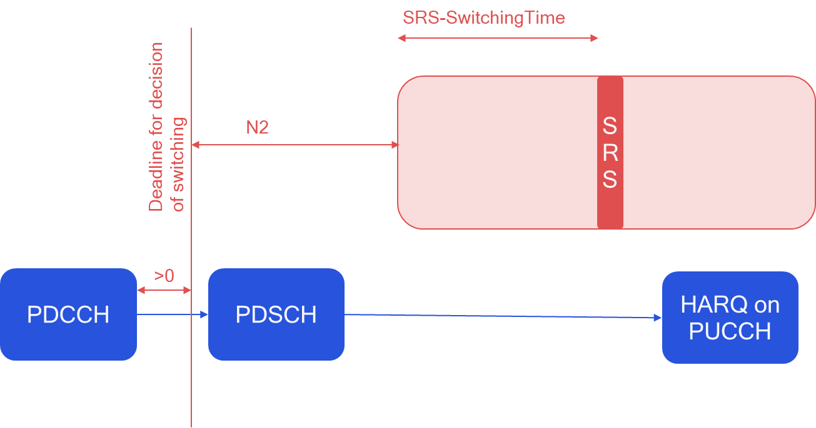

To solve this issue, the following text proposal is provided:

**<TP1, 38.214>**

6.2.1.3 UE sounding procedure between component carriers

For an SRS transmission starting in symbol $N_{c_{1}}$ of a carrier $c_{1}$ with slot formats comprised of DL and UL symbols, not configured for PUSCH/PUCCH transmission, and with $c_{2}$ carrier the UE is configured to switch from according to higher layer parameters *srs-SwitchFromServCellIndex* and *srs-SwitchFromCarrier*, for a conflicting transmission in $c_{2}$ starting in symbol $N_{c_{2}}$ the UE shall apply the rules in the remaining of this subclause based on:

* DCI(s) for which the time interval between the last symbol of PDCCH and $N_{c_{1}}$ is at least ${ N}_{2}$ symbols and an additional time duration $T_{SRS_{CS}}$, and the time interval between the last symbol of PDCCH and $N_{c_{2}}$ is at least ${ N}_{2}$ symbols*;* and
* semi-persistent CSI reports or SRS for which the HARQ-ACK information on PUCCH in response to the activation command would be transmitted in slot $n$, and $N_{slot}$ being the first symbol of the first slot which is after slot $n+3N_{slot}^{subframe,μ}$, and the time interval between $N_{slot}$ and $N_{c_{1}}$ is at least $N_{2}$ symbols and an additional time duration $T_{SRS_{CS}}$, and the time interval between $N_{slot}$ and $N_{c_{2}}$ is at least $N_{2}$ symbols, where $μ$ is the SCS configuration of the PUCCH.

where $T_{SRS_{CS}}=max⁡\{switchingTimeUL,switchingTimeDL\}$, and the time interval unit of OFDM symbol is counted based on the minimum subcarrier spacing given by $min⁡\{μ_{PDCCH,c_{1},} μ_{SRS,c_{1}},μ_{PDCCH,c_{2},} μ_{UL,c_{2}}\}$, with $μ_{PDCCH,c_{1},}$ the SCS configuration for the PDCCH carrying the triggering commands for the SRS in $c_{1}$, $μ_{SRS,c_{1}}$ the SCS configuration for SRS in $c_{1}$, $μ_{PDCCH,c_{2}}$ the SCS configuration for the PDCCH that schedules PUSCH in $c_{2}$, and $μ_{UL,c_{2}}$ the SCS configuration for the PUSCH in $c_{2}$.

**</TP1>**

In the following, we try to collect views from companies on the following two questions: whether the change is needed (and if not, what is the UE behavior), and any comments on the provided TP:

# Discussion

**Q1: Do you agree that the timelines for SRS carrier switching dropping rules are not specified and, therefore, a correction is needed?**

* **If you do not agree, please provide a spec reference / justification on what is the UE behavior.**

|  |  |  |
| --- | --- | --- |
| Company name | Answer (Yes/no) | If the answer is no, please provide reference / justification |
| Qualcomm | Yes |  |
| Ericsson | Yes, although it is not clear that the feature is broken without a fix. |  |
| Samsung | No | We think that this CR is not essential in Rel-15. This problematic issue can be avoided by gNB implementation. |
| Nokia | OK to have an update | As long as the specification update is such that all existing UEs are compliant with the CR |
| HW | Partially Yes | We think that this CR is NBC in Rel1-15 so that gNB can avoid that by longer gap. If it is needed, we are open to address this in Rel-16 TEI. With possible different SCS, proposed spec may not be straightforward. |

**Q1: • Do you have any comments on the provided TP in 2101432?**

|  |  |
| --- | --- |
| Company name | Comments on TP |
| Ericsson | To be honest, I’m having trouble parsing the TP. Some initial questions for my understanding:   * Are the conflicting transmissions in response to the DCI(s)? If so, where is this stated? * Does ‘at least N_2 symbols and an additional time duration T_SRS_CS’ mean ‘N_2 + T_SRS_CS’? * When does either one or the other of the DCIs related to Nc1 and Nc2 apply in the remainder of the subclause? |
| Nokia | Have some difficulties with the TP as well  What type of carrier does this refer to, a TDD carrier only, or is this meant to rule out SUL and SDL? a carrier $c_{1}$ with slot formats comprised of DL and UL symbols  What is a conflicting transmission? I suppose the intention is to say something like “for an uplink transmission in carrier C2 starting in symbol Nc2 that is to overlap with the SRS transmission, the…”?  What is done if the rules are not satisfied? |

# Summary

**To be completed after discussion phase**