3GPP TSG RAN WG1 #104-e R1-210xxxx

e-Meeting, January 25th – February 5th, 2021

**Agenda item:** 7.1

**Source:** Moderator (Qualcomm Incorporated)

**Title:** [104-e-NR-7.1CRs-13]

**Document for:** Discussion and Decision

# Background

In R1-2101432, it is proposed to define timelines for SRS carrier switching. The contribution highlights that, for priority rules related to SRS carrier switching, there are no timelines specified. For example, in the case of collision between PUCCH with HARQ-ACK and SRS, the following timeline is missing:

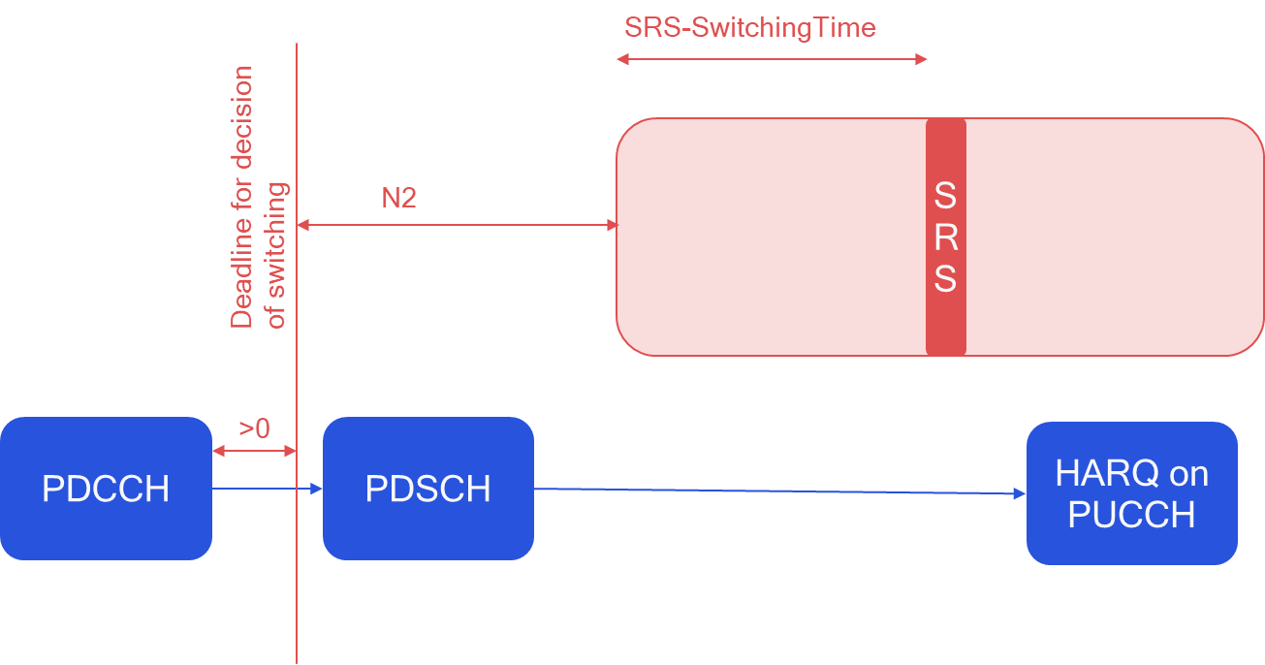

To solve this issue, the following text proposal is provided:

**<TP1, 38.214>**

6.2.1.3 UE sounding procedure between component carriers

For an SRS transmission starting in symbol of a carrier with slot formats comprised of DL and UL symbols, not configured for PUSCH/PUCCH transmission, and with carrier the UE is configured to switch from according to higher layer parameters *srs-SwitchFromServCellIndex* and *srs-SwitchFromCarrier*, for a conflicting transmission in starting in symbol the UE shall apply the rules in the remaining of this subclause based on:

* DCI(s) for which the time interval between the last symbol of PDCCH and is at leastsymbols and an additional time duration , and the time interval between the last symbol of PDCCH and is at least symbols*;* and
* semi-persistent CSI reports or SRS for which the HARQ-ACK information on PUCCH in response to the activation command would be transmitted in slot , and being the first symbol of the first slot which is after slot , and the time interval between and is at least symbols and an additional time duration , and the time interval between and is at least symbols, where is the SCS configuration of the PUCCH.

where , and the time interval unit of OFDM symbol is counted based on the minimum subcarrier spacing given by , with the SCS configuration for the PDCCH carrying the triggering commands for the SRS in , the SCS configuration for SRS in , the SCS configuration for the PDCCH that schedules PUSCH in , and the SCS configuration for the PUSCH in .

**</TP1>**

In the following, we try to collect views from companies on the following two questions: whether the change is needed (and if not, what is the UE behavior), and any comments on the provided TP:

# Discussion

**Q1: Do you agree that the timelines for SRS carrier switching dropping rules are not specified and, therefore, a correction is needed?**

* **If you do not agree, please provide a spec reference / justification on what is the UE behavior.**

|  |  |  |
| --- | --- | --- |
| Company name | Answer (Yes/no) | If the answer is no, please provide reference / justification |
| Qualcomm | Yes |  |

**Q1: • Do you have any comments on the provided TP in 2101432?**

|  |  |
| --- | --- |
| Company name | Comments on TP |
|  |  |

# Summary

**To be completed after discussion phase**