**Moderator’s proposal**

* As for the agreement on antenna gain and antenna gain components including antenna gain correction factors, Table A and Table B clarified as below

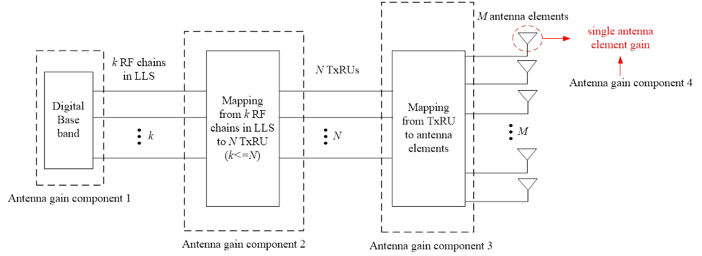

Table A. antenna gain components for TDL option 1



Table B. antenna gain components for TDL option 2 and CDL