**--------------------------------------- Start of template for collection of NR positioning results --------------------------------**

# 8 Performance evaluations for R17 performance targets

## 8.1 Performance analysis of Rel-16 positioning solutions

Including accuracy and latency (objective 1b) performance, compared to rel17 performance targets

### 8.1.1 Positioning accuracy analysis

#### 8.1.1.1 Results from source [X]

##### 8.1.1.1.1 Description of evaluation scenarios

The scenarios to be presented in this contribution include

* Baseline scenarios with InF-SH/InF-DH with fixed UE/gNB height and without UE/gNB calibration error (Case 0xx series)
* InF-DH with variable UE/gNB height (Case 1xx series)
* InF-SH/In-DH with UE/gNB calibration error (Case 2xx series)

Evaluation assumptions for system level analysis are provided in Table 8.1.1.1.1-1 to 8.1.1.1.1-5.

Table 8.1.1.1.1-1: Rel.16 NR positioning (baseline) - evaluation scenarios and parameters

|  |  |  |  |  |  |  |  |  |
| --- | --- | --- | --- | --- | --- | --- | --- | --- |
| Parameter | Case 1 (InF-SH, FR1) | Case 2 (InF-SH, FR1) | Case 3 (InF-SH, FR1) | Case 4 (InF-SH, FR1) | Case 5 (InF-DH, FR1) | Case 6 (InF-DH, FR1) | Case 7 (InF-DH, FR1) | Case 8 (InF-DH, FR1) |
| Channel model (baseline, otherwise state any modifications) | InF-SH | InF-SH | In-SH | InF-SH | InF-DH  (40%, 2, 2) | InF-DH  (40%, 2, 2) | InF-DH  (40%, 2, 2) | InF-DH  (40%, 2, 2) |
| Carrier frequency | 3.5GHz | 3.5GHz | 3.5GHz | 3.5GHz | 3.5GHz | 3.5GHz | 3.5GHz | 3.5GHz |
| Subcarrier spacing | 30kHz | 30kHz | 30kHz | 30kHz | 30kHz | 30kHz | 30kHz | 30kHz |
| Reference Signal Transmission Bandwidth | 100MHz | 100MHz | 100MHz | 100MHz | 100MHz | 100MHz | 100MHz | 100MHz |
| Reference Signal Physical Structure and Resource Allocation (RE pattern) (reference to figure in contribution) | DL-PRS (Comb-4, 4 symbol) | PosSRS (Comb-4, 4 symbol) | PosSRS (Comb-4, 4 symbol) | DL-PRS+PosSRS (Comb-4, 4 symbol) | DL-PRS (Comb-4, 4 symbol) | PosSRS (Comb-4, 4 symbol) | PosSRS (Comb-4, 4 symbol) | DL-PRS+PosSRS (Comb-4, 4 symbol) |
| Reference signal  (type of sequence, number of ports, …) | Gold, single port | ZC, single port | ZC, single port | Gold/ZC, single port | Gold, single port | ZC, single port | ZC, single port | Gold/ZC, single port |
| Number of sites | 7 | 7 | 7 | 7 | 7 | 7 | 7 | 7 |
| Number of symbols used per occasion | 4 | 4 | 4 | 4 | 4 | 4 | 4 | 4 |
| number of occasions used per positioning estimate | 1 | 1 | 1 | 1 | 1 | 1 | 1 | 1 |
| Power-boosting level | 6dB | 6dB | 6dB | 6dB | 6dB | 6dB | 6dB | 6dB |
| Uplink power control (applied/not applied) | Not applied | Not applied | Not applied | Not applied | Not applied | Not applied | Not applied | Not applied |
| interference modelling (ideal muting, or other) | Ideal | Ideal | Ideal | Ideal | Ideal | Ideal | Ideal | Ideal |
| Description of Measurement Algorithm (e.g. super resolution, interference cancellation, ….) | Super resolution  No LOS/NLOS detection | Super resolution  No LOS/NLOS detection | Super resolution  No LOS/NLOS detection | Super resolution  No LOS/NLOS detection | Super resolution  No LOS/NLOS detection | Super resolution  No LOS/NLOS detection | Super resolution  No LOS/NLOS detection | Super resolution  No LOS/NLOS detection |
| Description of positioning technique / applied positioning algorithm (e.g. Least square, Taylor series, etc) | DL-TDOA  PSO | UL-TDOA  PSO | UL-TDOA+UL-AoA  PSO | Multi-RTT  PSO | DL-TDOA  PSO | UL-TDOA  PSO | UL-TDOA+UL-AoA  PSO | Multi-RTT  PSO |
| Network synchronization assumptions | Ideal | Ideal | Ideal | Ideal | Ideal | Ideal | Ideal | Ideal |
| UE/gNB Tx/Rx  Calibration Error | Ideal | Ideal | Ideal | Ideal | Ideal | Ideal | Ideal | Ideal |
| Beam-related assumption (beam sweeping / alignment assumptions at the tx and rx sides) | Tx beam sweeping | Tx beam sweeping | Tx beam sweeping | Tx beam sweeping | Tx beam sweeping | Tx beam sweeping | Tx beam sweeping | Tx beam sweeping |
| Precoding assumptions (codebook, nrof antenna elements used, etc) | Tx codebook-based | Tx codebook-based | Tx codebook-based | Tx codebook-based | Tx codebook-based | Tx codebook-based | Tx codebook-based | Tx codebook-based |
| Additional notes, if any | Fixed UE/gNB height. | Fixed UE/gNB height. | Fixed UE/gNB height. | Fixed UE/gNB height. | Fixed UE/gNB height. | Fixed UE/gNB height. | Fixed UE/gNB height. | Fixed UE/gNB height. |

Table 8.1.1.1.1-2: Rel.16 NR positioning (baseline) - evaluation scenarios and parameters

|  |  |  |  |  |  |  |  |  |
| --- | --- | --- | --- | --- | --- | --- | --- | --- |
| Parameter | Case 9 (InF-SH, FR2) | Case 10 (InF-SH, FR2) | Case 11 (InF-SH, FR2) | Case 12 (InF-SH, FR2) | Case 13 (InF-DH, FR2) | Case 14 (InF-DH, FR2) | Case 15 (InF-DH, FR2) | Case 16 (InF-DH, FR2) |
| Channel model (baseline, otherwise state any modifications) | InF-SH | InF-SH | In-SH | InF-SH | InF-DH  (40%, 2, 2) | InF-DH  (40%, 2, 2) | InF-DH  (40%, 2, 2) | InF-DH  (40%, 2, 2) |
| Carrier frequency | 28GHz | 28GHz | 28GHz | 28GHz | 28GHz | 28GHz | 28GHz | 28GHz |
| Subcarrier spacing | 120kHz | 120kHz | 120kHz | 120kHz | 120kHz | 120kHz | 120kHz | 120kHz |
| Reference Signal Transmission Bandwidth | 400MHz | 400MHz | 400MHz | 400MHz | 400MHz | 400MHz | 400MHz | 400MHz |
| Reference Signal Physical Structure and Resource Allocation (RE pattern) (reference to figure in contribution) | DL-PRS (Comb-4, 4 symbol) | DL-PRS (Comb-4, 4 symbol) | PosSRS (Comb-4, 4 symbol) | DL-PRS+PosSRS (Comb-4, 4 symbol) | DL-PRS (Comb-4, 4 symbol) | DL-PRS (Comb-4, 4 symbol) | PosSRS (Comb-4, 4 symbol) | DL-PRS+PosSRS (Comb-4, 4 symbol) |
| Reference signal  (type of sequence, number of ports, …) | Gold, single port | Gold, single port | ZC, single port | Gold/ZC, single port | Gold, single port | Gold, single port | ZC, single port | Gold/ZC, single port |
| Number of sites | 7 | 7 | 7 | 7 | 7 | 7 | 7 | 7 |
| Number of symbols used per occasion | 4 | 4 | 4 | 4 | 4 | 4 | 4 | 4 |
| number of occasions used per positioning estimate | 1 | 1 | 1 | 1 | 1 | 1 | 1 | 1 |
| Power-boosting level | 6dB | 6dB | 6dB | 6dB | 6dB | 6dB | 6dB | 6dB |
| Uplink power control (applied/not applied) | Not applied | Not applied | Not applied | Not applied | Not applied | Not applied | Not applied | Not applied |
| interference modelling (ideal muting, or other) | Ideal | Ideal | Ideal | Ideal | Ideal | Ideal | Ideal | Ideal |
| Description of Measurement Algorithm (e.g. super resolution, interference cancellation, ….) | Super resolution  No LOS/NLOS detection | Super resolution  No LOS/NLOS detection | Super resolution  No LOS/NLOS detection | Super resolution  No LOS/NLOS detection | Super resolution  No LOS/NLOS detection | Super resolution  No LOS/NLOS detection | Super resolution  No LOS/NLOS detection | Super resolution  No LOS/NLOS detection |
| Description of positioning technique / applied positioning algorithm (e.g. Least square, Taylor series, etc) | DL-TDOA  PSO | DL-TDOA+DL-AoD  PSO | UL-TDOA+UL-AoA  PSO | Multi-RTT  PSO | DL-TDOA  PSO | DL-TDOA+DL-AoD  PSO | UL-TDOA+UL-AoA  PSO | Multi-RTT  PSO |
| Network synchronization assumptions | Ideal | Ideal | Ideal | Ideal | Ideal | Ideal | Ideal | Ideal |
| UE/gNB Tx/Rx  Calibration Error | Ideal | Ideal | Ideal | Ideal | Ideal | Ideal | Ideal | Ideal |
| Beam-related assumption (beam sweeping / alignment assumptions at the tx and rx sides) | Tx beam sweeping  Rx beam sweeping | Tx beam sweeping  Rx beam sweeping | Tx beam sweeping  Rx beam sweeping | Tx beam sweeping  Rx beam sweeping | Tx beam sweeping  Rx beam sweeping | Tx beam sweeping  Rx beam sweeping | Tx beam sweeping  Rx beam sweeping | Tx beam sweeping  Rx beam sweeping |
| Precoding assumptions (codebook, nrof antenna elements used, etc) | Tx codebook-based  Rx codebook based | Tx codebook-based  Rx codebook based | Tx codebook-based  Rx codebook based | Tx codebook-based  Rx codebook based | Tx codebook-based  Rx codebook based | Tx codebook-based  Rx codebook based | Tx codebook-based  Rx codebook based | Tx codebook-based  Rx codebook based |
| Additional notes, if any | Fixed UE/gNB height. | Fixed UE/gNB height. | Fixed UE/gNB height. | Fixed UE/gNB height. | Fixed UE/gNB height. | Fixed UE/gNB height. | Fixed UE/gNB height. | Fixed UE/gNB height. |

Table 8.1.1.1.1-3: Rel.16 NR positioning (modified DH and 3D positioning) - evaluation scenarios and parameters

|  |  |  |  |  |  |  |  |  |
| --- | --- | --- | --- | --- | --- | --- | --- | --- |
| Parameter | Case 101 (InF-DH, FR1) | Case 102 (InF-DH, FR1) | Case 103 (InF-DH, FR1) | Case 104 (InF-DH, FR1) | Case 105 (InF-DH, FR2) | Case 106 (InF-DH, FR2) | Case 107 (InF-DH, FR2) | Case 108 (InF-DH, FR2) |
| Channel model (baseline, otherwise state any modifications) | InF-DH  (40%, 3, 5) | InF-DH  (40%, 3, 5) | InF-DH  (40%, 3, 5) | InF-DH  (40%, 3, 5) | InF-DH  (40%, 3, 5) | InF-DH  (40%, 3, 5) | InF-DH  (40%, 3, 5) | InF-DH  (40%, 3, 5) |
| Carrier frequency | 3.5GHzHz | 3.5GHz | 3.5GHz | 3.5GHz | 28GHz | 28GHz | 28GHz | 28GHz |
| Subcarrier spacing | 30kHz | 30kHz | 30kHz | 30kHz | 120kHz | 120kHz | 120kHz | 120kHz |
| Reference Signal Transmission Bandwidth | 100Mhz | 100Mhz | 100Mhz | 100Mhz | 400MHz | 400MHz | 400MHz | 400MHz |
| Reference Signal Physical Structure and Resource Allocation (RE pattern) (reference to figure in contribution) | DL-PRS (Comb-4, 4 symbol) | DL-PRS (Comb-4, 4 symbol) | PosSRS (Comb-4, 4 symbol) | DL-PRS+PosSRS (Comb-4, 4 symbol) | DL-PRS (Comb-4, 4 symbol) | DL-PRS (Comb-4, 4 symbol) | PosSRS (Comb-4, 4 symbol) | DL-PRS+PosSRS (Comb-4, 4 symbol) |
| Reference signal  (type of sequence, number of ports, …) | Gold, single port | Gold, single port | ZC, single port | Gold/ZC, single port | Gold, single port | Gold, single port | ZC, single port | Gold/ZC, single port |
| Number of sites | 7 | 7 | 7 | 7 | 7 | 7 | 7 | 7 |
| Number of symbols used per occasion | 4 | 4 | 4 | 4 | 4 | 4 | 4 | 4 |
| number of occasions used per positioning estimate | 1 | 1 | 1 | 1 | 1 | 1 | 1 | 1 |
| Power-boosting level | 6dB | 6dB | 6dB | 6dB | 6dB | 6dB | 6dB | 6dB |
| Uplink power control (applied/not applied) | Not applied | Not applied | Not applied | Not applied | Not applied | Not applied | Not applied | Not applied |
| interference modelling (ideal muting, or other) | Ideal | Ideal | Ideal | Ideal | Ideal | Ideal | Ideal | Ideal |
| Description of Measurement Algorithm (e.g. super resolution, interference cancellation, ….) | Super resolution  No LOS/NLOS detection | Super resolution  No LOS/NLOS detection | Super resolution  No LOS/NLOS detection | Super resolution  No LOS/NLOS detection | Super resolution  No LOS/NLOS detection | Super resolution  No LOS/NLOS detection | Super resolution  No LOS/NLOS detection | Super resolution  No LOS/NLOS detection |
| Description of positioning technique / applied positioning algorithm (e.g. Least square, Taylor series, etc) | DL-TDOA  PSO | DL-TDOA+DL-AoD  PSO | UL-TDOA+UL-AoA  PSO | Multi-RTT  PSO | DL-TDOA  PSO | DL-TDOA+DL-AoD  PSO | UL-TDOA+UL-AoA  PSO | Multi-RTT  PSO |
| Network synchronization assumptions | Ideal | Ideal | Ideal | Ideal | Ideal | Ideal | Ideal | Ideal |
| UE/gNB Tx/Rx  Calibration Error | Ideal | Ideal | Ideal | Ideal | Ideal | Ideal | Ideal | Ideal |
| Beam-related assumption (beam sweeping / alignment assumptions at the tx and rx sides) | Tx beam sweeping | Tx beam sweeping | Tx beam sweeping | Tx beam sweeping | Tx beam sweeping  Rx beam sweeping | Tx beam sweeping  Rx beam sweeping | Tx beam sweeping  Rx beam sweeping | Tx beam sweeping  Rx beam sweeping |
| Precoding assumptions (codebook, nrof antenna elements used, etc) | Tx codebook-based | Tx codebook-based | Tx codebook-based | Tx codebook-based | Tx codebook-based  Rx codebook based | Tx codebook-based  Rx codebook based | Tx codebook-based  Rx codebook based | Tx codebook-based  Rx codebook based |
| Additional notes, if any | Fixed UE/gNB height. | Fixed UE/gNB height. | UE height within [0.5, 3]  gNB height {4, 8} | UE height within [0.5, 3]  gNB height {4, 8} | Fixed UE/gNB height. | Fixed UE/gNB height. | UE height within [0.5, 3]  gNB height {4, 8} | UE height within [0.5, 3]  gNB height {4, 8} |

Table 8.1.1.1.1-4: Rel.16 NR positioning (UE/gNB calibration error) - evaluation scenarios and parameters

|  |  |  |  |  |  |  |  |  |
| --- | --- | --- | --- | --- | --- | --- | --- | --- |
| Parameter | Case 201 (InF-SH, FR1) | Case 202 (InF-SH, FR1) | Case 203 (InF-SH, FR1) | Case 204 (InF-SH, FR1) | Case 205 (InF-DH, FR1) | Case 206 (InF-DH, FR1) | Case 207 (InF-DH, FR1) | Case 208 (InF-DH, FR1) |
| Channel model (baseline, otherwise state any modifications) | InF-SH | In-SH | InF-SH | InF-SH | InF-DH  (40%, 2, 2) | InF-DH  (40%, 2, 2) | InF-DH  (40%, 2, 2) | InF-DH  (40%, 2, 2) |
| Carrier frequency | 3.5GHzHz | 3.5GHz | 3.5GHz | 3.5GHz | 3.5GHzHz | 3.5GHz | 3.5GHz | 3.5GHz |
| Subcarrier spacing | 30kHz | 30kHz | 30kHz | 30kHz | 30kHz | 30kHz | 30kHz | 30kHz |
| Reference Signal Transmission Bandwidth | 100Mhz | 100Mhz | 100Mhz | 100Mhz | 100Mhz | 100Mhz | 100Mhz | 100Mhz |
| Reference Signal Physical Structure and Resource Allocation (RE pattern) (reference to figure in contribution) | DL-PRS (Comb-4, 4 symbol) | PosSRS (Comb-4, 4 symbol) | PosSRS (Comb-4, 4 symbol) | DL-PRS+PosSRS (Comb-4, 4 symbol) | DL-PRS (Comb-4, 4 symbol) | PosSRS (Comb-4, 4 symbol) | PosSRS (Comb-4, 4 symbol) | DL-PRS+PosSRS (Comb-4, 4 symbol) |
| Reference signal  (type of sequence, number of ports, …) | Gold, single port | ZC, single port | ZC, single port | Gold/ZC, single port | Gold, single port | ZC, single port | ZC, single port | Gold/ZC, single port |
| Number of sites | 7 | 7 | 7 | 7 | 7 | 7 | 7 | 7 |
| Number of symbols used per occasion | 4 | 4 | 4 | 4 | 4 | 4 | 4 | 4 |
| number of occasions used per positioning estimate | 1 | 1 | 1 | 1 | 1 | 1 | 1 | 1 |
| Power-boosting level | 6dB | 6dB | 6dB | 6dB | 6dB | 6dB | 6dB | 6dB |
| Uplink power control (applied/not applied) | Not applied | Not applied | Not applied | Not applied | Not applied | Not applied | Not applied | Not applied |
| interference modelling (ideal muting, or other) | Ideal | Ideal | Ideal | Ideal | Ideal | Ideal | Ideal | Ideal |
| Description of Measurement Algorithm (e.g. super resolution, interference cancellation, ….) | Super resolution  No LOS/NLOS detection | Super resolution  No LOS/NLOS detection | Super resolution  No LOS/NLOS detection | Super resolution  No LOS/NLOS detection | Super resolution  No LOS/NLOS detection | Super resolution  No LOS/NLOS detection | Super resolution  No LOS/NLOS detection | Super resolution  No LOS/NLOS detection |
| Description of positioning technique / applied positioning algorithm (e.g. Least square, Taylor series, etc) | DL-TDOA  PSO | UL-TDOA  PSO | UL-TDOA+UL-AoA  PSO | Multi-RTT  PSO | DL-TDOA  PSO | UL-TDOA  PSO | UL-TDOA+UL-AoA  PSO | Multi-RTT  PSO |
| Network synchronization assumptions | Ideal | Ideal | Ideal | Ideal | Ideal | Ideal | Ideal | Ideal |
| UE/gNB Tx/Rx  Calibration Error | gNB Rx/Tx Time error T1=1.4ns  UE Rx/Tx time error T1=5.6ns | | | | | | | |
| Beam-related assumption (beam sweeping / alignment assumptions at the tx and rx sides) | Tx beam sweeping | Tx beam sweeping | Tx beam sweeping | Tx beam sweeping | Tx beam sweeping | Tx beam sweeping | Tx beam sweeping | Tx beam sweeping |
| Precoding assumptions (codebook, nrof antenna elements used, etc) | Tx codebook-based | Tx codebook-based | Tx codebook-based | Tx codebook-based | Tx codebook-based | Tx codebook-based | Tx codebook-based | Tx codebook-based |
| Additional notes, if any | Fixed UE/gNB height. | Fixed UE/gNB height. | Fixed UE/gNB height. | Fixed UE/gNB height. | Fixed UE/gNB height. | Fixed UE/gNB height. | Fixed UE/gNB height. | Fixed UE/gNB height. |

Table 8.1.1.1.1-5: Rel.16 NR positioning (gNB angle calibration error) - evaluation scenarios and parameters

|  |  |  |  |  |
| --- | --- | --- | --- | --- |
| Parameter | Case 209 (InF-SH, FR1) | Case 210 (InF-SH, FR1) | Case 211 (InF-SH, FR1) | Case 212 (InF-SH, FR1) |
| Channel model (baseline, otherwise state any modifications) | InF-SH | In-SH | InF-SH | InF-SH |
| Carrier frequency | 3.5GHzHz | 3.5GHz | 3.5GHz | 3.5GHz |
| Subcarrier spacing | 30kHz | 30kHz | 30kHz | 30kHz |
| Reference Signal Transmission Bandwidth | 100Mhz | 100Mhz | 100Mhz | 100Mhz |
| Reference Signal Physical Structure and Resource Allocation (RE pattern) (reference to figure in contribution) | PosSRS (Comb-4, 4 symbol) | PosSRS (Comb-4, 4 symbol) | PosSRS (Comb-4, 4 symbol) | PosSRS (Comb-4, 4 symbol) |
| Reference signal  (type of sequence, number of ports, …) | ZC, single port | ZC, single port | ZC, single port | ZC, single port |
| Number of sites | 7 | 7 | 7 | 7 |
| Number of symbols used per occasion | 4 | 4 | 4 | 4 |
| number of occasions used per positioning estimate | 1 | 1 | 1 | 1 |
| Power-boosting level | 6dB | 6dB | 6dB | 6dB |
| Uplink power control (applied/not applied) | Not applied | Not applied | Not applied | Not applied |
| interference modelling (ideal muting, or other) | Ideal | Ideal | Ideal | Ideal |
| Description of Measurement Algorithm (e.g. super resolution, interference cancellation, ….) | Super resolution  No LOS/NLOS detection | Super resolution  No LOS/NLOS detection | Super resolution  No LOS/NLOS detection | Super resolution  No LOS/NLOS detection |
| Description of positioning technique / applied positioning algorithm (e.g. Least square, Taylor series, etc) | UL-AOA  PSO | UL-AOA  PSO | UL-AOA  PSO | UL-AOA  PSO |
| Network synchronization assumptions | Ideal | Ideal | Ideal | Ideal |
| UE/gNB Tx/Rx  Calibration Error | Ideal | gNB Rx Angle error | gNB Rx Angle error | gNB Rx Angle error |
| Beam-related assumption (beam sweeping / alignment assumptions at the tx and rx sides) | Tx beam sweeping | Tx beam sweeping | Tx beam sweeping | Tx beam sweeping |
| Precoding assumptions (codebook, nrof antenna elements used, etc) | Tx codebook-based | Tx codebook-based | Tx codebook-based | Tx codebook-based |
| Additional notes, if any | Fixed UE/gNB height. | Fixed UE/gNB height. | Fixed UE/gNB height. | Fixed UE/gNB height. |

##### 8.1.1.1.2 Positioning accuracy evaluation results

Table 8.1.1.1.2-1 provides summary of NR positioning evaluations results for horizontal location error under the baseline scenarios.

Table 8.1.1.1.2-2 provides summary of NR positioning evaluations results for horizontal location error under the modified DH and 3D positioning.

Table 8.1.1.1.2-3 provides summary of NR positioning evaluations results for horizontal location error under UE/gNB calibration error.

Table 8.1.1.1.2-4 provides summary of NR positioning evaluations results for vertical location error under the 3D positioning.

Table 8.1.1.1.2-1: Rel.16 NR positioning (baseline) - horizontal location error results from [X]

|  |  |  |  |  |  |
| --- | --- | --- | --- | --- | --- |
| Cases |  | 50% | 67% | 80% | 90% |
| 1, InF-SH, FR1, DL-TDOA | (Optional) All UEs | 0.077 | 0.153 | 0.419 | 2.789 |
| Convex UEs | 0.053 | 0.090 | 0.224 | 1.964 |
| 2, InF-SH, FR1, UL-TDOA | (Optional) All UEs | 0.0871 | 0.1708 | 0.4013 | 1.8678 |
| Convex UEs | 0.0621 | 0.1096 | 0.2410 | 1.0277 |
| 3, InF-SH, FR1, UL-TDOA/AoA | (Optional) All UEs | 0.0465 | 0.0731 | 0.1271 | 0.299 |
| Convex UEs | 0.0434 | 0.0648 | 0.1116 | 0.2682 |
| 4, InF-SH, FR1, Multi-RTT | (Optional) All UEs | 0.0721 | 0.2035 | 0.6628 | 1.9481 |
| Convex UEs | 0.0665 | 0.1798 | 0.5628 | 1.6992 |
| 5, InF-DH422, FR1, DL-TDOA | (Optional) All UEs | 0.861 | 3.448 | 8.103 | 15.212 |
| Convex UEs | 0.703 | 2.904 | 8.399 | 15.635 |
| 6, InF-DH422, FR1, UL-TDOA | (Optional) All UEs | 0.4309 | 1.6317 | 4.9693 | 9.9453 |
| Convex UEs | 0.3354 | 1.2393 | 4.6237 | 9.6631 |
| 7, InF-DH422, FR1, UL-TDOA/AoA | (Optional) All UEs | 0.0702 | 0.1673 | 0.3825 | 1.0453 |
| Convex UEs | 0.0643 | 0.1529 | 0.3206 | 0.8016 |
| 8, InF-DH422, FR1, Multi-RTT | (Optional) All UEs | 0.0699 | 0.1260 | 0.3916 | 7.8992 |
| Convex UEs | 0.0667 | 0.1164 | 0.3338 | 7.3110 |
| 9, InF-SH, FR2, DL-TDOA | (Optional) All UEs | 0.0089 | 0.0329 | 0.1935 | 1.1281 |
| Convex UEs | 0.0077 | 0.0265 | 0.1586 | 0.9633 |
| 10, InF-SH, FR2, DL-TDOA/AoD | (Optional) All UEs | 0.0118 | 0.0203 | 0.0345 | 0.0918 |
| Convex UEs | 0.0143 | 0.0231 | 0.0387 | 0.0654 |
| 11, InF-SH, FR2, UL-TDOA/AoA | (Optional) All UEs | 0.0102 | 0.0191 | 0.0365 | 0.0991 |
| Convex UEs | 0.0084 | 0.0156 | 0.0296 | 0.0694 |
| 12, InF-SH, FR2, Multi-RTT | (Optional) All UEs | 0.0049 | 0.0143 | 0.0881 | 0.4697 |
| Convex UEs | 0.0048 | 0.0137 | 0.0841 | 0.4496 |
| 13, InF-DH422, FR2, DL-TDOA | (Optional) All UEs | 0.0466 | 0.5795 | 3.6866 | 9.2401 |
| Convex UEs | 0.0321 | 0.4003 | 2.7974 | 9.6798 |
| 14, InF- DH422, FR2, DL-TDOA/AoD | (Optional) All UEs | 0.0755 | 0.1861 | 0.4228 | 0.9619 |
| Convex UEs | 0.0587 | 0.1452 | 0.3221 | 0.7197 |
| 15, InF-DH422, FR2, UL-TDOA/AoA | (Optional) All UEs | 0.0732 | 0.1728 | 0.3750 | 0.9277 |
| Convex UEs | 0.0603 | 0.1309 | 0.2717 | 0.7086 |
| 16, InF- DH422, FR2, Multi-RTT | (Optional) All UEs | 0.0317 | 0.1905 | 1.0572 | 4.1555 |
| Convex UEs | 0.0259 | 0.1425 | 0.8398 | 4.2895 |

Table 8.1.1.1.2-2: Rel.16 NR positioning (modified DH and 3D positioning) - horizontal location error results from [X]

|  |  |  |  |  |  |
| --- | --- | --- | --- | --- | --- |
| Cases |  | 50% | 67% | 80% | 90% |
| 101, InF-DH435, FR1, UL-TDOA/AoA | (Optional) All UEs | 0.0742 | 0.1792 | 0.4392 | 1.3838 |
| Convex UEs | 0.0628 | 0.1571 | 0.3844 | 1.3012 |
| 102, InF-DH435, FR1, Multi-RTT | (Optional) All UEs | 0.0713 | 0.1249 | 0.4734 | 8.6557 |
| Convex UEs | 0.0663 | 0.1082 | 0.4952 | 9.8411 |
| 103, InF-DH435-3D, FR1, UL-TDOA/AoA | (Optional) All UEs | 0.3405(H) | 1.0103(H) | 2.3157(H) | 5.1203(H) |
| Convex UEs | 0.2923(H) | 0.8122(H) | 2.0088(H) | 4.3405(H) |
| 104, InF-DH435-3D, FR1, Multi-RTT | (Optional) All UEs | 0.1721(H) | 1.3411(H) | 7.4143(H) | 15.4966(H) |
| Convex UEs | 0.1258(H) | 1.4345(H) | 8.9295(H) | 16.0515(H) |
| 105, InF-DH435, FR2, UL-TDOA/AoA | (Optional) All UEs | 0.0943 | 0.2314 | 0.4973 | 1.3007 |
| Convex UEs | 0.0865 | 0.2101 | 0.4707 | 1.1486 |
| 106, InF-DH435, FR2, Multi-RTT | (Optional) All UEs | 0.3364 | 0.9128 | 2.4777 | 5.7209 |
| Convex UEs | 0.3079 | 0.8594 | 2.2392 | 5.4600 |
| 107, InF-DH435-3D, FR2, UL-TDOA/AoA | (Optional) All UEs | 0.1297(H) | 0.4173(H) | 1.1042(H) | 2.6878(H) |
| Convex UEs | 0.1109(H) | 0.3273(H) | 0.8667(H) | 2.4365(H) |
| 108, InF-DH435-3D, FR2, Multi-RTT | (Optional) All UEs | 0.5012(H) | 2.2343(H) | 6.6096(H) | 15.6304(H) |
| Convex UEs | 0.4304(H) | 2.4466(H) | 7.9926(H) | 15.5828(H) |

Table 8.1.1.1.2-3: Rel.16 NR positioning (UE/gNB calibration error) - horizontal location error results from [X]

|  |  |  |  |  |  |
| --- | --- | --- | --- | --- | --- |
| Cases |  | 50% | 67% | 80% | 90% |
| 201, InF-SH, FR1, DL-TDOA, Group Delay Error | (Optional) All UEs | 0.587 | 0.874 | 1.462 | 3.540 |
| Convex UEs | 0.462 | 0.614 | 0.829 | 1.458 |
| 202, InF-SH, FR1, UL-TDOA, Group delay error | (Optional) All UEs | 0.5937 | 0.8672 | 1.3135 | 2.6395 |
| Convex UEs | 0.4653 | 0.6145 | 0.8120 | 1.2343 |
| 203, InF-SH, FR1, UL-TDOA/AoA, Group delay error | (Optional) All UEs | 0.0699 | 0.1180 | 0.2034 | 0.3878 |
| Convex UEs | 0.0661 | 0.1094 | 0.1750 | 0.3251 |
| 204, InF-SH, FR1, Multi-RTT, Group delay error | (Optional) All UEs | 1.7167 | 2.3902 | 3.3592 | 4.4076 |
| Convex UEs | 1.7105 | 2.3963 | 3.3574 | 4.2662 |
| 205, InF-DH422, FR1, DL-TDOA, Group delay error | (Optional) All UEs | 1.719 | 4.034 | 8.588 | 15.330 |
| Convex UEs | 1.391 | 3.407 | 8.570 | 15.039 |
| 206, InF-DH422, FR1, UL-TDOA, Group delay error | (Optional) All UEs | 1.0065 | 2.0631 | 4.7037 | 10.459 |
| Convex UEs | 0.8741 | 1.5739 | 4.2751 | 9.4102 |
| 207, InF-DH422, FR1, UL-TDOA/AoA, Group delay error | (Optional) All UEs | 0.0810 | 0.184 | 0.4251 | 1.1961 |
| Convex UEs | 0.0717 | 0.1577 | 0.3371 | 0.8662 |
| 208, InF-DH422, FR1, Multi-RTT, Group delay error | (Optional) All UEs | 2.2640 | 3.2695 | 4.7279 | 8.9874 |
| Convex UEs | 2.2784 | 3.3381 | 5.0728 | 9.5701 |
| 209, InF-SH, FR1, UL-AoA | (Optional) All UEs | 0.0446 | 0.0615 | 0.0879 | 0.1383 |
| Convex UEs | 0.0410 | 0.0552 | 0.0758 | 0.1119 |
| 210, InF-SH, FR1, UL-AoA, Angle error 1 degree | (Optional) All UEs | 0.4960 | 0.6675 | 0.8724 | 1.3003 |
| Convex UEs | 0.4629 | 0.6280 | 0.8016 | 1.1676 |
| 211, InF-SH, FR1, UL-AoA, Angle error 2 degrees | (Optional) All UEs | 0.9357 | 1.2729 | 1.6915 | 2.6204 |
| Convex UEs | 0.8848 | 1.1961 | 1.5487 | 2.1732 |
| 212, InF-SH, FR1, UL-AoA, Angle error 5 degrees | (Optional) All UEs | 2.3274 | 3.1571 | 4.2839 | 5.9433 |
| Convex UEs | 2.2187 | 2.9534 | 4.0582 | 5.3982 |

Table 8.1.1.1.2-4: Rel.16 NR positioning (modified DH and 3D positioning) - altitude location error results from [X]

|  |  |  |  |  |  |
| --- | --- | --- | --- | --- | --- |
| Cases |  | 50% | 67% | 80% | 90% |
| 103, InF-DH435-3D, FR1, UL-TDOA/AoA | (Optional) All UEs | 0.0905(V) | 0.2923(V) | 0.7287(V) | 1.3239(V) |
| Convex UEs | 00682(V) | 0.2182(V) | 0.5301(V) | 1.1585(V) |
| 104, InF-DH435-3D, FR1, Multi-RTT | (Optional) All UEs | 0.2176(V) | 0.6510(V) | 1.1742(V) | 1.7622(V) |
| Convex UEs | 0.1666(V) | 0.5005(V) | 1.0346(V) | 1.6675(V) |
| 107, InF-DH435-3D, FR2, UL-TDOA/AoA | (Optional) All UEs | 0.0361(V) | 0.1075(V) | 0.2471(V) | 0.5573(V) |
| Convex UEs | 0.0288(V) | 0.0796(V) | 0.1879(V) | 0.4593(V) |
| 108, InF-DH435-3D, FR2, Multi-RTT | (Optional) All UEs | 0.3436(V) | 0.9022(V) | 1.5000(V) | 1.9555(V) |
| Convex UEs | 0.2871(V) | 0.7927(V) | 1.3316(V) | 1.8800(V) |

Figures 8.1.1.1.2-1 to 8.1.1.1.2-4 provide positioning evaluations results for the baseline scenario.

Figures 8.1.1.1.2-5 to 8.1.1.1.2-8 provide positioning evaluation results for the modified DH and 3D positioning (including horizontal and vertical error).

Figures 8.1.1.1.2-9 to 8.1.1.1.2-11 provide positioning evaluation results for the UE/gNB calibration error.

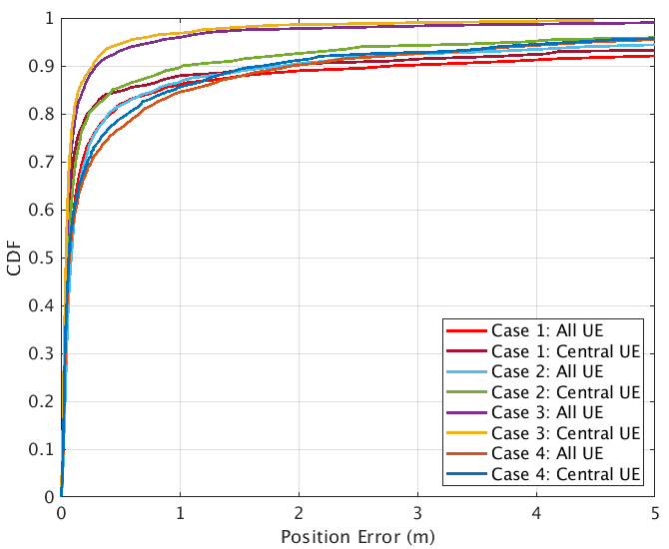

Figure 8.1.1.1.2-1: Rel.16 NR positioning error results (baseline) from [X]

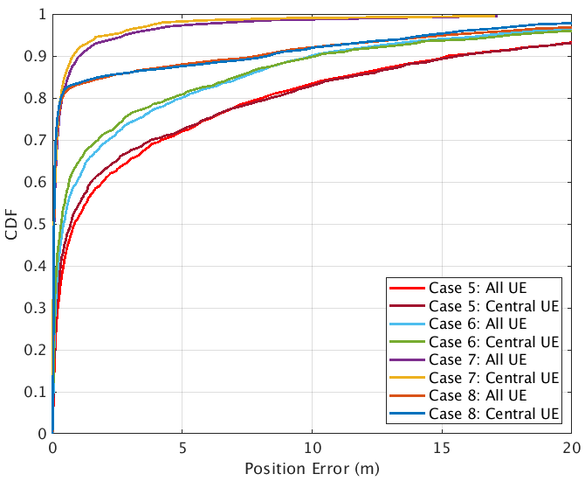

Figure 8.1.1.1.2-2: Rel.16 NR positioning error results (baseline) from [X]

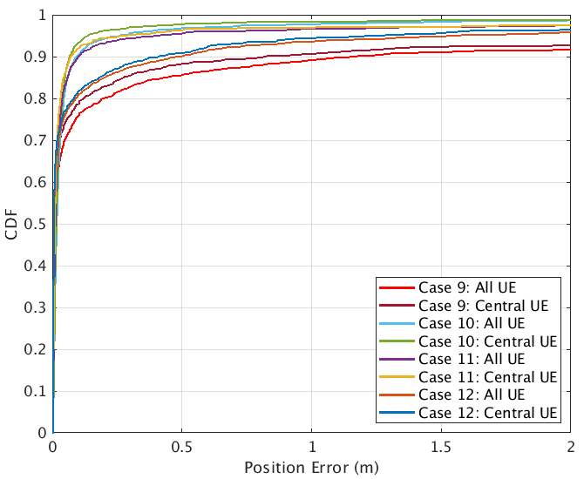

Figure 8.1.1.1.2-3: Rel.16 NR positioning error results (baseline) from [X]

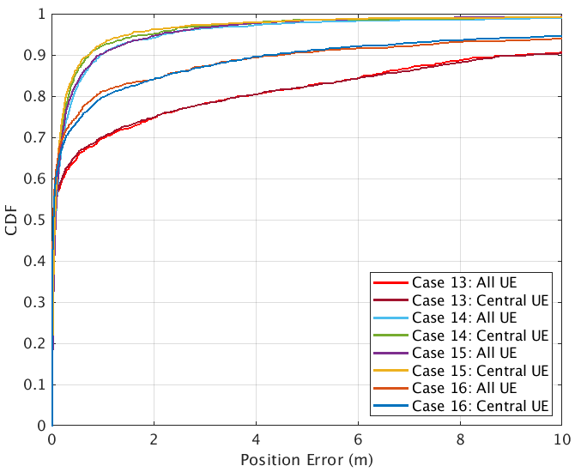

Figure 8.1.1.1.2-4: Rel.16 NR positioning error results (baseline) from [X]

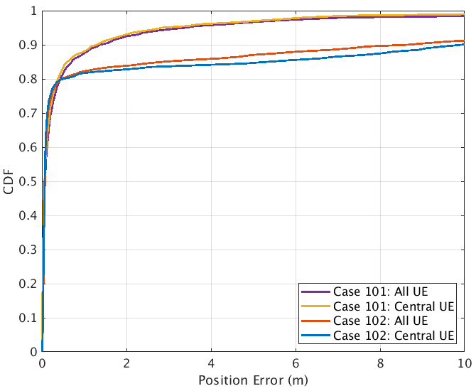

Figure 8.1.1.1.2-5: Rel.16 NR positioning error results (modified DH and 2D) from [X]

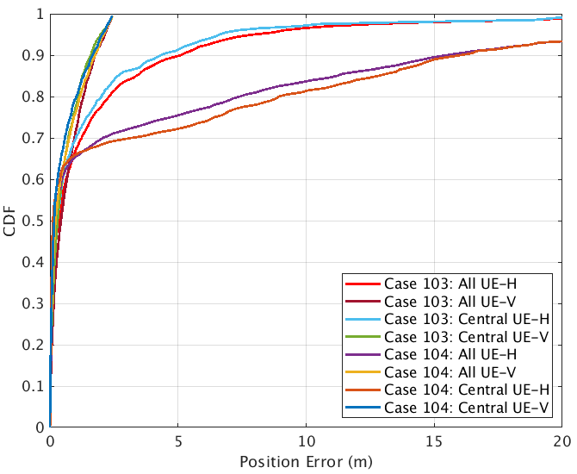

Figure 8.1.1.1.2-6: Rel.16 NR positioning error results (modified DH and 3D) from [X]

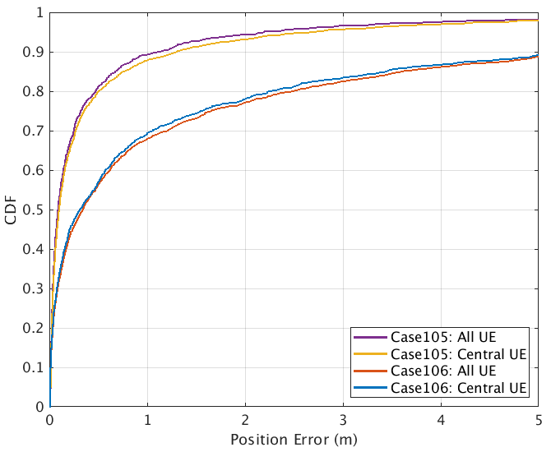

Figure 8.1.1.1.2-7: Rel.16 NR positioning error results (modified DH and 2D) from [X]

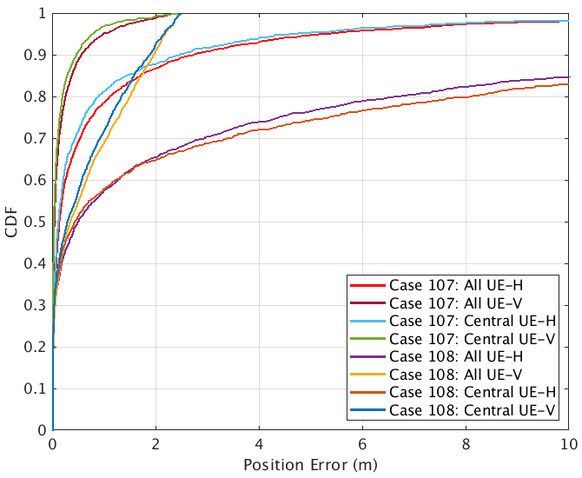

Figure 8.1.1.1.2-8: Rel.16 NR positioning error results (modified DH and 3D) from [X]

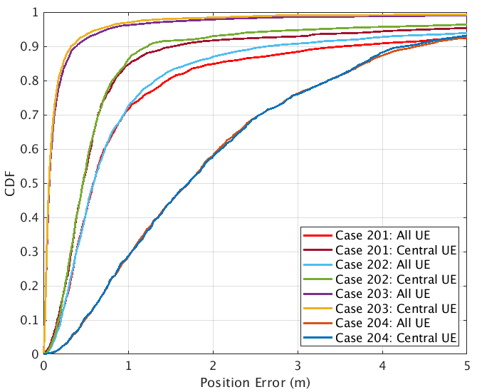

Figure 8.1.1.1.2-9: Rel.16 NR positioning error results (UE/gNB calibration error) from [X]

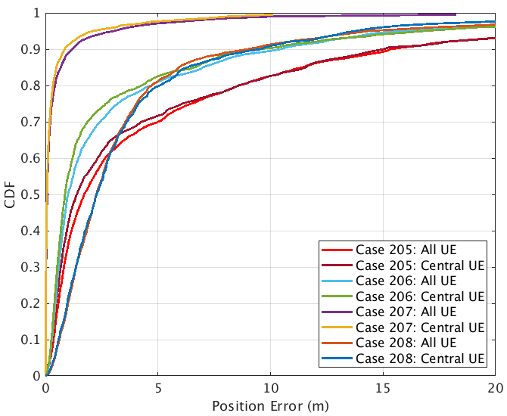

Figure 8.1.1.1.2-10: Rel.16 NR positioning error results (UE/gNB calibration error) from [X]

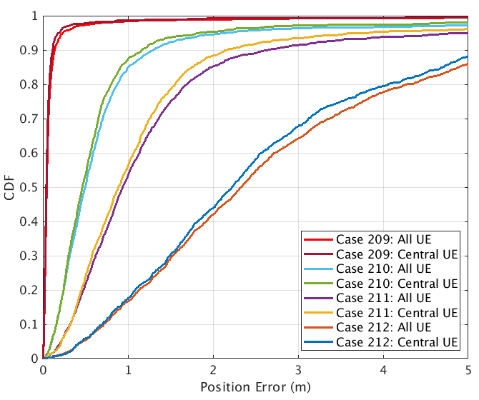

Figure 8.1.1.1.2-11: Rel.16 NR positioning error results (gNB angle calibration error) from [X]

##### 8.1.1.1.3 Observations on Rel-16 NR positioning accuracy

Table 8.1.1.1.3-1 captures observations based on NR positioning evaluations results for horizontal location error for baseline scenarios.

Table 8.1.1.1.3-2 captures observations based on NR positioning evaluations results for horizontal location error for modified DH and 3D positioning.

Table 8.1.1.1.3-3 captures observations based on NR positioning evaluations results for horizontal location error for UE/gNB calibration error.

Table 8.1.1.1.3-4 captures observations based on NR positioning evaluations results for vertical location error for modified DH and 3D positioning.

Table 8.1.1.1.3-1: Rel.16 NR positioning (baseline) – horizontal accuracy performance summary [X]

|  |  |  |  |  |
| --- | --- | --- | --- | --- |
| Simulation case  (Horizontal Error) | Accuracy achieved @[90]% | Commercial horizontal accuracy requirements [1]m @[90]% are met - Yes/No.  If no, provide performance gaps @[90]% | IIoT horizontal accuracy requirements of [0.2]m @[90]%are met - Yes/No. If no, provide performance gaps @[90]% | IIoT horizontal accuracy requirements of [0.5]m @[90]%are met -Yes/No.  If no, provide performance gaps @[90]% |
| 1, InF-SH, FR1, DL-TDOA | 1.964 | 0.964 | 1.764 | 1.464 |
| 2, InF-SH, FR1, UL-TDOA | 1.0277 | 0.0277 | 0.8277 | 0.5277 |
| 3, InF-SH, FR1, UL-TDOA/AoA | 0.2682 | Yes | 0.0682 | Yes |
| 4, InF-SH, FR1, Multi-RTT | 1.6992 | 0.6992 | 1.4992 | 1.1992 |
| 5, InF-DH422, FR1, DL-TDOA | 15.635 | 14.635 | 15.435 | 15.135 |
| 6, InF- DH422, FR1, UL-TDOA | 9.6631 | 9.163 | 9.963 | 9.663 |
| 7, InF-DH422, FR1, UL-TDOA/AoA | 0.8016 | Yes | 0.6016 | 0.3016 |
| 8, InF- DH422, FR1, Multi-RTT | 7.311 | 6.311 | 7.111 | 6.811 |
| 9, InF-SH, FR2, DL-TDOA | 0.9633 | Yes | 0.7633 | 0.4633 |
| 10, InF-SH, FR2, DL-TDOA/AoD | 0.0654 | Yes | Yes | Yes |
| 11, InF-SH, FR2, UL-TDOA/AoA | 0.0694 | Yes | Yes | Yes |
| 12, InF-SH, FR2, Multi-RTT | 0.4496 | Yes | 0.2496 | Yes |
| 13, InF-DH422, FR2, DL-TDOA | 9.6798 | 8.6798 | 9.4798 | 9.1798 |
| 14, InF- DH422, FR2, DL-TDOA/AoD | 0.7197 | Yes | 0.5197 | 0.2197 |
| 15, InF-DH422, FR2, UL-TDOA/AoA | 0.7086 | Yes | 0.5086 | 0.2086 |
| 16, InF- DH422, FR2, Multi-RTT | 4.2895 | 3.2895 | 4.0895 | 3.7895 |

Table 8.1.1.1.3-2: Rel.16 NR positioning (modified DH and 3D positioning) – horizontal accuracy performance summary [X]

|  |  |  |  |  |
| --- | --- | --- | --- | --- |
| Simulation case  (Horizontal Error) | Accuracy achieved @[90]% | Commercial horizontal accuracy requirements [1]m @[90]% are met - Yes/No.  If no, provide performance gaps @[90]% | IIoT horizontal accuracy requirements of [0.2]m @[90]%are met - Yes/No. If no, provide performance gaps @[90]% | IIoT horizontal accuracy requirements of [0.5]m @[90]%are met -Yes/No.  If no, provide performance gaps @[90]% |
| 101, InF-DH435, FR1, UL-TDOA/AoA | 1.3012 | 0.3012 | 1.1012 | 0.8012 |
| 102, InF-DH435, FR1, Multi-RTT | 9.8411 | 8.8411 | 9.6411 | 9.3411 |
| 103, InF-DH435-3D, FR1, UL-TDOA/AoA | 4.3405(H) | 3.3405 | 4.1405 | 3.8405 |
| 104, InF-DH435-3D, FR1, Multi-RTT | 16.0515(H) | 15.0515 | 15.8515 | 15.5515 |
| 105, InF-DH435, FR2, UL-TDOA/AoA | 1.1486 | 0.1486 | 0.9486 | 0.6486 |
| 106, InF-DH435, FR2, Multi-RTT | 5.46 | 4.46 | 5.26 | 4.96 |
| 107, InF-DH435-3D, FR2, UL-TDOA/AoA | 2.4365(H) | 1.4365 | 2.2365 | 1.9365 |
| 108, InF-DH435-3D, FR2, Multi-RTT | 15.5828(H) | 14.5828 | 15.3828 | 15.0828 |

Table 8.1.1.1.3-3: Rel.16 NR positioning (UE/gNB calibration error) – horizontal accuracy performance summary [X]

|  |  |  |  |  |
| --- | --- | --- | --- | --- |
| Simulation case  (Horizontal Error) | Accuracy achieved @[90]% | Commercial horizontal accuracy requirements [1]m @[90]% are met - Yes/No.  If no, provide performance gaps @[90]% | IIoT horizontal accuracy requirements of [0.2]m @[90]%are met - Yes/No. If no, provide performance gaps @[90]% | IIoT horizontal accuracy requirements of [0.5]m @[90]%are met -Yes/No.  If no, provide performance gaps @[90]% |
| 201, InF-SH, FR1, DL-TDOA, Group Delay Error | 0.462 | 0.458 | 1.258 | 0.958 |
| 202, InF-SH, FR1, UL-TDOA, Group delay error | 0.4653 | 0.2343 | 1.0343 | 0.7343 |
| 203, InF-SH, FR1, UL-TDOA/AoA, Group delay error | 0.0661 | Yes | 0.1251 | Yes |
| 204, InF-SH, FR1, Multi-RTT, Group delay error | 1.7105 | 3.2662 | 4.0662 | 3.7662 |
| 205, InF-DH422, FR1, DL-TDOA, Group delay error | 1.391 | 14.039 | 14.839 | 14.539 |
| 206, InF-DH422, FR1, UL-TDOA, Group delay error | 0.8741 | 8.4102 | 9.2102 | 8.9102 |
| 207, InF-DH422, FR1, UL-TDOA/AoA, Group delay error | 0.0717 | Yes | 0.6662 | 0.3662 |
| 208, InF-DH422, FR1, Multi-RTT, Group delay error | 2.2784 | 8.5701 | 9.3701 | 9.0701 |
| 209, InF-SH, FR1, UL-AoA | 0.041 | Yes | Yes | Yes |
| 210, InF-SH, FR1, UL-AoA, Angle error 1 degree | 0.4629 | 0.1676 | 0.9676 | 0.6676 |
| 211, InF-SH, FR1, UL-AoA, Angle error 2 degrees | 0.8848 | 1.1732 | 1.9732 | 1.6732 |
| 212, InF-SH, FR1, UL-AoA, Angle error 5 degrees | 2.2187 | 4.3982 | 5.1982 | 4.8982 |

Table 8.1.1.1.3-4: Rel.16 NR positioning (modified DH and 3D positioning) – vertical accuracy performance summary [X]

|  |  |  |  |  |
| --- | --- | --- | --- | --- |
| Simulation case  (Vertical Error) | Accuracy achieved @[90]% | Commercial vertical accuracy requirements [3]m @[90]% are met - Yes/No.  If no, provide performance gaps @[90]% | IIoT vertical accuracy requirements of [0.2]m @[90]% are met - Yes/No. If no, provide performance gaps @[90]% | IIoT vertical accuracy requirements of [1]m at @[90]% are met - Yes/No.  If no, provide performance gaps @[90]% |
| 103, InF-DH435-3D, FR1, UL-TDOA/AoA | 1.1585(V) | Yes | 0.9585 | 0.1585 |
| 104, InF-DH435-3D, FR1, Multi-RTT | 1.6675(V) | Yes | 1.4675 | 0.6675 |
| 107, InF-DH435-3D, FR2, UL-TDOA/AoA | 0.4593(V) | Yes | 0.2593 | Yes |
| 108, InF-DH435-3D, FR2, Multi-RTT | 1.8800(V) | Yes | 1.68 | 0.88 |

#### 8.1.1.2 Results from source [ZTE, R1-2007754]

##### 8.1.1.2.1 Description of evaluation scenarios

The evaluation scenarios for verifying achievable accuracy based on Rel-16 positioning methods in this contribution include,

* Baseline scenarios with InF-SH/InF-DH (both FR1 and FR2) with fixed UE/gNB height and without network synchronization, for comparing results when UEs are uniformly distributed and inside the covex hull over the factory.
* Baseline scenarios with InF-SH/InF-DH (both FR1 and FR2) with fixed UE/gNB height and without network synchronization, for comparing results when gNBs have different Tx calibration errors (0ns ,0.5 ns, 1 ns and 2 ns).
* InF-SH/InF-DH (both FR1 and FR2) with discrete gNB (staggered distribution) height and uniformly distributed UE height, for investigating vertical positioning accuracy.

Some scenario common parameters can be found in Table 8.1.2.2.1-1. In addition, Table 8.1.2.2.1-2 reveals some controlled variables of all simulation cases (Case 1-24).

**Table** 8.1.1.2.1-1 **Scenario common parameters**

|  |  |  |
| --- | --- | --- |
| Parameter | FR1 | FR2 |
| Channel model (baseline, otherwise state any modifications) | Baseline Channel Model based on common assumptions defined related to the channel models of 3GPP TRs 38.901 / 38.802 / 37.857. | |
| Carrier frequency | 3.5 GHz | 28 GHz |
| Subcarrier spacing | 30 KHz | 120 KHz |
| Reference Signal Transmission Bandwidth | 100 MHz | 400 MHz |
| gNB noise Figure, dB | 5dB | 7dB |
| UE noise Figure, dB | 9dB | 13dB |
| UE max. TX power, dBm | 23dBm | 23dBm EIRP should not exceed 43 dBm. |
| Reference Signal Physical Structure and Resource Allocation (RE pattern) | DL-PRS-CombSizeN-r16 = 6  DL-PRS-ReOffset-r16 = {0,3,1,4,2,5}  DL-PRS-NumSymbols-r16 = 6 | |
| Number of sites | 18 | |
| UE number per site | 20 | |
| number of occasions used per positioning estimate | 4 | |
| Power-boosting level | 7.8dB | |
| Uplink power control (applied/not applied) | Not applied | |
| interference modelling (ideal muting, or other) | Ideal muting | |
| Description of Measurement Algorithm (e.g. super resolution, interference cancellation, ….) | MUSIC algorithm | |
| Description of positioning technique / applied positioning algorithm (e.g. Least square, Taylor series, etc) | DL-TDOA, Guass-Newton algorithm | |
| Network synchronization assumptions | Without sync error | |
| gNB Tx calibration Error | 0ns, 0.5ns, 1ns, 2ns | |
| Precoding assumptions (codebook, nrof antenna elements used, etc) | DFT codebook | |
| Beam-related assumption (beam sweeping / alignment assumptions at the tx and rx sides) | Tx beam sweeping | |
| Additional notes, if any | The absolute time of arrival is applied according to TR 38.901 | |

**Table** 8.1.1.2.1-1 **All simulation cases for positioning accuracy evaluation based on Rel-16 positioning methods**

|  |  |  |  |  |  |
| --- | --- | --- | --- | --- | --- |
| **Simulation cases** | **Scenario** | **FR1/FR2** | **UE horizontal drop procedure** | **gNB Tx calibration error** | **Clutter parameters** |
| Case 1 | InF-SH | FR1 | Uniformly distributed | 0ns | {20%, 2m, 10m} |
| Case 2 | InF-SH | FR1 | Inside convex hull | 0ns | {20%, 2m, 10m} |
| Case 3 | InF-SH | FR1 | Inside convex hull | 0.5ns | {20%, 2m, 10m} |
| Case 4 | InF-SH | FR1 | Inside convex hull | 1ns | {20%, 2m, 10m} |
| Case 5 | InF-SH | FR1 | Inside convex hull | 2ns | {20%, 2m, 10m} |
| Case 6 | InF-SH | FR2 | Uniformly distributed | 0ns | {20%, 2m, 10m} |
| Case 7 | InF-SH | FR2 | Inside convex hull | 0ns | {20%, 2m, 10m} |
| Case 8 | InF-SH | FR2 | Inside convex hull | 0.5ns | {20%, 2m, 10m} |
| Case 9 | InF-SH | FR2 | Inside convex hull | 1ns | {20%, 2m, 10m} |
| Case 10 | InF-SH | FR2 | Inside convex hull | 2ns | {20%, 2m, 10m} |
| Case 11 | InF-DH | FR1 | Uniformly distributed | 0ns | {40%, 2m, 2m} |
| Case 12 | InF-DH | FR1 | Inside convex hull | 0ns | {40%, 2m, 2m} |
| Case 13 | InF-DH | FR1 | Inside convex hull | 0.5ns | {40%, 2m, 2m} |
| Case 14 | InF-DH | FR1 | Inside convex hull | 1ns | {40%, 2m, 2m} |
| Case 15 | InF-DH | FR1 | Inside convex hull | 2ns | {40%, 2m, 2m} |
| Case 16 | InF-DH | FR2 | Uniformly distributed | 0ns | {40%, 2m, 2m} |
| Case 17 | InF-DH | FR2 | Inside convex hull | 0ns | {40%, 2m, 2m} |
| Case 18 | InF-DH | FR2 | Inside convex hull | 0.5ns | {40%, 2m, 2m} |
| Case 19 | InF-DH | FR2 | Inside convex hull | 1ns | {40%, 2m, 2m} |
| Case 20 | InF-DH | FR2 | Inside convex hull | 2ns | {40%, 2m, 2m} |
| Case 21 | InF-SH | FR1 | Inside convex hull | 0ns | {20%, 2m, 10m} |
| Case 22 | InF-SH | FR2 | Inside convex hull | 0ns | {20%, 2m, 10m} |
| Case 23 | InF-DH | FR1 | Inside convex hull | 0ns | {40%, 3m,5m} |
| Case 24 | InF-DH | FR2 | Inside convex hull | 0ns | {40%, 3m, 5m} |

##### 8.1.1.2.2 Positioning accuracy evaluation results

Table 8.1.1.2.2-1 provides CDF of horizontal positioning accuracy at some specific percentiles for InF-SH, FR1 scenario, and corresponding CDF curves can be found in Figure 8.1.1.2.2-1-1.

Table 8.1.1.2.2-2 provides CDF of horizontal positioning accuracy at some specific percentiles for InF-SH, FR2 scenario, and corresponding CDF curves can be found in Figure 8.1.1.2.2-1-2.

Table 8.1.1.2.2-3 provides CDF of horizontal positioning accuracy at some specific percentiles for InF-DH, FR1 scenario, and corresponding CDF curves can be found in Figure 8.1.1.2.2-1-3.

Table 8.1.1.2.2-4 provides CDF of horizontal positioning accuracy at some specific percentiles for InF-DH, FR2 scenario, and corresponding CDF curves can be found in Figure 8.1.1.2.2-1-4.

Table 8.1.1.2.2-5 provides CDF of vertical positioning accuracy at some specific percentiles for InF-SH and InF-DH, and corresponding CDF curves can be found in Figure 8.1.1.2.2-2.

Table 8.1.1.2.2-1 CDF of horizontal positioning accuracy at some specific percentiles for InF-SH, FR1 scenario

|  |  |  |  |  |
| --- | --- | --- | --- | --- |
| **Cases** | **Horizontal positioning accuracy (m)** | | | |
| **50%** | **67%** | **80%** | **90%** |
| Case 1 | 0.282 | 0.370 | 0.467 | **0.603** |
| Case 2 | 0.264 | 0.350 | 0.469 | **0.568** |
| Case 3 | 0.301 | 0.411 | 0.549 | **0.704** |
| Case 4 | 0.475 | 0.616 | 0.767 | **0.943** |
| Case 5 | **0.841** | 1.042 | 1.239 | 1.479 |

Table 8.1.1.2.2-2 CDF of horizontal positioning accuracy at some specific percentiles for InF-SH, FR2 scenario

|  |  |  |  |  |
| --- | --- | --- | --- | --- |
| **Cases** | **Horizontal positioning accuracy (m)** | | | |
| **50%** | **67%** | **80%** | **90%** |
| Case 6 | 0.044 | 0.059 | 0.072 | **0.092** |
| Case 7 | 0.041 | 0.055 | 0.070 | **0.090** |
| Case 8 | 0.171 | 0.223 | 0.257 | **0.300** |
| Case 9 | 0.419 | 0.480 | 0.545 | **0.615** |
| Case 10 | 0.833 | **0.971** | 1.086 | 1.224 |

Table 8.1.1.2.2-3 CDF of horizontal positioning accuracy at some specific percentiles for InF-DH, FR1 scenario

|  |  |  |  |  |
| --- | --- | --- | --- | --- |
| **Cases** | **Horizontal positioning accuracy (m)** | | | |
| **50%** | **67%** | **80%** | **90%** |
| Case 11 | **0.552** | 5.708 | 10.120 | 12.433 |
| Case 12 | **0.414** | 1.060 | 7.337 | 12.345 |
| Case13 | **0.885** | 1.719 | 7.544 | 12.386 |
| Case 14 | **1.242** | 3.560 | 8.249 | 12.368 |
| Case 15 | **1.632** | 4.127 | 7.701 | 12.458 |

Table 8.1.1.2.2-4 CDF of horizontal positioning accuracy at some specific percentiles for InF-DH, FR2 scenario

|  |  |  |  |  |
| --- | --- | --- | --- | --- |
| **Cases** | **Horizontal positioning accuracy (m)** | | | |
| **50%** | **67%** | **80%** | **90%** |
| Case 16 | 0.076 | **0.150** | 10.255 | 14.759 |
| Case 17 | 0.062 | 0.097 | **0.174** | 12.174 |
| Case 18 | 0.323 | 0.458 | **0.665** | 10.815 |
| Case 19 | 0.542 | **0.738** | 1.045 | 12.285 |
| Case 20 | **0.958** | 1.220 | 11.075 | 14.845 |

Table 8.1.1.2.2-5 CDF of vertical positioning accuracy at some specific percentiles for InF-SH and InF-DH

|  |  |  |  |  |
| --- | --- | --- | --- | --- |
| **Simulation cases** | **Vertical positioning accuracy (m)** | | | |
| **50%** | **67%** | **80%** | **90%** |
| Case 21 | 0.411 | 0.623 | 0.815 | **0.979** |
| Case 22 | 0.185 | 0.293 | 0.362 | **0.459** |
| Case 23 | 0.522 | **0.814** | 1.062 | 1.419 |
| Case 24 | 0.222 | **0.414** | 0.705 | 1.271 |

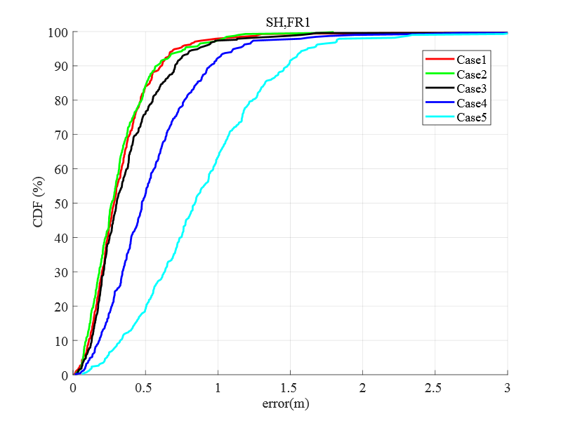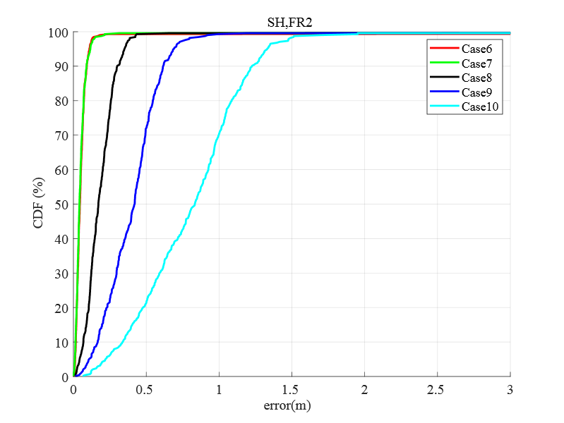

Figure 8.1.1.2.2-1-1 InF-SH, FR1 Figure 8.1.1.2.2-1-2 InF-SH, FR2

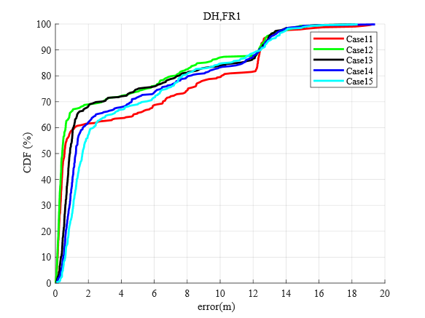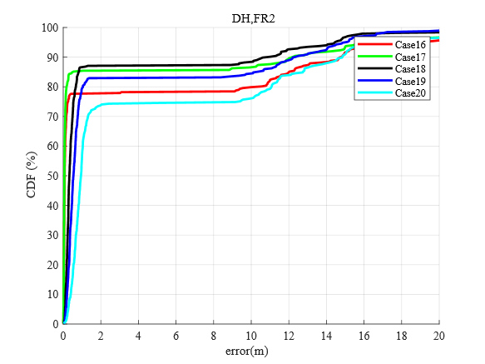

Figure 8.1.1.2.2-1-3 InF-DH, FR1 Figure 8.1.1.2.2-1-4 InF-DH, FR2

**Figure 8.1.1.2.2-1 Horizontal positioning accuracy based on Rel-16 DL-TDOA method**

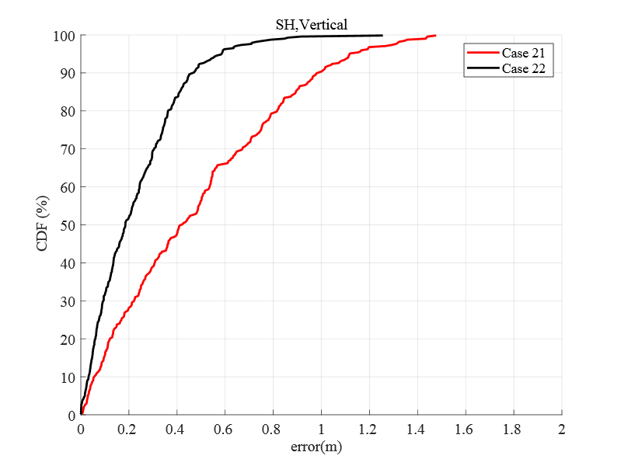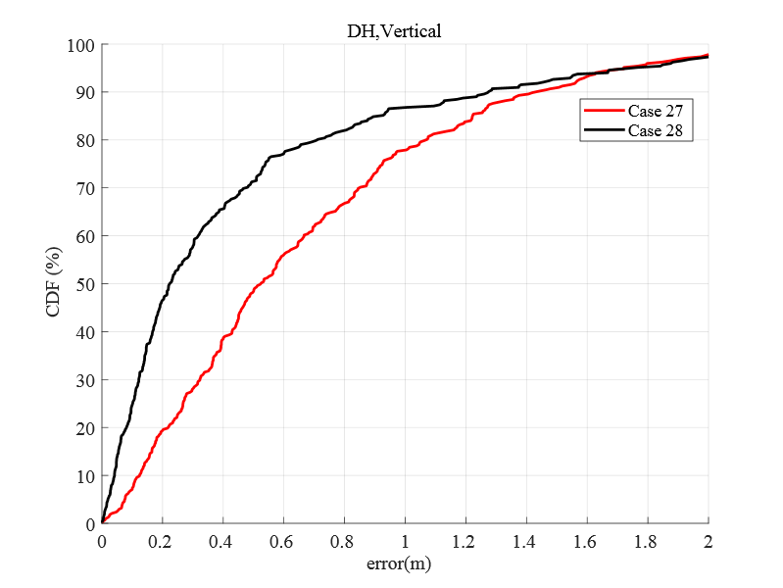

Figure **8.1.1.2.2-2**-1 InF-SH Figure **8.1.1.2.2-2**-2 InF-DH

**Figure 8.1.1.2.2-2 Vertical positioning accuracy based on Rel-16 DL-TDOA method**

##### 8.1.1.2.3 Observations on Rel-16 NR positioning accuracy

**Table 8.1.1.2.3-1: Rel.16 NR positioning – horizontal accuracy performance summary**

|  |  |
| --- | --- |
| Simulation case  (Horizontal Error) | Accuracy achieved @[90]% |
| Case 1 | 0.603 |
| Case 2 | 0.568 |
| Case 3 | 0.704 |
| Case 4 | 0.943 |
| Case 5 | 1.479 |
| Case 6 | 0.092 |
| Case 7 | 0.090 |
| Case 8 | 0.300 |
| Case 9 | 0.615 |
| Case 10 | 1.224 |
| Case 11 | 12.433 |
| Case 12 | 12.345 |
| Case13 | 12.386 |
| Case 14 | 12.368 |
| Case 15 | 12.458 |
| Case 16 | 14.759 |
| Case 17 | 12.174 |
| Case 18 | 10.815 |
| Case 19 | 12.285 |
| Case 20 | 14.845 |

Table 8.1.1.1.3-2: Rel.16 NR positioning – vertical accuracy performance summary [X]

|  |  |
| --- | --- |
| Simulation case  (Vertical Error) | Accuracy achieved @[90]% |
| Case 21 | 0.979 |
| Case 22 | 0.459 |
| Case 23 | 1.419 |
| Case 24 | 1.271 |

Based on the evaluation results above, the following observations are presented in the contribution,

***Observation 1****:**For horizontal positioning accuracy of InF-SH scenario based on Rel-16 DL-TDOA method,*

* *The positioning accuracy of UE inside convex hull is slightly better than the case where all UEs are uniformly distributed over the factory, because the high quality links for positioning are always enough under high LOS probability scenario.*
* *When there is no network synchronization error and gNB Tx calibration error, the horizontal positioning accuracy of 90% UEs inside convex hull are less than 0.568 m in FR1, while the value is 0.090 m in FR2.*
* *The sub-meter level horizontal positioning accuracy at the percentile of 90% UEs will be fulfilled, if gNB Tx calibration error is larger than 1 ns in FR1 and 2 ns in FR2.*

***Observation 2****: For horizontal positioning accuracy of InF-DH scenario based on Rel-16 DL-TDOA method,*

* *The positioning accuracy of UE inside convex hull is much better than the case where all UEs are uniformly distributed over the factory, because the high quality links for positioning may not be enough under low LOS probability scenario.*
* *When there is no network synchronization error and gNB Tx calibration error, sub-meter level horizontal positioning accuracy will be fulfilled for UEs inside convex hull at the percentile of 67% in FR1 and 80% in FR2.*
* *gNB Tx calibration error significantly degrades the positioning performance, e.g. 1ns in FR1 and 2 ns in FR2.*

***Observation 3****: For vertical positioning accuracy based on Rel-16 DL-TDOA method, all cases of InF-SH scenario can meet the loose vertical accuracy requirement (i.e. 1 m for 90% of UEs), but in the InF-DH scenario, only 67% UEs in FR1 and 80% UEs in FR2 can meet sub-meter level requirement.*

#### 8.1.1.3 Results from source [CATT, R1-2007859]

##### 8.1.1.3.1 Description of evaluation scenarios

Evaluation assumptions for system level analysis are provided from Table 8.1.1.1.3-1a to Table 8.1.1.1.3-1f.

* Case IDs: 1 to 36.
* Scenarios: InF-SH-2D, InF-DH-2D, InF-SH-3D, InF-DH-3D, IOO.
* Frequency Bands: FR1, FR2.
* Positioning Techniques: R.16 DL-TDOA, R.16 UL-TDOA, R.16 Multi-RTT, R.16 DL-AOD, R.16 UL-TDOA +R.16 UL-AOA.

**Note 1：**

* InF-SH-2D: 300x150 m, Horizontal: gNB antenna height (8m), UE antenna height (1.5m), low clutter density {20%, 2m, 10m}.
* InF-SH-3D: 300x150 m, Horizontal and vertical: gNB antenna height (4m+8m), UE antenna height uniformly distributed [0.5m, 2m], low clutter density {20%, 2m, 10m}
* InF-DH-2D: 120x60 m, Horizontal: gNB antenna height (8m), UE antenna height (1.5m), high clutter density #1{40%, 2m, 2m}
* InF-DH-3D: 120x60 m, Horizontal and vertical: gNB antenna height (4m+8m), UE antenna height uniformly distributed [0.5m, 3m], high clutter density #2{40%, 3m, 5m}.

**Table 8.1.1.1.3-1a: Rel.16 NR positioning - evaluation scenarios and parameters [InF-SH-FR1]**

|  |  |  |  |  |  |  |  |
| --- | --- | --- | --- | --- | --- | --- | --- |
| **Parameter** | **[Case 1], [InF-SH-2D], [FR1], [DL-TDOA]** | **[Case 2], [InF- SH-2D], [FR1], [UL-TDOA]** | **[Case 3], [InF- SH-2D], [FR1], [Multi-RTT]** | **[Case 4], [InF-SH-3D], [FR1], [DL-TDOA]** | **[Case 5], [InF- SH-3D], [FR1], [UL-TDOA]** | **[Case 6], [InF-SH-3D], [FR1], [UL-TDOA+UL-AOA]** | **[Case 7], [InF-SH-3D], [FR1], [Multi-RTT]** |
| Channel model (baseline) | InF-SH-2D | InF-SH-2D | InF-SH-2D | InF-SH-3D | InF-SH-3D | InF-SH-3D | InF-SH-3D |
| Carrier frequency | 3.5GHz | 3.5GHz | 3.5GHz | 3.5GHz | 3.5GHz | 3.5GHz | 3.5GHz |
| Subcarrier spacing | 30KHz | 30KHz | 30KHz | 30KHz | 30KHz | 30KHz | 30KHz |
| Reference Signal Transmission Bandwidth | 100MHz | 100MHz | 100MHz | 100MHz | 100MHz | 100MHz | 100MHz |
| Reference Signal Physical Structure and Resource Allocation (RE pattern) | DL PRS,  Comb- 6 | UL SRS,  Comb- 8 | DL PRS, Comb- 6; UL SRS, Comb- 8 | DL PRS,  Comb- 6 | UL SRS,  Comb- 8 | UL SRS,  Comb- 8 | DL PRS, Comb- 6;  UL SRS, Comb- 8 |
| Reference signal  (type of sequence, number of ports, …) | Gold sequence,  Port-1 | ZC sequence,  Port-1 | Gold & ZC sequence,  Port-1 | Gold sequence,  Port-1 | ZC sequence,  Port-1 | ZC sequence,  Port-1 | Gold & ZC sequence  Port-1 |
| Number of sites | 6 | 6 | 6 | 6 | 6 | 6 | 6 |
| Number of symbols used per occasion | 1 for FR1;  12 for FR2 | 1 for FR1;  12 for FR2 | 1 for FR1;  12 for FR2 | 1 for FR1;  12 for FR2 | 1 for FR1;  12 for FR2 | 1 for FR1;  12 for FR2 | 1 for FR1;  12 for FR2 |
| number of occasions used per positioning estimate | 1 | 1 | 1 | 1 | 1 | 1 | 1 |
| Power-boosting level | 7.78dB | 9dB | 7.78 / 9 dB | 7.78dB | 9dB | 9dB | 7.78 / 9 dB |
| Uplink power control (applied/Not applied) | —— | —— | —— | —— | —— | —— | —— |
| interference modelling (ideal muting, or other) | Ideal muting | Ideal muting | Ideal muting | Ideal muting | Ideal muting | Ideal muting | Ideal muting |
| Description of Measurement Algorithm | MUSIC | MUSIC | MUSIC | MUSIC | MUSIC | MUSIC | MUSIC |
| Description of positioning technique / applied positioning algorithm (e.g. Least square, Taylor series, etc) | R.16 DL-TDOA | R.16 UL-TDOA | R.16 Multi-RTT | R.16 DL-TDOA | R.16 UL-TDOA | R.16 UL-TDOA+ R.16 UL-AOA | R.16 Multi-RTT |
| Network synchronization assumptions | Perfect | Perfect | Perfect | Perfect | Perfect | Perfect | Perfect |
| UE/gNB Tx/Rx  Calibration Error | 0 | 0 | 0 | 0 | 0 | 0 | 0 |
| Beam-related assumption (beam sweeping / alignment assumptions at the tx and rx sides) | No | No | No | No | No | No | No |
| Precoding assumptions (codebook, nrof antenna elements used, etc) | No | No | No | No | No | No | No |
| Additional Notes, if any |  |  |  |  |  |  |  |

**Table 8.1.1.1.3-1b: Rel.16 NR positioning - evaluation scenarios and parameters [InF-DH-FR1]**

|  |  |  |  |  |  |  |  |
| --- | --- | --- | --- | --- | --- | --- | --- |
| **Parameter** | **[Case 8], [InF-DH-2D], [FR1], [DL-TDOA]** | **[Case 9], [InF- DH-2D], [FR1], [UL-TDOA]** | **[Case 10], [InF-DH-2D], [FR1], [Multi-RTT]** | **[Case 11], [InF-DH-3D], [FR1], [DL-TDOA]** | **[Case 12], [InF-DH-3D], [FR1], [UL-TDOA]** | **[Case 13], [InF-DH-3D], [FR1], [UL-TDOA+UL-AOA]** | **[Case 14], [InF-DH-3D], [FR1], [Multi-RTT]** |
| Channel model (baseline) | InF-DH-2D | InF-DH-2D | InF-DH-2D | InF-DH-3D | InF-DH-3D | InF-DH-3D | InF-DH-3D |
| Carrier frequency | 3.5GHz | 3.5GHz | 3.5GHz | 3.5GHz | 3.5GHz | 3.5GHz | 3.5GHz |
| Subcarrier spacing | 30KHz | 30KHz | 30KHz | 30KHz | 30KHz | 30KHz | 30KHz |
| Reference Signal Transmission Bandwidth | 100MHz | 100MHz | 100MHz | 100MHz | 100MHz | 100MHz | 100MHz |
| Reference Signal Physical Structure and Resource Allocation (RE pattern) | DL PRS,  Comb- 6 | UL SRS,  Comb- 8 | DL PRS, Comb- 6; UL SRS, Comb- 8 | DL PRS,  Comb- 6 | UL SRS,  Comb- 8 | UL SRS,  Comb- 8 | DL PRS, Comb- 6;  UL SRS, Comb- 8 |
| Reference signal  (type of sequence, number of ports, …) | Gold sequence,  Port-1 | ZC sequence,  Port-1 | Gold & ZC sequence,  Port-1 | Gold sequence,  Port-1 | ZC sequence,  Port-1 | ZC sequence,  Port-1 | Gold & ZC sequence  Port-1 |
| Number of sites | 6 | 6 | 6 | 6 | 6 | 6 | 6 |
| Number of symbols used per occasion | 1 for FR1;  12 for FR2 | 1 for FR1;  12 for FR2 | 1 for FR1;  12 for FR2 | 1 for FR1;  12 for FR2 | 1 for FR1;  12 for FR2 | 1 for FR1;  12 for FR2 | 1 for FR1;  12 for FR2 |
| number of occasions used per positioning estimate | 1 | 1 | 1 | 1 | 1 | 1 | 1 |
| Power-boosting level | 7.78dB | 9dB | 7.78 / 9 dB | 7.78dB | 9dB | 9dB | 7.78 / 9 dB |
| Uplink power control (applied/Not applied) | —— | —— | —— | —— | —— | —— | —— |
| interference modelling (ideal muting, or other) | Ideal muting | Ideal muting | Ideal muting | Ideal muting | Ideal muting | Ideal muting | Ideal muting |
| Description of Measurement Algorithm | MUSIC | MUSIC | MUSIC | MUSIC | MUSIC | MUSIC | MUSIC |
| Description of positioning technique / applied positioning algorithm | R.16 DL-TDOA | R.16 UL-TDOA | R.16 Multi-RTT | R.16 DL-TDOA | R.16 UL-TDOA | R.16 UL-TDOA+ R.16 UL-AOA | R.16 Multi-RTT |
| Network synchronization assumptions | Perfect | Perfect | Perfect | Perfect | Perfect | Perfect | Perfect |
| UE/gNB Tx/Rx  Calibration Error | 0 | 0 | 0 | 0 | 0 | 0 | 0 |
| Beam-related assumption (beam sweeping / alignment assumptions at the tx and rx sides) | No | No | No | No | No | No | No |
| Precoding assumptions | No | No | No | No | No | No | No |
| Additional Notes, if any |  |  |  |  |  |  |  |

**Table 8.1.1.1.3-1c: Rel.16 NR positioning - evaluation scenarios and parameters [IOO-FR1]**

|  |  |  |  |  |  |  |  |  |
| --- | --- | --- | --- | --- | --- | --- | --- | --- |
| **Parameter** | **[Case 15], [IOO], [FR1], [DL-TDOA]** | **[Case 16], [IOO], [FR1], [UL-TDOA]** | **[Case 17], [IOO], [FR1], [UL-TDOA+UL-AOA]** | **[Case 18], [IOO], [FR1], [Multi-RTT]** | **[Case 19], [IOO], [FR1], [DL-TDOA]** | **[Case 20], [IOO], [FR1], [UL-TDOA]** | **[Case 21], [IOO], [FR1], [UL-TDOA+UL-AOA]** | **[Case 22], [IOO], [FR1], [Multi-RTT]** |
| Channel model (baseline) | IOO | IOO | IOO | IOO | IOO | IOO | IOO | IOO |
| Carrier frequency | 3.5GHz | 3.5GHz | 3.5GHz | 3.5GHz | 3.5GHz | 3.5GHz | 3.5GHz | 3.5GHz |
| Subcarrier spacing | 30KHz | 30KHz | 30KHz | 30KHz | 30KHz | 30KHz | 30KHz | 30KHz |
| Reference Signal Transmission Bandwidth | 100MHz | 100MHz | 100MHz | 100MHz | 100MHz | 100MHz | 100MHz | 100MHz |
| Reference Signal Physical Structure and Resource Allocation (RE pattern) (reference to figure in contribution) | DL PRS,  Comb- 6 | UL SRS,  Comb- 8 | UL SRS, Comb- 8 | DL PRS, Comb- 6; UL SRS, Comb- 8 | DL PRS,  Comb- 6 | UL SRS,  Comb- 8 | UL SRS,  Comb- 8 | DL PRS, Comb- 6;  UL SRS, Comb- 8 |
| Reference signal  (type of sequence, number of ports, …) | Gold sequence,  Port-1 | ZC sequence,  Port-1 | ZC sequence,  Port-1 | Gold & ZC sequence,  Port-1 | Gold sequence,  Port-1 | ZC sequence,  Port-1 | ZC sequence,  Port-1 | Gold & ZC sequence  Port-1 |
| Number of sites | 6 | 6 | 6 | 6 | 6 | 6 | 6 | 6 |
| Number of symbols used per occasion | 1 for FR1;  12 for FR2 | 1 for FR1;  12 for FR2 | 1 for FR1;  12 for FR2 | 1 for FR1;  12 for FR2 | 1 for FR1;  12 for FR2 | 1 for FR1;  12 for FR2 | 1 for FR1;  12 for FR2 | 1 for FR1;  12 for FR2 |
| number of occasions used per positioning estimate | 1 | 1 | 1 | 1 | 1 | 1 | 1 | 1 |
| Power-boosting level | 7.78dB | 9dB | 9dB | 7.78 / 9 dB | 7.78dB | 9dB | 9dB | 7.78 / 9 dB |
| Uplink power control (applied/Not applied) | —— | —— | —— | —— | —— | —— | —— | —— |
| interference modelling (ideal muting, or other) | Ideal muting | Ideal muting | Ideal muting | Ideal muting | Ideal muting | Ideal muting | Ideal muting | Ideal muting |
| Description of Measurement Algorithm | MUSIC | MUSIC | MUSIC | MUSIC | MUSIC | MUSIC | MUSIC | MUSIC |
| Description of positioning technique / applied positioning algorithm (e.g. Least square, Taylor series, etc) | R.16 DL-TDOA | R.16 UL-TDOA | R.16 UL-TDOA+ R.16 UL-AOA | R.16 Multi-RTT | R.16 DL-TDOA | R.16 UL-TDOA | R.16 UL-TDOA+ R.16 UL-AOA | R.16 Multi-RTT |
| Network synchronization assumptions | Perfect | Perfect | Perfect | Perfect | Not Perfect | Not Perfect | Not Perfect | Not Perfect |
| UE/gNB Tx/Rx  Calibration Error | 0 | 0 | 0 | 0 | Yes | Yes | Yes | Yes |
| Beam-related assumption (beam sweeping / alignment assumptions at the tx and rx sides) | No | No | No | No | No | No | No | No |
| Precoding assumptions (codebook, nrof antenna elements used, etc) | No | No | No | No | No | No | No | No |
| Additional Notes, if any |  |  |  |  |  |  |  |  |

**Table 8.1.1.1.3-1d: Rel.16 NR positioning - evaluation scenarios and parameters [InF-SH-FR2]**

|  |  |  |  |  |
| --- | --- | --- | --- | --- |
| **Parameter** | **[Case 23], [InF-SH-2D], [FR2], [DL-TDOA]** | **[Case 24], [InF- SH-2D], [FR2], [UL-TDOA]** | **[Case 25], [InF-SH-3D], [FR2], [DL-TDOA]** | **[Case 26], [InF- SH-3D], [FR2], [UL-TDOA]** |
| Channel model (baseline, otherwise state any modifications) | InF-SH-2D | InF-SH-2D | InF-SH-3D | InF-SH-3D |
| Carrier frequency | 28GHz | 28GHz | 28GHz | 28GHz |
| Subcarrier spacing | 120KHz | 120KHz | 120KHz | 120KHz |
| Reference Signal Transmission Bandwidth | 400MHz | 400MHz | 400MHz | 400MHz |
| Reference Signal Physical Structure and Resource Allocation (RE pattern) (reference to figure in contribution) | DL PRS,  Comb- 6 | UL SRS,  Comb- 8 | DL PRS,  Comb- 6 | UL SRS,  Comb- 8 |
| Reference signal  (type of sequence, number of ports, …) | Gold sequence,  Port-1 | ZC sequence,  Port-1 | Gold sequence,  Port-1 | ZC sequence,  Port-1 |
| Number of sites | 6 | 6 | 6 | 6 |
| Number of symbols used per occasion | 1 for FR1;  12 for FR2 | 1 for FR1;  12 for FR2 | 1 for FR1;  12 for FR2 | 1 for FR1;  12 for FR2 |
| number of occasions used per positioning estimate | 1 | 1 | 1 | 1 |
| Power-boosting level | 7.78dB | 9dB | 7.78dB | 9dB |
| Uplink power control (applied/Not applied) | —— | —— | —— | —— |
| interference modelling (ideal muting, or other) | Ideal muting | Ideal muting | Ideal muting | Ideal muting |
| Description of Measurement Algorithm | MUSIC | MUSIC | MUSIC | MUSIC |
| Description of positioning technique / applied positioning algorithm | R.16 DL-TDOA | R.16 UL-TDOA | R.16 DL-TDOA | R.16 UL-TDOA |
| Network synchronization assumptions | Perfect | Perfect | Perfect | Perfect |
| UE/gNB Tx/Rx  Calibration Error | 0 | 0 | 0 | 0 |
| Beam-related assumption (beam sweeping / alignment assumptions at the tx and rx sides) | No | No | No | No |
| Precoding assumptions (codebook, nrof antenna elements used, etc) | No | No | No | No |
| Additional Notes, if any |  |  |  |  |

**Table 8.1.1.1.3-1e: Rel.16 NR positioning - evaluation scenarios and parameters [InF-DH-FR2]**

|  |  |  |  |  |
| --- | --- | --- | --- | --- |
| **Parameter** | **[Case 27], [InF-DH-2D], [FR2], [DL-TDOA]** | **[Case 28], [InF-DH-2D], [FR2], [UL-TDOA]** | **[Case 29], [InF-DH-3D], [FR2], [DL-TDOA]** | **[Case 30], [InF-DH-3D], [FR2], [UL-TDOA]** |
| Channel model (baseline, otherwise state any modifications) | InF-DH-2D | InF-DH-2D | InF-DH-3D | InF-DH-3D |
| Carrier frequency | 28GHz | 28GHz | 28GHz | 28GHz |
| Subcarrier spacing | 120KHz | 120KHz | 120KHz | 120KHz |
| Reference Signal Transmission Bandwidth | 400MHz | 400MHz | 400MHz | 400MHz |
| Reference Signal Physical Structure and Resource Allocation (RE pattern) (reference to figure in contribution) | DL PRS,  Comb- 6 | UL SRS,  Comb- 8 | DL PRS,  Comb- 6 | UL SRS,  Comb- 8 |
| Reference signal  (type of sequence, number of ports, …) | Gold sequence,  Port-1 | ZC sequence,  Port-1 | Gold sequence,  Port-1 | ZC sequence,  Port-1 |
| Number of sites | 6 | 6 | 6 | 6 |
| Number of symbols used per occasion | 1 for FR1;  12 for FR2 | 1 for FR1;  12 for FR2 | 1 for FR1;  12 for FR2 | 1 for FR1;  12 for FR2 |
| number of occasions used per positioning estimate | 1 | 1 | 1 | 1 |
| Power-boosting level | 7.78dB | 9dB | 7.78dB | 9dB |
| Uplink power control (applied/Not applied) | —— | —— | —— | —— |
| interference modelling (ideal muting, or other) | Ideal muting | Ideal muting | Ideal muting | Ideal muting |
| Description of Measurement Algorithm (e.g. super resolution, interference cancellation, ….) | MUSIC | MUSIC | MUSIC | MUSIC |
| Description of positioning technique / applied positioning algorithm (e.g. Least square, Taylor series, etc) | R.16 DL-TDOA | R.16 UL-TDOA | R.16 DL-TDOA | R.16 UL-TDOA |
| Network synchronization assumptions | Perfect | Perfect | Perfect | Perfect |
| UE/gNB Tx/Rx  Calibration Error | 0 | 0 | 0 | 0 |
| Beam-related assumption (beam sweeping / alignment assumptions at the tx and rx sides) | No | No | No | No |
| Precoding assumptions (codebook, nrof antenna elements used, etc) | No | No | No | No |
| Additional Notes, if any |  |  |  |  |

**Table 8.1.1.1.3-1f: Rel.16 NR positioning - evaluation scenarios and parameters [IOO-FR2]**

|  |  |  |  |  |  |  |
| --- | --- | --- | --- | --- | --- | --- |
| **Parameter** | **[Case 31], [IOO], [FR2], [DL-TDOA]** | **[Case 32], [IOO], [FR2], [UL-TDOA]** | **[Case 33], [IOO], [FR2], [Multi-RTT]** | **[Case 34], [IOO], [FR2], [DL-TDOA]** | **[Case 35], [IOO], [FR2], [UL-TDOA]** | **[Case 36], [IOO], [FR2], [Multi-RTT]** |
| Channel model (baseline, otherwise state any modifications) | IOO | IOO | IOO | IOO | IOO | IOO |
| Carrier frequency | 28GHz | 28GHz | 28GHz | 28GHz | 28GHz | 28GHz |
| Subcarrier spacing | 120KHz | 120KHz | 120KHz | 120KHz | 120KHz | 120KHz |
| Reference Signal Transmission Bandwidth | 400MHz | 400MHz | 400MHz | 400MHz | 400MHz | 400MHz |
| Reference Signal Physical Structure and Resource Allocation (RE pattern) (reference to figure in contribution) | DL PRS,  Comb- 6 | UL SRS,  Comb- 8 | DL PRS, Comb- 6; UL SRS, Comb- 8 | DL PRS,  Comb- 6 | UL SRS,  Comb- 8 | DL PRS, Comb- 6;  UL SRS, Comb- 8 |
| Reference signal  (type of sequence, number of ports, …) | Gold sequence,  Port-1 | ZC sequence,  Port-1 | Gold & ZC sequence,  Port-1 | Gold sequence,  Port-1 | ZC sequence,  Port-1 | Gold & ZC sequence  Port-1 |
| Number of sites | 6 | 6 | 6 | 6 | 6 | 6 |
| Number of symbols used per occasion | 1 for FR1;  12 for FR2 | 1 for FR1;  12 for FR2 | 1 for FR1;  12 for FR2 | 1 for FR1;  12 for FR2 | 1 for FR1;  12 for FR2 | 1 for FR1;  12 for FR2 |
| number of occasions used per positioning estimate | 1 | 1 | 1 | 1 | 1 | 1 |
| Power-boosting level | 7.78dB | 9dB | 7.78 / 9 dB | 7.78dB | 9dB | 7.78 / 9 dB |
| Uplink power control (applied/Not applied) | —— | —— | —— | —— | —— | —— |
| interference modelling (ideal muting, or other) | Ideal muting | Ideal muting | Ideal muting | Ideal muting | Ideal muting | Ideal muting |
| Description of Measurement Algorithm (e.g. super resolution, interference cancellation, ….) | MUSIC | MUSIC | MUSIC | MUSIC | MUSIC | MUSIC |
| Description of positioning technique / applied positioning algorithm (e.g. Least square, Taylor series, etc) | R.16 DL-TDOA | R.16 UL-TDOA | R.16 Multi-RTT | R.16 DL-TDOA | R.16 UL-TDOA | R.16 Multi-RTT |
| Network synchronization assumptions | Perfect | Perfect | Perfect | Not Perfect | Not Perfect | Not Perfect |
| UE/gNB Tx/Rx  Calibration Error | 0 | 0 | 0 | Yes | Yes | Yes |
| Beam-related assumption (beam sweeping / alignment assumptions at the tx and rx sides) | No | No | No | No | No | No |
| Precoding assumptions (codebook, nrof antenna elements used, etc) | No | No | No | No | No | No |
| Additional Notes, if any |  |  |  |  |  |  |

##### 8.1.1.3.2 Positioning accuracy evaluation results

Evaluation results are presented from Table 8.1.1.3.2-1 to Table 8.1.1.3.2-2.

Table 8.1.1.3.2-1 provides summary of NR positioning evaluations results for horizontal location error.

**Table 8.1.1.3.2-1: Rel.16 NR positioning - horizontal location error results from [CATT, R1-2007859]**

|  |  |  |  |  |  |
| --- | --- | --- | --- | --- | --- |
|  |  | 50% | 67% | 80% | 90% |
| [Case 1], [InF-SH-2D], [FR1], [DL-TDOA] | Convex UEs | 0.0418 | 0.0603 | 0.0836 | 0.1650 |
| (Optional) All UEs | 0.0996 | 0.104 | 0.1196 | 0.3159 |
| [Case 2], [InF-SH-2D], [FR1], [UL-TDOA] | Convex UEs | 0.0430 | 0.0621 | 0.0823 | 0.1551 |
| [Case 3], [InF-SH-2D], [FR1], [Multi-RTT] | Convex UEs | 0.03969 | 0.05828 | 0.08561 | 0.1650 |
| [Case 4], [InF-SH-3D], [FR1], [DL-TDOA] | Convex UEs | 0.079 | 0.1083 | 0.1379 | 0.2045 |
| [Case 5], [InF-SH-3D], [FR1], [UL-TDOA] | Convex UEs | 0.0754 | 0.1143 | 0.1728 | 0.2574 |
| [Case 6], [InF-SH-3D], [FR1], [UL-TDOA+UL-AOA] | Convex UEs | 0.033 | 0.054 | 0.1428 | 0.2677 |
| [Case 7], [InF-SH-3D], [FR1], [Multi-RTT] | Convex UEs | 0.08 | 0.108 | 0.153 | 0.2540 |
| [Case 8], [InF-DH-2D], [FR1], [DL-TDOA] | Convex UEs | 0.0599 | 0.088 | 0.1185 | 0.1693 |
| [Case 9], [InF-DH-2D], [FR1], [UL-TDOA] | Convex UEs | 0.0488 | 0.0695 | 0.0856 | 0.1184 |
| [Case 10], [InF-DH-2D], [FR1], [Multi-RTT] | Convex UEs | 0.04744 | 0.06356 | 0.08704 | 0.1237 |
| [Case 11], [InF-DH-3D], [FR1], [DL-TDOA] | Convex UEs | 0.1201 | 0.2499 | 0.4116 | 0.7089 |
| [Case 12], [InF-DH-3D], [FR1], [UL-TDOA] | Convex UEs | 0.108 | 0.155 | 0.3692 | 0.6937 |
| [Case 13], [InF-DH-3D], [FR1], [UL-TDOA+UL-AOA] | Convex UEs | 0.044 | 0.062 | 0.118 | 0.151 |
| [Case 14], [InF-DH-3D], [FR1], [Multi-RTT] | Convex UEs | 0.115 | 0.179 | 0.391 | 0.692 |
| [Case 15], [IOO], [FR1], [DL-TDOA] | Convex UEs | 0.079 | 0.1028 | 0.1338 | 0.2288 |
| [Case 16], [IOO], [FR1], [UL-TDOA] | Convex UEs | 0.0646 | 0.0984 | 0.127 | 0.1836 |
| [Case 17], [IOO], [FR1], [UL-TDOA+UL-AOA] | Convex UEs | 0.013 | 0.031 | 0.049 | 0.1219 |
| [Case 18], [IOO], [FR1], [Multi-RTT] | Convex UEs | 0.073 | 0.1024 | 0.1331 | 0.283 |
| [Case 19], [IOO], [FR1], [DL-TDOA] | Convex UEs | 7.4192 | 13.0891 | 18.592 | 32.4509 |
| [Case 20], [IOO], [FR1], [UL-TDOA] | Convex UEs | 6.6813 | 12.6521 | 18.281 | 32.0927 |
| [Case 21], [IOO], [FR1], [UL-TDOA+UL-AOA] | Convex UEs | 2.4591 | 3.7312 | 5.603 | 9.2356 |
| [Case 22], [IOO], [FR1], [Multi-RTT] | Convex UEs | 0.3828 | 0.4918 | 0.6728 | 1.3668 |
| [Case 23], [InF-SH-2D], [FR2], [DL-TDOA] | Convex UEs | 0.0136 | 0.0223 | 0.028 | 0.0372 |
| [Case 24], [InF-SH-2D], [FR2], [UL-TDOA] | Convex UEs | 0.022 | 0.0296 | 0.041 | 0.0538 |
| [Case 25], [InF-SH-3D], [FR2], [DL-TDOA] | Convex UEs | 0.025 | 0.0324 | 0.046 | 0.0789 |
| [Case 26], [InF-SH-3D], [FR2], [UL-TDOA] | Convex UEs | 0.0223 | 0.0276 | 0.0383 | 0.0817 |
| [Case 27], [InF-DH-2D], [FR2], [DL-TDOA] | Convex UEs | 0.0178 | 0.023 | 0.0277 | 0.0388 |
| [Case 28], [InF-DH-2D], [FR2], [UL-TDOA] | Convex UEs | 0.0204 | 0.0296 | 0.0416 | 0.0553 |
| [Case 29], [InF-DH-3D], [FR2], [DL-TDOA] | Convex UEs | 0.0314 | 0.089 | 0.2996 | 0.7033 |
| [Case 30], [InF-DH-3D], [FR2], [UL-TDOA] | Convex UEs | 0.0282 | 0.0561 | 0.2827 | 0.6848 |
| [Case 31], [IOO], [FR2], [DL-TDOA] | Convex UEs | 0.0166 | 0.0225 | 0.0301 | 0.0406 |
| [Case 32], [IOO], [FR2], [UL-TDOA] | Convex UEs | 0.011 | 0.0179 | 0.0243 | 0.0397 |
| [Case 33], [IOO], [FR2], [Multi-RTT] | Convex UEs | 0.01636 | 0.022 | 0.03 | 0.0402 |
| [Case 34], [IOO], [FR2], [DL-TDOA] | Convex UEs | 7.3189 | 13.0765 | 18.572 | 32.3809 |
| [Case 35], [IOO], [FR2], [UL-TDOA] | Convex UEs | 6.6798 | 12.5968 | 18.2581 | 32.0887 |
| [Case 36], [IOO], [FR2], [Multi-RTT] | Convex UEs | 0.3475 | 0.4718 | 0.6565 | 1.2681 |

Table 8.1.1.3.2-2 provides summary of NR positioning evaluations results for vertical location error.

**Table 8.1.1.3.2-2: Rel.16 NR positioning - altitude location error results from [CATT, R1-2007859]**

|  |  |  |  |  |  |
| --- | --- | --- | --- | --- | --- |
|  |  | 50% | 67% | 80% | 90% |
| [Case 4], [InF-SH-3D], [FR1], [DL-TDOA] | Convex UEs | 0.608 | 0.9636 | 1.3383 | 1.8954 |
| [Case 5], [InF-SH-3D], [FR1], [UL-TDOA] | Convex UEs | 0.608 | 1.036 | 1.3383 | 2.0599 |
| [Case 6], [InF-SH-3D], [FR1], [UL-TDOA+UL-AOA] | Convex UEs | 0.8572 | 1.154 | 1.516 | 2.256 |
| [Case 7], [InF-SH-3D], [FR1], [Multi-RTT] | Convex UEs | 0.639 | 0.917 | 1.60 | 2.18 |
| [Case 11], [InF-DH-3D], [FR1], [DL-TDOA] | Convex UEs | 0.461 | 0.8138 | 1.3474 | 2.9917 |
| [Case 12], [InF- DH-3D], [FR1], [UL-TDOA] | Convex UEs | 0.4167 | 0.6408 | 1.0091 | 2.049 |
| [Case 13], [InF- DH-3D], [FR1], [UL-TDOA+UL-AOA] | Convex UEs | 0.334 | 0.486 | 0.593 | 0.633 |
| [Case 14], [InF- DH-3D], [FR1], [Multi-RTT] | Convex UEs | 0.507 | 0.723 | 1.59 | 2.82 |
| [Case 25], [InF-SH-3D], [FR2], [DL-TDOA] | Convex UEs | 0.1581 | 0.277 | 0.3961 | 0.6283 |
| [Case 26], [InF- SH-3D], [FR2], [UL-TDOA] | Convex UEs | 0.2018 | 0.3084 | 0.4611 | 0.8304 |
| [Case 29], [InF-DH-3D], [FR2], [DL-TDOA] | Convex UEs | 0.1337 | 0.2703 | 0.6779 | 3.0578 |
| [Case 30], [InF-DH-3D], [FR2], [UL-TDOA] | Convex UEs | 0.116 | 0.2358 | 0.5051 | 3.1267 |

##### 8.1.1.3.3 Observations on Rel-16 NR positioning accuracy

Table 8.1.1.3.3-1 captures observations based on NR positioning evaluations results for horizontal location error.

**Table 8.1.1.3.3-1: Rel.16 NR positioning – horizontal accuracy performance summary [CATT, R1-2007859]**

|  |  |  |  |
| --- | --- | --- | --- |
| Simulation case  (Horizontal Error) | Accuracy achieved @[90]% | IIoT horizontal accuracy requirements of [0.2]m @[90]%are met - Yes/No. If No, provide performance gaps @[90]% | IIoT horizontal accuracy requirements of [0.5]m @[90]%are met -Yes/No.  If No, provide performance gaps @[90]% |
| [Case 1], [InF-SH-2D], [FR1], [DL-TDOA] | 0.1650 | Yes | Yes |
| [Case 2], [InF-SH-2D], [FR1], [UL-TDOA] | 0.3159 | Yes | Yes |
| [Case 3], [InF-SH-2D], [FR1], [Multi-RTT] | 0.1551 | Yes | Yes |
| [Case 4], [InF-SH-3D], [FR1], [DL-TDOA] | 0.1650 | No  （0.0045） | Yes |
| [Case 5], [InF-SH-3D], [FR1], [UL-TDOA] | 0.2045 | No  （0.0574） | Yes |
| [Case 6], [InF-SH-3D], [FR1], [UL-TDOA+UL-AOA] | 0.2574 | No  （0.0677） | Yes |
| [Case 7], [InF-SH-3D], [FR1], [Multi-RTT] | 0.2677 | No  (0.054) | Yes |
| [Case 8], [InF-DH-2D], [FR1], [DL-TDOA] | 0.2540 | Yes | Yes |
| [Case 9], [InF-DH-2D], [FR1], [UL-TDOA] | 0.1693 | Yes | Yes |
| [Case 10], [InF-DH-2D], [FR1], [Multi-RTT] | 0.1184 | Yes | Yes |
| [Case 11], [InF-DH-3D], [FR1], [DL-TDOA] | 0.1237 | No  (0.5089) | No  (0.2089) |
| [Case 12], [InF-DH-3D], [FR1], [UL-TDOA] | 0.7089 | No  （0.4937） | No  (0.1937) |
| [Case 13], [InF-DH-3D], [FR1], [UL-TDOA+UL-AOA] | 0.6937 | Yes | Yes |
| [Case 14], [InF-DH-3D], [FR1], [Multi-RTT] | 0.151 | No  (0.362) | No  (0.062) |
| [Case 15], [IOO], [FR1], [DL-TDOA] | 0.692 | —— | —— |
| [Case 16], [IOO], [FR1], [UL-TDOA] | 0.2288 | —— | —— |
| [Case 17], [IOO], [FR1], [UL-TDOA+UL-AOA] | 0.1836 | —— | —— |
| [Case 18], [IOO], [FR1], [Multi-RTT] | 0.1219 | —— | —— |
| [Case 19], [IOO], [FR1], [DL-TDOA] | 0.283 | —— | —— |
| [Case 20], [IOO], [FR1], [UL-TDOA] | 32.4509 | —— | —— |
| [Case 21], [IOO], [FR1], [UL-TDOA+UL-AOA] | 32.0927 | —— | —— |
| [Case 22], [IOO], [FR1], [Multi-RTT] | 9.2356 | —— | —— |
| [Case 23], [InF-SH-2D], [FR2], [DL-TDOA] | 1.3668 | Yes | Yes |
| [Case 24], [InF-SH-2D], [FR2], [UL-TDOA] | 0.0372 | Yes | Yes |
| [Case 25], [InF-SH-3D], [FR2], [DL-TDOA] | 0.0538 | Yes | Yes |
| [Case 26], [InF-SH-3D], [FR2], [UL-TDOA] | 0.0789 | Yes | Yes |
| [Case 27], [InF-DH-2D], [FR2], [DL-TDOA] | 0.0817 | Yes | Yes |
| [Case 28], [InF-DH-2D], [FR2], [UL-TDOA] | 0.0388 | Yes | Yes |
| [Case 29], [InF-DH-3D], [FR2], [DL-TDOA] | 0.0553 | No  （0.5033） | No  （0.2033） |
| [Case 30], [InF-DH-3D], [FR2], [UL-TDOA] | 0.7033 | No  （0.4848） | No  （0.1848） |
| [Case 31], [IOO], [FR2], [DL-TDOA] | 0.6848 | —— | —— |
| [Case 32], [IOO], [FR2], [UL-TDOA] | 0.0406 | —— | —— |
| [Case 33], [IOO], [FR2], [Multi-RTT] | 0.0397 | —— | —— |
| [Case 34], [IOO], [FR2], [DL-TDOA] | 0.0402 | —— | —— |
| [Case 35], [IOO], [FR2], [UL-TDOA] | 32.3809 | —— | —— |
| [Case 36], [IOO], [FR2], [Multi-RTT] | 32.0887 | —— | —— |

Table 8.1.1.3.3-2 captures observations based on NR positioning evaluations results for vertical location error.

**Table 8.1.1.3.3-2: Rel.16 NR positioning – vertical accuracy performance summary [CATT, R1-2007859]**

|  |  |  |  |
| --- | --- | --- | --- |
| Simulation case  (Vertical Error) | Accuracy achieved @[90]% | IIoT vertical accuracy requirements of [0.2]m @[90]% are met - Yes/No. If No, provide performance gaps@[90]% | IIoT vertical accuracy requirements of [1]m at @[90]% are met - Yes/No.  If No, provide performance gaps@[90]% |
| [Case 4], [InF-SH-3D], [FR1], [DL-TDOA] | 1.8954 | No  （1.6954） | No  （0.8954） |
| [Case 5], [InF-SH-3D], [FR1], [UL-TDOA] | 2.0599 | No  （1.6599） | No  （1.0599） |
| [Case 6], [InF-SH-3D], [FR1], [UL-TDOA+UL-AOA] | 2.256 | No  (2.056) | No  (1.256) |
| [Case 7], [InF-SH-3D], [FR1], [Multi-RTT] | 2.18 | No  (1.98) | No  (1.18) |
| [Case 11], [InF-DH-3D], [FR1], [DL-TDOA] | 2.9917 | No  （2.7917） | No  （1.9917） |
| [Case 12], [InF-DH-3D], [FR1], [UL-TDOA] | 2.049 | No  （1.849） | No  （1.049） |
| [Case 13], [InF-DH-3D], [FR1], [UL-TDOA+UL-AOA] | 0.633 | No  (0.433) | Yes |
| [Case 14], [InF-DH-3D], [FR1], [Multi-RTT] | 2.82 | No  (2.62) | No  (1.82) |
| [Case 25], [InF-SH-3D], [FR2], [DL-TDOA] | 0.6283 | No  （0.4283） | Yes |
| [Case 26], [InF-SH-3D], [FR2], [UL-TDOA] | 0.8304 | No  （0.6304） | Yes |
| [Case 29], [InF-DH-3D], [FR2], [DL-TDOA] | 3.0578 | No  （2.8578） | No  （2.0578） |
| [Case 30], [InF-DH-3D], [FR2], [UL-TDOA] | 3.1267 | No  （2.9267） | No  （2.1267） |

#### 8.1.1.4 Results from source [Nokia, Nokia Shanghai Bell, R1-2008300]

##### 8.1.1.4.1 Description of evaluation scenarios

In this section results are provided for the InF-SH, InF-DH, IOO, and UMi scenarios.

|  |  |  |  |  |  |  |
| --- | --- | --- | --- | --- | --- | --- |
| **Parameter** | Case 1 [InF-SH, DL-TDOA, FR1, 100 MHz] | Case 2 [InF-DH, DL-TDOA, FR1, 100 MHz] | Case 3 [IOO, DL-TDOA, FR1, 100 MHz] | Case 4 [UMi, DL-TDOA, FR1, 100 MHz] | Case 5 [InF-SH, DL-TDOA, FR1, 100 MHz] | Case 6 [InF-DH, DL-TDOA, FR1, 100 MHz] |
| **Channel model (baseline, otherwise state any modifications)** | Baseline | Baseline | Baseline | Baseline | Baseline | Baseline |
| **Reference Signal Physical Structure and Resource Allocation (RE pattern)** | Comb-6, 6 symbol NR PRS | Comb-6, 6 symbol NR PRS | Comb-6, 6 symbol NR PRS | Comb-6, 6 symbol NR PRS | Comb-6, 6 symbol NR PRS | Comb-6, 6 symbol NR PRS |
| **Reference signal (type of sequence, number of ports, …)** | NR PRS, single port | NR PRS, single port | NR PRS, single port | NR PRS, single port | NR PRS, single port | NR PRS, single port |
| **Number of sites** | 18 | 18 | 18 | 18 | 18 | 18 |
| **Number of symbols used per slot per positioning estimate** | 6 symbols per slot | 6 symbols per slot | 6 symbols per slot | 6 symbols per slot | 6 symbols per slot | 6 symbols per slot |
| **Number of slots per positioning estimate** | 1 slot | 1 slot | 1 slot | 1 slot | 1 slot | 1 slot |
| **Power-boosting level** | 6 dB | 6 dB | 6 dB | 6 dB | 6 dB | 6 dB |
| **Uplink power control (applied/not applied)** | Not applicable | Not applicable | Not applicable | Not applicable | Not applicable | Not applicable |
| **interference modelling (ideal muting, or other)** | Ideal muting | Ideal muting | Ideal muting | Ideal muting | Ideal muting | Ideal muting |
| **Description of Measurement Algorithm (e.g. super resolution, interference cancellation, ….)** | Thresholding, 0.5, (No oversampling) | Thresholding, 0.5, (No oversampling) | Thresholding, 0.5, (No oversampling) | Thresholding, 0.5, (No oversampling) | Thresholding, 0.5, (Oversampling x4) | Thresholding, 0.5, (Oversampling x4) |
| **Description of positioning technique / applied positioning algorithm (e.g. Least square, taylor series, etc)** | Taylor Series, Least Squares | Taylor Series, Least Squares | Taylor Series, Least Squares | Taylor Series, Least Squares | Taylor Series, Least Squares | Taylor Series, Least Squares |
| **Network synchronization assumptions** | Perfect Synchronization | Perfect Synchronization | Perfect Synchronization | Perfect Synchronization | Perfect Synchronization | Perfect Synchronization |
| **Beam-related assumption (beam sweeping / alignment assumptions at the tx and rx sides)** | N/A | N/A | N/A | N/A | N/A | N/A |
| **Precoding assumptions (codebook, nr of antenna elements used, etc)** | N/A | N/A | N/A | N/A | N/A | N/A |

##### 8.1.1.4.2 Positioning accuracy evaluation results

|  |  |  |  |  |  |
| --- | --- | --- | --- | --- | --- |
| Case | UEs | 50% | 67% | 80% | 90% |
| Case 1, [InF-SH, DL-TDOA, FR1] | Convex UEs | 0.98 | 1.47 | 2.13 | 4.35 |
| Case 2, [InF-DH, DL-TDOA, FR1] | Convex UEs | 1.71 | 3.15 | 4.39 | 7.16 |
| Case 3, [IOO, DL-TDOA, FR1] | All UEs | 1.17 | 1.92 | 3.24 | 6.50 |
| Case 4, [UMi, DL-TDOA, FR1] | All UEs | 5.29 | 9.59 | 14.92 | 23.81 |
| Case 5, [InF-SH, DL-TDOA, FR1] | Convex UEs | 0.26 | 0.38 | 0.66 | 1.65 |
| Case 6, [InF-DH, DL-TDOA, FR1] | Convex UEs | 1.29 | 2.04 | 3.34 | 4.99 |

##### 8.1.1.4.3 Observations on Rel-16 NR positioning accuracy

|  |  |
| --- | --- |
| Simulation case  (Horizontal Error) | Accuracy achieved @[90]% |
| Case 1, [InF-SH, DL-TDOA, FR1] | 4.35 |
| Case 2, [InF-DH, DL-TDOA, FR1] | 7.16 |
| Case 3, [IOO, DL-TDOA, FR1] | 6.50 |
| Case 4, [UMi, DL-TDOA, FR1] | 23.81 |
| Case 5, [InF-SH, DL-TDOA, FR1] | 1.65 |
| Case 6, [InF-DH, DL-TDOA, FR1] | 4.99 |

### 8.1.2 Physical layer latency analysis for Rel-16

#### 8.1.2.1 Results from source [X]

##### 8.1.2.1.1 Description of evaluation scenarios

The physical layer latency for the following positioning methods are provided

* UE-A DL-only positioning
* UL-only positioning
* DL E-CID
* UL E-CID
* UE-B DL-only positioning

##### 8.1.2.1.2 Latency analysis of NR positioning enhancements

Latency analysis for the Rel.16 NR positioning is provided in Tables 8.1.2.1.2-1 to 8.1.2.1.2-6.

The latency for multi-RTT positioning should be the maximum between DL-TDOA/DL-AoD and UL-TDOA/UL-AoA, which is the same as DL-TDOA/DL-AoD considering UL delay is much smaller than DL.

Table 8.1.2.1.2-1: Rel.16 NR positioning latency [X]

|  |  |  |
| --- | --- | --- |
| Case L1, DL-TDOA/DL-AoD/Multi-RTT w/ Gap request and PRS periodicity 20ms  Source NW/Destination NW  Positioning technique DL-TDOA and/or DL-AoD, type DL, mode UE-A  Initial and Final RRC States CONNECTED  Gap is requested, and PRS periodicity is 20ms  This can also be used for Multi-RTT positioning. | | |
| Latency Components | Value Range, ms | Description of Latency Component |
| Start trigger |  | Transmission of the PDSCH from the gNB carrying the LPP Request Location Information message |
| UE Rx higher layer processing | 5ms | Handling of the DL-SCH payload to upper layers, including ASN.1 decoding of the LPP message |
| UE Tx higher layer processing | 3ms | UL RRC message preparation for gap request |
| PUSCH scheduling | 0.5-7.5ms | Considering TDD configuration DDDSU, using U to transmit PUSCH, the maximum delay could be SR 🡪 BSR 🡪 PUSCH using 3 cycles. The minimum delay could be a slot. |
| gNB Rx higher layer processing | 3ms | Decoding measurement gap request |
| gNB Tx higher layer processing | 3ms | Reconfiguration with a measurement gap of MGRP = 20ms, MGL = 3ms (MG pattern 10) |
| PDSCH scheduling | 0.5-1ms | Considering TDD configuration DDDSU, using D or S to transmit PDSCH. |
| UE Rx higher layer processing | 10ms | RRC reconfiguration delay in TS 38.331 |
| PRS measurement delay | 23 (1 samp.)  83ms (4 samp. CSSF = 1)  143 (4 samp. CSSF = 2) | According to RAN4, assuming PRS periodicity being 20ms and single frequency layer processing , = $\left\lceil \frac{T_{\text{i}}}{T_{available_PRS\text{,i}}}\right\rceil *T_{available_PRS\text{,i}}$ Assuming   * NRxBeam, i=1, i.e. the number of Rx beams is 1 at UE * , i.e. UE can process all PRS in a slot and UE can buffer all PRS within a P-ms window * Nsample = 1 or 4, i.e., the measurement average time is 1 or 4 * Ti = 20ms as the UE capability T * Tavailable_PRS, i=20ms, i.e., the LCM of PRS periodicity and MGRP is 20ms |
| UE Tx higher layer processing | 3ms | UL LPP message preparation |
| PUSCH scheduling | 0.5ms-7.5ms | Considering TDD configuration DDDSU, using U to transmit PUSCH, the maximum delay could be SR 🡪 BSR 🡪 PUSCH using 3 cycles. The minimum delay could be a slot. |
| End trigger |  | Successful decoding of the PUSCH carrying the LPP Provide Location Information message |
| Total values | 51.5-66ms (1 samp.)  111.5-126.5ms (4 samp. CSSF = 1)  171.5-186ms (4 samp. CSSF = 2) |  |

Table 8.1.2.1.2-2: Rel.16 NR positioning latency [X]

|  |  |  |
| --- | --- | --- |
| Case L2, DL-TDOA/DL-AoD/Multi-RTT w/o Gap request and PRS periodicity 160ms  Source NW/Destination NW  Positioning technique DL-TDOA and/or DL-AoD, type DL, mode UE-A  Initial and Final RRC States CONNECTED  Gap is not requested, and PRS periodicity is 160ms  This can also be used for Multi-RTT positioning. | | |
| Latency Components | Value Range, ms | Description of Latency Component |
| Start trigger |  | Transmission of the PDSCH from the gNB carrying the LPP Request Location Information message |
| UE Rx higher layer processing | 5ms | Handling of the DL-SCH payload to upper layers, including ASN.1 decoding of the LPP message |
| PRS measurement delay | 163ms (1 samp.)  643ms (4 samp. CSSF = 1) | According to RAN4, assuming PRS periodicity being 160ms and single frequency layer processing , = $\left\lceil \frac{T_{\text{i}}}{T_{available_PRS\text{,i}}}\right\rceil *T_{available_PRS\text{,i}}$ Assuming   * NRxBeam, i=1, i.e. the number of Rx beams is 1 at UE* , i.e. UE can process all PRS in a slot and UE can buffer all PRS within a P-ms window * Nsample = 1 or 4, i.e., the measurement average time is 1 or 4 * Ti = 20ms as the UE capability T   Tavailable_PRS, i=20ms, i.e., the LCM of PRS periodicity and MGRP is 20ms |
| UE Tx higher layer processing | 3ms | UL LPP message preparation |
| PUSCH scheduling | 0.5-7.5ms | Considering TDD configuration DDDSU, using U to transmit PUSCH, the maximum delay could be SR 🡪 BSR 🡪 PUSCH using 3 cycles. The minimum delay could be a slot. |
| End trigger |  | Successful decoding of the PUSCH carrying the LPP Provide Location Information message |
| Total values | 171.5-178.5ms (1 samp.)  651.5-658.5ms (4 samp. CSSF = 1) |  |

Table 8.1.2.1.2-3: Rel.16 NR positioning latency [X]

|  |  |  |
| --- | --- | --- |
| Case L3, UL-TDOA/UL-AoA  Source NW/Destination NW  Positioning technique UL-TDOA and/or UL-AoA, type UL  Initial and Final RRC States CONNECTED | | |
| Latency Components | Value Range, ms | Description of Latency Component |
| Start trigger |  | Reception by the gNB of the NRPPa measurement request message |
| gNB Rx higher layer processing | 3ms | Processing NRPPa message from the NGAP message |
| SRS measurement delay | 0.5-20ms (1 samp.)  60.5-80ms  (4 samp.) | Assuming SRS periodicity is 20ms. Using 1 or 4 samples. |
| gNB Tx higher layer processing | 3ms | Processing NRPPa message into the NGAP message |
| End trigger |  | The transmission by the gNB of the NRPPa measurement response message |
| Total values | 6.5-26ms (1 samp.)  66.5-86.5ms (4 samp) |  |

Table 8.1.2.1.2-4: Rel.16 NR positioning latency [X]

|  |  |  |
| --- | --- | --- |
| Case L4, DL E-CID  Source NW/Destination NW  Positioning technique DL E-CID, type DL, mode UE-A  Initial and Final RRC States CONNECTED | | |
| Latency Components | Value Range, ms | Description of Latency Component |
| Start trigger |  | Transmission of the PDSCH from the gNB carrying the LPP Request Location Information message |
| UE Rx higher layer processing | 5ms | Handling of the DL-SCH payload to upper layers, including ASN.1 decoding of the LPP message |
| DL E-CID measurement | 0ms | Using only existing RRM measurement |
| UE Tx higher layer processing | 3ms | UL LPP message preparation |
| PUSCH scheduling | 0.5-7.5ms | Considering TDD configuration DDDSU, using U to transmit PUSCH, the maximum delay could be SR 🡪 BSR 🡪 PUSCH using 3 cycles. The minimum delay could be a slot. |
| End trigger |  | Successful decoding of the PUSCH carrying the LPP Provide Location Information message |
| Total values | 8.5-15ms |  |

Table 8.1.2.1.2-5: Rel.16 NR positioning latency [X]

|  |  |  |
| --- | --- | --- |
| Case L5, UL E-CID  Source NW/Destination NW  Positioning technique UL-E-CID, type DL+UL, mode UE-A  Initial and Final RRC States CONNECTED | | |
| Latency Components | Value Range, ms | Description of Latency Component |
| Start trigger |  | Reception by the gNB of the NRPPa measurement request message |
| gNB Rx higher layer processing | 3ms | Processing NRPPa message from the NGAP message |
| AoA measurement delay | 0-20ms | Assuming SRS periodicity is 20ms. Either AoA is not measured or AoA is measured by 1 sample. |
| gNB Tx higher layer processing | 3ms | Processing NRPPa message into the NGAP message |
| End trigger |  | The transmission by the gNB of the NRPPa measurement response message |
| Total values | 6-26ms |  |

Table 8.1.2.1.2-6: Rel.16 NR positioning latency [X]

|  |  |  |
| --- | --- | --- |
| Case L6, UE-based DL-TDOA/DL-AoD w/ gap request t and PRS periodicity 20ms  Source UE/Destination UE  Positioning technique DL-TDOA and/or DL-AoD, type DL, mode UE-B  Initial and Final RRC States CONNECTED  MO-LR, i.e. UE as the location consumer | | |
| Latency Components | Value Range, ms | Description of Latency Component |
| Start trigger |  | Alt. 2: Transmission of the PDSCH from the gNB carrying the LPP message containing the assistance data |
| UE Rx higher layer processing | 5ms | Handling of the DL-SCH payload to upper layers, including ASN.1 decoding of the LPP message |
| UE Tx higher layer processing | 3ms | UL RRC message preparation for gap request |
| PUSCH scheduling | 0.5-7.5ms | Considering TDD configuration DDDSU, using U to transmit PUSCH, the maximum delay could be SR 🡪 BSR 🡪 PUSCH using 3 cycles. The minimum delay could be a slot. |
| gNB Rx higher layer processing | 3ms | Decoding measurement gap request |
| gNB Tx higher layer processing | 3ms | Reconfiguration with a measurement gap of MGRP = 20ms, MGL = 3ms (MG pattern 10) |
| PDSCH scheduling | 0.5-1ms | Considering TDD configuration DDDSU, using D or S to transmit PDSCH. |
| UE Rx higher layer processing | 10ms | RRC reconfiguration delay in TS 38.331 |
| PRS measurement delay | 23 (1 samp.) | According to RAN4, assuming PRS periodicity being 20ms and single frequency layer processing , = $\left\lceil \frac{T_{\text{i}}}{T_{available_PRS\text{,i}}}\right\rceil *T_{available_PRS\text{,i}}$ Assuming   * NRxBeam, i=1, i.e. the number of Rx beams is 1 at UE * , i.e. UE can process all PRS in a slot and UE can buffer all PRS within a P-ms window * Nsample = 1 or 4, i.e., the measurement average time is 1 or 4 * Ti = 20ms as the UE capability T   Tavailable_PRS, i=20ms, i.e., the LCM of PRS periodicity and MGRP is 20ms |
| Location calculation | 3ms | UE |
| End trigger |  | Calculation of Location Estimate at the UE |
| Total values | 51-58.5ms (1 samp.) |  |

##### 8.1.2.1.3 Latency analysis for Rel.16 solutions

Summary of latency performance analysis is provided in Table 8.1.2.1.3-1.

Table 8.1.2.1.3-1: NR positioning enhancements – latency performance summary [X]

|  |  |  |  |  |
| --- | --- | --- | --- | --- |
| Description  Evaluation Case | L1 Latency, ms | Commercial requirements [100]ms are met -Yes/No - If no, provide performance gaps | IIoT requirements of [10ms] are met - Yes/No.  If no, provide performance gaps | IIoT requirements of [100]ms are met - Yes/No. If no, provide performance gaps |
| Case L1, DL-TDOA/DL-AoD/Multi-RTT w/ Gap request and PRS periodicity 20ms | 51.5-66ms (1 samp.)  111.5-126.5ms (4 samp. CSSF = 1)  171.5-186ms (4 samp. CSSF = 2) | Yes (1 samp.)  >=11.5ms (4 samp. CSSF = 1)  >=71.5ms (4 samp. CSSF = 2) | >=41.5ms (1 samp.)  >=101.5ms (4 samp. CSSF = 1)  >=161.5ms (4 samp. CSSF = 2) | Yes (1 samp.)  >=11.5ms (4 samp. CSSF = 1)  >=71.5ms (4 samp. CSSF = 2) |
| Case L2, DL-TDOA/DL-AoD/Multi-RTT w/o Gap request and PRS periodicity 160ms | 171.5-178.5ms (1 samp.)  651.5-658.5ms (4 samp. CSSF = 1) | No (1 samp.)  No (4 samp. CSSF = 1) | No (1 samp.)  No (4 samp. CSSF = 1) | No (1 samp.)  No (4 samp. CSSF = 1) |
| Case L3, UL-TDOA/UL-AoA | 6.5-26ms (1 samp.)  66.5-86.5ms (4 samp) | Yes (1 samp.)  Yes (4 samp.) | Yes/No (1 samp.)  >=56.5ms (4 samp.) | Yes (1 samp.)  Yes (4 samp.) |
| Case L4, DL E-CID | 8.5-15ms | Yes | Yes/No | Yes |
| Case L5, UL E-CID | 6-26ms | Yes | Yes/No | Yes |
| Case L6, UE-based DL-TDOA/DL-AoD w/ gap request t and PRS periodicity 20ms | 51-58.5ms (1 samp.) | Yes | >=41ms | Yes |

#### 8.1.2.2 Results from source [ZTE, R1-2007754]

##### 8.1.2.2.1 Description of evaluation scenarios

In this contribution, the following positioning methods are included in physical layer latency analysis,

* DL-TDOA, UE-A
* DL-TDOA, UE-B
* DL-ECID

##### 8.1.2.2.2 Latency analysis for Rel.16 solutions

**Table** 8.1.2.2.2-1 **physical layer latency analysis for UE-assisted positioning based on DL-TDOA method**

|  |  |  |
| --- | --- | --- |
| **[Case** PHY-L1**]**  **Source [UE]/Destination [NW]**  **Positioning technique [DL-TDOA],type [DL], mode [UE-A]**  **Initial and Final RRC States [CONNECTED]** | | |
| **Latency Components** | **Value Range**  **(ms)** | **Description of Latency Component** |
| Start trigger (step 1) | N/A | Transmission of the PDSCH from the gNB carrying the LPP Request Location Information message |
| UE decodes and applies the Location Request (step 2) | 10 | RRC Processing time at the UE are captured in 38.331 Section 12, where defines the following RRC procedure delay,   * reception of the network -> UE message on the UE physical layer up to when the UE shall be ready for the reception of uplink grant for the UE -> network response message |
| Measurement gap request (step 3) | Corresponding values can be found in right column. | UL user plane latency defined in 37.910 clause 5.7.1.2.2 is applicable to measurement gap request, where the latency includes   * UE processing delay * UL frame alignment (transmission alignment) * TTI for UL data packet transmission * BS processing delay   The grant free based UL transmission is assumed in this contribution, some typical cases can be found in 37.910 clause 5.7.1.2.2. We choose following cases as examples,  **UL user plane latency for NR FDD with grant free transmission:**   |  |  |  |  |  | | --- | --- | --- | --- | --- | | UL user plane latency (Grant free)(ms) – NR FDD | | | UE capability 2 | | | SCS | | | 30 KHz | 60 KHz | | **Resource mapping Type B** | M=7 (7OS non-slot) | p=0 | 0.43 | 0.30 |   **UL user plane latency for NR TDD with grant free transmission:**   |  |  |  |  |  | | --- | --- | --- | --- | --- | | UL user plane latency (Grant free,DDDXU, with ‘X’=’U’ for UL traffic)(ms) – NR TDD | | | UE capability 2 | | | SCS | | | 30 KHz | 60 KHz | | **Resource mapping Type B** | M=7 (7OS non-slot) | p=0 | 1.09 | 0.64 | |
| Serving gNB decodes and interprets the measurement gap request (step 4) | 3 | Regarding the RRC processing time at the gNB, 37.910 clause 5.7.1.1.1 defines processing delay in gNB for L2 and RRC. |
| Measurement gap configuration(step 5) | Corresponding values can be found in right column. | DL user plane latency defined in 37.910 clause 5.7.1.2.1 is applicable to measurement gap configuration, where the latency includes   * BS processing delay * DL Frame alignment (transmission alignment) * TTI for DL data packet transmission * UE processing delay   The latency may be different according to various configurations,some typical cases can be found in in 37.910 clause 5.7.1.2.2. We choose following cases as examples,  **DL user plane latency for NR FDD:**   |  |  |  |  |  | | --- | --- | --- | --- | --- | | DL user plane latency (ms) – NR FDD | | | UE capability 2 | | | SCS | | | 30 KHz | 60 KHz | | **Resource mapping Type B** | M=4 (7OS non-slot) | p=0 | 0.37 | 0.27 |   **DL user plane latency for NR TDD:**   |  |  |  |  |  | | --- | --- | --- | --- | --- | | DL user plane latency (ms – NR TDD (DDDXU,’X’=’D’ for DL traffic) | | | UE capability 2 | | | SCS | | | 30 KHz | 60 KHz | | **Resource mapping Type B** | M=4 (7OS non-slot) | p=0 | 0.45 | 0.32 | |
| UE interprets and applies the measurement gap configuration(step 6) | 10 | RRC Processing time at the UE are captured in 38.331 Section 12, where defines the following RRC procedure delay,  reception of the network -> UE message on the UE physical layer up to when the UE shall be ready for the reception of uplink grant for the UE -> network response message |
| UE positioning measurement(step 7) | 82 ( FR1) or 644 ( FR2) | Measurement period requirements defined in 38.133 clause 9.9.2.5 should be satisfied, more detailed configurations can refer to Table 8.1.2.2.2-2. |
| UE positioning measurement transmission(step 8) | Corresponding values can be found in right column. | The same latency is assumed as “Measurement gap request”. |
| End trigger (step 9) | N/A | Successful decoding of the PUSCH carrying the LPP Provide Location Information message |
| Total values | Corresponding values can be found in right column. | |  |  | | --- | --- | | FDD/TDD, SCS | Total values | | FDD and 30KHz SCS | 106.23 | | FDD and 60KHz SCS | 667.87 | | TDD and 30KHz SCS | 107.63 | | TDD and 60KHz SCS | 668.60 | |

**Table** 8.1.2.2.2-2 **Measurement period requirements for DL-TDOA method**

|  |  |  |  |
| --- | --- | --- | --- |
| **Parameters** | **FR1** | **FR2** | **Additional Explanations** |
| MGRP ( Measurement Gap Repetition Period ) | 20 ms | 20 ms |  |
| MGL ( Measurement Gap Length ) | 4 ms | 4 ms | PRS is configured in a compact way, we assume the MGL can cover all PRS occasions from different TRPs. |
| TPRS ( DL PRS periodicity ) | 4 ms | 4 ms | All PRS resource sets have the same periodicity. |
| (N,T) ( Duration of DL PRS symbols N in units of ms a UE can process every T ms ) | (4, 20) ms | (4, 20) ms | The DL PRS buffering time fully aligns the MGL. |
| L ( Number of positioning frequency layer ) | 1 | 1 |  |
| Number of TRP | 4 | 4 |  |
| SCS ( Sub-carrier Spacing ) | 30 KHz | 60 KHz | MGL will span 8 slots for FR1, while the value is 16 slots for FR2. |
| LPRS ( the duration of DL PRS symbols within any a window ) | 2 ms | 4 ms | Type II DL PRS buffering capability is assumed. |
| ( carrier-specific scaling factor ) | 1 | 1 |  |
| ( UE Rx beam sweeping factor ) | 1 | 8 |  |
| ( Number of PRS RSTD samples ) | 4 | 4 |  |
| Total measurement period | 82 ms | 644 ms |  |
| Other assumptions | 1. The number of PRS resources in a slot as configured by the assistance data is smaller the UE capability of max number of DL PRS resources that UE can process in a slot. 2. UE is not required to measure PRS resources from multiple TRPs on the same OFDM symbol in FR2. | | |

**Table** 8.1.2.2.2-3 **physical layer latency for UE-based positioning based on DL-TDOA method**

|  |  |  |  |
| --- | --- | --- | --- |
| [Case PHY-L2]  **Source [UE]/Destination [NW]**  **Positioning technique [DL-TDOA],type [DL], mode [UE-B]**  **Initial and Final RRC States [CONNECTED]** | | | |
| **Start trigger** | **End trigger** | **Components that are different from UE-assisted positioning in Table** 8.1.2.2.2-1**.** | **Total values (ms)** |
| Transmission of the PDSCH from the gNB carrying the LPP Request Location Information | Successful decoding of the PUSCH at gNB carrying the LPP Provide Location Information message | 1. Update the start and end triggers accordingly. 2. Step 8 should be removed since UE is the location consumer, which is replaced by “ UE location calculation” ( assume the latency is [1 slot ]) 3. All other steps are the same as UE-assisted positioning in Table 8.1.2.2.2-1. | |  |  | | --- | --- | | FDD/TDD, SCS | Total values | | FDD and 30KHz SCS | 106.73 | | FDD and 60KHz SCS | 668.02 | | TDD and 30KHz SCS | 108.13 | | TDD and 60KHz SCS | 668.85 | |
| Transmission of the PDSCH from the gNB carrying the LPP Request Location Information | Calculation of Location Estimate at the UE | 1. Update the start and end triggers accordingly. 2. Step 8 should be removed since UE is the location consumer, which is replaced by “ UE location calculation” ( assume the latency is [1 slot ]) 3. All other steps are the same as UE-assisted positioning in Table 8.1.2.2.2-1. | |  |  | | --- | --- | | FDD/TDD, SCS | Total values | | FDD and 30KHz SCS | 106.30 | | FDD and 60KHz SCS | 667.82 | | TDD and 30KHz SCS | 107.08 | | TDD and 60KHz SCS | 668.51 | |
| Transmission of the PDSCH from the gNB carrying the LPP message containing the assistance data | Successful decoding of the PUSCH at gNB carrying the LPP Provide Location Information message | 1. Update the start and end triggers accordingly. 2. Step 2 is replaced by “UE decodes and applies the LPP message containing the assistance data”. 3. Another step for “ UE location calculation” ( assume the latency is [1 slot ] ) is added between step 7 and step 8. 4. All other steps are the same as UE-assisted positioning in Table 8.1.2.2.2-1. | |  |  | | --- | --- | | FDD/TDD, SCS | Total values | | FDD and 30KHz SCS | 106.73 | | FDD and 60KHz SCS | 668.02 | | TDD and 30KHz SCS | 108.13 | | TDD and 60KHz SCS | 668.85 | |
| Transmission of the PDSCH from the gNB carrying the LPP message containing the assistance data | Calculation of Location Estimate at the UE | 1. Update the start and end triggers accordingly. 2. Step 2 is replaced by “UE decodes and applies the LPP message containing the assistance data”. 3. Step 8 should be removed since UE is the location consumer, which is replaced by “ UE location calculation” ( assume the latency is [1 slot ] ) 4. All other steps are the same as UE-assisted positioning in Table 8.1.2.2.2-1. | |  |  | | --- | --- | | FDD/TDD, SCS | Total values | | FDD and 30KHz SCS | 106.30 | | FDD and 60KHz SCS | 667.82 | | TDD and 30KHz SCS | 107.08 | | TDD and 60KHz SCS | 668.51 | |

**Table** 8.1.2.2.2-3 **physical layer latency for UE-based positioning based on DL-ECID method**

|  |  |  |
| --- | --- | --- |
| [Case PHY-L**3**]  **Source [UE]/Destination [NW]**  **Positioning technique [DL-ECID],type [DL], mode [UE-A],**  **Initial and Final RRC States [CONNECTED]** | | |
| **Latency Component** | **Value Range (ms)** | **Description of Latency Component** |
| Start trigger | N/A | Transmission of the PDSCH from the gNB carrying the LPP Request Location Information message |
| UE interprets and applies the measurement configuration | 10 | RRC Processing time at the UE are captured in 38.331 Section 12, where defines the following RRC procedure delay,  reception of the network -> UE message on the UE physical layer up to when the UE shall be ready for the reception of uplink grant for the UE -> network response message |
| UE ECID measurement time | 0 | If RRM measurement is available (i.e. buffered) at UE side, UE can forward the ECID measurement directly without consuming additional time. |
| UE positioning measurement transmission | Corresponding values can be found in right column. | UL user plane latency defined in 37.910 clause 5.7.1.2.2 is applicable to measurement gap request, where the latency includes   * UE processing delay * UL frame alignment (transmission alignment) * TTI for UL data packet transmission * BS processing delay   The grant free based UL transmission is assumed in this contribution, some typical cases can be found in 37.910 clause 5.7.1.2.2. We choose following cases as examples,  **UL user plane latency for NR FDD with grant free transmission:**   |  |  |  |  |  | | --- | --- | --- | --- | --- | | UL user plane latency (Grant free)(ms) – NR FDD | | | UE capability 2 | | | SCS | | | 30 KHz | 60 KHz | | **Resource mapping Type B** | M=7 (7OS non-slot) | p=0 | 0.43 | 0.30 |   **UL user plane latency for NR TDD with grant free transmission:**   |  |  |  |  |  | | --- | --- | --- | --- | --- | | UL user plane latency (Grant free,DDDXU, with ‘X’=’U’ for UL traffic)(ms) – NR TDD | | | UE capability 2 | | | SCS | | | 30 KHz | 60 KHz | | **Resource mapping Type B** | M=7 (7OS non-slot) | p=0 | 1.09 | 0.64 | |
| End trigger | N/A | Successful decoding of the PUSCH carrying the LPP Provide Location Information message |
| Total values | Corresponding values can be found in right column. | |  |  | | --- | --- | | FDD/TDD, SCS | Total values | | FDD and 30KHz SCS | 10.43 ms | | FDD and 60KHz SCS | 10.30 ms | | TDD and 30KHz SCS | 11.09 ms | | TDD and 60KHz SCS | 10.64 ms | |

##### 8.1.2.2.3 Observations on Rel-16 NR positioning latency

Summary of latency performance analysis is provided in Table 8.1.2.2.3-1.

Table 8.1.2.2.3-1: NR positioning enhancements – latency performance summary

|  |  |
| --- | --- |
| Description  Evaluation Case | L1 Latency, ms |
| Case PHY-L1, UE-A, DL-TDOA, FR1, FDD | 106.23 |
| Case PHY-L1, UE-A, DL-TDOA, FR2, FDD | 667.87 |
| Case PHY-L2, UE-B, DL-TDOA, FR1, FDD | 106.30 |
| Case PHY-L2, UE-B, DL-TDOA, FR2, FDD | 667.82 |
| Case PHY-L1, UE-A, DL-ECID, FR1,FDD | 10.43 |
| Case PHY-L1, UE-A, DL-ECID, FR2, FDD | 10.64 |

Based on the evaluation results above, the following observations are presented in the contribution,

***Observation 1:*** *The dominant contributors of physical layer latency for DL-TDOA method are UE positioning measurement and MG request procedures.*

***Observation 6:*** *TDD or FDD configuration is not the dominant contributor on physical layer latency.*

***Observation 2:*** *UE requires additional time for beam sweeping (or beam alignment) in FR2, which leads to much higher physical layer latency over FR1.*

***Observation 3:*** *Based on Rel-16 positioning procedures, DL-TDOA method is hard to meet stringent physical layer latency requirements in Rel-17.*

***Observation 4:*** *DL-ECID method consumes small physical layer latency if RRM measurement is available at UE side.*

#### 8.1.2.3 Results from source [CATT, R1-2007859]

##### 8.1.2.3.1 Description of evaluation scenarios

##### 8.1.2.3.2 Latency analysis for Rel.16 solutions

In this section, we analyse the physical layer latency for both DL-TDOA and UL-TDOA. For DL-TDOA, the physical layer procedure is shown in Figure 1.



**Figure 1: PHY procedure for DL-TDOA**

According to Figure 1, the total PHY delay could be calculated as



where,

* denotes the time to require measurement gap, which is 1ms according to the result of URLLC latency in TR 38.824 [5].
* denotes the time for measurement gap configuration, which could be assumed as 10ms according to RRC reconfiguration procedure delay in TS 38.331 [6].
* denotes the delay between the time when DL PRS is received and the time when measurement gap configuration is received, which is related to the maximum value of the configured periodicity of PRS and measurement gap.
* denotes the time from UE begins to measure PRS until the measurement result is ready to report. $T_{process}$ is related to UE capability and the number of PRS resources needed to be measured.
* denotes the time for measurement reporting, which includes SR request, PDCCH-based UL grant and PUSCH-based measurement result reporting.

The value of $T_{report}$ could be assumed as 0.5ms for URLLC according to section 5.2.1 of TR 36.881 [7]. The value of $T_{process}$ may be inferred from the minimum periodicity of PRS and measurement gap, since the measurement result has to be reported before the next PRS occasion.

In Rel-16, the periodicity of PRS includes the following values: $2^{μ}\left\{4, 5, 8, 10, 16, 20, 32, 40, 64, 80, 160, 320, 640, 1280, 2560, 5120, 10240\right\}$ slots. For the periodicity of measurement gap, the following values are supported: $\left\{20, 40, 80, 160, [320, 640]\right\}$ ms.

For example, assume SCS is 15kHz, the periodicity of PRS is 4 slots and the periodicity of measurement gap is 20ms, the PHY latency could be summarized in the following table.

Latency components are recommended to be captured in table and ordered consequently in time starting from the earliest oneLatency analysis for the Rel.16 NR positioning (DL-TDOA) is provided in Table 8.1.2.3.2-1.

**Table 8.1.2.3-1: Rel.16 NR positioning latency for DL-TDOA [CATT, R1-2007859]**

|  |  |  |
| --- | --- | --- |
| Case 1, 15kHz, FR1, DL-TDOA  Source UE/Destination NW  Positioning technique DL-TDOA, type DL, mode UE-assisted,  Initial and Final RRC States CONNECTED | | |
| Latency Components | Value Range, ms | Description of Latency Component |
| Start trigger | 1 | Measurement gap request |
| Measurement gap configuration | 10 | Measurement gap configuration delay by RRC |
| PRS arrival delay |, (e.g. $X_{1}=4$ when $T_{cPRS}=4$ and $T_{cmgap}=20$) | DL PRS arrived for measurement, which is related to the maximum value of the configured periodicity of PRS $T_{cPRS}$ and the configured periodicity of measurement gap $T_{cmgap}$ |
| Process time |,, as ${min⁡(T}_{PRS})$ =4 and $min⁡(T_{mgap})$ =20) | UE begins to measure PRS until the measurement result is ready. This value depends on UE capability the number of PRS resources to be measured. The value is assumed to be determined by the supported minimum periodicity of PRS $T_{PRS}$ and measurement gap $T_{mgap}$. |
| End trigger | 0.5 | SR request, PDCCH UL grant and PUSCH-based measurement result reporting are included, wherein URLLC is assumed |
| Total values | 51.5 |  |

For UL-TDOA, the physical layer procedure is shown in Figure 2.



**Figure 2: PHY procedure for UL-TDOA**

The total delay could be calculated as



where,

* denotes the time to activate the SRS transmission.
* denotes the delay from effective time of SRS activation until UE begins to transmit SRS, which is related to the value of the configured periodicity of SRS.
* denotes the time from gNB begins to measure SRS until the measurement result is ready, which is related to UE capability and the number of SRS resources needed to be measured.

If SRS is activated by MAC-CE, 3ms delay could be assumed. Similar to Case 1, the value of $T_{process}$ may be inferred from the minimum periodicity of SRS. In Rel-16, the periodicity of SRS for 15 kHz SCS includes the following values:

{1, 2, 4, 5, 8, 10, 16, 20, 32, 40, 64, 80, 160, 320, 640, 1280, 2560, 5120, 10240} slots. Assume the periodicity of SRS is 1 slot, the PHY latency could be get.

Latency components are recommended to be captured in table and ordered consequently in time starting from the earliest oneLatency analysis for the Rel.16 NR positioning (UL-TDOA) is provided in Table 8.1.2.3.2-2.

**Table 8.1.2.3-2: Rel.16 NR positioning latency for UL-TDOA [CATT, R1-2007859]**

|  |  |  |
| --- | --- | --- |
| Case 2, 15kHz, FR1, UL-TDOA  Source UE/Destination NW  Positioning technique UL-TDOA, type UL, mode UE-assisted,  Initial and Final RRC States CONNECTED | | |
| Latency Components | Value Range, ms | Description of Latency Component |
| Start trigger | 3 | UE SRS transmission is activated |
| UL SRS arrival delay |, (e.g. $X_{1}=1$ when $T_{cSRS}=1$) | UL SRS arrived for measurement, which is related to the value of the configured periodicity of SRS $T_{cSRS}$ |
| End trigger |,, as ${min⁡(T}_{SRS})$ =1) | gNB begins to measure SRS until the measurement result is ready. This value depends on gNB capability, and the number of SRS resources to be measured. The value is assumed to be determined by the minimum periodicity of SRS, $T_{SRS}$. |
| Total values | 5 |  |

##### 8.1.2.3.3 Observations on Rel-16 NR positioning latency

Summary of latency performance analysis is provided in Table 8.1.2.3.3-1.

1. **Table 8.1.2.3.1-1: NR Rel.16 positioning - latency performance summary [CATT, R1-2007859]**

|  |  |  |  |  |
| --- | --- | --- | --- | --- |
| Description  Evaluation Case | L1 Latency, ms | Commercial requirements [100]ms are met -Yes/No - If No, provide performance gaps | IIoT requirements of [10ms] are met - Yes/No.  If No, provide performance gaps | IIoT requirements of [100]ms are met - Yes/No. If No, provide performance gaps |
| Case 1, 15kHz, FR1, DL-TDOA | 51.5 | Yes | No (41.5ms gaps) | Yes |
| Case 2, 15kHz, FR1, UL-TDOA | 5 | Yes | Yes | Yes |

#### 8.1.2.4 Results from source [Nokia, Nokia Shanghai Bell, R1-2008300]

##### 8.1.2.4.1 Description of evaluation scenarios

We analyse the case of Network Initiated location request where the positioning method is DL-TDOA/DL-AoD in Case 1 and also for UL-TDOA/UL-AoA in Case 2. We only consider the RRC state as connected mode. Note that this analysis assumes that the higher layer components are taken into account in separate analysis and the definition of start and stop times for PHY layer latency are used. For Case 2 we assume that SRS-Pos already being configured (e.g., higher layer latency takes this into account, see RAN2 analysis).

##### 8.1.2.4.2 Latency analysis for Rel.16 solutions

|  |  |  |
| --- | --- | --- |
| **Case 1**  **Source: NW/Destination: NW**  **Positioning technique: DL-TDOA/DL-AoD, type: DL, mode: UE-A**  **Initial and Final RRC States: Initial/Final - CONNECTED** | | |
| **Latency Component** | Value Range | Description of Latency Component |
| **Start trigger** |  | Transmission of the PDSCH from the gNB carrying the LPP Request Location Information message |
| **Processing of PDSCH** | [3-24 symbols] | UE processing – based on N1 values from 38.214 |
| **Transmission of DL PRS** | [4-10240 slots] | Worst case time between periodic DL PRS based on values from 38.211 |
| **Processing of DL PRS at UE** | [8-1280 ms] | Assume average value of T=8 (lowest value) is reported by UE as capability and UE is able to process all DL PRS resources (i.e., N is sufficient). |
| **Transmit SR** | [2 symbols – 1640 slots] | Wait for SR transmission occasion and transmit SR to gNB |
| **Processing of SR at gNB** | [1 symbol] | SR decoding |
| **UL grant preparation and transmission of UL grant by gNB** | [3 symbols ] | UL grant generation and waiting for scheduling opportunity (based on CORESET configuration). Typical value. |
| **UE processing of PDCCH and UL preparation** | [5-36 symbols] | Based on N2 values from 38.214. |
| **Scheduling delay - K2** | [0-32 slots] | Scheduling delay from UL grant to PUSCH |
| **gNB processing of RSTD Report** | [1-2 symbol] |  |
| **End trigger** |  | Successful decoding of the PUSCH carrying the LPP Provide Location Information message |
| **Total PHY latency** | [13.07 – 2956.71] ms | Assuming 15 kHz SCS |

|  |  |  |
| --- | --- | --- |
| **Case 2**  **Source: NW/Destination: NW**  **Positioning technique: UL-TDOA/UL-AoA, type: UL, mode: UE-A**  **Initial and Final RRC States: Initial/Final - CONNECTED** | | |
| **Latency Component** | Value Range | Description of Latency Component |
| **Start trigger** |  | Reception by the gNB of the NRPPa measurement request message (assumption is that UE has already been configured with periodic SRS-Pos) |
| **Wait for transmission of SRS-Pos** | [1-81920 slots] | Periodicity of SRS-Pos |
| **Transmission of SRS-Pos** | [2 symbols- 8 symbols] | Assuming effective comb-1. In FR2 case this will be much longer (e.g., multiple resources per set) |
| **Processing of SRS-Pos at gNB/RP-only** | [1-5 slots] |  |
| **Preparation of UL measurement report** | [3 symbols ] | Typical value |
| **End trigger** |  | The transmission by the gNB of the NRPPa measurement response message |
| **Total PHY latency** | [2.35 – 81925] ms | Assuming 15 kHz SCS |

##### 8.1.2.4.3 Observations on Rel-16 NR positioning latency

|  |  |
| --- | --- |
| Description  Evaluation Case | L1 Latency, ms |
| Case 1, DL-TDOA/DL-AoD | [13.07 – 2956.71] |
| Case 2, UL-TDOA/UL-AoA | [2.35 – 81925] |

#### 8.1.2.5 Results from source [Lenovo, Motorola Mobility; R1-2007997]

##### 8.1.2.5.1 Description of evaluation scenarios

The physical layer latency evaluations are captured for the following Rel-16 DL-based positioning scenarios:

1. Case ID: 1- DL-TDOA / DL-AoD, UE-Assisted (UE-A) Positioning with MG configuration.
2. Case ID: 2- DL-TDOA/ DL-AoD, UE-Assisted (UE-A) Positioning without MG configuration.
3. Case ID: 3- DL-TDOA/ DL-AoD, UE-Based (UE-B) Positioning with MG configuration.
4. Case ID: 4- DL-TDOA/ DL-AoD, UE-Based (UE-B) Positioning without MG configuration.

##### 8.1.2.5.2 Latency analysis for Rel.16 solutions

Table 8.1.2.5.2-1 presents the UE-Assisted DL-TDOA/DL-AoD physical layer latency evaluations by taking into account the minimum and cautious latency estimates (within the value range) of the various delay components (starting with the earliest component) with a Measurement Gap (MG) configuration, while Table 8.1.2.5.2-2 presents the same scenario without a Measurement Gap (MG) configuration.

Table 8.1.2.5.2-3 presents the UE-Based DL-TDOA/DL-AoD physical layer latency evaluations by taking into account the minimum and cautious latency estimates (within the value range) of the various delay components (starting with the earliest component) with a Measurement Gap (MG) configuration, while Table 8.1.2.5.2-4 presents the same scenario without a Measurement Gap (MG) configuration.

Table 8.1.2.5.2-1: Rel.16 NR positioning latency [Lenovo, Motorola Mobility; R1-2007997]

|  |  |  |  |  |
| --- | --- | --- | --- | --- |
| Case ID: **1**, Scenario: **UE-Assisted Positioning with MG configuration**, Frequency Band: **FR1/FR2**, Technique: **R.16** **DL-TDOA or** **R.16** **DL-AoD**  Source: **NW**, Destination: **NW**  Positioning technique(s): **DL-TDOA or** **DL-AoD,** Type: **DL**, Mode: **UE-Assisted (UE-A)**  Initial RRC and Final RRC States: **CONNECTED** | | | | |
| **No.** | **Latency Component** | **Value Range (ms)** | | **Description of Latency Component** |
| **Min Value** | **Cautious Estimate7** |
| 1. **PHY Start** | |  |  |  |
| 1.1. | Start trigger (Air Interface1 Latency) | 1 – FR1: 30 kHz SCS | 2 - FR1: 30 kHz SCS | Transmission of the PDSCH from the gNB carrying the *LPP Request Location Information* message (Air Interface Latency)  Minimum value based on capability 2 (URLLC) device, while cautious estimate based on capability 1 (eMBB) device. |
| 0.25 – FR2: 120 kHz SCS | 0.5 – FR2: 120 kHz SCS |
| 1.2. | UE Processing4 of LPP Request Location Information message | 3 | 10 | UE Processing of the PDSCH carrying the *LPP Request Location Information* message |
| 1. **PUSCH Preparation Time2** | |  |  |  |
| 2. | UL Transmission of Measurement Gap Request (SR-based Scheduling) | 1 | 3.8 | Cautious Estimate = max (FDD, TDD) = max(2.8, 3.8). Minimum value based on capability 2 (URLLC) device with readily available UL grant. |
| 1. **Measurement Gap Configuration** | |  |  |  |
| 3.1 | Measurement Gap Request (Air Interface Latency1) | 1 - FR1: 30 kHz SCS | 2 - FR1: 30 kHz SCS | Transmission of the PUSCH from the UE carrying the MG Request/Need message (Air Interface Latency). Minimum value based on capability 2 (URLLC) device, while cautious estimate based on capability 1 (eMBB) device. |
| 0.25 – FR2:120 kHz SCS | 0.5 – FR2: 120 kHz SCS |
| 3.2 | gNB Processing3 of Measurement Gap Request | 3 | 10 | gNB Processing of the PUSCH carrying the MG Request message |
| 3.3 | Measurement Gap Configuration (Air Interface1 Latency) | 1 - FR1:30 kHz SCS | 2 - FR1: 30 kHz SCS | Transmission of the PDSCH from the gNB carrying the Measurement Gap Configuration (Air Interface Latency) |
| 0.25 – FR2: 120 kHz SCS | 0.5 – FR2: 120 kHz SCS |
| 3.4 | UE Processing4 of Measurement Gap Configuration message | 3 | 10 | UE Processing of the PDSCH carrying the Measurement Gap Configuration message |
| 1. **DL-PRS Configuration within** TMGRP | |  |  |  |
| 4.1 | MG Gap Repetition Period (TMGRP), NOcc5= 1 | 1×20 | 1×160 | UE processing of PRS within a MG |
| 4.2 | UE Processing of DL-PRS Units (N*Proc*,T) in addition to the TMGRP | (N*Proc*,T) = (6,8)  0 | (N*Proc*,T)6 = (20, 160)  20 | Duration of DL PRS symbols N in units of ms a UE can process every T ms assuming maximum DL PRS bandwidth in MHz, which is supported and reported by UE.  UE Processing time =max (0, T-(TMGRP-N)) |
| 1. **PUSCH Preparation Time2** | |  |  |  |
| 5.1 | UL Transmission of Measurement Report without UL grant | 1 | 3.8 | Cautious Estimate = max (FDD, TDD) = max (2.8, 3.8). Minimum value based on capability 2 (URLLC) device with readily available UL grant. |
| 1. **PHY End** | |  |  |  |
| 6.1 | End Trigger (Air Interface1 Latency) | 1 - FR1: 30 kHz SCS | 2 - FR1: 30 kHz SCS | Transmission of the PUSCH from the UE carrying the LPP Provide Location Information (Air Interface Latency). Minimum value based on capability 2 (URLLC) device, while cautious estimate based on capability 1 (eMBB) device. |
| 0.25 – FR2: 120 kHz SCS | 0.5 – FR2: 120 kHz SCS |
| 6.2 | End Trigger (Processing) | 3 | 10 | Successful decoding of the PUSCH carrying the LPP Provide Location Information message containing the measurement report. |
|  | **Total Values** | 38 - FR1: 30 kHz SCS | 235.6- FR1: 30 kHz SCS |  |
| 35 – FR2: 120 kHz SCS | 229.6 – FR2: 120 kHz SCS |
| Notes:  1: The Air Interface is a function dependent on the selected numerology, TDD/FDD configuration, and FR1/FR2 band.  2: The PUSCH processing time is based on the SR-based scheduling of PUSCH in [4].  3: gNB Processing: The minimum processing estimates in [4] served as a guideline. The cautious estimates of the gNB processing times of the RRC messages are based on the delay requirements in [5]. The value is used for evaluation only; gNB processing delay may vary depending on implementation/deployment.  4: UE Processing: The minimum estimate in [4] served as a guideline. The cautious estimates of the UE processing times of the RRC messages are based on the delay requirements in [5].  5: The number of DL-PRS occasions, N*Occ* = 1, although this may not be a typical value for obtaining accurate positioning measurements. The positioning measurements would need to be averaged over a higher number of DL-PRS occasions for accurate measurements.  6: The symbol processing time of N=20 ms was selected to align with the associated MGL=20, which has a corresponding TMGRP = 160 ms.  7: The cautious estimate is not intended to indicate the physical layer latency upper bound. | | | | |

Table 8.1.2.5.2-2: Rel.16 NR positioning latency [Lenovo, Motorola Mobility; R1-2007997]

|  |  |  |  |  |
| --- | --- | --- | --- | --- |
| Case ID: **2**, Scenario: **UE-Assisted Positioning without MG configuration**, Frequency Band: **FR1/FR2**, Technique: **R.16** **DL-TDOA or** **R.16** **DL-AoD**  Source: **NW**, Destination: **NW**  Positioning technique(s): **DL-TDOA,** **DL-AoD,** Type: **DL**, Mode: **UE-Assisted (UE-A)**  Initial RRC and Final RRC States: **CONNECTED** | | | | |
| **No.** | **Latency Component** | **Value Range (ms)** | | **Description of Latency Component** |
| **Min Value** | **Cautious Estimate6** |
| 1. **PHY Start** | |  |  |  |
| 1.1. | Start trigger (Air Interface1 Latency) | 1 - FR1: 30 kHz SCS | 2 - FR1: 30 kHz SCS | Transmission of the PDSCH from the gNB carrying the *LPP Request Location Information* message (Air Interface Latency)  Minimum value based on capability 2 (URLLC) device, while cautious estimate based on capability 1 (eMBB) device. |
| 0.25 – FR2: 120 kHz SCS | 0.5 - FR1: 120 kHz SCS |
| 1.2. | UE Processing4 of LPP Request Location Information message | 3 | 10 | UE Processing of the PDSCH carrying the *LPP Request Location Information* message |
| 1. **DL-PRS Configuration = TPRS ×** **NOcc5** | |  |  |  |
| 2.1 | DL-PRS Resources  (DL-PRS Periodicity (T*PRS*) & (NOcc5= 1)) | 1×4 | 1×5120 | T*PRS* of 5120 selected as cautious estimate. It is a function of the PRS periodicity and number of occasions (NOcc5=1) over which the measurements will be averaged. |
| 2.2 | UE Processing4 of DL-PRS Units (N*Proc*,T) | 4 | 0 | Duration of DL PRS symbols N in units of ms a UE can process every T ms assuming maximum DL PRS bandwidth in MHz. Minimum estimate is based on minimum T of 8 ms while cautious estimate is based on maximum T of 1280 ms.  Processing time =max (0, T-T*PRS* ) |
| 1. **PUSCH Preparation Time2** | |  |  |  |
| 3.1 | UL Transmission of Measurement Report without UL grant | 1 | 3.8 | Cautious Estimate = max (FDD, TDD)= max(2.8, 3.8). Minimum value based on capability 2 (URLLC) device with readily available UL grant. |
| 1. **PHY End** | |  |  |  |
| 4.1 | End Trigger (Air Interface1 Latency) | 1 - FR1: 30 kHz SCS | 2 - FR1: 30 kHz SCS | Transmission of the PUSCH from the UE carrying the LPP Provide Location Information (Air Interface Latency). Minimum value based on capability 2 (URLLC) device, while cautious estimate based on capability 1 (eMBB) device. |
| 0.25 - FR2: 120 kHz SCS | 0.5 - FR2: 120 kHz SCS |
| 4.2 | End Trigger (Processing) | 3 | 10 | Successful decoding of the PUSCH carrying the LPP Provide Location Information message containing the measurement report. |
|  | **Total Values** | 17 - FR1: 30 kHz SCS | 5147.8 - FR1: 30 kHz SCS |  |
| 15.5 - FR2: 120 kHz SCS | 5144.8 - FR2: 120 kHz SCS |
| Notes:  1: The Air Interface is a function dependent on the selected numerology, TDD/FDD configuration, and FR1/FR2 band.  2: The PUSCH processing time is based on SR-based scheduling of PUSCH in [4].  3: gNB Processing: The minimum estimate in [4] served as a guideline. The value is used for evaluation only; gNB processing delay may vary depending on implementation/deployment.  4: UE Processing: The minimum estimate in [4] served as a guideline. The cautious estimates UE processing times of the RRC messages are based on the delay requirements in [5].  5: The number of DL-PRS occasions, N*Occ* = 1, although this may not be a typical value for obtaining accurate positioning measurements. The positioning measurements would need to be averaged over a higher number of DL-PRS occasions for accurate measurements.  6: The cautious estimate is not intended to indicate the physical layer latency upper bound. | | | | |

Table 8.1.2.5.2-3: Rel.16 NR positioning latency [Lenovo, Motorola Mobility; R1-2007997]

|  |  |  |  |  |
| --- | --- | --- | --- | --- |
| Case ID: **3**, Scenario: **UE-based Positioning with MG configuration**, Frequency Band: **FR1/FR2**, Technique: **R.16** **DL-TDOA or** **R.16** **DL-AoD**  Source: **UE**, Destination: **UE**  Positioning technique(s): **DL-TDOA, DL-AoD** Type: **DL**, Mode: **UE-Based (UE-B)**  Initial RRC and Final RRC States: **CONNECTED** | | | | |
| **No.** | **Latency Component** | **Value Range (ms)** | | **Description of Latency Component** |
| **Min Value** | **Cautious Estimate9** |
| 1. **PHY Start (If applicable)7** | |  |  |  |
| 1.1. | Start trigger (Air Interface1 Latency) | 1 - FR1: 30 kHz SCS | 2 - FR1: 30 kHz SCS | Transmission of the PDSCH from the gNB carrying the *LPP Request Location Information* message (Air Interface Latency)  Minimum value based on capability 2 (URLLC) device, while cautious estimate based on capability 1 (eMBB) device. |
| 0.25 – FR2: 120 kHz SCS | 0.5 - FR2: 120 kHz SCS |
| 1.2. | UE Processing4 of LPP Request Location Information message | 3 | 10 | UE Processing of the PDSCH carrying the *LPP Request Location Information* message |
| 1. **PHY Start (Alt. 1): PUSCH Preparation Time2** | |  |  |  |
| 2.1 | UL Transmission Preparation of Measurement Gap Request (SR-based Scheduling) | 1 | 3.8 | Cautious Estimate = max (FDD, TDD)= max(2.8, 3.8). Minimum value based on capability 2 (URLLC) device with readily available UL grant. |
| 1. **Measurement Gap Configuration** | |  |  |  |
| 3.1 | Measurement Gap Request (Air Interface Latency1) | 1 - FR1: 30 kHz SCS | 2 - FR1: 30 kHz SCS | Transmission of the PUSCH from the UE carrying the MG Request/Need message (Air Interface Latency). Minimum value based on capability 2 (URLLC) device, while cautious estimate based on capability 1 (eMBB) device. |
| 0.25 - FR2: 120 kHz SCS | 0.5 - FR2: 120 kHz SCS |
| 3.2 | gNB Processing3 of Measurement Gap Request | 3 | 10 | gNB Processing of the PUSCH carrying the MG Request message |
| 3.3 | Measurement Gap Configuration (Air Interface Latency) | 1 - FR1: 30 kHz SCS | 2 - FR1: 30 kHz SCS | Transmission of the PDSCH from the gNB carrying the Measurement Gap Configuration (Air Interface Latency) |
| 0.25 - FR2: 120 kHz SCS | 0.5 - FR2: 120 kHz SCS |
| 3.4 | UE Processing4 of Measurement Gap Configuration message | 3 | 10 | UE Processing of the PDSCH carrying the Measurement Gap Configuration message |
| 1. **With MG Gap of DL-PRS Configuration** | |  |  |  |
| 4.1 | MG Gap Repetition Period (TMGRP), , NOcc5= 1 | 1×20 | 1×160 | UE processing of PRS within a MG |
| 4.2 | UE Processing of DL-PRS Units (N*Proc*,T) in addition to the TMGRP | (N*Proc*,T) = (6,8)  0 | (N*Proc*,T)8 = (20, 160)  20 | Duration of DL PRS symbols N in units of ms a UE can process every T ms assuming maximum DL PRS bandwidth in MHz, which is supported and reported by UE.  UE Processing time =max (0, T-(TMGRP-N)) |
| 1. **PUSCH Preparation Time (If applicable) 2** | |  |  |  |
| 5.1 | UL Transmission of Measurement Report without UL grant | 1 | 3.8 | Cautious Estimate = max (FDD, TDD)= max(2.8, 3.8). Minimum value based on capability 2 (URLLC) device with readily available UL grant. |
| 1. **PHY End (If applicable) 7** | |  |  |  |
| 6.1 | End Trigger (Air Interface1 Latency) | 1 - FR1: 30 kHz SCS | 2 - FR1: 30 kHz SCS | Transmission of the PUSCH from the UE carrying the LPP Provide Location Information (Air Interface Latency). Minimum value based on capability 2 (URLLC) device, while cautious estimate based on capability 1 (eMBB) device. |
| 0.25 - FR2: 120 kHz SCS | 0.5 - FR2: 120 kHz SCS |
| 6.2 | End Trigger (Processing) | 3 | 10 | Successful decoding of the PUSCH carrying the LPP Provide Location Information message containing the UE location estimate. |
|  | **Total Values**  **without *Request and Provide Location Information*** **Message Components = {2-5}** | 29 - FR1: 30 kHz SCS | 207.8- FR1: 30 kHz SCS |  |
| 27.5 - FR2: 120 kHz SCS | 204.8 - FR2: 120 kHz SCS |
|  | **With MG Gap and with *Request and Provide Location Information*** **message (If applicable)**  **Components = {1-6}** | 38 - FR1: 30 kHz SCS | 265.6- FR1: 30 kHz SCS |  |
| 35 - FR2: 120 kHz SCS | 259.6 - FR2: 120 kHz SCS |
| Notes:  1: The Air Interface is a function dependent on the selected numerology, TDD/FDD configuration, and FR1/FR2 band.  2: The PUSCH processing time is based on SR-based scheduling of PUSCH in [4].  3: gNB Processing: The minimum estimate in [4] served as a guideline. The value is used for evaluation only; gNB processing delay may vary depending on implementation/deployment.  4: UE Processing: The minimum estimate in [4] served as a guideline. The cautious estimates UE processing times of the RRC messages are based on the delay requirements in [5].  5: The number of DL-PRS occasions, N*Occ* = 1, although this may not be a typical value for obtaining accurate positioning measurements. The positioning measurements would need to be averaged over a higher number of DL-PRS occasions for accurate measurements.  6: For the evaluation scenario, the starting trigger for UE-based positioning considers the transmission of the PUSCH carrying the MG Request from the UE.  7: The *LPP Request Location Information* and *Provide Location Information* messages are considered in the evaluation as the UE may transmit the location estimate to the LMF, when applicable.  8: The symbol processing time of N=20 ms was selected to align with the associated MGL=20, which has a corresponding TMGRP = 160 ms.  9: The cautious estimate is not intended to indicate the physical layer latency upper bound. | | | | |

Table 8.1.2.5.2-4: Rel.16 NR positioning latency [Lenovo, Motorola Mobility; R1-2007997]

|  |  |  |  |  |
| --- | --- | --- | --- | --- |
| Case ID: **4**, Scenario: **UE-based Positioning without MG configuration**, Frequency Band: **FR1/FR2**, Technique: **R.16** **DL-TDOA or** **R.16** **DL-AoD**  Source: **UE**, Destination: **UE**  Positioning technique(s): **DL-TDOA, DL-AoD** Type: **DL**, Mode: **UE-Based (UE-B)**  Initial RRC and Final RRC States: **CONNECTED** | | | | |
| **No.** | **Latency Component** | **Value Range (ms)** | | **Description of Latency Component** |
| **Min Value** | **Cautious Estimate8** |
| 1. **PHY Start (If applicable)7** | |  |  |  |
| 1.1. | Start trigger (Air Interface1 Latency) | 1 - FR1: 30 kHz SCS | 2 - FR1: 30 kHz SCS | Transmission of the PDSCH from the gNB carrying the *LPP Request Location Information* message (Air Interface Latency)  Minimum value based on capability 2 (URLLC) device, while cautious estimate based on capability 1 (eMBB) device. |
| 0.25 - FR2: 120 kHz SCS | 0.5 - FR2: 120 kHz SCS |
| 1.2. | UE Processing4 of LPP Request Location Information message | 3 | 10 | UE Processing of the PDSCH carrying the *LPP Request Location Information* message |
| 1. **DL-PRS Configuration = TPRS ×** **NOcc5** | |  |  |  |
| 2.1 | DL-PRS Resources  (DL-PRS Periodicity (T*PRS*) & (NOcc5= 1)) | 1×4 | 1×5120 | T*PRS* of 5120 selected as cautious estimate. It is a function of the PRS periodicity and number of occasions (NOcc5=1) over which the measurements will be averaged. |
| 2.2 | UE Processing4 of DL-PRS Units (N,T) | 4 | 0 | Duration of DL PRS symbols N in units of ms a UE can process every T ms assuming maximum DL PRS bandwidth in MHz. Minimum estimate is based on minimum T of 8 ms while cautious estimate is based on maximum T of 1280 ms.  Processing time =max(0, T-T*PRS* ) |
| 1. **PUSCH Preparation Time (If applicable) 2** | |  |  |  |
| 3.1 | UL Transmission of Measurement Report without UL grant | 1 | 3.8 | Cautious Estimate = max (FDD, TDD)= max(2.8, 3.8). Minimum value based on capability 2 (URLLC) device with readily available UL grant. |
| 1. **PHY End (If applicable) 7** | |  |  |  |
| 4.1 | End Trigger (Air Interface1 Latency) | 1 - FR1: 30 kHz SCS | 2 - FR1: 30 kHz SCS | Transmission of the PUSCH from the UE carrying the LPP Provide Location Information (Air Interface Latency). Minimum value based on capability 2 (URLLC) device, while cautious estimate based on capability 1 (eMBB) device. |
| 0.25 - FR2: 120 kHz SCS | 0.5 - FR2: 120 kHz SCS |
| 4.2 | End Trigger (Processing) | 3 | 10 | Successful decoding of the PUSCH carrying the LPP Provide Location Information message containing the UE location estimate. |
|  | **Total Values**  **Components = {2}** | 8 | 5120 |  |
|  | **Without MG Gap and with *Request and Provide Location Information*** **message (If applicable)**  **Components = {1-4}** | 17 - FR1: 30 kHz SCS | 5147.8 - FR1: 30 kHz SCS |  |
| 15.5 - FR2: 120 kHz SCS | 5144.8 - FR2: 120 kHz SCS |
| Notes:  1: The Air Interface is dependent on the selected numerology, TDD/FDD configuration, and FR1/FR2 band.  2: The PUSCH processing time is based on SR-based scheduling of PUSCH in [4].  3: gNB Processing: The minimum estimate in [4] served as a guideline. The value is used for evaluation only; gNB processing delay may vary depending on implementation/deployment.  4: UE Processing: The minimum estimate in [4] served as a guideline. The cautious estimates UE processing times of the RRC messages are based on the delay requirements in [5].  5: The number of DL-PRS occasions, N*Occ* = 1, although this may not be a typical value for obtaining accurate positioning measurements. The positioning measurements would need to be averaged over a higher number of DL-PRS occasions for accurate measurements.  6: For the evaluation scenario, the starting trigger for UE-based positioning considers the transmission of the PUSCH carrying the MG Request from the UE.  7: The *LPP Request Location Information* and *Provide Location Information* messages are considered in the evaluation as the UE may transmit the location estimate to the LMF, when applicable.  8: The cautious estimate is not intended to indicate the physical layer latency upper bound. | | | | |

##### 8.1.2.5.3 Observations on Rel-16 NR positioning latency

A summary of the physical layer latency performance analysis for the DL-based positioning methods is provided in provided in Table 8.1.2.5.3-1.

Table 8.1.2.5.3-1: NR positioning enhancements – latency performance summary [Lenovo, Motorola Mobility; R1-2007997]

|  |  |
| --- | --- |
| **Description  Evaluation Case** | **L1 Latency1, ms** |
| Case ID: **1**, Scenario: **UE-Assisted Positioning with MG configuration**, Frequency Band: **FR1/FR2**, Technique: **R.16** **DL-TDOA/R.16** **DL-AoD** | **[38 - 235.6]**: 30 kHz SCS |
| **[35 - 229.6]**: 120 kHz SCS |
| Case ID: **2**, Scenario: **UE-Assisted Positioning without MG configuration**, Frequency Band: **FR1/FR2**, Technique: **R.16** **DL-TDO/** **R.16** **DL-AoD** | **[17 - 5147.8]**: 30 kHz SCS |
| **[15.5 - 5144.8]**: 120 kHz SCS |
| Case ID: **3**, Scenario: **UE-based Positioning with MG configuration**, Frequency Band: **FR1/FR2**, Technique: **R.16** **DL-TDOA/R.16** **DL-AoD** | **[29 - 207.8]**: 30 kHz SCS |
| **[27.5 - 204.8]**: 120 kHz SCS |
| Case ID: **4**, Scenario: **UE-based Positioning without MG configuration**, Frequency Band: **FR1/FR2**, Technique: **R.16** **DL-TDOA/R.16** **DL-AoD** | [**8 – 5120]**: 120 kHz SCS |
| Notes:  1: The presented L1 latency values correspond to the minimum and cautious estimates provided in Tables 8.1.2.5.2-1 - 8.1.2.5.2-4. Therefore, due to the assumptions of a single DL-PRS occasion, this may not correspond to an accurate positioning measurement and serves a guideline for the achievable physical layer latency. The cautious estimate is not intended to indicate the physical layer latency upper bound. | |

## 8.2 Performance of studied NR positioning enhancements

Including performance of positioning techniques, DL/UL positioning reference signals, signalling and procedures for improved accuracy, reduced latency, network efficiency, and device efficiency ((objective 1c).

### 8.2.1 Positioning accuracy analysis for NR positioning enhancements

#### 8.2.1.1 Results from source [X]

##### 8.2.1.1.1 Description of evaluation scenarios

The following enhancements are evaluated for accuracy.

* LOS/NLOS identification
* PRS/SRS frequency aggregation
* 1-symbol PRS
* PRS punctured by SSB
* AoA with ULA
* E-CID enhancement

Evaluation assumptions for system level analysis of NR positioning accuracy enhancements are provided in Tables 8.2.1.1.1-1 to Table 8.2.1.1.1-3.

Table 8.2.1.1.1-1: NR positioning enhancements (LOS/NLOS identification 31x and PRS/SRS frequency aggregation 32x) - evaluation scenarios and parameters

|  |  |  |  |  |  |  |  |
| --- | --- | --- | --- | --- | --- | --- | --- |
| Parameter | Case 311 (InF-DH, FR1) | Case 312 (InF-DH, FR1) | Case 313 (InF-DH, FR1) | Case 314 (InF-DH, FR1) | Case 321 (InF-DH, FR1) | Case 322 (InF-DH, FR1) | Case 323 (InF-DH, FR1) |
| Channel model (baseline, otherwise state any modifications) | InF-DH  (40%, 2, 2) | InF-DH  (40%, 2, 2) | InF-DH  (40%, 2, 2) | InF-DH  (40%, 2, 2) | InF-DH  (40%, 2, 2) | InF-DH  (40%, 2, 2) | InF-DH  (40%, 2, 2) |
| Carrier frequency | 3.5GHz | 3.5GHz | 3.5GHz | 3.5GHz | 3.5GHz | 3.5GHz | 3.5GHz |
| Subcarrier spacing | 30kHz | 30kHz | 30kHz | 30kHz | 30kHz | 30kHz | 30kHz |
| Reference Signal Transmission Bandwidth | 100MHz | 100MHz | 100MHz | 100MHz | 100MHz | 200MHz | 50MHz+100MHz (gap)+50MHz |
| Reference Signal Physical Structure and Resource Allocation (RE pattern) (reference to figure in contribution) | PosSRS (Comb-4, 4 symbol) | PosSRS (Comb-4, 4 symbol) | PosSRS (Comb-4, 4 symbol) | PosSRS (Comb-4, 4 symbol) | PosSRS (Comb-4, 4 symbol) | PosSRS (Comb-4, 4 symbol) | PosSRS (Comb-4, 4 symbol) |
| Reference signal  (type of sequence, number of ports, …) | ZC, single port | ZC, single port | ZC, single port | ZC, single port | ZC, single port | ZC, single port | ZC, single port |
| Number of sites | 7 | 7 | 7 | 7 | 7 | 7 | 7 |
| Number of symbols used per occasion | 4 | 4 | 4 | 4 | 4 | 4 | 4 |
| number of occasions used per positioning estimate | 1 | 1 | 1 | 1 | 1 | 1 | 1 |
| Power-boosting level | 6dB | 6dB | 6dB | 6dB | 6dB | 6dB | 6dB |
| Uplink power control (applied/not applied) | Not applied | Not applied | Not applied | Not applied | Not applied | Not applied | Not applied |
| interference modelling (ideal muting, or other) | Ideal | Ideal | Ideal | Ideal | Ideal | Ideal | Ideal |
| Description of Measurement Algorithm (e.g. super resolution, interference cancellation, ….) | Super resolution  No LOS/NLOS detection | Super resolution  RAIM | Super resolution  LOS/NLOS detection | Super resolution  Ideal LOS/NLOS detection | Super resolution  No LOS/NLOS detection | Super resolution  No LOS/NLOS detection | Super resolution  No LOS/NLOS detection |
| Description of positioning technique / applied positioning algorithm (e.g. Least square, Taylor series, etc) | UL-TDOA  PSO | UL-TDOA  PSO | UL-TDOA  PSO | UL-TDOA  PSO | UL-TDOA  PSO | UL-TDOA  PSO | UL-TDOA  PSO |
| Network synchronization assumptions | Ideal | Ideal | Ideal | Ideal | Ideal | Ideal | Ideal |
| UE/gNB Tx/Rx  Calibration Error | Ideal | Ideal | Ideal | Ideal | Ideal | Ideal | Ideal |
| Beam-related assumption (beam sweeping / alignment assumptions at the tx and rx sides) | Tx beam sweeping | Tx beam sweeping | Tx beam sweeping | Tx beam sweeping | Tx beam sweeping | Tx beam sweeping | Tx beam sweeping |
| Precoding assumptions (codebook, nrof antenna elements used, etc) | Tx codebook-based | Tx codebook-based | Tx codebook-based | Tx codebook-based | Tx codebook-based | Tx codebook-based | Tx codebook-based |
| Additional notes, if any |  |  |  |  |  |  |  |

Table 8.2.1.1.1-2: NR positioning enhancements (1-symbol PRS 33x and PRS punctured by SSB 34x) - evaluation scenarios and parameters

|  |  |  |  |  |  |  |
| --- | --- | --- | --- | --- | --- | --- |
| Parameter | Case 331 (InF-SH, FR1) | Case 332 (InF-SH, FR1) | Case 333 (InF-SH, FR1) | Case 334 (InF-SH, FR1) | Case 341 (InF-SH, FR1) | Case 342 (InF-SH, FR1) |
| Channel model (baseline, otherwise state any modifications) | InF-SH | InF-SH | InF-SH | InF-SH | InF-SH | InF-SH |
| Carrier frequency | 3.5GHz | 3.5GHz | 3.5GHz | 3.5GHz | 3.5GHz | 3.5GHz |
| Subcarrier spacing | 30kHz | 30kHz | 30kHz | 30kHz | 30kHz | 30kHz |
| Reference Signal Transmission Bandwidth | 100MHz | 100MHz | 100MHz | 100MHz | 100MHz | 100MHz |
| Reference Signal Physical Structure and Resource Allocation (RE pattern) (reference to figure in contribution) | DL-PRS (Comb-4, 4 symbol) | DL-PRS (Comb-4, 1 symbol) | DL-PRS (Comb-12, 12 symbol) | DL-PRS (Comb-12, 1 symbol) | DL-PRS (Comb-4, 4 symbol) | DL-PRS (Comb-4, 1 symbol) |
| Reference signal  (type of sequence, number of ports, …) | Gold, single port | Gold, single port | Gold, single port | Gold, single port | Gold, single port | Gold, single port |
| Number of sites | 7 | 7 | 7 | 7 | 7 | 7 |
| Number of symbols used per occasion | 4 | 4 | 4 | 4 | 4 | 4 |
| number of occasions used per positioning estimate | 1 | 1 | 1 | 1 | 1 | 1 |
| Power-boosting level | 6dB | 6dB | 10.8dB | 10.8dB | 6dB | 6dB |
| Uplink power control (applied/not applied) | Not applied | Not applied | Not applied | Not applied | Not applied | Not applied |
| interference modelling (ideal muting, or other) | Ideal | Ideal | Ideal | Ideal | Ideal | Ideal |
| Description of Measurement Algorithm (e.g. super resolution, interference cancellation, ….) | Super resolution  Ideal LOS/NLOS detection | Super resolution  Ideal LOS/NLOS detection | Super resolution  Ideal LOS/NLOS detection | Super resolution  Ideal LOS/NLOS detection | Super resolution  Ideal LOS/NLOS detection | Super resolution  Ideal LOS/NLOS detection |
| Description of positioning technique / applied positioning algorithm (e.g. Least square, Taylor series, etc) | DL-TDOA  PSO | DL-TDOA  PSO | DL-TDOA  PSO | DL-TDOA  PSO | DL-TDOA  PSO | DL-TDOA  PSO |
| Network synchronization assumptions | Ideal | Ideal | Ideal | Ideal | Ideal | Ideal |
| UE/gNB Tx/Rx  Calibration Error | Ideal | Ideal | Ideal | Ideal | Ideal | Ideal |
| Beam-related assumption (beam sweeping / alignment assumptions at the tx and rx sides) | Tx beam sweeping | Tx beam sweeping | Tx beam sweeping | Tx beam sweeping | Tx beam sweeping | Tx beam sweeping |
| Precoding assumptions (codebook, nrof antenna elements used, etc) | Tx codebook-based | Tx codebook-based | Tx codebook-based | Tx codebook-based | Tx codebook-based | Tx codebook-based |
| Additional notes, if any |  |  |  |  |  | PRS center 20RBs are punctured by SSB |

Table 8.2.1.1.1-3: Rel.16 NR positioning (UL-AoA enhancement with ULA 36x and E-CID enhancement 37x) - evaluation scenarios and parameters

|  |  |  |  |  |  |
| --- | --- | --- | --- | --- | --- |
| Parameter | Case 361 (InF-DH, FR1) | Case 362 (InF-DH, FR1) | Case 363 (InF-DH, FR1) | Case 371 (InF-DH, FR1) | Case 372 (InF-DH, FR1) |
| Channel model (baseline, otherwise state any modifications) | InF-DH  (40%, 2, 2) | InF-DH  (40%, 2, 2) | InF-DH  (40%, 2, 2) | InF-DH  (40%, 2, 2) | InF-DH  (40%, 2, 2) |
| Carrier frequency | 3.5GHz | 3.5GHz | 3.5GHz | 3.5GHz | 3.5GHz |
| Subcarrier spacing | 30kHz | 30kHz | 30kHz | 30kHz | 30kHz |
| Reference Signal Transmission Bandwidth | 100MHz | 100MHz | 100MHz | 100MHz | 100MHz |
| Reference Signal Physical Structure and Resource Allocation (RE pattern) (reference to figure in contribution) | PosSRS (Comb-4, 4 symbol) | PosSRS (Comb-4, 4 symbol) | PosSRS (Comb-4, 4 symbol) | DL-PRS+PosSRS (Comb-4, 4 symbol) | CSI-RS+SRS (Comb-4, 4 symbol) |
| Reference signal  (type of sequence, number of ports, …) | ZC, single port | ZC, single port | ZC, single port | Gold/ZC, single port | Gold/ZC, single port |
| Number of sites | 7 | 7 | 7 | 7 | 1 |
| Number of symbols used per occasion | 4 | 4 | 4 | 4 | 4 |
| number of occasions used per positioning estimate | 1 | 1 | 1 | 1 | 1 |
| Power-boosting level | 6dB | 6dB | 6dB | 6dB | 6dB |
| Uplink power control (applied/not applied) | Not applied | Not applied | Not applied | Not applied | Not applied |
| interference modelling (ideal muting, or other) | Ideal | Ideal | Ideal | Ideal | Ideal |
| Description of Measurement Algorithm (e.g. super resolution, interference cancellation, ….) | Super resolution  Ideal LOS/NLOS detection | Super resolution  Ideal LOS/NLOS detection | Super resolution  Ideal LOS/NLOS detection | Super resolution  Ideal LOS/NLOS detection | Super resolution  Ideal LOS/NLOS detection |
| Description of positioning technique / applied positioning algorithm (e.g. Least square, Taylor series, etc) | UL-TDOA+UL-AoA  PSO | UL-TDOA+UL-AoA  PSO | UL-TDOA+UL-AoA  PSO | Multi-RTT  PSO | E-CID (RTT+AoA only from the serving cell) |
| Network synchronization assumptions | Ideal | Ideal | Ideal | Ideal | Ideal |
| UE/gNB Tx/Rx  Calibration Error | Ideal | Ideal | Ideal | Ideal | Ideal |
| Beam-related assumption (beam sweeping / alignment assumptions at the tx and rx sides) | Tx beam sweeping | Tx beam sweeping | Tx beam sweeping | Tx beam sweeping | Tx beam sweeping |
| Precoding assumptions (codebook, nrof antenna elements used, etc) | Tx codebook-based | Tx codebook-based | Tx codebook-based | Tx codebook-based | Tx codebook-based |
| Additional notes, if any | UPA 4x4x2 | ULA 1x4x1 assuming legacy AoA | ULA 1x4x1 with modified AoA |  |  |

##### 8.2.1.1.2 Positioning accuracy evaluation results for NR positioning enhancements

Evaluation results of horizontal location error for NR positioning enhancements are provided in Table 8.2.1.1.2-1:

Table 8.2.1.1.2-1: NR positioning enhancements - horizontal location error results from [X]

|  |  |  |  |  |  |  |
| --- | --- | --- | --- | --- | --- | --- |
| Features | Cases |  | 50% | 67% | 80% | 90% |
| LOS/NLOS identification | 311, InF-DH422, FR1, UL-TDOA | (Optional) All UEs | 0.4309 | 1.6317 | 4.9693 | 9.9453 |
| Convex UEs | 0.3354 | 1.2393 | 4.6237 | 9.6631 |
| 312, InF-DH422, FR1, UL-TDOA w/ RAIM | (Optional) All UEs | 0.0371 | 0.0748 | 0.1912 | 1.4517 |
| Convex UEs | 0.0301 | 0.0554 | 0.1217 | 0.6569 |
| 313, InF-DH422, FR1, UL-TDOA w/ LOS/NLOS identification | (Optional) All UEs | 0.0397 | 0.0701 | 0.1354 | 0.4836 |
| Convex UEs | 0.0311 | 0.0505 | 0.0862 | 0.2111 |
| 314, InF-DH422, FR1, UL-TDOA w/ ideal LOS selection | (Optional) All UEs | 0.0394 | 0.0608 | 0.1399 | 0.4452 |
| Convex UEs | 0.0310 | 0.0506 | 0.0855 | 0.2022 |
| PRS/SRS frequency aggregation | 321, InF-DH422, FR1, UL-TDOA, 100M contiguous | (Optional) All UEs | 0.0394 | 0.0608 | 0.1399 | 0.4452 |
| Convex UEs | 0.0310 | 0.0506 | 0.0855 | 0.2022 |
| 322, InF-DH422, FR1, UL-TDOA, 200M contiguous | (Optional) All UEs | 0.0106 | 0.0179 | 0.0332 | 0.0827 |
| Convex UEs | 0.0082 | 0.0122 | 0.0197 | 0.0384 |
| 323, InF-DH422, FR1, UL-TDOA, 50MHz+100MHz (Gap)+50MHz | (Optional) All UEs | 0.0148 | 0.0273 | 0.0570 | 0.2244 |
| Convex UEs | 0.0109 | 0.0189 | 0.0337 | 0.0912 |
| 1-symbol PRS | 331, InF-SH, FR1, DL-TDOA, Comb-4 and 4-symbol | (Optional) All UEs | 0.0252 | 0.0425 | 0.0718 | 0.1531 |
| Convex UEs | 0.0196 | 0.0314 | 0.0504 | 0.0939 |
| 332, InF-SH, FR1, DL-TDOA, Comb-4 and 1-symbol | (Optional) All UEs | 0.0268 | 0.0473 | 0.0836 | 0.1693 |
| Convex UEs | 0.0210 | 0.0347 | 0.0567 | 0.1123 |
| 333, InF-SH, FR1, DL-TDOA, Comb-12 and 12-symbol | (Optional) All UEs | 0.0279 | 0.0492 | 0.0835 | 0.1647 |
| Convex UEs | 0.0219 | 0.0347 | 0.0573 | 0.1091 |
| 334, InF-SH, FR1, DL-TDOA, Comb-12 and 1-symbol | (Optional) All UEs | 0.0284 | 0.0484 | 0.0866 | 0.1784 |
| Convex UEs | 0.0209 | 0.0359 | 0.0595 | 0.1199 |
| PRS punctured by SSB | 341, InF-SH, FR1, DL-TDOA | (Optional) All UEs | 0.0252 | 0.0425 | 0.0718 | 0.1531 |
| Convex UEs | 0.0196 | 0.0314 | 0.0504 | 0.0939 |
| 342, InF-SH, FR1, DL-TDOA, 20-RB of PRS punctured by SSB | (Optional) All UEs | 0.0293 | 0.0475 | 0.0846 | 0.1699 |
| Convex UEs | 0.0213 | 0.0346 | 0.0539 | 0.1090 |
| UL-AoA enhancement with ULA | 361, InF-DH422, FR1, UL-TDOA/AoA | (Optional) All UEs | 0.0216 | 0.0318 | 0.0460 | 0.0735 |
| Convex UEs | 0.0203 | 0.0276 | 0.0396 | 0.0665 |
| 362, InF-DH422, FR1, UL-TDOA/AoA, ULA 4x1 w/ legacy AoA) | (Optional) All UEs | 2.4977 | 3.3503 | 4.1807 | 4.9986 |
| Convex UEs | 2.2164 | 3.1038 | 3.9067 | 4.8161 |
| 363, InF-DH422, FR1, UL-TDOA/AoA, ULA 4x1 w/ modified AoA | (Optional) All UEs | 0.0406 | 0.0626 | 0.1027 | 0.2058 |
| Convex UEs | 0.0348 | 0.0525 | 0.0821 | 0.1694 |
| E-CID enhancement | 371, InF-DH422, FR1, Multi-RTT | (Optional) All UEs | 0.0423 | 0.0591 | 0.0901 | 0.1756 |
| Convex UEs | 0.0388 | 0.0555 | 0.0871 | 0.1694 |
| 372, InF-DH422, FR1, E-CID w/ single cell RTT/AoA | (Optional) All UEs | 0.0471 | 0.0651 | 0.1068 | 0.2497 |
| Convex UEs | 0.0473 | 0.0647 | 0.1040 | 0.2395 |

Figure 8.2.1.1.2-1 provides the positioning evaluation results for LOS/NLOS identification.

Figure 8.2.1.1.2-2 provides the positioning evaluation results for PRS/SRS frequency aggregation.

Figure 8.2.1.1.2-3 provides the positioning evaluation results for 1-symbol PRS.

Figure 8.2.1.1.2-4 provides the positioning evaluation results for PRS punctured by SSB.

Figure 8.2.1.1.2-5 provides the positioning evaluation results for UL-AoA enhancement with ULA.

Figure 8.2.1.1.2-6 provides the positioning evaluation results for E-CID enhancement.

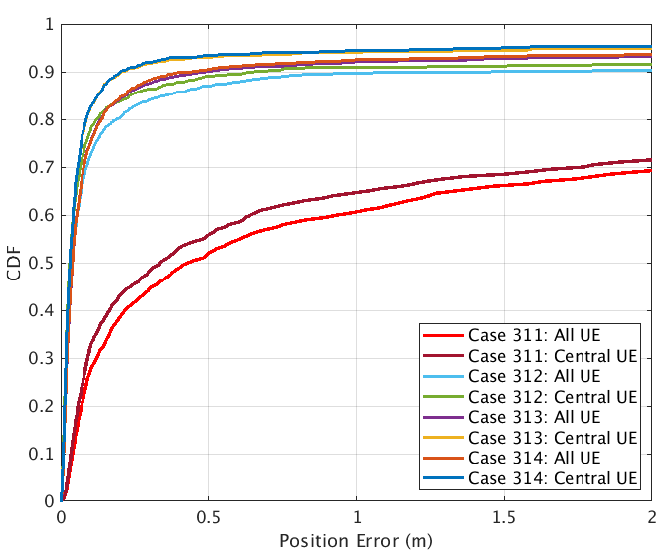

Figure 8.2.1.1.2-1: Positioning error results for LOS/NLOS identification from [X]

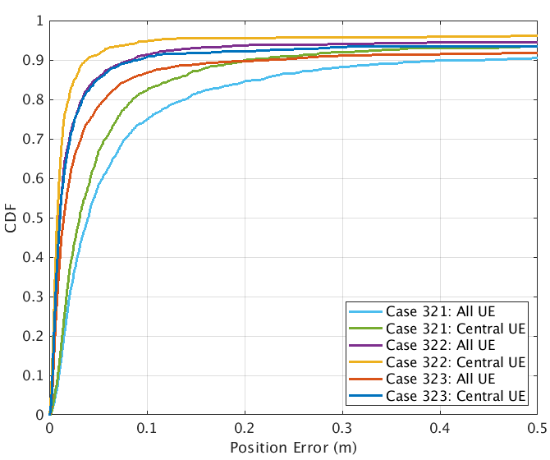

Figure 8.2.1.1.2-2: Positioning error results for PRS/SRS frequency aggregation from [X]

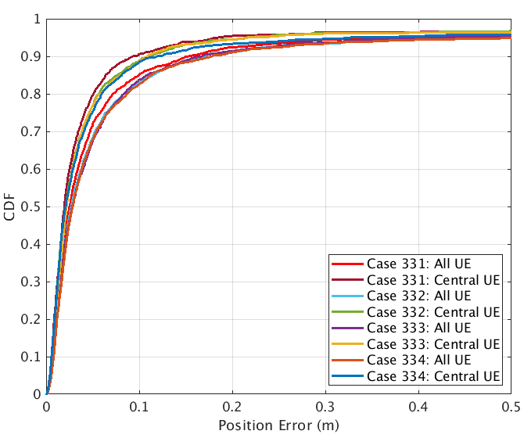

Figure 8.2.1.1.2-3: Positioning error results for 1-symbol PRS from [X]

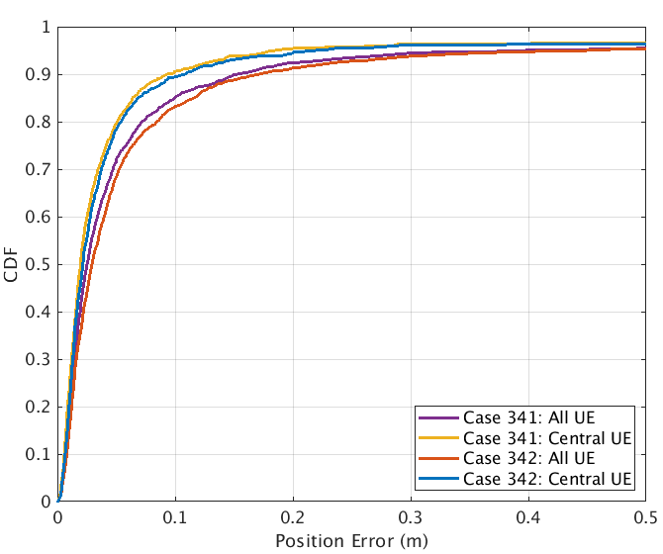

Figure 8.2.1.1.2-4: Positioning error results for PRS punctured by SSB from [X]

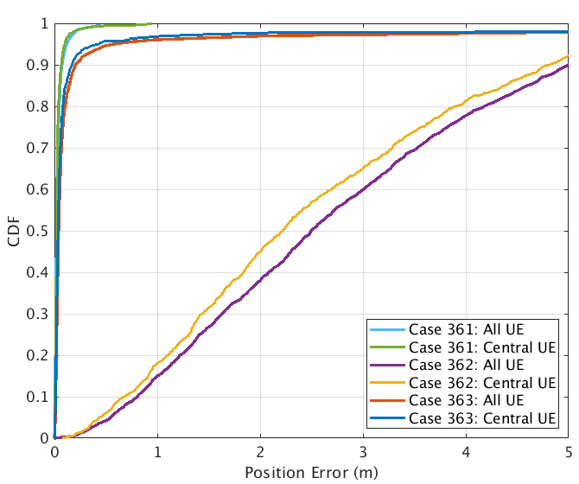

Figure 8.2.1.1.2-5: Positioning error results for UL-AoA enhancement with ULA from [X]

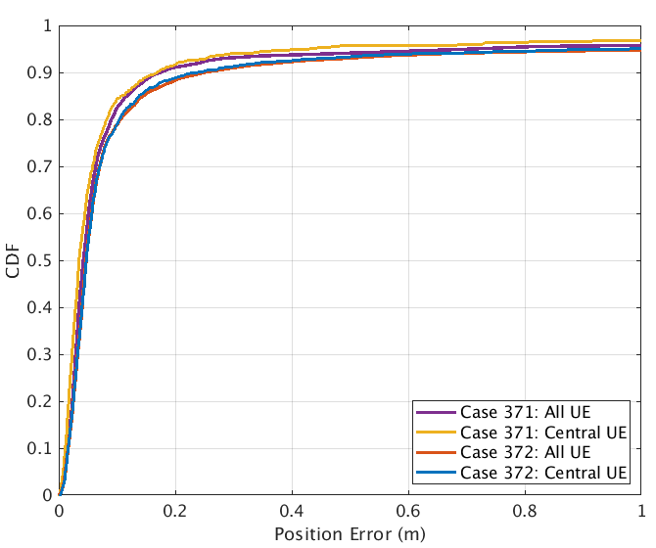

Figure 8.2.1.1.2-6: Positioning error results for E-CID enhancement from [X]

##### 8.2.1.1.3 Observations on NR positioning enhancements

Table 8.2.1.1.3-1 captures observations based on evaluations results of NR positioning enhancements for horizontal location error.

Table 8.2.1.1.3-1: NR positioning enhancements – horizontal accuracy performance summary [X]

|  |  |  |  |  |  |
| --- | --- | --- | --- | --- | --- |
| Simulation case  (Horizontal Error) | Gain vs Rel.16 solution, @[90]%, [m] | Accuracy achieved @[90]% | Commercial horizontal accuracy requirements [1]m @[90]% are met - Yes/No.  If no, provide performance gaps | IIoT horizontal accuracy requirements of [0.2]m @[90]%are met - Yes/No. If no, provide performance gaps | IIoT horizontal accuracy requirements of [0.5]m @[90]%are met -Yes/No.  If no, provide performance gaps |
| 311, InF-DH422, FR1, UL-TDOA | **Rel-16 baseline** | 9.6631 | No | No | No |
| 312, InF-DH422, FR1, UL-TDOA w/ RAIM | 9.0062 | 0.6569 | Yes | 0.4569 | 0.1569 |
| 313, InF-DH422, FR1, UL-TDOA w/ LOS/NLOS identification | 9.452 | 0.2111 | Yes | 0.0111 | Yes |
| 321, InF-DH422, FR1, UL-TDOA, 100M contiguous | **Rel-16 baseline** | 0.2022 | Yes | No | Yes |
| 322, InF-DH422, FR1, UL-TDOA, 200M contiguous | 0.1638 | 0.0384 | Yes | Yes | Yes |
| 323, InF-DH422, FR1, UL-TDOA, 50MHz+100MHz (Gap)+50MHz | 0.111 | 0.0912 | Yes | Yes | Yes |
| 331, InF-SH, FR1, DL-TDOA, Comb-4 and 4-symbol | **Rel-16 baseline** | 0.0939 | Yes | Yes | Yes |
| 332, InF-SH, FR1, DL-TDOA, Comb-4 and 1-symbol | -0.0184 | 0.1123 | Yes | Yes | Yes |
| 333, InF-SH, FR1, DL-TDOA, Comb-12 and 12-symbol | **Rel-16 baseline** | 0.1091 | Yes | Yes | Yes |
| 334, InF-SH, FR1, DL-TDOA, Comb-12 and 1-symbol | -0.0108 | 0.1199 | Yes | Yes | Yes |
| 341, InF-SH, FR1, DL-TDOA | **Rel-16 baseline** | 0.0939 | Yes | Yes | Yes |
| 342, InF-SH, FR1, DL-TDOA, 20-RB of PRS punctured by SSB | -0.0151 | 0.109 | Yes | Yes | Yes |
| 362, InF-DH422, FR1, UL-TDOA/AoA, ULA 4x1 w/ legacy AoA) | **Rel-16 baseline** | 0.0665 | No | No | No |
| 363, InF-DH422, FR1, UL-TDOA/AoA, ULA 4x1 w/ modified AoA | 4.6467 | 4.8161 | Yes | Yes | Yes |
| 371, InF-DH422, FR1, Multi-RTT | **Rel-16 baseline** | 0.1694 | Yes | Yes | Yes |
| 372, InF-DH422, FR1, E-CID w/ single cell RTT/AoA | -0.0701 | 0.2395 | Yes | No | Yes |

#### 8.2.1.2 Results from source [ZTE, R1-2007754]

##### 8.2.1.2.1 Description of evaluation scenarios

The evaluation scenarios in this contribution for verifying achievable accuracy based on enhanced positioning methods include,

* InF-DH (both FR1 and FR2) with fixed UE/gNB height and without network synchronization, ideal LOS identification is assumed.
* InF-DH (both FR1 and FR2) with fixed UE/gNB height and without network synchronization, Rician K-factor as assistance information to determine LOS and NLOS links.
* InF-DH (both FR1 and FR2) with fixed UE/gNB height and without network synchronization, coherence bandwidth as assistance information to determine LOS and NLOS links.

Some scenario common parameters can be found in Table 8.1.2.2.1-1. In addition, Table 8.2.1.2.1-1 reveals some controlled variables of all simulation cases.

**Table** 8.2.1.2.1-1 **All simulation cases for positioning accuracy evaluation based on enhanced positioning methods**

|  |  |  |  |  |  |  |
| --- | --- | --- | --- | --- | --- | --- |
| **Simulation cases** | **Scenario** | **FR1/FR2** | **Whether Rel-17 enhancement is implemented** | **UE horizontal drop procedure** | **gNB Tx calibration error** | **Clutter parameters** |
| Case 12 | InF-DH | FR1 | NO | Inside convex hull | 0ns | {40%, 2m, 2m} |
| Case 25 | InF-DH | FR1 | Ideal LOS identification | Inside convex hull | 0ns | {40%, 2m, 2m} |
| Case 26 | InF-DH | FR1 | Rician K-factor | Inside convex hull | 0ns | {40%, 2m, 2m} |
| Case 27 | InF-DH | FR1 | Coherence bandwidth | Inside convex hull | 0ns | {40%, 2m, 2m} |
| Case 17 | InF-DH | FR2 | NO | Inside convex hull | 0ns | {40%, 2m, 2m} |
| Case 28 | InF-DH | FR2 | Ideal LOS identification | Inside convex hull | 0ns | {40%, 2m, 2m} |
| Case 29 | InF-DH | FR2 | Rician K-factor | Inside convex hull | 0ns | {40%, 2m, 2m} |
| Case 30 | InF-DH | FR2 | Coherence bandwidth | Inside convex hull | 0ns | {40%, 2m, 2m} |

##### 8.2.1.2.2 Positioning accuracy evaluation results for NR positioning enhancements

Table 8.1.1.2.2-1 provides CDF of horizontal positioning accuracy at some specific percentiles for InF-DH scenario based on enhanced positioning method, and corresponding CDF curves can be found in Figure 8.2.1.2.2-1.

Table 8.2.1.2.2-1: NR positioning enhancements - horizontal location error results from [X]

|  |  |  |  |  |
| --- | --- | --- | --- | --- |
| **Cases** | **Horizontal positioning accuracy (m)** | | | |
| **50%** | **67%** | **80%** | **90%** |
| Case 12 | **0.414** | 1.060 | 7.337 | 12.345 |
| Case 25 | 0.261 | 0.371 | 0.493 | **0.648** |
| Case 26 | 0.294 | 0.4207 | **0.786** | 7.205 |
| Case 27 | 0.300 | 0.4232 | **0.659** | 2.003 |
| Case 17 | 0.062 | 0.097 | **0.174** | 12.174 |
| Case 28 | 0.047 | 0.062 | 0.080 | **0.107** |
| Case 29 | 0.053 | 0.074 | **0.101** | 9.248 |
| Case 30 | 0.051 | 0.069 | 0.091 | **0.228** |

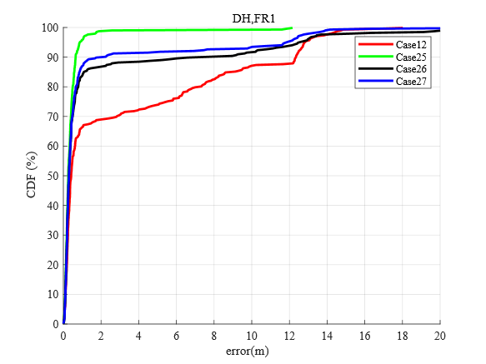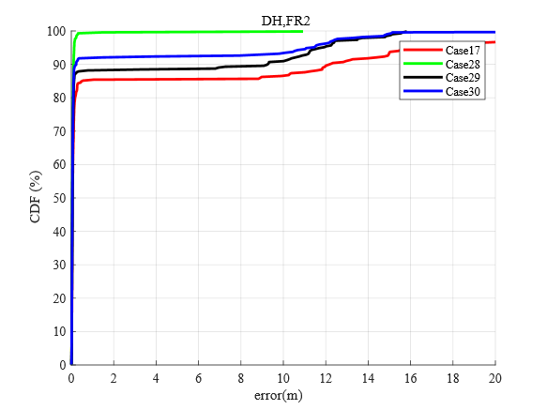

Figure 3-1 InF-DH, FR1 Figure 3-2 InF-DH, FR2

**Figure 8.2.1.2.2-1 Rel-17 enhancements with LOS identification**

##### 8.2.1.2.3 Observations on NR positioning enhancements

Table 8.2.1.1.3-1 captures observations based on evaluations results of NR positioning enhancements for horizontal location error.

Table 8.2.1.1.3-1: NR positioning enhancements – horizontal accuracy performance summary [X]

|  |  |  |
| --- | --- | --- |
| Simulation case  (Horizontal Error) | Gain vs Rel.16 solution, @[90]%, [m] | Accuracy achieved @[90]% |
| Case 26 | 5.140 | 7.205 |
| Case 27 | 10.342 | 2.003 |
| Case 29 | 2.926 | 9.248 |
| Case 30 | 11.946 | **0.228** |

Based on the evaluation results above, the following observation is summarized in the contribution,

***Observation 1:*** *For InF-DH scenario with enhancements on LOS identification,*

* *When positioning is done without assistance information, the positioning performance degrades rapidly for UEs connected with small LOS communication links.*
* *If ideal classification of LOS and NLOS links is assumed, all cases meet sub-meter level positioning accuracy requirement.*
* *By utilizing Rician K-factor and coherence bandwidth as assistance information, positioning accuracy is largely improved compared to without assistance information and sub-meter level positioning accuracy requirement can be fulfilled at the percentile of 90% UEs in FR2.*

#### 8.2.1.3 Results from source [CATT, R1-2007859]

##### 8.2.1.3.1 Description of evaluation scenarios

Evaluation assumptions for system level analysis of NR positioning accuracy enhancements are provided in Table 8.2.1.3.1-1.

* Case ID: 1 to 2.
* Scenario: InF-HH-2D.
* Frequency Band: FR1.
* Positioning Technique: DL-TDOA +DL-CPP, UL-TDOA + UL-CPP [R1-2007860].

**Table 8.2.1.3.1-1: NR positioning enhancements - evaluation scenarios and parameters [CATT, R1-2007859]**

|  |  |  |
| --- | --- | --- |
| **Parameter** | **[Case 1], [InF-HH-2D], [FR1], [DL-TDOA+ DL-CPP]** | **[Case 2], [InF-HH-2D], [FR1], [UL-TDOA+ UL-CPP]** |
| Channel model (baseline) | InF-HH-2D | InF-HH-2D |
| Carrier frequency | 3.5GHz | 3.5GHz |
| Subcarrier spacing | 30KHz | 30KHz |
| Reference Signal Transmission Bandwidth | 100MHz | 100MHz |
| Reference Signal Physical Structure and Resource Allocation (RE pattern) | DL PRS,  Comb- 6 | UL SRS,  Comb- 8 |
| Reference signal  (type of sequence, number of ports, …) | Gold sequence,  Port-1 | ZC sequence,  Port-1 |
| Number of sites | 6 | 6 |
| Number of symbols used per occasion | 12 | 12 |
| number of occasions used per positioning estimate | 1 | 1 |
| Power-boosting level | 7.78dB | 9dB |
| Uplink power control (applied/Not applied) | —— | —— |
| interference modelling (ideal muting, or other) | Ideal muting | Ideal muting |
| Description of Measurement Algorithm | MUSIC + PLL | MUSIC + PLL |
| Description of positioning technique / applied positioning algorithm (e.g. Least square, Taylor series, etc) | EKF + Chan | EKF + Chan |
| Network synchronization assumptions | Perfect | Perfect |
| UE/gNB Tx/Rx  Calibration Error | 0 | 0 |
| Beam-related assumption (beam sweeping / alignment assumptions at the tx and rx sides) | No | No |
| Precoding assumptions (codebook, nrof antenna elements used, etc) | No | No |
| Evaluated Enhancement  for Rel.17 | DL-TDOA+ DL-CPP | UL-TDOA+ UL-CPP |
| Additional Notes, if any | Double differential with reference UE to overcome network synchronization error [R1-2007860] | Double differential with reference UE to overcome network synchronization error  [R1-2007860] |

##### 8.2.1.3.2 Positioning accuracy evaluation results for NR positioning enhancements

Evaluation results of horizontal location error for NR positioning enhancements are provided in Table 8.2.1.3.2-1:

**Table 8.2.1.3.2-1: NR positioning enhancements - horizontal location error results from [CATT, R1-2007859]**

|  |  |  |  |  |  |
| --- | --- | --- | --- | --- | --- |
|  |  | 50% | 67% | 80% | 90% |
| [Case 1], [InF-HH-2D], [FR1], [DL- TDOA+ DL-CPP] | Convex UEs | 0.0218 | 0.0321 | 0.0387 | 0.051 |
| [Case 2], [InF-HH-2D], [FR1], [UL- TDOA+ UL-CPP] | Convex UEs | 0.0196 | 0.0306 | 0.0368 | 0.049 |

##### 8.2.1.3.3 Observations on NR positioning enhancements

Table 8.2.1.3.3-1 captures observations based on evaluations results of NR positioning enhancements for horizontal location error.

**Table 8.2.1.3.3-1: NR positioning enhancements – horizontal accuracy performance summary [CATT, R1-2007859]**

|  |  |  |  |  |
| --- | --- | --- | --- | --- |
| Simulation case  (Horizontal Error) | Gain vs Rel.16 solution, @[90]%, [m] | Accuracy achieved @[90]% | IIoT horizontal accuracy requirements of [0.2]m @[90]%are met - Yes/No. If No, provide performance gaps | IIoT horizontal accuracy requirements of [0.5]m @[90]%are met -Yes/No.  If No, provide performance gaps |
| [Case 1], [InF-HH-2D], [FR1], [DL- TDOA+ DL-CPP] | 0.133m Vs CASE 1 in section 8.1.1.1 | 0.051 | YES | YES |
| [Case 2], [InF-HH-2D], [FR1], [UL- TDOA+ UL-CPP] | 0.1261m Vs CASE 2 in section 8.1.1.1 | 0.049 | YES | YES |

#### 8.2.1.4 Results from source [Nokia, Nokia Shanghai Bell, R1-2008300]

##### 8.2.1.4.1 Description of evaluation scenarios

|  |  |  |
| --- | --- | --- |
| **Parameter** | Case 1 [InF-SH, UL-TDOA, FR1, 100 MHz] | Case 1 [InF-DH, UL-TDOA, FR1, 100 MHz] |
| **Channel model (baseline, otherwise state any modifications)** | Baseline | Baseline |
| **Reference Signal Physical Structure and Resource Allocation (RE pattern)** | Comb-2, 2 symbol SRS-Pos | Comb-2, 2 symbol SRS-Pos |
| **Reference signal (type of sequence, number of ports, …)** | NR SRS-Pos | NR SRS-Pos |
| **Number of sites** | 18 | 18 |
| **Number of symbols used per slot per positioning estimate** | 2 symbols per slot | 2 symbols per slot |
| **Number of slots per positioning estimate** | 1 slot | 1 slot |
| **Power-boosting level** | fixed power (max) | fixed power (max) |
| **Uplink power control (applied/not applied)** | Not applicable | Not applicable |
| **interference modelling (ideal muting, or other)** | Ideal muting | Ideal muting |
| **Description of Measurement Algorithm (e.g. super resolution, interference cancellation, ….)** | Thresholding, 0.5, (Oversampling x4) | Thresholding, 0.5, (Oversampling x4) |
| **Description of positioning technique / applied positioning algorithm (e.g. Least square, taylor series, etc)** | Taylor Series, Least Squares | Taylor Series, Least Squares |
| **Network synchronization assumptions** | Perfect Synchronization | Perfect Synchronization |
| **Beam-related assumption (beam sweeping / alignment assumptions at the tx and rx sides)** | N/A | N/A |
| **Precoding assumptions (codebook, nr of antenna elements used, etc)** | N/A | N/A |
| **Additional notes, if any** | LoS detector and Outlier rejection algorithm based on relative path powers | LoS detector and Outlier rejection algorithm based on relative path powers |

##### 8.2.1.4.2 Positioning accuracy evaluation results for NR positioning enhancements

|  |  |  |  |  |  |
| --- | --- | --- | --- | --- | --- |
| Case | UEs | 50% | 67% | 80% | 90% |
| Case 1, [InF-SH, UL-TDOA, FR1,100 MHz] | Convex UEs | 0.38 | 0.55 | 1.06 | 1.94 |
| Case 2, [InF-DH, UL-TDOA, FR1, 100 MHz] | Convex UEs | 1.60 | 2.35 | 3.08 | 4.2 |

##### 8.2.1.4.3 Observations on NR positioning enhancements

### 8.2.2 Physical layer latency analysis for NR positioning enhancements

#### 8.2.2.1 Results from source [X]

##### 8.2.2.1.1 Description of evaluation scenarios

The physical layer latency for the following positioning methods are provided

* Enhanced UL E-CID

##### 8.2.2.1.2 Latency analysis of NR positioning enhancements

Latency analysis for the Rel.16 NR positioning is provided ins Table 8.2.2.1.2-1 and 8.2.2.1.2-2.

Table 8.2.2.1.2-1: NR positioning enhancements – latency analysis [X]

|  |  |  |
| --- | --- | --- |
| Case L101, UL E-CID w/ measurements available  Source NW/Destination NW  Positioning technique UL-E-CID, type DL+UL, mode UE-A,  Initial and Final RRC States CONNECTED  Assuming UE Rx – Tx time difference is already available | | |
| Latency Components | Value Range, ms | Description of Latency Component |
| Start trigger |  | Reception by the gNB of the NRPPa measurement request message |
| gNB Rx higher layer processing | 3ms | Processing NRPPa message from the NGAP message |
| gNB Rx – Tx time difference measurement and AoA measurements | 0-20ms | Assuming SRS periodicity is 20ms |
| gNB Tx higher layer processing | 3ms | Processing NRPPa message into the NGAP message |
| End trigger |  | The transmission by the gNB of the NRPPa measurement response message |
| Total values | 6-26ms |  |

Table 8.2.2.1.2-2: NR positioning enhancements – latency analysis [X]

|  |  |  |
| --- | --- | --- |
| Case L102, UL E-CID w/o measurements available  Source NW/Destination NW  Positioning technique UL-E-CID, type DL+UL, mode UE-A,  Initial and Final RRC States CONNECTED  Assuming UE Rx – Tx time difference is not available | | |
| Latency Components | Value Range, ms | Description of Latency Component |
| Start trigger |  | Reception by the gNB of the NRPPa measurement request message |
| gNB Rx higher layer processing | 3ms | Processing NRPPa message from the NGAP message |
| gNB Tx higher layer processing | 3ms | Configuration of UE Rx – Tx time difference based on SRS and TRS/CSI-RS |
| PDSCH scheduling | 0.5-1ms | Considering TDD configuration DDDSU, using D or S to transmit PDSCH. |
| UE Rx higher layer processing | 10ms | RRC reconfiguration delay in TS 38.331 |
| UE Rx – Tx time difference measurement/gNB Rx – Tx time difference measurement and AoA measurements | 20ms | Assuming TRS/CSI-RS periodicity is 20ms  Assuming SRS periodicity is 20ms |
| UE Tx higher layer processing | 3ms | UL RRC message preparation for RRM measurement reporting, including UE Rx – Tx time difference measurement |
| PUSCH scheduling | 0.5-7.5ms | Considering TDD configuration DDDSU, using U to transmit PUSCH, the maximum delay could be SR 🡪 BSR 🡪 PUSCH using 3 cycles. The minimum delay could be a slot. |
| gNB Rx higher layer processing | 3ms | Processing UL-SCH containing the measurement and including gNB measurements |
| gNB Tx higher layer processing | 3ms | Processing NRPPa message into the NGAP message |
| End trigger |  | The transmission by the gNB of the NRPPa measurement response message |
| Total values | 46-53.5ms |  |

##### 8.2.2.1.3 Observations on NR positioning latency enhancements

Observations on NR positioning latency enhancements are provided in Table 8.2.2.1.3-1.

Table 8.2.2.1.3-1: NR positioning enhancements - physical layer latency performance summary [X]

|  |  |  |  |  |  |
| --- | --- | --- | --- | --- | --- |
| Description  Evaluation Case | L1 Latency,ms | Gain over R16, ms | Commercial requirements [100]ms are met  Yes/No.  If no, provide performance gaps | IIoT requirements of [10]ms are met  Yes/No.  If no, provide performance gaps | IIoT requirements of [100]ms are met  Yes/No.  If no, provide performance gaps |
| Case L101, UL E-CID w/ measurements available | 6-26ms | 0 | Yes | Yes/No | Yes |
| Case L102, UL E-CID w/o measurements available | 46-53.5ms | Negative | Yes | No | Yes |

#### 8.2.2.2 Results from source [CATT, R1-2007859]

##### 8.2.2.2.1 Description of evaluation scenarios

For DL positioning enhancement, aperiodic PRS (A-PRS) could be introduced to reduce positioning latency. In this section, evaluation scenarios and parameters for positioning latency analysis of A-PRS based positioning solution are given as below:

* Case ID: 1.
* SCS: 15kHz.
* Frequency Band: FR1.
* Positioning Technique: DL-TDOA.
* Periodicity of PRS: Aperiodic PRS [R1-2007860]
* Duration time of PRS: 4ms

##### 8.2.2.2.2 Latency analysis of NR positioning enhancements

For DL positioning enhancement, aperiodic PRS could be introduced. From our point of view, aperiodic measurement gap can be configured for aperiodic PRS [R1-2007860]. Therefore, whenever triggering, UE should measure those PRS resources. In addition, for measurement reporting, the SR request and UL grant procedures could be arranged before A-PRS triggering. Therefore, the reporting time could be reduced further. The enhanced procedure of DL-TDOA is shown in Figure 3.



**Figure 3: Enhanced PHY procedure for DL-TDOA**

The total delay could be calculated as



where,

* denotes the time to receive and decode the A-PRS triggering signaling.
* denotes the delay when DL PRS is received, which is related to the PRS offset value configured by the A-PRS triggering signaling
* denotes the time from UE begins to measure PRS until the measurement result is ready, which is related to UE capability and the number of PRS resources needed to be measured.
* denotes the time for measurement reporting, which includes SR request, PDCCH-based UL grant and PUSCH-based measurement result reporting..

Assume DCI signalling is used to trigger A-PRS, 1ms could be assumed for $T_{trig}$. Current UE capability is defined as N ms of DL PRS symbols being processed in every T ms for a given maximum bandwidth (B) in MHz supported by UE. N = {0.125, 0.25, 0.5, 1, 2, 4, 8, 12, 16, 20, 25, 30, 35, 40, 45, 50}ms and T = {8, 16, 20, 30, 40, 80, 160, 320, 640, 1280}ms. Assume Y ms of PRS resources are configured, the processing time could be calculated as $T_{process}=\frac{Y}{N}∙T$.

Summary of latency performance analysis for NR positioning enhancements is provided in Table 8.2.2.2.2-1 with the assumption of SCS 15 kHz, and a moderate UE capability, i.e. N=4, T=8, the.

**Table 8.2.2.2.2-1: NR positioning enhancements – latency analysis [CATT, R1-2007859]**

|  |  |  |
| --- | --- | --- |
| Case 1, 15kHz, FR1, DL-TDOA  Source UE / Destination NW  Positioning technique DL-TDOA, type DL, mode UE-assisted,  Initial and Final RRC States CONNECTED | | |
| Latency Component | Value Range, ms | Description of Latency Component |
| Start trigger | 1 | receive and decode the A-PRS triggering signaling |
| PRS arrival delay | 4 | DL PRS arrived for measurement, which is related to the PRS offset value configured by the A-PRS triggering signaling |
| Process time |, (e.g. X=8 for Y=4, N=4, T=8 ) | UE begins to measure PRS until the measurement result is ready. This value depends on UE capability the number of PRS resources to be measured. |
| End trigger | 0.5 | PUSCH-based measurement result reporting are included |
| Total values | 13.5 |  |

##### 8.2.2.2.3 Observations on NR positioning latency enhancements

**Table 8.2.2.2.3-1: NR positioning enhancements - physical layer latency performance summary [CATT, R1-2007859]**

|  |  |  |  |  |  |
| --- | --- | --- | --- | --- | --- |
| Description  Evaluation Case | L1 Latency,  ms | Gain over R16, ms | Commercial requirements [100]ms are met  Yes/No.  If No, provide performance gaps | IIoT requirements of [10]ms are met  Yes/No.  If No, provide performance gaps | IIoT requirements of [100]ms are met  Yes/No.  If No, provide performance gaps |
| Case 1, 15kHz, FR1, DL-TDOA | 13.5 | 38 | Yes | No (3.5ms gap) | Yes |

## 8.3 Efficiency analysis for NR positioning enhancements

### 8.3.1 Network efficiency analysis for NR positioning enhancements

#### 8.3.1.1 Results from source [X]

##### 8.3.1.1.1 Description of evaluation scenarios

1-symbol PRS with comb-4 and comb-12 is evaluated compared to 4-symbol and 12-symbol, respectively, assuming

* PRS transmission periodicity is 160ms
* PRS numerology is 30kHz
* 8 PRS resources with 12 symbols or 4 symbols per PRS resource
* The PRS bandwidth is 100MHz

In addition, E-CID is also compared against PRS-based methods.

##### 8.3.1.1.2 Network efficiency analysis of NR positioning enhancements

The evaluation results are summarized in Table 8.3.1.1.2-1.

Table 8.3.1.1.2-1: NR positioning enhancements – network efficiency summary [X]

|  |  |
| --- | --- |
| Case | Positioning resource utilization |
| Case E1: PRS with 12 symbols | 2.14% |
| Case E2: PRS with 4 symbols | 0.714% |
| Case E3: PRS with 1 symbol | 0.179% |
| Case E4: E-CID enhancement | 0% |

By reducing the PRS symbols from 12 and 4 to 1 for comb-12 and comb-4, respectively, the overhead of PRS transmission is reduced by 11/12 and 3/4, respectively.

Moreover, by allowing 1-symbol PRS transmission, network may reuse CSI-RS for mobility for positioning, further reducing the PRS overhead.

Since enhanced E-CID may only use existing communication signals, it has not extra positioning overhead.

##### 8.3.1.1.3 Observations on network efficiency of NR positioning enhancements

The single PRS symbol transmission achieves almost the same accuracy with that of multiple PRS symbols for InF scenarios, yet with reduced network overhead.

E-CID can achieve similar performance compared to Multi-RTT for InF-DH scenarios, yet without any additional network overhead compared to communication.

#### 8.3.1.2 Results from source [CATT, R1-2007859]

##### 8.3.1.2.1 Description of evaluation scenarios

In this section, evaluation scenarios and parameters of network efficiency analysis for NR positioning enhancements are given in Table 8.2.3.1.1-1.

**Table 8.2.3.1.1-1: NR positioning enhancements - evaluation scenarios and parameters [CATT, R1-2007859]**

|  |  |  |
| --- | --- | --- |
| **Parameter** | **[Case 1], [InF-HH-2D], [FR1], [DL-TDOA+ DL-CPP]** | **[Case 2], [InF-HH-2D], [FR1], [UL-TDOA+ UL-CPP]** |
| Channel model (baseline) | InF-HH-2D | InF-HH-2D |
| Carrier frequency | 3.5GHz | 3.5GHz |
| Subcarrier spacing | 30KHz | 30KHz |
| System Bandwidth | 100MHz | 100MHz |
| Reference Signal Transmission Bandwidth | 100MHz | 100MHz |
| Reference Signal Physical Structure and Resource Allocation (RE pattern) | DL PRS,  Comb- 6 | UL SRS,  Comb- 8 |
| Reference signal  (type of sequence, number of ports, …) | Gold sequence,  Port-1 | ZC sequence,  Port-1 |
| Number of sites | 6 | 6 |
| Number of symbols used per occasion | 12 | 12 |
| number of occasions used per positioning estimate | 1 | 1 |
| Evaluated Enhancement  for Rel.17 | DL-TDOA+ DL-CPP | UL-TDOA+ UL-CPP |
| Periodicity of reference signal | 20ms | 20ms |
| Number of PRS resource sets in one periodicity | 1 | 1 |
| Number of PRS Resources per PRS resource set | 1 | 1 |
| Number of users per site | 1,30 | 1,30 |

##### 8.3.1.2.2 Network efficiency analysis of NR positioning enhancements

For the proposed NR positioning enhancements, we use DL-TDOA+DL-CPP or UL-TDOA+UL-CPP as the Rel.17 enhancement scheme. Carrier Phase Positioning can be supported by using Rel.16 DL-PRS or UL-SRS, i.e., the UE or gNB can get the carrier phase measurements together with other NR positioning measurements without additional RF resources and new reference signals. Therefore, the network efficiency of our proposed NR positioning enhancements is the same as that of Rel.16 positioning solutions.

The definition of DL-PRS/UL-SRS resource utilization and the calculation of DL-PRS/UL-SRS resource utilization according to the described definition are shown as in below.

* **Definition of DL-PRS resource utilization**

Assume gNB *x* has *M* TRPs (the index of TRP is *j*, and *j=1~M-1*) which are configured to transmit DL-PRS, and each TRP is configured with *N* DL-PRS resource sets (the index of DL-PRS resource set is *i*, *i=1~N-1*). In order to avoid the interference among these DL-PRS resource sets, either the time-domain resources or the frequency-domain resources are orthogonal among these DL-PRS resource sets belongs to the same gNB.

We use *DL_PRS_RU* to denote DL-PRS resource utilization, then the DL-PRS resource utilization of gNB *x* (${DL_PRS_RU}_{gNB x}$) can be derived as follows,











* **Calculation of DL-PRS resource utilization**

The calculation of DL-PRS resource utilization according to the above described definition are shown as follows,











* **Definition of SRS-Pos resource utilization**

Assume gNB *x* serves *M* UEs (the index of UE is *j*, and *j=1~M-1*) which are configured to transmit SRS-Pos, and each UE is configured with *N* SRS-Pos resource sets (the index of SRS-Pos resource set is *i*, *i=1~N-1*). In order to avoid the interference among these SRS-Pos resource sets, either the time-domain resources or the frequency-domain resources are orthogonal among these SRS-Pos resource sets belongs to the same gNB.

We use *SRS_Pos_RU* to denote SRS-Pos resource utilization, then the SRS-Pos resource utilization of gNB *x* (${SRS_Pos_RU}_{gNB x}$) can be derived as follows,











* **Calculation of SRS-Pos resource utilization**

The calculation of UL-SRS resource utilization according to the above described definition are shown as follows,









When there are 1 user per site,



When there are 30 users per site,



##### 8.3.1.2.3 Observations on network efficiency of NR positioning enhancements

Although the carrier phase positioning (CPP) scheme needs to measure the carrier phase to calculate the UE position, considering Rel.16 DL-PRS or UL-SRS can be reused to complete the carrier phase measurement, there is no increase in terms of reference signal resource overhead as the metric for network efficiency, compared with Rel.16 positioning solutions.

***Observation 1: NR positioning enhancements with carrier phase measurements* *has no impact on UE and network RF resource usage efficiency.***

### 8.3.2 UE efficiency analysis for NR positioning enhancements

#### 8.3.2.1 Results from source [X]

##### 8.3.2.1.1 Description of evaluation scenarios

The UE efficiency is evaluated based on UE power consumption. The following evaluation assumptions on UE power model besides what is already defined TR 38.840 are considered for PRS Rx and SRS Tx.

The both DL PRS Rx related and UL SRS Tx related power evaluation,

* The following C-DRX configuration are assumed
  + C-DRX cycle 160msec
    - 8 msec on-duration timer
    - 100 msec inactivity timer
* The following I-DRX configuration are assumed
  + I-DRX cycle 1.28msec
* Table 8.3.2.1.1-1 shows the UE power model for IDLE/INACTIVE state

Table 8.3.2.1.1-1: UE power model for IDLE/INACTIVE state [X]

|  |  |  |
| --- | --- | --- |
| **Power State** | **Relative Power**  **(FR1 reference from TR 38.840)** | **Relative Power  (Idle/inactive-mode operation with reception bandwidth 20 MHz)** |
| Deep Sleep (PDS) | 1 | 1 |
| Light Sleep (PLS) | 20 | 20 |
| Micro sleep (PMS) | 45 | 45 |
| PDCCH-only (PPDCCH) | 100 | 50Note |
| PDCCH + PDSCH (PPDCCH+PDSCH) | 300 | 120 |
| PDSCH-only (PPDSCH) | 280 | 112 |
| SSB/CSI-RS proc. (PSSB) | 100 (synchronization or serving cell measurement) | 50 |
| Intra-frequency RRM measurement (Pintra) | ·        150 (synchronous case, N=8, measurement only; Pintra, meas-only)  ·        200 (combined search and measurement; Pintra, search+meas) | ·        [60] (synchronous case, N=8, measurement only; Pintra, meas-only)  ·        [80] (combined search and measurement; Pintra, search+meas) |
| Inter-frequency RRM measurement (Pinter) | ·        150 (measurement only per freq. layer; Pinter, meas-only)  ·        150 (neighbor cell search power per freq. layer; Pinter, search-only)  ·        Micro sleep power assumed for switch in/out a freq. layer | ·        [60] (measurement only per freq. layer; Pinter, meas-only)  ·        [150] (neighbor cell search power per freq. layer; Pinter, search-only)  ·        Micro sleep power assumed for switch in/out a freq. layer |
| Note: Power scaling to 20MHz reception bandwidth follows the rule in Section 8.1.3 of TR 38.840, i.e., max{reference power * 0.4, 50}. | | |

For DL PRS Rx related power evaluation:

* Table 8.3.2.1.1-2 shows the PRS Rx power model
* Figures 8.3.2.1.1-1 and 8.3.2.1.1-2 show the UE power state transit for IDLE/INACTIVE state and CONNECTED state, respectively

Table 8.3.2.1.1-2: UE PRS Rx power model [X]

|  |  |  |
| --- | --- | --- |
| N: Number of TRPs for intra-frequency measurement & search | Synchronous case | |
| FR1 | FR2 |
| N=8 | 200 | 320 |



Figure 8.3.2.1.1-1: UE power state transit for IDLE/INACTIVE state from [X]



Figure 8.3.2.1.1-2: UE power state transit for CONNECTED state from [X]

For UL SRS Tx related power evaluation:

* Figure 8.3.2.1.1-3 shows the slot-level UE behaviour for the purpose SRS Tx and Paging DRX
* Figures 8.3.2.1.1-4 and 8.3.2.1.1-5 show the UE power state transit for IDLE/INACTIVE state and CONNECTED state, respectively



Figure 8.3.2.1.1-3: Slot-level behaviour for UE to transmit SRS in IDLE/INACTIVE state from [X]



Figure 8.3.2.1.1-4: UE power state transit for IDLE/INACTIVE state from [X]



Figure 8.3.2.1.1-5: UE power state transit for CONNECTED state from [X]

##### 8.3.2.1.2 UE efficiency analysis of NR positioning enhancements

The UE power consumption for PRS Rx is shown in Table 8.3.2.1.2-1.

Table 8.3.2.1.2-1: UE PRS Rx power consumption [X]

|  |  |  |  |  |  |
| --- | --- | --- | --- | --- | --- |
| Case P1: IDLE/INACTIVE state in every 1.28s | | | | | |
| Power state | Power unit | # slot | Power | Slot ratio | Power ratio |
| PDCCH-only | 50 | 2 | 100 | 0.0781% | 0.3789% |
| SSB RRM | 80 | 4 | 320 | 0.1563% | 1.2125% |
| Micro-sleep | 45 | 6 | 270 | 0.2344% | 1.0230% |
| PRS RRM | 200 | 96 | 19200 | 3.7500% | 72.7493% |
| Deep sleep | 1 | 2452 | 2452 | 95.7813% | 24.6363% |
| -- State transit | 450 | 9 | 4050 |
| Total |  | 2560 | 26392 | 100.0000% | 100.0000% |
|  |  |  |  |  |  |
| Case P2: CONNECTED state inside on-duration in every 1.28s | | | | | |
| Power state | Power unit | # slot | Power | Slot ratio | Power ratio |
| PDCCH-only | 100 | 32 | 3200 | 1.2500% | 11.2549% |
| PRS RRM | 200 | 96 | 19200 | 3.7500% | 67.5295% |
| Deep sleep | 1 | 2432 | 2432 | 95.0000% | 21.2155% |
| -- State transit | 450 | 8 | 3600 |
| Total |  | 2560 | 28432 | 100.0000% | 100.0000% |
|  |  |  |  |  |  |
| Case P3: CONNECTED state outside on-duration in every 1.28s | | | | | |
| Power state | Power unit | # slot | Power | Slot ratio | Power ratio |
| PDCCH-only | 100 | 128 | 12800 | 5.0000% | 33.7410% |
| PRS RRM | 200 | 96 | 19200 | 3.7500% | 50.6116% |
| Deep sleep | 1 | 2336 | 2336 | 91.2500% | 15.6474% |
| -- State transit | 450 | 8 | 3600 |
| Total |  | 2560 | 37936 | 100.0000% | 100.0000% |

The UE power consumption for SRS Tx is shown in Table 8.3.2.1.2-2.

Table 8.3.2.1.2-2: UE SRS Tx power consumption [X]

|  |  |  |  |  |  |
| --- | --- | --- | --- | --- | --- |
| Case P4: IDLE/INACTIVE state in every 1.28s | | | | | |
| Power state | Power unit | # slot | Power | Slot ratio | Power ratio |
| PDCCH-only | 50 | 2 | 100 | 0.0781% | 0.8396% |
| SSB RRM | 80 | 32 | 2560 | 1.2500% | 21.4945% |
| Micro-sleep | 45 | 33 | 1485 | 1.2891% | 12.4685% |
| SRS Tx | 210 | 8 | 1680 | 0.3125% | 14.1058% |
| Deep sleep | 1 | 2485 | 2485 | 97.0703% | 51.0915% |
| -- State transit | 450 | 8 | 3600 |
| Total |  | 2560 | 11910 | 100.0000% | 100.0000% |
|  |  |  |  |  |  |
| Case P5: CONNECTED state outside on-duration in every 1.28s | | | | | |
| Power state | Power unit | # slot | Power | Slot ratio | Power ratio |
| PDCCH-only | 100 | 120 | 12000 | 4.6875% | 60.8766% |
| SRS Tx | 210 | 8 | 1680 | 0.3125% | 8.5227% |
| Deep sleep | 1 | 2432 | 2432 | 95.0000% | 30.6006% |
| -- State transit | 450 | 8 | 3600 |
| Total |  | 2560 | 19712 | 100.0000% | 100.0000% |

##### 8.3.2.1.3 Observations on UE efficiency of NR positioning enhancements

Observations on NR positioning UE efficiency enhancements are provided in Table 8.3.2.1.3-1.

Table 8.3.2.1.3-1: NR positioning enhancements – UE efficiency summary [X]

|  |  |  |
| --- | --- | --- |
| Description  Evaluation Case | Power consumption | Power saved |
| Case P1: IDLE/INACTIVE state in every 1.28s | 26392 | 7.2% to Case P2  30.4% to Case P3 |
| Case P2: CONNECTED state inside on-duration in every 1.28s | 28432 | - |
| Case P3: CONNECTED state outside on-duration in every 1.28s | 37936 | - |
| Case P4: IDLE/INACTIVE state in every 1.28s | 11910 | 39.6% to Case P5 |
| Case P5: CONNECTED state outside on-duration in every 1.28s | 19712 | - |

**--------------------------------------- End of template for collection of NR positioning results ---------------------------------**