**--------------------------------------- Start of template for collection of NR positioning results --------------------------------**

# 8 Performance evaluations for R17 performance targets

## 8.1 Performance analysis of Rel-16 positioning solutions

Including accuracy and latency (objective 1b) performance, compared to rel17 performance targets

### 8.1.1 Positioning accuracy analysis

#### 8.1.1.1 Results from source [X]

##### 8.1.1.1.1 Description of evaluation scenarios

The scenarios to be presented in this contribution include

* Baseline scenarios with InF-SH/InF-DH with fixed UE/gNB height and without UE/gNB calibration error (Case 0xx series)
* InF-DH with variable UE/gNB height (Case 1xx series)
* InF-SH/In-DH with UE/gNB calibration error (Case 2xx series)

Evaluation assumptions for system level analysis are provided in Table 8.1.1.1.1-1 to 8.1.1.1.1-5.

Table 8.1.1.1.1-1: Rel.16 NR positioning (baseline) - evaluation scenarios and parameters

|  |  |  |  |  |  |  |  |  |
| --- | --- | --- | --- | --- | --- | --- | --- | --- |
| Parameter | Case 1 (InF-SH, FR1) | Case 2 (InF-SH, FR1) | Case 3 (InF-SH, FR1) | Case 4 (InF-SH, FR1) | Case 5 (InF-DH, FR1) | Case 6 (InF-DH, FR1) | Case 7 (InF-DH, FR1) | Case 8 (InF-DH, FR1) |
| Channel model (baseline, otherwise state any modifications) | InF-SH | InF-SH | In-SH | InF-SH | InF-DH  (40%, 2, 2) | InF-DH  (40%, 2, 2) | InF-DH  (40%, 2, 2) | InF-DH  (40%, 2, 2) |
| Carrier frequency | 3.5GHz | 3.5GHz | 3.5GHz | 3.5GHz | 3.5GHz | 3.5GHz | 3.5GHz | 3.5GHz |
| Subcarrier spacing | 30kHz | 30kHz | 30kHz | 30kHz | 30kHz | 30kHz | 30kHz | 30kHz |
| Reference Signal Transmission Bandwidth | 100MHz | 100MHz | 100MHz | 100MHz | 100MHz | 100MHz | 100MHz | 100MHz |
| Reference Signal Physical Structure and Resource Allocation (RE pattern) (reference to figure in contribution) | DL-PRS (Comb-4, 4 symbol) | PosSRS (Comb-4, 4 symbol) | PosSRS (Comb-4, 4 symbol) | DL-PRS+PosSRS (Comb-4, 4 symbol) | DL-PRS (Comb-4, 4 symbol) | PosSRS (Comb-4, 4 symbol) | PosSRS (Comb-4, 4 symbol) | DL-PRS+PosSRS (Comb-4, 4 symbol) |
| Reference signal  (type of sequence, number of ports, …) | Gold, single port | ZC, single port | ZC, single port | Gold/ZC, single port | Gold, single port | ZC, single port | ZC, single port | Gold/ZC, single port |
| Number of sites | 7 | 7 | 7 | 7 | 7 | 7 | 7 | 7 |
| Number of symbols used per occasion | 4 | 4 | 4 | 4 | 4 | 4 | 4 | 4 |
| number of occasions used per positioning estimate | 1 | 1 | 1 | 1 | 1 | 1 | 1 | 1 |
| Power-boosting level | 6dB | 6dB | 6dB | 6dB | 6dB | 6dB | 6dB | 6dB |
| Uplink power control (applied/not applied) | Not applied | Not applied | Not applied | Not applied | Not applied | Not applied | Not applied | Not applied |
| interference modelling (ideal muting, or other) | Ideal | Ideal | Ideal | Ideal | Ideal | Ideal | Ideal | Ideal |
| Description of Measurement Algorithm (e.g. super resolution, interference cancellation, ….) | Super resolution  No LOS/NLOS detection | Super resolution  No LOS/NLOS detection | Super resolution  No LOS/NLOS detection | Super resolution  No LOS/NLOS detection | Super resolution  No LOS/NLOS detection | Super resolution  No LOS/NLOS detection | Super resolution  No LOS/NLOS detection | Super resolution  No LOS/NLOS detection |
| Description of positioning technique / applied positioning algorithm (e.g. Least square, Taylor series, etc) | DL-TDOA  PSO | UL-TDOA  PSO | UL-TDOA+UL-AoA  PSO | Multi-RTT  PSO | DL-TDOA  PSO | UL-TDOA  PSO | UL-TDOA+UL-AoA  PSO | Multi-RTT  PSO |
| Network synchronization assumptions | Ideal | Ideal | Ideal | Ideal | Ideal | Ideal | Ideal | Ideal |
| UE/gNB Tx/Rx  Calibration Error | Ideal | Ideal | Ideal | Ideal | Ideal | Ideal | Ideal | Ideal |
| Beam-related assumption (beam sweeping / alignment assumptions at the tx and rx sides) | Tx beam sweeping | Tx beam sweeping | Tx beam sweeping | Tx beam sweeping | Tx beam sweeping | Tx beam sweeping | Tx beam sweeping | Tx beam sweeping |
| Precoding assumptions (codebook, nrof antenna elements used, etc) | Tx codebook-based | Tx codebook-based | Tx codebook-based | Tx codebook-based | Tx codebook-based | Tx codebook-based | Tx codebook-based | Tx codebook-based |
| Additional notes, if any | Fixed UE/gNB height. | Fixed UE/gNB height. | Fixed UE/gNB height. | Fixed UE/gNB height. | Fixed UE/gNB height. | Fixed UE/gNB height. | Fixed UE/gNB height. | Fixed UE/gNB height. |

Table 8.1.1.1.1-2: Rel.16 NR positioning (baseline) - evaluation scenarios and parameters

|  |  |  |  |  |  |  |  |  |
| --- | --- | --- | --- | --- | --- | --- | --- | --- |
| Parameter | Case 9 (InF-SH, FR2) | Case 10 (InF-SH, FR2) | Case 11 (InF-SH, FR2) | Case 12 (InF-SH, FR2) | Case 13 (InF-DH, FR2) | Case 14 (InF-DH, FR2) | Case 15 (InF-DH, FR2) | Case 16 (InF-DH, FR2) |
| Channel model (baseline, otherwise state any modifications) | InF-SH | InF-SH | In-SH | InF-SH | InF-DH  (40%, 2, 2) | InF-DH  (40%, 2, 2) | InF-DH  (40%, 2, 2) | InF-DH  (40%, 2, 2) |
| Carrier frequency | 28GHz | 28GHz | 28GHz | 28GHz | 28GHz | 28GHz | 28GHz | 28GHz |
| Subcarrier spacing | 120kHz | 120kHz | 120kHz | 120kHz | 120kHz | 120kHz | 120kHz | 120kHz |
| Reference Signal Transmission Bandwidth | 400MHz | 400MHz | 400MHz | 400MHz | 400MHz | 400MHz | 400MHz | 400MHz |
| Reference Signal Physical Structure and Resource Allocation (RE pattern) (reference to figure in contribution) | DL-PRS (Comb-4, 4 symbol) | DL-PRS (Comb-4, 4 symbol) | PosSRS (Comb-4, 4 symbol) | DL-PRS+PosSRS (Comb-4, 4 symbol) | DL-PRS (Comb-4, 4 symbol) | DL-PRS (Comb-4, 4 symbol) | PosSRS (Comb-4, 4 symbol) | DL-PRS+PosSRS (Comb-4, 4 symbol) |
| Reference signal  (type of sequence, number of ports, …) | Gold, single port | Gold, single port | ZC, single port | Gold/ZC, single port | Gold, single port | Gold, single port | ZC, single port | Gold/ZC, single port |
| Number of sites | 7 | 7 | 7 | 7 | 7 | 7 | 7 | 7 |
| Number of symbols used per occasion | 4 | 4 | 4 | 4 | 4 | 4 | 4 | 4 |
| number of occasions used per positioning estimate | 1 | 1 | 1 | 1 | 1 | 1 | 1 | 1 |
| Power-boosting level | 6dB | 6dB | 6dB | 6dB | 6dB | 6dB | 6dB | 6dB |
| Uplink power control (applied/not applied) | Not applied | Not applied | Not applied | Not applied | Not applied | Not applied | Not applied | Not applied |
| interference modelling (ideal muting, or other) | Ideal | Ideal | Ideal | Ideal | Ideal | Ideal | Ideal | Ideal |
| Description of Measurement Algorithm (e.g. super resolution, interference cancellation, ….) | Super resolution  No LOS/NLOS detection | Super resolution  No LOS/NLOS detection | Super resolution  No LOS/NLOS detection | Super resolution  No LOS/NLOS detection | Super resolution  No LOS/NLOS detection | Super resolution  No LOS/NLOS detection | Super resolution  No LOS/NLOS detection | Super resolution  No LOS/NLOS detection |
| Description of positioning technique / applied positioning algorithm (e.g. Least square, Taylor series, etc) | DL-TDOA  PSO | DL-TDOA+DL-AoD  PSO | UL-TDOA+UL-AoA  PSO | Multi-RTT  PSO | DL-TDOA  PSO | DL-TDOA+DL-AoD  PSO | UL-TDOA+UL-AoA  PSO | Multi-RTT  PSO |
| Network synchronization assumptions | Ideal | Ideal | Ideal | Ideal | Ideal | Ideal | Ideal | Ideal |
| UE/gNB Tx/Rx  Calibration Error | Ideal | Ideal | Ideal | Ideal | Ideal | Ideal | Ideal | Ideal |
| Beam-related assumption (beam sweeping / alignment assumptions at the tx and rx sides) | Tx beam sweeping  Rx beam sweeping | Tx beam sweeping  Rx beam sweeping | Tx beam sweeping  Rx beam sweeping | Tx beam sweeping  Rx beam sweeping | Tx beam sweeping  Rx beam sweeping | Tx beam sweeping  Rx beam sweeping | Tx beam sweeping  Rx beam sweeping | Tx beam sweeping  Rx beam sweeping |
| Precoding assumptions (codebook, nrof antenna elements used, etc) | Tx codebook-based  Rx codebook based | Tx codebook-based  Rx codebook based | Tx codebook-based  Rx codebook based | Tx codebook-based  Rx codebook based | Tx codebook-based  Rx codebook based | Tx codebook-based  Rx codebook based | Tx codebook-based  Rx codebook based | Tx codebook-based  Rx codebook based |
| Additional notes, if any | Fixed UE/gNB height. | Fixed UE/gNB height. | Fixed UE/gNB height. | Fixed UE/gNB height. | Fixed UE/gNB height. | Fixed UE/gNB height. | Fixed UE/gNB height. | Fixed UE/gNB height. |

Table 8.1.1.1.1-3: Rel.16 NR positioning (modified DH and 3D positioning) - evaluation scenarios and parameters

|  |  |  |  |  |  |  |  |  |
| --- | --- | --- | --- | --- | --- | --- | --- | --- |
| Parameter | Case 101 (InF-DH, FR1) | Case 102 (InF-DH, FR1) | Case 103 (InF-DH, FR1) | Case 104 (InF-DH, FR1) | Case 105 (InF-DH, FR2) | Case 106 (InF-DH, FR2) | Case 107 (InF-DH, FR2) | Case 108 (InF-DH, FR2) |
| Channel model (baseline, otherwise state any modifications) | InF-DH  (40%, 3, 5) | InF-DH  (40%, 3, 5) | InF-DH  (40%, 3, 5) | InF-DH  (40%, 3, 5) | InF-DH  (40%, 3, 5) | InF-DH  (40%, 3, 5) | InF-DH  (40%, 3, 5) | InF-DH  (40%, 3, 5) |
| Carrier frequency | 3.5GHzHz | 3.5GHz | 3.5GHz | 3.5GHz | 28GHz | 28GHz | 28GHz | 28GHz |
| Subcarrier spacing | 30kHz | 30kHz | 30kHz | 30kHz | 120kHz | 120kHz | 120kHz | 120kHz |
| Reference Signal Transmission Bandwidth | 100Mhz | 100Mhz | 100Mhz | 100Mhz | 400MHz | 400MHz | 400MHz | 400MHz |
| Reference Signal Physical Structure and Resource Allocation (RE pattern) (reference to figure in contribution) | DL-PRS (Comb-4, 4 symbol) | DL-PRS (Comb-4, 4 symbol) | PosSRS (Comb-4, 4 symbol) | DL-PRS+PosSRS (Comb-4, 4 symbol) | DL-PRS (Comb-4, 4 symbol) | DL-PRS (Comb-4, 4 symbol) | PosSRS (Comb-4, 4 symbol) | DL-PRS+PosSRS (Comb-4, 4 symbol) |
| Reference signal  (type of sequence, number of ports, …) | Gold, single port | Gold, single port | ZC, single port | Gold/ZC, single port | Gold, single port | Gold, single port | ZC, single port | Gold/ZC, single port |
| Number of sites | 7 | 7 | 7 | 7 | 7 | 7 | 7 | 7 |
| Number of symbols used per occasion | 4 | 4 | 4 | 4 | 4 | 4 | 4 | 4 |
| number of occasions used per positioning estimate | 1 | 1 | 1 | 1 | 1 | 1 | 1 | 1 |
| Power-boosting level | 6dB | 6dB | 6dB | 6dB | 6dB | 6dB | 6dB | 6dB |
| Uplink power control (applied/not applied) | Not applied | Not applied | Not applied | Not applied | Not applied | Not applied | Not applied | Not applied |
| interference modelling (ideal muting, or other) | Ideal | Ideal | Ideal | Ideal | Ideal | Ideal | Ideal | Ideal |
| Description of Measurement Algorithm (e.g. super resolution, interference cancellation, ….) | Super resolution  No LOS/NLOS detection | Super resolution  No LOS/NLOS detection | Super resolution  No LOS/NLOS detection | Super resolution  No LOS/NLOS detection | Super resolution  No LOS/NLOS detection | Super resolution  No LOS/NLOS detection | Super resolution  No LOS/NLOS detection | Super resolution  No LOS/NLOS detection |
| Description of positioning technique / applied positioning algorithm (e.g. Least square, Taylor series, etc) | DL-TDOA  PSO | DL-TDOA+DL-AoD  PSO | UL-TDOA+UL-AoA  PSO | Multi-RTT  PSO | DL-TDOA  PSO | DL-TDOA+DL-AoD  PSO | UL-TDOA+UL-AoA  PSO | Multi-RTT  PSO |
| Network synchronization assumptions | Ideal | Ideal | Ideal | Ideal | Ideal | Ideal | Ideal | Ideal |
| UE/gNB Tx/Rx  Calibration Error | Ideal | Ideal | Ideal | Ideal | Ideal | Ideal | Ideal | Ideal |
| Beam-related assumption (beam sweeping / alignment assumptions at the tx and rx sides) | Tx beam sweeping | Tx beam sweeping | Tx beam sweeping | Tx beam sweeping | Tx beam sweeping  Rx beam sweeping | Tx beam sweeping  Rx beam sweeping | Tx beam sweeping  Rx beam sweeping | Tx beam sweeping  Rx beam sweeping |
| Precoding assumptions (codebook, nrof antenna elements used, etc) | Tx codebook-based | Tx codebook-based | Tx codebook-based | Tx codebook-based | Tx codebook-based  Rx codebook based | Tx codebook-based  Rx codebook based | Tx codebook-based  Rx codebook based | Tx codebook-based  Rx codebook based |
| Additional notes, if any | Fixed UE/gNB height. | Fixed UE/gNB height. | UE height within [0.5, 3]  gNB height {4, 8} | UE height within [0.5, 3]  gNB height {4, 8} | Fixed UE/gNB height. | Fixed UE/gNB height. | UE height within [0.5, 3]  gNB height {4, 8} | UE height within [0.5, 3]  gNB height {4, 8} |

Table 8.1.1.1.1-4: Rel.16 NR positioning (UE/gNB calibration error) - evaluation scenarios and parameters

|  |  |  |  |  |  |  |  |  |
| --- | --- | --- | --- | --- | --- | --- | --- | --- |
| Parameter | Case 201 (InF-SH, FR1) | Case 202 (InF-SH, FR1) | Case 203 (InF-SH, FR1) | Case 204 (InF-SH, FR1) | Case 205 (InF-DH, FR1) | Case 206 (InF-DH, FR1) | Case 207 (InF-DH, FR1) | Case 208 (InF-DH, FR1) |
| Channel model (baseline, otherwise state any modifications) | InF-SH | In-SH | InF-SH | InF-SH | InF-DH  (40%, 2, 2) | InF-DH  (40%, 2, 2) | InF-DH  (40%, 2, 2) | InF-DH  (40%, 2, 2) |
| Carrier frequency | 3.5GHzHz | 3.5GHz | 3.5GHz | 3.5GHz | 3.5GHzHz | 3.5GHz | 3.5GHz | 3.5GHz |
| Subcarrier spacing | 30kHz | 30kHz | 30kHz | 30kHz | 30kHz | 30kHz | 30kHz | 30kHz |
| Reference Signal Transmission Bandwidth | 100Mhz | 100Mhz | 100Mhz | 100Mhz | 100Mhz | 100Mhz | 100Mhz | 100Mhz |
| Reference Signal Physical Structure and Resource Allocation (RE pattern) (reference to figure in contribution) | DL-PRS (Comb-4, 4 symbol) | PosSRS (Comb-4, 4 symbol) | PosSRS (Comb-4, 4 symbol) | DL-PRS+PosSRS (Comb-4, 4 symbol) | DL-PRS (Comb-4, 4 symbol) | PosSRS (Comb-4, 4 symbol) | PosSRS (Comb-4, 4 symbol) | DL-PRS+PosSRS (Comb-4, 4 symbol) |
| Reference signal  (type of sequence, number of ports, …) | Gold, single port | ZC, single port | ZC, single port | Gold/ZC, single port | Gold, single port | ZC, single port | ZC, single port | Gold/ZC, single port |
| Number of sites | 7 | 7 | 7 | 7 | 7 | 7 | 7 | 7 |
| Number of symbols used per occasion | 4 | 4 | 4 | 4 | 4 | 4 | 4 | 4 |
| number of occasions used per positioning estimate | 1 | 1 | 1 | 1 | 1 | 1 | 1 | 1 |
| Power-boosting level | 6dB | 6dB | 6dB | 6dB | 6dB | 6dB | 6dB | 6dB |
| Uplink power control (applied/not applied) | Not applied | Not applied | Not applied | Not applied | Not applied | Not applied | Not applied | Not applied |
| interference modelling (ideal muting, or other) | Ideal | Ideal | Ideal | Ideal | Ideal | Ideal | Ideal | Ideal |
| Description of Measurement Algorithm (e.g. super resolution, interference cancellation, ….) | Super resolution  No LOS/NLOS detection | Super resolution  No LOS/NLOS detection | Super resolution  No LOS/NLOS detection | Super resolution  No LOS/NLOS detection | Super resolution  No LOS/NLOS detection | Super resolution  No LOS/NLOS detection | Super resolution  No LOS/NLOS detection | Super resolution  No LOS/NLOS detection |
| Description of positioning technique / applied positioning algorithm (e.g. Least square, Taylor series, etc) | DL-TDOA  PSO | UL-TDOA  PSO | UL-TDOA+UL-AoA  PSO | Multi-RTT  PSO | DL-TDOA  PSO | UL-TDOA  PSO | UL-TDOA+UL-AoA  PSO | Multi-RTT  PSO |
| Network synchronization assumptions | Ideal | Ideal | Ideal | Ideal | Ideal | Ideal | Ideal | Ideal |
| UE/gNB Tx/Rx  Calibration Error | gNB Rx/Tx Time error T1=1.4ns  UE Rx/Tx time error T1=5.6ns | | | | | | | |
| Beam-related assumption (beam sweeping / alignment assumptions at the tx and rx sides) | Tx beam sweeping | Tx beam sweeping | Tx beam sweeping | Tx beam sweeping | Tx beam sweeping | Tx beam sweeping | Tx beam sweeping | Tx beam sweeping |
| Precoding assumptions (codebook, nrof antenna elements used, etc) | Tx codebook-based | Tx codebook-based | Tx codebook-based | Tx codebook-based | Tx codebook-based | Tx codebook-based | Tx codebook-based | Tx codebook-based |
| Additional notes, if any | Fixed UE/gNB height. | Fixed UE/gNB height. | Fixed UE/gNB height. | Fixed UE/gNB height. | Fixed UE/gNB height. | Fixed UE/gNB height. | Fixed UE/gNB height. | Fixed UE/gNB height. |

Table 8.1.1.1.1-5: Rel.16 NR positioning (gNB angle calibration error) - evaluation scenarios and parameters

|  |  |  |  |  |
| --- | --- | --- | --- | --- |
| Parameter | Case 209 (InF-SH, FR1) | Case 210 (InF-SH, FR1) | Case 211 (InF-SH, FR1) | Case 212 (InF-SH, FR1) |
| Channel model (baseline, otherwise state any modifications) | InF-SH | In-SH | InF-SH | InF-SH |
| Carrier frequency | 3.5GHzHz | 3.5GHz | 3.5GHz | 3.5GHz |
| Subcarrier spacing | 30kHz | 30kHz | 30kHz | 30kHz |
| Reference Signal Transmission Bandwidth | 100Mhz | 100Mhz | 100Mhz | 100Mhz |
| Reference Signal Physical Structure and Resource Allocation (RE pattern) (reference to figure in contribution) | PosSRS (Comb-4, 4 symbol) | PosSRS (Comb-4, 4 symbol) | PosSRS (Comb-4, 4 symbol) | PosSRS (Comb-4, 4 symbol) |
| Reference signal  (type of sequence, number of ports, …) | ZC, single port | ZC, single port | ZC, single port | ZC, single port |
| Number of sites | 7 | 7 | 7 | 7 |
| Number of symbols used per occasion | 4 | 4 | 4 | 4 |
| number of occasions used per positioning estimate | 1 | 1 | 1 | 1 |
| Power-boosting level | 6dB | 6dB | 6dB | 6dB |
| Uplink power control (applied/not applied) | Not applied | Not applied | Not applied | Not applied |
| interference modelling (ideal muting, or other) | Ideal | Ideal | Ideal | Ideal |
| Description of Measurement Algorithm (e.g. super resolution, interference cancellation, ….) | Super resolution  No LOS/NLOS detection | Super resolution  No LOS/NLOS detection | Super resolution  No LOS/NLOS detection | Super resolution  No LOS/NLOS detection |
| Description of positioning technique / applied positioning algorithm (e.g. Least square, Taylor series, etc) | UL-AOA  PSO | UL-AOA  PSO | UL-AOA  PSO | UL-AOA  PSO |
| Network synchronization assumptions | Ideal | Ideal | Ideal | Ideal |
| UE/gNB Tx/Rx  Calibration Error | Ideal | gNB Rx Angle error | gNB Rx Angle error | gNB Rx Angle error |
| Beam-related assumption (beam sweeping / alignment assumptions at the tx and rx sides) | Tx beam sweeping | Tx beam sweeping | Tx beam sweeping | Tx beam sweeping |
| Precoding assumptions (codebook, nrof antenna elements used, etc) | Tx codebook-based | Tx codebook-based | Tx codebook-based | Tx codebook-based |
| Additional notes, if any | Fixed UE/gNB height. | Fixed UE/gNB height. | Fixed UE/gNB height. | Fixed UE/gNB height. |

##### 8.1.1.1.2 Positioning accuracy evaluation results

Table 8.1.1.1.2-1 provides summary of NR positioning evaluations results for horizontal location error under the baseline scenarios.

Table 8.1.1.1.2-2 provides summary of NR positioning evaluations results for horizontal location error under the modified DH and 3D positioning.

Table 8.1.1.1.2-3 provides summary of NR positioning evaluations results for horizontal location error under UE/gNB calibration error.

Table 8.1.1.1.2-4 provides summary of NR positioning evaluations results for vertical location error under the 3D positioning.

Table 8.1.1.1.2-1: Rel.16 NR positioning (baseline) - horizontal location error results from [X]

|  |  |  |  |  |  |
| --- | --- | --- | --- | --- | --- |
| Cases |  | 50% | 67% | 80% | 90% |
| 1, InF-SH, FR1, DL-TDOA | (Optional) All UEs | 0.077 | 0.153 | 0.419 | 2.789 |
| Convex UEs | 0.053 | 0.090 | 0.224 | 1.964 |
| 2, InF-SH, FR1, UL-TDOA | (Optional) All UEs | 0.0871 | 0.1708 | 0.4013 | 1.8678 |
| Convex UEs | 0.0621 | 0.1096 | 0.2410 | 1.0277 |
| 3, InF-SH, FR1, UL-TDOA/AoA | (Optional) All UEs | 0.0465 | 0.0731 | 0.1271 | 0.299 |
| Convex UEs | 0.0434 | 0.0648 | 0.1116 | 0.2682 |
| 4, InF-SH, FR1, Multi-RTT | (Optional) All UEs | 0.0721 | 0.2035 | 0.6628 | 1.9481 |
| Convex UEs | 0.0665 | 0.1798 | 0.5628 | 1.6992 |
| 5, InF-DH422, FR1, DL-TDOA | (Optional) All UEs | 0.861 | 3.448 | 8.103 | 15.212 |
| Convex UEs | 0.703 | 2.904 | 8.399 | 15.635 |
| 6, InF-DH422, FR1, UL-TDOA | (Optional) All UEs | 0.4309 | 1.6317 | 4.9693 | 9.9453 |
| Convex UEs | 0.3354 | 1.2393 | 4.6237 | 9.6631 |
| 7, InF-DH422, FR1, UL-TDOA/AoA | (Optional) All UEs | 0.0702 | 0.1673 | 0.3825 | 1.0453 |
| Convex UEs | 0.0643 | 0.1529 | 0.3206 | 0.8016 |
| 8, InF-DH422, FR1, Multi-RTT | (Optional) All UEs | 0.0699 | 0.1260 | 0.3916 | 7.8992 |
| Convex UEs | 0.0667 | 0.1164 | 0.3338 | 7.3110 |
| 9, InF-SH, FR2, DL-TDOA | (Optional) All UEs | 0.0089 | 0.0329 | 0.1935 | 1.1281 |
| Convex UEs | 0.0077 | 0.0265 | 0.1586 | 0.9633 |
| 10, InF-SH, FR2, DL-TDOA/AoD | (Optional) All UEs | 0.0118 | 0.0203 | 0.0345 | 0.0918 |
| Convex UEs | 0.0143 | 0.0231 | 0.0387 | 0.0654 |
| 11, InF-SH, FR2, UL-TDOA/AoA | (Optional) All UEs | 0.0102 | 0.0191 | 0.0365 | 0.0991 |
| Convex UEs | 0.0084 | 0.0156 | 0.0296 | 0.0694 |
| 12, InF-SH, FR2, Multi-RTT | (Optional) All UEs | 0.0049 | 0.0143 | 0.0881 | 0.4697 |
| Convex UEs | 0.0048 | 0.0137 | 0.0841 | 0.4496 |
| 13, InF-DH422, FR2, DL-TDOA | (Optional) All UEs | 0.0466 | 0.5795 | 3.6866 | 9.2401 |
| Convex UEs | 0.0321 | 0.4003 | 2.7974 | 9.6798 |
| 14, InF- DH422, FR2, DL-TDOA/AoD | (Optional) All UEs | 0.0755 | 0.1861 | 0.4228 | 0.9619 |
| Convex UEs | 0.0587 | 0.1452 | 0.3221 | 0.7197 |
| 15, InF-DH422, FR2, UL-TDOA/AoA | (Optional) All UEs | 0.0732 | 0.1728 | 0.3750 | 0.9277 |
| Convex UEs | 0.0603 | 0.1309 | 0.2717 | 0.7086 |
| 16, InF- DH422, FR2, Multi-RTT | (Optional) All UEs | 0.0317 | 0.1905 | 1.0572 | 4.1555 |
| Convex UEs | 0.0259 | 0.1425 | 0.8398 | 4.2895 |

Table 8.1.1.1.2-2: Rel.16 NR positioning (modified DH and 3D positioning) - horizontal location error results from [X]

|  |  |  |  |  |  |
| --- | --- | --- | --- | --- | --- |
| Cases |  | 50% | 67% | 80% | 90% |
| 101, InF-DH435, FR1, UL-TDOA/AoA | (Optional) All UEs | 0.0742 | 0.1792 | 0.4392 | 1.3838 |
| Convex UEs | 0.0628 | 0.1571 | 0.3844 | 1.3012 |
| 102, InF-DH435, FR1, Multi-RTT | (Optional) All UEs | 0.0713 | 0.1249 | 0.4734 | 8.6557 |
| Convex UEs | 0.0663 | 0.1082 | 0.4952 | 9.8411 |
| 103, InF-DH435-3D, FR1, UL-TDOA/AoA | (Optional) All UEs | 0.3405(H) | 1.0103(H) | 2.3157(H) | 5.1203(H) |
| Convex UEs | 0.2923(H) | 0.8122(H) | 2.0088(H) | 4.3405(H) |
| 104, InF-DH435-3D, FR1, Multi-RTT | (Optional) All UEs | 0.1721(H) | 1.3411(H) | 7.4143(H) | 15.4966(H) |
| Convex UEs | 0.1258(H) | 1.4345(H) | 8.9295(H) | 16.0515(H) |
| 105, InF-DH435, FR2, UL-TDOA/AoA | (Optional) All UEs | 0.0943 | 0.2314 | 0.4973 | 1.3007 |
| Convex UEs | 0.0865 | 0.2101 | 0.4707 | 1.1486 |
| 106, InF-DH435, FR2, Multi-RTT | (Optional) All UEs | 0.3364 | 0.9128 | 2.4777 | 5.7209 |
| Convex UEs | 0.3079 | 0.8594 | 2.2392 | 5.4600 |
| 107, InF-DH435-3D, FR2, UL-TDOA/AoA | (Optional) All UEs | 0.1297(H) | 0.4173(H) | 1.1042(H) | 2.6878(H) |
| Convex UEs | 0.1109(H) | 0.3273(H) | 0.8667(H) | 2.4365(H) |
| 108, InF-DH435-3D, FR2, Multi-RTT | (Optional) All UEs | 0.5012(H) | 2.2343(H) | 6.6096(H) | 15.6304(H) |
| Convex UEs | 0.4304(H) | 2.4466(H) | 7.9926(H) | 15.5828(H) |

Table 8.1.1.1.2-3: Rel.16 NR positioning (UE/gNB calibration error) - horizontal location error results from [X]

|  |  |  |  |  |  |
| --- | --- | --- | --- | --- | --- |
| Cases |  | 50% | 67% | 80% | 90% |
| 201, InF-SH, FR1, DL-TDOA, Group Delay Error | (Optional) All UEs | 0.587 | 0.874 | 1.462 | 3.540 |
| Convex UEs | 0.462 | 0.614 | 0.829 | 1.458 |
| 202, InF-SH, FR1, UL-TDOA, Group delay error | (Optional) All UEs | 0.5937 | 0.8672 | 1.3135 | 2.6395 |
| Convex UEs | 0.4653 | 0.6145 | 0.8120 | 1.2343 |
| 203, InF-SH, FR1, UL-TDOA/AoA, Group delay error | (Optional) All UEs | 0.0699 | 0.1180 | 0.2034 | 0.3878 |
| Convex UEs | 0.0661 | 0.1094 | 0.1750 | 0.3251 |
| 204, InF-SH, FR1, Multi-RTT, Group delay error | (Optional) All UEs | 1.7167 | 2.3902 | 3.3592 | 4.4076 |
| Convex UEs | 1.7105 | 2.3963 | 3.3574 | 4.2662 |
| 205, InF-DH422, FR1, DL-TDOA, Group delay error | (Optional) All UEs | 1.719 | 4.034 | 8.588 | 15.330 |
| Convex UEs | 1.391 | 3.407 | 8.570 | 15.039 |
| 206, InF-DH422, FR1, UL-TDOA, Group delay error | (Optional) All UEs | 1.0065 | 2.0631 | 4.7037 | 10.459 |
| Convex UEs | 0.8741 | 1.5739 | 4.2751 | 9.4102 |
| 207, InF-DH422, FR1, UL-TDOA/AoA, Group delay error | (Optional) All UEs | 0.0810 | 0.184 | 0.4251 | 1.1961 |
| Convex UEs | 0.0717 | 0.1577 | 0.3371 | 0.8662 |
| 208, InF-DH422, FR1, Multi-RTT, Group delay error | (Optional) All UEs | 2.2640 | 3.2695 | 4.7279 | 8.9874 |
| Convex UEs | 2.2784 | 3.3381 | 5.0728 | 9.5701 |
| 209, InF-SH, FR1, UL-AoA | (Optional) All UEs | 0.0446 | 0.0615 | 0.0879 | 0.1383 |
| Convex UEs | 0.0410 | 0.0552 | 0.0758 | 0.1119 |
| 210, InF-SH, FR1, UL-AoA, Angle error 1 degree | (Optional) All UEs | 0.4960 | 0.6675 | 0.8724 | 1.3003 |
| Convex UEs | 0.4629 | 0.6280 | 0.8016 | 1.1676 |
| 211, InF-SH, FR1, UL-AoA, Angle error 2 degrees | (Optional) All UEs | 0.9357 | 1.2729 | 1.6915 | 2.6204 |
| Convex UEs | 0.8848 | 1.1961 | 1.5487 | 2.1732 |
| 212, InF-SH, FR1, UL-AoA, Angle error 5 degrees | (Optional) All UEs | 2.3274 | 3.1571 | 4.2839 | 5.9433 |
| Convex UEs | 2.2187 | 2.9534 | 4.0582 | 5.3982 |

Table 8.1.1.1.2-4: Rel.16 NR positioning (modified DH and 3D positioning) - altitude location error results from [X]

|  |  |  |  |  |  |
| --- | --- | --- | --- | --- | --- |
| Cases |  | 50% | 67% | 80% | 90% |
| 103, InF-DH435-3D, FR1, UL-TDOA/AoA | (Optional) All UEs | 0.0905(V) | 0.2923(V) | 0.7287(V) | 1.3239(V) |
| Convex UEs | 00682(V) | 0.2182(V) | 0.5301(V) | 1.1585(V) |
| 104, InF-DH435-3D, FR1, Multi-RTT | (Optional) All UEs | 0.2176(V) | 0.6510(V) | 1.1742(V) | 1.7622(V) |
| Convex UEs | 0.1666(V) | 0.5005(V) | 1.0346(V) | 1.6675(V) |
| 107, InF-DH435-3D, FR2, UL-TDOA/AoA | (Optional) All UEs | 0.0361(V) | 0.1075(V) | 0.2471(V) | 0.5573(V) |
| Convex UEs | 0.0288(V) | 0.0796(V) | 0.1879(V) | 0.4593(V) |
| 108, InF-DH435-3D, FR2, Multi-RTT | (Optional) All UEs | 0.3436(V) | 0.9022(V) | 1.5000(V) | 1.9555(V) |
| Convex UEs | 0.2871(V) | 0.7927(V) | 1.3316(V) | 1.8800(V) |

Figures 8.1.1.1.2-1 to 8.1.1.1.2-4 provide positioning evaluations results for the baseline scenario.

Figures 8.1.1.1.2-5 to 8.1.1.1.2-8 provide positioning evaluation results for the modified DH and 3D positioning (including horizontal and vertical error).

Figures 8.1.1.1.2-9 to 8.1.1.1.2-11 provide positioning evaluation results for the UE/gNB calibration error.

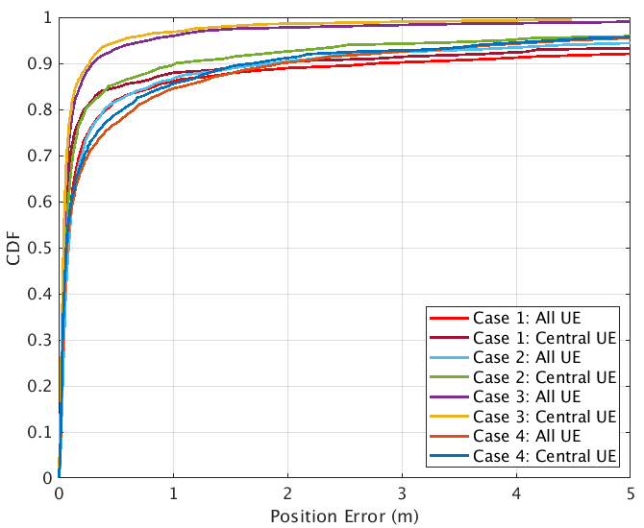

Figure 8.1.1.1.2-1: Rel.16 NR positioning error results (baseline) from [X]

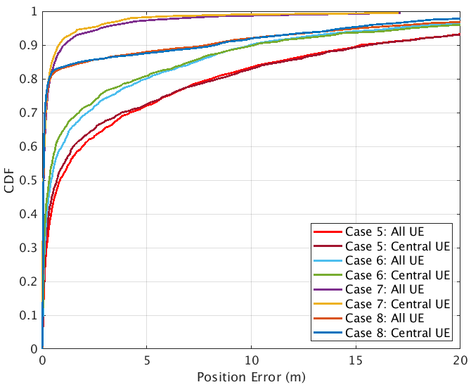

Figure 8.1.1.1.2-2: Rel.16 NR positioning error results (baseline) from [X]

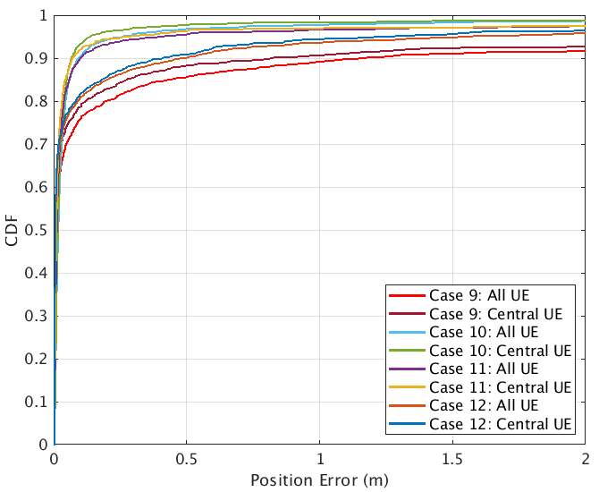

Figure 8.1.1.1.2-3: Rel.16 NR positioning error results (baseline) from [X]

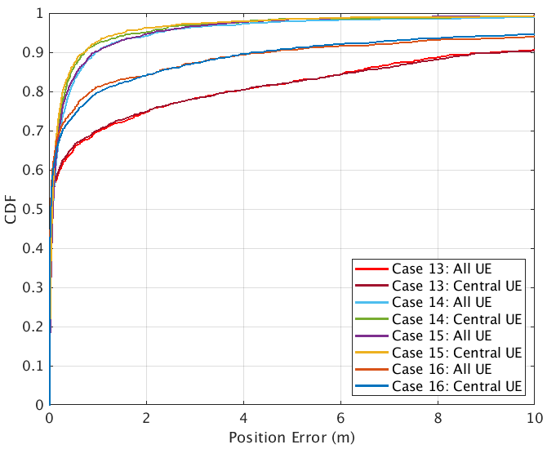

Figure 8.1.1.1.2-4: Rel.16 NR positioning error results (baseline) from [X]

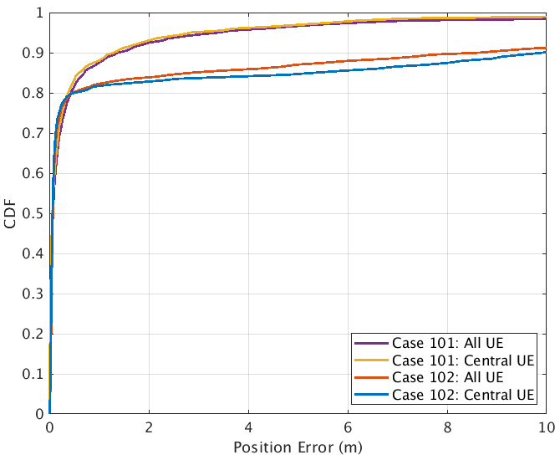

Figure 8.1.1.1.2-5: Rel.16 NR positioning error results (modified DH and 2D) from [X]

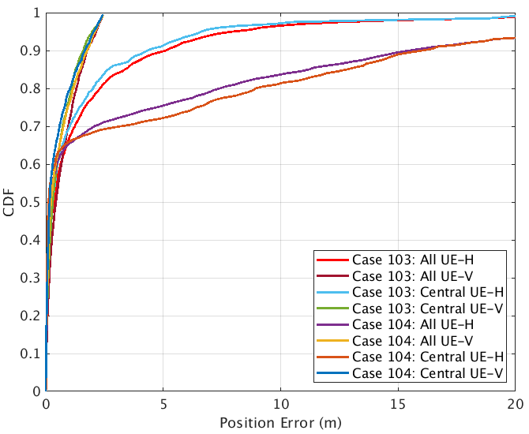

Figure 8.1.1.1.2-6: Rel.16 NR positioning error results (modified DH and 3D) from [X]

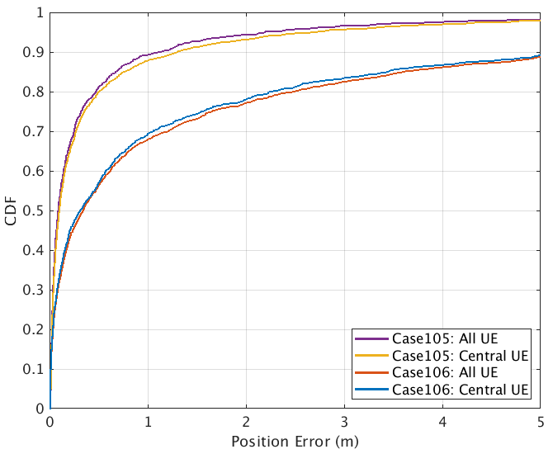

Figure 8.1.1.1.2-7: Rel.16 NR positioning error results (modified DH and 2D) from [X]

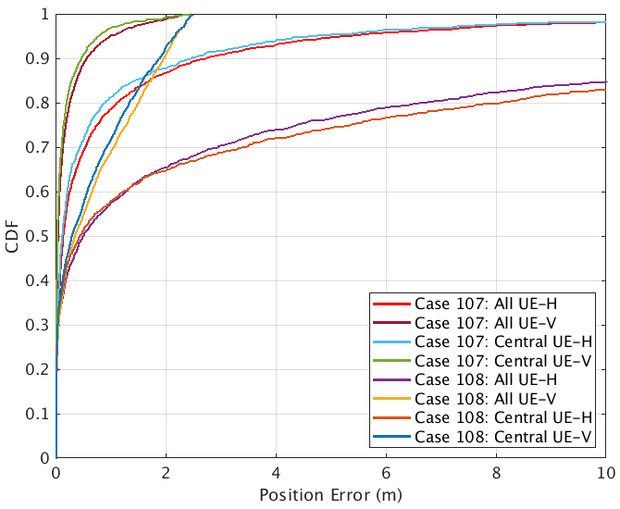

Figure 8.1.1.1.2-8: Rel.16 NR positioning error results (modified DH and 3D) from [X]

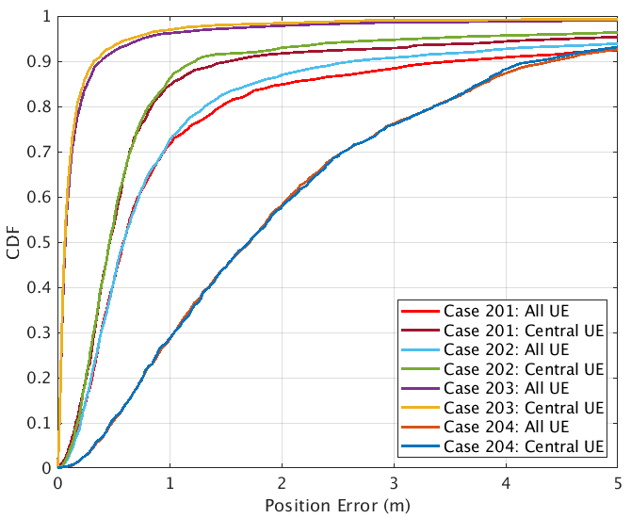

Figure 8.1.1.1.2-9: Rel.16 NR positioning error results (UE/gNB calibration error) from [X]

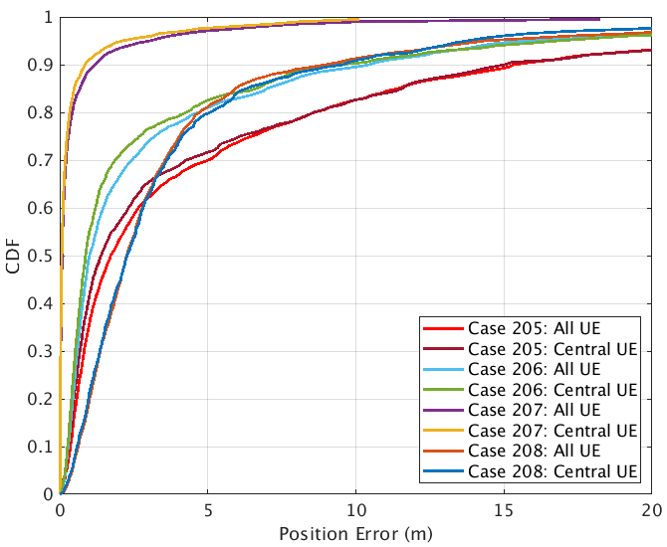

Figure 8.1.1.1.2-10: Rel.16 NR positioning error results (UE/gNB calibration error) from [X]

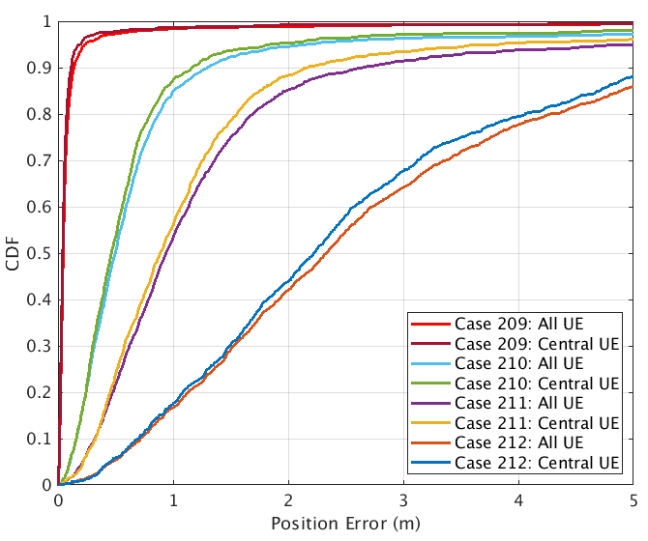

Figure 8.1.1.1.2-11: Rel.16 NR positioning error results (gNB angle calibration error) from [X]

##### 8.1.1.1.3 Observations on Rel-16 NR positioning accuracy

Table 8.1.1.1.3-1 captures observations based on NR positioning evaluations results for horizontal location error for baseline scenarios.

Table 8.1.1.1.3-2 captures observations based on NR positioning evaluations results for horizontal location error for modified DH and 3D positioning.

Table 8.1.1.1.3-3 captures observations based on NR positioning evaluations results for horizontal location error for UE/gNB calibration error.

Table 8.1.1.1.3-4 captures observations based on NR positioning evaluations results for vertical location error for modified DH and 3D positioning.

Table 8.1.1.1.3-1: Rel.16 NR positioning (baseline) – horizontal accuracy performance summary [X]

|  |  |  |  |  |
| --- | --- | --- | --- | --- |
| Simulation case  (Horizontal Error) | Accuracy achieved @[90]% | Commercial horizontal accuracy requirements [1]m @[90]% are met - Yes/No.  If no, provide performance gaps @[90]% | IIoT horizontal accuracy requirements of [0.2]m @[90]%are met - Yes/No. If no, provide performance gaps @[90]% | IIoT horizontal accuracy requirements of [0.5]m @[90]%are met -Yes/No.  If no, provide performance gaps @[90]% |
| 1, InF-SH, FR1, DL-TDOA | 1.964 | 0.964 | 1.764 | 1.464 |
| 2, InF-SH, FR1, UL-TDOA | 1.0277 | 0.0277 | 0.8277 | 0.5277 |
| 3, InF-SH, FR1, UL-TDOA/AoA | 0.2682 | Yes | 0.0682 | Yes |
| 4, InF-SH, FR1, Multi-RTT | 1.6992 | 0.6992 | 1.4992 | 1.1992 |
| 5, InF-DH422, FR1, DL-TDOA | 15.635 | 14.635 | 15.435 | 15.135 |
| 6, InF- DH422, FR1, UL-TDOA | 9.6631 | 9.163 | 9.963 | 9.663 |
| 7, InF-DH422, FR1, UL-TDOA/AoA | 0.8016 | Yes | 0.6016 | 0.3016 |
| 8, InF- DH422, FR1, Multi-RTT | 7.311 | 6.311 | 7.111 | 6.811 |
| 9, InF-SH, FR2, DL-TDOA | 0.9633 | Yes | 0.7633 | 0.4633 |
| 10, InF-SH, FR2, DL-TDOA/AoD | 0.0654 | Yes | Yes | Yes |
| 11, InF-SH, FR2, UL-TDOA/AoA | 0.0694 | Yes | Yes | Yes |
| 12, InF-SH, FR2, Multi-RTT | 0.4496 | Yes | 0.2496 | Yes |
| 13, InF-DH422, FR2, DL-TDOA | 9.6798 | 8.6798 | 9.4798 | 9.1798 |
| 14, InF- DH422, FR2, DL-TDOA/AoD | 0.7197 | Yes | 0.5197 | 0.2197 |
| 15, InF-DH422, FR2, UL-TDOA/AoA | 0.7086 | Yes | 0.5086 | 0.2086 |
| 16, InF- DH422, FR2, Multi-RTT | 4.2895 | 3.2895 | 4.0895 | 3.7895 |

Table 8.1.1.1.3-2: Rel.16 NR positioning (modified DH and 3D positioning) – horizontal accuracy performance summary [X]

|  |  |  |  |  |
| --- | --- | --- | --- | --- |
| Simulation case  (Horizontal Error) | Accuracy achieved @[90]% | Commercial horizontal accuracy requirements [1]m @[90]% are met - Yes/No.  If no, provide performance gaps @[90]% | IIoT horizontal accuracy requirements of [0.2]m @[90]%are met - Yes/No. If no, provide performance gaps @[90]% | IIoT horizontal accuracy requirements of [0.5]m @[90]%are met -Yes/No.  If no, provide performance gaps @[90]% |
| 101, InF-DH435, FR1, UL-TDOA/AoA | 1.3012 | 0.3012 | 1.1012 | 0.8012 |
| 102, InF-DH435, FR1, Multi-RTT | 9.8411 | 8.8411 | 9.6411 | 9.3411 |
| 103, InF-DH435-3D, FR1, UL-TDOA/AoA | 4.3405(H) | 3.3405 | 4.1405 | 3.8405 |
| 104, InF-DH435-3D, FR1, Multi-RTT | 16.0515(H) | 15.0515 | 15.8515 | 15.5515 |
| 105, InF-DH435, FR2, UL-TDOA/AoA | 1.1486 | 0.1486 | 0.9486 | 0.6486 |
| 106, InF-DH435, FR2, Multi-RTT | 5.46 | 4.46 | 5.26 | 4.96 |
| 107, InF-DH435-3D, FR2, UL-TDOA/AoA | 2.4365(H) | 1.4365 | 2.2365 | 1.9365 |
| 108, InF-DH435-3D, FR2, Multi-RTT | 15.5828(H) | 14.5828 | 15.3828 | 15.0828 |

Table 8.1.1.1.3-3: Rel.16 NR positioning (UE/gNB calibration error) – horizontal accuracy performance summary [X]

|  |  |  |  |  |
| --- | --- | --- | --- | --- |
| Simulation case  (Horizontal Error) | Accuracy achieved @[90]% | Commercial horizontal accuracy requirements [1]m @[90]% are met - Yes/No.  If no, provide performance gaps @[90]% | IIoT horizontal accuracy requirements of [0.2]m @[90]%are met - Yes/No. If no, provide performance gaps @[90]% | IIoT horizontal accuracy requirements of [0.5]m @[90]%are met -Yes/No.  If no, provide performance gaps @[90]% |
| 201, InF-SH, FR1, DL-TDOA, Group Delay Error | 0.462 | 0.458 | 1.258 | 0.958 |
| 202, InF-SH, FR1, UL-TDOA, Group delay error | 0.4653 | 0.2343 | 1.0343 | 0.7343 |
| 203, InF-SH, FR1, UL-TDOA/AoA, Group delay error | 0.0661 | Yes | 0.1251 | Yes |
| 204, InF-SH, FR1, Multi-RTT, Group delay error | 1.7105 | 3.2662 | 4.0662 | 3.7662 |
| 205, InF-DH422, FR1, DL-TDOA, Group delay error | 1.391 | 14.039 | 14.839 | 14.539 |
| 206, InF-DH422, FR1, UL-TDOA, Group delay error | 0.8741 | 8.4102 | 9.2102 | 8.9102 |
| 207, InF-DH422, FR1, UL-TDOA/AoA, Group delay error | 0.0717 | Yes | 0.6662 | 0.3662 |
| 208, InF-DH422, FR1, Multi-RTT, Group delay error | 2.2784 | 8.5701 | 9.3701 | 9.0701 |
| 209, InF-SH, FR1, UL-AoA | 0.041 | Yes | Yes | Yes |
| 210, InF-SH, FR1, UL-AoA, Angle error 1 degree | 0.4629 | 0.1676 | 0.9676 | 0.6676 |
| 211, InF-SH, FR1, UL-AoA, Angle error 2 degrees | 0.8848 | 1.1732 | 1.9732 | 1.6732 |
| 212, InF-SH, FR1, UL-AoA, Angle error 5 degrees | 2.2187 | 4.3982 | 5.1982 | 4.8982 |

Table 8.1.1.1.3-4: Rel.16 NR positioning (modified DH and 3D positioning) – vertical accuracy performance summary [X]

|  |  |  |  |  |
| --- | --- | --- | --- | --- |
| Simulation case  (Vertical Error) | Accuracy achieved @[90]% | Commercial vertical accuracy requirements [3]m @[90]% are met - Yes/No.  If no, provide performance gaps @[90]% | IIoT vertical accuracy requirements of [0.2]m @[90]% are met - Yes/No. If no, provide performance gaps @[90]% | IIoT vertical accuracy requirements of [1]m at @[90]% are met - Yes/No.  If no, provide performance gaps @[90]% |
| 103, InF-DH435-3D, FR1, UL-TDOA/AoA | 1.1585(V) | Yes | 0.9585 | 0.1585 |
| 104, InF-DH435-3D, FR1, Multi-RTT | 1.6675(V) | Yes | 1.4675 | 0.6675 |
| 107, InF-DH435-3D, FR2, UL-TDOA/AoA | 0.4593(V) | Yes | 0.2593 | Yes |
| 108, InF-DH435-3D, FR2, Multi-RTT | 1.8800(V) | Yes | 1.68 | 0.88 |

### 8.1.2 Physical layer latency analysis for Rel-16

#### 8.1.2.1 Results from source [X]

##### 8.1.2.1.1 Description of evaluation scenarios

The physical layer latency for the following positioning methods are provided

* UE-A DL-only positioning
* UL-only positioning
* DL E-CID
* UL E-CID
* UE-B DL-only positioning

##### 8.1.2.1.2 Latency analysis of NR positioning enhancements

Latency analysis for the Rel.16 NR positioning is provided in Tables 8.1.2.1.2-1 to 8.1.2.1.2-6.

The latency for multi-RTT positioning should be the maximum between DL-TDOA/DL-AoD and UL-TDOA/UL-AoA, which is the same as DL-TDOA/DL-AoD considering UL delay is much smaller than DL.

Table 8.1.2.1.2-1: Rel.16 NR positioning latency [X]

|  |  |  |
| --- | --- | --- |
| Case L1, DL-TDOA/DL-AoD/Multi-RTT w/ Gap request and PRS periodicity 20ms  Source NW/Destination NW  Positioning technique DL-TDOA and/or DL-AoD, type DL, mode UE-A  Initial and Final RRC States CONNECTED  Gap is requested, and PRS periodicity is 20ms  This can also be used for Multi-RTT positioning. | | |
| Latency Components | Value Range, ms | Description of Latency Component |
| Start trigger |  | Transmission of the PDSCH from the gNB carrying the LPP Request Location Information message |
| UE Rx higher layer processing | 5ms | Handling of the DL-SCH payload to upper layers, including ASN.1 decoding of the LPP message |
| UE Tx higher layer processing | 3ms | UL RRC message preparation for gap request |
| PUSCH scheduling | 0.5-7.5ms | Considering TDD configuration DDDSU, using U to transmit PUSCH, the maximum delay could be SR 🡪 BSR 🡪 PUSCH using 3 cycles. The minimum delay could be a slot. |
| gNB Rx higher layer processing | 3ms | Decoding measurement gap request |
| gNB Tx higher layer processing | 3ms | Reconfiguration with a measurement gap of MGRP = 20ms, MGL = 3ms (MG pattern 10) |
| PDSCH scheduling | 0.5-1ms | Considering TDD configuration DDDSU, using D or S to transmit PDSCH. |
| UE Rx higher layer processing | 10ms | RRC reconfiguration delay in TS 38.331 |
| PRS measurement delay | 23 (1 samp.)  83ms (4 samp. CSSF = 1)  143 (4 samp. CSSF = 2) | According to RAN4, assuming PRS periodicity being 20ms and single frequency layer processing , = $\left\lceil \frac{T_{\text{i}}}{T_{available_PRS\text{,i}}}\right\rceil *T_{available_PRS\text{,i}}$ Assuming   * NRxBeam, i=1, i.e. the number of Rx beams is 1 at UE * , i.e. UE can process all PRS in a slot and UE can buffer all PRS within a P-ms window * Nsample = 1 or 4, i.e., the measurement average time is 1 or 4 * Ti = 20ms as the UE capability T * Tavailable_PRS, i=20ms, i.e., the LCM of PRS periodicity and MGRP is 20ms |
| UE Tx higher layer processing | 3ms | UL LPP message preparation |
| PUSCH scheduling | 0.5ms-7.5ms | Considering TDD configuration DDDSU, using U to transmit PUSCH, the maximum delay could be SR 🡪 BSR 🡪 PUSCH using 3 cycles. The minimum delay could be a slot. |
| End trigger |  | Successful decoding of the PUSCH carrying the LPP Provide Location Information message |
| Total values | 51.5-66ms (1 samp.)  111.5-126.5ms (4 samp. CSSF = 1)  171.5-186ms (4 samp. CSSF = 2) |  |

Table 8.1.2.1.2-2: Rel.16 NR positioning latency [X]

|  |  |  |
| --- | --- | --- |
| Case L2, DL-TDOA/DL-AoD/Multi-RTT w/o Gap request and PRS periodicity 160ms  Source NW/Destination NW  Positioning technique DL-TDOA and/or DL-AoD, type DL, mode UE-A  Initial and Final RRC States CONNECTED  Gap is not requested, and PRS periodicity is 160ms  This can also be used for Multi-RTT positioning. | | |
| Latency Components | Value Range, ms | Description of Latency Component |
| Start trigger |  | Transmission of the PDSCH from the gNB carrying the LPP Request Location Information message |
| UE Rx higher layer processing | 5ms | Handling of the DL-SCH payload to upper layers, including ASN.1 decoding of the LPP message |
| PRS measurement delay | 163ms (1 samp.)  643ms (4 samp. CSSF = 1) | According to RAN4, assuming PRS periodicity being 160ms and single frequency layer processing , = $\left\lceil \frac{T_{\text{i}}}{T_{available_PRS\text{,i}}}\right\rceil *T_{available_PRS\text{,i}}$ Assuming   * NRxBeam, i=1, i.e. the number of Rx beams is 1 at UE* , i.e. UE can process all PRS in a slot and UE can buffer all PRS within a P-ms window * Nsample = 1 or 4, i.e., the measurement average time is 1 or 4 * Ti = 20ms as the UE capability T   Tavailable_PRS, i=20ms, i.e., the LCM of PRS periodicity and MGRP is 20ms |
| UE Tx higher layer processing | 3ms | UL LPP message preparation |
| PUSCH scheduling | 0.5-7.5ms | Considering TDD configuration DDDSU, using U to transmit PUSCH, the maximum delay could be SR 🡪 BSR 🡪 PUSCH using 3 cycles. The minimum delay could be a slot. |
| End trigger |  | Successful decoding of the PUSCH carrying the LPP Provide Location Information message |
| Total values | 171.5-178.5ms (1 samp.)  651.5-658.5ms (4 samp. CSSF = 1) |  |

Table 8.1.2.1.2-3: Rel.16 NR positioning latency [X]

|  |  |  |
| --- | --- | --- |
| Case L3, UL-TDOA/UL-AoA  Source NW/Destination NW  Positioning technique UL-TDOA and/or UL-AoA, type UL  Initial and Final RRC States CONNECTED | | |
| Latency Components | Value Range, ms | Description of Latency Component |
| Start trigger |  | Reception by the gNB of the NRPPa measurement request message |
| gNB Rx higher layer processing | 3ms | Processing NRPPa message from the NGAP message |
| SRS measurement delay | 0.5-20ms (1 samp.)  60.5-80ms  (4 samp.) | Assuming SRS periodicity is 20ms. Using 1 or 4 samples. |
| gNB Tx higher layer processing | 3ms | Processing NRPPa message into the NGAP message |
| End trigger |  | The transmission by the gNB of the NRPPa measurement response message |
| Total values | 6.5-26ms (1 samp.)  66.5-86.5ms (4 samp) |  |

Table 8.1.2.1.2-4: Rel.16 NR positioning latency [X]

|  |  |  |
| --- | --- | --- |
| Case L4, DL E-CID  Source NW/Destination NW  Positioning technique DL E-CID, type DL, mode UE-A  Initial and Final RRC States CONNECTED | | |
| Latency Components | Value Range, ms | Description of Latency Component |
| Start trigger |  | Transmission of the PDSCH from the gNB carrying the LPP Request Location Information message |
| UE Rx higher layer processing | 5ms | Handling of the DL-SCH payload to upper layers, including ASN.1 decoding of the LPP message |
| DL E-CID measurement | 0ms | Using only existing RRM measurement |
| UE Tx higher layer processing | 3ms | UL LPP message preparation |
| PUSCH scheduling | 0.5-7.5ms | Considering TDD configuration DDDSU, using U to transmit PUSCH, the maximum delay could be SR 🡪 BSR 🡪 PUSCH using 3 cycles. The minimum delay could be a slot. |
| End trigger |  | Successful decoding of the PUSCH carrying the LPP Provide Location Information message |
| Total values | 8.5-15ms |  |

Table 8.1.2.1.2-5: Rel.16 NR positioning latency [X]

|  |  |  |
| --- | --- | --- |
| Case L5, UL E-CID  Source NW/Destination NW  Positioning technique UL-E-CID, type DL+UL, mode UE-A  Initial and Final RRC States CONNECTED | | |
| Latency Components | Value Range, ms | Description of Latency Component |
| Start trigger |  | Reception by the gNB of the NRPPa measurement request message |
| gNB Rx higher layer processing | 3ms | Processing NRPPa message from the NGAP message |
| AoA measurement delay | 0-20ms | Assuming SRS periodicity is 20ms. Either AoA is not measured or AoA is measured by 1 sample. |
| gNB Tx higher layer processing | 3ms | Processing NRPPa message into the NGAP message |
| End trigger |  | The transmission by the gNB of the NRPPa measurement response message |
| Total values | 6-26ms |  |

Table 8.1.2.1.2-6: Rel.16 NR positioning latency [X]

|  |  |  |
| --- | --- | --- |
| Case L6, UE-based DL-TDOA/DL-AoD w/ gap request t and PRS periodicity 20ms  Source UE/Destination UE  Positioning technique DL-TDOA and/or DL-AoD, type DL, mode UE-B  Initial and Final RRC States CONNECTED  MO-LR, i.e. UE as the location consumer | | |
| Latency Components | Value Range, ms | Description of Latency Component |
| Start trigger |  | Alt. 2: Transmission of the PDSCH from the gNB carrying the LPP message containing the assistance data |
| UE Rx higher layer processing | 5ms | Handling of the DL-SCH payload to upper layers, including ASN.1 decoding of the LPP message |
| UE Tx higher layer processing | 3ms | UL RRC message preparation for gap request |
| PUSCH scheduling | 0.5-7.5ms | Considering TDD configuration DDDSU, using U to transmit PUSCH, the maximum delay could be SR 🡪 BSR 🡪 PUSCH using 3 cycles. The minimum delay could be a slot. |
| gNB Rx higher layer processing | 3ms | Decoding measurement gap request |
| gNB Tx higher layer processing | 3ms | Reconfiguration with a measurement gap of MGRP = 20ms, MGL = 3ms (MG pattern 10) |
| PDSCH scheduling | 0.5-1ms | Considering TDD configuration DDDSU, using D or S to transmit PDSCH. |
| UE Rx higher layer processing | 10ms | RRC reconfiguration delay in TS 38.331 |
| PRS measurement delay | 23 (1 samp.) | According to RAN4, assuming PRS periodicity being 20ms and single frequency layer processing , = $\left\lceil \frac{T_{\text{i}}}{T_{available_PRS\text{,i}}}\right\rceil *T_{available_PRS\text{,i}}$ Assuming   * NRxBeam, i=1, i.e. the number of Rx beams is 1 at UE * , i.e. UE can process all PRS in a slot and UE can buffer all PRS within a P-ms window * Nsample = 1 or 4, i.e., the measurement average time is 1 or 4 * Ti = 20ms as the UE capability T   Tavailable_PRS, i=20ms, i.e., the LCM of PRS periodicity and MGRP is 20ms |
| Location calculation | 3ms | UE |
| End trigger |  | Calculation of Location Estimate at the UE |
| Total values | 51-58.5ms (1 samp.) |  |

##### 8.1.2.1.3 Latency analysis for Rel.16 solutions

Summary of latency performance analysis is provided in Table 8.1.2.1.3-1.

Table 8.1.2.1.3-1: NR positioning enhancements – latency performance summary [X]

|  |  |  |  |  |
| --- | --- | --- | --- | --- |
| Description  Evaluation Case | L1 Latency, ms | Commercial requirements [100]ms are met -Yes/No - If no, provide performance gaps | IIoT requirements of [10ms] are met - Yes/No.  If no, provide performance gaps | IIoT requirements of [100]ms are met - Yes/No. If no, provide performance gaps |
| Case L1, DL-TDOA/DL-AoD/Multi-RTT w/ Gap request and PRS periodicity 20ms | 51.5-66ms (1 samp.)  111.5-126.5ms (4 samp. CSSF = 1)  171.5-186ms (4 samp. CSSF = 2) | Yes (1 samp.)  >=11.5ms (4 samp. CSSF = 1)  >=71.5ms (4 samp. CSSF = 2) | >=41.5ms (1 samp.)  >=101.5ms (4 samp. CSSF = 1)  >=161.5ms (4 samp. CSSF = 2) | Yes (1 samp.)  >=11.5ms (4 samp. CSSF = 1)  >=71.5ms (4 samp. CSSF = 2) |
| Case L2, DL-TDOA/DL-AoD/Multi-RTT w/o Gap request and PRS periodicity 160ms | 171.5-178.5ms (1 samp.)  651.5-658.5ms (4 samp. CSSF = 1) | No (1 samp.)  No (4 samp. CSSF = 1) | No (1 samp.)  No (4 samp. CSSF = 1) | No (1 samp.)  No (4 samp. CSSF = 1) |
| Case L3, UL-TDOA/UL-AoA | 6.5-26ms (1 samp.)  66.5-86.5ms (4 samp) | Yes (1 samp.)  Yes (4 samp.) | Yes/No (1 samp.)  >=56.5ms (4 samp.) | Yes (1 samp.)  Yes (4 samp.) |
| Case L4, DL E-CID | 8.5-15ms | Yes | Yes/No | Yes |
| Case L5, UL E-CID | 6-26ms | Yes | Yes/No | Yes |
| Case L6, UE-based DL-TDOA/DL-AoD w/ gap request t and PRS periodicity 20ms | 51-58.5ms (1 samp.) | Yes | >=41ms | Yes |

## 8.2 Performance of studied NR positioning enhancements

Including performance of positioning techniques, DL/UL positioning reference signals, signalling and procedures for improved accuracy, reduced latency, network efficiency, and device efficiency ((objective 1c).

### 8.2.1 Positioning accuracy analysis for NR positioning enhancements

#### 8.2.1.1 Results from source [X]

##### 8.2.1.1.1 Description of evaluation scenarios

The following enhancements are evaluated for accuracy.

* LOS/NLOS identification
* PRS/SRS frequency aggregation
* 1-symbol PRS
* PRS punctured by SSB
* AoA with ULA
* E-CID enhancement

Evaluation assumptions for system level analysis of NR positioning accuracy enhancements are provided in Tables 8.2.1.1.1-1 to Table 8.2.1.1.1-3.

Table 8.2.1.1.1-1: NR positioning enhancements (LOS/NLOS identification 31x and PRS/SRS frequency aggregation 32x) - evaluation scenarios and parameters

|  |  |  |  |  |  |  |  |
| --- | --- | --- | --- | --- | --- | --- | --- |
| Parameter | Case 311 (InF-DH, FR1) | Case 312 (InF-DH, FR1) | Case 313 (InF-DH, FR1) | Case 314 (InF-DH, FR1) | Case 321 (InF-DH, FR1) | Case 322 (InF-DH, FR1) | Case 323 (InF-DH, FR1) |
| Channel model (baseline, otherwise state any modifications) | InF-DH  (40%, 2, 2) | InF-DH  (40%, 2, 2) | InF-DH  (40%, 2, 2) | InF-DH  (40%, 2, 2) | InF-DH  (40%, 2, 2) | InF-DH  (40%, 2, 2) | InF-DH  (40%, 2, 2) |
| Carrier frequency | 3.5GHz | 3.5GHz | 3.5GHz | 3.5GHz | 3.5GHz | 3.5GHz | 3.5GHz |
| Subcarrier spacing | 30kHz | 30kHz | 30kHz | 30kHz | 30kHz | 30kHz | 30kHz |
| Reference Signal Transmission Bandwidth | 100MHz | 100MHz | 100MHz | 100MHz | 100MHz | 200MHz | 50MHz+100MHz (gap)+50MHz |
| Reference Signal Physical Structure and Resource Allocation (RE pattern) (reference to figure in contribution) | PosSRS (Comb-4, 4 symbol) | PosSRS (Comb-4, 4 symbol) | PosSRS (Comb-4, 4 symbol) | PosSRS (Comb-4, 4 symbol) | PosSRS (Comb-4, 4 symbol) | PosSRS (Comb-4, 4 symbol) | PosSRS (Comb-4, 4 symbol) |
| Reference signal  (type of sequence, number of ports, …) | ZC, single port | ZC, single port | ZC, single port | ZC, single port | ZC, single port | ZC, single port | ZC, single port |
| Number of sites | 7 | 7 | 7 | 7 | 7 | 7 | 7 |
| Number of symbols used per occasion | 4 | 4 | 4 | 4 | 4 | 4 | 4 |
| number of occasions used per positioning estimate | 1 | 1 | 1 | 1 | 1 | 1 | 1 |
| Power-boosting level | 6dB | 6dB | 6dB | 6dB | 6dB | 6dB | 6dB |
| Uplink power control (applied/not applied) | Not applied | Not applied | Not applied | Not applied | Not applied | Not applied | Not applied |
| interference modelling (ideal muting, or other) | Ideal | Ideal | Ideal | Ideal | Ideal | Ideal | Ideal |
| Description of Measurement Algorithm (e.g. super resolution, interference cancellation, ….) | Super resolution  No LOS/NLOS detection | Super resolution  RAIM | Super resolution  LOS/NLOS detection | Super resolution  Ideal LOS/NLOS detection | Super resolution  No LOS/NLOS detection | Super resolution  No LOS/NLOS detection | Super resolution  No LOS/NLOS detection |
| Description of positioning technique / applied positioning algorithm (e.g. Least square, Taylor series, etc) | UL-TDOA  PSO | UL-TDOA  PSO | UL-TDOA  PSO | UL-TDOA  PSO | UL-TDOA  PSO | UL-TDOA  PSO | UL-TDOA  PSO |
| Network synchronization assumptions | Ideal | Ideal | Ideal | Ideal | Ideal | Ideal | Ideal |
| UE/gNB Tx/Rx  Calibration Error | Ideal | Ideal | Ideal | Ideal | Ideal | Ideal | Ideal |
| Beam-related assumption (beam sweeping / alignment assumptions at the tx and rx sides) | Tx beam sweeping | Tx beam sweeping | Tx beam sweeping | Tx beam sweeping | Tx beam sweeping | Tx beam sweeping | Tx beam sweeping |
| Precoding assumptions (codebook, nrof antenna elements used, etc) | Tx codebook-based | Tx codebook-based | Tx codebook-based | Tx codebook-based | Tx codebook-based | Tx codebook-based | Tx codebook-based |
| Additional notes, if any |  |  |  |  |  |  |  |

Table 8.2.1.1.1-2: NR positioning enhancements (1-symbol PRS 33x and PRS punctured by SSB 34x) - evaluation scenarios and parameters

|  |  |  |  |  |  |  |
| --- | --- | --- | --- | --- | --- | --- |
| Parameter | Case 331 (InF-SH, FR1) | Case 332 (InF-SH, FR1) | Case 333 (InF-SH, FR1) | Case 334 (InF-SH, FR1) | Case 341 (InF-SH, FR1) | Case 342 (InF-SH, FR1) |
| Channel model (baseline, otherwise state any modifications) | InF-SH | InF-SH | InF-SH | InF-SH | InF-SH | InF-SH |
| Carrier frequency | 3.5GHz | 3.5GHz | 3.5GHz | 3.5GHz | 3.5GHz | 3.5GHz |
| Subcarrier spacing | 30kHz | 30kHz | 30kHz | 30kHz | 30kHz | 30kHz |
| Reference Signal Transmission Bandwidth | 100MHz | 100MHz | 100MHz | 100MHz | 100MHz | 100MHz |
| Reference Signal Physical Structure and Resource Allocation (RE pattern) (reference to figure in contribution) | DL-PRS (Comb-4, 4 symbol) | DL-PRS (Comb-4, 1 symbol) | DL-PRS (Comb-12, 12 symbol) | DL-PRS (Comb-12, 1 symbol) | DL-PRS (Comb-4, 4 symbol) | DL-PRS (Comb-4, 1 symbol) |
| Reference signal  (type of sequence, number of ports, …) | Gold, single port | Gold, single port | Gold, single port | Gold, single port | Gold, single port | Gold, single port |
| Number of sites | 7 | 7 | 7 | 7 | 7 | 7 |
| Number of symbols used per occasion | 4 | 4 | 4 | 4 | 4 | 4 |
| number of occasions used per positioning estimate | 1 | 1 | 1 | 1 | 1 | 1 |
| Power-boosting level | 6dB | 6dB | 10.8dB | 10.8dB | 6dB | 6dB |
| Uplink power control (applied/not applied) | Not applied | Not applied | Not applied | Not applied | Not applied | Not applied |
| interference modelling (ideal muting, or other) | Ideal | Ideal | Ideal | Ideal | Ideal | Ideal |
| Description of Measurement Algorithm (e.g. super resolution, interference cancellation, ….) | Super resolution  Ideal LOS/NLOS detection | Super resolution  Ideal LOS/NLOS detection | Super resolution  Ideal LOS/NLOS detection | Super resolution  Ideal LOS/NLOS detection | Super resolution  Ideal LOS/NLOS detection | Super resolution  Ideal LOS/NLOS detection |
| Description of positioning technique / applied positioning algorithm (e.g. Least square, Taylor series, etc) | DL-TDOA  PSO | DL-TDOA  PSO | DL-TDOA  PSO | DL-TDOA  PSO | DL-TDOA  PSO | DL-TDOA  PSO |
| Network synchronization assumptions | Ideal | Ideal | Ideal | Ideal | Ideal | Ideal |
| UE/gNB Tx/Rx  Calibration Error | Ideal | Ideal | Ideal | Ideal | Ideal | Ideal |
| Beam-related assumption (beam sweeping / alignment assumptions at the tx and rx sides) | Tx beam sweeping | Tx beam sweeping | Tx beam sweeping | Tx beam sweeping | Tx beam sweeping | Tx beam sweeping |
| Precoding assumptions (codebook, nrof antenna elements used, etc) | Tx codebook-based | Tx codebook-based | Tx codebook-based | Tx codebook-based | Tx codebook-based | Tx codebook-based |
| Additional notes, if any |  |  |  |  |  | PRS center 20RBs are punctured by SSB |

Table 8.2.1.1.1-3: Rel.16 NR positioning (UL-AoA enhancement with ULA 36x and E-CID enhancement 37x) - evaluation scenarios and parameters

|  |  |  |  |  |  |
| --- | --- | --- | --- | --- | --- |
| Parameter | Case 361 (InF-DH, FR1) | Case 362 (InF-DH, FR1) | Case 363 (InF-DH, FR1) | Case 371 (InF-DH, FR1) | Case 372 (InF-DH, FR1) |
| Channel model (baseline, otherwise state any modifications) | InF-DH  (40%, 2, 2) | InF-DH  (40%, 2, 2) | InF-DH  (40%, 2, 2) | InF-DH  (40%, 2, 2) | InF-DH  (40%, 2, 2) |
| Carrier frequency | 3.5GHz | 3.5GHz | 3.5GHz | 3.5GHz | 3.5GHz |
| Subcarrier spacing | 30kHz | 30kHz | 30kHz | 30kHz | 30kHz |
| Reference Signal Transmission Bandwidth | 100MHz | 100MHz | 100MHz | 100MHz | 100MHz |
| Reference Signal Physical Structure and Resource Allocation (RE pattern) (reference to figure in contribution) | PosSRS (Comb-4, 4 symbol) | PosSRS (Comb-4, 4 symbol) | PosSRS (Comb-4, 4 symbol) | DL-PRS+PosSRS (Comb-4, 4 symbol) | CSI-RS+SRS (Comb-4, 4 symbol) |
| Reference signal  (type of sequence, number of ports, …) | ZC, single port | ZC, single port | ZC, single port | Gold/ZC, single port | Gold/ZC, single port |
| Number of sites | 7 | 7 | 7 | 7 | 1 |
| Number of symbols used per occasion | 4 | 4 | 4 | 4 | 4 |
| number of occasions used per positioning estimate | 1 | 1 | 1 | 1 | 1 |
| Power-boosting level | 6dB | 6dB | 6dB | 6dB | 6dB |
| Uplink power control (applied/not applied) | Not applied | Not applied | Not applied | Not applied | Not applied |
| interference modelling (ideal muting, or other) | Ideal | Ideal | Ideal | Ideal | Ideal |
| Description of Measurement Algorithm (e.g. super resolution, interference cancellation, ….) | Super resolution  Ideal LOS/NLOS detection | Super resolution  Ideal LOS/NLOS detection | Super resolution  Ideal LOS/NLOS detection | Super resolution  Ideal LOS/NLOS detection | Super resolution  Ideal LOS/NLOS detection |
| Description of positioning technique / applied positioning algorithm (e.g. Least square, Taylor series, etc) | UL-TDOA+UL-AoA  PSO | UL-TDOA+UL-AoA  PSO | UL-TDOA+UL-AoA  PSO | Multi-RTT  PSO | E-CID (RTT+AoA only from the serving cell) |
| Network synchronization assumptions | Ideal | Ideal | Ideal | Ideal | Ideal |
| UE/gNB Tx/Rx  Calibration Error | Ideal | Ideal | Ideal | Ideal | Ideal |
| Beam-related assumption (beam sweeping / alignment assumptions at the tx and rx sides) | Tx beam sweeping | Tx beam sweeping | Tx beam sweeping | Tx beam sweeping | Tx beam sweeping |
| Precoding assumptions (codebook, nrof antenna elements used, etc) | Tx codebook-based | Tx codebook-based | Tx codebook-based | Tx codebook-based | Tx codebook-based |
| Additional notes, if any | UPA 4x4x2 | ULA 1x4x1 assuming legacy AoA | ULA 1x4x1 with modified AoA |  |  |

##### 8.2.1.1.2 Positioning accuracy evaluation results for NR positioning enhancements

Evaluation results of horizontal location error for NR positioning enhancements are provided in Table 8.2.1.1.2-1:

Table 8.2.1.1.2-1: NR positioning enhancements - horizontal location error results from [X]

|  |  |  |  |  |  |  |
| --- | --- | --- | --- | --- | --- | --- |
| Features | Cases |  | 50% | 67% | 80% | 90% |
| LOS/NLOS identification | 311, InF-DH422, FR1, UL-TDOA | (Optional) All UEs | 0.4309 | 1.6317 | 4.9693 | 9.9453 |
| Convex UEs | 0.3354 | 1.2393 | 4.6237 | 9.6631 |
| 312, InF-DH422, FR1, UL-TDOA w/ RAIM | (Optional) All UEs | 0.0371 | 0.0748 | 0.1912 | 1.4517 |
| Convex UEs | 0.0301 | 0.0554 | 0.1217 | 0.6569 |
| 313, InF-DH422, FR1, UL-TDOA w/ LOS/NLOS identification | (Optional) All UEs | 0.0397 | 0.0701 | 0.1354 | 0.4836 |
| Convex UEs | 0.0311 | 0.0505 | 0.0862 | 0.2111 |
| 314, InF-DH422, FR1, UL-TDOA w/ ideal LOS selection | (Optional) All UEs | 0.0394 | 0.0608 | 0.1399 | 0.4452 |
| Convex UEs | 0.0310 | 0.0506 | 0.0855 | 0.2022 |
| PRS/SRS frequency aggregation | 321, InF-DH422, FR1, UL-TDOA, 100M contiguous | (Optional) All UEs | 0.0394 | 0.0608 | 0.1399 | 0.4452 |
| Convex UEs | 0.0310 | 0.0506 | 0.0855 | 0.2022 |
| 322, InF-DH422, FR1, UL-TDOA, 200M contiguous | (Optional) All UEs | 0.0106 | 0.0179 | 0.0332 | 0.0827 |
| Convex UEs | 0.0082 | 0.0122 | 0.0197 | 0.0384 |
| 323, InF-DH422, FR1, UL-TDOA, 50MHz+100MHz (Gap)+50MHz | (Optional) All UEs | 0.0148 | 0.0273 | 0.0570 | 0.2244 |
| Convex UEs | 0.0109 | 0.0189 | 0.0337 | 0.0912 |
| 1-symbol PRS | 331, InF-SH, FR1, DL-TDOA, Comb-4 and 4-symbol | (Optional) All UEs | 0.0252 | 0.0425 | 0.0718 | 0.1531 |
| Convex UEs | 0.0196 | 0.0314 | 0.0504 | 0.0939 |
| 332, InF-SH, FR1, DL-TDOA, Comb-4 and 1-symbol | (Optional) All UEs | 0.0268 | 0.0473 | 0.0836 | 0.1693 |
| Convex UEs | 0.0210 | 0.0347 | 0.0567 | 0.1123 |
| 333, InF-SH, FR1, DL-TDOA, Comb-12 and 12-symbol | (Optional) All UEs | 0.0279 | 0.0492 | 0.0835 | 0.1647 |
| Convex UEs | 0.0219 | 0.0347 | 0.0573 | 0.1091 |
| 334, InF-SH, FR1, DL-TDOA, Comb-12 and 1-symbol | (Optional) All UEs | 0.0284 | 0.0484 | 0.0866 | 0.1784 |
| Convex UEs | 0.0209 | 0.0359 | 0.0595 | 0.1199 |
| PRS punctured by SSB | 341, InF-SH, FR1, DL-TDOA | (Optional) All UEs | 0.0252 | 0.0425 | 0.0718 | 0.1531 |
| Convex UEs | 0.0196 | 0.0314 | 0.0504 | 0.0939 |
| 342, InF-SH, FR1, DL-TDOA, 20-RB of PRS punctured by SSB | (Optional) All UEs | 0.0293 | 0.0475 | 0.0846 | 0.1699 |
| Convex UEs | 0.0213 | 0.0346 | 0.0539 | 0.1090 |
| UL-AoA enhancement with ULA | 361, InF-DH422, FR1, UL-TDOA/AoA | (Optional) All UEs | 0.0216 | 0.0318 | 0.0460 | 0.0735 |
| Convex UEs | 0.0203 | 0.0276 | 0.0396 | 0.0665 |
| 362, InF-DH422, FR1, UL-TDOA/AoA, ULA 4x1 w/ legacy AoA) | (Optional) All UEs | 2.4977 | 3.3503 | 4.1807 | 4.9986 |
| Convex UEs | 2.2164 | 3.1038 | 3.9067 | 4.8161 |
| 363, InF-DH422, FR1, UL-TDOA/AoA, ULA 4x1 w/ modified AoA | (Optional) All UEs | 0.0406 | 0.0626 | 0.1027 | 0.2058 |
| Convex UEs | 0.0348 | 0.0525 | 0.0821 | 0.1694 |
| E-CID enhancement | 371, InF-DH422, FR1, Multi-RTT | (Optional) All UEs | 0.0423 | 0.0591 | 0.0901 | 0.1756 |
| Convex UEs | 0.0388 | 0.0555 | 0.0871 | 0.1694 |
| 372, InF-DH422, FR1, E-CID w/ single cell RTT/AoA | (Optional) All UEs | 0.0471 | 0.0651 | 0.1068 | 0.2497 |
| Convex UEs | 0.0473 | 0.0647 | 0.1040 | 0.2395 |

Figure 8.2.1.1.2-1 provides the positioning evaluation results for LOS/NLOS identification.

Figure 8.2.1.1.2-2 provides the positioning evaluation results for PRS/SRS frequency aggregation.

Figure 8.2.1.1.2-3 provides the positioning evaluation results for 1-symbol PRS.

Figure 8.2.1.1.2-4 provides the positioning evaluation results for PRS punctured by SSB.

Figure 8.2.1.1.2-5 provides the positioning evaluation results for UL-AoA enhancement with ULA.

Figure 8.2.1.1.2-6 provides the positioning evaluation results for E-CID enhancement.

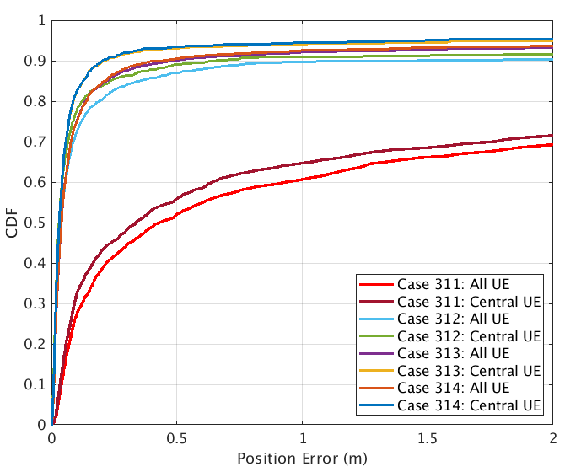

Figure 8.2.1.1.2-1: Positioning error results for LOS/NLOS identification from [X]

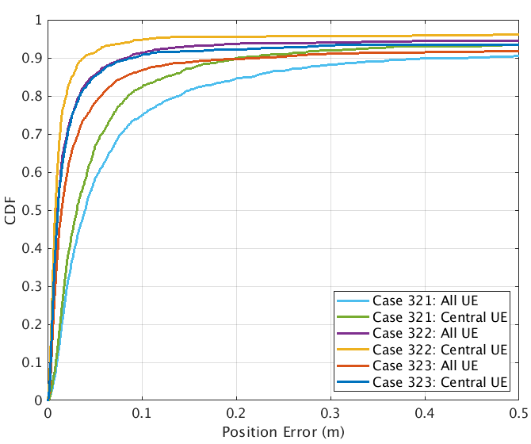

Figure 8.2.1.1.2-2: Positioning error results for PRS/SRS frequency aggregation from [X]

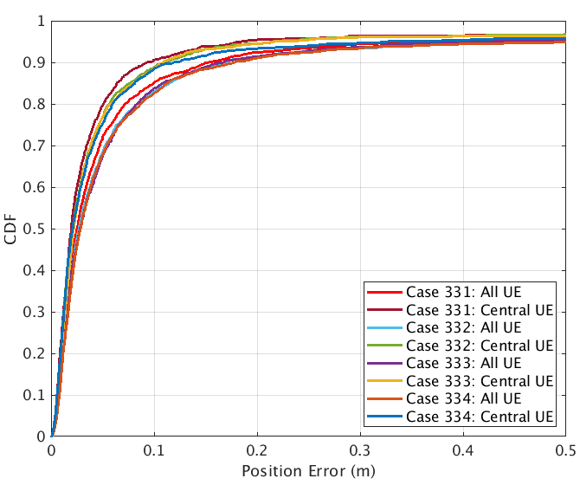

Figure 8.2.1.1.2-3: Positioning error results for 1-symbol PRS from [X]

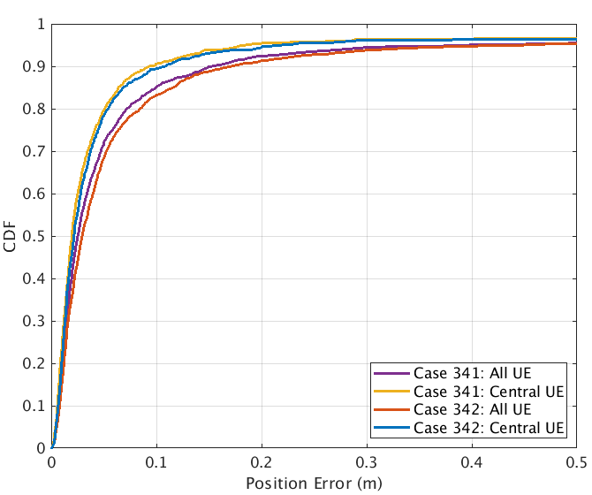

Figure 8.2.1.1.2-4: Positioning error results for PRS punctured by SSB from [X]

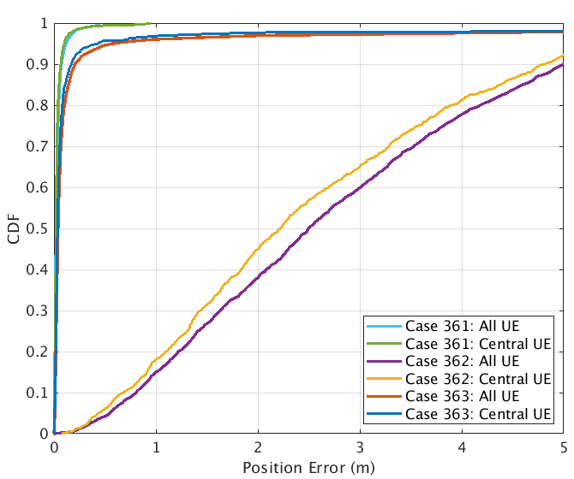

Figure 8.2.1.1.2-5: Positioning error results for UL-AoA enhancement with ULA from [X]

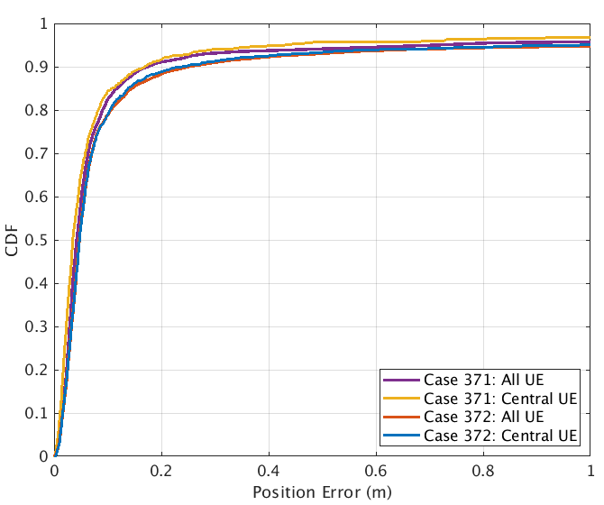

Figure 8.2.1.1.2-6: Positioning error results for E-CID enhancement from [X]

##### 8.2.1.1.3 Observations on NR positioning enhancements

Table 8.2.1.1.3-1 captures observations based on evaluations results of NR positioning enhancements for horizontal location error.

Table 8.2.1.1.3-1: NR positioning enhancements – horizontal accuracy performance summary [X]

|  |  |  |  |  |  |
| --- | --- | --- | --- | --- | --- |
| Simulation case  (Horizontal Error) | Gain vs Rel.16 solution, @[90]%, [m] | Accuracy achieved @[90]% | Commercial horizontal accuracy requirements [1]m @[90]% are met - Yes/No.  If no, provide performance gaps | IIoT horizontal accuracy requirements of [0.2]m @[90]%are met - Yes/No. If no, provide performance gaps | IIoT horizontal accuracy requirements of [0.5]m @[90]%are met -Yes/No.  If no, provide performance gaps |
| 311, InF-DH422, FR1, UL-TDOA | **Rel-16 baseline** | 9.6631 | No | No | No |
| 312, InF-DH422, FR1, UL-TDOA w/ RAIM | 9.0062 | 0.6569 | Yes | 0.4569 | 0.1569 |
| 313, InF-DH422, FR1, UL-TDOA w/ LOS/NLOS identification | 9.452 | 0.2111 | Yes | 0.0111 | Yes |
| 321, InF-DH422, FR1, UL-TDOA, 100M contiguous | **Rel-16 baseline** | 0.2022 | Yes | No | Yes |
| 322, InF-DH422, FR1, UL-TDOA, 200M contiguous | 0.1638 | 0.0384 | Yes | Yes | Yes |
| 323, InF-DH422, FR1, UL-TDOA, 50MHz+100MHz (Gap)+50MHz | 0.111 | 0.0912 | Yes | Yes | Yes |
| 331, InF-SH, FR1, DL-TDOA, Comb-4 and 4-symbol | **Rel-16 baseline** | 0.0939 | Yes | Yes | Yes |
| 332, InF-SH, FR1, DL-TDOA, Comb-4 and 1-symbol | -0.0184 | 0.1123 | Yes | Yes | Yes |
| 333, InF-SH, FR1, DL-TDOA, Comb-12 and 12-symbol | **Rel-16 baseline** | 0.1091 | Yes | Yes | Yes |
| 334, InF-SH, FR1, DL-TDOA, Comb-12 and 1-symbol | -0.0108 | 0.1199 | Yes | Yes | Yes |
| 341, InF-SH, FR1, DL-TDOA | **Rel-16 baseline** | 0.0939 | Yes | Yes | Yes |
| 342, InF-SH, FR1, DL-TDOA, 20-RB of PRS punctured by SSB | -0.0151 | 0.109 | Yes | Yes | Yes |
| 362, InF-DH422, FR1, UL-TDOA/AoA, ULA 4x1 w/ legacy AoA) | **Rel-16 baseline** | 0.0665 | No | No | No |
| 363, InF-DH422, FR1, UL-TDOA/AoA, ULA 4x1 w/ modified AoA | 4.6467 | 4.8161 | Yes | Yes | Yes |
| 371, InF-DH422, FR1, Multi-RTT | **Rel-16 baseline** | 0.1694 | Yes | Yes | Yes |
| 372, InF-DH422, FR1, E-CID w/ single cell RTT/AoA | -0.0701 | 0.2395 | Yes | No | Yes |

### 8.2.2 Physical layer latency analysis for NR positioning enhancements

#### 8.2.2.1 Results from source [X]

##### 8.2.2.1.1 Description of evaluation scenarios

The physical layer latency for the following positioning methods are provided

* Enhanced UL E-CID

##### 8.2.2.1.2 Latency analysis of NR positioning enhancements

Latency analysis for the Rel.16 NR positioning is provided ins Table 8.2.2.1.2-1 and 8.2.2.1.2-2.

Table 8.2.2.1.2-1: NR positioning enhancements – latency analysis [X]

|  |  |  |
| --- | --- | --- |
| Case L101, UL E-CID w/ measurements available  Source NW/Destination NW  Positioning technique UL-E-CID, type DL+UL, mode UE-A,  Initial and Final RRC States CONNECTED  Assuming UE Rx – Tx time difference is already available | | |
| Latency Components | Value Range, ms | Description of Latency Component |
| Start trigger |  | Reception by the gNB of the NRPPa measurement request message |
| gNB Rx higher layer processing | 3ms | Processing NRPPa message from the NGAP message |
| gNB Rx – Tx time difference measurement and AoA measurements | 0-20ms | Assuming SRS periodicity is 20ms |
| gNB Tx higher layer processing | 3ms | Processing NRPPa message into the NGAP message |
| End trigger |  | The transmission by the gNB of the NRPPa measurement response message |
| Total values | 6-26ms |  |

Table 8.2.2.1.2-2: NR positioning enhancements – latency analysis [X]

|  |  |  |
| --- | --- | --- |
| Case L102, UL E-CID w/o measurements available  Source NW/Destination NW  Positioning technique UL-E-CID, type DL+UL, mode UE-A,  Initial and Final RRC States CONNECTED  Assuming UE Rx – Tx time difference is not available | | |
| Latency Components | Value Range, ms | Description of Latency Component |
| Start trigger |  | Reception by the gNB of the NRPPa measurement request message |
| gNB Rx higher layer processing | 3ms | Processing NRPPa message from the NGAP message |
| gNB Tx higher layer processing | 3ms | Configuration of UE Rx – Tx time difference based on SRS and TRS/CSI-RS |
| PDSCH scheduling | 0.5-1ms | Considering TDD configuration DDDSU, using D or S to transmit PDSCH. |
| UE Rx higher layer processing | 10ms | RRC reconfiguration delay in TS 38.331 |
| UE Rx – Tx time difference measurement/gNB Rx – Tx time difference measurement and AoA measurements | 20ms | Assuming TRS/CSI-RS periodicity is 20ms  Assuming SRS periodicity is 20ms |
| UE Tx higher layer processing | 3ms | UL RRC message preparation for RRM measurement reporting, including UE Rx – Tx time difference measurement |
| PUSCH scheduling | 0.5-7.5ms | Considering TDD configuration DDDSU, using U to transmit PUSCH, the maximum delay could be SR 🡪 BSR 🡪 PUSCH using 3 cycles. The minimum delay could be a slot. |
| gNB Rx higher layer processing | 3ms | Processing UL-SCH containing the measurement and including gNB measurements |
| gNB Tx higher layer processing | 3ms | Processing NRPPa message into the NGAP message |
| End trigger |  | The transmission by the gNB of the NRPPa measurement response message |
| Total values | 46-53.5ms |  |

##### 8.2.2.1.3 Observations on NR positioning latency enhancements

Observations on NR positioning latency enhancements are provided in Table 8.2.2.1.3-1.

Table 8.2.2.1.3-1: NR positioning enhancements - physical layer latency performance summary [X]

|  |  |  |  |  |  |
| --- | --- | --- | --- | --- | --- |
| Description  Evaluation Case | L1 Latency,ms | Gain over R16, ms | Commercial requirements [100]ms are met  Yes/No.  If no, provide performance gaps | IIoT requirements of [10]ms are met  Yes/No.  If no, provide performance gaps | IIoT requirements of [100]ms are met  Yes/No.  If no, provide performance gaps |
| Case L101, UL E-CID w/ measurements available | 6-26ms | 0 | Yes | Yes/No | Yes |
| Case L102, UL E-CID w/o measurements available | 46-53.5ms | Negative | Yes | No | Yes |

## 8.3 Efficiency analysis for NR positioning enhancements

### 8.3.1 Network efficiency analysis for NR positioning enhancements

#### 8.3.1.1 Results from source [X]

##### 8.3.1.1.1 Description of evaluation scenarios

1-symbol PRS with comb-4 and comb-12 is evaluated compared to 4-symbol and 12-symbol, respectively, assuming

* PRS transmission periodicity is 160ms
* PRS numerology is 30kHz
* 8 PRS resources with 12 symbols or 4 symbols per PRS resource
* The PRS bandwidth is 100MHz

In addition, E-CID is also compared against PRS-based methods.

##### 8.3.1.1.2 Network efficiency analysis of NR positioning enhancements

The evaluation results are summarized in Table 8.3.1.1.2-1.

Table 8.3.1.1.2-1: NR positioning enhancements – network efficiency summary [X]

|  |  |
| --- | --- |
| Case | Positioning resource utilization |
| Case E1: PRS with 12 symbols | 2.14% |
| Case E2: PRS with 4 symbols | 0.714% |
| Case E3: PRS with 1 symbol | 0.179% |
| Case E4: E-CID enhancement | 0% |

By reducing the PRS symbols from 12 and 4 to 1 for comb-12 and comb-4, respectively, the overhead of PRS transmission is reduced by 11/12 and 3/4, respectively.

Moreover, by allowing 1-symbol PRS transmission, network may reuse CSI-RS for mobility for positioning, further reducing the PRS overhead.

Since enhanced E-CID may only use existing communication signals, it has not extra positioning overhead.

##### 8.3.1.1.3 Observations on network efficiency of NR positioning enhancements

The single PRS symbol transmission achieves almost the same accuracy with that of multiple PRS symbols for InF scenarios, yet with reduced network overhead.

E-CID can achieve similar performance compared to Multi-RTT for InF-DH scenarios, yet without any additional network overhead compared to communication.

### 8.3.2 UE efficiency analysis for NR positioning enhancements

#### 8.3.2.1 Results from source [X]

##### 8.3.2.1.1 Description of evaluation scenarios

The UE efficiency is evaluated based on UE power consumption. The following evaluation assumptions on UE power model besides what is already defined TR 38.840 are considered for PRS Rx and SRS Tx.

The both DL PRS Rx related and UL SRS Tx related power evaluation,

* The following C-DRX configuration are assumed
  + C-DRX cycle 160msec
    - 8 msec on-duration timer
    - 100 msec inactivity timer
* The following I-DRX configuration are assumed
  + I-DRX cycle 1.28msec
* Table 8.3.2.1.1-1 shows the UE power model for IDLE/INACTIVE state

Table 8.3.2.1.1-1: UE power model for IDLE/INACTIVE state [X]

|  |  |  |
| --- | --- | --- |
| **Power State** | **Relative Power**  **(FR1 reference from TR 38.840)** | **Relative Power  (Idle/inactive-mode operation with reception bandwidth 20 MHz)** |
| Deep Sleep (PDS) | 1 | 1 |
| Light Sleep (PLS) | 20 | 20 |
| Micro sleep (PMS) | 45 | 45 |
| PDCCH-only (PPDCCH) | 100 | 50Note |
| PDCCH + PDSCH (PPDCCH+PDSCH) | 300 | 120 |
| PDSCH-only (PPDSCH) | 280 | 112 |
| SSB/CSI-RS proc. (PSSB) | 100 (synchronization or serving cell measurement) | 50 |
| Intra-frequency RRM measurement (Pintra) | ·        150 (synchronous case, N=8, measurement only; Pintra, meas-only)  ·        200 (combined search and measurement; Pintra, search+meas) | ·        [60] (synchronous case, N=8, measurement only; Pintra, meas-only)  ·        [80] (combined search and measurement; Pintra, search+meas) |
| Inter-frequency RRM measurement (Pinter) | ·        150 (measurement only per freq. layer; Pinter, meas-only)  ·        150 (neighbor cell search power per freq. layer; Pinter, search-only)  ·        Micro sleep power assumed for switch in/out a freq. layer | ·        [60] (measurement only per freq. layer; Pinter, meas-only)  ·        [150] (neighbor cell search power per freq. layer; Pinter, search-only)  ·        Micro sleep power assumed for switch in/out a freq. layer |
| Note: Power scaling to 20MHz reception bandwidth follows the rule in Section 8.1.3 of TR 38.840, i.e., max{reference power * 0.4, 50}. | | |

For DL PRS Rx related power evaluation:

* Table 8.3.2.1.1-2 shows the PRS Rx power model
* Figures 8.3.2.1.1-1 and 8.3.2.1.1-2 show the UE power state transit for IDLE/INACTIVE state and CONNECTED state, respectively

Table 8.3.2.1.1-2: UE PRS Rx power model [X]

|  |  |  |
| --- | --- | --- |
| N: Number of TRPs for intra-frequency measurement & search | Synchronous case | |
| FR1 | FR2 |
| N=8 | 200 | 320 |



Figure 8.3.2.1.1-1: UE power state transit for IDLE/INACTIVE state from [X]



Figure 8.3.2.1.1-2: UE power state transit for CONNECTED state from [X]

For UL SRS Tx related power evaluation:

* Figure 8.3.2.1.1-3 shows the slot-level UE behaviour for the purpose SRS Tx and Paging DRX
* Figures 8.3.2.1.1-4 and 8.3.2.1.1-5 show the UE power state transit for IDLE/INACTIVE state and CONNECTED state, respectively



Figure 8.3.2.1.1-3: Slot-level behaviour for UE to transmit SRS in IDLE/INACTIVE state from [X]



Figure 8.3.2.1.1-4: UE power state transit for IDLE/INACTIVE state from [X]



Figure 8.3.2.1.1-5: UE power state transit for CONNECTED state from [X]

##### 8.3.2.1.2 UE efficiency analysis of NR positioning enhancements

The UE power consumption for PRS Rx is shown in Table 8.3.2.1.2-1.

Table 8.3.2.1.2-1: UE PRS Rx power consumption [X]

|  |  |  |  |  |  |
| --- | --- | --- | --- | --- | --- |
| Case P1: IDLE/INACTIVE state in every 1.28s | | | | | |
| Power state | Power unit | # slot | Power | Slot ratio | Power ratio |
| PDCCH-only | 50 | 2 | 100 | 0.0781% | 0.3789% |
| SSB RRM | 80 | 4 | 320 | 0.1563% | 1.2125% |
| Micro-sleep | 45 | 6 | 270 | 0.2344% | 1.0230% |
| PRS RRM | 200 | 96 | 19200 | 3.7500% | 72.7493% |
| Deep sleep | 1 | 2452 | 2452 | 95.7813% | 24.6363% |
| -- State transit | 450 | 9 | 4050 |
| Total |  | 2560 | 26392 | 100.0000% | 100.0000% |
|  |  |  |  |  |  |
| Case P2: CONNECTED state inside on-duration in every 1.28s | | | | | |
| Power state | Power unit | # slot | Power | Slot ratio | Power ratio |
| PDCCH-only | 100 | 32 | 3200 | 1.2500% | 11.2549% |
| PRS RRM | 200 | 96 | 19200 | 3.7500% | 67.5295% |
| Deep sleep | 1 | 2432 | 2432 | 95.0000% | 21.2155% |
| -- State transit | 450 | 8 | 3600 |
| Total |  | 2560 | 28432 | 100.0000% | 100.0000% |
|  |  |  |  |  |  |
| Case P3: CONNECTED state outside on-duration in every 1.28s | | | | | |
| Power state | Power unit | # slot | Power | Slot ratio | Power ratio |
| PDCCH-only | 100 | 128 | 12800 | 5.0000% | 33.7410% |
| PRS RRM | 200 | 96 | 19200 | 3.7500% | 50.6116% |
| Deep sleep | 1 | 2336 | 2336 | 91.2500% | 15.6474% |
| -- State transit | 450 | 8 | 3600 |
| Total |  | 2560 | 37936 | 100.0000% | 100.0000% |

The UE power consumption for SRS Tx is shown in Table 8.3.2.1.2-2.

Table 8.3.2.1.2-2: UE SRS Tx power consumption [X]

|  |  |  |  |  |  |
| --- | --- | --- | --- | --- | --- |
| Case P4: IDLE/INACTIVE state in every 1.28s | | | | | |
| Power state | Power unit | # slot | Power | Slot ratio | Power ratio |
| PDCCH-only | 50 | 2 | 100 | 0.0781% | 0.8396% |
| SSB RRM | 80 | 32 | 2560 | 1.2500% | 21.4945% |
| Micro-sleep | 45 | 33 | 1485 | 1.2891% | 12.4685% |
| SRS Tx | 210 | 8 | 1680 | 0.3125% | 14.1058% |
| Deep sleep | 1 | 2485 | 2485 | 97.0703% | 51.0915% |
| -- State transit | 450 | 8 | 3600 |
| Total |  | 2560 | 11910 | 100.0000% | 100.0000% |
|  |  |  |  |  |  |
| Case P5: CONNECTED state outside on-duration in every 1.28s | | | | | |
| Power state | Power unit | # slot | Power | Slot ratio | Power ratio |
| PDCCH-only | 100 | 120 | 12000 | 4.6875% | 60.8766% |
| SRS Tx | 210 | 8 | 1680 | 0.3125% | 8.5227% |
| Deep sleep | 1 | 2432 | 2432 | 95.0000% | 30.6006% |
| -- State transit | 450 | 8 | 3600 |
| Total |  | 2560 | 19712 | 100.0000% | 100.0000% |

##### 8.3.2.1.3 Observations on UE efficiency of NR positioning enhancements

Observations on NR positioning UE efficiency enhancements are provided in Table 8.3.2.1.3-1.

Table 8.3.2.1.3-1: NR positioning enhancements – UE efficiency summary [X]

|  |  |  |
| --- | --- | --- |
| Description  Evaluation Case | Power consumption | Power saved |
| Case P1: IDLE/INACTIVE state in every 1.28s | 26392 | 7.2% to Case P2  30.4% to Case P3 |
| Case P2: CONNECTED state inside on-duration in every 1.28s | 28432 | - |
| Case P3: CONNECTED state outside on-duration in every 1.28s | 37936 | - |
| Case P4: IDLE/INACTIVE state in every 1.28s | 11910 | 39.6% to Case P5 |
| Case P5: CONNECTED state outside on-duration in every 1.28s | 19712 | - |

**--------------------------------------- End of template for collection of NR positioning results ---------------------------------**