# Annex B: Evaluations results (vivo)

## B.1 Link level evaluation results

### B.1.1 Evaluation results for PDSCH/PUSCH

Table B.1.1-1: LLS template: SINR in dB achieving CP-OFDM PDSCH BLER of 10% /1%

|  |  |  |  |  |  |  |  |
| --- | --- | --- | --- | --- | --- | --- | --- |
| Tdoc /  Source | MCS | Channel | 120KHz /400MHz | 240KHz /400MHz | 480KHz /400MHz | 960KHz /400MHz | 960KHz /2GHz |
| R1-2007654 / Source 1 | 7 | TDL-A, 5ns | 1.8/  3.6 | 1.8/  3.6 | 1.8/  3.8 | 2.2/  4.2 | 1.5/  2.8 |
| TDL-A, 10ns | 1.7/  2.9 | 1.7/  2.9 | 1.8/  3.1 | 2.9/  4.3 | 2.4/  3.6 |
| TDL-A, 20ns | 1.4/  2.8 | 1.4/  2.8 | 2.4/  3.7 | 4.2/  5.2 | 3.6/  4.4 |
| TDL-A, 40ns | 1.5/  2.6 | 2.4/  3.4 | 3.8/  4.9 | 6.9/  7.8 | 6.5/  7.4 |
| 16 | TDL-A, 5ns | 10.3/  12.2 | 10/  11.7 | 9.9/  11.7 | 10/  11.7 | 9.4/  10.4 |
| TDL-A, 10ns | 10.1/  11.5 | 9.7/  11.2 | 9.7/  11.2 | 10.5/  11.9 | 10.3/  11.2 |
| TDL-A, 20ns | 10/  11.4 | 9.8/  10.9 | 10.5/  11.6 | 11.6/  12.9 | 11.1/  11.8 |
| TDL-A, 40ns | 10/  11.3 | 10.6/  11.7 | 11.5/  12.5 | 14.4/  16.6 | 13.7/  14.9 |
| 22 | TDL-A, 5ns |  | 19.8/ | 16/  18.8 | 15.1/  17.1 | 15.2/  17.3 |
| TDL-A, 10ns |  | 19.9/ | 16/  18.5 | 15.9  17.2 | 16.4/  18.2 |
| TDL-A, 20ns |  | 20/ | 16.8/  19.1 | 17.1/  18.8 | 17.5/  20 |
| TDL-A, 40ns |  | 21/ | 18.2/  21 |  |  |
| Additional report/notes:   1. CP type: NCP 2. Waveform: CP-OFDM waveform for PDSCH 3. PTRS configuration: K=2, L=1 4. DMRS configuration: Type 1 DMRS 5. Precoder: random precoder 6. No TRS, No CSI-RS | | | | | | |

Table B.1.1-2: LLS template: SINR in dB achieving DFT-S-OFDM PUSCH BLER of 10% /1%

|  |  |  |  |  |  |  |  |
| --- | --- | --- | --- | --- | --- | --- | --- |
| Tdoc /  Source | MCS | Channel | 120KHz /400MHz | 240KHz /400MHz | 480KHz /400MHz | 960KHz /400MHz | 960KHz /2GHz |
| R1-2007654 / Source 1 | 7 | TDL-A, 5ns | 5.5/  8.9 | 5.5/  8.5 | 6.4/  9.8 | 6.5/  9.9 | 4.8/  6.7 |
| TDL-A, 10ns | 5.1/  7.8 | 5.1/  7.8 | 6.1/  8.6 | 6.2/  9 | 4.8/  6.4 |
| TDL-A, 20ns | 5/  7 | 5/  7 | 6/  8.4 | 6.3/  8.8 | 4.6/  6.2 |
| TDL-A, 40ns | 5/  6.6 | 5/  6.6 | 6.2/  8.1 | 7.5/  10.1 | 5.4/  7.2 |
| 16 | TDL-A, 5ns | 12.2/  15.7 | 12.2/  15.2 | 12.3/  15.3 | 12.5/  15.7 | 11.5/  13.4 |
| TDL-A, 10ns | 11.8/  14.5 | 11.8/  14.5 | 11.9/  14.4 | 12.3/  15 | 11.5/  13.3 |
| TDL-A, 20ns | 11.7/  14.1 | 11.8/  14.1 | 11.9/  14.2 | 13.8/  15 | 11.9/  13.4 |
| TDL-A, 40ns | 11.8/  13.8 | 12/  13.8 | 12.5/  14.4 | 17/ | 15.5/  22 |
| 22 | TDL-A, 5ns | 18.7/  25 | 18.2/  22 | 17.4/  20.5 | 17.4/  20.7 | 17.3/  20 |
| TDL-A, 10ns | 18.5/  23 | 18.3/  21.7 | 17/  19.7 | 17.5/  20 | 17.8/  20.3 |
| TDL-A, 20ns | 19.5/ | 19.4/ | 17.2/  19.5 | 18.5/  21.5 | 19/  22.7 |
| TDL-A, 40ns | 20.4/ | 20.6/ | 18.4/  21.1 |  |  |
| Additional report/notes:   1. CP type: NCP 2. Waveform: DFT-S-OFDM waveform for PUSCH 3. PTRS configuration:  * 400MHz：SCS120:chunk5,SCS240:chunk4,SCS480:chunk3, SCS960:chunk1； * 2GHz：SCS480: chunk5, SCS960: chunk4   (chunk1:2*2, chunk2:2*4, chunk3:4*2, chunk4:4*4, chunk5:8*4);  occupy symbol index: 2-13   1. DMRS configuration: Type 1 DMRS 2. Precoder: random precoder 3. No TRS, No CSI-RS | | | | | | |

### B.1.2 Evaluation results for PSS/SSS

Table B.1.2.1: LLS template: SINR in dB achieving cell ID detection probability of 90% by one-shot detection from PSS/SSS

|  |  |  |  |  |  |
| --- | --- | --- | --- | --- | --- |
| Tdoc /  Source | Channel | 120KHz | 240KHz | 480KHz | 960KHz |
| R1-2007654 / Source 1 | TDL-A, 5ns | -5.5 | -5.8 | -5.8 | -6.2 |
| TDL-A, 10ns | -5.6 | -5.9 | -5.9 | -5.8 |
| TDL-A, 20ns | -5.6 | -6 | -6 | -5.8 |
| TDL-A, 40ns | -5.4 | -5.4 | -5.4 | -5.8 |
| Additional report/notes:   1. frequency offset：10ppm 2. the number and granularity of the frequency locations:  * Number (coarse search branch): SCS120:22, SCS240:11, SCS480:6, SCS960:3 * Granularity: , where is defined by the number of coarse search branch  1. CP type: NCP | | | | |

Table B.1.2.2: LLS template: SINR in dB achieving PBCH BLER of 10%, using 1 transmission

|  |  |  |  |  |  |
| --- | --- | --- | --- | --- | --- |
| Tdoc /  Source | Channel | 120KHz | 240KHz | 480KHz | 960KHz |
| R1-2007654 / Source 1 | TDL-A, 5ns | -4.3 | -5.0 | -5.0 | -5.2 |
| TDL-A, 10ns | -4.0 | -5.0 | -5.0 | -4.0 |
| TDL-A, 20ns | -4.9 | -5.1 | -5.1 | -3.0 |
| TDL-A, 40ns | -5.0 | -4.0 | -4.0 | 0 |
| Additional report/notes:   1. frequency offset：10ppm 2. the number and granularity of the frequency locations:  * Number (coarse search branch): SCS120:22, SCS240:11, SCS480:6, SCS960:3 * Granularity: , where is defined by the number of coarse search branch  1. CP type: NCP 2. Single PBCH transmission | | | | |

### B.1.3 Evaluation results for PRACH

Table B.1.3-1: LLS template: SINR in dB achieving PRACH preamble misdetection probability of 1% and corresponding false alarm probability

|  |  |  |  |  |  |
| --- | --- | --- | --- | --- | --- |
| Tdoc /  Source | Channel | 120KHz | 240KHz | 480KHz | 960KHz |
| R1-2007654 / Source 1 | TDL-A, 5ns | -2.9/0.0071 | -3.5/0.0038 | -3.7/0.0026 | -3.2/0.0020 |
| TDL-A, 10ns | -3.5/0.0071 | -4.2/0.0038 | -3.8/0.0026 | -2.9/0.0020 |
| TDL-A, 20ns | -4.4/0.0071 | -4.4/0.0038 | -3.5/0.0026 | -2.7/0.0020 |
| TDL-A, 40ns | -4.7/0.0071 | -3.9/0.0038 | -3.2/0.0026 | -1.8/0.0020 |
| Additional report/notes:  1. PRACH format：A1  2. values of $N_{cs}$：  SCS 120KHz:8, SCS 240KHz:15, SCS 480KHz:34, SCS 960KHz:69  3.Time advance：  SCS 120KHz: random in 0-82, SCS 240KHz: random in 0-163, SCS 480KHz: random in 0-325, SCS 960KHz: random in 0-649. | | | | |

## B.2 System level evaluation results

Table B.2-1: System level evaluation results for scenario

|  |  |  |  |  |  |  |  |  |  |  |  |  |  |  |  |  |  |  |
| --- | --- | --- | --- | --- | --- | --- | --- | --- | --- | --- | --- | --- | --- | --- | --- | --- | --- | --- |
| Tdoc /  Source | Cases(scenario A) | | no LBT | | | omni-directional LBT | | | directional LBT | | | receiver-assisted omni-directional LBT | | | receiver-assisted directional LBT | | | |
| R1-2007653 / Source 1 | Traffic load  Metrics | | Low load  10%~25% BO | Medium load  35%~50% BO | High load  above 55% BO | Low load  10%~25% BO | Medium load  35%~50% BO | High load  above 55% BO | Low load  10%~25% BO | Medium load  35%~50% BO | High load  above 55% BO | Low load  10%~25% BO | Medium load  35%~50% BO | High load  above 55% BO | Low load  10%~25% BO | Medium load  35%~50% BO | High load  above 55% BO | |
| DL UPT (Mbps) | 5%ile | 2855.02 | 1781.36 | 314.07 | 2852.51 | 1915.01 | 489.35 | 2283.13 | 1606.05 | 414.88 | 2821.80 | 1901.38 | 439.18 | 2681.82 | 1700.56 | 271.17 | |
| 50%ile | 9403.74 | 7295.97 | 3215.40 | 9261.99 | 7443.08 | 3722.77 | 8917.87 | 6844.76 | 3601.45 | 9257.08 | 7343.11 | 3761.23 | 9028.41 | 7077.76 | 3635.26 | |
| 95%ile | 15368.94 | 13972.57 | 10753.71 | 15796.49 | 13935.58 | 10900.44 | 15813.50 | 13931.07 | 10892.34 | 15801.13 | 14102.28 | 11123.56 | 15532.99 | 14000.36 | 11180.96 | |
| mean | 9533.10 | 7691.84 | 4148.07 | 9539.51 | 7744.95 | 4485.14 | 9372.87 | 7444.27 | 4442.28 | 9548.47 | 7762.27 | 4504.13 | 9384.98 | 7619.36 | 4489.52 | |
| DL delay (s) | 5%ile | 0.01 | 0.01 | 0.01 | 0.01 | 0.01 | 0.01 | 0.01 | 0.01 | 0.01 | 0.01 | 0.01 | 0.01 | 0.01 | 0.01 | 0.01 | |
| 50%ile | 0.02 | 0.03 | 0.08 | 0.02 | 0.03 | 0.08 | 0.02 | 0.03 | 0.07 | 0.02 | 0.03 | 0.08 | 0.02 | 0.03 | 0.07 | |
| 95%ile | 0.12 | 0.22 | 0.76 | 0.13 | 0.21 | 0.67 | 0.13 | 0.22 | 0.62 | 0.13 | 0.22 | 0.63 | 0.12 | 0.22 | 0.67 | |
| mean | 0.04 | 0.06 | 0.19 | 0.04 | 0.06 | 0.18 | 0.04 | 0.06 | 0.17 | 0.04 | 0.06 | 0.17 | 0.04 | 0.06 | 0.17 | |
| UL UPT (Mbps) | 5%ile | 1154.55 | 743.61 | 174.68 | 953.56 | 683.63 | 219.10 | 986.52 | 583.05 | 181.54 | 956.07 | 694.68 | 239.10 | 925.43 | 671.77 | 179.49 | |
| 50%ile | 5533.82 | 4394.30 | 2467.35 | 5297.09 | 4041.75 | 2142.84 | 4985.30 | 3782.74 | 2062.24 | 5228.97 | 4261.81 | 2413.70 | 5179.68 | 3879.64 | 2088.79 | |
| 95%ile | 14673.77 | 12899.08 | 9980.28 | 14754.13 | 12027.72 | 9256.56 | 14280.57 | 12204.77 | 9029.75 | 14238.00 | 12111.56 | 9187.09 | 14444.61 | 11873.55 | 8891.43 | |
| mean | 6629.05 | 5401.71 | 3392.04 | 6308.31 | 5007.02 | 3123.04 | 6070.00 | 4927.91 | 3022.04 | 6181.77 | 5029.66 | 3151.09 | 6120.56 | 4926.70 | 3076.43 | |
| UL delay (s) | 5%ile | 0.01 | 0.01 | 0.02 | 0.01 | 0.01 | 0.02 | 0.01 | 0.01 | 0.02 | 0.01 | 0.01 | 0.02 | 0.01 | 0.01 | 0.02 | |
| 50%ile | 0.01 | 0.02 | 0.02 | 0.01 | 0.02 | 0.03 | 0.01 | 0.02 | 0.03 | 0.01 | 0.02 | 0.03 | 0.01 | 0.02 | 0.02 | |
| 95%ile | 0.17 | 0.26 | 0.69 | 0.32 | 0.36 | 0.66 | 0.33 | 0.37 | 0.66 | 0.33 | 0.37 | 0.67 | 0.32 | 0.40 | 0.65 | |
| mean | 0.06 | 0.08 | 0.18 | 0.08 | 0.11 | 0.19 | 0.09 | 0.10 | 0.19 | 0.09 | 0.10 | 0.19 | 0.09 | 0.11 | 0.18 | |
| Arrival rate (files/s) | | 0.60 | 1.00 | 1.80 | 0.60 | 1.00 | 1.80 | 0.60 | 1.00 | 1.80 | 0.60 | 1.00 | 1.80 | 0.60 | 1.00 | 1.80 | |
| 𝜌DL | | 1.00 | 0.99 | 0.94 | 1.00 | 1.00 | 0.96 | 0.98 | 0.96 | 0.92 | 1.00 | 1.00 | 0.96 | 0.98 | 0.97 | 0.90 | |
| 𝜌UL | | 0.93 | 0.89 | 0.84 | 0.93 | 0.89 | 0.83 | 0.92 | 0.86 | 0.80 | 0.93 | 0.89 | 0.83 | 0.91 | 0.88 | 0.79 | |
| BO | | 0.22 | 0.40 | 0.73 | 0.27 | 0.45 | 0.75 | 0.29 | 0.46 | 0.76 | 0.27 | 0.44 | 0.75 | 0.28 | 0.45 | 0.76 | |
| Additional report/notes:  1. LBT procedure and parameters  The LBT procedure is based on the draft v2.1.20 of EN 302 567, generating a random back off counter that is decreasing upon CCA succeeds and channel is considered as available when the counter becomes 0. The difference lies in that only one category is defined for 60GHz band here instead of 4 categories in 5GHz.   |  |  | | --- | --- | | **Parameter** | **Value** | | ED threshold | -47dBm | | CCA slot length | 5us | | Maximum Channel Occupancy Time | 2ms | | Contention Window Size | [0,3] | |  | 1 | |  | 8us |   2. any assumptions/parameters used not as in the agreed baseline  3. Details of case: e.g., single or two operators; no-LBT, omni-directional LBT, directional LBT schemes etc.   * no LBT: without LBT scheme * omni-directional LBT: A transmission node listens to the channel using an omni-directional antenna and then performs transmission in any direction to the reception node(s). * directional LBT: A transmission node listens to the channel using an directional antenna and then performs transmission in this direction to the reception node(s). * receiver-assisted omni-directional LBT: A transmission node listens to the channel using an omni-directional antenna, and then send out RTS in omni-direction, and then performs transmission in the directions to the reception node(s) which send out CTS. * receiver-assisted directional LBT: A transmission node listens to the channel using an directional antenna, and then send out RTS in this dirction, and then performs transmission in the direction to the reception node(s) which send out CTS.   4. Other metric(s) and definition if reported  5. Details of COT sharing if used in evaluation  UE can share gNB’s initiated COT without LBT gap and transmit uplink signals. | | | | | | | | | | | | | | | | |

*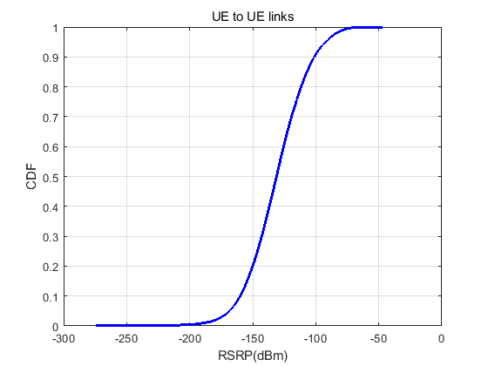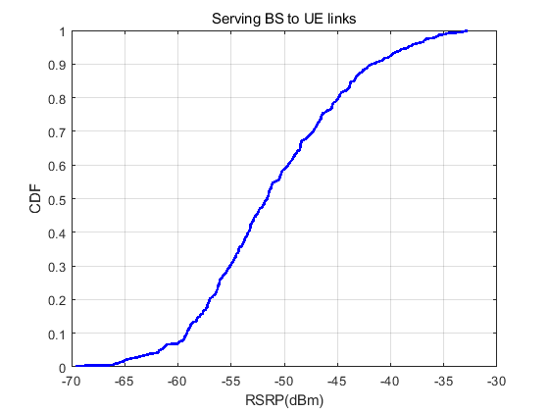RSRP distribution:*

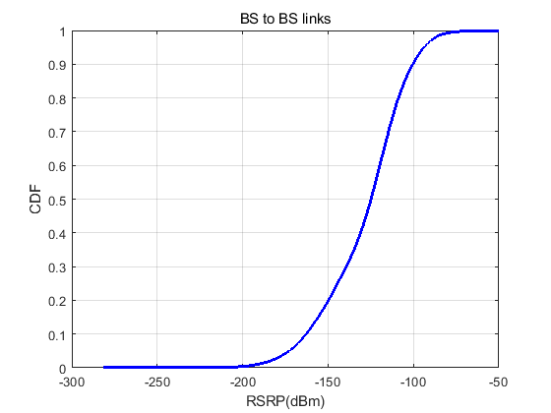

Note: companies are encouraged to also submit RSRP distribution (e.g. serving BS to UE links, BS-to-BS links, UE-to-UE links) for the evaluated scenario in SLS.