**3GPP TSG RAN WG1 Meeting #102-e R1-200xxxx**

**e-meeting, August 17th – 28th, 2020**

**Agenda item:** 8.1.2.1

**Source:** Qualcomm Incorporated

**Title:** Discussion Summary for mTRP PDCCH Reliability Enhancements

**Document for:** Discussion/Decision

# **Introduction**

The Rel-17 WID for further enhancements on MIMO (FeMIMO) includes the following objective:

1. Enhancement on the support for multi-TRP deployment, targeting both FR1 and FR2:
   1. Identify and specify features to improve reliability and robustness for channels other than PDSCH (that is, PDCCH, PUSCH, and PUCCH) using multi-TRP and/or multi-panel, with Rel.16 reliability features as the baseline

This document focuses on PDCCH reliability part. The company proposals are summarized, and further discussions are to be carried on based on the Chairman’s guidance:

[102-e-NR-feMIMO-02] Email discussion on enhancements on multi-TRP for PDCCH by 8/28 – Mostafa (Qualcomm)

* Prioritize topics to be resolved in RAN1#102-e by 8/19 (EVM should be highest priority)

# **High Priority Items for RAN1#102e**

This section includes two high-priority items for this meeting: EVM and categorization / alternatives based on companies’ proposals. For the second item (Section 2.2), the main goal is to agree on some alternatives, which can help the down-selection in future meetings. There is no plan for down-selection in RAN1#102e.

## **EVM for General Assumptions and PDCCH LLS**

Evaluation methodology / assumptions for multi-TRP PDCCH have been discussed offline (“Phase 2 - FeMIMO EVM Item 2a”). Detailed comments from each individual company can be found in Appendix. Followed by Phase 2 input, Phase 2 EVM discussion has concluded, and the final document includes two final proposals: One proposal for general channel model / antennas parameters, etc. by reusing Rel. 16 agreed tables (in TR38.824), and another proposal with 4 tables corresponding to “Common assumptions for PDCCH/PUCCH/PUSCH”, “Detailed assumptions for PDCCH”, “Detailed assumptions for PUCCH”, and “Detailed assumptions for PUSCH”. Subsequently, no proposal could be found in RAN1#102e company contributions to modify the Phase 2 final proposals. Hence, the outcome of Phase 2 offline discussion is assumed to be stable. The following proposal focuses on the general EVM for 2a as well as specific PDCCH EVM:

***Proposal 1 (Outcome of Phase 2 offline discussion):***

* ***According to the evaluation scenario (e.g., at FR1 in urban macro / at FR1 in indoor hotspot / at FR2 in indoor hotspot), one of three Tables (Table A.3-1 ~ A.3-3) in appendix can be a baseline of EVM for Rel-17 FeMIMO item 2a.***
  + ***System bandwidth other than those mentioned in the Tables can be considered and reported by the companies.***
* ***In addition, the following table is used for EVM for Rel-17 FeMIMO item 2a (Common assumptions for PDCCH/PUCCH/PUSCH)***

|  |  |
| --- | --- |
| Parameters | Potential values |
| The number of TRPs | 2 |
| Channel model | TDL for FR1 (CDL for FR1 can be optionally used)  CDL for FR2 (TDL for FR2 can be optionally used) |
| Path-loss modeling | {0,3,6} dB gap between TRPs |
| Blockage | Option 1: Blockage model from Rel-16 (x dB power offset with probability p): Companies to report x and p, and other assumptions, if any. |
| Target BLER | [10^-3, 10^-4, 10^-5]: BLER values shown in plots should be based on enough number of samples, e.g., ~100/BLER samples |

* ***The following table is used for detailed assumptions for PDCCH***

|  |  |
| --- | --- |
| Parameters | Potential values |
| Baseline schemes | Option 1: Rel-15 PDCCH  Option 2: Spec transparent SFN  For FR1: Both options 1 and 2 can be considered  For FR2: Option 1. |
| AL | 8 as baseline. Companies are encouraged to simulate other AL’s additionally for different code rate regimes. |
| # of RBs/symbols | 1 or 2 symbols. Companies to report # of RBs. |
| DCI payload | 40+24(CRC)=64 as baseline. Other payload values are not precluded. |
| CCE-to-REG mapping | Both Interleaved and non-interleaved can be considered. Companies to report the assumptions including interleaverSize in the case of interleaved. |
| REG bundling size | 6 and 2 as baseline. |
| Precoding assumptions | Precoding cycling, precoder granularity=REG bundle as baseline.  Closed-loop precoding can be used optionally |
| Schemes | Details of the schemes used (including TDM,FDM, etc.) to be reported by companies. |
| Receiver assumption | Up to companies to report |

As mentioned, proposal above is expected to be stable. The table below is added just in case there are minor last-minute comments:

|  |  |
| --- | --- |
| Company | Comments |
| Apple | Support the proposal |
| vivo | We are fine with the proposal in general. However, after reviewing contribution we noticed some phenomena on simulated curves thus we tried to verify as below. What we observed is that there is error floor in the curves in the case of blockage assuming the channel is continuous however there is no such phenomena if the channel is i.i.d. We think it may impact the conclusion/observation thus should be clarified in simulations.  cid:image004.jpg@01D67581.7F575870 cid:image005.jpg@01D67581.7F575870 |
| ZTE | Support the proposal |
| LG | Support the proposal |
| Ericsson | Support the proposal |
| NEC | Support the proposal |
| OPPO | Support the proposal |
| NTT DOCOMO | Support the proposal |
| Lenovo/Motorola Mobility | Support the proposal |
| InterDigital | Overall, we support the proposal. However, we have some concerns related to the blockage model. We believe that it is important to have an agreement on a set of p and x values (x dB power offset with probability p), as during the Rel-16 discussion some results were disputed as companies did not agree with the p and x values used by others. |
| Nokia/NSB | Support the proposal |

## **Categorization and Alternatives Based on Proposals**

Based on RAN1 102e contributions shown in References (see also Section 4 for detailed proposals), proposals can be categorized into three main issues (+ other issues):

* Multiplexing schemes (TDM / FDM / SDM)
* Framework to enable multi-TCI state PDCCH
* Joint vs separate encoding (no repetition vs repetition)

In general, there is dependency between the three issues above and a decision for one issue may impact the decision for another issue. Hence, it is suggested to focus on alternatives for each issue, and discuss the dependency when applicable.

For the first issue (multiplexing schemes), companies views are as follows:

* TDM: FUTUREWEI, Vivo, ZTE, NEC, Lenovo/Motorola Mobility, OPPO, TDM, Ericsson, Convida Wireless, LG (higher priority), AsusTek, Nokia, Qualcomm
* FDM: Vivo, Lenovo/Motorola Mobility, OPPO, Ericsson, Apple, Convida, LG, Qualcomm
* SDM (non-transparent SFN): Vivo, CATT, CMCC, LG
* SDM (two DMRS ports): CATT (can be discussed), Lenovo/Motorola Mobility
  + Notes: FUTUREWEI also mentions SDM but not explicitly clear from contribution if it refers to SFN or two ports

As mentioned by multiple companies, from specification perspective, SDM scheme with two ports has significant specification impact. Hence, it is suggested to deprioritize it. Majority of companies support TDM case as it can be also used for single Rx beam UEs in FR2. For TDM case, the specification impact may be different for intra-slot case versus inter-slot case (e.g. in terms of K0 indication or in terms of BD/CCE counting limit). Hence the two cases should be discussed having those aspects in mind. It is mentioned by multiple companies that FDM has advantage in term of latency but requires two Rx beams in FR2. SFN SDM scheme is proposed by some companies and it can be further studied, which may be also dependent on the progress of item 2d (HST-SFN). In addition, combinations of schemes are discussed by some companies. It is suggested to focus on the three schemes below initially, and combination of schemes can be discussed later. The following proposal can be discussed, and further refined based on the inputs:

***Proposal 2: For mTRP PDCCH reliability enhancements, study the following multiplexing schemes***

* ***TDM: Two sets of symbols of the PDCCH have different TCI states***
  + ***The two sets are completely overlapping in frequency domain.***
  + ***Aspects and specification impacts related to intra-slot vs inter-slot to be discussed***
* ***FDM: Two sets of REG bundles / CCEs of the PDCCH have different TCI states***
  + ***The two sets are completely overlapping in time domain***
* ***SFN: PDCCH DMRS is associated with two TCI states in all REGs/CCEs of the PDCCH***
  + ***Note: There is dependency between this scheme and AI 2d (HST-SFN)***
* ***Note: Combinations of the schemes are not precluded, and they can be discussed at a later stage.***

Please provide your input wrt description of different schemes in the above proposal as well as any other potential scheme that should be treated with high priority

|  |  |
| --- | --- |
| Company | Comments |
| MediaTek | We basically prefer TDM. In addition, we could also have TDM + FDM scheme (nonoverlapping in time and freq). For example, if we use Alt3 for the second issue, the gNB can transmit two PDCCHs in two SS sets in two different CORESETs. |
| Apple | Support the proposal. |
| ZTE | Two repeated PDCCHs corresponding to independent CORESET and SS can support both TDM and FDM schemes. In such case, for TDM, two sets of symbols can be able to non-overlapping in frequency domain. Likewise for FDM.  Therefore, we suggest making TDM/FDM schemes more general as  ***Proposal 2: For mTRP PDCCH reliability enhancements, study the following multiplexing schemes***   * ***TDM: Two sets of symbols of the PDCCH or two PDCCH repetitions have different TCI states***   + ***Aspects and specification impacts related to intra-slot vs inter-slot to be discussed*** * ***FDM: Two sets of REG bundles / CCEs of the PDCCH or two PDCCH repetitions have different TCI states*** * ***SFN: PDCCH DMRS is associated with two TCI states in all REGs/CCEs of the PDCCH***   + ***Note: There is dependency between this scheme and AI 2d (HST-SFN)*** * ***Note: Combinations of the schemes are not precluded, and they can be discussed at a later stage.*** |
| Xiaomi | Support the proposal. |
| LG | Regarding ZTE’s proposal, I understand the intention but it is quite controversial the meaning of two PDCCHs and repetition. Specifically, some companies see PDCCH repetition as just one PDCCH, and it is not clear whether repetition means the same DCI payload bits or not. In this sense, original wording is more generic. Also, we are fine with the description about resource overlapping. Since the Note says combination schemes are not precluded, we can further consider FDM+TDM with the original proposal by QC. |
| Ericsson | We agree with ZTE modifications. The FL proposal assumes that there is a single PDCCH where resources (symbols/REG/CCE) have different TCI states and is not generic enough. Several companies assumed that two PDCCH are transmitted with the same DCI payload (**PDCCH repetition**), one per TCI state. So either we discuss this issue first (one or two PDCCH), or we modify the proposal according to ZTE. Also, of two CORESETS are used, the repetition can be partially or non-overlapping, so striking our the subbullets (as in ZTE proposal) is necessary. |
| NEC | Support the modified proposal from ZTE. |
| OPPO | Support ZTE’s modification |
| CMCC | Support the modified proposal from ZTE. |
| Spreadtrum | Support modified proposal from ZTE. For example, there is no strict restriction on overlapping level in time domain and/or frequency domain for Alt.3 in Proposal 3. |
| Sony | Basically, Sony agree with the proposal. We think TDM is the most important for single RX antenna panel UE. Regarding TDM, why the restriction “The two sets are completely overlapping in frequency domain.” is needed? Time domain and frequency domain is orthogonal relationship. We don’t need the restriction. |
| NTT DOCOMO | We also think that TDM+FDM should be considered.  Like ZTE said, for TDM, two sets of symbols can be able to non-overlapping in frequency domain. Likewise for FDM.  Regarding ZTE’s modifications, to avoid misunderstanding, it is better to clarify that one PDCCH means the PDCCH is transmitted with the complete DCI payload. |
| Lenovo/Motorola Mobility | We generally support the modified proposals from ZTE. It is not quite clear whether non-transparent SFN and SDM are same or different, so we should change it SFN/SDM. SDM scheme can achieve good spectrum efficiency and should be studied. |
| Sharp | We support the modification of ZTE’s proposal. |
| InterDigital | Have a similar view as ZTE |
| Fraunhofer | Agree with ZTE’s modification of the proposal |
| Nokia/NSB | Agree with ZTE update. |

For the second issue (framework to enable multi-TCI state PDCCH), companies’ views are as follows:

* Alt1: One CORESET with 2 TCI states
  + Vivo (as starting point), CATT, Lenovo/Motorola Mobility, Intel, OPPO, Samsung, Apple, LG, NTT DOCOMO, Nokia, Qualcomm, CMCC
* Alt2: One SS set with 2 CORESETs
  + Vivo, Lenovo/Motorola Mobility, OPPO, DCM, Ericsson
* Alt3: Two SS sets and two corresponding CORESETs
  + Vivo, MTK, CATT, OPPO, Huawei, Ericsson, ZTE, Lenovo/Motorola Mobility
* Notes:
  + Fraunhofer mentions 2 CORESETs with different CORESETPoolIndex values but not clear explicitly from contribution if Alt2 or Alt3 is intended.
  + Intel mentions inter-CORESET approach (in addition to intra-CORESET), but not clear explicitly from contribution if Alt2 or Alt3 is intended.
  + Vivo mentions another Alt with 2 SS sets with one CORESET that has 2 TCI states

Different pros and cons for the alternatives above are mentioned by companies. In terms of specification impact, the following aspects should be further studied for each alternative: Multiplexing schemes (TDM / FDM / SDM), BD/CCE limits, overbooking, CCE-REG mapping, PDCCH candidate CCEs (i.e., hashing function), CORESET / SS set configuration changes, as well as other procedural changes that are a function of PDCCH reception. Hence, it is suggested to focus on the three alternatives above. Ideally, down selection to only one of the alternatives in early stage of Rel. 17 is desirable so that there is enough time for the details.

***Proposal 3: To enable a PDCCH transmission with two TCI states, study pros and cons of the following alternatives:***

* ***Alt 1: Support*** ***one CORESET with two active TCI states***
* ***Alt 2: Support one SS set to be associated with two different CORESETs***
* ***Alt 3: Support one PDCCH candidate to be defined in two SS sets associated with corresponding CORESETS***
* ***At least the following aspects can be considered: multiplexing schemes (TDM / FDM / SDM), BD/CCE limits, overbooking, CCE-REG mapping, PDCCH candidate CCEs (i.e. hashing function), CORESET / SS set configurations, and other procedural impacts.***
* ***Note: Strive to down-select to one alternative in RAN1#103-e***

Please provide your input wrt description of different alternative in the above proposal as well as any other potential alternative that should be treated with high priority. In addition, please mention any other aspect (in addition to what’s mentioned above) that should be considered for comparison.

|  |  |
| --- | --- |
| Company | Comments |
| MediaTek | Support Alt 3 with slight modification. We prefer separate encoding of two PDCCHs (repetition) in two SS sets associated with corresponding CORESETs. This scheme provides flexible resource allocation in time and freq domain. Less spec impact thanks to reuse of exiting configurations of SS sets and CORESETs. Also, we don’t need to introduce two TCI states for a CORESET. Also, this design is aligned with M-DCI MTRP where each TRP is transmitting a PDCCH using corresponding CORESET. |
| Apple | Support the proposal |
| ZTE | We have the same view with MediaTek for Alt3. Suggest changing Alt.3 or include one more option as   * ***Alt 3: Support PDCCH repetitions which correspond to separate CORESETs and SSs.***   With the modified Alt3, most flexibility can be achieved. gNB can either transmit one(no repetition) or two PDCCH repetitions. The spec impact is quite limited if UE does not need to do soft combining. |
| Xiaomi | Support the proposal. |
| LG | Alt 3 describes second level detail. It can be one PDCCH candidate or two PDCCH candidate as MediaTek mentioned. We suggest to revise Alt3 to align with other alts in the same level.   * ***Revised Alt 3: Support two SS sets associated with corresponding CORESETS*** |
| Ericsson | Support the proposal |
| NEC | We are fine with the modified Alt 3 either from ZTE or LG. |
| OPPO | Support the proposal |
| CMCC | Support the modified proposal from LG. |
| Spreadtrum | Fine with the modified Alt 3 from LG |
| Sony | We support Alt1. |
| NTT DOCOMO | We support the FL proposal and fine with LG’s update. |
| Lenovo/Motorola Mobility | We are fine with ZTE or LG modified version. |
| Sharp | We support the FL’s proposal and fine with LG’s modification |
| InterDigital | Support and understand the intention of proposals. However, for more clarity and have a same tone as Alt1, we suggest the following clarifications:   * ***Alt 2: Support one SS set to be associated with two different CORESETs/TCI states*** * ***Alt 3: Support one PDCCH candidate to be defined in two SS sets associated with corresponding CORESETS/TCI states*** |
| Fraunhofer | Support the FL’s proposal with LG’s or ZTE’s modification for the alternatives to be studied. In terms of support for the alternatives, we are ok with Alt 2 or 3. |
| Nokia/NSB | Support. |

For the third issue (joint vs separate encoding), companies views are as follows:

* Option 1: Joint encoding / TCI state agnostic PDCCH rate matching / one PDCCH (no repetition):
  + Vivo, Intel, Apple, LG, Nokia, Qualcomm
* Option 2: Separate encoding / TCI state dependent rate matching / two PDCCHs (repetition)
  + Vivo, MediaTek, CATT, Intel, Samsung, Ericsson, LG, Nokia, ZTE, CMCC

In addition, some companies provided simulation results comparing the two options above. Vivo, Apple and Qualcomm observed similar performance while Ericsson observed repetition can perform better. Furthermore, it is observed by most companies that in the case of repetition, the AL / # of CCEs should be the same for both repetitions due to Polar code rate matching procedures. Also, some companies (CATT, Intel, Samsung, Ericsson, LG) discussed aspects related to soft-combining vs selection diversity (mostly applicable to the case of repetition). Some discussions may be needed to clarify the specification impact for selection diversity as it may or may not be transparent. Hence, a question is asked in the proposal below to collect companies views, and the proposal will be refined based on companies views.

***Proposal 4: For mTRP PDCCH reliability enhancements, study the following options:***

* ***Option 1 (no repetition): One encoding / rate matching for a PDCCH with two TCI states***
* ***Option 2 (repetition): Encoding / rate matching is based on one repetition, and the same coded bits are repeated for the other repetition. Two repetitions have the same number of CCEs and coded bits.***
  + ***Question: In the case of selection diversity only (no soft combining), what are the anticipated specification impacts, and why it cannot be done based on Rel. 15 / 16?***
* ***Note: Companies are encouraged to evaluate the two options based on agreed LLS assumptions for possible down-selection in RAN1#103-e.***

Please provide your input wrt description of the two options in the above proposal. In addition, feel free to provide answer to the question above.

|  |  |
| --- | --- |
| Company | Comments |
| MediaTek | Support option 2 because repetition clearly provides combining gain especially for >2 repetitions. Even if we define the repetition in the spec, the UE can separately decode them to reduce the complexity. We don’t have to limit the capability of power UE. |
| Apple | Support the proposal.  For option 2, we are also wondering whether the receiving schemes, i.e. selection or soft combining, should be transparent to gNB or not. |
| ZTE | We have the similar concern with Apple for the description of option 2. If soft combining is not needed or is not supported for UE, the repetitions may be transparent to UE. The same coded bits / CCE are not necessary. Even the DCI bits can be different. The only necessity is the two PDCCH repetitions schedule the same PDSCH/PUSCH.  Then we suggest making option 2 more general as   * ***Option 2 (repetition): Encoding / rate matching is based on one repetition, and the same PDSCH/PUSCH/RS are scheduled by PDCCH repetitions.***    + ***Question: In the case of selection diversity only (no soft combining), what are the anticipated specification impacts, and why it cannot be done based on Rel. 15 / 16?***   + ***Study spec impact for intra-slot repetition and inter-slot repetition***   In our view, spec impact of option 2 can be further studied. For example, how to define DAI counter if two PDCCH repetitions schedule the same PDSCH. Further, the scheduling timing should be studied if two PDCCH repetitions are in different slots. |
| Xiaomi | Support option 2. |
| LG | Option 2 assumes soft combining while we can consider other option without soft combining. In this case, encoding/rate matching is conducted per transmission occasion (TO) and coded bits and even DCI payload can be different for each TO, which provides just multiple chance to decode the DCI indicating the same outcome.  So, we propose to add Option 3.  ***Option 3 (multi-chance without soft combining): Encoding / rate matching is conducted per transmission occasion, and the same/different coded bits are transmitted for each transmission occasion. Each DCI resulting in the same outcome.***  In addition, SFN based enhancement can be further investigated as a potential candidate.  ***Option 4 (SFN based enhancement): PDCCH DMRS is associated with two TCI states in all REGs/CCEs of the PDCCH*** |
| Ericsson | Support the proposal with the Question removed. Regarding the question of option 2, the spec impact relates to to timing, e.g., between a PDCCH and its scheduled PUSCH/PDSCH, which is used to determine whether a default TCI state is used in DL and PUSCH processing timing in UL. If the two PDCCHs ended at different symbols, the timing could be interpreted differently at UE and gNB depending on which one is detected by the UE which needs to be resolved. |
| NEC | Support the proposal, and we prefer Option 2.  And regarding PDCCH repetition, in our opinion, UE can be aware of the repetitions even without explicit configuration, for example, two PDCCHs are detected to schedule same data or RS. In this case, a unified scheme (based on which soft-combining is available) can be designed, and whether soft-combining is applied or not is up to UE. |
| OPPO | Support the proposal and prefer Option 2. From our understanding, Option 3 is included in Option 2 since whether soft combination used or not is transparent to gNB  A question for Option 4: Option 4 seems captured in Proposal 2 as SFN. Why is Option 4 listed here? |
| CMCC | Support FL’s proposal with the question removed. The spec impact can be further discussed. |
| Spreadtrum | Support the proposal with the question removed, and prefer option2.  For the question in option 2, one example, as ZTE has pointed that it will bring effect on type2 HARQ-ACK codebook if the DCI content, e.g., DAI, is the same across the PDCCH repetition. |
| NTT DOCOMO | Support the proposal. |
| Lenovo/Motorola Mobility | Support FL’s proposal with the question removed. The spec impact can be further discussed. |
| Sharp | Support the proposal |
| InterDigital | Have a similar view as Ericsson and CMCC.  Support the proposal with question removed. |
| Fraunhofer | Agree with FL’s proposal with the question removed |
| Nokia/NSB | Support the direction proposed by ZTE and FL. Some changes in the wording may be needed to avoid misunderstanding of use of words like encoding/rate matching. It should be clear enough that we do not talk anything related to changes on those parts.  ***Proposal 4: For mTRP PDCCH reliability enhancements, study the following options:***   * ***Option 1 (no repetition): ~~One~~ ~~encoding / rate matching for a~~ The coded bits of DCI of a PDCCH is associated with two TCI states,*** * ***Option 2 (repetition): ~~Encoding / rate matching is based on one repetition, and t~~ The same coded bits are repeated to schedule the same PDSCH/PUSCH/RS/other transmission ~~for the other repetition. Two repetitions have the same number of CCEs and coded bits.~~***   + ***Question: In the case of selection diversity only (no soft combining), what are the anticipated specification impacts, and why it cannot be done based on Rel. 15 / 16?***   + ***Study spec impact for intra-slot repetition and inter-slot repetition*** * ***Note: Companies are encouraged to evaluate the two options based on agreed LLS assumptions for possible down-selection in RAN1#103-e.*** |

In addition to the above three main issues, some other aspects are discussed by companies:

* Multi-DCI based mTRP:
  + FUTUREWEI: Cross-TRP scheduling, joint DCI to schedule PDSCHs associated with different CORESETPoolIndex, joint Tx of the same DCI
  + Two PDSCHs with different CORESETPoolIndex values correspond to the same TB: Vivo, SS (second priority), Sharp
* Other proposals:
  + Lenovo/Motorola Mobility: CSI feedback for PDCCH

Some of the above proposals do not seem to have wide support at this stage or are not directly in the scope of this item. The question below is to collect input from companies, and a proposal may be drafted based on the inputs.

***Question: Do you see any other issue for PDCCH reliability that should be discussed in this meeting with high priority (e.g. that requires categorizations / alternatives) to help possible down-selection in future meetings?***

|  |  |
| --- | --- |
| Company | Comments |
|  |  |

# **Pros and Cons for Different Alternatives of Proposal 3**

This section should be treated with lower priority compared to Section 2 in RAN1#102e. The intention is to start the discussions on pros and cons for different alternatives in proposal 3 in Section 2. As mentioned in Section 2, down selection to only one of the alternatives in early stage of Rel. 17 is desirable so that there is enough time for the details.

Please provide your input on pros / cons of Alt 1 (one CORESET with two active TCI states)

|  |  |  |
| --- | --- | --- |
| Company | Pros of Alt1 | Cons of Alt1 |
| MediaTek | One PDCCH candidate can be mapped to each group of REs corresponding to each TRP in TDM or FDM. | Much spec impact because we need to introduce two TCI mapping to one CORESET, Not flexible in freq allocation. |
| ZTE | SFN based solution should be prioritized for Alt.1 since it can be used which the same as PDSCH for HST. Spec impact is marginal. | It is not easy to support TDM beam diversity based on legacy PDCCH structure.  It may not be supported if UE is only able to support one receiving beam at a given symbol.  For wideband precoder, it may not be supported.  For AL=1 with CCE-interleaving is not enabled, it may not be supported.  It may not support dynamic switching between single TRP and MTRP. |
| CMCC | Since maximum 3 CORESETs are supported for UE, based on Alt2 or Alt3, the available CORESETs for each TRP is reduced, while based on Alt1, each TRP can still use maximum 3 CORESETs. Besides, one CORESET with two active TCI states is benefit for SFN scheme, which could enhance the channel estimation accuracy. |  |
| NTT DOCOMO | Good to support HST-SFN scenario. |  |

Please provide your input on pros / cons of Alt 2 (one SS set to be associated with two different CORESETs)

|  |  |  |
| --- | --- | --- |
| Company | Pros of Alt2 | Cons of Alt2 |
| MediaTek | Don’t need to introduce two TCI states for a CORESET | Much spec impact because we need to change the existing relationship between SS set and CORESET. |
| ZTE |  | Don’t support this solution.  CCE to SS/CORESET mapping may be impacted. |

Please provide your input on pros / cons of Alt 3 (one PDCCH candidate to be defined in two SS sets associated with corresponding CORESETS)

|  |  |  |
| --- | --- | --- |
| Company | Pros of Alt3 | Cons of Alt3 |
| MediaTek | Flexible resource allocation in time and freq domain. Less spec impact thanks to reuse of exiting configurations of SS sets and CORESETs. Don’t need to introduce two TCI states for a CORESET. Also, this design is aligned with M-DCI MTRP where each TRP is transmitting a PDCCH using corresponding CORESET. | Use of the limited number of CORESETs for multi-TRP. But we can resolve this issue to introduce dynamic signaling like MAC CE activate/deactivate PDCCH repetition. |
| ZTE | support dynamic switching between single TRP and MTRP.  Less spec impact  Can implement FDM, TDM and the combined multiplexing for beam diversity |  |

# **Detailed Proposals, Observations, and simulation Results**

[FUTUREWEI]:

**Proposal 4: For M-TRP PDCCH enhancement, support:**

* **PDCCH repetition in time domain and spatial domain**
* **Cross-TRP scheduling, joint DCI, and joint transmission of the same DCI**

-----------------------------------------------------------------------------------------------------------------------------

[Vivo]

1. SDM(SFN) based PDCCH transmission may has small spec impact compared to other schemes and is compatible to PDSCH design in HST scenarios.
2. FDM based PDCCH transmission with joint encoding across TRPs does not support AL=1 and the granularity of precoding based on wideband.
3. If UE can perform soft combining, FDM based PDCCH transmission of option2 should be configured same AL values.
4. TDM scheme is appliable for the scenarios where more repetition is needed and where simultaneous reception from multi-TRP is not feasible*.*

• Alt1: One Search Space ID mapped to one CORESET ID with Multi-TCI states.

• Alt2: One Search Space ID mapped to Multi-CORESET ID with respective TCI state.

• Alt3: Multi-Search Space ID mapped to one CORESET ID with Multi-TCI states

• Alt4: Multi-Search Space ID mapped to corresponding CORESET ID with different TCI state

1. Different mapping of TCI states to SS and CORESET can be investigated to facilitate design of different repetition schemes.





1. PDCCH enhancement based on SFN\FDM\TDM in two TRPs has similar performance in case of blockage.
2. Support multi-DCI PDCCH reliability enhancement in Rel-17.

-----------------------------------------------------------------------------------------------------------------------------

[ZTE]



***Observation 1：****PDCCH repetition with beam diversity provides better performance than single PDCCH under the blockage scenario.*

***Proposal 1:*** *Support PDCCH repetition with beam diversity, each beam corresponds to 1 TRP.*

Option 1: FDM scheme

1a. A single PDCCH is divided into 2 part of frequency domain resources, each of which corresponds to a different beam.

1b. Each PDCCH repetition is an independent DCI and occupies different frequency domain resources with multiple beams.

Option 2: TDM scheme

2a. The PDCCH repetitions are located in one slot using different beams.

2b. The PDCCH repetitions are located in different slots using different beams.

Option 3: combined scheme

1a. Each PDCCH repetition occupies non-overlapped time and frequency resources corresponding to different beams.



***Observation 2:*** *Single PDCCH and 2 PDCCH repetitions performs better than the FDM scheme.*

***Proposal 2:*** *TDM based PDCCH repetition with beam diversity should have the highest priority.*

-----------------------------------------------------------------------------------------------------------------------------

[InterDigital]

***Proposal 1:*** *Study solutions to enable PDCCH beam diversity.*

***Proposal 2:*** *Study benefits and issues related to both with and without combining schemes for PDCCH.*

-----------------------------------------------------------------------------------------------------------------------------

[Sony]

**Proposal 1:** Specify the UE capability whether the UE can monitor simultaneously two CORESETs using different antenna panels in UE side.

**Proposal 2:** Specify the gap between two different PDCCH from different TRPs for the UE without simultaneous reception capability.

-----------------------------------------------------------------------------------------------------------------------------

[MediaTek]

**Proposal 1: Associate two search space sets which are mapped onto two different CORESETs for PDCCH repetition.**

* **Use the same configurations such as *duration*, *nrofCandidates*, *monitoringSymbolsWithinSlot* for two associated search space sets and *cce-REG-MappingType*, *duration*, the number of RBs for two corresponding CORESETs**
* **Transmit the same payload of DCI using PDCCH candidates with the same index ($m_{{A,n}_{CI}}$ = $m_{{B,n}_{CI}}$) and the same aggregation level *L* in two associated search space sets A and B**

**Proposal 2: Introduce new MAC CE to activate/deactivate the association of two search space sets for PDCCH repetition.**

**Proposal 3: To indicate the repetition number, use *monitoringSlotPeriodicityAndOffset*, *duration* and/or *monitoringSymbolsWithinSlot* in *SearchSpace*.**

**Proposal 4: Slot offset *K0* can be calculated based on the last repetition where the index of repetition can be counted first in monitoring occasion and in ascending order of index(es) of CORESETs or search space sets.**

-----------------------------------------------------------------------------------------------------------------------------

[CATT]



**Figure 1 Possible repetition schemes for PDCCH**

***Proposal 1: The following repetition schemes can be considered to improve reliability and robustness for PDCCH using multi-TRP and/or multi-panel:***

* ***Intra-CORESET repetition***
* ***Intra-slot repetition with different CORESETs***
* ***Inter-slot repetition with the same CORESET index in each slot***
* ***Inter-slot repetition with different CORESET indexes in each slot***
* ***SDM based repetition***

***Proposal 2：Enhancements on TCI states are needed for the following PDCCH repetition schemes,***

* ***For intra-CORESET repetition scheme, TCI state can be configured per search space set or per PDCCH candidate.***
* ***For SDM based repetition scheme, a CORESET is associated with two (or more) TCI states.***

***Proposal 3: If multiple PDCCH repetitions are multiplexed in different symbols or slots, how to ensure two repetitions schedule the same PDSCH shall be discussed.***

***Proposal 4: With regarding to the content of DCI in PDCCH repetition, the following two alternatives can be considered:***

* ***Alt.1: DCIs in all PDCCH repetitions are exactly the same.***
* ***Alt.2: DCIs in all PDCCH repetitions can be different.***

***Proposal 5: The following associations among multiple PDCCH repetitions can be considered to reduce complexity of blind detection.***

* ***Option 1: Time or frequency offset between two repetitions is configured or predefined.***
* ***Option 2: Time and frequency resources of one DCI can be indicated by other DCI.***
* ***Option 3: Association of TCI states of multiple repetitions can be configured, predefined or indicated by one DCI.***

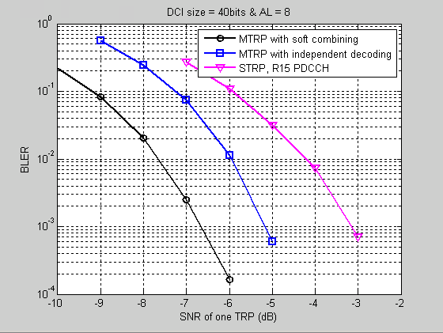

**Figure 5 BLER of PDCCH repetition, AL=8**

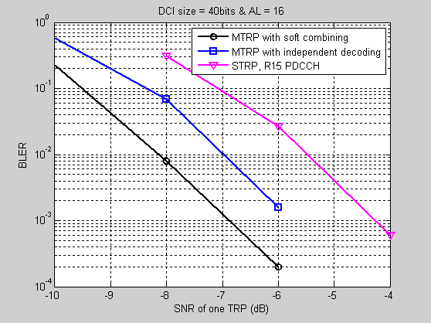

**Figure 6 BLER of PDCCH repetition, AL=16**

***Observation 1: For PDCCH repetition, both soft combining scheme and independent decoding scheme can bring performance gain.***

***Proposal 6: Transmission schemes which require soft combining or independent decoding at the receiver can both be considered in PDCCH repetition.***

-----------------------------------------------------------------------------------------------------------------------------

[China telecom]

***Proposal 1: PDCCH repetition transmitted from different TRPs can be considered.***

-----------------------------------------------------------------------------------------------------------------------------

[NEC]

***Proposal 1: For PDCCH repetition, TDM seems more suitable, which can be taken as a starting point.***

***Proposal 2: PDCCH repetitions should be well designed, and based on which combining can be achieved.***

-----------------------------------------------------------------------------------------------------------------------------

[Fraunhofer]

***Proposal 1:*** *Perform transmission of the same PDCCH on two different CORESETs to improve PDCCH reliability.*

***Proposal 2:*** *The two CORESETs on which the PDCCH is transmitted may be configured with different CORESETpoolIndex values.*

-----------------------------------------------------------------------------------------------------------------------------

[Lenovo, Motorola Mobility]

***Observation 3: Small bandwidth configuration scenario, e.g. 100M for FR2, 20M for FR1 can be considered for PDCCH enhancement.***

***Observation 4: From system view, transmission reliability and spectrum efficiency need to be considered together for PDCCH enhancement.***

***Proposal 1: TDM/FDM/SDM schemes proposed for PDSCH enhancement for URLLC with multiple TRPs transmission can be a start point for evaluation and specification discussion for PDCCH enhancement.***

***Proposal 2: TDM schemes can be considered as the baseline for PDCCH enhancement.***

***Proposal 3: FDM/SDM schemes can be considered only for UE with high capability for receiving multiple beams simultaneously, e.g. multiple panels.***

***Proposal 4: Multiple associated CORESETs or single CORESET with multiple TCI states can be considered for PDCCH enhancement.***

***Proposal 5: Multiple monitoring occasions in one search space set or multiple component search space sets can be used for PDCCH with multiple transmission.***

***Proposal 6: Blind decoding complexity for soft combination of candidates from multiple transmissions needs to be considered.***

***Proposal 7: CSI Feedback should be enhanced for PDCCH transmission.***

-----------------------------------------------------------------------------------------------------------------------------

[Intel]

|  |  |
| --- | --- |
| **Figure 1: Selection diversity vs soft-combining** | **Figure 2: 1 TRP vs 2 TRP (resource fair)** |

|  |  |
| --- | --- |
| **Figure 3: comparison of 1 TRP vs 2 TRP (resource additional)** | **Figure 4: comparison of SFN, selection-diversity and soft-combining schemes** |

***Observations-1:***

* ***Soft combining gain over selection diversity is about 1.5 dB* (**Figure 1**)**
* ***Considering resource fair comparison (AL4+AL4 vs AL8) multi-TRP repetition performance is about the same as single-TRP performance if selection diversity is used at the UE, multi-TRP repetition performance is better than single-TRP if soft-combining is used at the UE.*(**Figure 2**)**
* ***Considering additional resource for multi-TRP transmission available from the other TRP, selection diversity or soft-combining provides significant gains. In FR1 SFN transmission provides approximately similar performance as soft-combining with multi-TRP repetition* (**Figure 3**,** Figure 4**)**
* ***Overall, motivation for PDCCH repetition is primarily in FR2 environments where SFN is not feasible in most UE orientations***

***Proposal-2: All PDSCH transmission schemes in Rel-15/16 are in scope.***

***Proposal-3: Categorize PDCCH reliability schemes at high-level into – 1) selection diversity 2a) soft-combining with joint coding 2b) soft combining with repetition***

***Proposal-4: PDCCH repetition scheme should allow the NW to choose (dynamically) to transmit DCI from TRP-1 only or from TRP-2 only without repetition or from both TRP-1 and TRP-2 with repetition.***

***Proposal-5: BD/CCE provisioning principles to consider (for mTRP repetitions):***

* ***CCE provisioning → CCE (TRP-1) + CCE (TRP-2)***
* ***BD provisioning for selection diversity → BD (candidates from TRP-1) + BD (candidates from TRP-2)***
* ***BD provisioning for soft-combining → BD (candidates from TRP-1) + BD (candidates from TRP-2) + BD (soft-candidates from TRP-1, TRP-2)***

***Proposal-6: Flexible BD/CCE partitioning across TRPs (for repetitions) should be allowed where TRP-1 and TRP-2 may not consume equal BD/CCE capacity as BD/CCE capacity is quite limited at the UE.***

***Proposal-7: Consider the following framework for PDDCH repetition study***

* ***Inter-CORESET approach where different CORESETs can be associated with different TRPs. This allows fully flexible partitioning of BD/CCE between TRP-1 and TRP-2***
* ***Intra-CORESET approach where the same CORESET can be associated with different TRPs. As an example TRP-1 associated with monitoring occasion-1 and TRP-2 associated with monitoring ocassion-2***

-----------------------------------------------------------------------------------------------------------------------------

[OPPO]

***Proposal 1: Study FDM and TDM for PDCCH enhancement in Rel-17.***

***Proposal 2: Study the following schemes to support multi-TRP based PDCCH enhancement for URLLC:***

* ***One search space is associated with one CORESET where two TCI states are activated for the CORESET at the same time. Each repetition of PDCCH can be associated with one TCI state for the CORESET associated with that search space.***
* ***One search space is associated with two CORESETs. Each repetition of PDCCH can applies the TCI state of one CORESET associated with that search space.***
* ***Two search spaces are used and each search space is associated with one CORESET. Each repetition of PDCCH can be transmitted via one of the search spaces.***

-----------------------------------------------------------------------------------------------------------------------------

[Samsung]

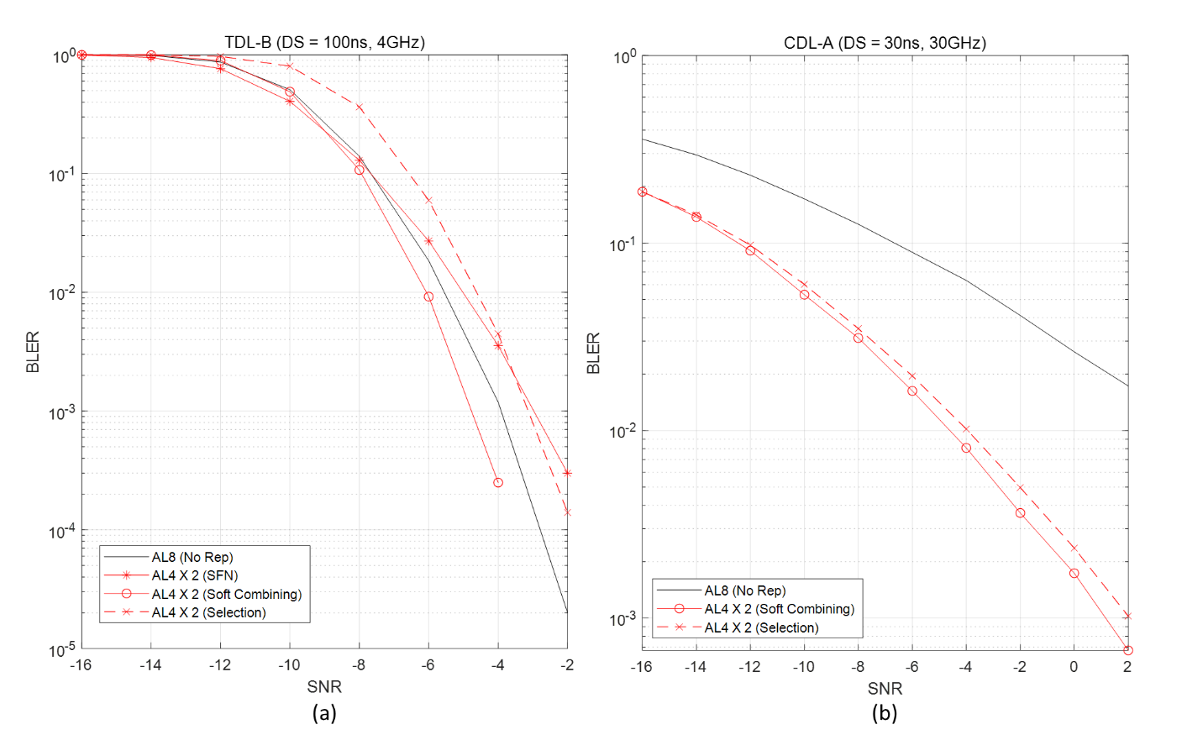

Figure 2. BLER performance of PDCCH with 40 + 24 bits of DCI size in FR1 (a) and FR2 (b).

**Observation 1**. *Both soft combining and selection based multi-TRP repetition can increase the reliability of PDCCH in FR2.*

**Proposal 1**. *Support both soft-combining and selection based multi-TRP repetition in Rel-17.*

**Proposal 2**. *Support multi-TRP based PDCCH repetition based on single-DCI framework.*

**Proposal 3**. *Consider multi-TRP based PDCCH repetition for multi-DCI framework as a second priority.*

**Proposal 4.** *Support TDM based PDCCH repetition as a starting point.*

**Proposal 5.** *For TDM-based PDCCH repetition for multi-TRP, support repeated PDCCHs to be configured within a single CORESET.*

-----------------------------------------------------------------------------------------------------------------------------

[CMCC]

***Proposal 1: Repetition of PDCCH candidate pairs are transmitted from different TRPs to improve PDCCH reliability.***

***Proposal 2: The DMRS port for PDCCH can be associated with two TCI state indices, where two TCI states are indicated by MAC CE.***

-----------------------------------------------------------------------------------------------------------------------------

[Spreadtrum Communications]

* Option 1: One DCI is carried by one PDCCH in SFN way from multiple TRPs;
* Option 2: One DCI is carried by multiple PDCCH repetition across multi-TRPs;
* Option 3: One DCI is carried by one PDCCH with REG bundle cycling;

***Proposal 1: For PDCCH enhancement across multi-TRP, further study and evaluation are needed.***

-----------------------------------------------------------------------------------------------------------------------------

[Ericsson]

|  |  |  |
| --- | --- | --- |
| DCI repetition cases | ***Single-CORESET (with two TCI states)*** | ***Multi-CORESETs (with one TCI state each)*** |
| ***Single-PDCCH transmitted*** | * Each CCE or REG associated with one of the TCI states * FDM reception of multi-TRP transmitted CCE/REG neccessary at the UE | * Not considered |
| ***Multi-PDCCH transmitted*** | * One or multiple search spaces in the CORESET * Multiple PDCCH repetitions * Each PDCCH candidate associated with one of the TCI states * FDM reception of multi-TRP transmitted PDCCH neccessary at the UE | * A single search space per CORESET * TDM or FDM recpetion of repeated PDCCH, depending on symbol allocations of the CORESETs |

1. Solutions for PDCCH robustness should allow for dynamic switching between single and multi-TRP transmission of a DCI to a given UE.

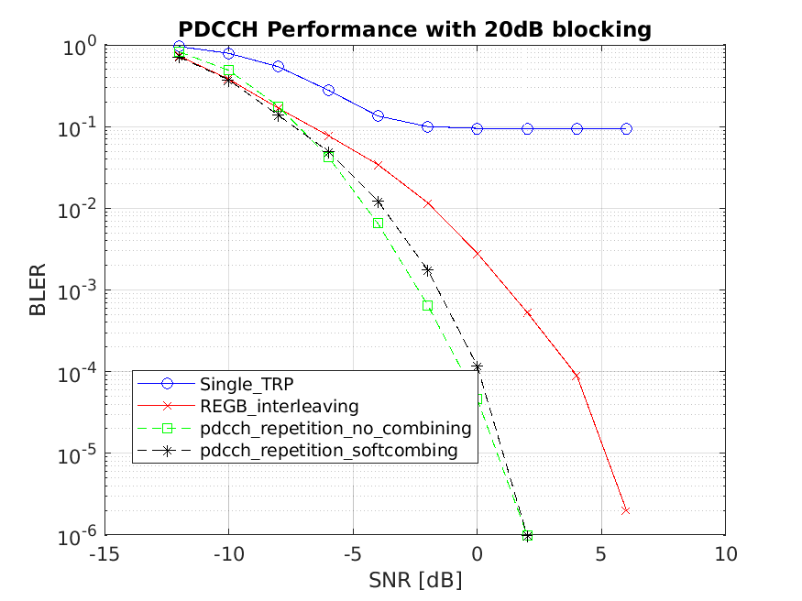

Figure 1: PDCCH performance with different multi-TRP schemes under channel blocking under indoor hot-spot scenario at 30GHz.

1. PDCCH repetition over 2 TRPs significantly outperforms REG bundle based interleaving over two TRPs under channel blocking.
2. Soft combining does not bring extra performance gain over no combining under channel blocking.
3. Consider PDCCH enhancement for link robustness with DCI repetition using multi-PDCCH, from different TRPs/different TCI states.
4. Soft combining is not required for PDCCH repetition.
5. Support multiple CORESETs with one TCI state per CORESET (as in Rel.15) where the same PDCCH is transmitted multiple times, once per CORESET.

-----------------------------------------------------------------------------------------------------------------------------

[Huawei/HiSilicon]

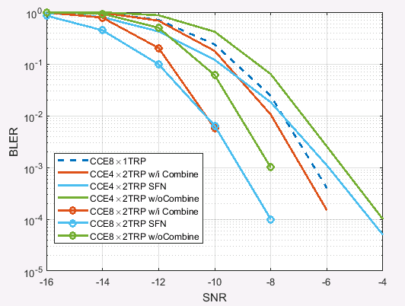

**Figure 3: Simulation results of PDCCH repetition without blockage**

***Observation 1: Without blockage, the repetition of PDCCH with soft combining the same AL is much more beneficial than the scheme without soft combining and SFN-based PDCCH transmission.***

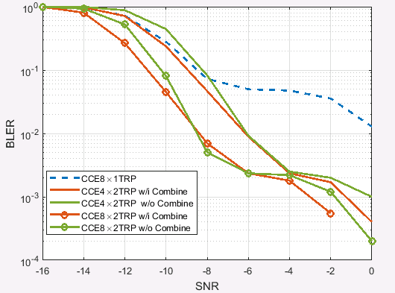

**Figure 4: Simulation results of PDCCH repetition with blockage**

***Observation 2: With potential blockage of PDCCH transmission, the multi-TRP transmission schemes are much more robust than single-TRP transmission.***

***Proposal 1: To reduce the complexity, association between PDCCH candidates from different TRPs should be supported for PDCCH repetition.***

-----------------------------------------------------------------------------------------------------------------------------

[Apple]



**Figure 1: Link Level Simulation Results for PDCCH**

***Proposal 2-1: Compared to multiple PDCCH repetitions, the scheme to apply different TCI states for different REG-bundle is preferred for PDCCH reliability enhancement.***

***Proposal 2-2: For PDCCH reliability enhancement, one DCI can be transmitted from up to 2 TCI states.***

***Proposal 2-3: Support MAC CE to indicate up to 2 TCI states for a CORESET.***

-----------------------------------------------------------------------------------------------------------------------------

[Xiaomi]

**Proposal 1:** It is better to take four PDSCH repetition schemes as a baseline when discussing PDCCH repetition.

**Proposal 2:** Beam failure recovery of each TRP need to be considered.

-----------------------------------------------------------------------------------------------------------------------------

[Sharp]

**Proposal 1:** RAN1 should discuss PDCCH reception in multi-DCI based PDSCH scheduling as a baseline.

-----------------------------------------------------------------------------------------------------------------------------

[LG]

**Proposal 1: TDM based MTRP PDCCH scheme should be supported with priority and FDM based scheme or SFN based enhancement can be considered additionally.**

**Proposal 2: Support 2 TCI states configuration/activation for a single CORESET for MTRP PDCCH scheme.**

**Proposal 3: For multi-chance PDCCH scheme, the scheme without combining can be considered with priority if additional gain from soft combining is not fully justified, taking into account UE complexity and specification impact.**

**Proposal 4: For a single PDCCH scheme, both SFN based enhancement and FDM based MTRP transmission can be considered.**

-----------------------------------------------------------------------------------------------------------------------------

[Convida Wireless]

***Proposal 5:* A DCI can be transmitted from multiple TRPs using at least TDM or FDM. Further study SDM.**

-----------------------------------------------------------------------------------------------------------------------------

[DCM]

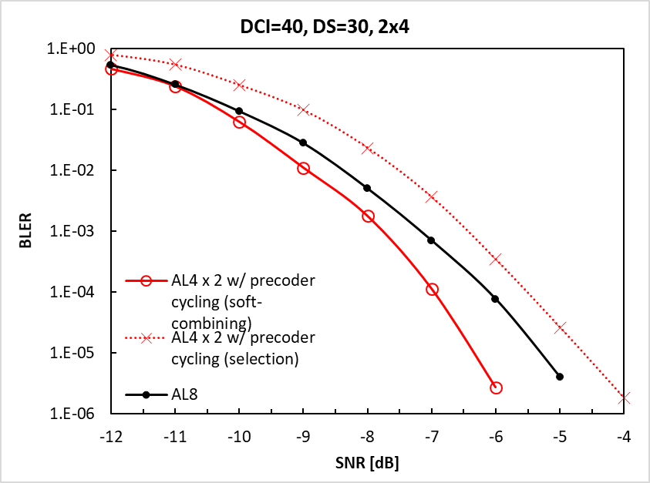 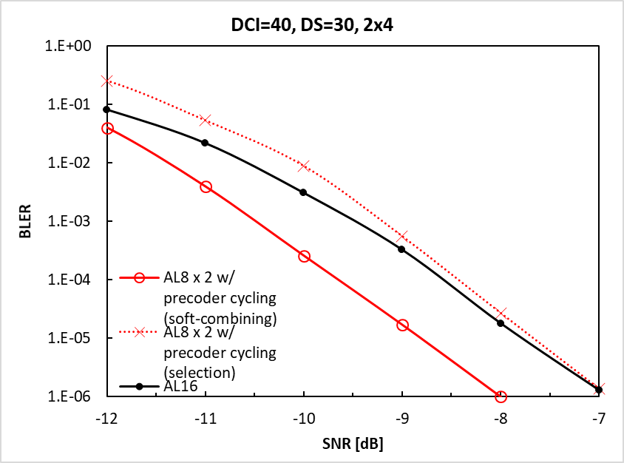

Case 1 Case 2

Figure 1 BLER performances of PDCCH repetitions.

**Observation 1:**

* ***Compared with single-TRP transmission, PDCCH repetitions over 2 TRPs with soft combining requires 1.0 dB lower SNR for achieving BLER=10-5.***

**Proposal 1:**

* ***Further discuss following methods for PDCCH repetition over multiple TRPs,***
  + ***A CORESET is configured with multiple (e.g., 2) TCI states;***
  + ***A search space is associated with multiple (e.g., 2) CORESETs.***

-----------------------------------------------------------------------------------------------------------------------------

[Nokia]

**Proposal 1:** Features to improve reliability and robustness for PDCCH using multi-TRP and/or multi-panel, shall consider,

* Both FR1 and FR2 with equal importance,
* Consider possible blockage scenarios,
* Provide backward compatibility to multi-TRP URLLC schemes introduced for PDSCH.

**Proposal 2:** Multi-TRP PDCCH reliability enhancement schemes can be identified considering different aspects such as,

* Repetition schemes for PDCCH considering SDM, FDM, and TDM.
* Transmission of the CCEs/REGs of the same PDCCH candidate via multiple TRPs.

**Proposal 3:** Multi-TRP PDCCH reliability enhancement shall not be focused on changing basic framework of NR PDCCH design, and should be more focused on the exact schemes that are required provide reliability enhancements considering mainly TCI framework of the PDCCH.

**Proposal 4:** For multi-TRP PDCCH reliability enhancement, RAN1 shall consider activating more than one TCI state per CORESET, which can be then further considered for different PDCCH repetition schemes.

**Proposal 5**: For PDCCH reliability enhancement schemes based on SDM shall be deprioritized.

**Proposal 6**: For PDCCH reliability enhancement schemes based on TDM, the following aspects shall be considered when defining the scheme(s).

* The UE is able to decode PDCCH independent of which transmission/repetition of the PDCCH is detected.
* How the UE determines correctly the time domain resource allocation e.g. for the scheduled PDSCH transmission.
* How to perform soft combining of different repetitions to improve reception performance.

**Proposal 7**: For PDCCH reliability enhancement schemes based on TDM, activated TCI states of the CORESET and monitoring occasions defined by the SSSs to that CORESET shall be mapped with a predefined rule or configuration by considering a fixed period.

-----------------------------------------------------------------------------------------------------------------------------

[ASUSTeK]

**Proposal: TDM repetition scheme is suggested as a starting point for M-TRP enhancement for PDCCH, PUSCH, PUCCH.**

-----------------------------------------------------------------------------------------------------------------------------

# **Reference**

[1] R1-2005285, “Multi-TRP/panel for non-PDSCH”, FUTUREWEI

[2] R1-2005364, “Discussion on enhancement on PDCCH, PUCCH, PUSCH in MTRP scenario”, vivo

[3] R1-2005455, “Multi-TRP enhancements for PDCCH, PUCCH and PUSCH”, ZTE

[4] R1-2005483, “Discussion on Multi-TRP Physical Channel Enhancements”, InterDigital, Inc.

[5] R1-2005542, “Enhancements on Multi-TRP for PUCCH and PUSCH”, Fujitsu

[6] R1-2005561, “Considerations on Multi-TRP for PDCCH, PUCCH, PUSCH”, Sony

[7] R1-2005621, “Enhancements on Multi-TRP for PDCCH, PUSCH and PUCCH”, MediaTek Inc.

[8] R1-2005684, “Discussion on enhancements on multi-TRP/panel for PDCCH, PUCCH and PUSCH”, CATT

[9] R1-2005728, “Discussion on multi-TRP enhancement”, China Telecom

[10] R1-2005751, “Discussion on multi-TRP for PDCCH, PUCCH and PUSCH”, NEC

[11] R1-2005783, “On multi-TRP enhancements for PDCCH and PUSCH”, Fraunhofer IIS, Fraunhofer HHI

[12] R1-2005821, “Enhancements on Multi-TRP for PDCCH, PUCCH and PUSCH”, Lenovo, Motorola Mobility

[13] R1-2005859, “Multi-TRP enhancements for PDCCH, PUCCH and PUSCH”, Intel Corporation

[14] R1-2005984, “Enhancements on Multi-TRP based enhancement for PDCCH, PUCCH and PUSCH”, OPPO

[15] R1-2006129, “Enhancements on Multi-TRP for PDCCH, PUCCH and PUSCH”, Samsung

[16] R1-2006201, “Enhancements on Multi-TRP for PDCCH, PUCCH and PUSCH”, CMCC

[17] R1-2006258, “Discussion on enhancements on multi-TRP for PDCCH, PUCCH and PUSCH”, Spreadtrum Communications

[18] R1-2006365, “Discussion on Multi-TRP”, TCL Communication Ltd.

[19] R1-2006367, “On PDCCH, PUCCH and PUSCH robustness”, Ericsson

[20] R1-2006391, “Enhancements on Multi-TRP for reliability and robustness in Rel-17”, Huawei, HiSilicon

[21] R1-2006500, “On multi-TRP reliability enhancement “, Apple

[22] R1-2006543, “Enhancements on Multi-TRP for PDCCH, PUCCH and PUSCH”, Beijing Xiaomi Electronics

[23] R1-2006566, “Enhancement on multi-TRP operation for PDCCH and PUSCH”, Sharp

[24] R1-2006597, “Enhancements on Multi-TRP for PDCCH, PUCCH and PUSCH”, LG Electronics

[25] R1-2006627, “Multi-TRP Enhancements for PDCCH, PUCCH and PUSCH”, Convida Wireless

[26] R1-2006637, “Discussion on enhancements on multi-TRP for uplink channels”, Asia Pacific Telecom co. Ltd

[27] R1-2006719, “Discussion on MTRP for reliability”, NTT DOCOMO, INC.

[28] R1-2006791, “Enhancements on Multi-TRP for PDCCH, PUCCH and PUSCH”, Qualcomm Incorporated

[29] R1-2006844, “Enhancements for Multi-TRP URLLC schemes”, Nokia, Nokia Shanghai Bell

[30] R1-2006868, “Discussion on enhancement on M-TRP”, ASUSTeK

[31] R1-2006901, “Discussion on multi-TRP/multi-panel transmission”, TCL Communication Ltd.

# **Appendix**

## **Appendix: LLS from TR 38.824**

Link level simulation assumptions from A.3 in TR38.824

Table A.3-1: Link-level simulation assumptions at 4 GHz for all cases with urban macro

|  |  |
| --- | --- |
| Parameter | Value |
| Carrier frequency for evaluation | 4 GHz |
| Channel model | TDL-C (delay spread: 300ns) as in 38.901 |
| UE speed | 3 km/h for power distribution and Rel-15 enabled use case;  60 km/h for remote driving and ITS; |
| BS antenna configuration | 4 Tx/4 Rx antenna ports and 8 Tx/8 Rx antenna ports  Higher BS antenna configurations for evaluation are not precluded |
| UE antenna configuration | 2 Tx/4 Rx antenna ports  Higher UE antenna configurations for evaluation are not precluded |
| System bandwidth | 40 MHz  Note:  For FDD, 40 MHz for DL and 40 MHz for UL. Note that this is for evaluation purpose because there is no FDD bands identified at 4 GHz currently.  For TDD, 40 MHz for DL/UL. |
| Sub-carrier spacing | 30 kHz  Note: Other values for evaluation are not precluded. |
| Channel estimation | Practical |
| Receiver type | MMSE |
| Q value (i.e. SINR range) | Companies report the 5% Q value |

- Evaluation of 700 MHz and 2 GHz carrier frequency are not precluded.

Table A.3-2: Link-level simulation assumptions at 4 GHz for all cases with indoor hot-spot and factory automation

|  |  |
| --- | --- |
| Parameter | Value |
| Carrier frequency for evaluation | 4 GHz |
| Channel model | TDL-D (delay spread: 30ns) as in 38.901  TDL-C (delay spread: 100ns) as in 38.901  Note: Companies report the modification of the channel model if any |
| UE speed | 3 km/h, 30 km/h |
| BS antenna configuration | 4 Tx/4 Rx antenna ports and 8 Tx/8 Rx antenna ports  Higher BS antenna configurations for evaluation are not precluded |
| UE antenna configuration | 2 Tx/4 Rx antenna ports  Higher UE antenna configurations for evaluation are not precluded |
| System bandwidth | 40 MHz  Note:  For FDD, 40 MHz for DL and 40 MHz for UL. Note that this is for evaluation purpose because there is no FDD bands identified at 4 GHz currently.  For TDD, 40 MHz for DL/UL. |
| Sub-carrier spacing | 30 kHz  Note: Other values for evaluation are not precluded. |
| Channel estimation | Practical |
| Receiver type | MMSE |
| Q value (i.e. SINR range) | Companies report the 5% Q value |

Table A.3-3: Link-level simulation assumptions at 30 GHz for all cases with indoor hot-spot and factory automation

|  |  |
| --- | --- |
| Parameter | Value |
| Carrier frequency for evaluation | 30 GHz |
| Channel model | CDL-A (delay spread: 20 ns) as in 38.901 |
| UE speed | 3 km/h, 30 km/h |
| BS antenna configuration | 2 Tx/2 Rx antenna ports |
| UE antenna configuration | 2 Tx/2 Rx antenna ports |
| System bandwidth | 160 MHz  Note: For TDD, 160 MHz for DL/UL. No FDD bands identified at 30 GHz currently. |
| Sub-carrier spacing | 120 kHz  Note: Other values for evaluation are not precluded. |
| Channel estimation | Practical |
| Receiver type | MMSE |
| Q value (i.e. SINR range) | Companies report the 5% Q value |

## **Appendix (Companies’ comments during phase 2 EVM discussion for item 2a)**

* **Table 1. Inputs from companies on the content of section 2**

|  |  |
| --- | --- |
| **Company** | **Input** |
| DOCOMO | Common assumptions for PDCCH/PUCCH/PUSCH  Path-loss modeling: 0 dB gap between TRPs is baseline. Companies can also evaluate other values.  Blockage: Option2  For PDCCH   |  |  | | --- | --- | | Parameters | Potential values | | Baseline schemes | Option 2: Spec transparent SFN | | AL | 4, 8, 16 | | Interleaving | enabled | | # of RBs/symbols | 4GHz: 102RBs/1 OFDM symbol  30GHz: 66RBs/2 OFDM symbols | | Code rates | For AL=16: 44/1728≈0.025  For AL=8: 44/864≈0.051  For AL=4: 44/432≈0.102 | | DCI payload | 44 bits | | CCE-to-REG mapping | Interleaved (Interleaver row: 2) | | REG bundling size | 6 | | Precoding assumptions | 1-port Precoder Cycling,  Precoder granularity: REG-bundle | | DMRS configuration | 1/4; symbol #1, #5, #9 within each REG | | Number of repetitions | 1, 2, 4 | | Repetition schemes | TDM/FDM | | Receiver assumption | soft combining or selection |   For PUSCH   |  |  | | --- | --- | | Parameters | Potential values | | Baseline scheme | Rel-15/-16 PUSCH repetition | | waveform | CP-OFDM | | TBS | 32 Bytes | | # of RBs/symbols | For 1 TRP: 31 RBs, 8 symbols  For 2 TRPs: 31 RBs, 4 symbols  For 4 TRPs: 29 RBs, 2 symbols | | DMRS pattern | DMRS configuration Type 1, 1 symbol DMRS | | # of layers | 1 | | Code rates | For 1 TRP: MCS2 (CR=50/1024)  For 2 TRPs: MCS6 (CR=120/1024)  For 4 TRPs: MCS9 (CR=250/1024) | | Frequency hopping | without FH | | UL transmission scheme | CB-based, open loop with random precoding | | Redundancy Version | For 1 TRP: 0  For 2 TRPs: (0,3)  For 4 TRPs: (0,3,0,3) | | Number of repetitions | 1, 2, 4 | | Repetition schemes | TDM | | Receiver assumption | soft combining | |
| ZTE | We have following suggestions  Proposal for Table 2:   * Channel model: CDL is the most typical model for MIMO evaluation. So we propose using CDL for both FR1 and FR2.   In Table 3 for PDCCH:   * Baseline schemes: Spec transparent SFN doesn’t work in FR2 since two TCI states are needed. So we propose to use Rel-15 PDCCH as baseline. * Receiver assumption: based on our understanding, soft combining cannot be done between two PDCCHs, so we suggest replacing soft combining by chase combing. * Repetition schemes: SDM for PDSCH needs separate DMRS ports for layers from two TRPs, but PDCCH only has single DMRS port. So we suggest removing SDM. * Precoding assumptions: Wideband * Number of repetitions: 1, 2, 4, 8 * DMRS configuration is not needed since PDCCH DM-RS pattern is fixed.   In Table 4 for PUCCH:   * Baseline: Rel-15 PUCCH repetition since no enhancement in Rel-16 * PUCCH format: format 0, 4 * Frequency hopping: enable * Number of repetitions: 2 4 8   In Table 5 for PUSCH   * Baseline: Rel-16 PUSCH repetition should be the baseline * UL transmission scheme: Codebook based PUSCH should be used. Companies should clarify TPMIs used for two TRPs are the same or different. Non-codebook based PUSCH is optional. * DMRS pattern: 1 front loaded DMRS symbol, 2 additional DMRS symbols, DMRS type 1 * Number of layers: 1 * Number of repetitions: 2 4 8 * Frequency hopping: enable |
| Ericsson | We have the following comments:  On Table 2:   * Regarding channel model, RAN1 made a Rel-16 agreement following an email discussion that both TDL and CDL can be used for either FR1 or FR2. So, we think the same assumption can be adopted in Rel-17 (i.e., TDL/CDL can be used for FR1/FR2). * Regarding blockage, we prefer Option 1 since it has been used in Rel-16 evaluations.   On Table 3 (PDCCH):   * AL: 4 or 8 can be considered with same number of CCEs for baseline and enhancement. * Interleaving: both interleaved and non-interleaved can be considered. * # of RBs/symbols: consider 1 symbol per TRP. The number of RBs depends on AL. * Code rate: depends on the AL and payload size. We can consider code rate of ~0.17 for AL=4 and ~0.09 for AL=8. * DCI payload: 52 bits * CCE-to-REG mapping: if interleaving is used, interleaver size and shift can be left up to companies. * REG bundling size: 6 * Precoding assumptions: Precoder cycling; precoder granularity: REG-bundle. * DMRS configuration: follow TCI state * Number of repetitions: 2     On Table 4 (PUCCH):   * PUCCH Format: 0, 1, 2, 3, 4. * # of RBs/symbols: we propose the following   + Formats 0: 2 symbols, 1RB   + Format 1: 4 symbols, 1RB   + Format 2: 2 symbols, 4RBs   + Formats 3, 4: 8 symbols, 1RB * UCI payload: we propose the following   + Formats 0, 1: 2 bits   + Formats 2, 3, 4: 8/16 bits * Code rates: Max rate of 0.35 * Frequency hopping: intra-slot frequency hopping * Number of repetitions: we propose the following   + 2 repetitions for Formats 0, 2   + 2/4/8 repetitions for Formats 1, 3, 4 * Receiver assumptions: with or without soft combining   On Table 5 (PUCCH):   * # of RBs/symbols: we propose the following   + 8 RBs and 10 symbols for Repetition Type A   + 40 RBs and 2 symbols for Repetition Type B * DMRS pattern: Type 1 DMRS, 1+1 for Type A. * # of layers: up to 2 * Code rates: medium (~0.4) and low (<0.2) * Frequency hopping: we propose the following   + intra-slot for Repetition Type A   + inter-repetition for Repetition Type B * UL transmission scheme: Codebook based. Companies can optionally evaluate non-codebook based. * Redundancy version: per TRP * # of repetitions: as supported in Rel-15/16 * Receiver assumption: with or without soft combining.   Regarding baseline assumptions in Tables A.3-1 and A.3-2:   * For BS antenna configuration, 2Tx/2Rx antenna ports can also be considered at 4GHz |
| Qualcomm | Comments regarding Table 2 (common assumptions):   * For Path-loss modeling: x=0,3,6 dB * For blockage: Both options 1 and 2 can be kept (option 2 may be more suitable for FR2 while options 1 is already used in Rel. 16 EVM). For option 2: x=10 / 20dB, p=5% * Target BLER: The range [10^-3, 10^-5] is reasonable and may be better to no fix it to one value given that 10^-5 requires longer simulations. In our view, it is preferred that all BLER curves show at least up to 10^-4, which requires ~10^6 samples for reliable statistics.   Comments regarding Table 3 (PDCCH):   * Baseline: Option 1. Agree with ZTE that transparent SFN may not work for FR2. * AL: It should not be limited to certain ALs. Otherwise, different behaviors for high vs low coding rate cannot be observed. * “Interleaving” is not clear. It should be part of “CCE-to-REG mapping” row unless if it refers to something else (other than RRC param “cce-REG-MappingType”) * # of RBs/symbols: Since AL 16 requires 96 REGs, for CORESET configuration we can have a) 48 RBs/2 symbols and b) 96 RBs/1 symbol * Code rates: Not needed. AL and DCI size determine it unambiguously. * DCI payload: 40+24 as baseline and 66+24 as optional. The higher DCI payload is good to be simulated in addition to the typical DCI size in order to ensure different coding rate regimes are simulated. * CCE-to-REG mapping: Both non-interleaved and interleaved should be considered. The detailed parameters (e.g. REG bundle size / interleaverSize) can be reported by companies. * “REG bundling size” is part of CCE-to-REG mapping and is not needed as a separate row. * Precoding assumption: This needs clarification as to whether it refers to RRC parameter “precoderGranularity” or not:   + For precoderGranularity: We suggest focussing on “sameAsREG-bundle”. Otherwise, interleaved CCE-to-REG mapping type is not possible in most cases.   + For general precoding assumption at the gNB: Precoder cycling can be used as closed-loop precoding is typically not assumed for PDCCH (even though it is possible by using SRS in TDD) * DMRS configuration: It may be needed only if SDM is considered. Otherwise, DMRS configuration for PDCCH is fixed and there is no reason to change that for FDM/TDM. * Number of repetitions: This should be removed. A multi-TCI state PDCCH may not use repetition (similar to schemes 1a (SDM) and 2a (FDM) in Rel. 16). * “Repetition scheme” can be replaced with “scheme” due to the reason mentioned above. SDM should be deprioritized for PDCCH as it requires two DMRS ports. Hence, FDM/TDM should be the focus. * Receiver assumption: This depends on the schemes to be considered by companies.   Comments regarding Table 4 (PUCCH):   * PUCCH format: Suggest to focus on Format 1 (for short PUCCH) and Format 3 (for long PUCCH). The same is agreed for EVM in coverage enhancement WI and would be good to align. Format 4 can be optional. * # of RBs/symbols: 1RB. 2-symbols for PUCCH format 1 and 8-symbols for PUCCH format 3 / 4. * Code rate: We prefer to agree on payload size instead: 2 bits for PUCCH format 1 and 11 bits for PUCCH format 3 (larger payload, e.g. for CSI, can be optional). * Frequency hopping: with and without freq. hopping * Receiver assumption: There can be different level of details here and should be reported by each company.   + Across beams / repetitions: Selection diversity / soft combining / joint processing   + Within one beam / repetition: Whether TRP1 tries to also decode / process the copy intended for TRP2   Comments regarding Table 5 (PUSCH):   * Baseline: Rel. 16 PUSCH repetition (Type A / Type B) * Transmission mode: codebook-based / non-codebook-based should be reported by companies * Number of layers=1 (2 can be optional) * Receiver assumption / Frequency hopping: Same as PUCCH |
| OPPO | On Table 2:   * Support TDL for FR1 and CDL for FR2 as baseline. Companies can use CDL for FR1 optionally. * Support x={0,3,6}dB gap between TRPs * Regarding blockage modeling, for consistence between companies, Option 1 used in Rel-16 can be baseline and companies can also use Option 2 optionally.   On Table 3:   * Support Rel-15 PDCCH as baseline for FR1 and FR2. * Precoding assumptions: Precoder cycling with granularity of REG-bundle * Number of repetitions: 2. With more repetitions, latency and resource would be an issue. * Repetition schemes: TDM and FDM should be prioritized. For SDM, URLLC scheme 1c (e.g. Two TCI states for the same PDCCH DMRS port) can be considered, but the priority should be lowered.   On Table 4:   * Baseline can be Rel-15 PUCCH repetition * Frequency hopping or not can be reported by companies. * Number of repetitions include at least {2,4,8} * Receiver assumption is reported by companies   On Table 5:   * Baseline can be Rel-16 PUSCH repetition for eURLLC * Number of layer: 1 * Frequency hopping or not can be reported by companies. * UL transmission scheme: Codebook based as baseline. The same TPMI (but same/differed Tx beams) for all the repetitions (the same as that in eURLLC) * Number of repetitions reuses that of Rel-16 eURLLC * Receiver assumption is reported by companies |
| Lenovo/MotM | For table 2:   * Path-loss modeling: 0dB gap between TRPs is baseline.   For table 3:   * Baseline scheme: Spec transparent SFN scheme cannot work in FR2, so we propose “Option 2: Spec transparent SFN in FR1” * AL: 8/16 * Interleaving: Enabled * # of RBs/symbols: 30GHz:66RBs/2 OFDM symbols. * Precoding assumption: Wideband should be the baseline * DMRS configuration: two DMRS ports are supported for SDM based scheme by configuring two different *pdcch-DMRS-ScramblingID*s. * Number of repetitions: 2/4/8. * Repetition Schemes: SDM / FDM / TDM(baseline scheme).   For table 4:   * PUCCH format: Format 0/4 * Frequency hopping: Enabled * Number of repetitions: 4/8/16 * Receiver assumption: Soft combining   For table 5:   * DMRS pattern: DMRS type 1, 1 front loaded DMRS symbol with [2] additional DMRS symbols * # of layers: Up to 2 layers * Frequency hopping: Enabled * UL transmission scheme: Codebook based PUSCH transmission. * Redundancy Version: Similar with Rel-16 PDSCH URLLC scheme 4. * Number of repetitions: 4/8/16 * Receiver assumption: Soft combining |
| Intel | Table 2 (Common assumption)   * Support TDL/CDL for FR1/FR2. To allow flexibility no need to define baseline/optional. TDLA30 can be used for FR2 as in 38.104. * pathloss modeling – current description is ok, up to proponents to choose x dB   Table 3 (PDCCH)   * Baseline – both options are valid for FR1 and can be kept – its up to companies to make a fair comparison. * AL: Rel-15 (up to company preference) * Interleaving/CCE-to-REG-map: Rel-15, up to company preference * # of RBs/symbols: depending on AL, up to company preference * Code-rates: depending on AL, up to company preference * DCI payload: 40 bits from URLLC EVM 38.824, additional up to company preference * CCE-to-REG mapping: see above * REG bundling size: Rel-15 based on interleaving, up to company preference * Precoding assumptions: 1-layer transparent to spec * DMRS configuration: Rel-15 * Number of repetitions: 2 * Repetition schemes: propose to only keep TDM/FDM * Receiver assumptions: soft-combining details, selection-diversity (up to proponents)   Table 4 (PUCCH)   * Baseline: Current description is ok * PUCCH format: Long (PF1 or PF3 or PF4), details up to company preference * # of RBs/symbols * code-rate: up to company preference * frequency hopping: up to company preference * Number of repetitions: 2 (other values up to company preference) * Receiver assumption: selection-diversity, soft-combining, up to company proponents   Table 5 (PUSCH)   * Baseline: Current description is ok * # of RBs/symbols: up to company preference * DMRS pattern: up to company preference * # of layers: 1, CP-OFDM * code-rate: up to company preference * frequency hopping: up to company preference * UL transmission scheme: spec. transparent Tx div * Redundancy version: Rel-15 * Number of repetitions: 2 (other values up to company preference) * Receiver assumption: selection-diversity, soft-combining, up to proponents |
| LG | On Table 2:   * Support x={0,3,6}dB gap between TRPs * Support Option 1 for blockage model, which was agreed for Rel-16 MTRP URLLC evaluation. * Support the current range [10^-3, 10^-4, 10^-5]. Target initial BLER 10^-3 can be used considering retransmission.   On Table 3:   * Baseline scheme: Option 1 for FR 2 and Option 2 for FR 1. * Precoding assumptions: Precoder cycling with granularity of REG-bundle makes senses. * Number of repetitions: it is up to company whether to evaluate more than 2. * Repetition schemes: Add SFN based repetition (i.e., scheme 1c, Two TCI states for the same PDCCH DMRS port), which uses the same time/frequency/spatial (=layer) resource, or leave it up to company.   On Table 4:   * Baseline scheme: Rel-15 PUCCH repetition * PUCCH format: Format 1 (for short PUCCH) and Format 3 (for long PUCCH) are good as a starting point, which are the same as EVM in coverage enhancement WI. * Frequency hopping: up to company   On Table 5:   * Baseline: Rel-16 PUSCH repetition * Number of layer: 1 * Frequency hopping: up to company * UL transmission scheme: Codebook based or non-codebook based. * Same number of repetitions as Rel-16 eURLLC |
| Apple | Target BLER   * We think target BLER = 0.01 for PUCCH/PDCCH and BLER=0.1/0.01 for PUSCH should be included as well * Suggest to define the antenna virtualization weight for PDCCH and PUCCH   PDCCH   |  |  | | --- | --- | | Parameters | Potential values | | Baseline schemes | Rel-15 PDCCH | | AL | 8 | | Interleaving | Companies provide input | | # of RBs/symbols | 1 symbol | | Code rates | Determined by payload size | | DCI payload | 40 without CRC | | CCE-to-REG mapping | Companies provide input | | REG bundling size | 6 | | Precoding assumptions | Companies provide input | | DMRS configuration | Rel-15 DMRS configuration | | Number of repetitions | Not needed | | Repetition schemes | Not needed | | Receiver assumption | MMSE-IRC |   PUCCH   |  |  | | --- | --- | | Parameters | Potential values | | Baseline scheme | Rel-15/-16 PUCCH repetition | | PUCCH format | Format 1 and 3 | | # of RBs/symbols | 1 RB, 4 symbols for Format 1 and 4 symbols for Format 3 | | Code rates | Companies provide input | | Frequency hopping | Companies provide input | | Number of repetitions | Companies provide input | | Repetition schemes | TDM | | Receiver assumption | MMSE-IRC |   PUSCH   |  |  | | --- | --- | | Parameters | Potential values | | Baseline scheme | Rel-15/-16 PUSCH repetition | | # of RBs/symbols | 50 RB, 4 symbols, 14 symbols | | DMRS pattern | Companies provide input | | # of layers | 1, 2 | | Code rates | MCS = 6, 14 from MCS table 1 | | Frequency hopping | Companies provide input | | UL transmission scheme | Codebook based | | Redundancy Version | Companies provide input | | Number of repetitions | Companies provide input | | Repetition schemes | TDM | | Receiver assumption | MMSE-IRC | |
| vivo | Please find the views on each tables below:   * **Common assumptions for PDCCH/PUCCH/PUSCH**  |  |  | | --- | --- | | Parameters | Potential values | | The number of TRPs | Only 2, similar to PDSCH enhancement in Rel-16 which supports at most two TRPs. | | Channel model | Prefer CDL for FR1 and FR2. AoD/ZoD/AoA/ZoA from each TRP to the UE panel can refer to the assumptions in Rel-16 LLS for multi-beam. | | Path-loss modeling | [0, 6] dB gap between TRPs | | Blockage | Prefer Option 1, but should be clarified time duration of blockage e.g. [100] consecutive slots. | |  |  | | Antenna configuration | Details on BS/UE antenna configuration in the tables in Appendix should be clarified, assumptions in Rel-16 LLS for multi-beam can be baseline. |   Detailed assumptions for each channel are updated as follows:   * **Detailed assumptions for PDCCH**  |  |  | | --- | --- | | Parameters | Potential values | | Baseline schemes | For FR1, the option2 (Spec transparent SFN) is OK  considering omni-antennas in UE side.  For FR2, UE cannot receive same DMRS port with  different TCI states configured by QCL-type D,  prefer option 1 as starting point | | AL | Candidate values: [16, 8, 4] | | Interleaving | Both non-interleaved and interleaved can be  considered. | | # of RBs/symbols | 48 or 96PRBs, and 2 symbols per CORESET | | Code rates | Code rate depends on payload and actual AL | | DCI payload | ~50bits | | CCE-to-REG mapping | If interleaving is configured, companies to report  the details. | | REG bundling size | 6 | | Precoding assumptions | Precoding cycling. | | DMRS configuration | Based on Rel-15. | | Number of repetitions | 2, 4 | | Repetition schemes | TDM/FDM/combination of TDM and FDM. | | Receiver assumption | Soft bit combining with same AL or independent  decoding |  * **Detailed assumptions for PUCCH**  |  |  | | --- | --- | | Parameters | Potential values | | Baseline scheme | Rel-15 PUCCH repetition | | PUCCH format | All formats can be considered | | UCI payload size | 2 bits for format 0, 1  20/40/100 bits for other formats | | # of RBs/symbols | [x] PRBs and 7, 14 symbols | | Code rates | Code rate depends on payload and number of PUCCH REs | | Frequency hopping | Inter-slot/intra-slot FH | | Number of repetitions | 2, 4 | | Repetition schemes | TDM | | Receiver assumption | MMSE with/without soft combining | | DMRS configuration | According to Rel-15 DMRS rule |  * **Detailed assumptions for PUSCH**  |  |  | | --- | --- | | Parameters | Potential values | | Baseline scheme | Rel-15/-16 PUSCH repetition  Prefer Type A to reduce simulation workload. | | DMRS pattern | Type1 DMRS, single symbol/single port. Additional DMRS is necessary for high speed [e.g 60km/h]. | | # of layers | 1 layer | | Code rates | QPSK with low code-rate. Prefer same MCS in each repetition. | | Frequency hopping | Both disabled and enabled FH can be considered. | | UL transmission scheme | Codebook and non-codebook are supported. But same scheme in each repetition. | | Redundancy Version | Based on PUSCH repetition typeA | | Number of repetitions | Based on PUSCH repetition typeA | | Repetition schemes | TDM | | Receiver assumption | Soft combining in case of ideal backhaul. | | Waveform | Both CP-OFDM and DFT-s-OFDM are supported. But same waveform in each repetition. | |
| CATT | * **Common assumptions for PDCCH/PUCCH/PUSCH**  |  |  | | --- | --- | | Parameters | Potential values | | The number of TRPs | 2 | | Channel model | TDL for FR1  CDL for FR2 | | Path-loss modeling | [0, 3, 6] dB gap between TRPs | | Blockage | Both options are fine.  Option 1: Blockage model from Rel-16 (x dB power offset with probability p)  Option 2: Blockage model A in TR38.901 | | Target BLER | [10^-3, 10^-4, 10^-5] |  * **Detailed assumptions for PDCCH**  |  |  | | --- | --- | | Parameters | Potential values | | Baseline schemes | Option 1: Rel-15 PDCCH | | AL | 4, 8, 16 | | Interleaving | Enabled | | # of RBs/symbols | Depends on AL | | Code rates | Depends on AL and payload size | | DCI payload | 40 bits | | CCE-to-REG mapping | Interleaved | | REG bundling size | 6 | | Precoding assumptions | 1-port precoder cycling | | DMRS configuration | 1/4 density | | Number of repetitions | 2 | | Repetition schemes | TDM | | Receiver assumption | soft combining or independent decoding for each  repetition |  * **Detailed assumptions for PUCCH**  |  |  | | --- | --- | | Parameters | Potential values | | Baseline scheme | Rel-15 PUCCH repetition | | PUCCH format | Reported by companies | | # of RBs/symbols | Reported by companies | | Code rates | Depends on UCI size and available REs for PUCCH | | Frequency hopping | Up to companies | | Number of repetitions | 2, 4, 8 | | Repetition schemes | TDM | | Receiver assumption | Soft combing |  * **Detailed assumptions for PUSCH**  |  |  | | --- | --- | | Parameters | Potential values | | Baseline scheme | Rel-15/-16 PUSCH repetition | | # of RBs/symbols | Up to companies | | DMRS pattern | Type1 DMRS, single symbol | | # of layers | 1 (2 can be optional) | | Code rates | Up to companies | | Frequency hopping | Up to companies | | UL transmission scheme | Codebook-based (non-codebook-based can be optional) | | Redundancy Version | Reported by companies | | Number of repetitions | 2, 4, 8 | | Repetition schemes | TDM or SDM | | Receiver assumption | Soft combing | |
| Huawei, HiSilicon | For common assumptions: Use 0dB gap between two TRPs as the baseline assumption. To avoid redundant discussion, the blockage model can be inherited from R16 agreement (option 1) if needed. For channel model, CDL channel for PUSCH should also be considered for FR1.  For PDCCH: R15 PDCCH can be the baseline assumption. Other spec transparent schemes, e.g. SFN, can be further analyzed. For the receiver assumption, how to process the PDCCH candidates should be reported by companies, e.g. whether the UE combines PDCCH candidates in signal level or performs soft combining. Several rows may not be needed, e.g. #of RBs (derived from AL), Code rate (derived from payload and AL), DMRS configuration (fixed for PDCCH).   * **PDCCH**  |  |  | | --- | --- | | Parameters | Potential values | | Baseline schemes | Rel-15 PDCCH | | AL | AL=4, 8, 16 | | Interleaving | Enable/Disable | | # of RBs/symbols | 1 or 2 symbol, # of RBs depends on the AL | | Code rates | Depends on the AL and DCI payload. | | DCI payload | 24/40 bits can be considered as starting point. | | CCE-to-REG mapping | Depends on the interleaving method. | | REG bundling size | 6 | | Precoding assumptions | closed loop precoding (PMI report for FDD and SRS for TDD) | | DMRS configuration | Not needed as DMRS configuration for PDCCH is fixed | | Number of repetitions | Can be 2 or without repetition. | | Repetition schemes | TDM/FDM | | Receiver assumption | e.g., soft combining or not |   For PUCCH, prefer to focus on format 0 (short PUCCH) with 2 bits for less latency and format 4 (long PUCCH) of 4 RBs with 11 bits for better frequency diversity.   * **PUCCH**  |  |  | | --- | --- | | Parameters | Potential values | | Baseline scheme | Rel-15/-16 PUCCH repetition | | PUCCH format | 0/4 | | # of RBs/symbols | Format 0: 2 symbols, 1RB  Formats 4: 4/8 symbols, 4RB | | Code rates | Format 0: 2 bits  Format 4: 11 bits | | Frequency hopping | Enable/Disable | | Number of repetitions | 1/2/4. Considering feedback latency, reliability enhancement within one repetition (no repetition) should also be considered. | | Repetition schemes | TDM | | Receiver assumption | Joint reception by TRPs. |   For PUSCH, R15/R16 schemes should be the baseline. For UL transmission scheme, both codebook and non-codebook schemes should be included. Companies report the FDM/TDM TPMIs for codebook schemes. For receiver assumption, joint detection by multi-TRPs is used, i.e. by combining received signal and detecting/decoding PUSCH with multiple receive antenna arrays.   * **PUSCH**  |  |  | | --- | --- | | Parameters | Potential values | | Baseline scheme | Rel-15/-16 PUSCH repetition | | # of RBs/symbols | 16/32 RBs or larger. | | DMRS pattern | DMRS configuration Type 1 and 2 | | # of layers | 1 | | Code rates | Medium (~0.4) and low (<0.2) | | Frequency hopping | Enable/Disable, companies report TPMI in different hopping for CB transmission. | | UL transmission scheme | CB or NCB. Companies report TPMI in FDM/TDM for CB transmission. | | Redundancy Version | If repetition>1, R16 URLLC scheme can be used. | | Number of repetitions | If repetition>1, companies report TPMI in repetitions for CB transmission. | | Repetition schemes | TDM/FDM. | | Receiver assumption | Joint reception by TRPs. | |
| MediaTek | For Table 2 (common assumptions):   * CDL should be applied to both FR1 and FR2. * The pathloss difference between TRPs can be 3 or 6 dB. * For blockage model, we prefer Option 1 for now unless there is a convincing model for LLS considering both blockage and mobility. * For comparing different schemes, it should be sufficient to set the target BLER as 10^-4. * Practical channel estimation but noise estimation can be ideal.   For Table 3 (PDCCH):   * Rel-15 PDCCH with DPS should be the baseline. Spec-transparent SFN should be considered for FR1 as well. * AL 4, 8 (to compare with DPS with AL 8, 16, respectively) * The CCE-to-REG mapping can be interleaved or non-interleaved. For an interleaved mapping, we prefer one aligned setting among companies. * Precoder cycling is applied across REG bundles. * REG bundle size = 6 * SDM can be deprioritized. * Number of repetitions: 2, 4   For Table 4 (PUCCH):   * PUCCH formats 1, 3 * Whether to enable frequency hopping can be reported by companies * Number of repetitions: 2, 4   For Table 5 (PUSCH)   * DMRS pattern: DM-RS configuration type 1 * Single-layer transmission * Codebook-based UL transmission is baseline. * Whether to enable frequency hopping can be reported by companies * Number of repetitions: 2, 4 |
| Nokia/NSB | **For Table 2,**  Channel model: TDL for FR1 and CDL for FR2 should be ok. No change to the table 2.  Path-loss modeling: x = 0,3, 6 dB  Blockage: option 1.  Target BLER: 10-5. All other targets can be derived by that.  **For Table 3,**  Baseline schemes: Rel-15 PDCCH. As several companies highlighted, SFN does not work for FR2.  AL: All AL can be used. If we do not use smaller AL, it may be harder to compare with baseline scheme as maximum that baseline scheme can use is Al = 16.  Interleaving: this may depend on the schemes that company propose. No need to fix.  # of RBs/symbols: remove RBs. Symbols can be 1-3.  Code rates: remove this field. Not make any sense.  DCI payload: no strong view. 40 bits payload should be good enough. With CRC = 64 bits.  CCE-to-REG mapping: companies to report as this may depend on proposals.  REG bundling size: Companies to report.  Precoding assumptions: Companies to report.  DMRS configuration: Companies to report for SDM case. Otherwise, Rel-15.  Number of repetitions: Companies to report. Depending on the scheme, can be 1/2/4.  Repetition schemes: TDM/FDM/SDM  Receiver assumption: companies to report.  **For Table 4,**  Baseline scheme: Rel-15 PUCCH repetition  PUCCH format: Companies to report. Can be format 0, 1 and 3.  # of RBs/symbols: Companies to report, and this may depend on the scheme.  Code rates: Companies to report.  Frequency hopping: enable/disable  Number of repetitions: 2, 4, 8  Repetition schemes: TDM  Receiver assumption: Companies to report.  **For Table 5,**  Baseline scheme: Rel-16 PUSCH repetition type A and B.  # of RBs/symbols: not needed. Payload size may be much better to define this.  DMRS pattern: Companies to report.  # of layers: 1 and 2.  Code rates: lower and moderate code rates. Companies to report exact MCS.  Frequency hopping: enable/disable.  UL transmission scheme: companies to report.  Redundancy Version: not needed to fix. Companies to report.  Number of repetitions: 2, 4, 8.  Repetition schemes: TDM  Receiver assumption: Companies to report. |
| Futurewei | **Table 2**  Path-loss of 0 dB gap as baseline; may allow up to +/- 6 dB gap. Even larger gaps may be simulated and reported by companies  Blockage: Option 1 Rel-16  Target BLER of 10^-5 should be included for control channels, including PDCCH/PUCCH, as generally control channels should be made more reliable than data channels. For PUSCH it should fine to simulate up to 10^-4.  As a general comment, there can be a lot of details in the schemes/enhancements/parameters, and the tables may not need to capture all possible ones. Those not listed in the tables can still be considered and reported.  **Table 3**  Baseline Option 1 Rel-15 PDCCH  AL of at least 8 or 16 should be included  Repetition schemes of TDM/FDM should be included. It is questionable how SDM may be used for PDCCH  **Table 4**  PUCCH format 0 or 4 should be the focus  Repetition of 2, 4, and 8 may be considered  Receiver assumption of soft combining or chase combining can be included, and companies should also report in which scenarios the assumption may hold (e.g., fast backhaul and tightly synchronized TRPs)  **Table 4**  Repetition of 2 and 4 may be considered  Receiver assumption of soft combining or chase combining can be included, and companies should also report in which scenarios the assumption may hold (e.g., fast backhaul and tightly synchronized TRPs) |
| Samsung | * Common assumptions for PDCCH/PUCCH/PUSCH  |  |  | | --- | --- | | Parameters | Potential values | | The number of TRPs | 2 | | Channel model | TDL for FR1  CDL for FR2 | | Path-loss modeling | [0, 3, 6] dB gap between TRPs | | Blockage | Option 1 (baseline)  Option 2 (optional) | | Target BLER | [10^-3, 10^-4] |  * Detailed assumptions for PDCCH  |  |  | | --- | --- | | Parameters | Potential values | | Baseline schemes | Option 1: Rel-15 PDCCH | | AL | 4, 8, 16 | | Interleaving | Companies provide input | | # of RBs/symbols | 1 or 2 symbol, # of RBs depends on the AL | | Code rates | Depends on the AL and DCI payload. | | DCI payload | 40 bits | | CCE-to-REG mapping | Depends on interleaving | | REG bundling size | Depends on interleaving | | Precoding assumptions | Precoder cycling with granularity of REG-bundle | | DMRS configuration | Rel-15 DMRS configuration | | Number of repetitions | 2, 4, 8 | | Repetition schemes | TDM/FDM | | Receiver assumption | with or without soft combining |  * Detailed assumptions for PUCCH  |  |  | | --- | --- | | Parameters | Potential values | | Baseline scheme | Rel-15/-16 PUCCH repetition | | PUCCH format | Format 2 for short PUCCH  Format 3 for long PUCCH  (For both short and long PUCCH formats, the performance evaluation should be performed according to various UCI payloads including HARQ-ACK/SR/CSI report cases.) | | # of RBs/symbols | # of RBs: up to companies  # of symbols:  2 symbols for Format 2  4 symbols for Format 3 | | Code rates | Depends on UCI size and available REs for PUCCH | | Frequency hopping | Up to companies | | Number of repetitions | 2, 4, 8 | | Repetition schemes | TDM | | Receiver assumption | with or without soft combining |   Detailed assumptions for PUSCH   |  |  | | --- | --- | | Parameters | Potential values | | Baseline scheme | Rel-15/-16 PUSCH repetition | | Waveform | CP-OFDM | | # of RBs/symbols | Up to companies | | DMRS pattern | DM-RS configuration type 1 | | # of layers | 1, 2 | | Code rates | Depending on RBs/layers/payload bits | | Frequency hopping | Up to companies | | UL transmission scheme | Codebook based UL transmission is baseline. Non-codebook based can be optional. | | Redundancy Version | Based on PUSCH repetition typeA | | Number of repetitions | 2, 4, 8 | | Repetition schemes | TDM | | Receiver assumption | with or without soft combining | |

Based on the inputs from companies, the proposals in the previous section were revised as follows.

Changes relative to V19_interim3 are marked in red:

|  |  |  |
| --- | --- | --- |
| Parameters | Potential values | comments |
| The number of TRPs | 2 |  |
| Channel model | TDL for FR1 (CDL for FR1 can be optionally used)  CDL for FR2 (TDL for FR2 can be optionally used) |  |
| Path-loss modeling | {0,3,6} dB gap between TRPs |  |
| Blockage | Option 1: Blockage model from Rel-16 (x dB power offset with probability p): Companies to report x and p, and other assumptions, if any. | Vivo suggested to use i.i.d. blockage / channel. The i.i.d. blockage is implied based on the description “with probability p”. Companies can report if they make other assumptions, e.g. blockage correlation in time. |
| Target BLER | [10^-3, 10^-4, 10^-5]: BLER values shown in plots should be based on enough number of samples, e.g., ~100/BLER samples | Based on the input from Huawei, HiSilicon. In addition, as mentioned by other companies, performance at 10^-2 can be seen of BLER curves are shown up to [10^-3,10^-4, 10^-5] points. |

For Common assumptions:

For PDCCH assumptions:

|  |  |  |
| --- | --- | --- |
| Parameters | Potential values | Comments |
| Baseline schemes | Option 1: Rel-15 PDCCH  Option 2: Spec transparent SFN  For FR1: Both options 1 and 2 can be considered  For FR2: Option 1. |  |
| AL | 8 as baseline. Companies are encouraged to simulate other AL’s additionally for different code rate regimes. |  |
| # of RBs/symbols | 1 or 2 symbols. Companies to report # of RBs. |  |
| DCI payload | 40+24(CRC)=64 as baseline. Other payload values are not precluded. | Based on input from Ericsson. |
| CCE-to-REG mapping | Both Interleaved and non-interleaved can be considered. Companies to report the assumptions including interleaverSize in the case of interleaved. |  |
| REG bundling size | 6 and 2 as baseline. | Based on input from Qualcomm. |
| Precoding assumptions | Precoding cycling, precoder granularity=REG bundle as baseline.  Closed-loop precoding can be used optionally | Huawei, HiSilicon commented that this can be reported by companies. Given that majority of companies support precoding cycling and granularity as REG bundle, we can keep it as baseline. |
| Schemes | ~~TDM/FDM as baseline~~  Details of the schemes used (including TDM,FDM, etc.) to be reported by companies. | Based on input from LG. Also, the schemes probably have more details than whether they are FDM/TDM/SDM. Hence, it makes sense that the details are reported by companies. |
| Receiver assumption | Up to companies to report |  |