3GPP TSG RAN WG1 #102-e R1-200xxxx
August 17th – 28th, 2020

Agenda item: 7.2.4.4
Source: Moderator (Qualcomm)
Title: Text Proposals for In-device Coexistence Aspects in NR-V2X
Document for: Discussion and Decision

Introduction
This document provides text proposals for the list of issues identified during the preparation pertaining to the coexistence aspects (AI 7.2.4.4) of NR V2X.
[102-e-NR- 5G_V2X_NRSL-InDevice-Coex-01] Email discussion/approval regarding
- processing time for prioritization of LTE sidelink and NR sidelink (Issue #1 in the summary)
by 8/20, followed by potential TPs, also including
- issue #2 (to start after 8/20) regarding capturing the agreement on prioritization of multiple overlapping transmissions between NR sidelink and LTE sidelink
by 8/25 – Gabi (Qualcomm)

Maximum Processing Time for Prioritization
The first issue was the value of UE processing time when performing prioritization between LTE sidelink and NR sidelink. The following agreements were made:
Agreement:
- T is up to UE implementation subject to a specified upper bound.
- Note: per prior agreements, T is measured after the priorities are known to both RATs.
Agreement:
- The upper bound on T is 4ms

Text Proposal
Reason for change: | Capture agreements from RAN1 #102-e, defining the maximum value of processing timeline when performing prioritization for in-device coexistence.  Agreement:  - T is up to UE implementation subject to a specified upper bound.  - Note: per prior agreements, T is measured after the priorities are known to both RATs.  Agreement:  - The upper bound on T is 4ms
Summary of change: | Introduce an upper bound of 4ms on the value of T measured from when all priorities are known to both RATs in the UE.
Consequences if not approved: | Incomplete specifications regarding processing timeline when performing prioritization for in-device coexistence.
Clauses affected: | 16.2.4.1
----------------------------------------------------begin text proposal for 38.213---------------------------------------------------
16.2.4.1 Simultaneous NR and E-UTRA transmission/reception
If a UE
- would transmit a first channel/signal using E-UTRA radio access and a second channel/signal using NR radio access, and
- a transmission of the first channel/signal would overlap in time with a transmission of the second channel/signal, and
- the priorities of the two channels/signals are known to both radio access technologies in the UE T≤4 msec prior to the start of the earlier of the two transmissions
the UE transmits only the channel/signal with the higher priority as determined by the SCI formats scheduling the transmissions or, in case of a S-SS/PSBCH block or a sidelink synchronization signal using E-UTRA radio access, as indicated by higher layers or, in case of PSFCH, equal to the priority of the corresponding PSSCH.
If a UE
- would respectively transmit or receive a first channel/signal using E-UTRA radio access and receive or transmit a second channel/signal using NR radio access, and
- a transmission or reception of the first channel/signal would respectively overlap in time with a reception or transmission of the second channel/signal, and
- the priorities of the two channels/signals are known to both radio access technologies in the UE T≤4 msec prior to the start of the earlier transmission or reception
the UE transmits or receives only the channel/signal with the higher priority as determined by the SCI formats scheduling the transmissions or, in case of a S-SS/PSBCH block or a sidelink synchronization signal using E-UTRA radio access, as indicated by higher layers or, in case of PSFCH, equal to the priority of the corresponding PSSCH.
-----------------------------------------------------end text proposal for 38.213----------------------------------------------------
Proposal 1: Capture the above TP in 38.213

Company | Comments
OPPO | Agree
ZTE, Sanechips | Agree
NEC | Agree
Ericsson | We would like to have a better understanding of the TP. As we interpret it, the TP right now is making the UE perform the procedure before the upper bound, but we are missing the part where the procedure is up to UE implementation. In our opinion, adding the following: “T ≤ 4 ms where value of T is up to UE implementation” is needed.
Huawei, HiSilicon | It should be: “…in the UE at least 4 ms prior to…”. The meaning of the agreement is that UE must perform these procedures as long as it has the information with enough time in advance, but does not have to if time is too short. All UEs are given 4 ms, and the ‘up to implementation’ part means that if UE can be ready when less than 4 ms is given, that is also OK (but not required).  Whereas the “≤” inequality says the opposite of this, because it forces the UE to respond even if the priorities are known with e.g. 1 ms or even 0 ms.

Prioritization of Multiple Overlapping Transmissions
The second issue in the email discussion is about capturing the agreement on prioritization of multiple overlapping transmissions between NR sidelink and LTE sidelink:
Agreements:
- When NR multiple transmissions (if supported) are overlapped with LTE SL TX/RX and if these NR multiple transmissions have different priorities (which are known in advance to the UE), the highest priority value of NR multiple transmissions is used for comparing that of LTE SL TX/RX and then SL operation with a higher relative priority is performed.
It should be noted that the discussion is ongoing, and it has not yet been concluded whether to capture the agreement of not in specifications.

Text Proposal
Reason for change: | Capturing agreement from RAN1 #99
Summary of change: | Capture that when multiple NR transmissions are overlapped with an E-UTRA sidelink transmission/reception, the highest priority of the NR transmission is compared with that of E-UTRA sidelink transmission/reception for in-device coexistence.  One potential outcome of prioritization according to current specifications (pair-wise prioritization only):  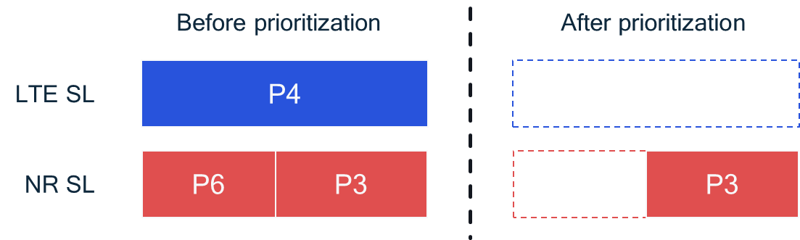  Expected outcome of prioritization (maximum priority within a radio access technology sidelink):  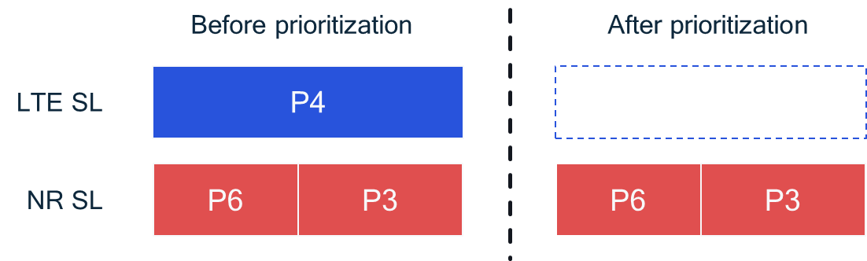
Consequences if not approved: | Incorrect behaviour in specifications when multiple NR transmissions are overlapped with an E-UTRA sidelink transmission/reception.
Clauses affected: | 16.2.4.1

----------------------------------------------------begin text proposal for 38.213---------------------------------------------------
16.2.4.1 Simultaneous NR and E-UTRA transmission/reception
<<<<<<unchanged text omitted>>>>>>
If a UE
- would transmit multiple channels/signals using NR radio access and receive or transmit a channel/signal using E-UTRA radio access, and
- transmission of the multiple channels/signals using NR radio access would overlap in time with a reception or transmission of the channel/signal using E-UTRA radio access, and
- the priorities of all the sidelink channels/signals are known to both radio access technologies in the UE $T$≤4 msec prior to the start of the earliest transmission or reception
the UE transmits or receives only the channels/signals using the radio access associated with the highest priority of all the channels/signals as determined by the SCI formats scheduling the transmissions/receptions or, in case of a S-SS/PSBCH block or a sidelink synchronization signal using E-UTRA radio access, as indicated by higher layers or, in case of PSFCH, equal to the priority of the corresponding PSSCH.
-----------------------------------------------------end text proposal for 38.213----------------------------------------------------
Proposal 2: If it is agreed to explicitly capture the agreement on multiple transmission prioritization, capture the above text proposal in 38.213.

Company | Comments
OPPO | Agree with a minor change. In case when the E-UTRA sidelink channel/signal has the highest priority among all overlap channels/signals, then the TP should be:  If a UE  - would transmit multiple channels/signals using NR radio access and receive or transmit a channel/signal using E-UTRA radio access, and  - transmission of the multiple channels/signals using NR radio access would overlap in time with a reception or transmission of the channel/signal using E-UTRA radio access, and  - the priorities of all the sidelink channels/signals are known to both radio access technologies in the UE $T$≤4 msec prior to the start of the earliest transmission or reception  the UE transmits or receives only the channel(s)/signal(s) using the radio access associated with the highest priority of all the channels/signals as determined by the SCI formats scheduling the transmissions/receptions or, in case of a S-SS/PSBCH block or a sidelink synchronization signal using E-UTRA radio access, as indicated by higher layers or, in case of PSFCH, equal to the priority of the corresponding PSSCH.
ZTE, Sanechips | Agree. Also ok with OPPO’s editing.
NEC | Agree with the TP with OPPO's editing.  Please let me request a clarification. We understood this is intend to pick the channel/signal with highest priority for comparison, but why "the highest priority value of NR multiple transmissions is used" was captured in the agreement, isn't it that highest priority value means lower priority?
Ericsson | Agree with the TP.
Huawei, HiSilicon | Agree to adopt the TP.

References
- 3GPP TS 38.213 V16.2.0, NR, Physical Layer Procedures for Control (Release 16).

