**3GPP TSG-RAN WG1 Meeting #102-e Draft R1-20XXXXX**

**e-Meeting, August 17th – 28th, 2020**

Source: Moderator (CMCC)

Title: FL summary on support of unaligned frame boundary for R16 NR inter-band CA

Agenda item: 7.2.10

Document for: Discussion & Decision

# Introduction

According to the RAN1#102 e-Meeting guidance, this contribution is to serve the preparation phase of the email discussion.

* August 10th – 14th: preparation phase (not for Rel-17 SI/WIs)
  + August 10th – 11th: FLs to prepare summary
  + August 12th – 14th: FLs to lead the discussion identifying the set of email threads
  + A single email thread is used for Rel-16 WIs with a total number of email thread budget (instead of per sub-agenda budget as for other WIs, as detailed in the next two slides)
    1. In the email approval phase, multiple email threads may be used (& announced accordingly)
  + **Note:** PLEASE KEEP THE EMAIL DISCUSSION **SCOPE** PER EMAIL THREAD **REASONABLE!**
    1. **Too much scope will force Chairman/Vice Chairman to step in to do the necessary cut down using the best judgement** 🡪 **if so, no complaints please.**

During the last few meetings, most of the remaining issues have been resolved, including specs corrections for inaccurate capture of agreements, introduction of if-else condition for CA slot offset, introduction of CA slot offset into pseudo-code for Type-1 HARQ-ACK codebook determination, clarification of slot offset related parameters to make the specs more clear, parameters alignment among high layer and physical layer specs, etc.

1 Contributions submitted to AI 7.2.10 is related to unaligned CA, and it is sumarized here, proposals are given from feature lead perspective.

# Remaining issues

According to [1], the raised issues are all related to SCell slot slit for unaligned CA.

* **Issue 1: Interpretation of slots indicated by the bitmap in measurementSlots in TS38.331 for unaligned CA case**

In [1], it is proposed “For the IE measurementSlots defined in 38.331, only complete slots inside the SMTC window are indicated by the bitmap in measurementSlots.”

The issue comes from that when unaligned CA is applied, there will be slots partially overlapped with the SMTC window. For example, for Pcell=60kHz, SCell=15kHz, N = -1 (ca_slot_offset = -1), it is not clear whether slot 0 or slot 1 shown below (in red rectangle) should be the first slot in measurementSlots for the SCell.

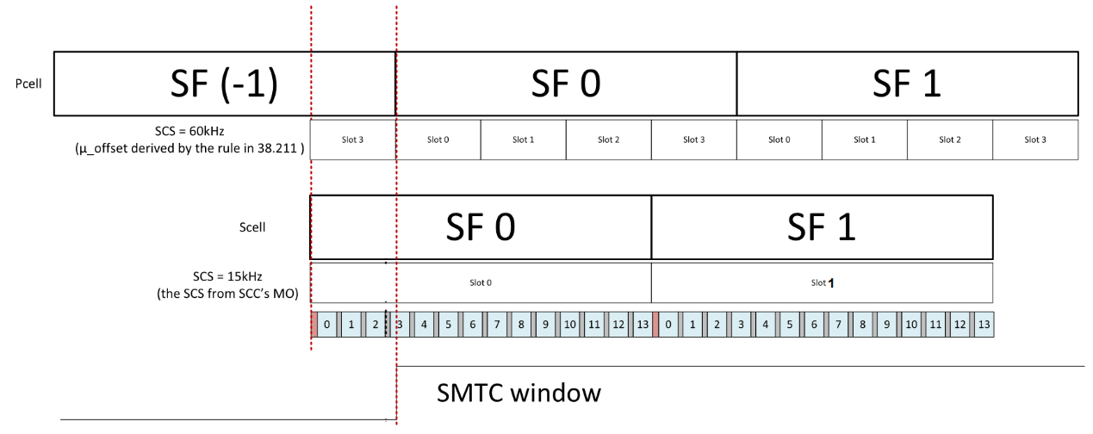

The definition of “first slot in the SMTC window” is highlighted in yellow, then for unaligned CA case, it is not clear whether a partially overlapped slot with SMTC window should be treated as “a slot in the SMTC window”. Then to avoid ambiguity, [1] proposes only complete slots inside the SMTC window are indicated by the bitmap in *measurementSlots.*

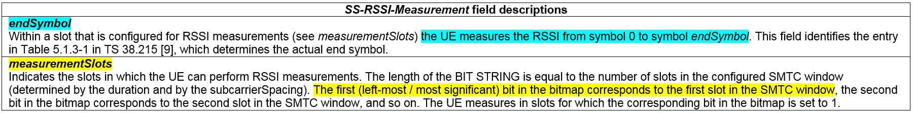

From the FL point of view, with the definition of “*periodicityAndOffset”*in TS38.331 for SMTC configuration, the offset is subframe-based granularity, however, in the case of unaligned CA or slot-aligned CA, the offset between Pcell/PScell and Scellis is slot-based granularity, which will produce the case that [1] exemplified, however, even in non-CA case, such example may present between two TDD bands when their frame boundaries are not aligned, furtherly, it may present in asynchronized FDD system for inter-frequency measurement, so it may up to RAN2 to handle this issue in the same way.

**FL Proposal 1:**

**Further clarification may be needed for the slot** **bitmap interpretation of *measurementSlots* in TS38.331, it’ s better to ask RAN2 to handle it as common issue related to inter-frequency measurement.**

* **Issue 2: Update of interruption time for serving cells during PCell measurement gap in TS38.133 for unaligned CA case**

It is proposed in [1] that “For unaligned CA scenario, a slot partially overlapped with the measurement gap is also included in the interruption time. RAN1 should send an LS to RAN4 to require a corresponding update in RAN4 spec for unaligned CA scenario about interruption time”

According to Table 9.1.2-4 in TS38.133, a slot partially overlapped with the measurement gap is also included in the interruption time, therefore, it is prosed in [1] that a slot partially overlapped with the measurement gap due to unaligned CA is also included in the interruption time.

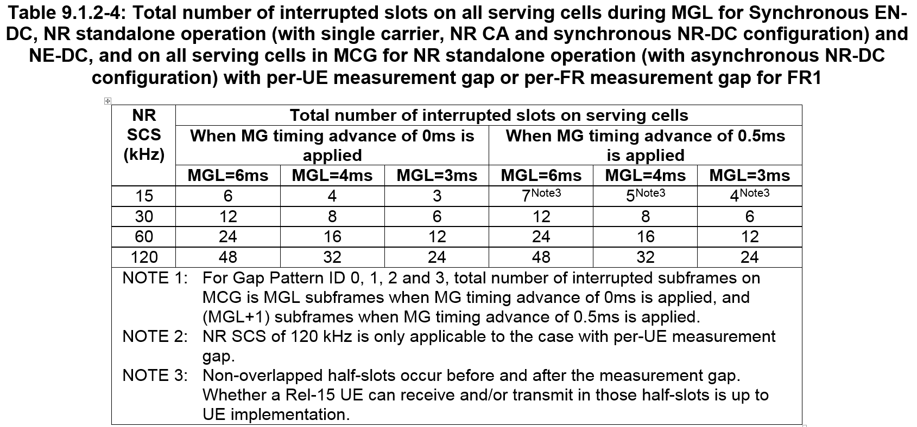

From the FL point of view, the proposal is aligned with the current definition, update of the interruption time during measurement gap is necessary for unaligned CA case.

**FL Proposal 2**

**Send a LS to RAN4 to update the interruption time definition for unaligned CA case.**

* **Issue 3: UE feature modification.**

It is suggested in [1] to further report the following candidate values to FG 18-7:

* **PCell/PSCell** lowest SCS among all the configured SCSs in DL/UL *SCS-SpecificCarrierList* in *ServingCellConfig* **<=** **SCell** lowest SCS among all the configured SCSs in DL/UL *SCS-SpecificCarrierList* in *ServingCellConfig*
* **PCell/PSCell** lowest SCS among all the configured SCSs in DL/UL *SCS-SpecificCarrierList* in *ServingCellConfig* **>** **SCell** lowest SCS among all the configured SCSs in DL/UL *SCS-SpecificCarrierList* in *ServingCellConfig*
* both

The reason is to avoid the SCell slot slit issue 1 and 2[1], since issue 1 and issue 2 only bring differences between aligned CA and unaligned CA when PCell/PSCell lowest SCS among all the configured SCSs in DL/UL SCS-SpecificCarrierList in ServingCellConfig > SCell lowest SCS among all the configured SCSs in DL/UL SCS-SpecificCarrierList in ServingCellConfig. However, when the clarifications have been made, whether to define such candidate values for UE feature needs further discussion.

**FL Proposal 3**

**The proposal will reduce the application of the whole feature in both network and UE which bring no benefit to neither network or UE, so it is not proposed to introduce additional capability.**

# Conclusion

Three issues summarized in section 2 is as following,

* **Issue 1: Interpretation of slots indicated by the bitmap in measurementSlots in TS38.331 for unaligned CA case**
* **Issue 2: Update of interruption time for serving cells during PCell measurement gap in TS38.133 for unaligned CA case**
* **Issue 3: UE feature modification.**

The following FL proposal is made,

**FL proposal 1: Further clarification may be needed for the slot** **bitmap interpretation of *measurementSlots* in TS38.331, it’ s better to ask RAN2 to handle it as common issue related to inter-frequency measurement.**

**FL proposal 2: Send a LS to RAN4 to update the interruption time definition for unaligned CA case.**

**FL proposal 3: Discuss whether the UE feature modification is neeeded.**

It is proposed to discuss issue 3 first, and then the clarification and update issues in this meeting.

# References

[1]. R1-2005626, Remaining issues on Rel-16 carrier aggregation, MediaTek Inc..