3GPP TSG RAN WG1 #102-e R1-200xxxx
E-Meeting, 17th August – 28th August, 2020

Agenda: 5
Source: Moderator (ZTE)
Title: Summary of [102-e-LS-AI5-05] discussions for a reply LS on exchange of information related to SRS-RSRP measurement resource configuration for UE-CLI
Document for: Discussion and Decision

Introduction
RAN1 received an LS [1] from RAN3 on exchange of information related to SRS-RSRP measurement resource configuration for UE-CLI. In the LS, RAN3 asked the following question and would like to receive RAN1 feedback.
Question to RAN1:
- What is the maximum frequency of inter-gNB exchange of SRS configuration required to enable configuration of SRS-RSRP measurements of potential CLI aggressor cells in served UEs?

As guided by the Chairman, this summary is to collect companies’ views on the questions in the LS and draft the reply based on the collected input.
[102-e-LS-AI5-05] Email discussion/approval of reply LS for R1-2005218 by 08/20 (TBD, ZTE)

Summary of views on reply LS
Six contributions providing the views and draft response to the RAN3 LS were submitted to RAN1#102-e meeting. The views are summarized in the following table.
Table 1 Summary of the views from the submitted contributions
company | view
ZTE[2] | The maximum exchange frequency of SRS configuration is hundreds of milliseconds or seconds depending on the scenarios in which CLI feature is applied
CATT[3] | The inter-gNB exchange of SRS configuration per several hundred milliseconds is sufficient considering only periodic SRS can be used for the L3 CLI measurement.
Samsung[4] | The maximum frequency of inter-gNB exchange of the SRS configuration can vary and depends on gNB implementation, as SRS configuration of the aggressor UE can be dynamically changed or can be changed for longer time or can be changed semi-statically for very long time
NOKIA[5,6] | The maximum exchange frequency of SRS configuration per UE is at least tens of seconds, or even longer, given the steps of implementing the SRS-RSRP measurement, the RRC signalling is relative slow and the victim UEs perform Layer-3 filtering of the CLI measurements. The overhead from such XnAP signalling of SRS configurations of victim UEs is therefore considered to be marginal, and desirable to have standardized.
Huawei, HiSilicon [7] | The maximum frequency of inter-gNB exchange of SRS configuration can be per millisecond per UE considering the aggressor UEs in the neighbouring cell are moving around and the dynamic TDD UL/DL configuration of potential aggressor UEs by dynamic SFI in the neighbouring aggressor cell

According to the above table, companies’ views of the maximum frequency of inter-gNB exchange of SRS configuration seem diverse. More discussions are needed to draft the response.

Discussion
The above proposals can be categorized to two levels of maximum frequency.
Semi-static or static (e.g. in the level of hundreds of milliseconds or more): ZTE/Sanechips, CATT, Nokia, Samsung
Dynamic (e.g. in the level of millisecond): Huawei/HiSi, Samsung
Since different companies have different views based on different understanding on the CLI feature, more input from companies are desirable. To help on drafting the LS response, companies are encouraged to provide any additional views of the maximum frequency of inter-gNB exchange of SRS configuration
Table 2 Additional views of the maximum frequency of inter-gNB exchange of SRS configuration
company | Comments
Qualcomm | Because the CLI RSRP measurement is a L3 measurement, this exchange is not expected to be very frequent. Besides, the SRS configuration to a UE should not be changed very frequently just for UL sounding purpose based on the realistic mobility condition. SRS configuration may most probably be updated if there is a change of the serving cell. The level of minute per UE and seconds or tens of seconds for all UEs is a reasonable assumption.
Huawei, HiSicon | One of typical applications of CLI is illustrated by the following figure,  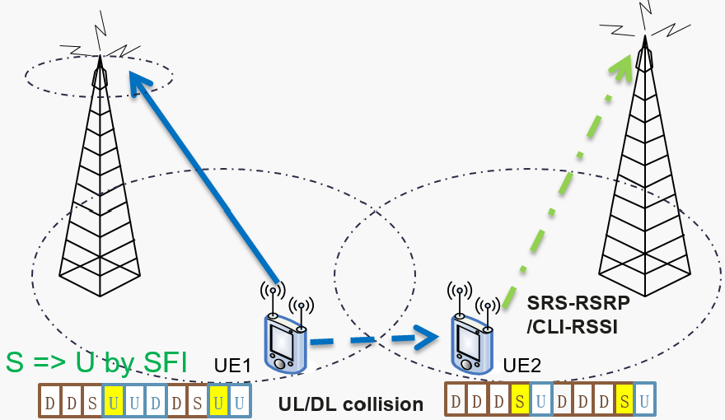  - UE1 is moving to the cell edge and needs more UL slots for UL throughput.  - BS1 indicates UE1 to flip the S slot to U slot (in yellow) by DCI SFI, which is dynamic.  - Then UE2 monitors the SRS transmitted on the new U slot of UE1 after it gets the dynamic information of SRS resource from BS1.  - The SRS resource cannot be predetermined by UE2/BS2 for the following reasons: 1) the maximum # of SRS resource for UE2 monitoring can be limited by 2 in UE feature FGI 17-2, which is much less than the # of potential interfering UEs; 2) There is no SRS usage dedicated to CLI but the SRS with CB or SAS usage at UE1 is reused for UE2 monitoring which should not be changed very frequently as Qualcomm commented, resulting in that the SRS to be monitored is different across potential interfering UEs and its potential set size is much larger than 2.  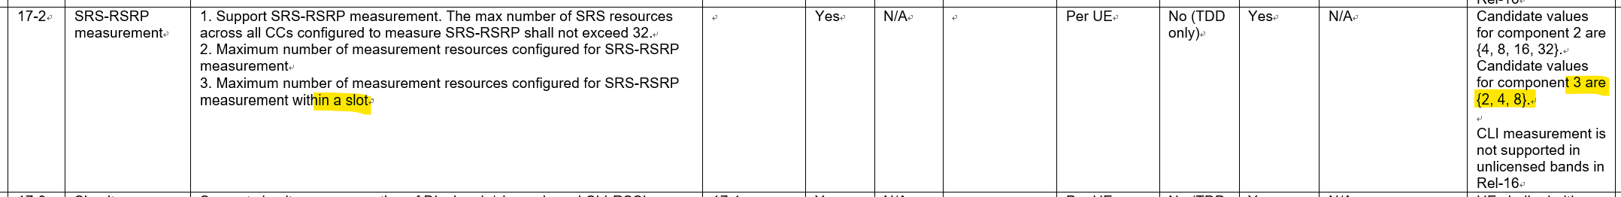  In summary, DCI SFI, UE1 mobility and the SRS with CB/SAS usage for CLI monitoring are dynamic, but the maximum # of SRS resources for UE2 monitoring is very limited, e.g. only 2. We just don’t understand how information exchange rate in order of hundreds of milliseconds for SRS resource indication can sufficiently work for the above CLI scenario. It is appreciated if proponents for low exchange rate could provide an example how the BS1 utilizes a size-2 of SRS resource pool determined by BS2 for a slot in an order of hundreds of millisecond or second to support dynamic SFI for UE1.  In response to Qualcomm, what to be exchanged across cells in the LS request is the SRS resource for monitoring instead of the L3 RSRP measurement results.
Nokia, NSB | As we have indicated already, because SRS-RSRP is L3 measurement, it cannot be dynamically indicated. It should be periodic SRS to be received with a long-term measurement, this is not intended for instant measurement but mid/long-term measurement. Generally, control signal such as SSB, periodic CSI-RS or even periodic SRS are RRC configured, and the configuration information cannot be updated frequently. In addition, the report interval for L3 measurement is at least 120ms, even for a single report, 120ms should be maintained.  In general, with larger number of UEs, fixed TDD should be considered while dynamic TDD is more suitable for low load in a cell. So, the number of SRS resources in a cell can be reduced, and how to manage this is up to implementation.  We don’t consider dynamic handling of CLI based on SRS-RSRP, which is not efficient or even not possible due to signalling structure in Rel-16. SRS-RSRP measurement should be used for identifying UE/UE groups causing CLI for a long-time.
Intel | The inter-gNB exchange frequency depends on many factors such as SRS periodicity, UE mobility, and dynamics of network topology. Since only periodic SRS is applicable for SRS-RSRP measurement, a practical setting is to let the interval between two inter-gNB exchanges to be multiple of SRS periodicities, which varies from a single slot to 640 slots.  Therefore, the maximum frequency of inter-gNB exchange of the SRS configuration can be left to gNB implementation, i.e., it depends on the SRS periodicity configured by gNBs and how frequent gNBs would change such SRS configurations.
Samsung | Although CLI RSRP measurement by a victim UE is L3 measurement, SRS periodicity configured for the aggressor UE may vary depending on current spec for SRS configuration. Also, the inter-gNB exchange based on the SRS configuration of the aggressor UE may be impacted. Therefore, the maximum frequency of inter-gNB exchange of the SRS configuration can depend on gNB implementation and then it is expected to vary from a single slot to hundreds of slots.
LG Electronics | We can consider the ‘SRS configuration’ in a perspective of gNB of an aggressor cell. The gNB of the aggressor cell provides a configuration to a UE for periodic SRS transmission. (Then, the periodic SRS is transmitted by a UE in the aggressor cell.) Also, the gNB of the aggressor cell can share the ‘SRS configuration’ to other cells. Especially, the resource information including at least time/frequency resource and sequence for SRS transmission can be shared. Since it is not necessity that the time/frequency resource and sequence for periodic SRS transmission are dynamically changed, it does not required that the gNB of an aggressor cell frequently shares the resource information (e.g., time/frequency resource, sequence) for periodic SRS transmission to a gNB of a victim cell. (Based on the information, UE(s) in a victim cell is/are configured SRS-RSRP measurement resource.)  In this aspect, we think it is reasonable that the maximum frequency of inter-gNB exchange of SRS configuration rages from hundreds of milliseconds to hundreds of seconds.
Ericsson | Agree with the companies above that the updates can be as frequent as on a ms-basis. As stated by others, the actual configuration is an implementation choice, but that means that in a multi-vendor deployment, potentially involving both gNBs and eNBs, there will be cases where the different networks have totally different update cycles. Therefore, further investigations are needed to determine the implications of exchange of information in such cases.

Draft reply LS
Based on the majority view we got so far, the reply LS is drafted as follows.
RAN1 would like to thank RAN3 for the LS. RAN1 discussed the question in the LS and reached the following agreement.
Question to RAN1:
- What is the maximum frequency of inter-gNB exchange of SRS configuration required to enable configuration of SRS-RSRP measurements of potential CLI aggressor cells in served UEs?

Answer: Since the CLI SRS-RSRP measurement is L3-measurement, the configuration of SRS resource would be static or semi-static. Once it is configured, the measurement can be done periodically. As a result, it does not usually require very frequent configuration. Therefore, to enable the CLI SRS-RSRP measurements, the maximum frequency of inter-gNB exchange of SRS configuration usually ranges from hundreds of milliseconds to tens of seconds.

Any comment?
Company | Comments
Qualcomm | We are fine with the draft reply in general.  Some update to the wording in red:  Answer: Since the CLI SRS-RSRP measurement is L3-measurement, the configuration of SRS resource would should be static or semi-static. Once it is configured, the measurement can be done periodically. As a result, it does not usually require very frequent configuration. Therefore, to enable the CLI SRS-RSRP measurements, the maximum frequency of inter-gNB exchange of SRS configuration usually ranges from hundreds of milliseconds to tens of seconds minute per UE and seconds or tens of seconds for all UEs is a reasonable assumption.
Huawei, HiSilicon | As commented above, we don’t feel the LS reply is correct because we don’t understand how information exchange rate in order of hundreds of milliseconds for SRS resource indication can sufficiently work for the above CLI scenario.
Nokia, NSB | Generally, we are fine with the draft reply. We are supporting that Qualcomm’s term of “seconds or tens of seconds” rather than hundreds of milliseconds …  However, “minute per UE” is not easy to say. So, update version as belows. However, we don’t have strong view for either ZTE’s and Qualcomm’s revision.  Answer: Since the CLI SRS-RSRP measurement is L3-measurement, the configuration of SRS resource would be static or semi-static. Once it is configured, the measurement can be done periodically. As a result, it does not usually require very frequent configuration. Therefore, to enable the CLI SRS-RSRP measurements, the maximum frequency of inter-gNB exchange of SRS configuration usually ranges from seconds to hundreds of milliseconds to tens of seconds.
LG Electronics | If necessity, it is necessity that the answer is changed in terms of sharing the ‘SRS configuration’ for periodic SRS transmission in an aggressor cell to a victim cell for the purpose of SRS-RSRP measurement in the victim cell.
Ericsson | As stated above, further investigations are needed before providing a reply.

Conclusion
[TBD]

References
- R1-2005218. Response LS on Exchange of information related to SRS-RSRP measurement resource configuration for UE-CLI, RAN3, ZTE
- R1-2005518. Draft reply LS on exchange of information related to SRS-RSRP measurement resource configuration for UE-CLI, ZTE
- R1-2005653. Draft reply LS to RAN3 on inter-gNB exchange of SRS configuration, CATT
- R1-2006083. [Draft] Reply LS on Exchange of information related to SRS-RSRP measurement resource configuration for UE-CLI, Samsung
- R1-2006450. Draft reply to the LS on Exchange of information related to SRS-RSRP measurement resource configuration for UE-CLI, Nokia, Nokia Shanghai-Bell
- R1-2006451. On inter-gNB exchange of SRS configuration for CLI measurement, Nokia, Nokia Shanghai-Bell
- R1-2006944. Discussion on Exchange of information related to SRS-RSRP measurement resource configuration for UE-CLI, Huawei, HiSilicon

