3GPP TSG RAN WG1 #102-e R1-200xxxx

e-Meeting, August 17th – 28th, 2020

Agenda item: 5
Source: Moderator (Qualcomm Incorporated)
Title: [102-e-LS-AI5-04] Discussion on NR SRS carrier switching
Document for: Discussion and Decision

Background
In LS R1-2005209, RAN1 received the following questions from RAN2:
[…]
for typeA RAN2 didn’t achieve consensus on whether the following 2 cases on NR SRS carrier switching are allowed:
- Case 1: SRS carrier switching to a SUL without PUCCH/PUSCH while PUCCH/PUSCH is configured in NUL;
- Case 2: SRS carrier switching to both NUL and SUL, neither of which are configured with PUCCH/PUSCH.

2. Actions:
To RAN1 group.
ACTION: RAN2 respectively asks RAN1 to provide feedback on the above

As a result of this LS, the following contributions were submitted to this meeting (7 contributions, 5 different sources):

R1-2005466 Draft reply LS on NR SRS carrier switching ZTE
R1-2005553 Discussion for NR SRS carrier switching on SUL ZTE
R1-2005652 Draft reply LS to RAN2 on NR SRS carrier switching CATT
R1-2005654 Discussion on NR SRS carrier switching on SUL carrier CATT
R1-2006078 [Draft] Reply LS on NR SRS carrier switching Samsung
R1-2006757 Discussion on SRS carrier switching Qualcomm Incorporated
R1-2006945 Discussion on NR SRS carrier switching Huawei, HiSilicon

Summary of input contributions
In the following, we summarize the received input:
- Three sources [ZTE, Samsung, Qualcomm] indicate that the two cases from RAN2 are not supported from RAN1 specification point of view.
- One source [CATT] indicates that Case 1 is not supported, and in Case 2 switching to SUL is not supported, but switching to NUL is supported.
- One source [Huawei/HiSi] indicates that both case 1 and Case 2 are supported.
- One source [Qualcomm] further states that SRS carrier switching is not supported for a target serving cell configured with SUL.
Several reasons are included in the contributions for the support / no support of this feature.
- Four sources [ZTE, CATT, Samsung, Qualcomm] mention the following specification snippet (TS 38.214) that indicates that SRS carrier switching is only supported for a “serving cell with slot formats comprised of DL and UL symbols”:

6.2.1.3 UE sounding procedure between component carriers
….

A UE can be configured with SRS resource(s) on a carrier c₁ with slot formats comprised of DL and UL symbols and not configured for PUSCH/PUCCH transmission. For carrier c₁, the UE is configured with higher layer parameter srs-SwitchFromServCellIndex and srs-SwitchFromCarrier the switching from carrier c₂ which is configured for PUSCH/PUCCH transmission. During SRS transmission on carrier c₁ (including any interruption due to uplink or downlink RF retuning time [11, TS 38.133] as defined by higher layer parameters switchingTimeUL and switchingTimeDL of srs-SwitchingTimeNR), the UE temporarily suspends the uplink transmission on carrier c₂.

….

- Two sources [Qualcomm, ZTE] mention that SRS carrier switching is for DL CSI acquisition (SRS resource set(s) with higher layer parameter usage set to 'antennaSwitching') and, therefore, there is no use case for SUL.

- One source [Huawei/HiSi] mentions the following two agreements (in RAN1#89 and RAN1#91) as justification for supporting both Case 1 and Case 2:

Agreements:
- For NR standalone operation for a UE,
  - NR supports that the UE is allowed to transmit on UL carriers on different frequency ranges but the UE has the capability to only transmit on one of the carriers at a given time in the following case:
    - case of SRS carrier switching with at least one of the frequency ranges agreed for LTE-NR UL sharing by RAN4 (e.g. refer to R4-1704411)

Agreement:
- For a UE configured two ULs in a cell, two TPC bit(s) fields within group common DCI for SRS power control can be configured to the UE, i.e., one for UL and one for SUL;

Discussion points
Q1: Is the following case supported form RAN1 point of view?
- Case 1: SRS carrier switching to a SUL without PUCCH/PUSCH while PUCCH/PUSCH is configured in NUL;
Company | Input
ZTE | Not supported. As we mentioned in our tdoc, SRS carrier switching is for DL CSI in TDD band. However, SUL has no DL symbols.
Qualcomm | Agree with ZTE. The specification explicitly says that SRS carrier switching is for carriers with “slot formats comprised of DL and UL symbols”
CATT | Not supported. We share the same view as ZTE.
OPPO | Not supported. ZTE showed the obvious reason above.
Samsung | Not supported.
MediaTek | Not supported. We share the same view with ZTE.
vivo | Not supported.
Huawei, HiSilicon | Firstly, please make the question clearer whether Type B SRS carrier switching is included. The questions from RAN2 LS address ONLY Type A SRS carrier switching, but the summary seems to extend it to both Type B and Type A. Please moderator clarify it.  Secondly, for Type B, it is quite clearly supported given by the agreement and spec excerpts below, we don’t feel it is an open question.  Agreement:  - For a UE configured two ULs in a cell, two TPC bit(s) fields within group common DCI for SRS power control can be configured to the UE, i.e., one for UL and one for SUL;  TS38.213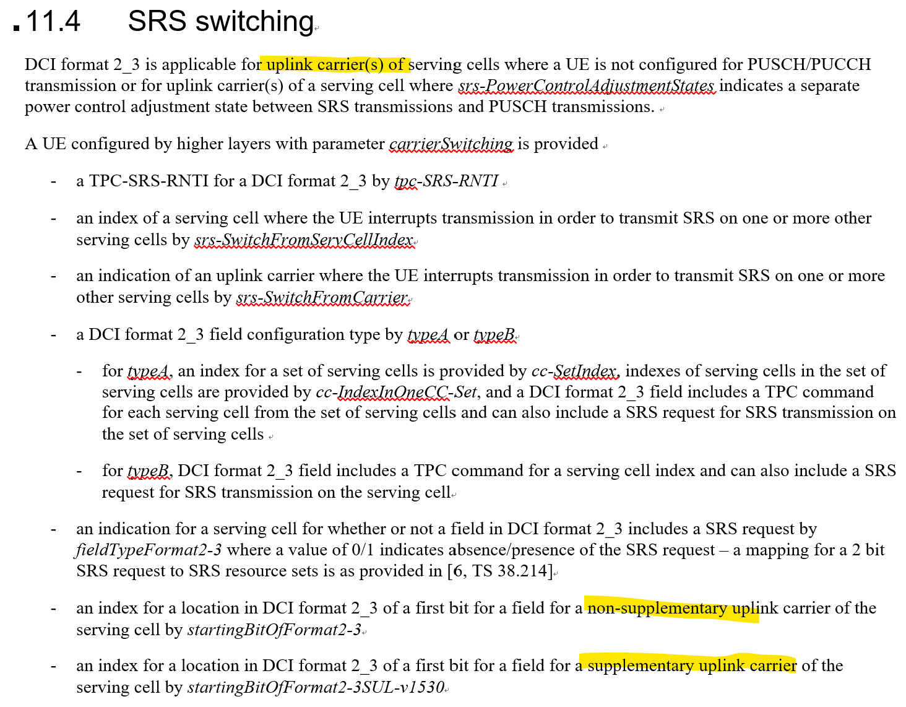  TS38.212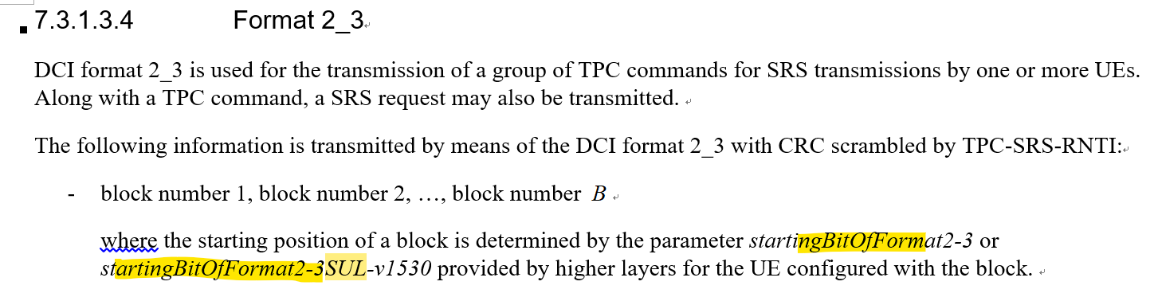  Thirdly, as for the text in TS 38.214 “slot formats comprised of DL and UL symbols”, it is simply not in line with the RAN1 agreements below and the spec excerpts of TS 38.213 and 38.214 above, and it should be corrected for SUL cell. We don’t feel such a solo incorrect spec text can overturn multiple RAN1 agreements and multiple pieces of spec texts.  Agreements:  - For NR standalone operation for a UE,  - NR supports that the UE is allowed to transmit on UL carriers on different frequency ranges but the UE has the capability to only transmit on one of the carriers at a given time in the following case:  - case of SRS carrier switching with at least one of the frequency ranges agreed for LTE-NR UL sharing by RAN4 (e.g. refer to R4-1704411)  Agreement:  - For a UE configured two ULs in a cell, two TPC bit(s) fields within group common DCI for SRS power control can be configured to the UE, i.e., one for UL and one for SUL;  Finally, let’s give you the application scenario for Case 1 and why the above agreements were made. The cell-centre UE is configured with PUCCH/PUSCH on NUL but only SRS on SUL with SRS carrier switching. Once the UE receives a DCI 2_3 to trigger the SRS on SUL, it transmits SRS on SUL so that the gNB can compare the channel qualities between SUL and NUL and execute a right strategy to switch PUCCH/PUSCH configuration to SUL.
Moderator (Qualcomm) | To reply to Huawei’s question: My feeling is that the majority of companies think that SRS carrier switching is not supported in either case, but we can discuss the wording when we are drafting the LS.
Qualcomm | Let me try to reply to Huawei’s comments:  - “Secondly” part: The specification text actually has an “OR”, that to us is the key thing:  DCI format 2_3 is applicable for uplink carrier(s) of serving cells where a UE is not configured for PUSCH/PUCCH transmission or for uplink carrier(s) of a serving cell where srs-PowerControlAdjustmentStates indicates a separate power control adjustment state between SRS transmissions and PUSCH transmissions.  So, we can use DCI format 2_3 for SUL, but it refers to the separate power control part. Note that even that paramenter has the following note in 38.331:  Indicates whether hsrs,c(i) = fc(i,1) or hsrs,c(i) = fc(i,2) (if twoPUSCH-PC-AdjustmentStates are configured) or separate close loop is configured for SRS. This parameter is applicable only for Uls on which UE also transmits PUSCH. If absent or release, the UE applies the value sameAs-Fci1 (see TS 38.213 [13], clause 7.3).  So, in summary, DCI format 2_3 is applicable for SUL with PUSCH configured (if PUSCH/SRS have separate power control loops), but not applicable for SUL without PUSCH configured.  - “Thirdly”: For the second agreement, we have the same comment as above: 2_3 can be used for power control, but not for switching. For the first agreement, we would like to note that the UE can transmit SRS in the SUL carrier, but it is not using the SRS CS framework - note the following note in 38.301: NOTE 1: If a UE is configured with both NR UL and NR SUL carriers in a cell, the switching time between NR UL carrier and NR SUL carrier is 0 us.

Q2: Is the following case supported form RAN1 point of view? (NOTE: Sub-case of Case 2)
- Case 2.1: SRS carrier switching to SUL, when neither SUL nor NUL of which are configured with PUCCH/PUSCH.

Company | Input
ZTE | Not supported.
Qualcomm | Not supported, same reasoning as Q1
CATT | Not supported.
OPPO | Not supported
Samsung | Not supported.
MediaTek | Not supported.
vivo | Not Supported.
Huawei, HiSilicon | Supported according to the RAN1 agreements, as commented to Q1.

Q3: Is the following case supported form RAN1 point of view? (NOTE: Sub-case of Case 2)
- Case 2.2: SRS carrier switching to NUL, when neither SUL nor NUL of which are configured with PUCCH/PUSCH.

Company | Input
ZTE | Not supported  As we explained in our tdoc, we don’t think it is a valid usecase that SUL is configured without PUCCH/PUSCH.
Qualcomm | Not supported. SUL should be configured with PUCCH or PUSCH.
CATT | Maybe we should first clarify whether this is a valid configuration. At least Rel-15 specs do not prohibit such configuration. One possible use case of such configuration is offloading PRACH to SUL carrier.
OPPO | Share the same view as ZTE/QC
Samsung | SRS carrier switching to NUL is supported when PUCCH/PUSCH is not configured in NUL. We think that SUL configuration does not matter in current RAN1 specification.
MediaTek | Not supported. SUL without PUxCH is invalid configuration.
vivo | Not Supported.
Huawei, HiSilicon | Supported according to RAN1 agreements, as comments to Q1.  Additionally, as commented as Samsung, it is quite clear in RAN2 LS that SRS carrier switching to NUL in the Case 0 where NUL has no PUCCH/PUSCH configuration but SUL has. Compared with the Case 0, the difference of Case 2.2 is only whether the gNB can configure PUSCH/PUCCH on SUL or not, which is simply up to gNB implementation and should not be restricted by specs. In other words, given Case 0 is supported, if Case 2.2 is not supported, it does not reduce any UE burden but just introduces unnecessary restriction to gNB implementation, which is not a 3GPP practice. It is appreciated if companies can clarify the benefit to have such extended restriction to gNB implementation.  RAN2 LS R1-2005209.  “RAN2 understanding is that for typeA "uplink carrier in which the SRS-CarrierSwitching field is configured" can be applied to any uplink carrier, except for the case that a UE is not configured for PUSCH/PUCCH transmission on SUL.”

Q4: Is SRS carrier switching supported for a target serving cell configured with SUL?

Company | Input
ZTE | This question is not related with the LS.  However, technically, we don’t think it is an appropriate usecase that SRS carrier switching to a target serving cell which is configured SUL.
Qualcomm | The case here would be when SUL is configured with PUSCH or PUCCH, but NUL is not. In this case, to transmit SRS in NUL, it wouldn’t make much sense to use SRS carrier switching (which has interruption / collisions / etc), but rather use the SUL framework to transmit SRS in the NUL.
CATT | We don’t think using SUL framework to transmit SRS in the NUL will always work. UE may not be able to switch RF chain from an SUL carrier to NUL carrier depending on UE implementation.
OPPO | Not supported as the use case is quite questionable.
Samsung | Same comment as in Q3.
vivo | Supported.
Huawei, HiSilicon | As commented as ZTE and Samsung, we don’t feel this is an open question or requested by RAN2. In RAN2 LS and the RAN1 agreement cited in our tdoc, as well as the spec 38.212 and 38.213, it is quite clearly supported.  As commented as CATT, similar to compare UL-CA with SRS carrier switching, the feature SRS carrier switching has its unique value for some UE implementation and the interruption is just the cost inherited from such UE implementation.

Conclusion
<To be completed after discussion>

Appendix: Summary of proposals in input contributions

R1-2005466 / R1-2005553 | ZTE | […] Thus, it is not valid that a SUL without any PUSCH and PUCCH transmission is configured with SRS carrier switching for DL CSI acquisition. Therefore, the above two cases are not allowed from RAN1 perspective.
R1-2005652 / R1-2005654 | CATT | […] that in both cases SRS carrier switching to SUL carrier shall NOT be allowed. In Case 2, SRS carrier switching to the NUL shall be allowed.
R1-2006078 | Samsung | […] Hence, the NR SRS carrier switching are not allowed for both Case 1 and Case 2.
R1-2006757 | Qualcomm | Indicate to RAN2 that Case 1 and Case 2 are not supported in RAN1 specifications.  […]  Include the following conclusion in the LS to RAN2:  - SRS carrier switching is not supported for a target serving cell configured with SUL.  - SRS carrier switching is supported for a source serving cell configured with SUL. The interrupted carrier is signaled by srs-SwitchFromCarrier.
R1-2006945 | Huawei, HiSilicon | Confirm that both Case 1 and Case 2 described in R1-2005209 are supported by Type A SRS carrier switching.

