3GPP TSG RAN WG1 Meeting #102-e R1-200xxxx
e-Meeting, August 17th – 28th, 2020

Agenda Item: 5
Source: Samsung
Title: [102-e-LS-AI5-03] Email discussion/approval of reply LS for R1-2005208, including its necessity (i.e., whether to have the LS or not)
Document for: Discussion and Decision

Introduction

[102-e-LS-AI5-03] Email discussion/approval of reply LS for R1-2005208, including its necessity (i.e., whether to have the LS or not), by 08/20 (TBD, Samsung)

Discussion
- Question1: Do you think the RAN1 reply LS in RAN1 #102-e is necessary?
Source | Yes or no | Comments
Huawei, HiSilicon | Yes | - In the LS action, RAN1 is clearly asked by RAN2 to response.  - The concerned per-UE capabilities in the RAN2 LS are all sourced from RAN1, as listed below. Companies can easily confirm RAN1 as a source by TR 38.822  - All of the concerned per-UE capabilities are baseband capabilities, otherwise they would have been per-band or other types of UE capabilities. Such baseband capabilities in the list does not require any RF or RAN4 expertise.  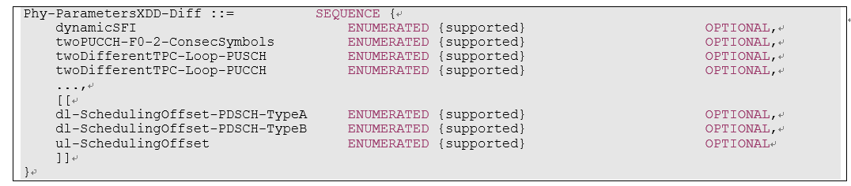
Observation: [TBD]
Possible conclusion: [TBD]

- Question2: If the RAN1 reply LS in RAN1 #102-e is necessary, what is your view about the following first question from RAN2 LS [1]?
Question:“Could per-UE capabilities for SUL/SDL bands be differentiated on the duplex mode(s) for Rel-15 and Rel-16?”

Source | Comments
Huawei, HiSilicon | Yes. Taking dynamicSFI as example, its functionality specified in 38.211 and 38.213 differentiate SUL from TDD.
Observation: [TBD]
Possible conclusion: [TBD]

- Question3: If the RAN1 reply LS in RAN1 #102-e is necessary, what is your view about the following second question from RAN2 LS [1]?
Question: “Which duplex mode(s) (i.e. FDD or TDD) for the per-UE capabilities which are differentiated by FDD and TDD are applied for SUL/SDL in both Rel-15 and Rel-16?”

Source | Comments
Huawei, HiSilicon | As analysis in R1-2006935, with respect to IoDT and functionality for those per-UE UE capabilities in the list, the capability value reported by a Rel-15 UE for FDD is also applied to SUL bands if it is applicable to uplink, otherwise, the capability value is also applied to SDL if it is applicable to downlink.  For Rel-16 UE, the same new mechanism in R1-2005212 is applied for SUL/SDL because all the concerned per-UE capabilities differentiating FDD/TDD have been changed to per-band in Rel-16 by RAN2. In short, those concerned capabilities are reported in a basis of per-band but required to be the same values among SUL bands per frequency range, so does among SDL bands per frequency range.  R1-2005212:  “For release-16 UE capabilities for which both xDD and FRx differentiations are allowed, RAN2 intends to use “per band” capability signalling. This way, the problem above no longer exists for release-16 capabilities.”  “
Observation: [TBD]
Possible conclusion: [TBD]

Conclusion
[TBD]

Reference
[1] R1-2005208 LS on UE capability xDD differentiation for SUL/SDL bands Samsung
[2] R1-2006082 [Draft] Reply LS on UE capability xDD differentiation for SUL/SDL bands Samsung
[3] R1-2006335 [DRAFT] Reply LS on UE capability xDD differentiation for SUL/SDL bands ZTE
[4] R1-2006934 Draft LS reply on UE capability xDD differentiation for SUL/SDL bands Huawei, HiSilicon
[5] R1-2006935 Discussion on UE capability xDD differentiation for SUL/SDL bands Huawei, HiSilicon

