**3GPP TSG WG RAN1 #114bis R1-230xxxx**

**Xiamen, China, 9th – 13th October, 2023**

Title: [DRAFT] Reply LS on Dual TCI state switching in mDCI

Response to: R1-2308813 LS on Dual TCI state switching in mDCI

Release: Rel-18

Work Item: NR_FR2_multiRX_DL-Core

Source: Ericsson [RAN1]

To: RAN2

Cc:

**Contact Person:**

Name: [Claes Tidestav]

E-mail Address: [[claes.tidestav@ericsson.com](mailto:claes.tidestav@ericsson.com)]

**1. Overall Description:**

RAN1 thanks RAN4 for the LS on Dual TCI state switching in mDCI and would like to provide the following response.

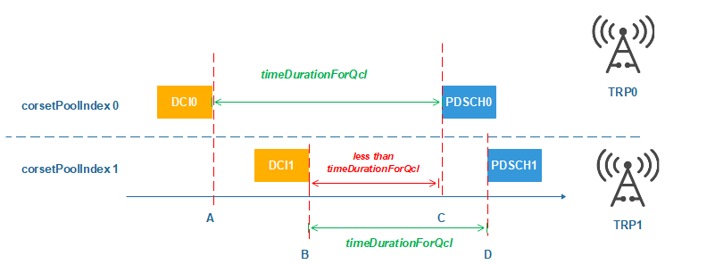

Figure 1: Example mDCI scenario

**Question1-1:**

For the scenario depicted in Figure 1, is there any minimum duration defined in RAN1 specifications between point B and point C?

**Answer:**

* If the UE supports *simultaneousReceptionDiffTypeD-r16,* there is no restriction on the duration between point B and C.

**Question 1-2:**

What is the expected UE behaviour after point C?

**Answer:**

After point C, the UE would receive PDSCH0 using the TCI state conveyed in DCI0. At point D, the UE would receive PDSCH1 using the TCI state conveyed in DCI1.

**Question 1-3:**

Does RAN1 sees the need to define such minimum duration between B and C to address potential UE implementation complexity for some UE implementations?

**Answer:**

No, RAN1 does not see a need to introduce any such restriction.

**Question 2:**

In mDCI scenario, can network configure two PDCCH transmission simultaneously with different QCL type D which are associated with different CoresetPoolIndex to UE?

* If yes, can UE receive two PDCCHs simultaneously with different QCL type D which are associated with different CoresetPoolIndex?

**Answer:**

In Rel-18, UE can receive two PDCCHs simultaneously with different QCL typeD which are associated with different CoresetPoolIndex, subject to UE capability. This is not possible for a UE before Rel-18.

**Question 3:**

Can RAN1 and RAN2 confirm if the RRC based TCI state switch (without MAC CE) is supported for the following scenario.

* Two TCI states are configured in the RRC configured TCI state list. Can UE perform PDCCH TCI state switch for individual TCI states without waiting for MAC CE command (i.e., RRC reconfiguration directly triggering TCI state switch for PDCCH for mDCI).

**Answer:**

RRC based TCI state switching is possible using the following procedure:

* the NW configures multiple TCI states using the field *tci-StatesToAddModList* in the RRC IE *PDSCH-Config.*
* The NW configures one TCI state in a first CORESET, and a second TCI state in a second CORESET, using the field *tci-StatesPDCCH-ToAddList* in the RRC IE *ControlResourceSet.* Each CORESET is associated with a different value of *coresetPoolIndex.*

The NW may subsequently update the field *tci-StatesPDCCH-ToAddList* using RRC to accomplish RRC based TCI state switching.

**2. Actions:**

**To RAN4 group:**

**ACTION:**

RAN1 respectfully asks RAN4 to take the above answers into consideration.

**3. Date of Next RAN1 Meetings:**

TSG WG RAN1 #115 13th – 17th November 2023 Chicago, USA

TSG WG RAN1 #116 26th February – 1st March 2024, Athens, Greece