**3GPP TSG RAN WG1 #111R1-221xxxx**

**Toulouse, France, November 14th - 18th, 2022**

**Agenda Item: 8.17**

**Source: Moderator (ZTE)**

**Title: Summary on remaining issues of SDT**

**Document for: Discussion**

# Introduction

This document contains the summary of remaining issues identified in RAN1#111 meeting. The following email thread is used:

[111-R17-Others] To be used for sharing updates on online/offline schedule, details on what is to be discussed in online/offline sessions, tdoc number of the moderator summary for online session, etc – Ziyang (ZTE)

# Issue#1 Repetitions for CG-SDT

## First round discussion

In RAN1#108-e, after several meetings’ discussion, RAN1 still cannot reach consensus on whether to support repetitions or not, so in RAN1 LS R1-2202656, RAN1 asked RAN2 to make decision on repetitions for CG-SDT:

“For CG-SDT, RAN1 cannot reach consensus on whether to support repetition or not, it’s up to RAN2 to decide on it.”

In RAN1#110, in RAN2 reply LS R1-2205736, RAN2 has the following reply on repetitions:

“With regards to the above issue about repetition for CG-SDT, the signalling in TS 38.331 reuses the existing ConfiguredGrantConfig and hence the signalling allows configuration of parameters related to repetition (i.e. repK, repK-RV (including repK-r17), pusch-RepTypeIndicator-r16 and frequencyHoppingPUSCH-RepTypeB-r16) within this IE.”

Based on RAN2’s reply on repetitions, RAN1 should discuss how to capture repetitions in RAN1 spec.

5 companies mention the repetition issue, while 2 different views are identified on how to capture the repetitions:

* Option 1: The repetitions in one CG period are considered as a PUSCH occasion that is mapped to the same SSB(s), the PUSCH occasion is invalid if any of these repetitions is invalid.
  + Intel, ZTE, Samsung
* Option 2: The repetitions are separate PUSCH occasions that are mapped to different SSBs
  + Samsung, vivo

In addition, one company[10] also proposes to introduce a separate capability for repetition.

The SSB and CG PUSCH occasion mapping relationship without repetition can be shown as follows:

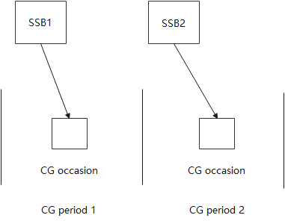

Figure 1 Mapping relationship without repetition

With repetition, the mapping relationship of these 2 options are shown as below:

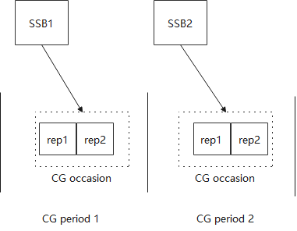 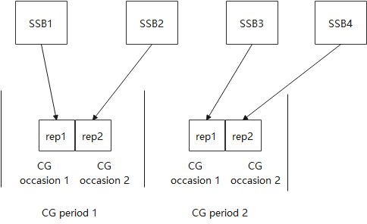

Option 1 Option 2

Figure 2 Mapping relationship with repetition

From FL’s understanding, Option 2 totally changes the mapping relationship, and the definition of repetition is different from legacy CG, because when UE selects one SSB, according to the mapping relationship, UE will only use one of these repetitions to transmit CG-SDT, there is actually NO repetition at all. Therefore, Option 2 is not preferred at this late CR stage.

**Proposal 2-1**

For CG-SDT, the repetitions in one CG period are considered as a PUSCH occasion that is mapped to the same SSB(s), the PUSCH occasion is invalid if any of these repetitions is invalid.

- Adopt the following TP#2-1

**TP#2-1 for TS 38.213 in section 19.1**

|  |
| --- |
| **< Unchanged text omitted >** 19.1 Configured-grant based PUSCH transmission A UE indicated to release a dedicated RRC connection can be provided one or more configurations by respective one or more *ConfiguredGrantConfig*, for configured grant Type 1 PUSCH transmissions on the initial UL BWP [12, TS 38.331]. For the remaining of this clause, PUSCH transmissions refer to configured grant Type-1 PUSCH transmissions for a configuration provided by *ConfiguredGrantConfig*.  A UE can be provided by *sdt-SSB-Subset* a number of SS/PBCH block indexes $N_{PUSCH}^{SS/PBCH}$ to map to a number of valid PUSCH occasions for PUSCH transmissions over an association period. If the UE is not provided *sdt-SSB-Subset*, the UE determines $N_{PUSCH}^{SS/PBCH}$ from the value of *ssb-PositionsInBurst* in *SIB1* or by *ServingCellConfigCommon*. A PUSCH occasion for a PUSCH transmission is defined by a time resource and a frequency resource and is associated with a DM-RS provided by *cg-DMRS-Configuration* for the configuration of PUSCH transmissions. A UE can be provided by a number of repetitions for a PUSCH transmission by *repK* or *numberOfRepetitions*. If the number of repetitions is provided and larger than 1, the PUSCH repetitions for the PUSCH transmission are regarded as a PUSCH occasion. The PUSCH occasion is invalid if any repetition within the occasion is invalid.  An association period, starting from frame with SFN 0, for mapping $N_{PUSCH}^{SS/PBCH}$ SS/PBCH block indexes, from the number of SS/PBCH block indexes, to valid PUSCH occasions and associated DM-RS resources is the smallest value in the set determined by the PUSCH configuration period provided by *periodicity* in *ConfiguredGrantConfig* according to Table 19.1-1 such that $N_{PUSCH}^{SS/PBCH}$ SS/PBCH block indexes are mapped at least once to valid PUSCH occasions and associated DM-RS resources within the association period. A UE is provided a number of SS/PBCH block indexes associated with a PUSCH occasion and a DM-RS resource by *sdt-SSB-perCG-PUSCH*. If after an integer number of SS/PBCH block indexes to PUSCH occasions and associated DMRS resources mapping cycles within the association period there is a set of PUSCH occasions and associated DMRS resources that are not mapped to $N_{PUSCH}^{SS/PBCH}$ SS/PBCH block indexes, no SS/PBCH block indexes are mapped to the set of PUSCH occasions and associated DMRS resources. An association pattern period includes one or more association periods and is determined so that a pattern between PUSCH occasions with associated DMRS resources and SS/PBCH block indexes repeats at most every 640 msec. PUSCH occasions and associated DMRS resources not associated with SS/PBCH block indexes after an integer number of association periods, if any, are not used for PUSCH transmissions.  **< Unchanged text omitted >** |

Any comments on Proposal 2-1 and TP#2-1?

In addition, according to the contribution[10], companies are also encouraged to share views on whether there is a need to separately introduce UE capability for repetition.

|  |  |
| --- | --- |
| Company | Comment |
|  |  |
|  |  |
|  |  |
|  |  |
|  |  |
|  |  |
|  |  |
|  |  |

# Issue#2 Redundancy versions of repetitions for CG-SDT

## First round discussion

In RAN1#110, the impact of the following agreement made by RAN2 for RV version has been captured in TS 38.213.

RAN2#117e agreements

=> For autonomous re-tx, fix the RV to be 0 for both the initial and retransmission of initial CG-SDT transmission.

In RAN1#110bis-e meeting, 2 options are identified to reflect the different understandings on the RAN2 agreements for RV determination, and it’s expected to down-select one of them in this meeting.

For initial transmission or autonomous retransmission of initial PUSCH transmission for CG-SDT,

-    Option 1: The RV is always fixed to be 0 no matter whether repetition is configured or not

-    Option 2: The RV is determined by repK-RV if repetition is configured

The behavior according to the 2 options can be illustrated below:

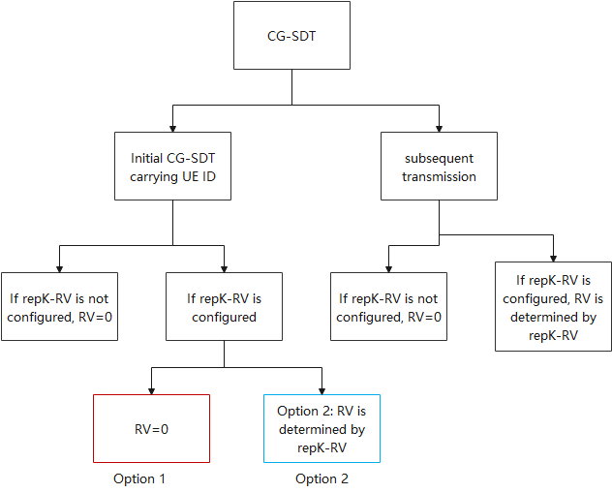

Figure 3. RV determination of Option 1 and 2

In addition, in R1-2211277, the RV determination in section 6.1.2.3.1 in TS 38.214 already includes the following cases:

Case 1: For CG transmission in unlicensed band, the RV is determined by UE

- Note: *cg-RetransmissionTimer* is only used in NRU, which is different from the new timer *cg-SDT-RetransmissionTimer* defined for the autonomous re-transmission in SDT

Case 2: For CG transmission in licensed band without repetition, the RV is always 0.

Case 3: For CG transmission in licensed band with repetition, the RV is determined by *repK-RV*

- Note: The CG transmission also includes CG-SDT transmission unless it’s explicitly indicated that special handling is needed for CG-SDT.

FL has the following observations on these 2 options:

**FL Observation:**

- Option 1：The RV is always fixed to be 0 no matter whether repetition is configured or not

- Benefit: This option provides more opportunity for gNB to detect the initial CG-SDT carrying UE ID to identify the UE triggering SDT.

- Spec impact: The spec change agreed in RAN1#110 has already covered the special handling of RV determination including repetition case, therefore, no spec impact is needed for now.

- Option 2：The RV is determined by repK-RV if repetition is configured

- Benefit: This option is exactly the same with legacy RV determination, which means that no special handling is needed for initial CG-SDT.

- Spec impact: Since we already specify the special handling of initial CG-SDT in TS 38.213, this option requires to remove the text agreed in RAN1#110 as shown in TP#3-1.

|  |
| --- |
| For initial transmission or autonomous retransmission of an initial transport block provided for the PUSCH transmission as described in clause 18.0 in [19, TS 38.300], the UE encodes the transport block using redundancy version number 0 |

**TP#3-1 for Option 2 in TS 38.213**

|  |
| --- |
| **< Unchanged text omitted >** 2 References ~~[19] 3GPP TS 38.300: "NR; NR and NG-RAN Overall Description"~~  **< Unchanged text omitted >** 19.1 Configured-grant based PUSCH transmission **< Unchanged text omitted >**  A UE determines a power of a PUSCH transmission as described in clause 7.1.1, where the UE obtains ${PL}_{b,f,c}(q_{d})$ using a RS resource from an SS/PBCH block with index associated with the PUSCH transmission.  A UE can be provided a USS set by *sdt-CG-SearchSpace*, or a CSS set by *sdt-SearchSpace*, to monitor PDCCH for detection of DCI format 0_0 with CRC scrambled by C-RNTI or CS-RNTI for scheduling PUSCH transmission or of DCI format 1_0 with CRC scrambled by C-RNTI for scheduling PDSCH receptions [12, TS 38.331]. The UE may assume that the DM-RS antenna port associated with the PDCCH receptions, the DM-RS antenna port associated with the PDSCH receptions, and the SS/PBCH block associated with the PUSCH transmission are quasi co-located with respect to average gain and quasi co-location 'typeA' or 'typeD' properties. The UE transmits a PUCCH with HARQ-ACK information associated with the PDSCH receptions as described in clause 9.2.1 using a same spatial domain transmission filter as for the last PUSCH transmission.  ~~For initial transmission or autonomous retransmission of an initial transport block provided for the PUSCH transmission as described in clause 18.0 in [19, TS 38.300], the UE encodes the transport block using redundancy version number 0.~~  **< Unchanged text omitted >** |

From FL’s understanding, Option 1 is more aligned with RAN2’s intention to introduce autonomous re-transmission and fix RV to be 0 for initial CG-SDT carrying UE ID, regarding Option 2, it’s not preferred to revert previous agreement unless there is consensus to do so.

With the analysis above, FL suggests the following:

**Conclusion 3-1:**

For initial transmission or autonomous retransmission of initial PUSCH transmission for CG-SDT, the RV is always fixed to be 0 no matter whether repetition is configured or not.

- There is no spec impact.

Any comments?

|  |  |
| --- | --- |
| Company | Comment |
|  |  |
|  |  |
|  |  |
|  |  |

# Summary

The final proposals will be added later.

# References

1. R1-2210987 Remaining issues of NR SDT in RRC INACTIVE state vivo
2. R1-2210988 Correction of CG PUSCH repetition in SDT vivo
3. R1-2210989 Correction of reduncancy version of CG PUSCH repetitions in SDT vivo
4. R1-2211276 Correction on repetition for CG-SDT in TS 38.213 ZTE, Sanechips
5. R1-2211277 Discussion on repetition and redundancy version for CG-SDT ZTE, Sanechips
6. R1-2211380 Discussion on redundancy version for PUSCH repetitions during SDT Intel Corporation
7. R1-2211381 Correction on CG-PUSCH repetitions for CG-SDT operation Intel Corporation
8. R1-2212024 Discussion on the repetition aspect for SDT in active state Samsung
9. R1-2212025 Draft CR for the repetition aspect for SDT in active state Samsung
10. R1-2212492 Remaining issues on repetition for CG-SDT Huawei, HiSilicon