3GPP TSG RAN WG1 #110bis-e R1-22xxxxx

e-Meeting, October 10th – 19th, 2022
Agenda Item: 8.10
Source: Moderator (Qualcomm Incorporated)
Title: Summary #1 of [110bis-e-R17-eIAB-02]
Document for: Discussion and decision

Introduction
This contribution provides a summary to support the following email discussion for agenda item 8.10, based on the recommendations following the preparation discussion in [110bis-e-R17-eIAB-01]:
[110bis-e-R17-eIAB-02] Email discussion on remaining eIAB maintenance issues by October 17 – Luca (Qualcomm)
- Topic #1. Coexistence of TD and FD DU resource configurations
- Topic #2. Corrections on RB set size for Rel-17 IAB FDM multiplexing
- Topic #4. Correction on the formula of Case-7 UL Tx timing for eIAB in TS 38.213
- Topic #5. Additional specification for DL Tx power adjustment
- Topic #8. Draft CR on guard symbols MAC CEs
- Topic #9. Draft CR on timing case indication
- Topic #11. Handling of interference between adjacent RB sets in FDM operation
- For alignment CRs: Topic #6 (R1-2208788), Topic #7 (R1-2208787), Topic #10 (R1-2210229)

Discussion plan
There are 11 topics identified based on the contributions and draft CRs [1] – [16] submitted for agenda item 8.10.
Based on the guidance from the discussion in [110bis-e-R17-eIAB-01] the following topics should be included in this discussion: #1, #2,, #4, #5, #6, #7, #8, #9, #10, #11.

Discussion topics

Topic #1. Coexistence of TD and FD DU resource configurations
Related decisions from prior meetings:
RAN1-106bise Working Assumption:
If both the Rel-16 time domain H/S/NA configuration and Rel-17 frequency domain H/S/NA configuration are provided for a given RB set within a slot, one of the following is selected:
Alt. 1: An IAB node applies the frequency domain H/S/NA only if the IAB node is currently operating in a non-TDM multiplexing mode in the slot, otherwise the Rel-16 time domain H/S/NA configuration is applied.

RAN1-107e Agreement:
Whether or not an IAB node can operate under a given non-TDM multiplexing mode (i.e. multiplexing info in 38.473) is left to IAB implementation in Rel-17

RAN1-109e Conclusion
If both Rel-16 H/S/NA and Rel-17 H/S/NA are configured for a given resource and the child node is operating in TDM multiplexing mode, consider the following alternatives until RAN1#110:
- Alt. 1: the child node follows the Rel-16 H/S/NA configuration for the resource
- Alt. 2: the child node follows the Rel-17 H/S/NA configuration for the resource
- Alt. 3: A resource configured with Rel-16 H or Rel-16 S with dynamic indication of availability overrides the Rel-17 H/S/NA configuration, otherwise the child node follows the Rel-17 H/S/NA configuration for the resource
- Alt. 4 the child node follows the Rel-16 or Rel-17 H/S/NA based on implicit indication (e.g. Case 6 timing indication) between parent and child node.

RAN1-110 Working Assumption
If Rel-16 H/S/NA resource configuration and Rel-17 H/S/NA resource configuration are both provided for a given RB set within a slot:
Alt 3b. A resource configured with Rel-16 H or Rel-16 S with dynamic indication of availability overrides the Rel-17 H/S/NA configuration, otherwise the child node follows the Rel-17 H/S/NA configuration for the resource.

Related input from contributions:
Huawei, Hisilicon  [1], [7] | Proposal 1: If Rel-16 H/S/NA resource configuration and Rel-17 H/S/NA resource configuration are both provided for a given RB set within a slot:  - A symbol configured with Rel-16 S with dynamic indication indicating available overrides the Rel-17 H/S/NA configuration  - For a symbol configured with Rel-16 S with dynamic indication indicating “no indication of availability”, the child node follows the Rel-17 H/S/NA configuration for the symbol  - For a symbol configured with Rel-16 S without receiving dynamic indication of availability, the child node follows the Rel-17 H/S/NA configuration for the symbol  - For a symbol configured with Rel-16 H/NA, the child node follows the Rel-17 H/S/NA configuration for the symbol  Proposal 2: If both Rel-16 H/S/NA and Rel-17 H/S/NA resource configuration are both provided for a given RB set within a slot, and both Rel-16 and Rel-17 dynamic indication of resource availability are received by child node:  - A symbol configured with Rel-16 S with Rel-16 dynamic indication indicating available overrides the Rel-17 H/S/NA configuration  - For a symbol configured with Rel-16 S with Rel-16 dynamic indication indicating “no indication of availability”, the child node follows the Rel-17 H/S/NA configuration and Rel-17 dynamic indication to determine resource availability for the RB set in the symbol  Proposal 3: If only Rel-16 H/S/NA resource configuration is provided for a given a slot:  - If Rel-16 dynamic indication of availability is not configured by RRC or not provided by DCI, the child node ignores the Rel-17 dynamic availability indication, if any.  - If both Rel-16 and Rel-17 dynamic indication of availability are configured and received, the child node ignores the Rel-17 dynamic availability indication.  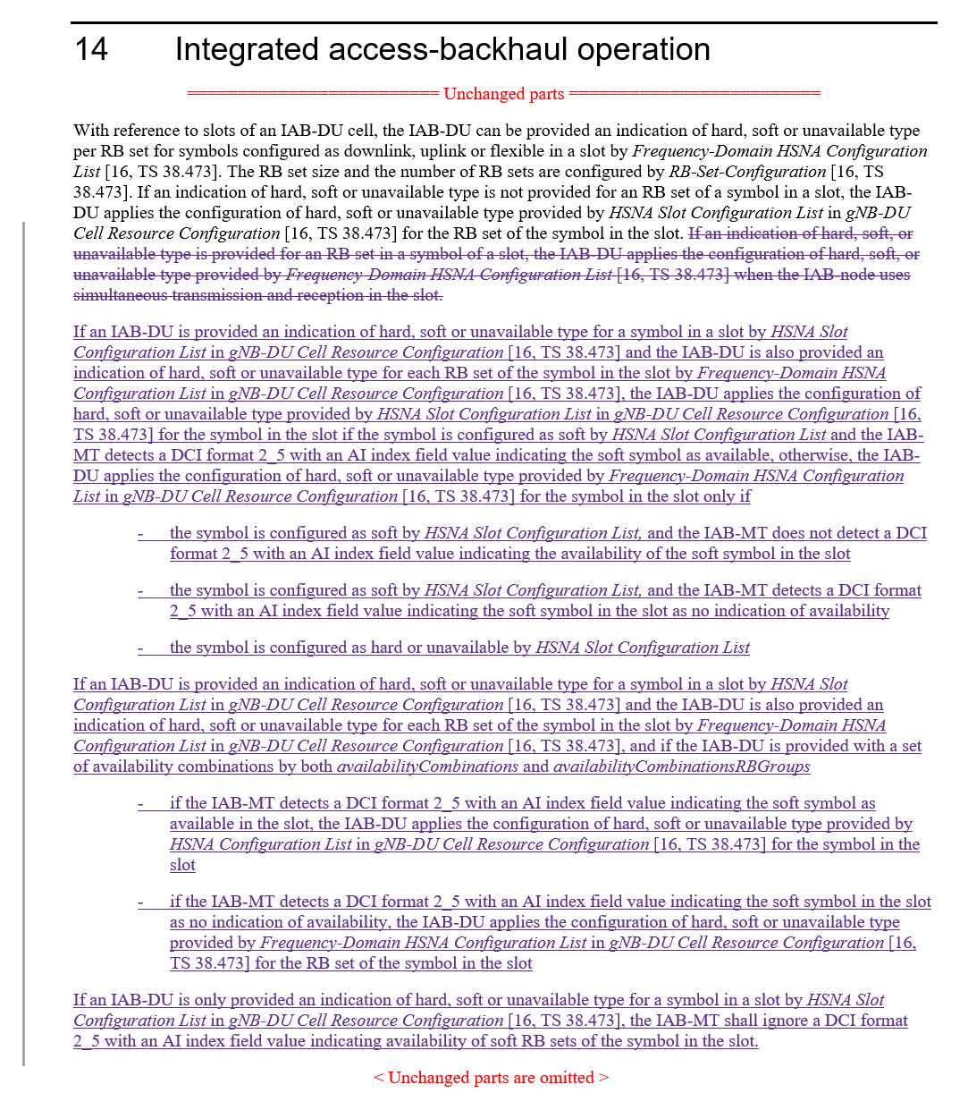
Lenovo  [6] | Observation 1: Compared to Al1. 2, Alt. 3b facilitates a fallback mode and provides higher resource efficiency if the IAB node is not capable of performing FDM at a particular moment.  Observation 2: Separate application of T-HSNA and F-HSNA is a special case of joint application. If joint application is agreed, the IAB-CU still has the possibility of separate (non-overlapping) configurations. Alt. 3b allows higher flexibility for resource configuration by the IAB-CU without loss of generality for TDM-only or FDM-only configurations if desired in a specific implementation.  Observation 3: Since the IAB-CU cannot be informed of whether an IAB node’s channel conditions at a specific time allows simultaneous MT-DU operations, the safe choice for the IAB-CU with Alt. 2 could be to avoid Rel-17 H/S/NA configuration, which could make the new specification useless in practice.  Proposal: Confirm the working assumption from RAN1#110, agenda item 8.10.
Qualcomm  [9] | 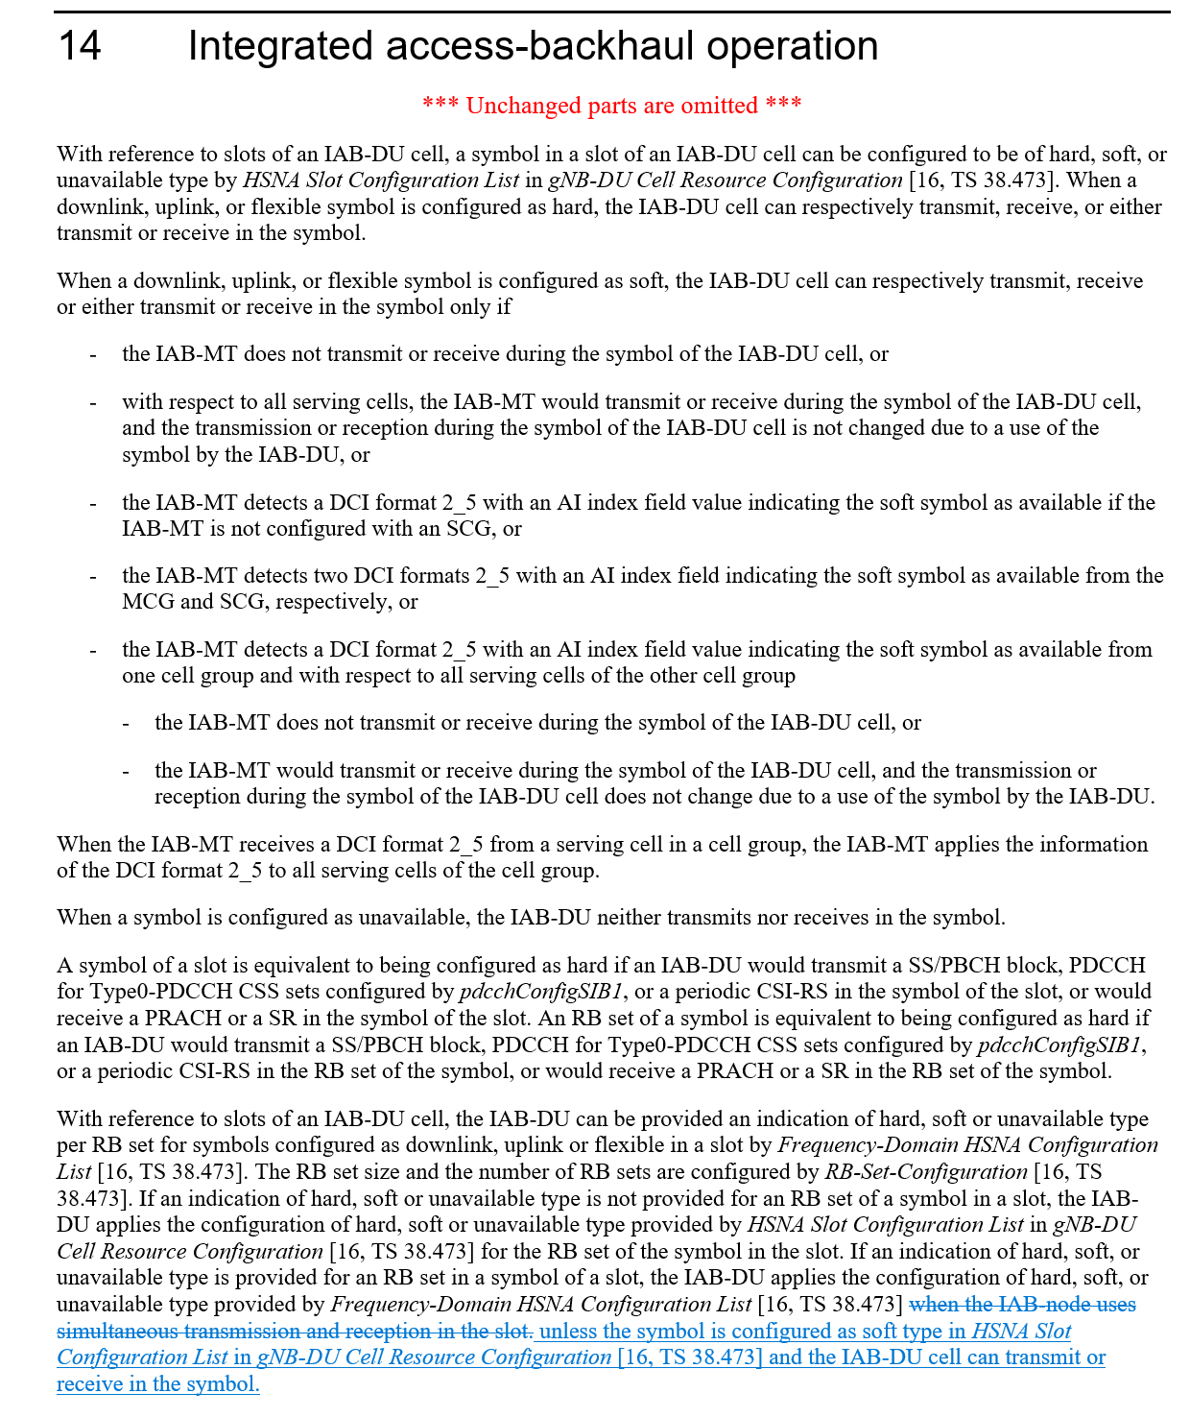
Nokia, Nokia Shanghai Bell  [10] | 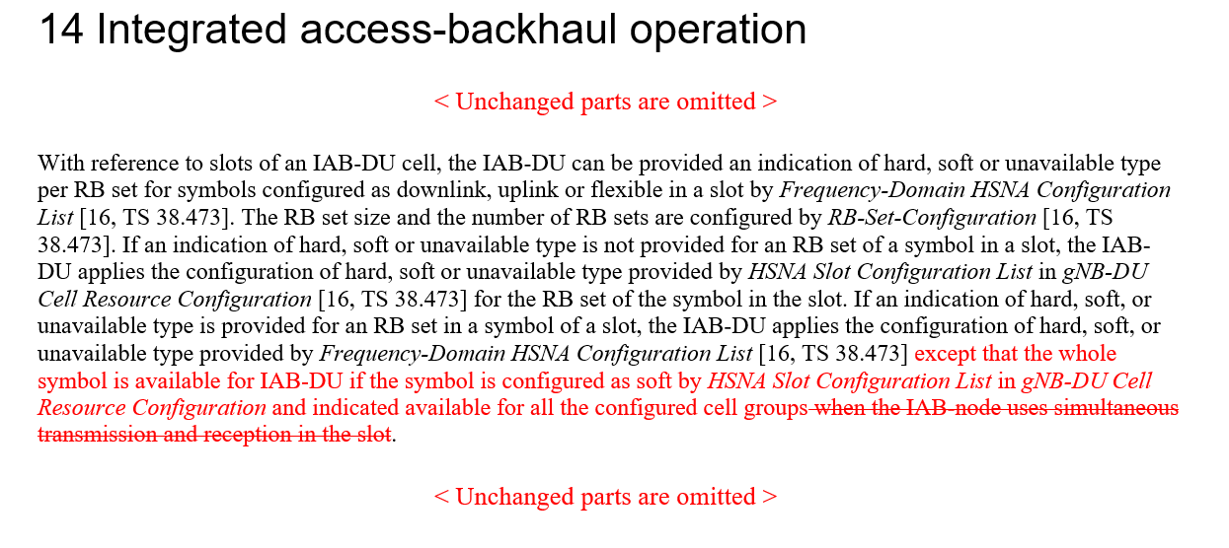
Ericsson  [16] | Proposal 1 If both Rel-16 time-domain H/S/NA configuration and Rel-17 frequency domain H/S/NA configuration are provided for a given RB set within a slot, the AvailabilityCombinationsPerCell-r17 is used to provide dynamic availability indication for both Rel-16 and Rel-17 Soft resource.

Based on the contributions it seems the WA from RAN1#110 can be confirmed. However, there are two related aspects requiring discussion:
- The WA states that “A resource configured with Rel-16 H or Rel-16 S with dynamic indication of availability overrides the Rel-17 H/S/NA configuration”. The question is whether ‘dynamic indication of availability’ refers solely to the explicit indication of availability via DCI or also includes the implicit determination of availability.
- Whether the behavior described in the WA is contingent on the mechanism (Rel-16 vs. Rel-17) to provide the explicit indication of availability.

In regard to 1) the FL understanding is that ‘dynamic indication of availability’ includes the implicit determination of availability, as that was the intent of the related FL proposal that led to the WA in RAN1#110. Moreover, there does not seem any advantage of precluding an implicitly determined time domain S resource to override the Rel-17 FDM configuration for the given symbol, in fact there seems to be a disadvantage in precluding it.
In regard to 2) the FL understanding is that the mechanism to provide the explicit indication of availability has no bearing on the behavior described by the WA. Moreover, assuming both Rel-16 and Rel-17 mechanisms can be used to provide an explicit indication of availability, there will never by a conflict since there is only the possibility to provide an indication of availability and there is no possibility to provide an indication of unavailability.

As a result the FL recommends we confirm the WA and adopt the corresponding TP change in TS 38.213:

FL Proposal 3.1
Confirm the WA from RAN1#110:

If Rel-16 H/S/NA resource configuration and Rel-17 H/S/NA resource configuration are both provided for a given RB set within a slot:
Alt 3b. A resource configured with Rel-16 S with dynamic indication of availability overrides the Rel-17 H/S/NA configuration, otherwise the child node follows the Rel-17 H/S/NA configuration for the resource.

Adopt the following TP in TS38.213:

Company | Comments
Ericsson | Support the proposal. However, we disagree with the FL conclusions that both Rel-16 and Rel-17 mechanisms can be used to provide an explicit indication of availability, if it is not clear whether an indication of availability refers to the Rel-16 or Rel-17 AvailabilityCombinations. The DCI itself looks the same.
Nokia | Support the proposal.
Lenovo, Motorola Mobility | Re: FL’s conclusion, our understanding of dynamic indication of availability is explicit signaling. Please note that the effort is to ensure that the IAB node and its parent node are on the same page on which configuration is to be used. We won’t achieve this goal by allowing implicit determination at the IAB node. We support confirming the WA, but we do not agree with the FL’s conclusion and the CR that seems to follow the conclusion in “can transmit or receive in the symbol.” Further discussion seems needed.
AT&T | Support the proposal. If the intention is to exclude implicit determination of availability that should be made clear in the agreement/CR, otherwise the current text should be understood that both explicit and implicit mechanisms are supported. We do not see a need to restrict the behavior to either Rel-16 or Rel-17 DCI format 2_5 since in either case the parent node will provide that indication and so it should be clear between the child and parent what Tx/Rx behaviors are possible in that symbol.
Samsung | We share a view with the FL about 2). On the other hand, for 1), we tend to agree with Lenovo that the intention is to ensure IAB and parent IAB are on the same page and then implicit indication does not serve the intention.
Huawei, HiSilicon | We are fine to confirm the working assumption.  On 1), we think the dynamic indication of availability is explicit signaling. The implicit determination if the parent node assumes Rel-17 H/S/NA to preform scheduling while the IAB node assumes Rel-16 to determine resource availability. The benefit of including implicit determination can hardly be achieved.  On 2) , we are open to discuss whether both Rel-16 and Rel-17 explicit indication of availability are possible. The fundamental issue is if one resource is only configured with Rel-16 H/S/NA, is it possible to indicate the resource availability using a Rel-17 availability indicator.

Based on the feedback there are no objections to confirm the WA.

In regard to whether ‘dynamic indication of availability’ refers solely to the explicit indication of availability via DCI or also includes the implicit determination of availability, a few companies raised concerns about including the implicit determination of availability since this may cause a misalignment at the parent node on which configuration is used by its child. The FL notes that such potential misalignment is perfectly acceptable in these conditions (i.e. for S symbols implicitly determined as available) because if the node has determined implicit availability for the full symbol, it does not matter to the parent, since, by definition of implicit determination, the IAB-node MT behavior cannot be impacted, so the potential communication in the upstream link with the parent is protected for all RBs of the (implicitly determined available) symbol. Given this observation the FL proposes to maintain FL Proposal 3.1 as is.

In response to Ericsson, the FL would like to note that the FL did not conclude that both Rel-16 and Rel-17 mechanisms can be used to provide an explicit indication of availability. The FL indicated that even if it was assumed both indications of availability were possible, there would be no issue with the WA.

Company | Any objections to FL Proposal 3.1?
Ericsson | Support
Huawei, HiSilicon | Thanks for the clarification from the FL, we tend to agree that the implicit determination of availability can also be included in the proposal even though this may complicate the IAB behavior a bit since there are more conditions for the IAB to check the resource availability in this case.  On the second point raised by the FL in the 1st round, we also agree that it does have an impact to confirm the WA. However, there seems still one remaining issue, i.e. whether a Rel-17 availability indication can be applicable for Rel-16 H/S/NA resource configuration. We would like to highlight that this may not be a corner case given that Rel-17 H/S/NA is only configured for some slots while the Rel-16 and Rel-17 availability indications are configured to a consecutive number of slots.
Nokia | Agree with FL assessment. Support FL Proposal 3.1.
Lenovo, Motorola Mobility | There seem to be two matters that should be distinguished:  - What the DU can do with its own S resource if it is not indicated available by the parent node. Here, the DU can use the S resource if its capability allows, i.e., the DU’s use of the S resource does not conflict with an MT communication. This is in line with Rel-16 concept of S symbol availability.  - Whether the IAB node can take this capability for other decision making, here for deciding what configuration to use: TDM HSNA or FDM HSNA. This is the subject of the discussion here.  Our understanding is that this whole discussion is to determine the DU behavior, and that is defined with respect to the signaling it receives from the parent node.  We may need to answer a key question: Does the IAB node expect to receive DCI 2-5 for both TDM HSNA and FDM HSNA for a PRB on a symbol?  If yes, then the matter can be implementation and we won’t need any agreement. If no, then we are deciding which of the two DCI 2-5 the IAB node is expected to receive. In the latter case, the IAB node and its parent node need to be on the same page, which does not occur if the IAB node follows implicit determination.  This is another way of explaining the issue: if the only matter is whether the IAB node can transmit or receive on the symbol, then why doesn’t this rule allow the DU to use a TDM H resource, and instead, it only allows the DU to use a TDM S resource if it is determined available? The rule seems a bit arbitrary.  In summary, we need to make sure we are on the same page on the purpose of this discussion. The purpose in our opinion is to determine which resource availability is to be sent by the parent node, if the IAB node is supposed to receive only one of TDM and FDM resource availability. If this restriction does NOT apply, then the IAB node can use either or both resource availability indications based on its capability and implementation. If the restriction does apply, then the parent node needs to know which resource availability (DCI 2-5) to send to the IAB node, which requires the IAB node and its parent node to be on the same page on use of TDM or FDM HSNA configurations.  Therefore, it’s still not clear to us whether it is practical or beneficial to capture the WA as the proposed CR.

Topic #2. Corrections on RB set size for Rel-17 IAB FDM multiplexing
Related input from contributions:
Nokia, Nokia Shanghai Bell  [5] | 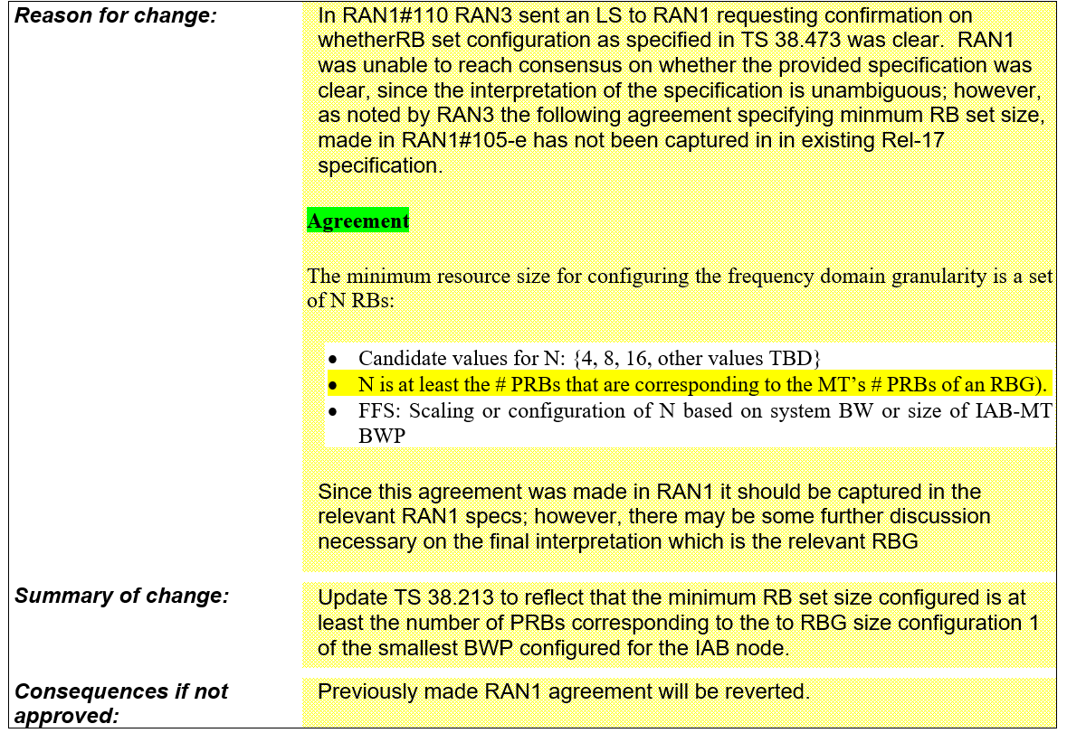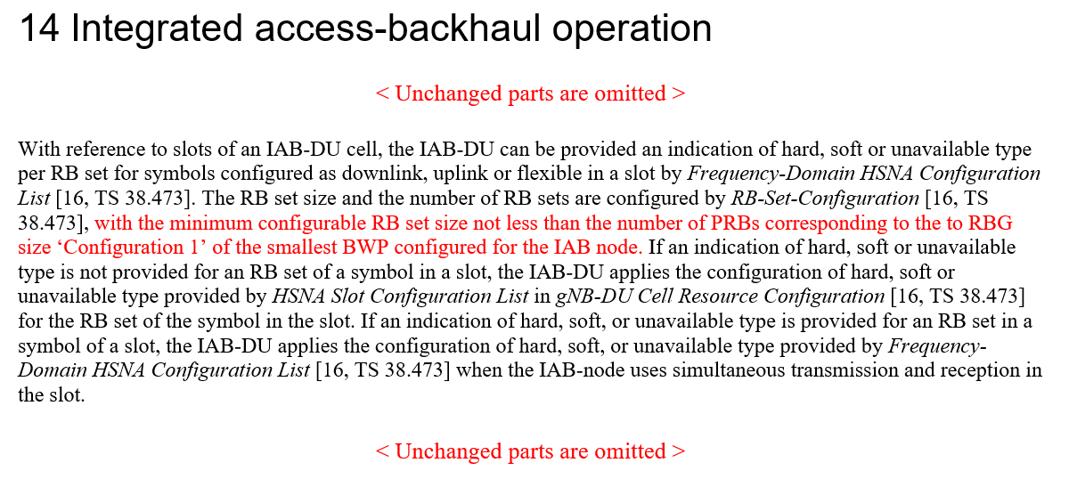

This topic was discussed extensively in RAN1#110 in the context of the reply LS to R1-2205705.
The FL assessment is that all companies are in alignment on the fact the aforementioned highlighted portion of the RAN1#105-e agreement (N is at least the # PRBs that are corresponding to the MT’s # PRBs of an RBG) needs to be captured in the specifications. On the other hand there are diverging views on whether that is actually the case. It is the FL understanding that the divergence likely stems from two different interpretations:
- Interpretation 1: the agreement indicates an operational constraint that the specification should reflect so that the network shall enforce it.
- Interpretation 2: the agreement indicates a constraint that is already reflected in the values that were eventually agreed for N in RAN1#106-e:
RAN1#106-e Agreement
N is a configured number of PRBs, where the CU configures N
- N = {2, 4, 8, 16, 32, 64}
- FFS: Value(s) of N in case of multiple configured BWPs at the IAB-MT
- This agreement does not revert any existing RAN1 agreement

The FL view is that regardless of the interpretation, given the possible values of N were defined and agreed, it is a network configuration issue to ensure the system is configured properly for best system performance. It is expected that in any case the network will use a suitable configuration for the desired system performance, which is true in general for network parameters. In that context, the FL believes this is not a critical issue and if there is no consensus on the interpretation of the RAN1#105-e agreement, the current specifications are acceptable.

Company | Comments
ZTE, Sanechips | We are OK to discuss whether RAN1 spec can capture this agreement, but we cannot accept the CR in[5], it is far beyond the agreement we have achieved in RAN1#105-e, especially for the ‘RBG size ‘Configuration 1’ of the smallest BWP configured for the IAB node ’ part.
Ericsson | Support the CR. In the RAN1 #106 agreement, the last bullet was explicitly included to not invalidate the RAN1 #105 agreement that the PRB set size is at least the size of an RBG. Without including the RB set size limitation in the spec, that part of the RAN1 #105 agreement is indeed invalidated. For that reason, Interpretation 2 is incorrect.  In response to ZTE, on the contrary, we think the draft CR provides maximum flexibility in the selection of the RB set size and is therefore not at all “far beyond the agreement.”
Nokia | Support the proposal. Regarding ZTE’s comment, we share a similar view with Ericsson. The intent of the proposal is to provide the maximum flexibility in configuring the minimum RB set size. Any other constraint would be more restrictive.
Lenovo, Motorola Mobility | It is crucial to honor agreements and hopefully we’ll be able to conclude this topic in the current meeting. We support this CR or a revised version that is accepted to reflect the RAN1 agreement.  Our reading of the agreement is as follows:  If we had “an MT’s #PRBs of an RBG,” it would seem to mean Interpretation 2, i.e., a constraint on values in the specification.  But the agreement reads “the MT’s #PRBs of an RBG,” which seems to mean the specific MT being configured. This suggests an operation-related specification, i.e., Interpretation 1.  We think Interpretation 1 is closer to the agreement, which is in line with the CR. We’ll be fine with revising details as requested by ZTE or other companies.
AT&T | Let’s capture that at least interpretation 1 is the correct way to capture that RAN1#105 agreement which needs to be reflected in RAN1 specifications as discussed in the email thread.
Samsung | Taking into account the guideline from Chair, we are OK with discussing how to capture it in RAN1 spec and open to further suggestion in order to well reflect the agreement in RAN1 spec.
Huawei, HiSilicon | We don’t support the CR.  First, it is not consistent with the agreement for both interpretation 1 and interpretation 2.  Secondly, following the direction of interpretation 1 will lead to additional issues as discussed before, e.g. what if an IAB-MT is configured with multiple BWPs or multiple CCs.  Finally, we agree with the FL’s analysis that there are two possible interpretations of the agreement and believe with interpretation 1 put an unnecessary restriction. We don’t understand how this could provide any flexibility given that interpretation 1 clearly put a restriction how the RS set size can be configured since it is coupled with the RBG size of the IAB-MT.
Ericsson | In response to Huawei:  - As explained above, Interpretation 2 is wrong since it does not consider the agreed constraint on the RB set size.  - The CR clearly describes how which BWP to relate to and it is minimally restrictive.  Having said that, we are not opposed to improving the CR further, in line with Interpretation 1. So far, no constructive alternative proposal has been presented by any company, thus the CR from Nokia is what we have to relate to.
ZTE, Sanechips | Our interpretation is 2, as Huawei mentioned, interpretation 1 will trigger further discussion to determine which BWP is referred as ‘the BWP’. There are also other reasons that we think a F1AP DU configuration should not be coupled with an IAB MT RRC configuration:  - And if they were coupled with each other, then it would be happen that, if the BWP configuration is changed, the RB set configuration update will be also triggered.  - Technically, the IAB MT BWP may have different SCS configuration than the reference SCS of the RB set configuration, we do not think just restrict the ‘number of PRBs’ is reasonable, and up to network implementation can achieve maximum flexibility and best system performance.  Considering the motivation ‘provides maximum flexibility in the selection of the RB set size’ and not trigger further discussion on the definition of ‘the BWP’ and the above ‘couple F1AP signalling with RRC signalling’, we propose the following for a compromise for both interpretation 1 and 2:  ...., with the minimum configurable RB set size not less than 2 PRBs, .....  Sine value 2 is the smallest RBG size can be configured to a IAB MT BWP, which provides maximum flexibility.

Based on the feedback and the related discussion in the tail of the [110bis-e-R17-eIAB-01] email thread including the guidance from the Chairman, the direction is to capture ‘interpretation 1’ in the RAN1 specification.
There are concerns with the proposed CR from Nokia, hence the FL would like to propose the following for 38.213 with the intent to capture in a simple but effective way the agreement.

FL Proposal 3.2
Add the following TP to clause 14 of TS 38.213:
The IAB-node can assume the RB set size for the IAB-DU is larger than or equal to the minimum RBG of the IAB-MT.

Company | Views on FL Proposal 3.2?
Ericsson | Support
Huawei, HiSilicon | As commented previously, we strongly believe interpretation 2 will provide the maximum configuration flexibility since there will be no explicit restriction for the RB set size configuration. Following the interpretation 1 leads to more issues as pointed out by ZTE.  The latest proposal from the FL is still not clear, the IAB-MT can be configured with multiple BWPs and/or multiple serving cells. What is the minimum RBG of the IAB-MT in these cases and what is the technical motivation to choose this value?  TO move forward and resolve this long-hanging issue, we are fine with the latest proposal from the ZTE in the previous round. Alternatively, we can try to amend the previously agreement following interpretation 1. We suggest the following  The IAB-node can assume the RB set size for the IAB-DU is larger than or equal to the minimum possible RBG size of the IAB-MT assuming different Bandwidth Part Size configurations.
Nokia | The sub-bullet in the RAN1#106-e agreement provided by the FL, “This agreement does not revert any existing RAN1 agreement,” makes it clear that interpretation 2 is not correct. The agreed candidate values of N do not revert the agreement that, “N is at least the # PRBs that are corresponding to the MT’s # PRBs of an RBG.” Discussions on supporting the maximum configuration flexibility are not relevant, as we specifically agreed to constrain the configuration flexibility.  We are supportive of the FL’s proposed modification, since in our view it is consistent with the original intent of the proposed CR, but more concisely worded.  In our view, Huawei’s proposed modification is inconsistent with the straightforward reading of the agreement. We did not agree that the constraint is the minimum possible RBG size, but the MT’s minimum RBG size.

Topic #4. Correction on the formula of Case-7 UL Tx timing for eIAB in TS 38.213
Related input from contributions:
ZTE, Sanechips  [2] | 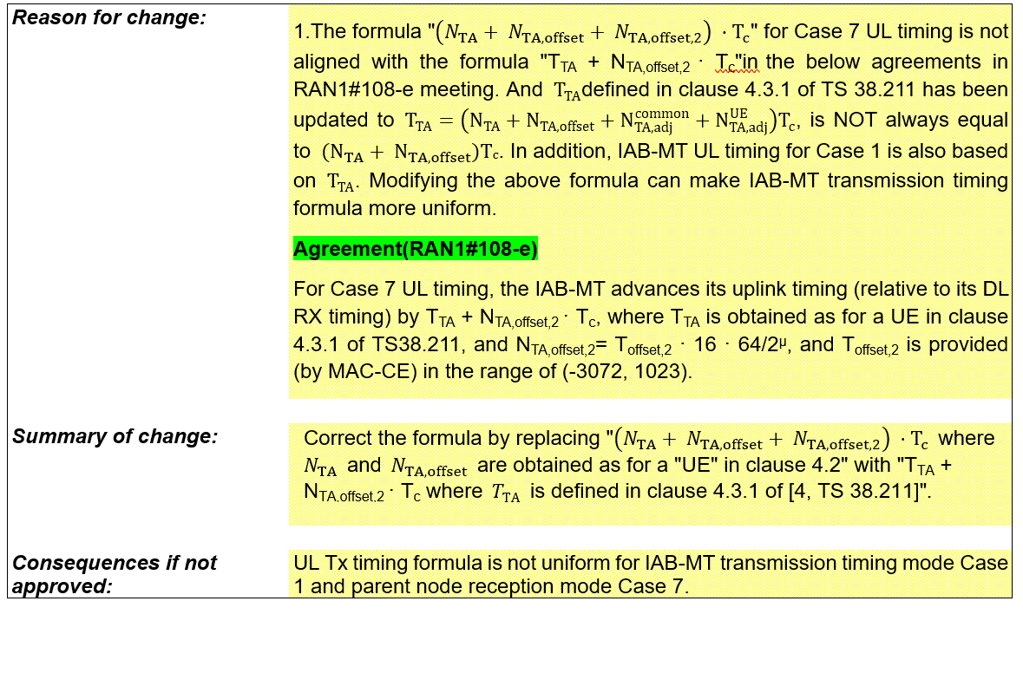

The FL assessment is that the CR has merit and it needs to be implemented to reflect the aforementioned agreement.

FL Proposal 3.4
Endorse draft CR in R1-2208786.

Company | Comments
ZTE, Sanechips | Support, it reflects the agreement of RAN1#108-e, BTW, similar discussion has been made for OTA formula, and T_{TA} is used instead of N_{TA}+N_{TA,offset}.
Ericsson | Support
Nokia | Support the proposal.
Lenovo, Motorola Mobility | Support
Samsung | OK
Huawei, HiSilicon | We don’t see a strong need for the change.

There does not seem to be any strong objection, so this is promoted for email endorsement.

Topic #5. Additional specification for DL Tx power adjustment
Related input from contributions:
Ericsson  [11], [12] | Proposal 1 The following RAN1#107-e agreement is amended as: The indicated desired/provided DL Tx power adjustment is in terms of a relative offset to the non-offset PDSCH Tx power, as derived from a CSI-RS TX power that is RRC configured.  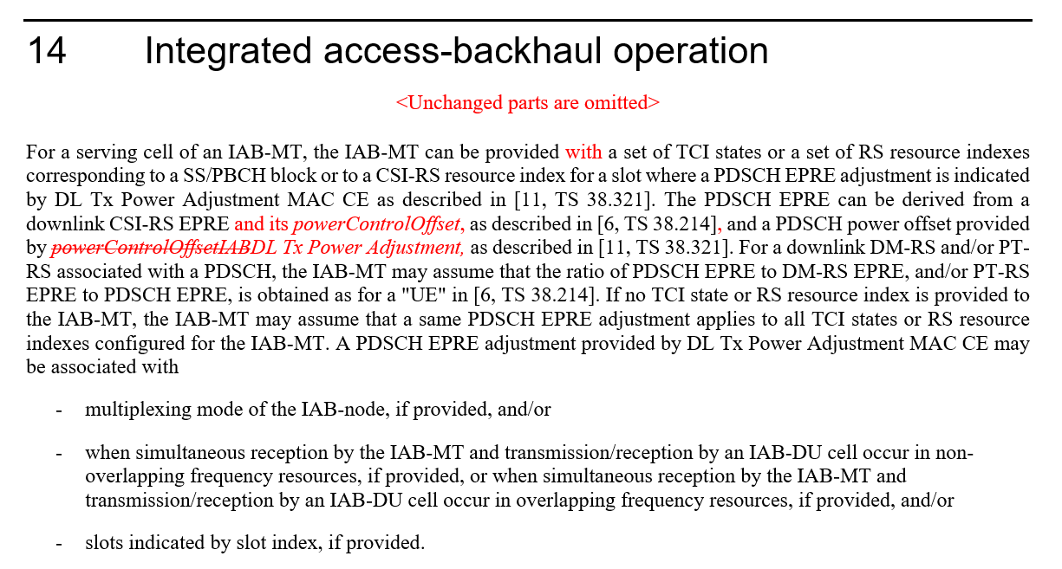

This topic was briefly addressed in RAN1#110 but there was no time to conclude. Based on the input in [12] it seems the proposed CR is necessary to avoid being limited by the agreed dynamic range for DL TX Power Adjustment.
FL Proposal 3.5
Endorse draft CR in R1-2210225.

Company | Comments
ETRI | Support.
ZTE, Sanechips | Not support, RAN2 has made their spec based on the agreement of RAN1#107-e, and current spec works well, no further changes are necessary.
Ericsson | Support
Nokia | Support the proposal.
Lenovo, Motorola Mobility | Fine
Huawei, HiSilicon
Ericsson | In response to ZTE:  RAN2 made specification changes based on information from RAN1. RAN1 provided a DL Tx power adjustment that does not allow to operate with the legacy power setting range, if the legacy power range is simply substituted by a new power range and not complemented. That would not be compatible to Rel-16 DL Tx power specification. The current RAN1 description is ambiguous in the question of how to determine an adjusted DL Tx power (see our contribution R1-2210226, Alt a) and Alt b)). Thus, current specification does not work well and requires adjustment.
ZTE, Sanechips | Thanks to Ericsson’s response, but form our point of view, the new DL Tx power adjustment is only applied on some of slots which requires a different DL Tx power than the legacy DL Tx power, e.g., slots that non-TDM operation is performed. For the other slots such adjustment is not required, the new DL Tx power adjustment is not indicated for these slots, i.e., legacy Rel-16 DL Tx power allocation will be used. This is why we think current spec works well and it is not necessary to cover ‘the legacy power setting range’ for DL Tx power adjustment range.

The FL understanding is that, while it is true the Dl Tx power adjustment is meant for operation in non-TDM modes, the explanation of the issue provided by Ericsson indicates the problem applies in general, also including non-TDM slots.

Company | Any further comments?
Ericsson | In our understanding, if RAN1 does not endorse the CR, for the slots applying DL TX Power Adjustment, output power will not have the same power range as other slots, but a much more restricted and weaker output power range due to the agreed DL TX Power Adjustment range from RAN1 #110. This will render the whole feature useless.

Topic #6. Corrections on misaligment for MAC CE or RRC parameters for eIAB TS 38.213
Related input from contributions:
ZTE, Sanechips  [4] | 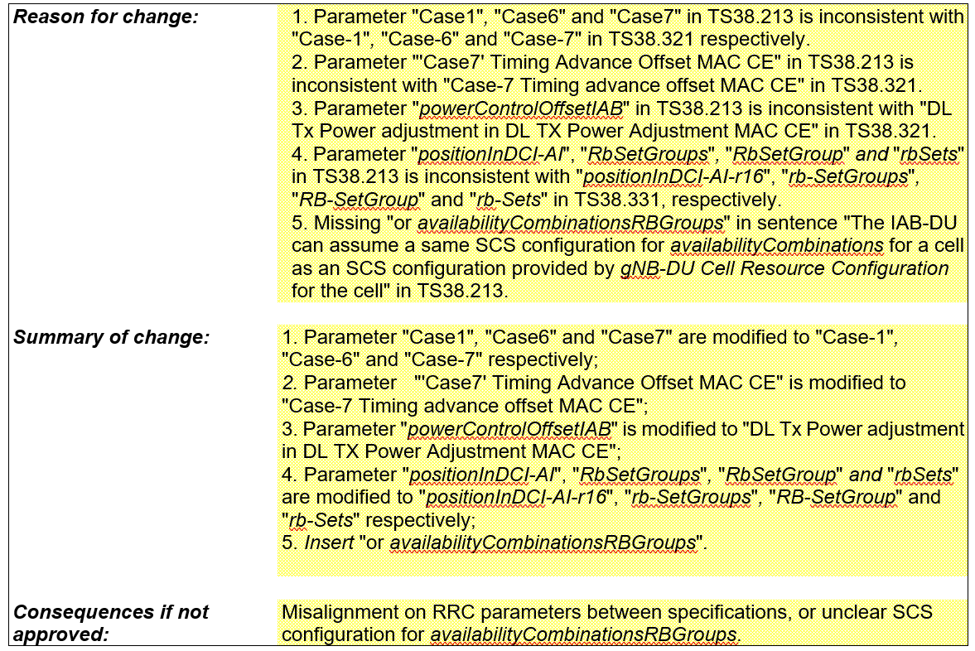

The FL assessment is that the CR has merit.

FL Proposal 3.6
Endorse draft CR in R1-2208788.

Company | Comments
ETRI | OK with other than change #3.  Change #3 in 8788 is overlapped with Topic #5 above.
ZTE, Sanechips | Support
Ericsson | Support. Share ETRI’s concern about the 3rd change.
Nokia | Support the proposal.
Lenovo, Motorola Mobility | Support
Samsung | OK
Huawei, HiSilicon | Okay

Except for proposed change #3 there is consensus on supporting this CR. The FL suggest to leave this open until consensus on Topic #5 is achieved one way or another. The proposed CR here will be adjusted accordingly, if needed.

Company | Any further comments?
Ericsson | Agree with FL’s suggestion.
Nokia | Fine with FL’s suggestion.

Topic #7. Correction on the position related to the description that the RB set is equivalent to hard for eIAB in TS 38.213
Related input from contributions:
ZTE, Sanechips  [3] | 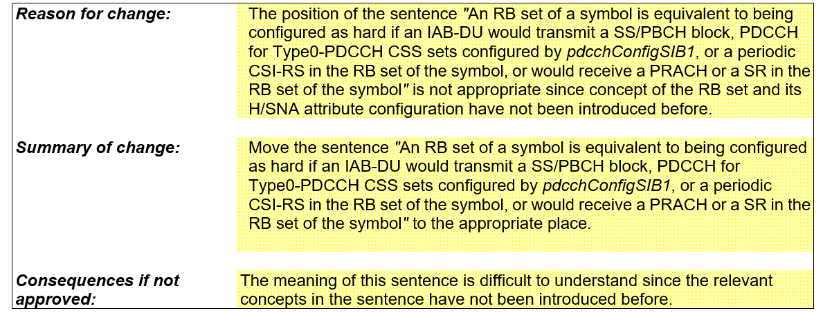

The FL assessment is that the CR has merit.

FL Proposal 3.7
Endorse draft CR in R1-2208787.

Company | Comments
ZTE, Sanechips | Support
Ericsson | The proposed changes overlap with the proposed changes proposed in topic #10 which provides additional improvements in spec readability.
Nokia | Support the proposal.
Lenovo, Motorola Mobility | Fine
Huawei, HiSilicon | Okay

Given the overlap with the draft CR in Topic #10 that has full support, the FL suggests to endorse the draft CR in Topic #10.

Topic #8. Draft CR on guard symbols MAC CEs
Related input from contributions:
Ericsson  [13] | 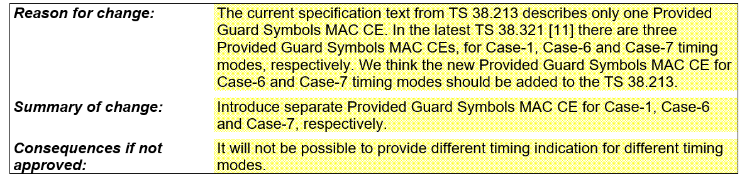  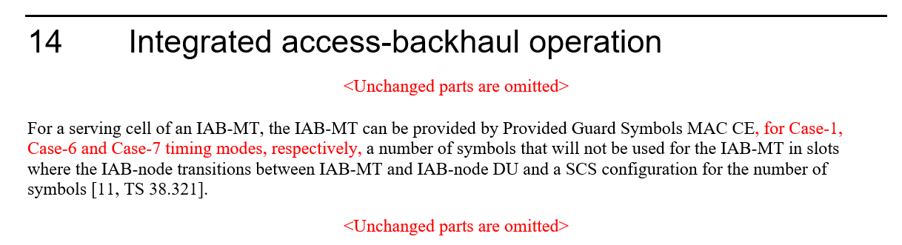

The FL assessment is that the CR has merit. For reference here is also the related RAN1#106-e agreement:

RAN1#106-e Agreement
MAC-CE signaling of Desired/Provided Guard Symbols is enhanced (e.g. using the same Rel-16 MAC-CE design) to support indication of guard symbols additionally required for Case #6 and Case #7 timing cases.
- FFS: Number of guard symbols associated with Case #6 and Case #7 timing modes
- FFS: Need for explicit indication of guard symbols switching between timing cases

FL Proposal 3.8
Endorse draft CR in R1-2210227.

Company | Comments
ZTE, Sanechips | OK
Ericsson | Support
Nokia | Support the proposal.
Lenovo, Motorola Mobility | Fine
Samsung | OK
Huawei, HiSilicon | We don’t see the need for the CR.

Based on the feedback there is large support for this proposed CR. The FL sympathizes with Huawei this may not be strongly needed, however, it is s straightforward change and there does not seem to be a strong need for an objection, also in light of the aforementioned agreement. Hence this is promoted for email endorsement.

Topic #9. Draft CR on timing case indication
Related input from contributions:
Ericsson  [14] | 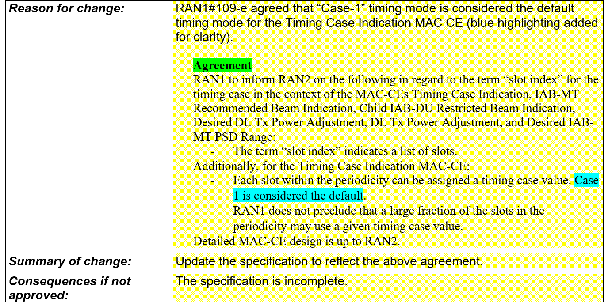  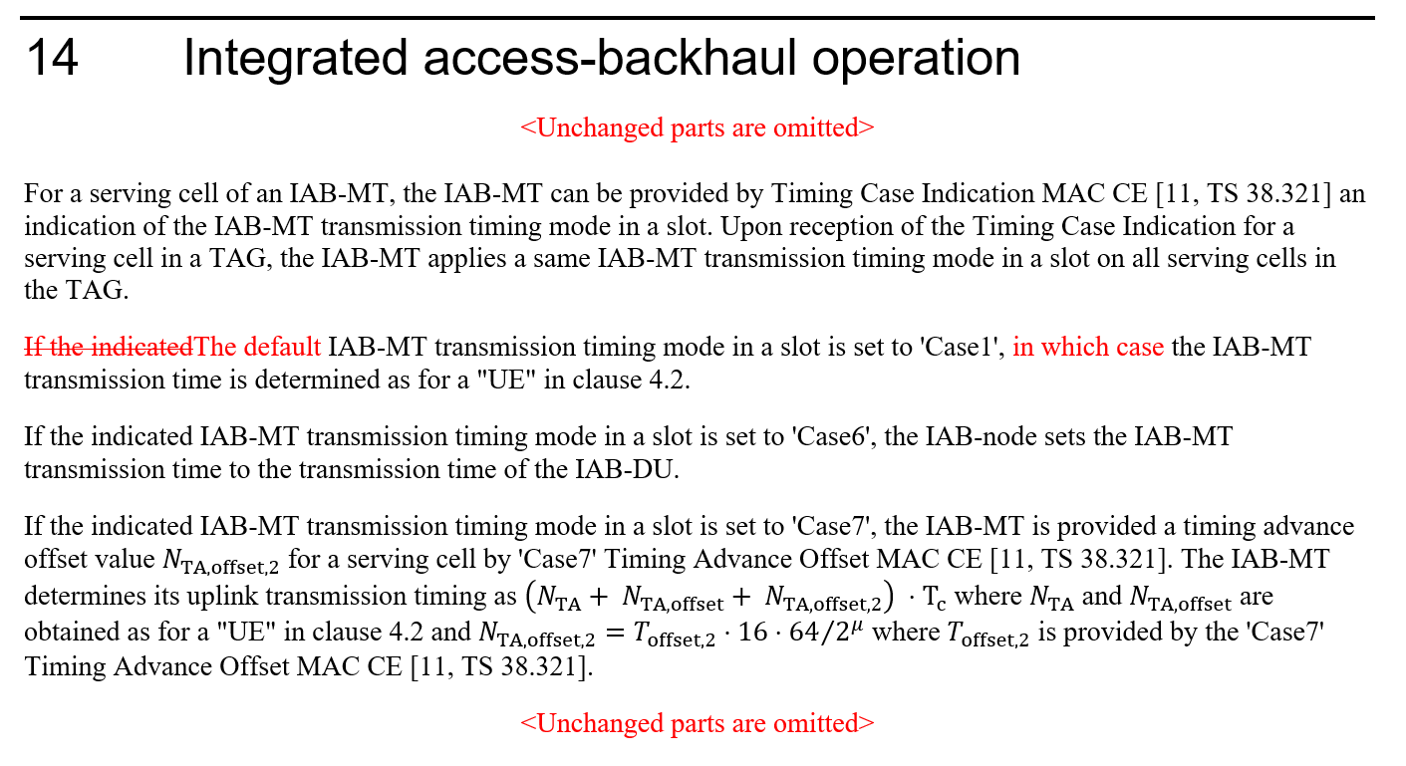

The FL assessment is that the CR has merit.

FL Proposal 3.9
Endorse draft CR in R1-2210228.

Company | Comments
ZTE, Sanechips | We prefer to change the text to cover both explicit case-1 indication case and default case 1 case:  If the indicated IAB-MT transmission timing mode in a slot is set to 'Case1' or the IAB-MT transmission timing mode indication in a slot is not provided, the IAB-MT transmission time is determined as for a "UE" in clause 4.2.
Ericsson | Support
Nokia | Prefer ZTE’s proposed modification.
Lenovo, Motorola Mobility | Support, and okay with ZTE’s version.
Samsung | OK with the revision from ZTE.
Huawei, HiSilicon | Support ZTE’s revision

There is consensus in principle on this draft CR, with a preference for the ZTE’s version which is then promoted for email endorsement.

Topic #10. Draft CR on Hard/Soft/Not Available resource definition
Related input from contributions:
Ericsson  [15] | 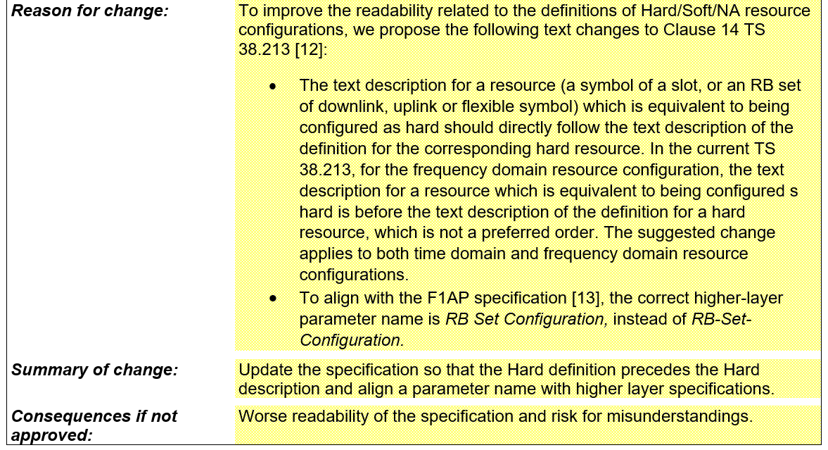  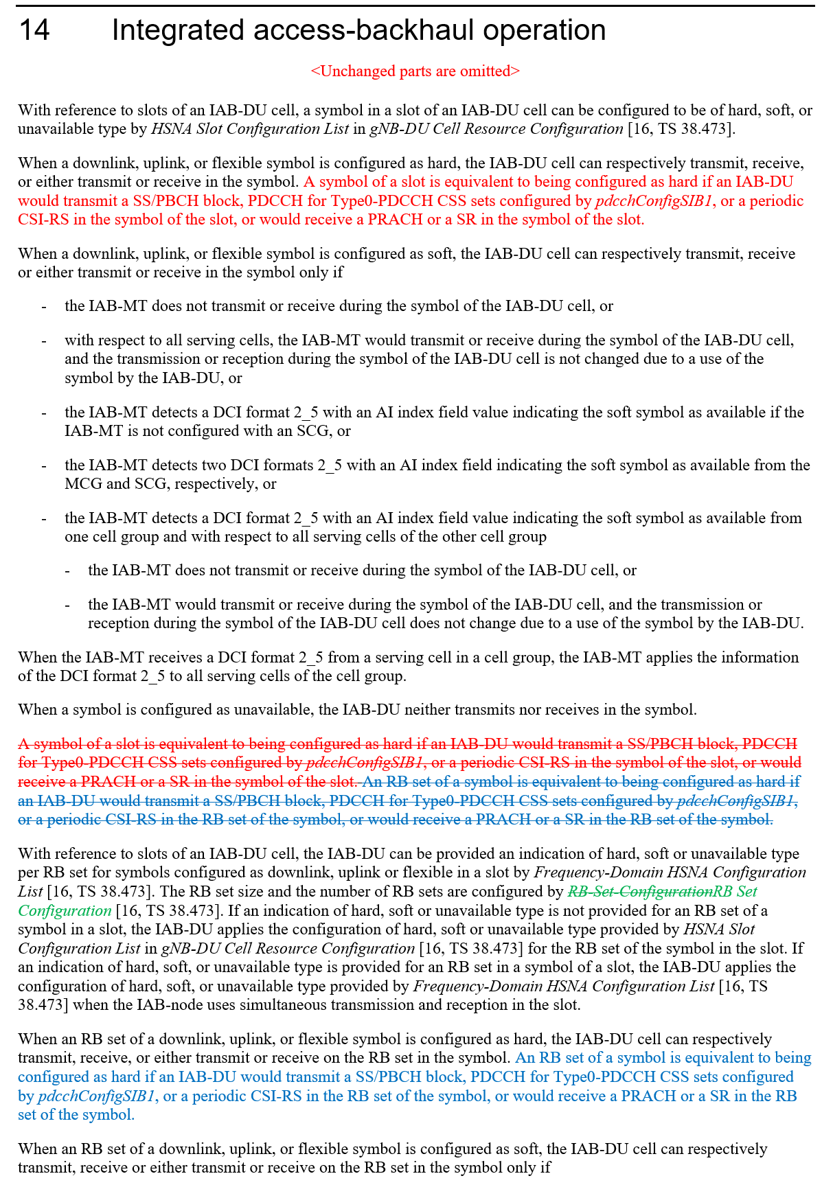

The FL assessment is that the CR has merit.

FL Proposal 3.10
Endorse draft CR in R1-2210229.

Company | Comments
ZTE, Sanechips | OK
Ericsson | Support
Nokia | Support the proposal.
Lenovo, Motorola Mobility | Fine
AT&T | Support
Samsung | OK
Huawei, HiSilicon | OK

There is consensus on this draft CR, so it is promoted for email endorsement.

Topic #11. Handling of interference between adjacent RB sets in FDM operation

Related input from contributions:
Huawei, Hisilicon  [1] | Observation 1: Guard band can provide better frequency domain isolation and may be needed to enable the FDM operation between MT and DU.  Observation 2: Placing the guard band on DU resource by implementation to achieve the FDM violates the definition of DU hard resources.  Proposal 4: The guard band including its size and location should be made aware of by IAB node’s parent node and donor node to facilitate efficient FDM operation.
Ericsson  [16] | Observation 1 Allowing the DU unconditional use of Hard resources, irrespective of interference on Soft or Not Available resources, assumes static channel conditions and will require a different solution for Rel-18 mIAB.  Proposal 2 To address the adjacent channel leakage between RB sets in FDM operation, RAN1 to decide to adopt  a. Alt 1: RAN1 based solution, restricting Hard resource utilization, or  b. Alt 2: RAN4 based solution, imposing adjacent leakage requirements into NA and Soft-NIA resources.

The FL assessment is that the issue related to this topic can be handled by implementation and with existing specifications, a view that was shared by a majority of companies in prior meetings.
In regard to the proposal in [1], at this stage of the WI it seems too late to introduce new signaling for a non critical issue.
In regard to the proposal in [16], the motivation of forward compatibility to Rel-18 mIAB is understandable, but it is a Rel-18 issue outside of the scope of Rel-17 maintenance for eIAB.

Company | Comments
ZTE, Sanechips | We support FL assessment.
Ericsson | With respect to Proposal 2 in [16], in our understanding, that means that RAN1 agrees that RAN4 will specify adjacent leakage requirements into NA and Soft-NIA resources. In that case, we propose that RAN1 sends an LS to RAN4, informing RAN4 about the possible leakage from Hard into NA and Soft-NIA resources.  We wonder why we did specify guard symbols for Rel-16 and additional guard symbols in Rel-17 for UL/DL switching coordination if the corresponding frequency domain problem can be left to implementation.
Nokia | Agree with FL assessment. Correction is not necessary.
Lenovo, Motorola Mobility | Agree with FL assessment.
AT&T | Both [1] and [16] have merit – especially for mobile IAB nodes. Unfortunately, there was no consensus for this in Rel-17 so we believe this may have to be handled in other WGs (RAN2? RAN4?) or TUs added to RAN1.
Samsung | OK with FL assessment.
Huawei, HiSilicon | Agree with FL assessment. We prefer not to discuss this at maintenance phase.

Based on the feedback the FL conclusion is that this should not be discussed in RAN1 for Rel-17.

References
[1] R1-2208471 Remaining issues on resource multiplexing for IAB, Huawei, HiSilicon
[2] R1-2208786 Correction on the formula of Case-7 UL Tx timing for eIAB in TS 38.213, ZTE, Sanechips
[3] R1-2208787 Correction on the position related to the description that the RB set is equivalent to hard for eIAB in TS 38.213, ZTE, Sanechips
[4] R1-2208788 Corrections on misalignment for MAC CE or RRC parameters for eIAB TS 38.213, ZTE, Sanechips
[5] R1-2209084 Correction on RB set size for Rel-17 IAB FDM multiplexing, Nokia, Nokia Shanghai Bell
[6] R1-2209118 Resource multiplexing in enhanced IAB systems, Lenovo
[7] R1-2209834 Correction on coexistance between Rel-16 and Rel-17 H/S/NA configuration, Huawei, HiSilicon
[8] R1-2209835 Correction on TDD configuration for IAB-MT, Huawei, HiSilicon
[9] R1-2209949 Draft CR on FD and TD DU resource configuration coexistence, Qualcomm
[10] R1-2210170 Clarification on Rel-16 and Rel-17 H/S/NA Configuration, Nokia, Nokia Shanghai Bell
[11] R1-2210225 Draft CR on DL Tx power control, Ericsson
[12] R1-2210226 Discussion on DL Tx power control, Ericsson
[13] R1-2210227 Draft CR on guard symbols MAC CEs, Ericsson
[14] R1-2210228 Draft CR on timing case indication, Ericsson
[15] R1-2210229 Draft CR on Hard/Soft/Not Available resource definition, Ericsson
[16] R1-2210230 Maintenance on enhanced IAB, Ericsson

