3GPP TSG RAN WG1 #110bis-e R1-22xxxxx

e-Meeting, October 10th – 19th, 2022
Agenda Item: 8.10
Source: Moderator (Qualcomm Incorporated)
Title: Summary #1 of [110bis-e-R17-eIAB-02]
Document for: Discussion and decision

Introduction
This contribution provides a summary to support the following email discussion for agenda item 8.10, based on the recommendations following the preparation discussion in [110bis-e-R17-eIAB-01]:
[110bis-e-R17-eIAB-02] Email discussion on remaining eIAB maintenance issues by October 17 – Luca (Qualcomm)
- Topic #1. Coexistence of TD and FD DU resource configurations
- Topic #2. Corrections on RB set size for Rel-17 IAB FDM multiplexing
- Topic #4. Correction on the formula of Case-7 UL Tx timing for eIAB in TS 38.213
- Topic #5. Additional specification for DL Tx power adjustment
- Topic #8. Draft CR on guard symbols MAC CEs
- Topic #9. Draft CR on timing case indication
- Topic #11. Handling of interference between adjacent RB sets in FDM operation
- For alignment CRs: Topic #6 (R1-2208788), Topic #7 (R1-2208787), Topic #10 (R1-2210229)

Discussion plan
There are 11 topics identified based on the contributions and draft CRs [1] – [16] submitted for agenda item 8.10.
Based on the guidance from the discussion in [110bis-e-R17-eIAB-01] the following topics should be included in this discussion: #1, #2,, #4, #5, #6, #7, #8, #9, #10, #11.

Discussion topics

Topic #1. Coexistence of TD and FD DU resource configurations
Related decisions from prior meetings:
RAN1-106bise Working Assumption:
If both the Rel-16 time domain H/S/NA configuration and Rel-17 frequency domain H/S/NA configuration are provided for a given RB set within a slot, one of the following is selected:
Alt. 1: An IAB node applies the frequency domain H/S/NA only if the IAB node is currently operating in a non-TDM multiplexing mode in the slot, otherwise the Rel-16 time domain H/S/NA configuration is applied.

RAN1-107e Agreement:
Whether or not an IAB node can operate under a given non-TDM multiplexing mode (i.e. multiplexing info in 38.473) is left to IAB implementation in Rel-17

RAN1-109e Conclusion
If both Rel-16 H/S/NA and Rel-17 H/S/NA are configured for a given resource and the child node is operating in TDM multiplexing mode, consider the following alternatives until RAN1#110:
- Alt. 1: the child node follows the Rel-16 H/S/NA configuration for the resource
- Alt. 2: the child node follows the Rel-17 H/S/NA configuration for the resource
- Alt. 3: A resource configured with Rel-16 H or Rel-16 S with dynamic indication of availability overrides the Rel-17 H/S/NA configuration, otherwise the child node follows the Rel-17 H/S/NA configuration for the resource
- Alt. 4 the child node follows the Rel-16 or Rel-17 H/S/NA based on implicit indication (e.g. Case 6 timing indication) between parent and child node.

RAN1-110 Working Assumption
If Rel-16 H/S/NA resource configuration and Rel-17 H/S/NA resource configuration are both provided for a given RB set within a slot:
Alt 3b. A resource configured with Rel-16 H or Rel-16 S with dynamic indication of availability overrides the Rel-17 H/S/NA configuration, otherwise the child node follows the Rel-17 H/S/NA configuration for the resource.

Related input from contributions:
Huawei, Hisilicon  [1], [7] | Proposal 1: If Rel-16 H/S/NA resource configuration and Rel-17 H/S/NA resource configuration are both provided for a given RB set within a slot:  - A symbol configured with Rel-16 S with dynamic indication indicating available overrides the Rel-17 H/S/NA configuration  - For a symbol configured with Rel-16 S with dynamic indication indicating “no indication of availability”, the child node follows the Rel-17 H/S/NA configuration for the symbol  - For a symbol configured with Rel-16 S without receiving dynamic indication of availability, the child node follows the Rel-17 H/S/NA configuration for the symbol  - For a symbol configured with Rel-16 H/NA, the child node follows the Rel-17 H/S/NA configuration for the symbol  Proposal 2: If both Rel-16 H/S/NA and Rel-17 H/S/NA resource configuration are both provided for a given RB set within a slot, and both Rel-16 and Rel-17 dynamic indication of resource availability are received by child node:  - A symbol configured with Rel-16 S with Rel-16 dynamic indication indicating available overrides the Rel-17 H/S/NA configuration  - For a symbol configured with Rel-16 S with Rel-16 dynamic indication indicating “no indication of availability”, the child node follows the Rel-17 H/S/NA configuration and Rel-17 dynamic indication to determine resource availability for the RB set in the symbol  Proposal 3: If only Rel-16 H/S/NA resource configuration is provided for a given a slot:  - If Rel-16 dynamic indication of availability is not configured by RRC or not provided by DCI, the child node ignores the Rel-17 dynamic availability indication, if any.  - If both Rel-16 and Rel-17 dynamic indication of availability are configured and received, the child node ignores the Rel-17 dynamic availability indication.  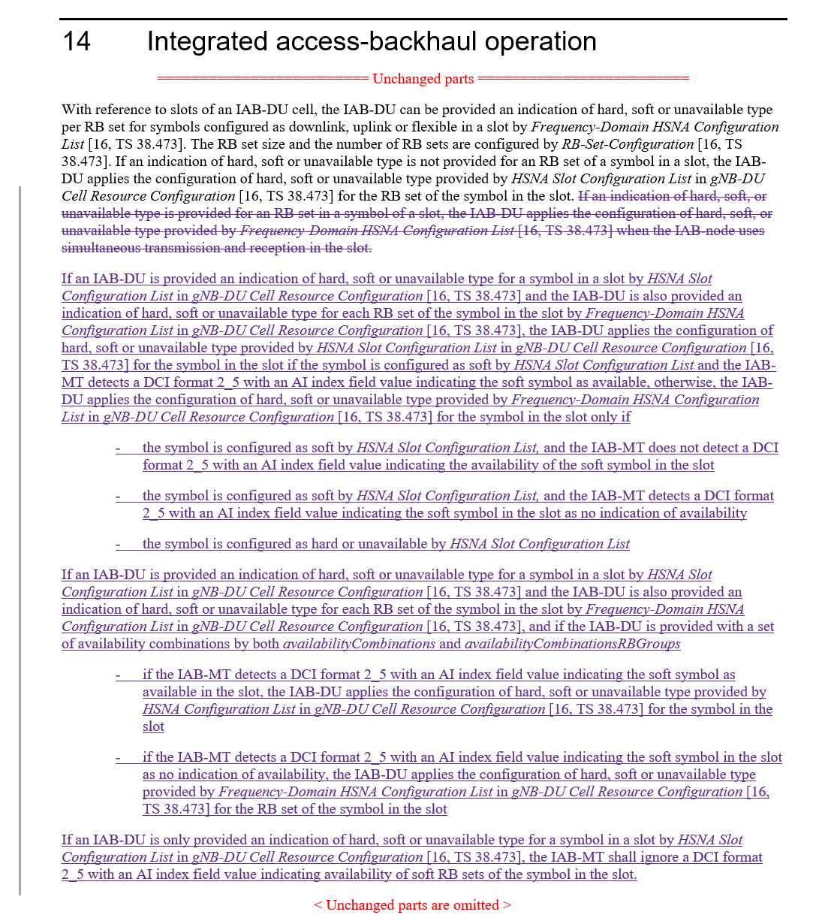
Lenovo  [6] | Observation 1: Compared to Al1. 2, Alt. 3b facilitates a fallback mode and provides higher resource efficiency if the IAB node is not capable of performing FDM at a particular moment.  Observation 2: Separate application of T-HSNA and F-HSNA is a special case of joint application. If joint application is agreed, the IAB-CU still has the possibility of separate (non-overlapping) configurations. Alt. 3b allows higher flexibility for resource configuration by the IAB-CU without loss of generality for TDM-only or FDM-only configurations if desired in a specific implementation.  Observation 3: Since the IAB-CU cannot be informed of whether an IAB node’s channel conditions at a specific time allows simultaneous MT-DU operations, the safe choice for the IAB-CU with Alt. 2 could be to avoid Rel-17 H/S/NA configuration, which could make the new specification useless in practice.  Proposal: Confirm the working assumption from RAN1#110, agenda item 8.10.
Qualcomm  [9] | 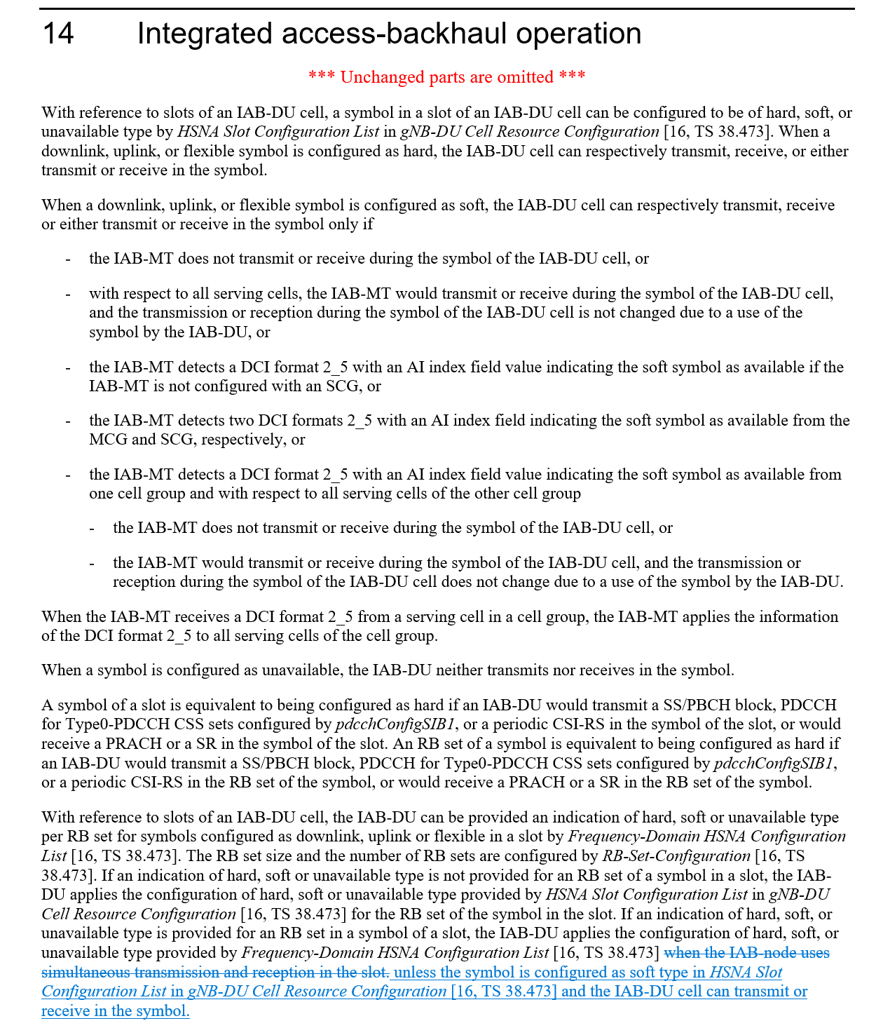
Nokia, Nokia Shanghai Bell  [10] | 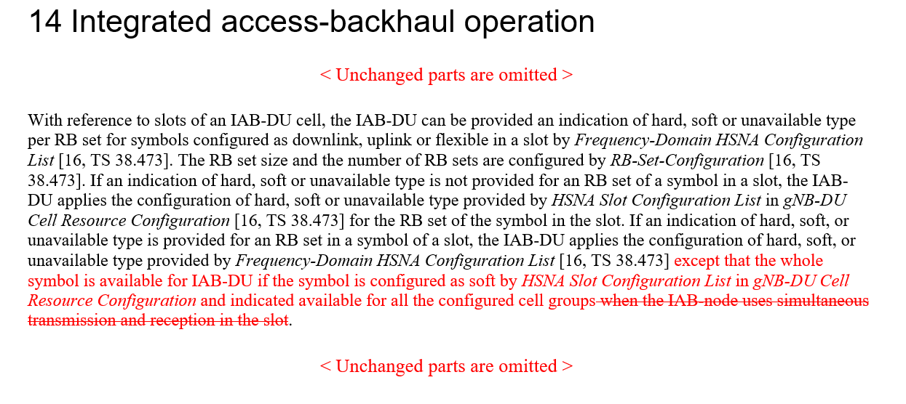
Ericsson  [16] | Proposal 1 If both Rel-16 time-domain H/S/NA configuration and Rel-17 frequency domain H/S/NA configuration are provided for a given RB set within a slot, the AvailabilityCombinationsPerCell-r17 is used to provide dynamic availability indication for both Rel-16 and Rel-17 Soft resource.

Based on the contributions it seems the WA from RAN1#110 can be confirmed. However, there are two related aspects requiring discussion:
- The WA states that “A resource configured with Rel-16 H or Rel-16 S with dynamic indication of availability overrides the Rel-17 H/S/NA configuration”. The question is whether ‘dynamic indication of availability’ refers solely to the explicit indication of availability via DCI or also includes the implicit determination of availability.
- Whether the behavior described in the WA is contingent on the mechanism (Rel-16 vs. Rel-17) to provide the explicit indication of availability.

In regard to 1) the FL understanding is that ‘dynamic indication of availability’ includes the implicit determination of availability, as that was the intent of the related FL proposal that led to the WA in RAN1#110. Moreover, there does not seem any advantage of precluding an implicitly determined time domain S resource to override the Rel-17 FDM configuration for the given symbol, in fact there seems to be a disadvantage in precluding it.
In regard to 2) the FL understanding is that the mechanism to provide the explicit indication of availability has no bearing on the behavior described by the WA. Moreover, assuming both Rel-16 and Rel-17 mechanisms can be used to provide an explicit indication of availability, there will never by a conflict since there is only the possibility to provide an indication of availability and there is no possibility to provide an indication of unavailability.

As a result the FL recommends we confirm the WA and adopt the corresponding TP change in TS 38.213:

FL Proposal 3.1
Confirm the WA from RAN1#110:

If Rel-16 H/S/NA resource configuration and Rel-17 H/S/NA resource configuration are both provided for a given RB set within a slot:
Alt 3b. A resource configured with Rel-16 S with dynamic indication of availability overrides the Rel-17 H/S/NA configuration, otherwise the child node follows the Rel-17 H/S/NA configuration for the resource.

Adopt the following TP in TS38.213:

Company | Comments

Topic #2. Corrections on RB set size for Rel-17 IAB FDM multiplexing
Related input from contributions:
Nokia, Nokia Shanghai Bell  [5] | 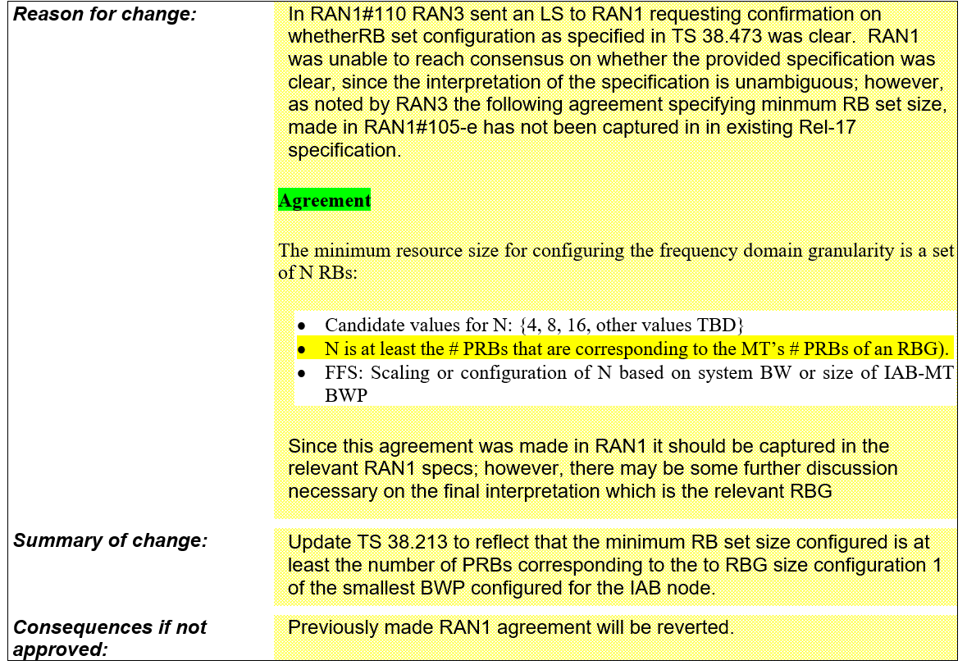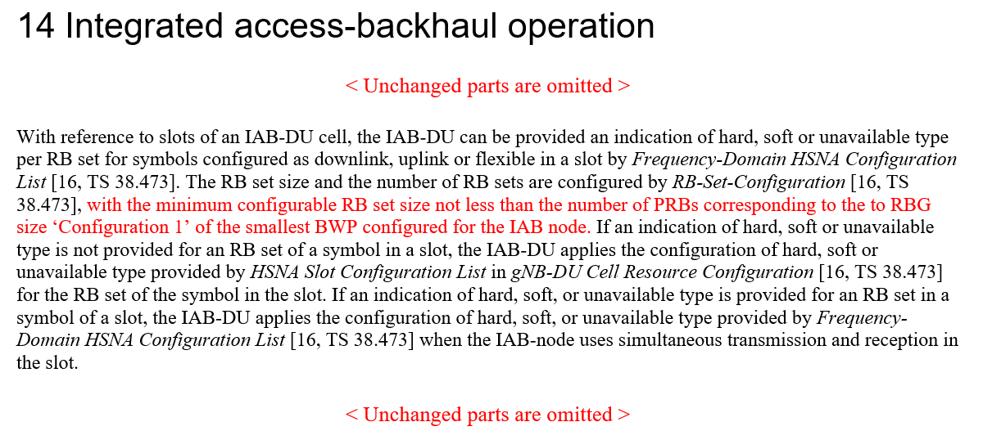

This topic was discussed extensively in RAN1#110 in the context of the reply LS to R1-2205705.
The FL assessment is that all companies are in alignment on the fact the aforementioned highlighted portion of the RAN1#105-e agreement (N is at least the # PRBs that are corresponding to the MT’s # PRBs of an RBG) needs to be captured in the specifications. On the other hand there are diverging views on whether that is actually the case. It is the FL understanding that the divergence likely stems from two different interpretations:
- Interpretation 1: the agreement indicates an operational constraint that the specification should reflect so that the network shall enforce it.
- Interpretation 2: the agreement indicates a constraint that is already reflected in the values that were eventually agreed for N in RAN1#106-e:
RAN1#106-e Agreement
N is a configured number of PRBs, where the CU configures N
- N = {2, 4, 8, 16, 32, 64}
- FFS: Value(s) of N in case of multiple configured BWPs at the IAB-MT
- This agreement does not revert any existing RAN1 agreement

The FL view is that regardless of the interpretation, given the possible values of N were defined and agreed, it is a network configuration issue to ensure the system is configured properly for best system performance. It is expected that in any case the network will use a suitable configuration for the desired system performance, which is true in general for network parameters. In that context, the FL believes this is not a critical issue and if there is no consensus on the interpretation of the RAN1#105-e agreement, the current specifications are acceptable.

Company | Comments

Topic #4. Correction on the formula of Case-7 UL Tx timing for eIAB in TS 38.213
Related input from contributions:
ZTE, Sanechips  [2] | 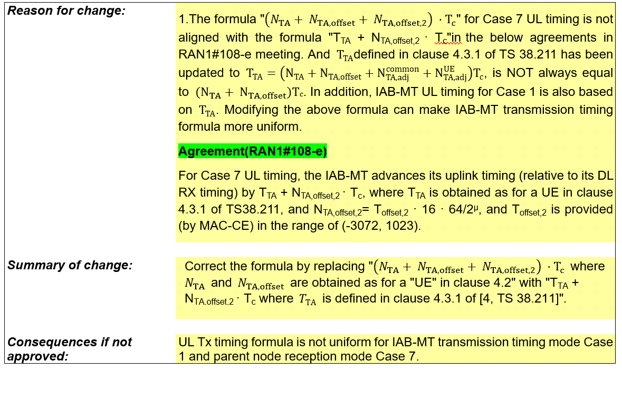

The FL assessment is that the CR has merit and it needs to be implemented to reflect the aforementioned agreement.

FL Proposal 3.4
Endorse draft CR in R1-2208786.

Company | Comments

Topic #5. Additional specification for DL Tx power adjustment
Related input from contributions:
Ericsson  [11], [12] | Proposal 1 The following RAN1#107-e agreement is amended as: The indicated desired/provided DL Tx power adjustment is in terms of a relative offset to the non-offset PDSCH Tx power, as derived from a CSI-RS TX power that is RRC configured.  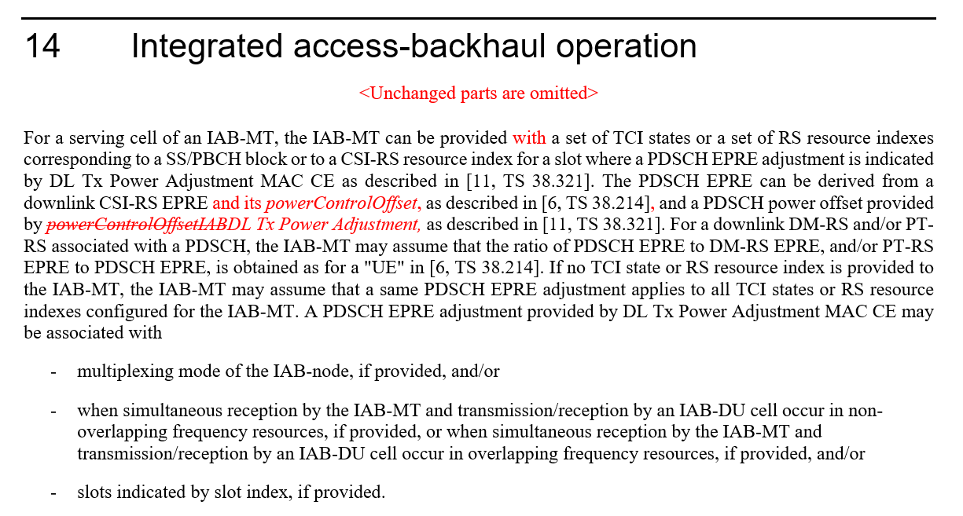

This topic was briefly addressed in RAN1#110 but there was no time to conclude. Based on the input in [12] it seems the proposed CR is necessary to avoid being limited by the agreed dynamic range for DL TX Power Adjustment.
FL Proposal 3.5
Endorse draft CR in R1-2210225.

Company | Comments
ETRI | Support.

Topic #6. Corrections on misaligment for MAC CE or RRC parameters for eIAB TS 38.213
Related input from contributions:
ZTE, Sanechips  [4] | 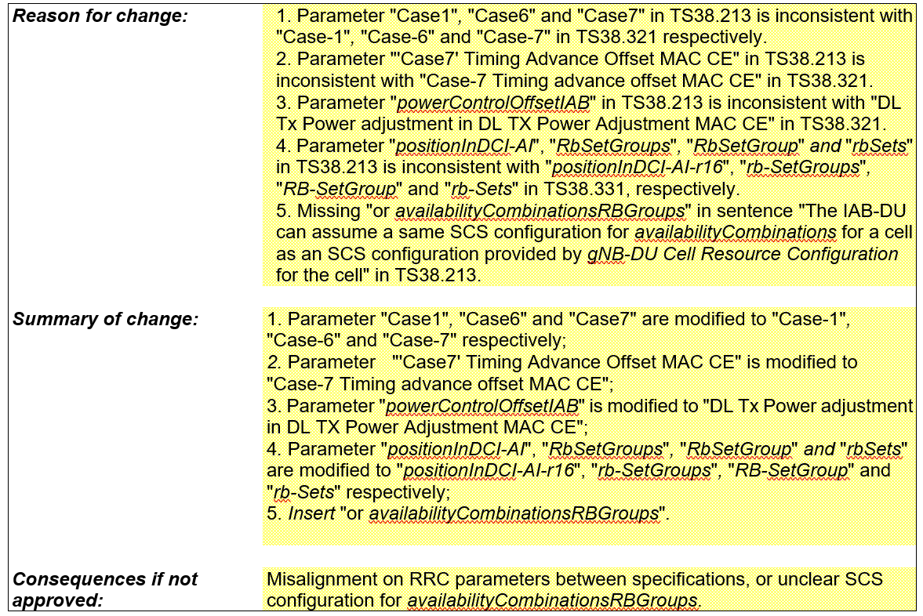

The FL assessment is that the CR has merit.

FL Proposal 3.6
Endorse draft CR in R1-2208788.

Company | Comments
ETRI | OK with other than change #3.  Change #3 in 8788 is overlapped with Topic #5 above.

Topic #7. Correction on the position related to the description that the RB set is equivalent to hard for eIAB in TS 38.213
Related input from contributions:
ZTE, Sanechips  [3] | 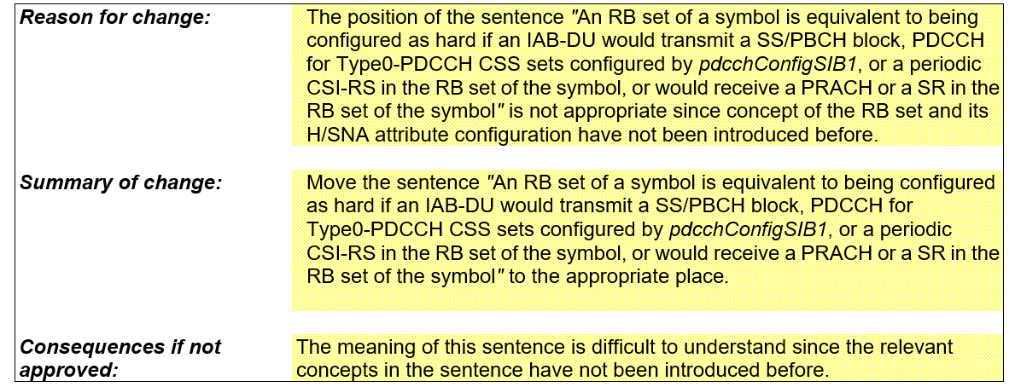

The FL assessment is that the CR has merit.

FL Proposal 3.7
Endorse draft CR in R1-2208787.

Company | Comments

Topic #8. Draft CR on guard symbols MAC CEs
Related input from contributions:
Ericsson  [13] | 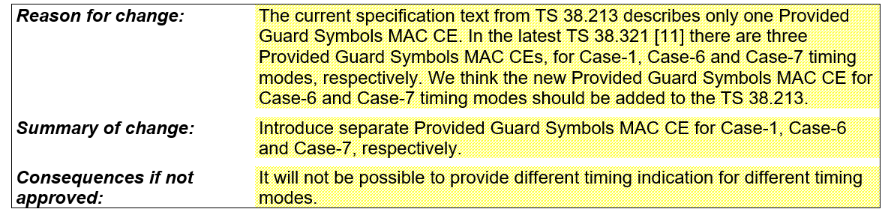  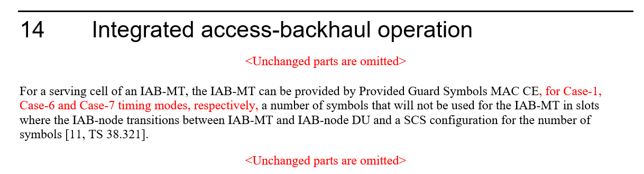

The FL assessment is that the CR has merit. For reference here is also the related RAN1#106-e agreement:

RAN1#106-e Agreement
MAC-CE signaling of Desired/Provided Guard Symbols is enhanced (e.g. using the same Rel-16 MAC-CE design) to support indication of guard symbols additionally required for Case #6 and Case #7 timing cases.
- FFS: Number of guard symbols associated with Case #6 and Case #7 timing modes
- FFS: Need for explicit indication of guard symbols switching between timing cases

FL Proposal 3.8
Endorse draft CR in R1-2210227.

Company | Comments

Topic #9. Draft CR on timing case indication
Related input from contributions:
Ericsson  [14] | 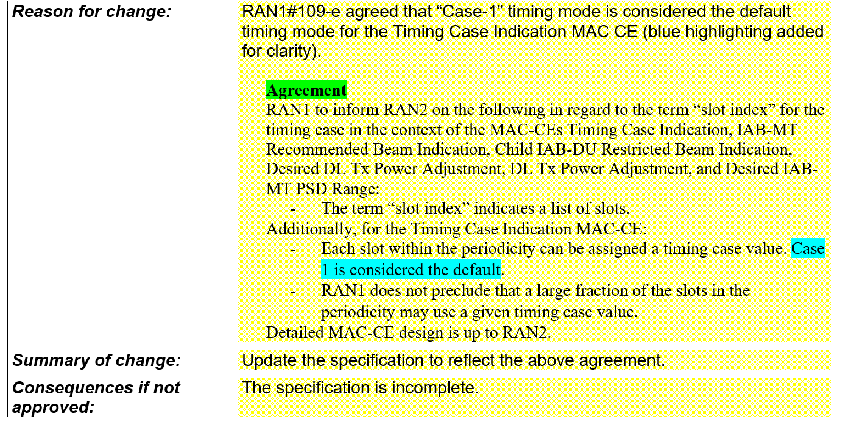  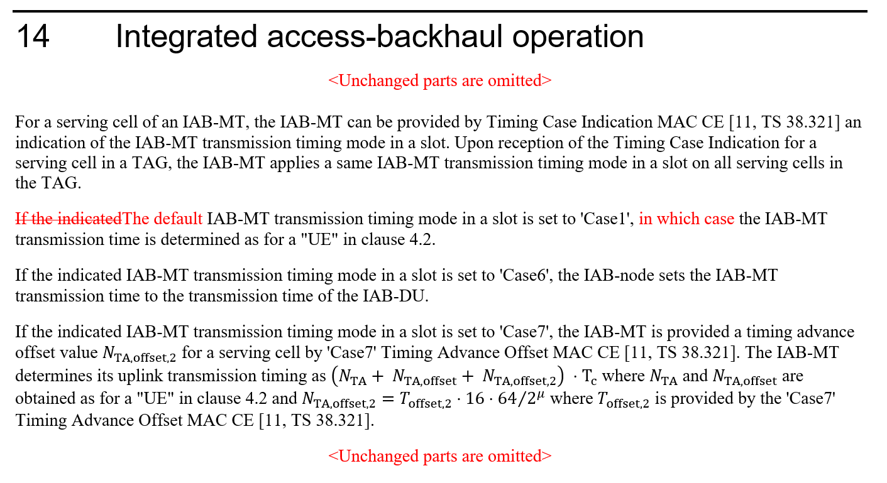

The FL assessment is that the CR has merit.

FL Proposal 3.9
Endorse draft CR in R1-2210228.

Company | Comments

Topic #10. Draft CR on Hard/Soft/Not Available resource definition
Related input from contributions:
Ericsson  [15] | 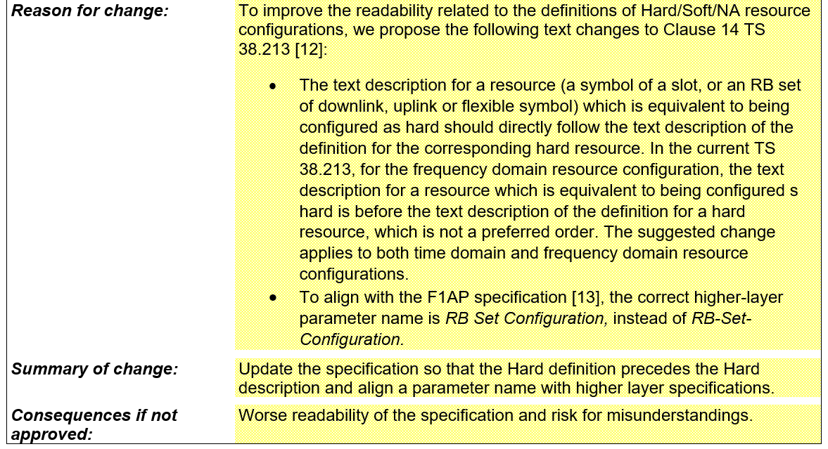  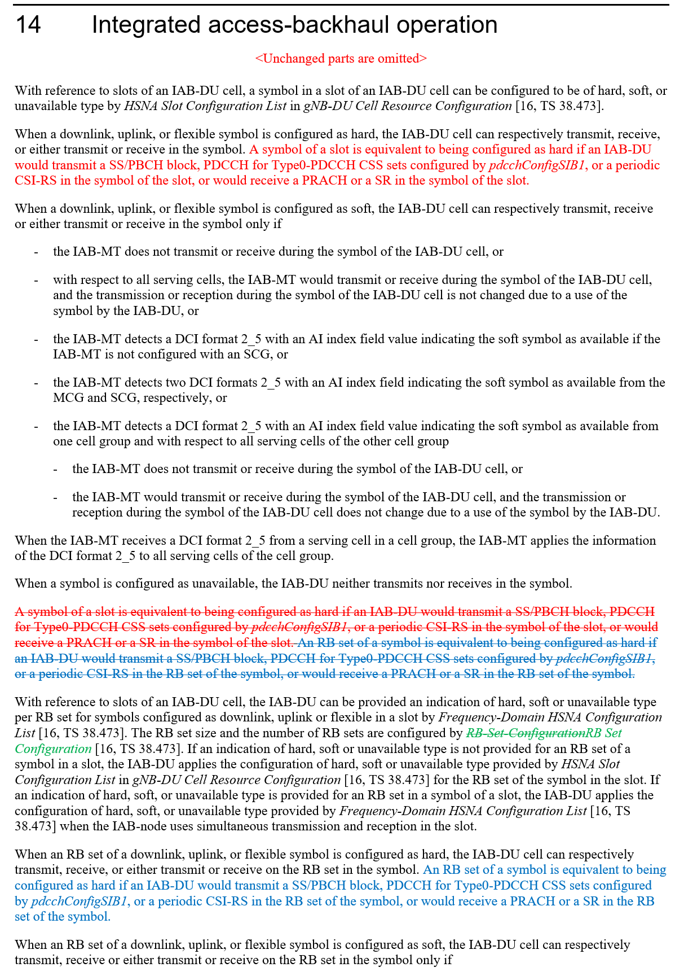

The FL assessment is that the CR has merit.

FL Proposal 3.10
Endorse draft CR in R1-2210229.

Company | Comments

Topic #11. Handling of interference between adjacent RB sets in FDM operation

Related input from contributions:
Huawei, Hisilicon  [1] | Observation 1: Guard band can provide better frequency domain isolation and may be needed to enable the FDM operation between MT and DU.  Observation 2: Placing the guard band on DU resource by implementation to achieve the FDM violates the definition of DU hard resources.  Proposal 4: The guard band including its size and location should be made aware of by IAB node’s parent node and donor node to facilitate efficient FDM operation.
Ericsson  [16] | Observation 1 Allowing the DU unconditional use of Hard resources, irrespective of interference on Soft or Not Available resources, assumes static channel conditions and will require a different solution for Rel-18 mIAB.  Proposal 2 To address the adjacent channel leakage between RB sets in FDM operation, RAN1 to decide to adopt  a. Alt 1: RAN1 based solution, restricting Hard resource utilization, or  b. Alt 2: RAN4 based solution, imposing adjacent leakage requirements into NA and Soft-NIA resources.

The FL assessment is that the issue related to this topic can be handled by implementation and with existing specifications, a view that was shared by a majority of companies in prior meetings.
In regard to the proposal in [1], at this stage of the WI it seems too late to introduce new signaling for a non critical issue.
In regard to the proposal in [16], the motivation of forward compatibility to Rel-18 mIAB is understandable, but it is a Rel-18 issue outside of the scope of Rel-17 maintenance for eIAB.

Company | Comments

References
[1] R1-2208471 Remaining issues on resource multiplexing for IAB, Huawei, HiSilicon
[2] R1-2208786 Correction on the formula of Case-7 UL Tx timing for eIAB in TS 38.213, ZTE, Sanechips
[3] R1-2208787 Correction on the position related to the description that the RB set is equivalent to hard for eIAB in TS 38.213, ZTE, Sanechips
[4] R1-2208788 Corrections on misalignment for MAC CE or RRC parameters for eIAB TS 38.213, ZTE, Sanechips
[5] R1-2209084 Correction on RB set size for Rel-17 IAB FDM multiplexing, Nokia, Nokia Shanghai Bell
[6] R1-2209118 Resource multiplexing in enhanced IAB systems, Lenovo
[7] R1-2209834 Correction on coexistance between Rel-16 and Rel-17 H/S/NA configuration, Huawei, HiSilicon
[8] R1-2209835 Correction on TDD configuration for IAB-MT, Huawei, HiSilicon
[9] R1-2209949 Draft CR on FD and TD DU resource configuration coexistence, Qualcomm
[10] R1-2210170 Clarification on Rel-16 and Rel-17 H/S/NA Configuration, Nokia, Nokia Shanghai Bell
[11] R1-2210225 Draft CR on DL Tx power control, Ericsson
[12] R1-2210226 Discussion on DL Tx power control, Ericsson
[13] R1-2210227 Draft CR on guard symbols MAC CEs, Ericsson
[14] R1-2210228 Draft CR on timing case indication, Ericsson
[15] R1-2210229 Draft CR on Hard/Soft/Not Available resource definition, Ericsson
[16] R1-2210230 Maintenance on enhanced IAB, Ericsson

