**3GPP TSG RAN WG1 #109-e R1-22xxxxx**

**e-Meeting, May 9th – 20th, 2022**

**Source: Moderator (MediaTek)**

**Title: [109-e-R16-2Step-RACH-01] Email discussion/approval the draft CR in R1-2204700**

**Agenda item: 7.2.1**

**Document for:** **Discussion and Decision**

Introduction

In RAN1#109-e meeting, one contribution [1, MTK] is submitted to clarify the spec text related to δ(b,f,c) value of SRS power control in 38.213 V16.9.0.

As guided by the Chairman, this contribution provides summary of the submitted contributions (Section 4), discussion points (Section 2), and possible RAN1 consensus during this meeting (Section 3, TBD).

[109-e-R16-2Step-RACH-01] Email discussion/approval the draft CR in R1-2204700 – James (MediaTek)

* Discussion and decision by 5/11, CR by 5/13, final check by 5/17

Discussion points (phase 1 until 11-May)

Based on the submitted contribution [1, MTK], it is mentioned that

* The spec text related to δ(b,f,c) value of PUCCH power control is revised from 38.213 V15.3.0 [2] to 38.213 V16.9.0 [3], to take into account the case of 2-step RACH (fallback RAR).
* However, the spec text related to δ(b,f,c) value of SRS power control in 38.213 V16.9.0 [3] is NOT revised accordingly.

Hence, [1] proposes to revise the spec text related to δ(b,f,c) value of SRS power control in 38.213 V16.9.0 [3], following the text revision of δ(b,f,c) value for PUCCH power control from 38.213 V15.3.0 [2] to 38.213 V16.9.0 [3].

The current spec text related to δ(b,f,c) value copied from 38.213 V15.3.0 [2] and 38.213 V16.9.0 [3] for PUCCH and SRS power control are shown below in Figures 1, 2, and 3.

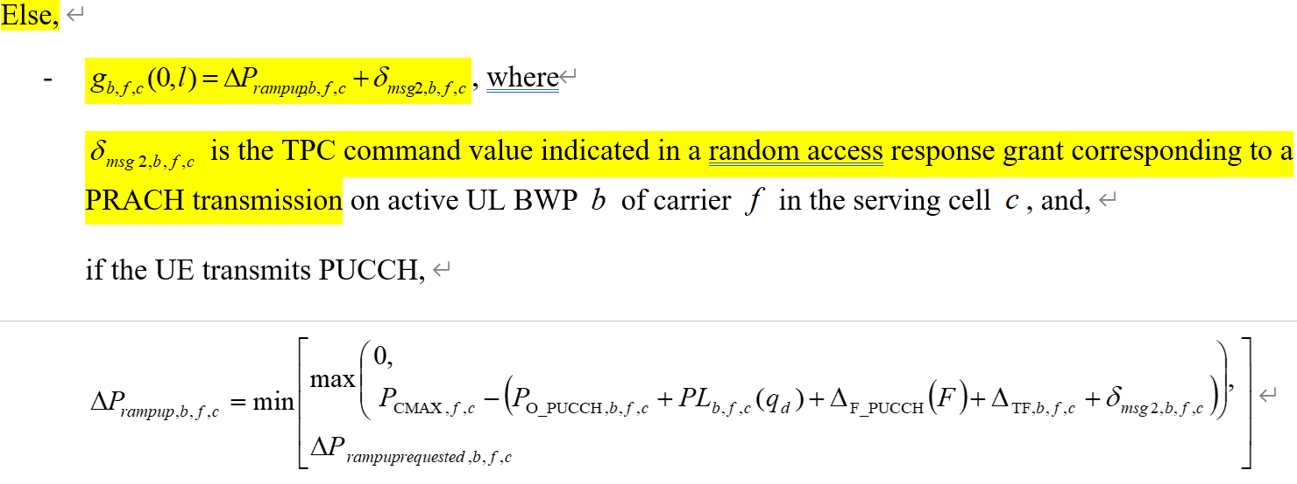

**Figure 1. Spec text related to δ(b,f,c) value of PUCCH power control in 38.213 V15.3.0 [2]**

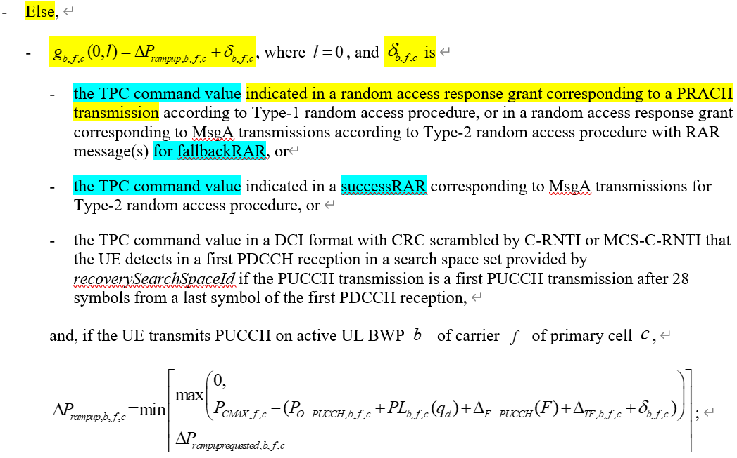

**Figure 2. Spec text related to δ(b,f,c) value of PUCCH power control in 38.213 V16.9.0 [3]**

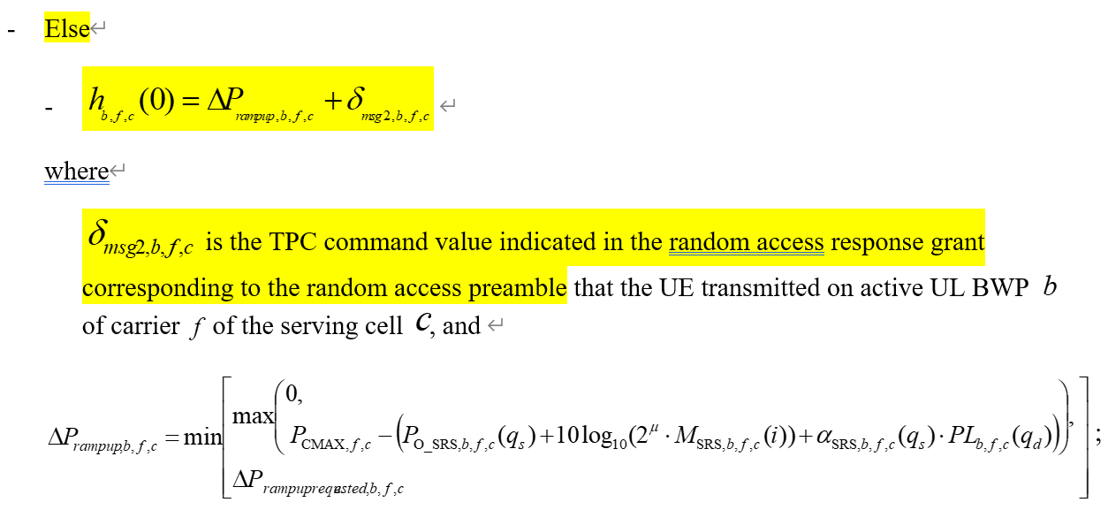

**Figure 3. Same spec text related to δ(b,f,c) value of SRS power control in 38.213 V15.3.0 [2] and 38.213 V16.9.0 [3]**

**Discussion point 1:**

**Do you agree with [1] to adopt the CR below to 38.213 V16.9.0, to revise the spec text related to δ(b,f,c) value of SRS power control, following the text revision of δ(b,f,c) value for PUCCH power control from 38.213 V15.3.0 to 38.213 V16.9.0?**

**If your answer is “No”, please describe why you think it is not necessary to revise spec to take into account 2-step RACH (fallback RAR) for SRS power control in the comment.**

If a configuration for a  value or for a  value for a corresponding SRS power control adjustment state  for active UL BWP  of carrier  of serving cell  is provided by higher layers

- 

- Else

-

where

is

* the TPC command value indicated in the random access response grant corresponding to ~~the random access preamble that the UE transmitted on active UL BWP  of carrier  of the serving cell ,~~ a PRACH transmission according to Type-1 random access procedure, or in a random access response grant corresponding to MsgA transmissions according to Type-2 random access procedure with RAR message(s) for fallbackRAR, or
* the TPC command value indicated in a successRAR corresponding to MsgA transmissions for Type-2 random access procedure,

and

;

|  |  |  |
| --- | --- | --- |
| **Company** | **Yes/No** | **Comment** |
| MTK | Yes |  |
| vivo |  | Agree that a TP is needed given TPC is indicated in the success RAR rather than the UL grant when MsgA is successfully decoded in 2-step RACH.  However, we propose to keep the text for 4-step RACH as much as possible and only the success RAR case should be additionally added as the TPC is still in the RAR UL grant for fallback RAR which still corresponds to a preamble in MsgA.  So, we propose to have following TP to be more consistent with the legacy wording used for 4-step RACH:  - Else  - $h_{b,f,c}\left(0\right)= ΔP_{rampup,b,f,c}+δ_{msg2,b,f,c}$ where $δ_{msg2,b,f,c}$ is   * the TPC command value indicated in the random access response grant corresponding to the random access preamble that the UE transmitted on active UL BWP  of carrier  of the serving cell , or * the TPC command value indicated in the successRAR corresponding to the MsgA that the UE transmitted on active UL BWP $b$ of carrier $f$ of the serving cell $c$ according to Type-2 random access procedure. |
| Intel | Yes | We are fine with the CR, which follows the description for PUCCH power control. |
| Nokia, Nokia Shanghai Bell | No | We prefer the alternative proposed by vivo, as it fits better the structure present for the PUCCH power control (having better separation of the 2-step RACH operations). |
| Qualcomm | Yes | Support the CR |
| ZTE | Yes | We prefer the CR from Moderator because it is exactly aligned with wording of PUCCH power control. As for vivo’s version, although it also works, it may result in different descriptions of TPC command for SRS and PUCCH, which may probably cause confusion to the readers.  PUCCH power control:  If a configuration of a  value for a corresponding PUCCH power control adjustment state  for active UL BWP  of carrier  of primary cell  is provided by higher layers,  -  If the UE is provided *PUCCH-SpatialRelationInfo*, the UE determines the value of  from the value of  based on a *pucch-SpatialRelationInfoId* value associated with the *p0-PUCCH-Id* value corresponding to  and with the *closedLoopIndex* value corresponding to ; otherwise,  - Else,  - , where , and  is  - the TPC command value indicated in a random access response grant corresponding to a PRACH transmission according to Type-1 random access procedure, or in a random access response grant corresponding to MsgA transmissions according to Type-2 random access procedure with RAR message(s) for fallbackRAR, or  - the TPC command value indicated in a successRAR corresponding to MsgA transmissions for Type-2 random access procedure, or |
| New H3C | Yes | We are fine with this CR with FL’s version. |
| Apple | Yes | We support the TP from moderator, which is the same handling as PUCCH. |
| Ericsson | Yes | We are fine with the TP to be aligned with PUCCH power control. |

Resulted RAN1 conclusion/agreement (phase 2 until 13-May)

TBD based on outcome/situation of phase 1 discussion.

Summary of contribution inputs

**Summary for [1, MTK]:**

In [1], it is mentioned that

* In 38.213 V16.9.0 [3], when determining the δ(b,f,c) value of PUCCH power control, the case of 2-step RACH (fallback RAR) is considered, as shown below in blue highlighted text from [3]:

<Begin of spec text>

If a configuration of a  value for a corresponding PUCCH power control adjustment state  for active UL BWP  of carrier  of primary cell  is provided by higher layers,

- 

If the UE is provided *PUCCH-SpatialRelationInfo*, the UE determines the value of  from the value of  based on a *pucch-SpatialRelationInfoId* value associated with the *p0-PUCCH-Id* value corresponding to  and with the *closedLoopIndex* value corresponding to ; otherwise, 

- Else,

- , where , and  is

- the TPC command value indicated in a random access response grant corresponding to a PRACH transmission according to Type-1 random access procedure, or in a random access response grant corresponding to MsgA transmissions according to Type-2 random access procedure with RAR message(s) for fallbackRAR, or

- the TPC command value indicated in a successRAR corresponding to MsgA transmissions for Type-2 random access procedure, or

- the TPC command value in a DCI format with CRC scrambled by C-RNTI or MCS-C-RNTI that the UE detects in a first PDCCH reception in a search space set provided by *recoverySearchSpaceId* if the PUCCH transmission is a first PUCCH transmission after 28 symbols from a last symbol of the first PDCCH reception,

and, if the UE transmits PUCCH on active UL BWP  of carrier  of primary cell ,

;

<End of spec text>

However, in 38.213 V16.9.0 [3], when determining the δ(b,f,c) value of SRS power control, the case of 2-step RACH (fallback RAR) is NOT considered:

<Begin of spec text>

If a configuration for a  value or for a  value for a corresponding SRS power control adjustment state  for active UL BWP  of carrier  of serving cell  is provided by higher layers

- 

- Else

- 

where

 is the TPC command value indicated in the random access response grant corresponding to the random access preamble that the UE transmitted on active UL BWP  of carrier  of the serving cell , and

;

<End of spec text>

**Observation 1: In 38.213 V16.9.0 [3], when determining the δ(b,f,c) value of PUCCH power control, the case of 2-step RACH (fallback RAR) is considered. However, when determining the δ(b,f,c) value of SRS power control, the case of 2-step RACH (fallback RAR) is NOT considered.**

It can be observed that the determination of δ(b,f,c) value of SRS power control in 38.213 V16.9.0 [3] is similar to the one of PUCCH power control in 38.213 V15.3.0 [2]:

<Begin of spec text>

Else,

- , where

 is the TPC command value indicated in a random access response grant corresponding to a PRACH transmission on active UL BWP  of carrier  in the serving cell , and,

if the UE transmits PUCCH,



<End of spec text>

**Observation 2: The determination of δ(b,f,c) value of SRS power control in 38.213 V16.9.0 [3] is similar to the one of PUCCH power control in 38.213 V15.3.0 [2]. Similar modification for SRS power control in 38.213 V16.9.0 [3] should be applied, if we follow the logic of revision of PUCCH power control from 38.213 V15.3.0 [2] to 38.213 V16.9.0 [3].**

Proposal 1: Adopt the CR below in 38.213 V16.9.0 [3] to revise SRS power control following the logic of revision of PUCCH power control from 38.213 V15.3.0 [2] to 38.213 V16.9.0 [3]:

<Begin of spec text>

If a configuration for a  value or for a  value for a corresponding SRS power control adjustment state  for active UL BWP  of carrier  of serving cell  is provided by higher layers

- 

- Else

-

where

is

* the TPC command value indicated in the random access response grant corresponding to ~~the random access preamble that the UE transmitted on active UL BWP  of carrier  of the serving cell ,~~ a PRACH transmission according to Type-1 random access procedure, or in a random access response grant corresponding to MsgA transmissions according to Type-2 random access procedure with RAR message(s) for fallbackRAR, or
* the TPC command value indicated in a successRAR corresponding to MsgA transmissions for Type-2 random access procedure,

and

;

<End of spec text>

References

[1] R1-2204700 On delta value of SRS power control, MediaTek, RAN1 #109e

[2] 3GPP TS 38.213 V15.3.0, NR; Physical layer procedures for control

[3] 3GPP TS 38.213 V16.9.0, NR; Physical layer procedures for control