3GPP TSG RAN WG1 Meeting #107-e R1-210xxxx
Nov 11th – 19th, 2021

Agenda item: 7.2.2
Source: Moderator (Qualcomm Incorporated)
Title: Preparation phase email discussion for NR-U
Document for: Discussion and Decision

Introduction
The paper summarizes the preparation phase email discussion for contribution submitted to 7.2.2 on NR-U CR under the following email thread
- [107-e-Prep-AI7.2.2] Preparation phase for Rel-16 NR-U maintenance: Jing (Qualcomm)

Issues identified
This section lists the issues discussed in submitted papers. I tried to put them under technical proposal or editorial proposal categories, but I might be wrong though.

Issues may need technical discussion:
Issue ID | Brief summary | Summary  document | Supporting document
T1 | Channel access updates for MIIT | [2] | [1]. CR for 37.213  [3]. CR for 38.212
T2 | CG-UCI multiplexing condition | [4] | [4]. CR for 38.212
T3 | Freq hopping for single/multi-PUSCH | [5], [8] | [9]. CR for 38.214
T4 | Channel access for consecutive UL transmission | [6] | [7]. CR for 37.213
T5 | Correction on unit of CP extension | [12] | [12]. CR for 38.211
T6 | UL transmission in wideband operation | [13] | [13]. CR for 37.211
T7 | Discussion on LS from RAN4 on measing CSI-RS during SCell activation | [14]
T8 | Changes of channel access procedure in TS 37.213 | [16] | [16]. CR for 37.213
T9 | On additional PDSCH DM-RS dropping with double symbol | [17] | [17]. CR for 38.211

Issues more editorial in nature:
Issue ID | Brief summary | Summary  document | Supporting document
E1 | Correct IE name for availableRB-SetsToReleaseList | [10] | [10]. CR for 38.213
E2 | Type 3 HARQ codebook construction, change “HARQ process number h” to “HARQ process h” | [11] | [11]. CR for 38.213
E3 | Correction on usage of subCarrierSpacingCommon for unlicensed | [15] | [15]. CR for 38.213
E4 | Correction on UL channel access procedure Type 2A/2B/2C | [18] | [18]. CR for 37.213

Discussion on which CR to treat
Please provide your view below. “Y” to discuss.
Company | T1 | T2 | T3 | T4 | T5 | T6 | T7 | T8 | T9
MTK | Y | Y | Y | Y | Y | Y | Y | Y | Y
Ericsson |  | Y (OK with 1st change) | Y |  |  | Y | N | Y
LG Electronics |  | Y (but the second change doesn’t seem to be needed) | Y |  | Y | Y |  | Y | Y
Transsion | Y | Y | Y |  |  | Y |  | Y | N
Huawei, HiSilicon | Y, comment below | Y, response to LG below | Y |  | Comment below | Y |  | Y | resolved in RAN1#104,
CAICT |  | Y | Y |  | Y | Y |  | Y | Y
ZTE, Sanechips | Y(specific CR can be further discussed) | Y(fine with 1st change, and not understand the motivation of 2nd change) | Y |  | Y(can be further clarified) | Y |  | Y | Y
Intel |  | Y | Y |  |  | Y | Y | Y | Y
vivo |  | Y | Y | Y (Comment below) |  | Y |  | Y
Sharp |  |  |  |  | Y | Y |  | Y
Nokia, NSB | Y | Y | Y |  |  | Y |  | Y
Lenovo, Motorola Mob. | Y | Y | Y | Y | Y |  | Y  (see Comment below) | Y
Samsung |  | Y | Y |  |  | Y |  | Y

Company | E1 | E2 | E3 | E4
MTK | Y | Y | Y | Y
Ericsson | Y | N | Y | N
LG Electronics | Y | Y | Y | Y
Transsion | Y | Y | Y | Y
Huawei, HiSilicon | Y | Y | Y | Comment below
CAICT | Y | Y | Y | Y
ZTE, Sanechips | Y | Y(but suggest to align name between different specs) | Y | Y
Intel | Y | Y | Y | Y
vivo | Y | Y | Y | Y (Comment below)
Sharp | Y |  | Y
Nokia, NSB | Y | Y | Y | Y
Lenovo, Motorola Mob. | Y |  |  | Y  (see Comment)
Samsung | Y |  | Y | Y

Other comments:
Company Name | Comments
MTK | For T9, we are trying to discuss the issue about additional PDSCH DM-RS dropping with double symbol. With the Rel-16 NR-U introduced Type B PDSCH duration $l_{\text{d}}$ $∈\left\{8,9,10,11,12,13\right\}$:  In some condition, only the second symbol of an additional double-symbol DM-RS is out of bound according to current Rel-16 RAN1 spec, and it breaks the orthogonality of orthogonal cover code (OCC) applied on the DM-RS. As a result, we prefer to adopt Alt 1 below (drop both symbols when the second symbol of DMRS is out of bound) to avoid this kind of scenario.  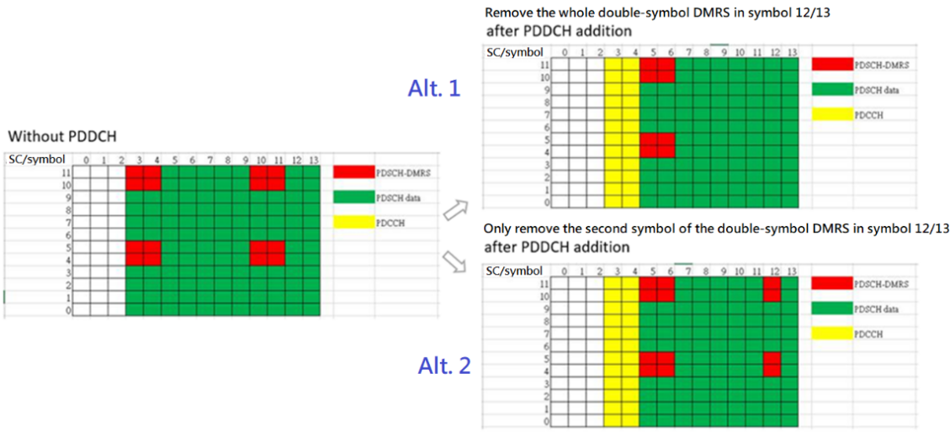
Ericsson | T7: This issue has been discussed for 3 meetings now (one of them in Rel-15 maintenance) without consensus. We see little point in continuing the discussion which will end up with the same result.
Transsion | T9: This issue has been discussed and identified at the RAN1#104-e meeting, and the intention of the final CR R1-2102009 is the same as that of MTK. In current specification, “for all values of the PDSCH duration l_{d} other than 2, 5, and 7 symbols, the UE is not expected to receive DM-RS beyond the (l_{d} - 1):th symbol” means that for double-symbol DMRS, the UE is not expected to receive the two DM-RS symbols. The language “DM-RS” highlighted in yellow in current spec is for simplicity and to be consistent with the description in “if the PDSCH duration $l_{\text{d}}$ is 12 or 13 symbols, the UE is not expected to receive DM-RS mapped to symbol 12 or later in the slot”. Hence, we believe that this issue should not be discussed again.
MTK2 | Thanks Transsion for pointing out that T9 is already discussed before and had a corresponding CR R1-2102009. The information is very helpful to us. We agree with Transsion that T9 is not needed to be discussed again in RAN1 #107e.
Huawei, HiSilicon | T1: The new regulation for 2.4GHz, 5.1GHz and 5.8GHz in China was formally issued on Sept 8. It will take effect from Jan 1 2022. Current FBE mechanism did not conform to the regulation and should be resolved.  T2: As for the 2nd change, the current spec allocate all RE of PUSCH to CG-UCI, CSI-part- 1 and CSI-part-2. There is no space for CG-PUSCH.  T5: We think this correction is inaccurate as $T_{\text{ext}}$ is used for defining the time interval ${t_{\text{start,}l}^{μ}-T}_{\text{ext}}≤t<t_{\text{start,}l}^{μ}$ on which the extension time-continuous signal $s_{\text{ext}}^{(p,μ)}\left(t\right)$ is generated from the discrete samples using Tc. Therefore, $Δ_{i}$ should be also calculated in a time-continuous manner which also captures the gap duration accurately. Then, the calculation of the signal ${\overline{s}}_{l}^{(p,μ)}\left(t\right)$ takes care of the Tc time unit.  E4: This clarifying editorial can be handled, if needed, without deletion
vivo | T4: We are trying to discuss the scenario that consecutive UL transmissions are scheduled by multiple UL grant(s) and one example is illustrated below:  If following current spec below in 37.213, if Type 2B for PUSCH 1 failed, PUSCH2 and PUSCH3 will be transmitted by performing Type 2A LBT, which is not correct since it is already out of COT.  If a UE is scheduled to transmit a set of UL transmissions using one or more UL grant(s) or DL assignment(s), and if the UE cannot access the channel for a transmission in the set prior to the last transmission according to one of Type 1, Type 2, or Type 2A UL channel access procedures, the UE shall attempt to transmit the next transmission according to the channel access type indicated in the corresponding UL grant or DL assignment. Otherwise, if the UE cannot access the channel for a transmission in the set prior to the last transmission according to Type 2B UL channel access procedure, the UE shall attempt to transmit the next transmission according to Type 2A UL channel access procedure.  If looking at the agreement below, it only involves the UL transmission(s) by a single UL grant. For multiple UL grants, it should follow the channel access type in DCI.  Agreement:  For LBT type and CP extension, after failing to transmit first PUSCH(s) of a set scheduled by a single UL grant,  - If a UE fails to access the channel with UL Type 2B channel access, Type 2A UL channel access shall be used for the following consecutively scheduled transmissions.  - If a UE fails to access the channel prior to the first of the consecutive UL transmissions, it shall use “0” CP extension for the subsequent UL transmissions irrespective of the CP extension indicated in the scheduling grant.  E4: This clarification editorial can be handled by adding ‘,’ before ‘where’.
Sharp | We think that T8 is more like editorial corrections.
Lenovo, Motorola Mobility | T7: CSI-RS measurement during SCell activation is also addressed by R1-2111846 submitted to AI 7.1, it might be better adressed there (if at all).  E4: We consider this as an essential correction to remove ambiguity, and not just an editorial change.

Reference
- R1-2110822, Changes of channel access procedure in TS 37.213 according to MIIT regulation, Huawei, HiSilicon
- R1-2110823, Discussion on the impact of MIIT consultation to channel access procedure, Huawei, HiSilicon
- R1-2110824, Changes of channel access types tables in TS 38.212, Huawei, HiSilicon
- R1-2110825, Corrections on CG-UCI multiplexing in TS38.212, Huawei, HiSilicon
- R1-2110826, Discussion on the frequency hopping for single/multi PUSCH transmission, Huawei, HiSilicon
- R1-2110974, Discussion on channel access procedures for consecutive UL transmissions, vivo
- R1-2110975, Correction on channel access procedures for consecutive UL transmission(s), vivo
- R1-2110977, Discussions on frequency hopping for PUSCH,PUCCH and SRS, vivo
- R1-2110978, Draft CR on 38.214 on frequency hopping for multi-PUSCH scheduling by a single DCI, vivo
- R1-2111082, Correction on slot configuration in TS 38.213, ZTE, Sanechips
- R1-2111339, Correction on Type-3 HARQ-ACK codebook, OPPO
- R1-2111340, Draft CR for correction on unit of CP extension, OPPO
- R1-2111461, UL Transmissions in Wideband Operation, Ericsson, Nokia, NSB, LG Electronics, Qualcomm, Huawei, HiSilicon
- R1-2111462, Discussion on LS from RAN4 on measing CSI-RS during SCell activation, Ericsson
- R1-2111714, Correction on usage of subCarrierSpacingCommon for unlicensed, Samsung
- R1-2111927, Changes of channel access procedure in TS 37.213, Huawei, HiSilicon
- R1-2112294, On additional PDSCH DM-RS dropping with double symbol, MediaTek Inc.
- R1-2112350, Correction on UL channel access procedure Type 2A/2B/2C , Lenovo, Motorola Mobility, ZTE, Sanechips, Xiaomi, Intel, OPPO

