3GPP TSG RAN WG1 Meeting #107-e R1-210xxxx
Nov 11th – 19th, 2021

Agenda item: 7.2.2
Source: Moderator (Qualcomm Incorporated)
Title: Preparation phase email discussion for NR-U
Document for: Discussion and Decision

Introduction
The paper summarizes the preparation phase email discussion for contribution submitted to 7.2.2 on NR-U CR under the following email thread
- [107-e-Prep-AI7.2.2] Preparation phase for Rel-16 NR-U maintenance: Jing (Qualcomm)

Issues identified
This section lists the issues discussed in submitted papers. I tried to put them under technical proposal or editorial proposal categories, but I might be wrong though.

Issues may need technical discussion:
Issue ID | Brief summary | Summary  document | Supporting document
T1 | Channel access updates for MIIT | [2] | [1]. CR for 37.213  [3]. CR for 38.212
T2 | CG-UCI multiplexing condition | [4] | [4]. CR for 38.212
T3 | Freq hopping for single/multi-PUSCH | [5], [8] | [9]. CR for 38.214
T4 | Channel access for consecutive UL transmission | [6] | [7]. CR for 37.213
T5 | Correction on unit of CP extension | [12] | [12]. CR for 38.211
T6 | UL transmission in wideband operation | [13] | [13]. CR for 37.211
T7 | Discussion on LS from RAN4 on measing CSI-RS during SCell activation | [14]
T8 | Changes of channel access procedure in TS 37.213 | [16] | [16]. CR for 37.213
T9 | On additional PDSCH DM-RS dropping with double symbol | [17] | [17]. CR for 38.211

Issues more editorial in nature:
Issue ID | Brief summary | Summary  document | Supporting document
E1 | Correct IE name for availableRB-SetsToReleaseList | [10] | [10]. CR for 38.213
E2 | Type 3 HARQ codebook construction, change “HARQ process number h” to “HARQ process h” | [11] | [11]. CR for 38.213
E3 | Correction on usage of subCarrierSpacingCommon for unlicensed | [15] | [15]. CR for 38.213
E4 | Correction on UL channel access procedure Type 2A/2B/2C | [18] | [18]. CR for 37.213

Discussion on which CR to treat
Please provide your view below. “Y” to discuss.
Company | T1 | T2 | T3 | T4 | T5 | T6 | T7 | T8 | T9
MTK | Y | Y | Y | Y | Y | Y | Y | Y | Y

Company | E1 | E2 | E3 | E4
MTK | Y | Y | Y | Y

Other comments:
Company Name | Comments
MTK | For T9, we are trying to discuss the issue about additional PDSCH DM-RS dropping with double symbol. With the Rel-16 NR-U introduced Type B PDSCH duration $l_{\text{d}}$ $∈\left\{8,9,10,11,12,13\right\}$:  In some condition, only the second symbol of an additional double-symbol DM-RS is out of bound according to current Rel-16 RAN1 spec, and it breaks the orthogonality of orthogonal cover code (OCC) applied on the DM-RS. As a result, we prefer to adopt Alt 1 below (drop both symbols when the second symbol of DMRS is out of bound) to avoid this kind of scenario.  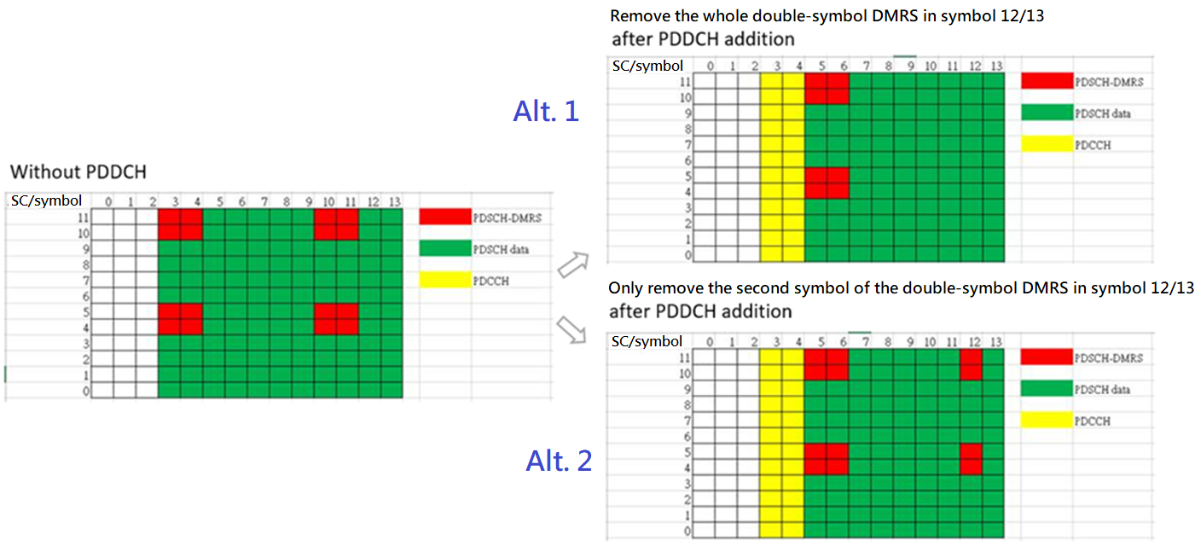

Reference
- R1-2110822, Changes of channel access procedure in TS 37.213 according to MIIT regulation, Huawei, HiSilicon
- R1-2110823, Discussion on the impact of MIIT consultation to channel access procedure, Huawei, HiSilicon
- R1-2110824, Changes of channel access types tables in TS 38.212, Huawei, HiSilicon
- R1-2110825, Corrections on CG-UCI multiplexing in TS38.212, Huawei, HiSilicon
- R1-2110826, Discussion on the frequency hopping for single/multi PUSCH transmission, Huawei, HiSilicon
- R1-2110974, Discussion on channel access procedures for consecutive UL transmissions, vivo
- R1-2110975, Correction on channel access procedures for consecutive UL transmission(s), vivo
- R1-2110977, Discussions on frequency hopping for PUSCH,PUCCH and SRS, vivo
- R1-2110978, Draft CR on 38.214 on frequency hopping for multi-PUSCH scheduling by a single DCI, vivo
- R1-2111082, Correction on slot configuration in TS 38.213, ZTE, Sanechips
- R1-2111339, Correction on Type-3 HARQ-ACK codebook, OPPO
- R1-2111340, Draft CR for correction on unit of CP extension, OPPO
- R1-2111461, UL Transmissions in Wideband Operation, Ericsson, Nokia, NSB, LG Electronics, Qualcomm, Huawei, HiSilicon
- R1-2111462, Discussion on LS from RAN4 on measing CSI-RS during SCell activation, Ericsson
- R1-2111714, Correction on usage of subCarrierSpacingCommon for unlicensed, Samsung
- R1-2111927, Changes of channel access procedure in TS 37.213, Huawei, HiSilicon
- R1-2112294, On additional PDSCH DM-RS dropping with double symbol, MediaTek Inc.
- R1-2112350, Correction on UL channel access procedure Type 2A/2B/2C , Lenovo, Motorola Mobility, ZTE, Sanechips, Xiaomi, Intel, OPPO

